Supplementary Materials for

Vegetation greening enhances global fire activity

Gengke Lai, Yongguang Zhang, Chaoyang Wu, Alessandro Cescatti, Gregory Duveiller, Juli G. Pausas, Stijn Hantson, Zhaoying Zhang, Adrià Descals, Min Cao, Huazheng Lu, Josep Peñuelas

Corresponding author: ygz@nju.edu.cn and wucy@igsnrr.ac.cn

The Supplementary Materials file includes:

Supplementary Text S1-S3
Figs. S1 to S21
Tables S1 to S4

Supplementary Text
S1. Assessment of the representativeness of LAI_{dead} to the inter-annual variations of litterfall
We assessed the representativeness of LAI_{dead} calculated by our method to the interannual variations of litterfall (dead fine fuel). We used a global aboveground litterfall production dataset (cLitter) over the period of 2002-2013 produced by ref.¹ for LAI_{dead} assessment. cLitter is produced by random forest algorithm that relates a substantial number of field measurements of aboveground litterfall production with vegetation index and climatic variables. This dataset refers to plant material shed in one year and is composed primarily of leaves, twigs (< 2.5 cm in diameter), flowers, fruits and bark, but not dead roots and coarse woody detritus¹.
We further collected some site-level litterfall ground measurements to validate the representativeness of LAI_{dead} in forest ecosystems (Table S4). Bubeng and Menglun sites (tropical seasonal rainforest) are located in the Xishuangbanna National Nature Reserve, southwestern China, providing long-term litterfall field measurements twice and once a month, respectively (http://bnf.cern.ac.cn/). Barro Colorado Island (BCI) site is in Panama, which is a tropical moist forest and provides weekly litterfall collections². The SMEAR Ⅱ station is located next to the Hyytiälä forest, southern Finland, which is a homogeneous Scots pine stand and provides monthly litterfall collections (https://smear.avaa.csc.fi/download)³. For the above sites with higher sampling frequencies, we first divided the original litterfall dry weight by the trap area (expressed in unit of g m⁻²), and then averaging the resultant values across all traps collected simultaneously. Next, they were divided by the days since last collection to represent the rate of litterfall (expressed in unit of g m⁻² day⁻¹). The rates in the same month were averaged. We obtained the final monthly litterfall mass by multiplying litterfall rate by the days of month (expressed in unit of g m⁻² month⁻¹). Finally, we calculated the averaged litterfall during the senescence period. To correspond with the calculation of LAI_{dead}, the senescence period was determined from the month with maximum LAI to the subsequent month with minimum LAI based on GLASS LAI products. We additionally collected data in two temperate forest sites, including Harvard forest in the USA⁴ and Hainich site in Germany⁵. Differently, they provide yearly litterfall ground measurements. Thus, we assumed that the yearly litterfall mostly corresponds to the senescence period. Note that the Harvard forest litterfall data were collected in a simulated hurricane experiment, so we only used the data from their control experiment. Moreover, we only focused on the leaf dry weight in the total litterfall.
For the global validations, we examined the relationships between detrended LAI_{dead} and detrended cLitter at the grid cell level, as well as the spatial correlations of their annual averages across 12 biomes (Fig. S6). For the site-level validations, we tested the correlations between detrended LAI_{dead} and detrended litterfall measurements (Fig. S7 and Table S4). Two different scales of GLASS LAI products (0.25° and 500 m) were used to validate that the method to calculate LAI_{dead} and our findings were independent of spatial scale and heterogeneity. Considering the orientation bias, we used a 5×5 spatial smoothing window when extracting 500m LAI for each site. We also tried the 3×3 and 7×7 spatial smoothing windows, and obtained similar results.
S2. Bioclimatic spaces
Following the method of ref.⁶, we also described fire variations as a function of LAI (LAI_{live} and LAI_{dead}) changes and water availability (aridity index and RH) or vegetation growth (LAI_{live} and tree cover) to qualitatively analyze fire responses to LAI changes and drivers of their variabilities. For each grid cell, fire and LAI variations were represented by the relative year-to-year variations (i.e. difference between two consecutive years divided by the multi-year mean) of BF (ΔBF_{rel}) and LAI (ΔLAI_{rel}). We first divided ΔLAI_{rel} and multi-year averaged drivers (aridity index, RH, LAI_{live}, and tree cover) into 50 bins and formed a 50×50 ΔLAI_{rel}-driver space. Then ΔBF_{rel} was allocated into each ΔLAI_{rel}-driver bin and averaged. This analysis was based on MCD64A1 burned area and GLASS LAI product. Similar with the findings of sensitivity analysis by ridge regression, an increase in LAI_{dead} consistently enhanced fire activity along the moisture and productivity gradients (Fig. S15). LAI_{live} had regional contrasting effects on fire activity, which were regulated by the critical thresholds of water availability and vegetation growth (Fig. S16).
S3. Random forest and SHAP
Despite we used ridge regression to alleviate the impacts of multicollinearity among explanatory factors on our results, traditional statistical approaches still operate under the assumption of a linear relationship between factors and fire activity. To verify whether our finding was an artefact of our regression method, we also used random forest and explainable machine learning (SHapley Additive exPlanations, SHAP) methods to estimate fire sensitivities to LAI_{live} and LAI_{dead}. In contrast to conventional statistical approaches, this method synergizes the benefits of random forest, encompassing bootstrap aggregation and non-distribution assumption, with the strengths of SHAP, ensuring coherence between global interpretations and local explanations. This method strengthens the robustness of the results compared to traditional statistical methods⁷. First, for each grid cell, the random forest model was trained using the year-to-year variations of burn fraction, LAI_{live}, LAI_{dead}, temperature, and total precipitation. To ensure the stability and reliability of the random forest model by increasing sample size, we used a 9×9 spatial moving window (2.25°×2.25°) to train the model for the centered grid cell. The hyperparameter settings for random forest were number of estimators=100; maximum features=30%; random state=42. Then, SHAP was used to interpret trained model and calculate the marginal contributions of LAI_{live} and LAI_{dead} on burned fraction. Finally, fire sensitivities to LAI_{live} (LAI_{dead}) were calculated as the slope between SHAP-derived marginal contributions of LAI_{live} (LAI_{dead}) and LAI_{live} (LAI_{dead}) anomalies by using the Theil-Sen regression. The results were consistent with those estimated from ridge regression (Fig. S17), showing globally positive sensitivity to LAI_{dead} and regional contrasting sensitivity to LAI_{live}.

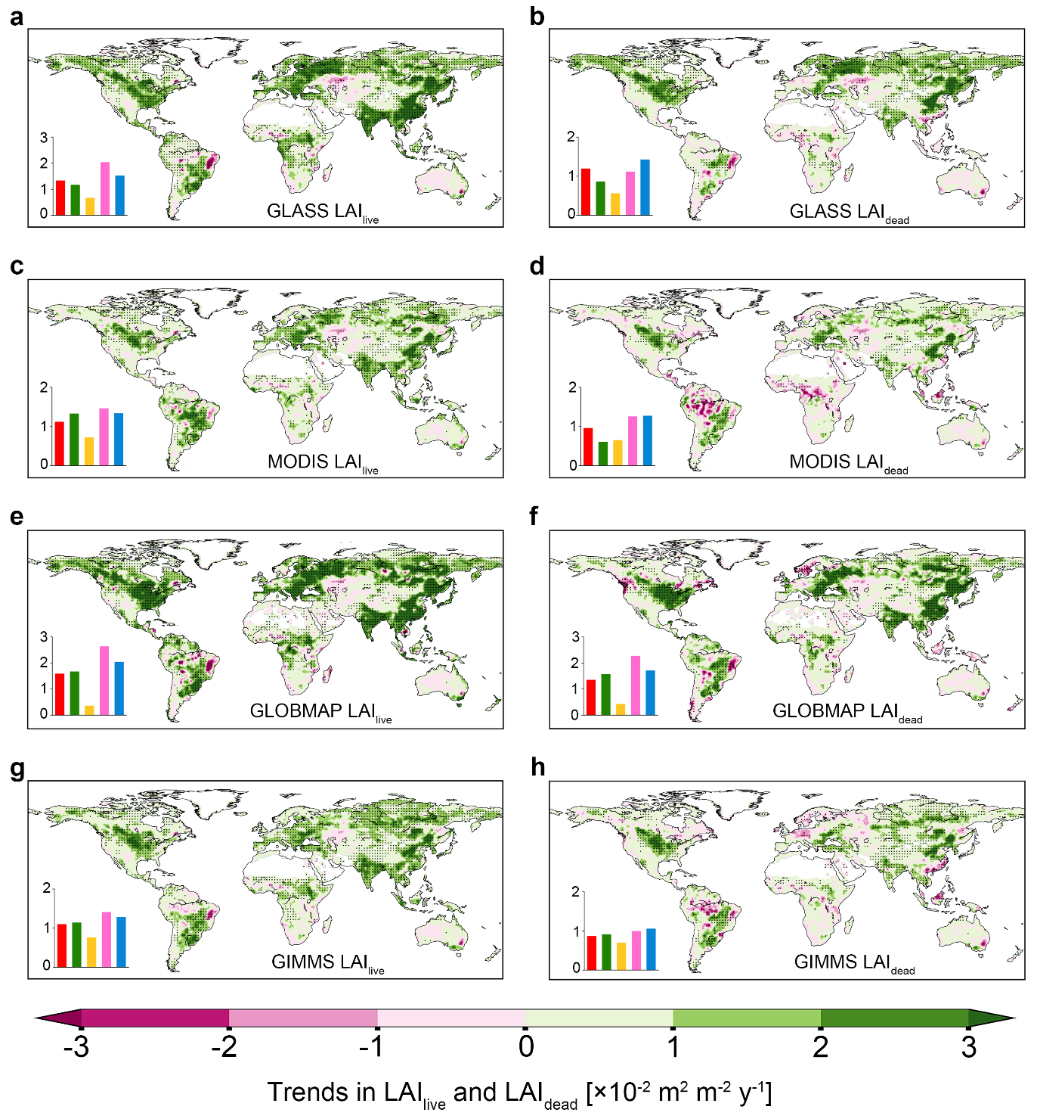
Fig. S1 | Long-term trends in LAI_{live} (left) and LAI_{dead} (right) over the period 2002-2020 for GLASS (a, b), MODIS (c, d), GLOBMAP (e, f) and GIMMS (g, h) LAI products. The black dots indicate regions with significant trend (p-value < 0.1). The insets at bottom left represent median trends for global (red), tropical (green), arid (orange), temperate (pink), and cold (blue) regions.

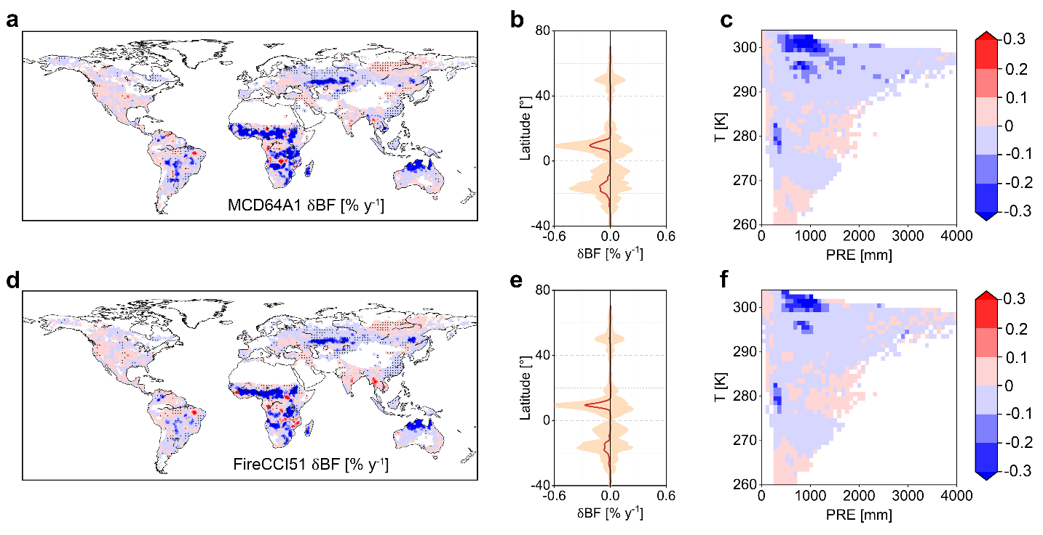
Fig. S2 | Long-term trends in burned fraction (BF) for MCD64A1 V6 and FireCCI51 burned area products over the period 2002-2020. a, Long-term trends in BF (δBF) of MCD64A1 V6 product. The black dots indicate regions with significant trend (p-value < 0.1). b, Latitudinal median of δBF. The shaded area indicates the standard deviation of each latitudinal zone. c, δBF binned as a function of annual mean temperature (T) and precipitation (PRE). d-f, Same as a-c but for FireCCI51 burned area product.

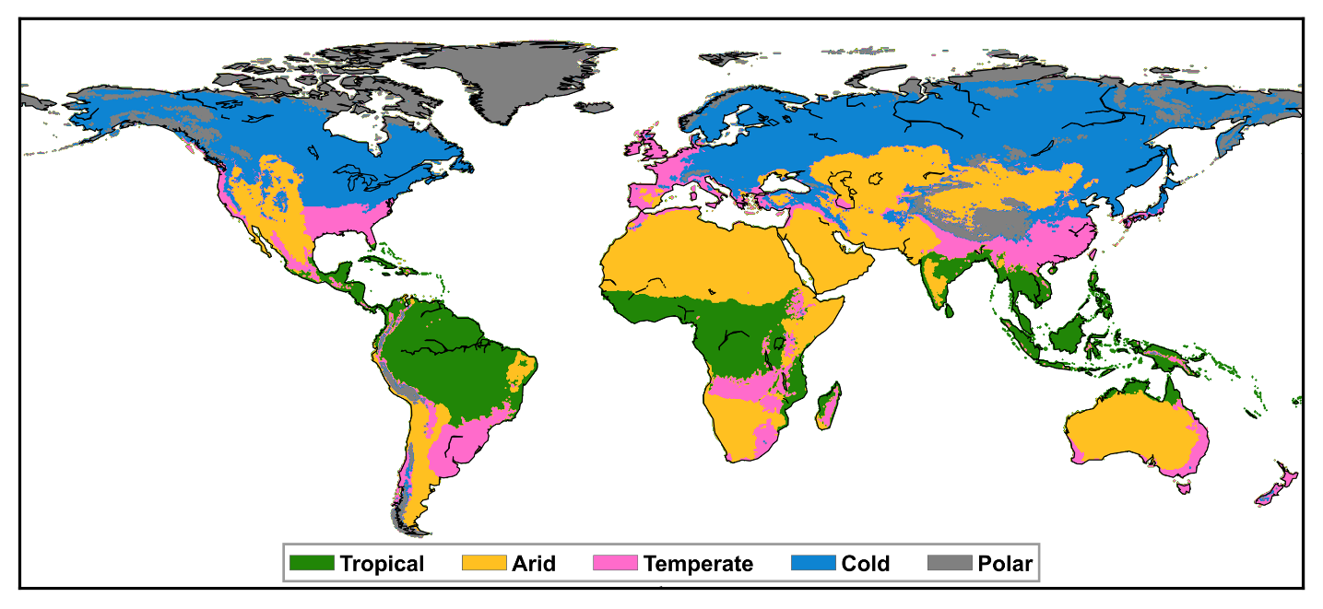
Fig. S3 | Global map of tropical, arid, temperate, and cold regions derived from Köppen-Geiger climate classification map.

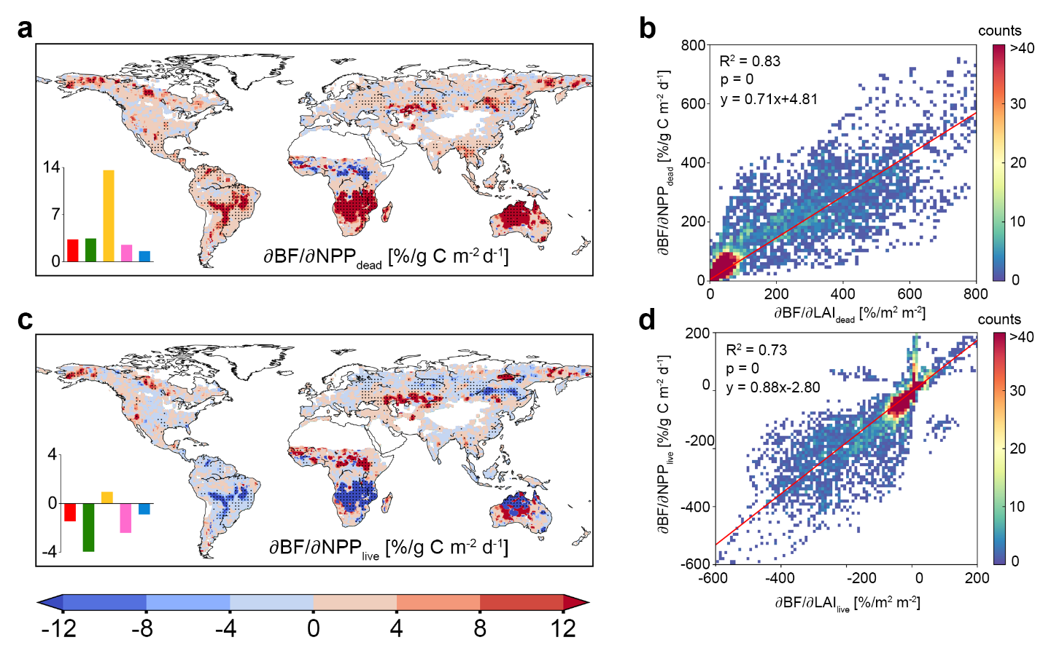
Fig. S4 | Relationships between the fire sensitivities to vegetation greening derived from NPP (∂BF/∂NPP) and those from LAI (∂BF/∂LAI). a, Global patterns of ∂BF/∂NPP_{dead}. The black dots indicate regions with significant sensitivity (p-value < 0.1). The inset at bottom left indicates the median sensitivities for global (red), tropical (green), arid (orange), temperate (pink), and cold (blue) regions. b, Comparison between ∂BF/∂NPP_{dead} and ∂BF/∂LAI_{dead}. c-d, Same as a-b but for the comparison between ∂BF/∂NPP_{live} and ∂BF/∂LAI_{live}. ∂BF/∂NPP was calculated from MCD64A1 burned area and satellite LAI driven BEPS NPP products. ∂BF/∂LAI was calculated from MCD64A1 burned area and GLOBMAP LAI products, given the BEPS NPP is driven by GLOBMAP LAI.

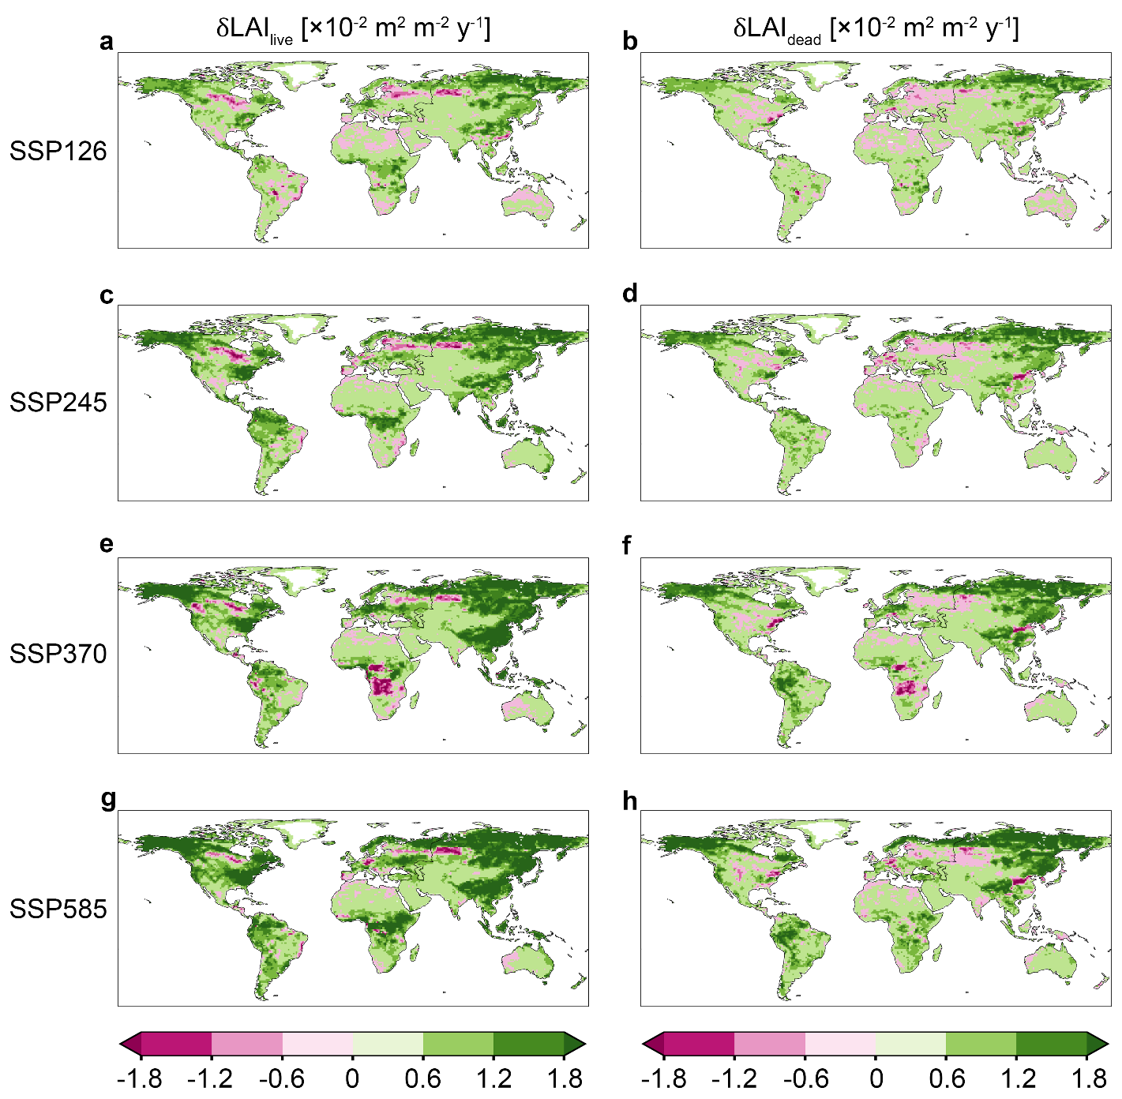
Fig. S5 | Ensemble means of temporal trends in the projected LAI_{live} (left) and LAI_{dead} (right) from 2015-2100 under the scenarios of SSP126, 245, 370 and 585. Ensemble includes three CMIP6 models (Table S3).

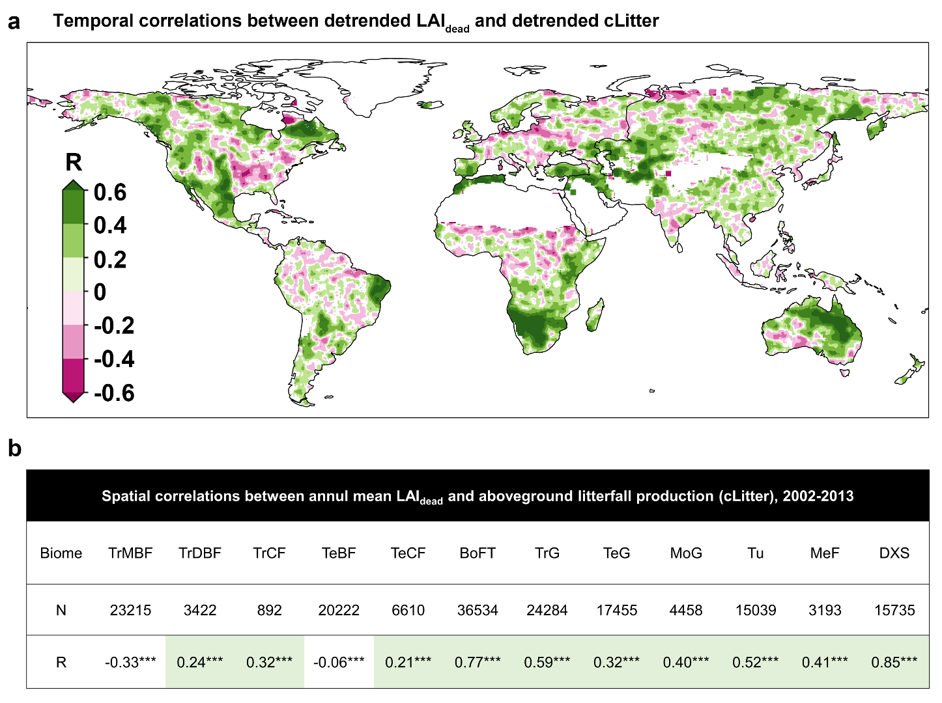
Fig. S6 | The spatiotemporal correlations between LAI_{dead} and aboveground litterfall production (cLitter). a, Temporal Spearman correlation (R) between detrended LAI_{dead} and detrended cLitter at grid cell scale over the period 2002-2013. The white area indicates non-vegetated area or area with non-significant correlation. b, Spatial correlations (R) between annual mean LAI_{dead} and cLitter for 12 biomes. N indicates the sample size. *** indicates p-value < 0.01.

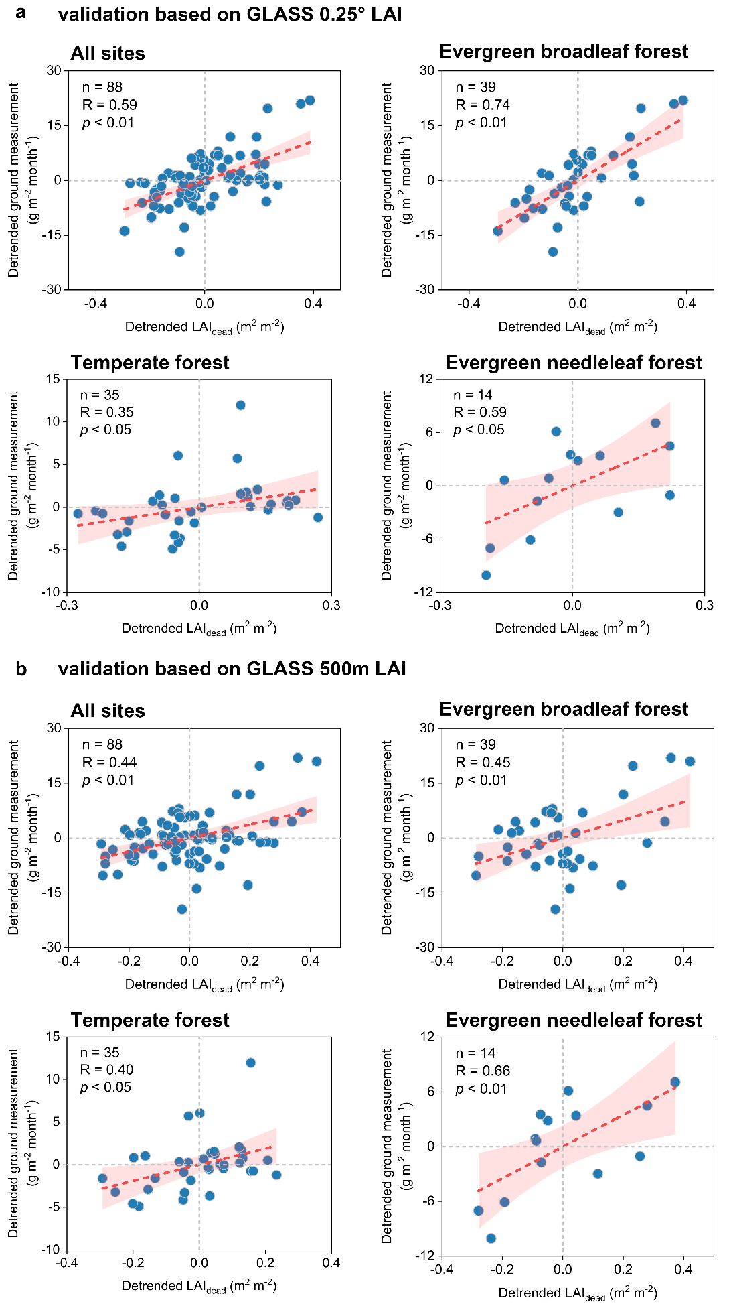
Fig. S7 | Validations of the representativeness of LAI_{dead} on the interannual variation of litterfall based on ground measurements. a, Relationships between detrended LAI_{dead} and detrended litterfall ground measurements for all sites and three different biomes (evergreen broadleaf forest, temperate forest, and evergreen needleleaf forest). LAI_{dead} is derived from GLASS 0.25° LAI product. b, Same as a but based on GLASS 500-m LAI product. Considering the orientation bias, we used a 5×5 spatial smoothing window when extracting 500m LAI for each site. We also tried the 3×3 and 7×7 spatial smoothing windows, and obtained similar results. The site information and the validated result of individual site were presented in Table S4.

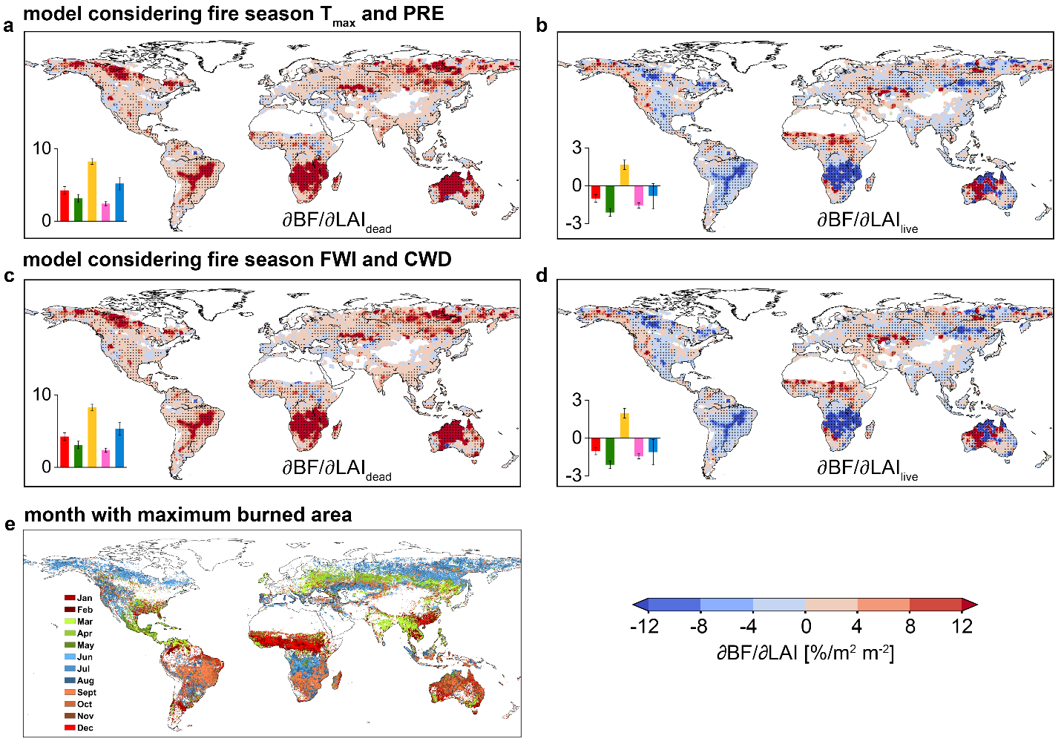
Fig. S8 | The robustness of fire sensitivity to vegetation greening for the attribution model considering LAI_{dead}, LAI_{live} and fire season maximum temperature (T_{max}) and precipitation (PRE) or fire season fire weather index (FWI) and climatic water deficit (CWD) as explainable variables (see Methods). a-b, Global pattern of ∂BF/∂LAI_{dead} and ∂BF/∂LAI_{live} for the attribution model considering fire season T_{max} and PRE. The black dots indicate regions with significant sensitivity (p-value < 0.1). The bars and error bars at bottom left indicate the ensemble mean of median sensitivity and standard error across products, respectively, for global (red), tropical (green), arid (orange), temperate (pink), and cold (blue) regions. c-d, Same as a-b but for the attribution model considering fire season FWI and CWD. e, Global map of month with maximum burned area. The fire season is defined as the three consecutive months centered around the month with maximum burned area.

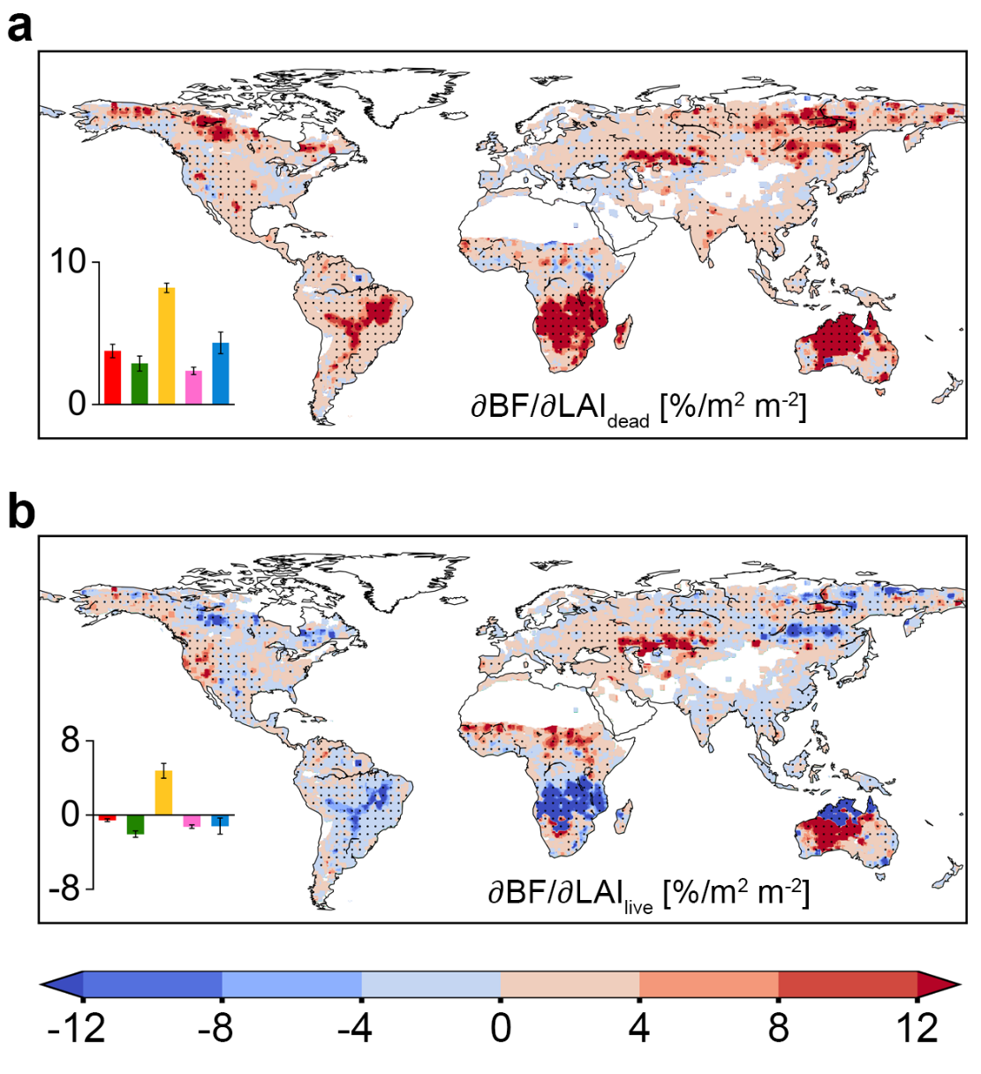
Fig. S9 | The robustness of fire sensitivity to vegetation greening for the attribution model considering LAI_{dead}, LAI_{live} and VPD as explainable variables (see Methods). a, Global pattern of ensemble mean of ∂BF/∂LAI_{dead}. The black dots indicate regions with significant sensitivity (p-value < 0.1). The bars and error bars at bottom left indicate the ensemble mean of median sensitivity and standard error across products, respectively, for global (red), tropical (green), arid (orange), temperate (pink), and cold (blue) regions. b, Same as a but for ensemble mean of ∂BF/∂LAI_{live}.

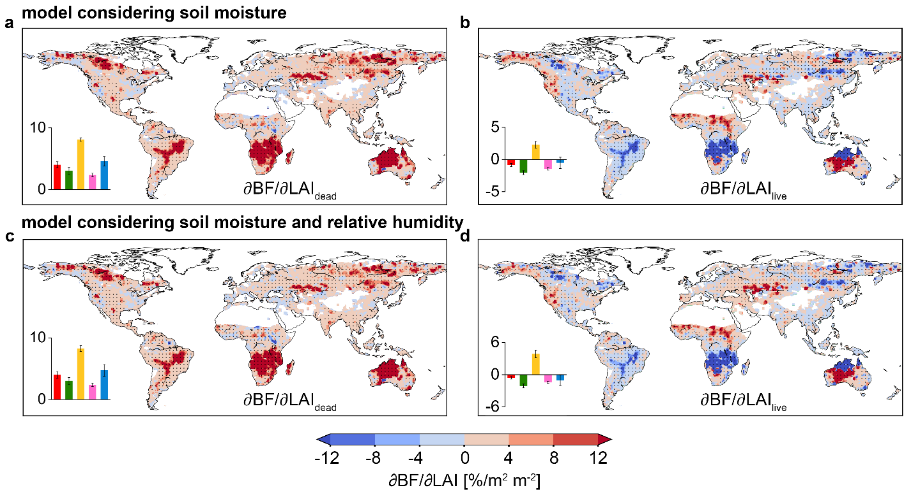
Fig. S10 | The robustness of fire sensitivity to vegetation greening for the attribution model considering LAI_{dead}, LAI_{live}, temperature and water availability as explainable variables (see Methods). a-b, Global pattern of ∂BF/∂LAI_{dead} and ∂BF/∂LAI_{live} for the attribution model considering surface soil moisture as water availability. The black dots indicate regions with significant sensitivity (p-value < 0.1). The bars and error bars at bottom left indicate the ensemble mean of median sensitivity and standard error across products, respectively, for global (red), tropical (green), arid (orange), temperate (pink), and cold (blue) regions. c-d, Same as a-b but for the attribution model considering surface soil moisture and relative humidity as water availability.

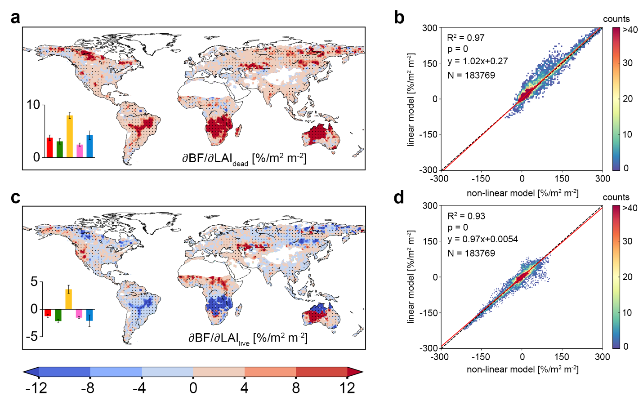
Fig. S11 | The robustness of ∂BF/∂LAI_{dead} (a, b) and ∂BF/∂LAI_{live} (c, d) derived from non-linear model (see Methods). a, Global patterns of ∂BF/∂LAI_{dead}. The black dots indicate regions with significant sensitivity (p-value < 0.1). The inset at bottom left indicates ensemble mean of median sensitivity for global (red), tropical (green), arid (orange), temperate (pink), and cold (blue) regions. The error bar indicates the standard error across products. b, Comparison of ∂BF/∂LAI_{dead} between non-linear and linear models. c-d, Same as a-b but for ∂BF/∂LAI_{live}.

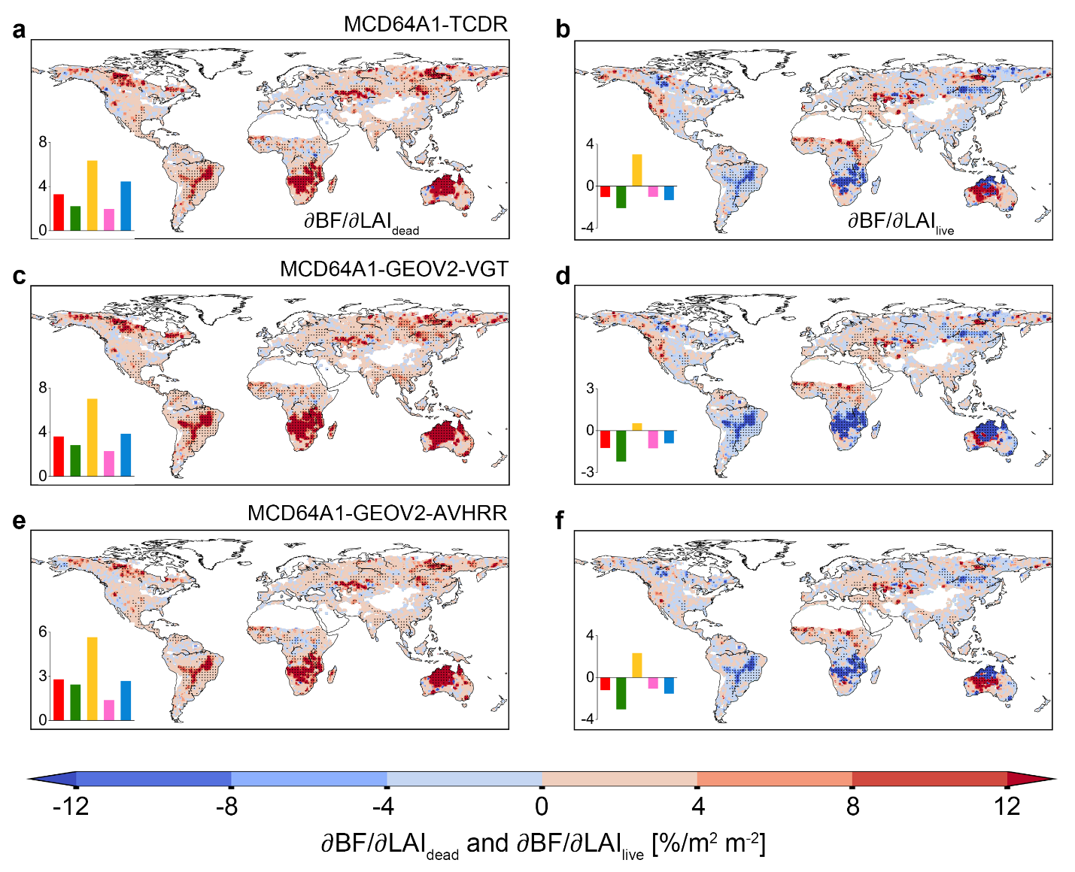
Fig. S12 | The robustness of ∂BF/∂LAI_{dead} (left) and ∂BF/∂LAI_{live} (right) for different sources of LAI products, including TCDR (a, b), GEOV2-VGT (c, d), and GEOV2-AVHRR (e, f). The black dots indicate regions with significant sensitivity (p-value < 0.1). The inset at bottom left indicates median sensitivity for global (red), tropical (green), arid (orange), temperate (pink), and cold (blue) regions.

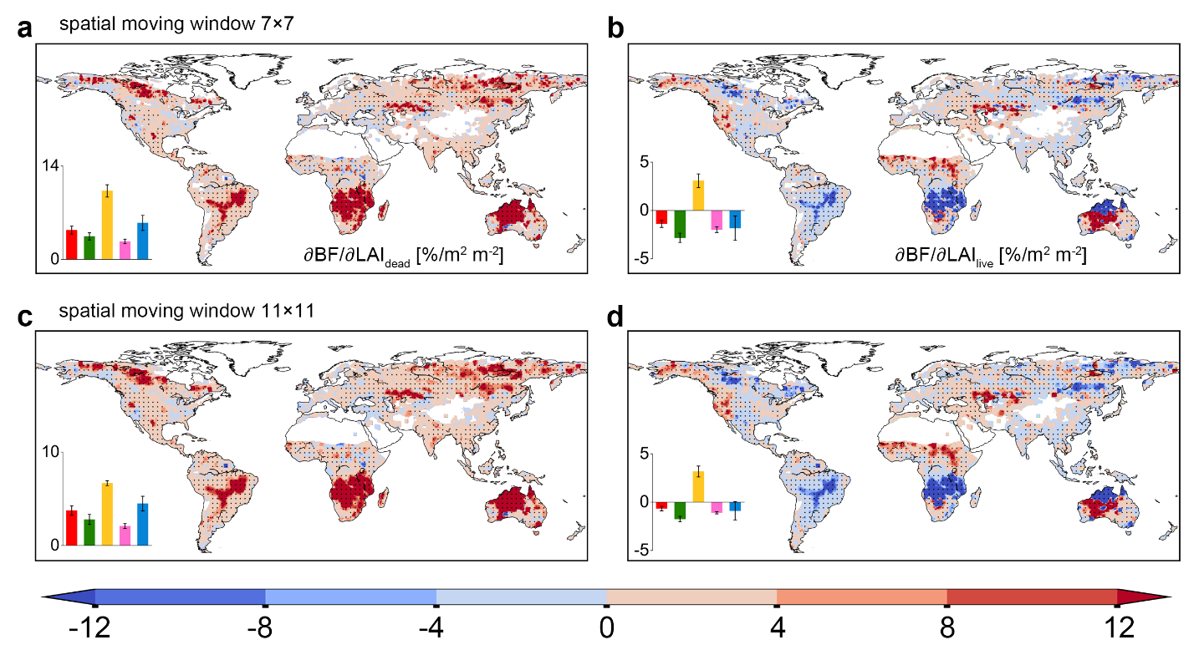
Fig. S13 | The robustness of fire sensitivity to vegetation greening for 7×7 (a-b) and 11×11 (c-d) spatial moving windows. The black dots indicate regions with significant sensitivity (p-value < 0.1). The bars and error bars at bottom left indicate the ensemble mean of median sensitivity and standard error across products, respectively, for global (red), tropical (green), arid (orange), temperate (pink), and cold (blue) regions.

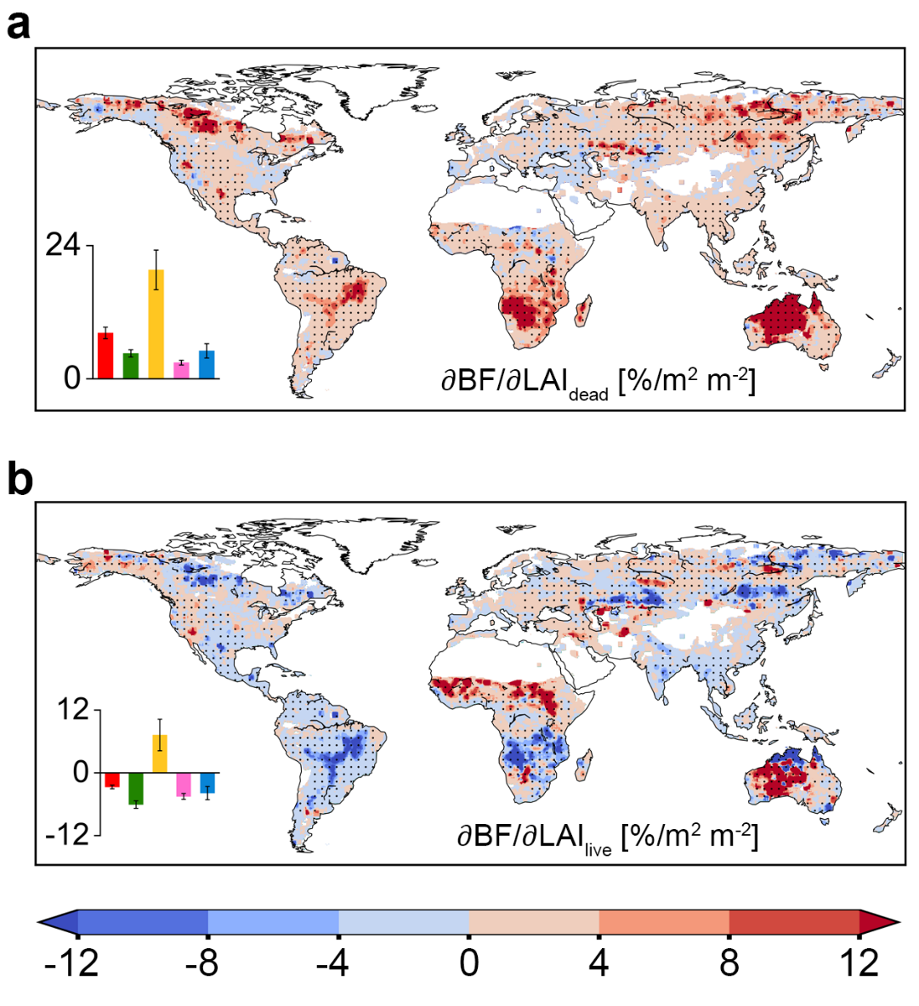
Fig. S14 | The robustness of fire sensitivity to vegetation greening by calculating LAI_{live} as the maximum monthly LAI, and LAI_{dead} as the difference between maximum and the subsequent minimum monthly LAI. The black dots indicate regions with significant sensitivity (p-value < 0.1). The bars and error bars at bottom left indicate the ensemble mean of median sensitivity and standard error across products, respectively, for global (red), tropical (green), arid (orange), temperate (pink), and cold (blue) regions.

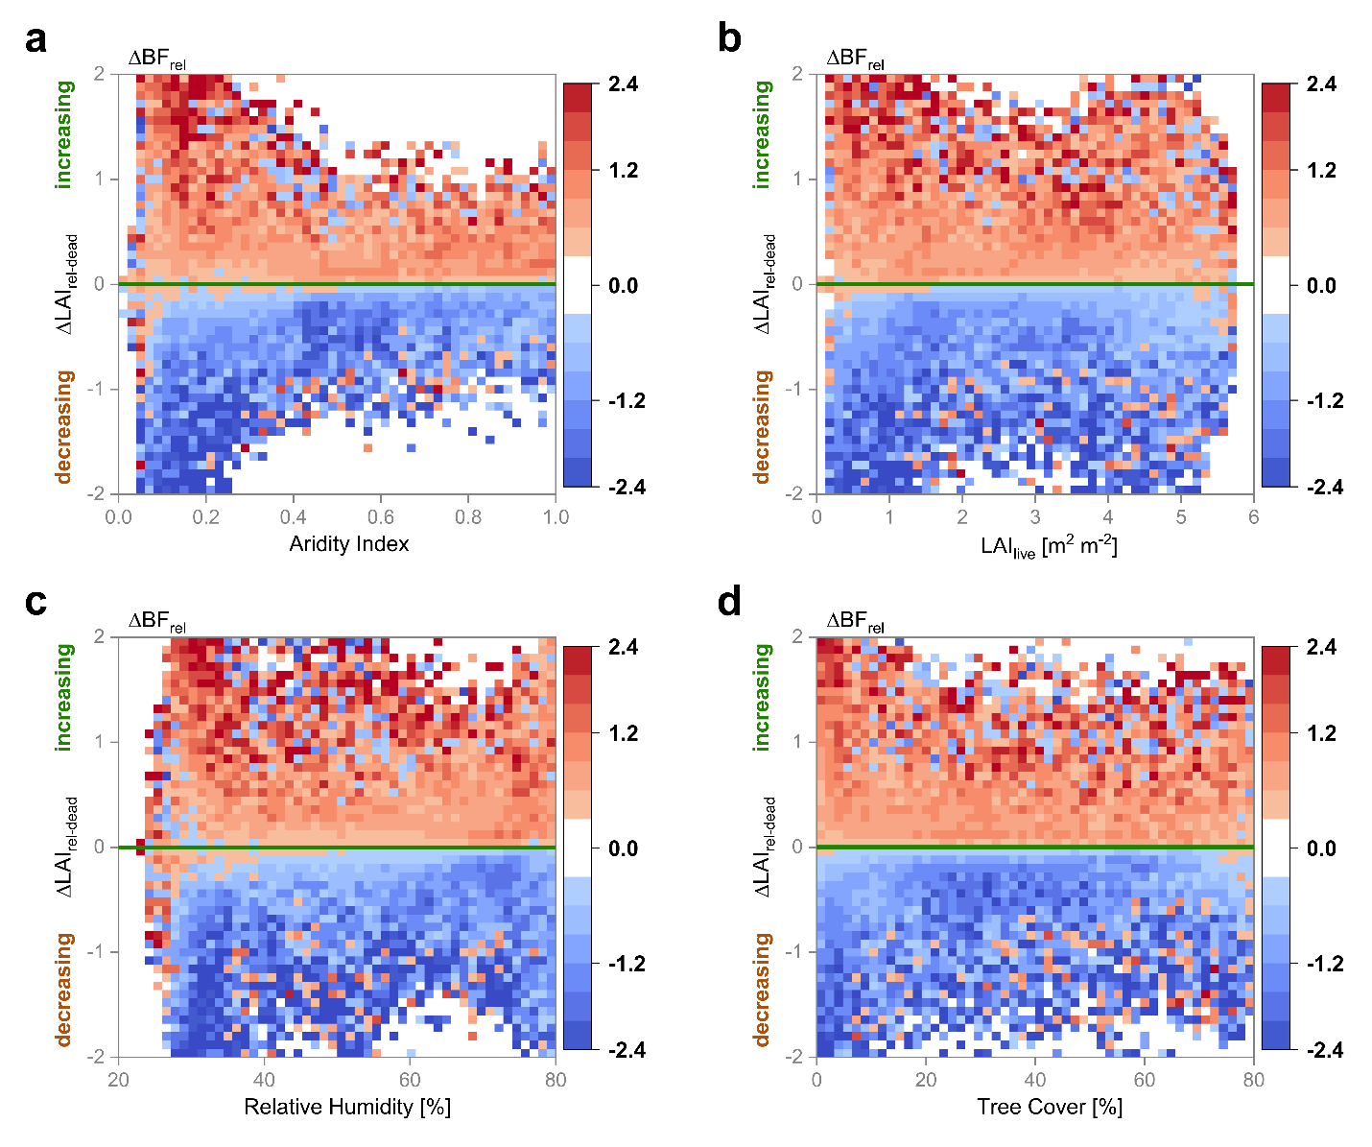
Fig. S15 | The impacts of changes in LAI_{dead} (∆LAI_{rel-dead}) on fire (∆BF_{rel}) along the gradients of water availability (a, aridity index; c, relative humidity) and vegetation growth (b, LAI_{live}; d, tree cover). ∆X_{rel} indicates year-to-year variation (i.e. consecutive two-year difference) of X normalized by annual mean X. ∆BF_{rel} is binned as a function of ∆LAI_{rel-dead} and AI/RH/LAI_{live}/tree cover. ∆LAI_{rel-dead} > 0 and < 0 represent increase and decrease of dead litter, respectively. ∆BF_{rel} > 0 and < 0 represent BF increasing (red) and decreasing (blue), respectively.

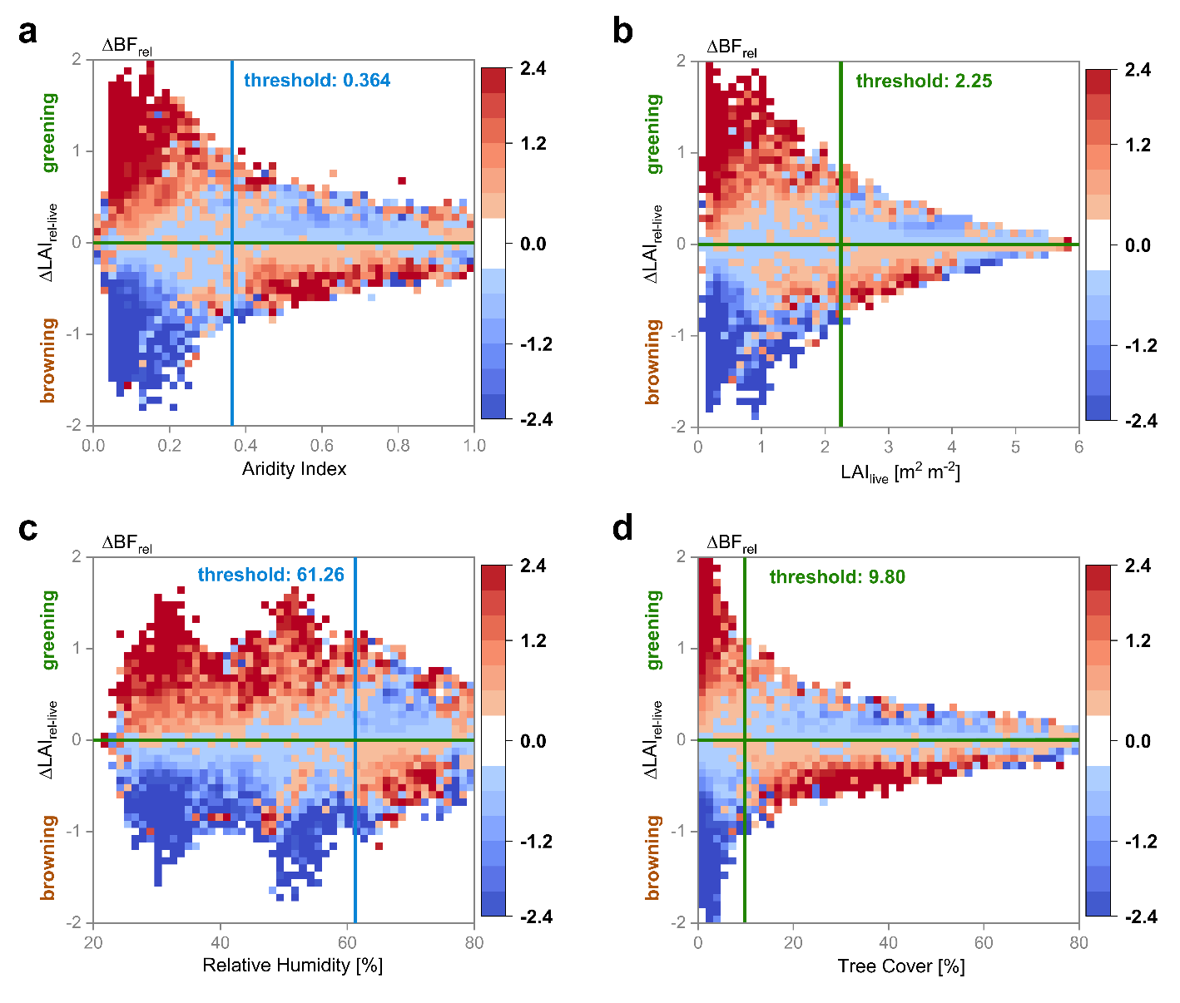
Fig. S16 | Same as Fig. S15 but for the impacts of changes in LAI_{live} (∆LAI_{rel-live}) on fire (∆BF_{rel}) along the gradients of water availability (a, aridity index; c, relative humidity) and vegetation growth (b, LAI_{live}; d, tree cover). ∆X_{rel} indicates year-to-year variation (i.e. consecutive two-year difference) of X normalized by annual mean X. ∆BF_{rel} is binned as a function of ∆LAI_{rel-live} and AI/RH/LAI_{live}/tree cover. ∆LAI_{rel-live} > 0 and < 0 represent greening and browning, respectively. ∆BF_{rel} > 0 and < 0 represent BF increasing (red) and decreasing (blue), respectively. The colored labels refer to the ensemble mean thresholds identified in Fig. 3e-f in the main text and Extended Data Fig. 6b and d.

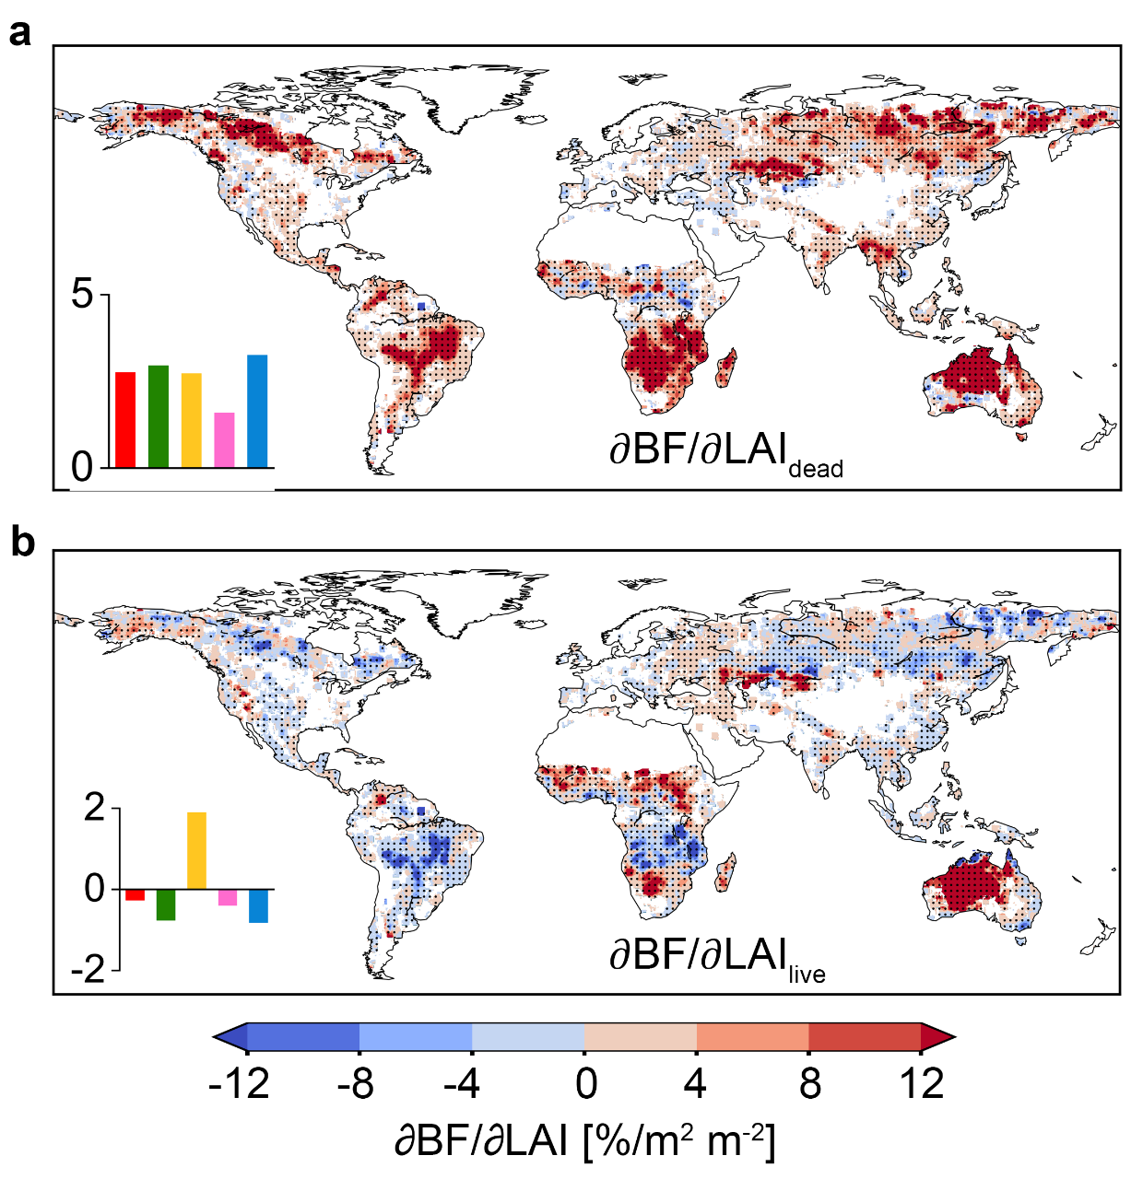
Fig. S17 | The robustness of fire sensitivity to vegetation greening derived from combining random forest and explainable machine learning (SHapley Additive exPlanations, SHAP). a-b, Global pattern of ∂BF/∂LAI_{dead} and ∂BF/∂LAI_{live}, respectively. The black dots indicate regions with significant sensitivity (p-value < 0.1). The bars at bottom left indicate the median sensitivity for global (red), tropical (green), arid (orange), temperate (pink), and cold (blue) regions. This analysis was based on the time series of MCD64A1 BF and the GLASS LAI.

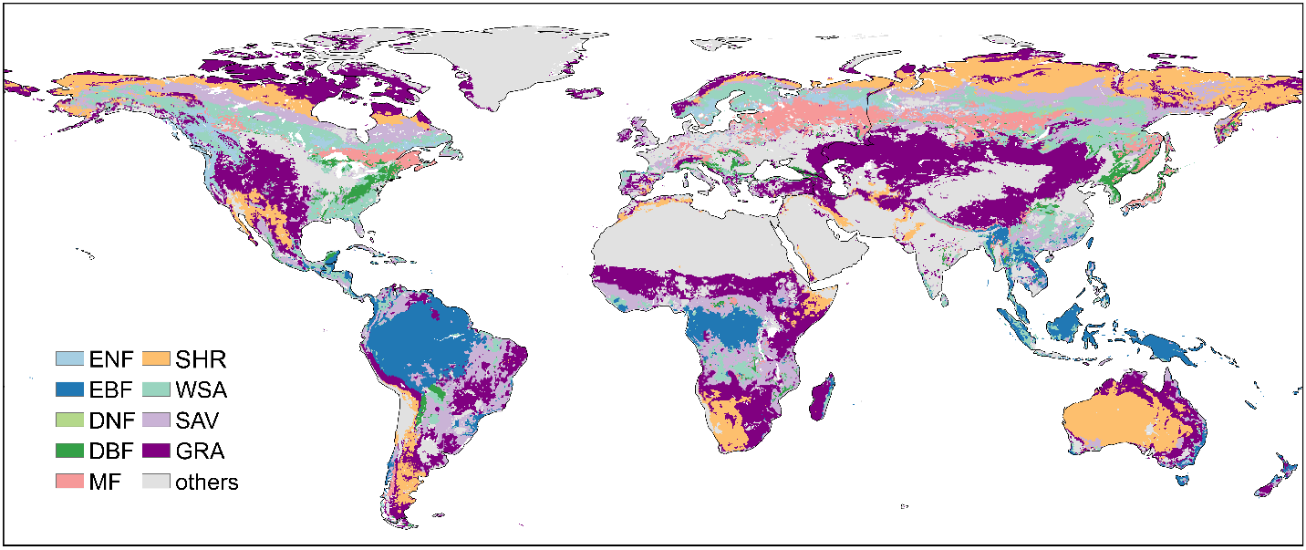
Fig. S18 | Global map of ten plant functional types (PFTs) derived from 2010 MCD12Q1 V6 IGBP land cover map. ENF, evergreen needleleaf forest; EBF, evergreen broadleaf forest; DNF, deciduous needleleaf forest; DBF, deciduous broadleaf forest; MF, mixed forest; SHR, shrubland (including closed and open shrublands); WSA, woody savannas; SAV, savannas; GRA, grassland.

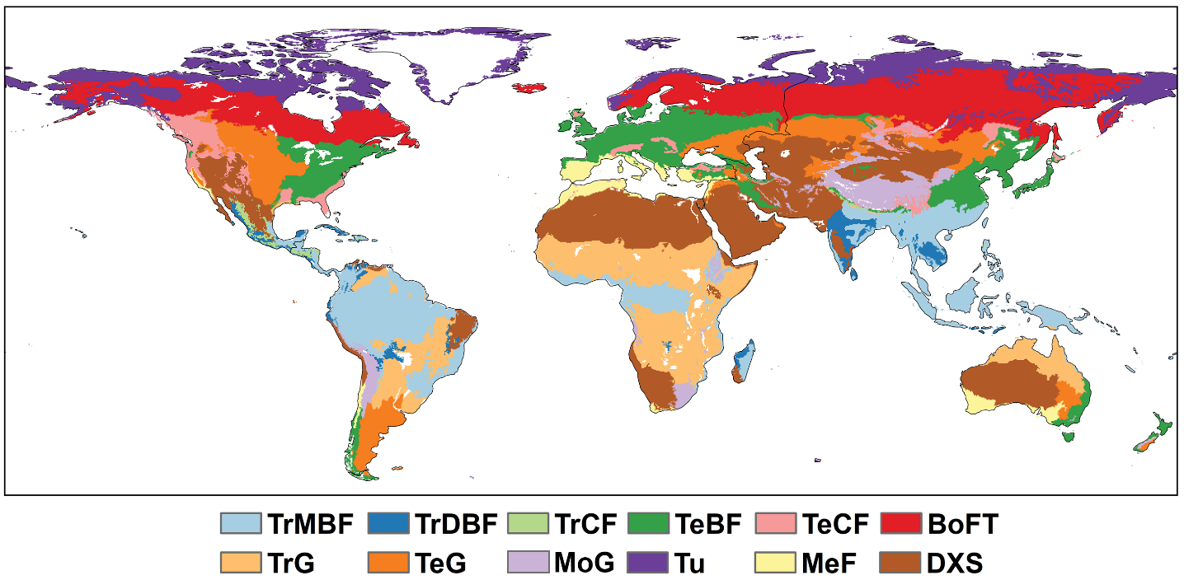
Fig. S19 | Global map of biomes derived from Terrestrial Ecoregions of the World. TrMBF: Tropical and Subtropical Moist Broadleaf Forests; TrDBF: Tropical and Subtropical Dry Broadleaf Forests; TrCF: Tropical and Subtropical Coniferous Forests; TeBF: Temperate Broadleaf and Mixed Forests; TeCF: Temperate Coniferous Forests; BoFT: Boreal Forests/Taiga; TrG: Tropical and Subtropical Grasslands, Savannas and Shrublands; TeG: Temperate Grasslands, Savannas and Shrublands; MoG: Montane Grasslands and Shrublands; Tu: Tundra; MeF: Mediterranean Forests, Woodlands and Scrub; DXS: Deserts and Xeric Shrublands.

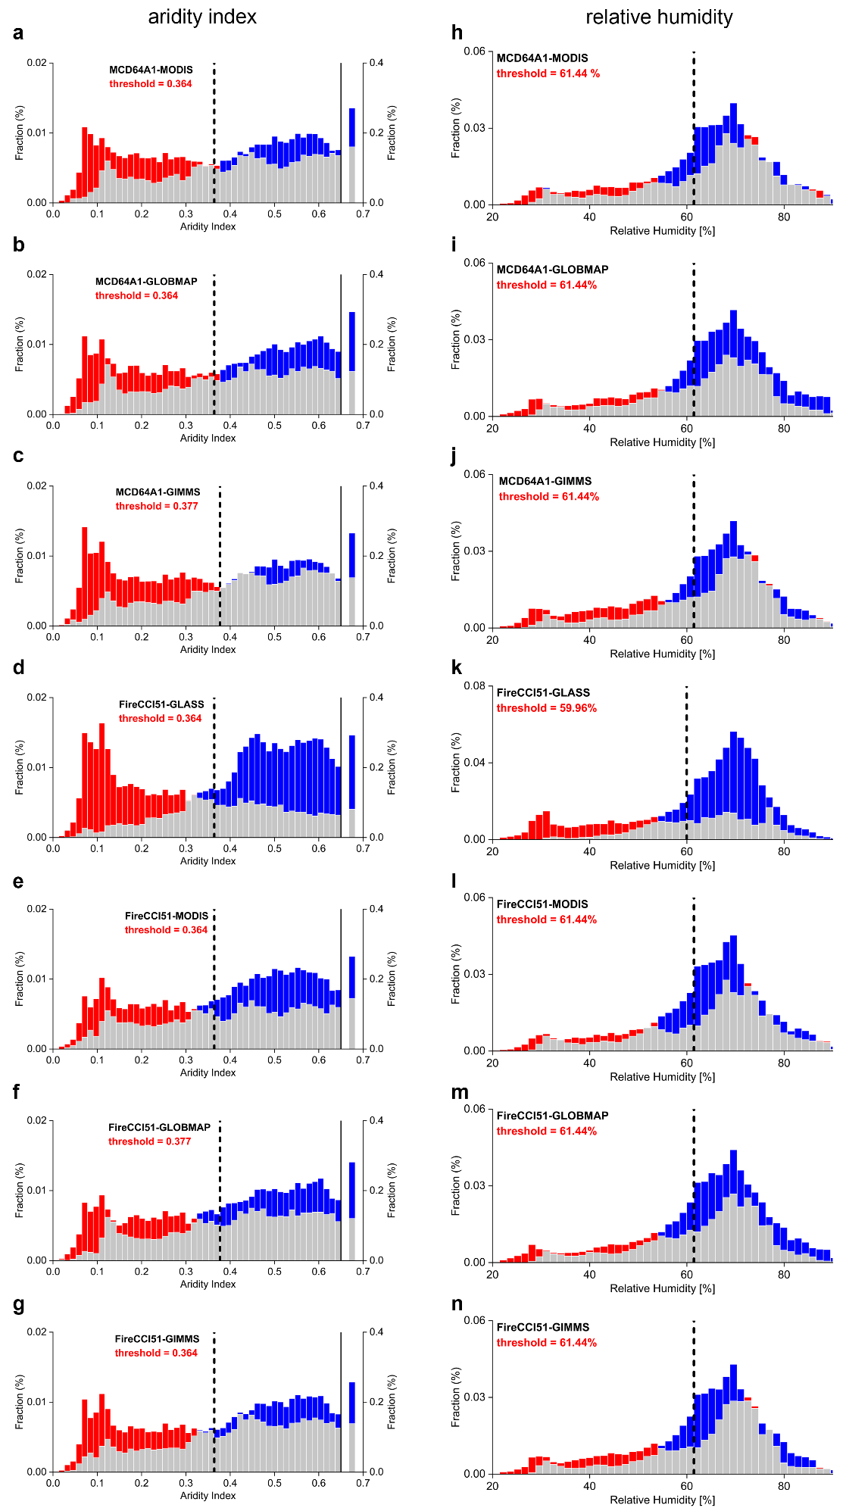
Fig. S20 | The thresholds of water availability (a-g, aridity index; h-n, relative humidity) regulate the spatial variability of ∂BF/∂LAI_{live} for MCD64A1-MODIS, MCD64A1-GLOBMAP, MCD64A1-GIMMS, FireCCI51-GLASS, FireCCI51-MODIS, FireCCI51-GLOBMAP, and FireCCI51-GIMMS. Detailed description refers to Fig. 3 in the main text.

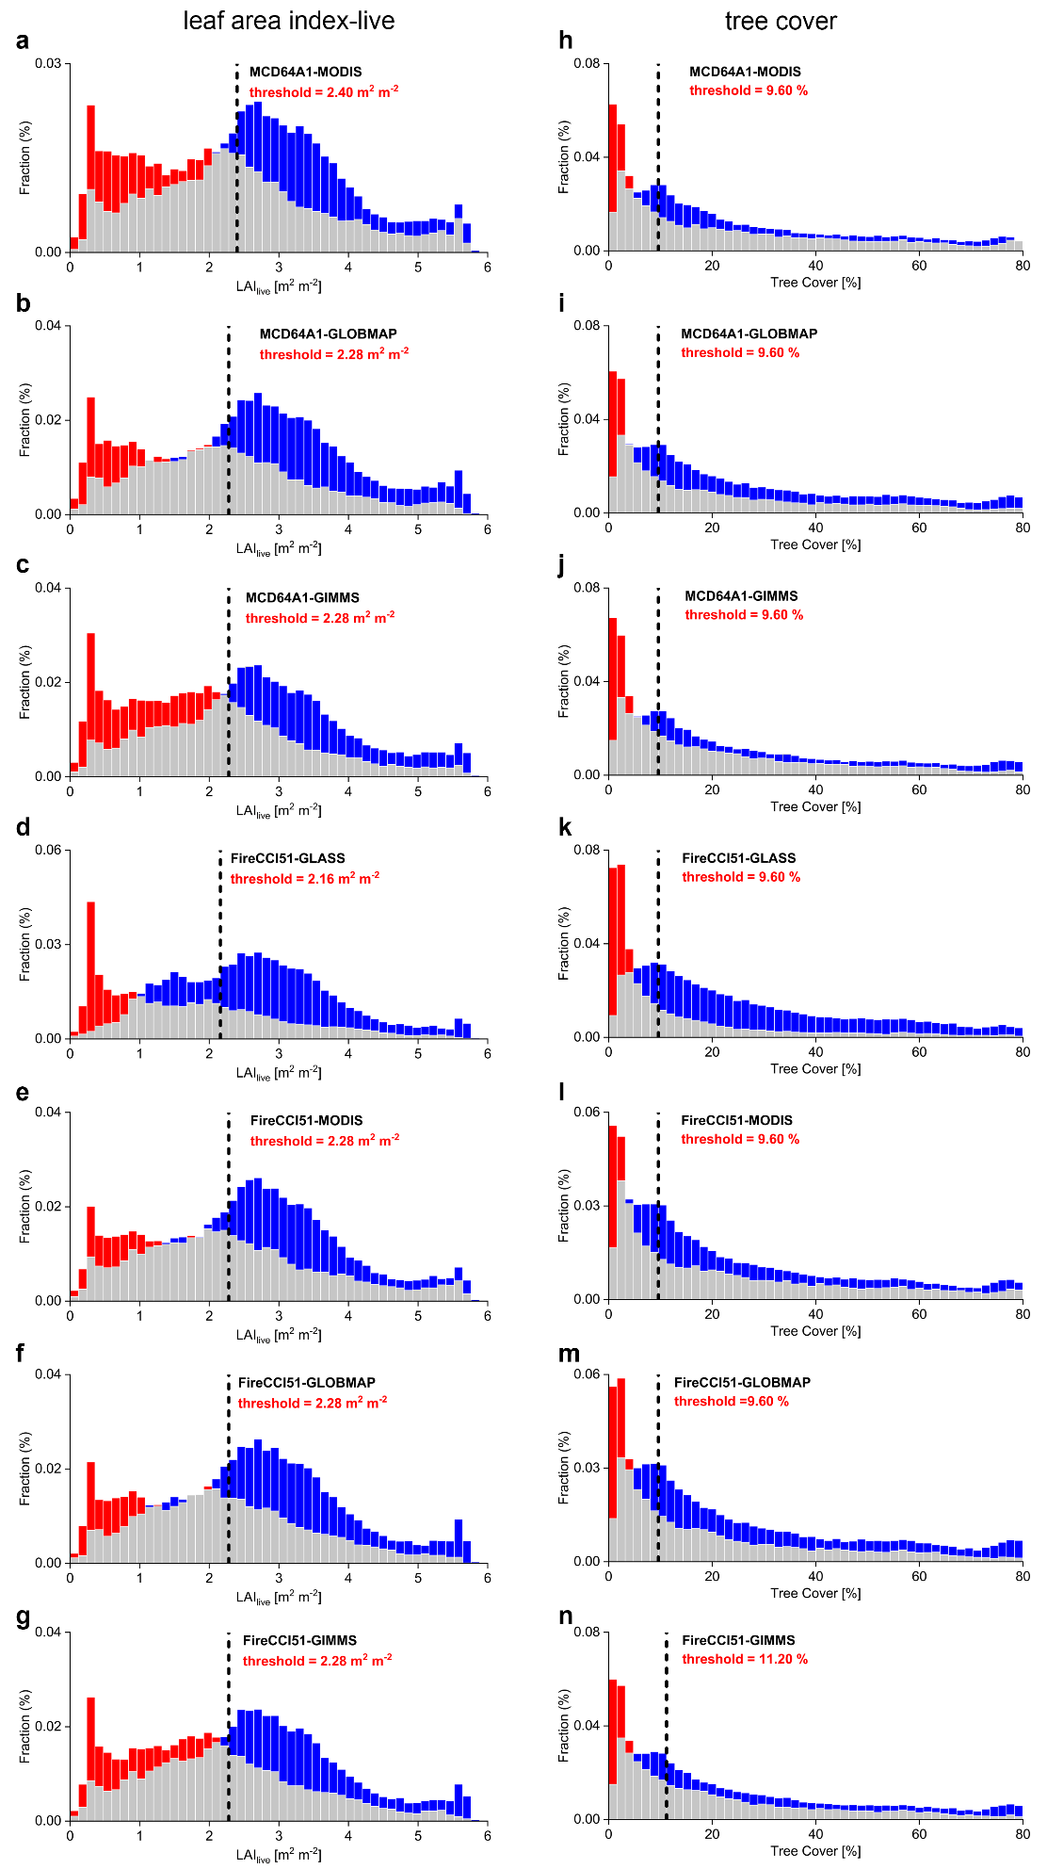
Fig. S21 | The thresholds of vegetation growth (a-g, LAI_{live}; h-n, tree cover) regulate the spatial variability of ∂BF/∂LAI_{live} for MCD64A1-MODIS, MCD64A1-GLOBMAP, MCD64A1-GIMMS, FireCCI51-GLASS, FireCCI51-MODIS, FireCCI51-GLOBMAP, and FireCCI51-GIMMS. Detailed description refers to Fig. 3 in the main text.

Table S1. Descriptions and access information of the datasets.
Variables | Datasets | Resolution | Periods | Data access
LAI | GLASS V6 | 0.25°/500m, monthly | 2001-2020 | http://glass.umd.edu/LAI/MODIS/0.25D/
LAI | MOD15A2H V6 | 500m, 8 days | 2001-2020 | https://doi.org/10.5067/MODIS/MOD15A2H.006
LAI | GLOBMAP V3 | 0.0727273°, 8 days | 2001-2020 | https://zenodo.org/record/4700264
LAI | GIMMS LAI4g | 1/12°, half-monthly | 2001-2020 | https://zenodo.org/record/7649108
LAI | TCDR V4 | 0.05°, daily | 2001-2020 | https://www.ncei.noaa.gov/data/avhrr-land-leaf-area-index-and-fapar/access/
LAI | GEOV2-VGT | 1 km, 10 days | 2001-2019 | https://land.copernicus.eu/global/products/lai
LAI | GEOV2-AVHRR | 0.05°, 10 days | 2001-2019 | https://www.theia-land.fr/en/geov2-avhrr-monitoring-changes-in-vegetation-on-a-global-scale-over-the-last-38-years/
Vegetation Index | NIRv and EVI derived from MOD13A2 V6.1 | 1 km, 16 days | 2001-2020 | https://doi.org/10.5067/MODIS/MOD13A2.061
Fire activity | MCD64A1 V6 BA | 500 m, monthly | 2001-2020 | https://doi.org/10.5067/MODIS/MCD64A1.006
Fire activity | FireCCI V5.1 BA | 250 m, monthly | 2001-2020 | https://climate.esa.int/en/projects/fire/data/
Fire activity | MCD14ML V6 FRP | 0.25°, yearly | 2001-2020 | https://www.earthdata.nasa.gov/learn/find-data/near-real-time/firms/mcd14ml
Climate variable | ERA5-Land monthly averaged reanalysis data (T, PRE, SM, Td) | 0.1°, monthly | 2001-2020 | https://cds.climate.copernicus.eu/cdsapp#!/dataset/reanalysis-era5-land-monthly-means?tab=overview
Climate variable | TerraClimate data (T_{max} and CWD) | 1/24°, monthly | 2001-2020 | https://www.climatologylab.org/terraclimate.html
Climate variable | ERA5-based global meteorological wildfire danger dataset (FWI) | 0.25°, daily | 2001-2020 | https://cds.climate.copernicus.eu/cdsapp#!/dataset/cems-fire-historical-v1?tab=overview
Aridity Index | Global Aridity Index and Potential Evapotranspiration (ET0) Climate Database V2 | 30 arc-seconds | annual average over the 1970-2000 period | https://doi.org/10.6084/m9.figshare.7504448.v3
Land cover type | MCD12Q1 V6 IGBP classification | 500 m, yearly | 2001-2020 | https://doi.org/10.5067/MODIS/MCD12Q1.006
Climate classification | Köppen-Geiger climate classification | 0.083° | present-day (1980-2016) | http://www.gloh2o.org/koppen/
NPP | The dataset of simulated daily NPP over the globe during 1981-2019 | 0.072727°, daily | 2001-2012 | http://www.nesdc.org.cn/sdo/detail?id=612f42ee7e28172cbed3d80b
Aboveground litterfall production | Li et al. cLitter¹ | 0.5°, yearly | 2002-2013 | http://www.nesdc.org.cn/sdo/detail?id=618a22467e2817667e3c7d9e
Biome | Terrestrial Ecoregions of the World | shapefile | -- | https://www.worldwildlife.org/publications/terrestrial-ecoregions-of-the-world
LAI: leaf area index; NIRv: near-infrared reflectance of vegetation; EVI: enhanced vegetation index; BA: burned area; FRP: fire radiative power; T: 2 m air temperature; PRE: total precipitation; SM: soil moisture at a layer of 0–7 cm; Td: 2 m dewpoint temperature; T_{max}: maximum temperature; CWD: climatic water deficit; FWI: fire weather index; NPP: net primary productivity. T and Td were used to calculate vapor pressure deficit (VPD) and relative humidity (RH) following ref.⁸.

Table S2. Summary of the FireMIP fire-vegetation models^{9,10} used in this study.
Model | Resolution | Period | Output
CLM¹¹ | 2.5°×1.875°, monthly | 2001-2012 | NPP, BF
JSBACH-SPITFIRE¹² | 1.875°×1.875°, monthly | 2001-2012 | NPP, BF
LPJ-GUESS-SPITFIRE¹³ | 0.5°×0.5°, monthly | 2001-2012 | NPP, BF
ORCHIDEE-SPITFIRE¹⁴ | 0.5°×0.5°, monthly | 2001-2012 | NPP, BF
CTEM¹⁵ | 2.8125°×2.8125°, monthly | 2001-2012 | NPP, BF
JULES-INFERNO¹⁶ | 1.875°×1.245°, monthly | 2001-2012 | NPP, BF
LPJ-GUESS-SIMFIRE-BLAZE¹⁷ | 0.5°×0.5°, monthly | 2001-2012 | NPP, BF
NPP: net primary productivity; BF: burned fraction, the fraction of burned area within a grid cell (%). Notably another two FireMIP models, LPJ-GUESS-GlobFIRM¹⁸ and MC2¹⁹, were excluded in this study because they perform less well globally than other models in simulating global burned areas⁹.

Table S3. CMIP6 models used in this study.
Model abbreviation | Variant label | historical | Future | Scenarios | Resolution
CMCC-CM2-SR5 | r1i1p1f1 | 2000-2014 | 2015-2100 | SSP126, 245, 370, 585 | 0.94°×1.25°, monthly
CMCC-ESM2 | r1i1p1f1 | 2000-2014 | 2015-2100 | SSP126, 245, 370, 585 | 0.94°×1.25°, monthly
GFDL-ESM4 | r1i1p1f1 | 2000-2014 | 2015-2100 | SSP126, 245, 370, 585 | 1°×1.25°, monthly
Availability: https://esgf-node.llnl.gov/projects/cmip6/

Table S4. Information of litterfall ground measurements and the LAI_{dead} validation of individual site.
Biome | Site | Lat | Lon | Country | Period | GLASS 0.25° LAI |  | GLASS 500m LAI¹
 |  |  |  |  |  | n | R | n | R
EBF | Bubeng | 21.60 | 101.58 | China | 2011-2020 | 10 | 0.86*** | 10 | 0.72**
EBF | Menglun | 21.92 | 101.27 | China | 2006-2020 | 14 | 0.76*** | 14 | 0.67***
EBF | BCI | 9.15 | -79.83 | Panama | 2002-2016 | 15 | 0.48* | 15 | n.s.
EBF | All |  |  |  |  | 39 | 0.74*** | 39 | 0.45**
TF | Harvard forest | 42.49 | -72.20 | USA | 2002-2020 | 19 | 0.44* | 19 | 0.52**
TF | Hainich | 51.08 | 10.45 | Germany | 2003-2020 | 16 | 0.50** | 16 | n.s.
TF | All |  |  |  |  | 35 | 0.35** | 35 | 0.40**
ENF | SMEAR Ⅱ Hyytiälä forest | 61.85 | 24.29 | Finland | 2005-2018 | 14 | 0.59** | 14 | 0.66***
All sites |  |  |  |  |  | 88 | 0.59*** | 88 | 0.44***
EBF: evergreen broadleaf forest; TF: temperate forest; ENF: evergreen needleleaf forest.
***: p-value < 0.01; **: p-value < 0.05; *: p-value < 0.1; n.s.: not significant.
¹Note that considering the orientation bias, we used a 5×5 spatial smoothing window when extracting 500m LAI for each site. We also tried the 3×3 and 7×7 spatial smoothing windows, and obtained similar results.

References
1 Li, S. et al. Benchmark estimates for aboveground litterfall data derived from ecosystem models. Environmental Research Letters 14 (2019).
2 Detto, M., Wright, S. J., Calderón, O. & Muller-Landau, H. C. Resource acquisition and reproductive strategies of tropical forest in response to the El Niño–Southern Oscillation. Nature Communications 9 (2018).
3 Suni, T. et al. Long-term measurements of surface fluxes above a Scots pine forest in Hyytiälä, southern Finland, 1996–2001. Boreal Env. Res. 8, 287–301 (2003).
4 A, M. & A, B. P. Litterfall in Simulated Hurricane Experiment at Harvard Forest since 1989. Harvard Forest Data Archive: HF101 (v.25). Environmental Data Initiative: https://doi.org/10.6073/pasta/f5ae1e144e434ec8198cf75682db33ac. (2023).
5 Pinty, B. et al. Evaluation of the JRC-TIP 0.01° products over a mid-latitude deciduous forest site. Remote Sensing of Environment 115, 3567-3581 (2011).
6 Forzieri, G., Alkama, R., Miralles, D. G. & Cescatti, A. Satellites reveal contrasting responses of regional climate to the widespread greening of Earth. Science 356, 1180-1184 (2017).
7 Li, W. et al. Widespread increasing vegetation sensitivity to soil moisture. Nat Commun 13, 3959 (2022).
8 Yuan, W. et al. Increased atmospheric vapor pressure deficit reduces global vegetation growth. Science Advances 5, eaax1396 (2019).
9 Hantson, S. et al. Quantitative assessment of fire and vegetation properties in simulations with fire-enabled vegetation models from the Fire Model Intercomparison Project. Geoscientific Model Development 13, 3299-3318 (2020).
10 Hantson, S. et al. Model outputs: Quantitative assessment of fire and vegetation properties in historical simulations with fire-enabled vegetation models from the Fire Model Intercomparison Project [Data set]. Zenodo https://doi.org/10.5281/zenodo.3555562 (2019).
11 Li, F., Levis, S. & Ward, D. S. Quantifying the role of fire in the Earth system – Part 1: Improved global fire modeling in the Community Earth System Model (CESM1). Biogeosciences 10, 2293-2314 (2013).
12 Lasslop, G., Thonicke, K. & Kloster, S. SPITFIRE within the MPI Earth system model: Model development and evaluation. Journal of Advances in Modeling Earth Systems 6, 740-755 (2014).
13 Lehsten, V. et al. Estimating carbon emissions from African wildfires. Biogeosciences 6, 349-360 (2009).
14 Yue, C. et al. Modelling the role of fires in the terrestrial carbon balance by incorporating SPITFIRE into the global vegetation model ORCHIDEE – Part 1: simulating historical global burned area and fire regimes. Geoscientific Model Development 7, 2747-2767 (2014).
15 Melton, J. R. & Arora, V. K. Competition between plant functional types in the Canadian Terrestrial Ecosystem Model (CTEM) v. 2.0. Geoscientific Model Development 9, 323-361 (2016).
16 Mangeon, S. et al. INFERNO: a fire and emissions scheme for the UK Met Office's Unified Model. Geoscientific Model Development 9, 2685-2700 (2016).
17 Knorr, W., Jiang, L. & Arneth, A. Climate, CO2 and human population impacts on global wildfire emissions. Biogeosciences 13, 267-282 (2016).
18 Smith, B. et al. Implications of incorporating N cycling and N limitations on primary production in an individual-based dynamic vegetation model. Biogeosciences 11, 2027-2054 (2014).
19 Bachelet, D., Ferschweiler, K., Sheehan, T. J., Sleeter, B. M. & Zhu, Z. Projected carbon stocks in the conterminous USA with land use and variable fire regimes. Glob Chang Biol 21, 4548-4560 (2015).

