A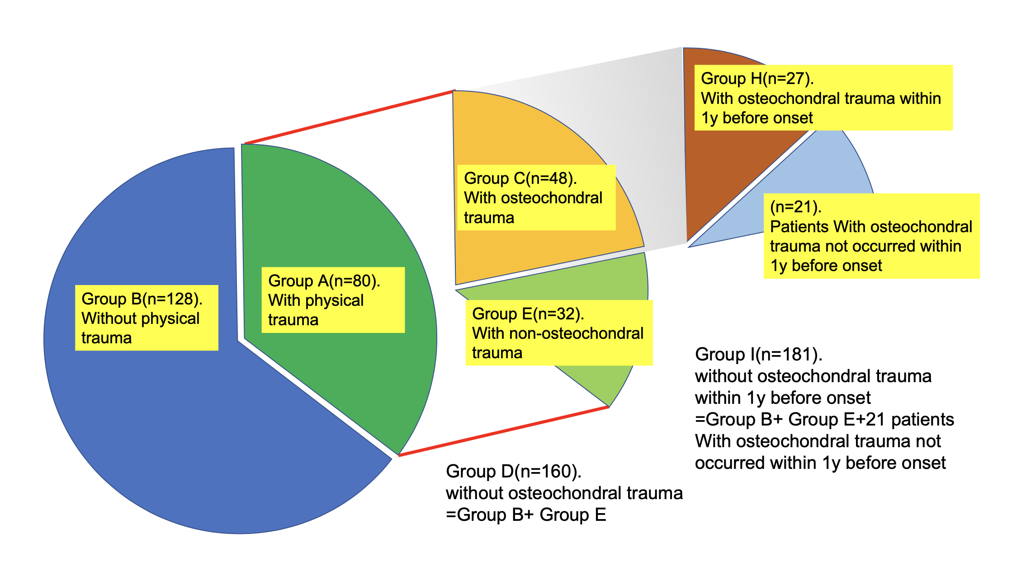
B
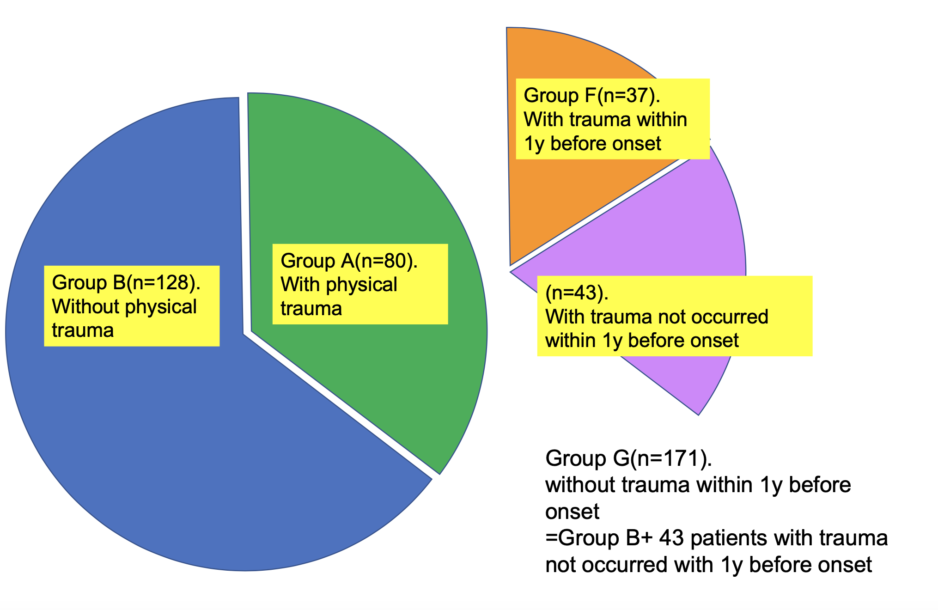

Supplementary Figure 1 Illustration of different groups according to the types of physical trauma and whether the trauma occurred in the preceding 1 year before disease onset or not.

Suplementary Table 1 Traumatic events in chronological order before disease onset
 | Years before disease onset | 50 | 40 | 30 | 27 | 24 | 20 | 18 | 17 | 15 | 14 | 13 | 12 | 10 | 9 | 8 | 7 | 6 | 5 | 4 | 3 | 2 | 1 | 0.5 | Total
Cartilage related injuries
 | ENT procedure |  |  |  |  |  |  |  |  |  |  |  |  |  |  |  |  |  | 1 |  | 1 |  | 3 | 7 | 12
 | Teeth extraction |  |  |  |  |  |  |  |  |  |  |  |  | 1 |  | 2 |  |  |  |  |  |  | 1 | 3 | 7
 | Tracheotomy |  |  |  |  |  |  |  |  |  |  |  |  |  |  |  |  |  |  |  |  |  |  | 1 | 1
 | Total |  |  |  |  |  |  |  |  |  |  |  |  | 1 |  | 2 |  |  | 1 |  | 1 |  | 4 | 11 | 20
Bone/joint related injuries
 | Bone surgery (Lumbar，knee replacement) |  |  |  |  |  | 1 | 1 |  |  |  |  |  | 1 | 1 |  |  |  |  |  | 1 | 1 | 2 |  | 8
 | head trauma |  |  |  |  |  |  |  |  |  |  |  |  |  |  |  |  |  |  | 1 |  |  |  |  | 1
 | Skull surgery |  |  |  |  |  |  |  |  |  |  |  |  |  |  |  |  |  |  |  |  |  |  | 2 | 2
 | Chin trauma |  |  |  |  |  |  |  |  |  |  |  |  |  |  |  |  |  |  |  |  |  |  | 1 | 1
 | Bony fracture, joint sprain |  | 1 | 2 |  |  | 2 |  | 1 | 1 |  | 2 |  |  | 1 |  | 1 | 2 |  | 1 |  | 1 | 2 | 3 | 20
 | Total |  | 1 | 2 |  |  | 3 | 1 | 1 | 1 |  | 2 |  | 1 | 2 |  | 1 | 2 |  | 2 | 1 | 2 | 4 | 6 | 32
Non osteochondral injuries
 | Gastrointestinal procedures | 1 | 1 |  | 1 |  |  |  |  | 1 |  |  |  | 1 |  |  |  |  | 2 |  |  | 1 | 2 | 3 | 13
 | Obstetrical-gynecological |  |  |  |  | 1 | 1 |  |  |  | 1 | 1 | 1 |  | 2 |  |  | 2 | 2 |  |  | 1 | 1 | 2 | 15
 | Cutaneous injuries |  |  |  |  | 1 |  |  |  |  |  |  |  | 2 |  |  |  |  |  |  |  |  | 2 | 1 | 6
 | Breast procedures |  |  |  |  |  |  |  |  |  |  |  |  |  |  |  |  |  |  | 2 |  |  |  | 1 | 3
 | Thyroidectomy |  |  |  |  |  |  |  |  |  |  |  |  |  |  |  |  | 1 |  |  |  |  |  |  | 1
 | Ophthalmological procedure |  |  |  |  |  |  |  |  |  |  |  |  |  |  |  |  |  |  |  |  |  |  |  | 0
 | popliteal cyst |  |  |  |  |  |  |  |  |  |  |  |  |  |  |  |  |  |  |  |  |  |  |  | 0
 | Percutaneous Coronary Intervention |  |  |  |  |  |  |  |  |  |  |  |  |  |  |  |  |  |  | 1 |  | 1 | 1 | 1 | 4
 | Thoracic puncture |  |  |  |  |  |  |  |  |  |  |  |  |  |  |  |  |  |  |  | 1 |  |  |  | 1
 | Tympanic membrane repair |  |  |  |  |  |  |  |  |  |  |  |  |  |  |  |  |  |  |  |  |  |  | 1 | 1
 | Total | 1 | 1 |  | 1 | 2 | 1 |  |  | 1 | 1 | 1 | 1 | 3 | 2 |  |  | 3 | 4 | 3 | 1 | 3 | 6 | 9 | 44

Supplementary Table 2 Characteristics between RPC patients with and without physical trauma.
 | RPC with  physical trauma  (Group A, n=80) | RPC without  physical trauma  (Group B, n=128) | P value
Age at onset, mean ± SD (years) | 49.6±13.1 | 47.1±14.2 | 0.329
Female(n,%) | 44(55.0) | 56(43.0) | 0.114
Clinical features(n, %)
Auricular chondritis | 45(56.3) | 84(65.6) | 0.175
Hearing loss | 9(11.3) | 20(15.6) | 0.376
Nasal chondritis | 14(17.5) | 18(14.1) | 0.504
Ocular inflammation | 16(20) | 36(28.1) | 0.188
Arthritis | 18(22.5) | 23(18.0) | 0.424
Airway involvement | 40(50) | 56(43.8) | 0.379
Fever | 19(23.8) | 24(18.8) | 0.386
Costal chondritis | 10(12.5) | 13(10.2) | 0.6
Death(n, %) | 12(15) | 10(7.8) | 0.101

Supplementary Table 3 Characteristics between RPC patients with and without osteochondral injury
 | RPC with  osteochondral injury  (Group C, n=48) | RPC without  osteochondral injury  (Group D, n=160) | P value
Age at onset, mean ± SD (years) | 49.3±13.3 | 49.2±14.0 | 0.624
Female(n,%) | 23(47.9) | 77(48.1) | 0.98
Clinical features(n, %)
Auricular chondritis | 22(45.8) | 107(66.9) | 0.008
Hearing loss | 6(12.5) | 23(14.4) | 0.742
Nasal chondritis | 10(20.8) | 22(13.8) | 0.233
Ocular inflammation | 10(20.8) | 42(26.2) | 0.447
Arthritis | 8(16.7) | 33(20.6) | 0.545
Airway involvement | 31(64.6) | 65(40.6) | 0.003
Fever | 11(22.9) | 32(20) | 0.662
Costal chondritis | 6(12.5) | 17(10.6) | 0.716
Death(n, %) | 8(16.7) | 14(8.8) | 0.118

Supplementary Table 4 Characteristics between RPC patients with osteochondral injury and non-osteochondral injury among patients with physical trauma(n=80)
 | RPC with  osteochondral injury  (Group C, n=48) | RPC with  non-osteochondral injury  (Group E, n=32) | P value
Age at onset, mean ± SD (years) | 49.3±13.3 | 50.1±13.0 | 0.788
Female(n,%) | 23(47.9) | 21(65.6) | 0.119
Clinical features(n, %)
Auricular chondritis | 22(45.8) | 23(71.9) | 0.021
Hearing loss | 6(12.5) | 3(9.4) | 0.667
Nasal chondritis | 10(20.8) | 4(13.8) | 0.233
Ocular inflammation | 10(20.8) | 6(18.8) | 0.819
Arthritis | 8(16.7) | 10(31.2) | 0.126
Airway involvement | 31(64.6) | 9(28.1) | 0.001
Fever | 11(22.9) | 8(25) | 0.83
Costal chondritis | 6(12.5) | 4(12.5) | 1.0
Death(n, %) | 8(16.7) | 4(12.5) | 0.754

Supplementary Table 5 Characteristics between RPC patients with and without physical trauma in the preceding 1 year before disease onset.
 | RPC with  physical trauma  (Group F, n=37) | RPC without  physical trauma  (Group G, n=171) | P value
Age at onset, mean ± SD (years) | 47.1±12.7 | 48.8±14.1 | 0.499
Female(n,%) | 21(56.8) | 79(46.2) | 0.244
Clinical features(n, %)
Auricular chondritis | 19(51.4) | 110(64.3) | 0.14
Hearing loss | 4(10.8) | 25(14.6) | 0.544
Nasal chondritis | 8(21.6) | 24(14.0) | 0.246
Ocular inflammation | 6(16.2) | 46(26.9) | 0.174
Arthritis | 6(16.2) | 35(20.5) | 0.556
Airway involvement | 20(54.1) | 76(44.4) | 0.288
Fever | 11(29.7) | 32(18.7) | 0.134
Costal chondritis | 3(8.1) | 20(11.7) | 0.773*
Death(n, %) | 9(24.3) | 13(7.6) | 0.006*
*Fisher’s exact test.

Supplementary Table 6 Characteristics between RPC patients with and without osteochondral injury in the preceding 1 year before disease onset.
 | RPC with  osteochondral injury  (Group H, n=27) | RPC without  osteochondral injury  (Group I, n=181) | P value
Age at onset, mean ± SD (years) | 45.3±12.4 | 48.9±13.9 | 0.209
Female(n,%) | 14(51.9) | 86(47.5) | 0.674
Clinical features(n, %)
Auricular chondritis | 13(48.1) | 116(64.1) | 0.111
Hearing loss | 3(11.1) | 26(14.4) | >0.99*
Nasal chondritis | 6(22.2) | 26(14.4) | 0.268*
Ocular inflammation | 3(11.1) | 49(27.1) | 0.095
Arthritis | 5(18.5) | 36(19.9) | 0.867
Airway involvement | 16(59.3) | 80(44.2) | 0.143
Fever | 9(33.3) | 34(18.8) | 0.082
Costal chondritis | 2(7.4) | 21(11.6) | 0.745*
Death(n, %) | 7(25.9) | 15(8.3) | 0.012*
*Fisher’s exact test.

Group I included patients with non-osteochondral injuries , patients without any physical trauma and patients with osteochondral injuries that not occurred in the preceding 1 year before disease onset.

Supplementary Table 7 Characteristics between RPC patients with osteochondral and patients without osteochondral injury in the preceding 1 year before disease onset among RPC patients with physical trauma (n=80)
 | RPC with  osteochondral injury  (Group H, n=27) | RPC with Non-osteochondral injury  (Group J, n=53) | P value
Age at onset, mean ± SD (years) | 45.3±12.4 | 51.8±13.1 | 0.035
Female(n,%) | 14(51.9) | 30(56.6) | 0.686
Clinical features(n, %)
Auricular chondritis | 13(48.1) | 32(60.4) | 0.297
Hearing loss | 3(11.1) | 6(11.3) | >0.99*
Nasal chondritis | 6(22.2) | 8(15.1) | 0.428
Ocular inflammation | 3(11.1) | 13(24.5) | 0.156
Arthritis | 5(18.5) | 13(24.5) | 0.543
Airway involvement | 16(59.3) | 24(45.3) | 0.237
Fever | 9(33.3) | 10(18.9) | 0.151
Costal chondritis | 2(7.4) | 8(15.1) | 0.481*
Death(n,%) | 7(25.9) | 5(9.4) | 0.084
*Fisher’s exact test.

Supplementary text: Summary of the shared antigens of extra-cellular matrix in different structures.
Cartilage-specific collagens include type II, IX and XI collagens, which are present in three types of cartilages[1, 2]. Type VI, X, XII, XIV, XVI and XXVII collagens and cartilage oligomeric matrix protein (COMP) are expressed in cartilage, as well as in various non-cartilaginous tissues[1, 3-6]. Type I collagen is present in fibrous cartilage and bones. Type I and II have also been detected in vocal cord, trachea and laryngeal cartilages [7]. Thyroid cartilage expresses type I, II, IX, X and XI collagens [8]. Type I, V and VI collagens were detected in human permanent teeth and periodontal ligament[9, 10]. Matrilin-1, although is relative specific to trachea, could also be detected in articular cartilage [11]. In addition, matrilin-2 was found in epiphysis, auricles and discs, as well as calvaria , uterus, heart and brain, while matrilin-3 could also be detected in cartilages and, at a lower level, in trachea[11]. Matrilin-3 has been detected in septal cartilage and COMP in septal, alar, and triangular cartilages of human nose[12].
The cartilage and bones may share the same matrix, such as type II, IX and XI collagens, matrilin-1 and COMP, and the autoantibodies against these components have been reported[13-18]. Animal models of RPC induced by immunizing with type II collagen and matrilin-1 have been established[2].
Type VI, XII, XVI Collagens that appeared in cartilages may also be detected in cutaneous tissues (type VI collagen has been found in intact skin)[19-21]. Type I, III and XVI collagens have been found in gastrointestinal tracts and imbalance between type I and III collagens has been reported in inflammatory bowel diseases and diverticulitis or hernia[22-24]. Cornea and sclera can express type I, III, V, VI and XII collagens[25] and also matrilin-1, 2 and 4[26]. Matrilin-2 was found both in auricules and uterus [11].

References
1. Frisenda S, Perricone C, Valesini G. Cartilage as a target of autoimmunity: A thin layer. Autoimmun Rev 2013;12:591-8.
2. Hansson AS, Holmdahl R. Cartilage-specific autoimmunity in animal models and clinical aspects in patients - focus on relapsing polychondritis. Arthritis Res 2002;4:296-301.
3. Grassel S, Bauer RJ. Collagen xvi in health and disease. Matrix Biol 2013;32:64-73.
4. Holmdahl R, Malmstrom V, Vuorio E. Autoimmune recognition of cartilage collagens. Ann Med 1993;25:251-64.
5. Muller G, Michel A, Altenburg E. Comp (cartilage oligomeric matrix protein) is synthesized in ligament, tendon, meniscus, and articular cartilage. Connect Tissue Res 1998;39:233-44.
6. Eyre DR. Collagens and cartilage matrix homeostasis. Clin Orthop Relat Res 2004:S118-22.
7. Cohen SR, Perelman N, Mahnovski V, Nimni ME, Cheung DT. Whole organ evaluation of collagen in the developing human larynx and adjoining anatomic structures (hyoid and trachea). Ann Otol Rhinol Laryngol 1993;102:655-9.
8. Claassen H, Kirsch T. Areas of asbestoid (amianthoid) fibers in human thyroid cartilage characterized by immunolocalization of collagen types i, ii, ix, xi and x. Cell Tissue Res 1995;280:349-54.
9. Becker J, Schuppan D, Rabanus JP, Rauch R, Niechoy U, Gelderblom HR. Immunoelectron microscopic localization of collagens type i, v, vi and of procollagen type iii in human periodontal ligament and cementum. J Histochem Cytochem 1991;39:103-10.
10. Lukinmaa PL, Waltimo J. Immunohistochemical localization of types i, v, and vi collagen in human permanent teeth and periodontal ligament. J Dent Res 1992;71:391-7.
11. Segat D, Paulsson M, Smyth N. Matrilins: Structure, expression and function. Osteoarthritis Cartilage 2001;9 Suppl A:S29-35.
12. Wiggenhauser PS, Schwarz S, Rotter N. The distribution patterns of comp and matrilin-3 in septal, alar and triangular cartilages of the human nose. Histochem Cell Biol 2018;150:291-300.
13. Ebringer R, Rook G, Swana GT, Bottazzo GF, Doniach D. Autoantibodies to cartilage and type ii collagen in relapsing polychondritis and other rheumatic diseases. Ann Rheum Dis 1981;40:473-9.
14. Yang CL, Brinckmann J, Rui HF, Vehring KH, Lehmann H, Kekow J, et al. Autoantibodies to cartilage collagens in relapsing polychondritis. Arch Dermatol Res 1993;285:245-9.
15. Hansson AS, Heinegard D, Piette JC, Burkhardt H, Holmdahl R. The occurrence of autoantibodies to matrilin 1 reflects a tissue-specific response to cartilage of the respiratory tract in patients with relapsing polychondritis. Arthritis Rheum 2001;44:2402-12.
16. Makiguchi T, Koarai A, Inoue C, Aoyama Y, Hirano T, Ohe T, et al. A case of localized tracheobronchial relapsing polychondritis with positive matrilin-1 staining. BMC Rheumatol 2020;4:1.
17. Buckner JH, Wu JJ, Reife RA, Terato K, Eyre DR. Autoreactivity against matrilin-1 in a patient with relapsing polychondritis. Arthritis Rheum 2000;43:939-43.
18. Foidart JM, Abe S, Martin GR, Zizic TM, Barnett EV, Lawley TJ, et al. Antibodies to type ii collagen in relapsing polychondritis. N Engl J Med 1978;299:1203-7.
19. Keene DR, Engvall E, Glanville RW. Ultrastructure of type vi collagen in human skin and cartilage suggests an anchoring function for this filamentous network. J Cell Biol 1988;107:1995-2006.
20. Sasaki T, Akutsu N, Nishiyama T, Burgeson RE, Nishiyama T, Nakajima H. Type xii collagen in human skin: Studies on its localization with monoclonal antibodies. Arch Dermatol Res 1996;289:62-4.
21. Tajima S, Akagi A, Tanaka N, Ishibashi A, Kawada A, Yamaguchi N. Expression of type xvi collagen in cultured skin fibroblasts is related to cell growth arrest. FEBS Lett 2000;469:1-4.
22. Ratzinger S, Eble JA, Pasoldt A, Opolka A, Rogler G, Grifka J, et al. Collagen xvi induces formation of focal contacts on intestinal myofibroblasts isolated from the normal and inflamed intestinal tract. Matrix Biol 2010;29:177-93.
23. Brown SR, Melman L, Jenkins E, Deeken C, Frisella MM, Brunt LM, et al. Collagen type i:Iii ratio of the gastroesophageal junction in patients with paraesophageal hernias. Surgical Endoscopy 2010;25:1390-4.
24. Brown SR, Cleveland EM, Deeken CR, Huitron SS, Aluka KJ, Davis KG. Type i/type iii collagen ratio associated with diverticulitis of the colon in young patients. J Surg Res 2017;207:229-34.
25. Meek KM, Fullwood NJ. Corneal and scleral collagens--a microscopist's perspective. Micron 2001;32:261-72.
26. Klatt AR, Becker AK, Neacsu CD, Paulsson M, Wagener R. The matrilins: Modulators of extracellular matrix assembly. Int J Biochem Cell Biol 2011;43:320-30.

Supplementary table 8: Summary of the shared antigens of extra-cellular matrix in different structures.

 | Collagnes |  |  |  |  |  |  |  |  |  |  | Matrilins
 | I | II | III | V | VI | IX | X | XI | XII | XIV | XVI | 1 | 2 | 3 | 4 | COMP
Cartilageous tissue
Hyaline cartilages |  | +
Articular cartilage |  | + |  |  |  | + |  | + |  |  |  | +
Trachea | + | + |  |  |  |  |  |  |  |  |  | + |  | +
Laryngeal cartilage | + | +
Thyroid cartilage | + | + |  |  |  | + | + | +
Nasal Septum |  |  |  |  |  |  |  |  |  |  |  |  |  | + |  | +
Nasal alar |  |  |  |  |  |  |  |  |  |  |  |  |  |  |  | +
Epiphysis |  |  |  |  |  |  |  |  |  |  |  |  | +
Elastic cartilages |  | + |  |  |  | + |  | +
Auricles |  |  |  |  |  |  |  |  |  |  |  |  | +
Fibrocartilages | + | + |  |  |  | + |  | + |  |  |  |  | +
Non-cartilageous tissue
Bone | + | + |  |  |  | + |  | + |  |  |  | + |  |  |  | +
Vocal cord | + | +
Teeth | + |  |  | + | +
Periodontal ligament | + |  |  | + | +
Calvaria |  |  |  |  |  |  |  |  |  |  |  |  | +
Uterus |  |  |  |  |  |  |  |  |  |  |  |  | +
Heart |  |  |  |  |  |  |  |  |  |  |  |  | +
Brain |  |  |  |  |  |  |  |  |  |  |  |  | +
Skin |  |  |  |  | + |  |  |  | + |  | +
Gastrointestinal tract | + |  | + |  |  |  |  |  |  |  | +
Cornea | + |  | + | + | + |  |  |  | + |  |  | + | + |  | +
Sclera | + |  | + | + | + |  |  |  | + |  |  | + | + |  | +

