Effect of Calcination Temperature on the Transformation of Spent NCM811 into Efficient TMO Electrocatalysts

Hyeeun Kim¹, Seongkwan Kim¹, Min-Ho Kim², Chihyun Hwang^{3*} and Haeseong Jang^{1,4*}

¹ Department of Advanced Materials Engineering, Chung-Ang University, 4726, Seodong-daero, Daedeok-myeon, Anseong, Gyeonggi-do 17546, Republic of Korea
²Chemical and Biomolecular Engineering, University of California, Los Angeles, CA, 90095, United States
³Advanced Batteries Research Center, Korea Electronics Technology Institute, Seongnam 13509, Gyeonggi-do, Republic of Korea
⁴Department of Intelligent Energy and Industry, Chung-Ang University, Seoul 06974, Republic of Korea
(*hjang4765@gmail.com)

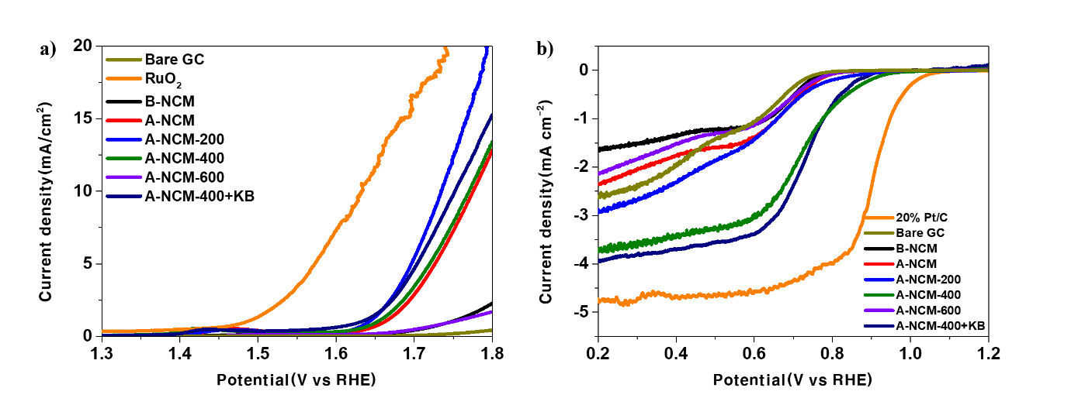
Fig. S1 (a) OER polarization curves of B-NCM, A-NCM, A-NCM-200, A-NCM-400, A-NCM-600, A-NCM-400 + KB, Bare GC and RuO₂. (b) ORR polarization curves of B-NCM, A-NCM, A-NCM-200, A-NCM-400, A-NCM-600, A-NCM-400 + KB, Bare GC and 20% Pt/C

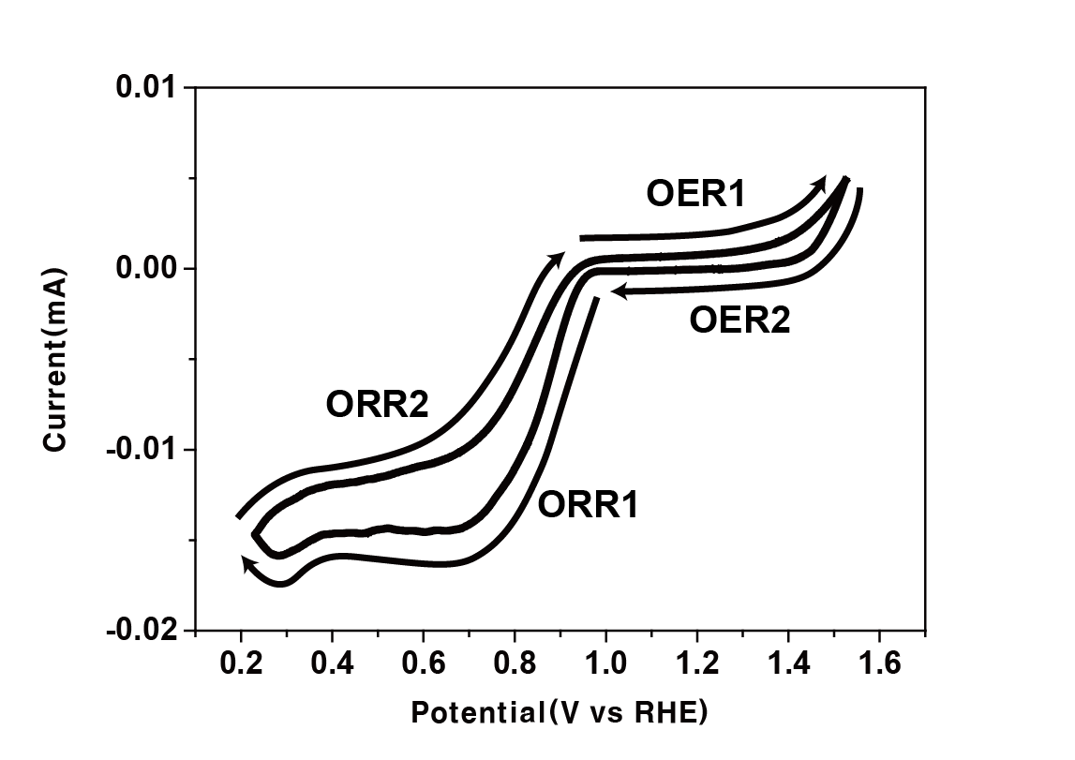
Fig. S2 CV profiles of A-NCM-400 during operando XAS measurement.

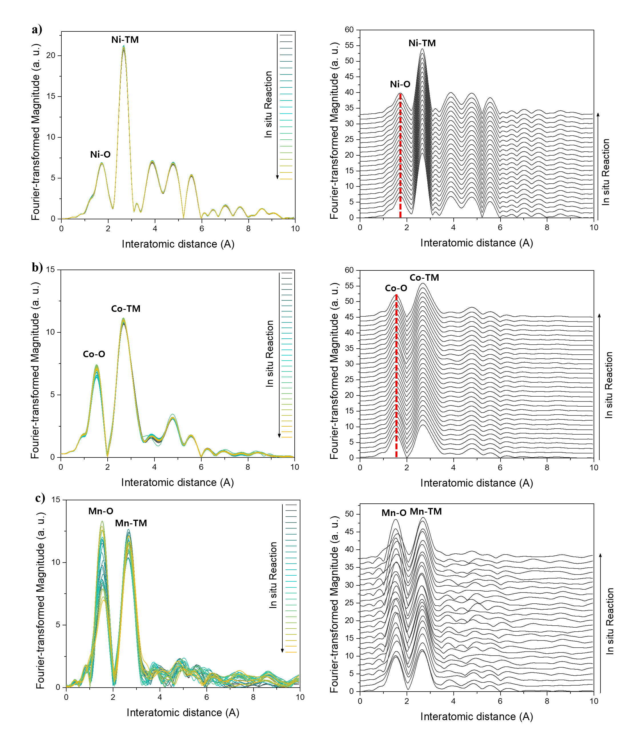
Fig. S3 Corresponding Operando k³-weighted EXAFS profile of (a) Ni K-edge, (b) Co K-edge and (c) Mn K-edge.

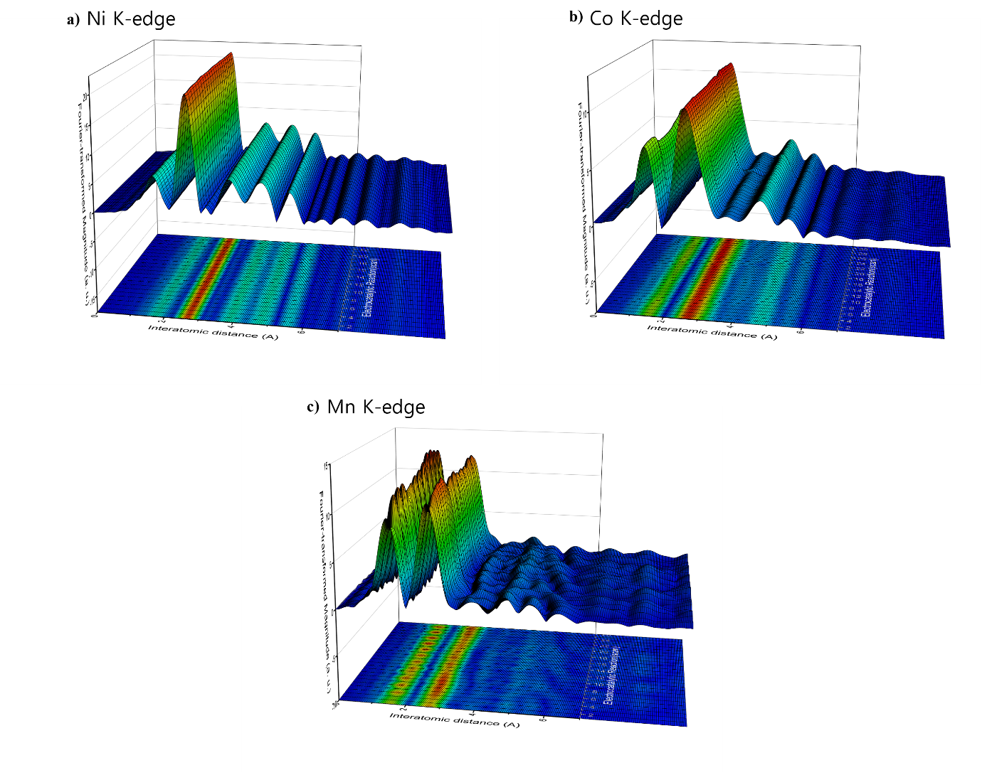
Fig. S4 Contour maps exhibiting Operando k³-weighted EXAFS of (a) Ni K-edge, (b) Co K-edge and (c) Mn K-edge.

