SUPPLEMENTARY INFORMATION
Serotonin Release Mediates Analgesia via Opioidergic System and Withdrawal Symptoms in Chronic Kratom Extract-Treated Mice
Dwi Wahyu Indriani^{1,*}, Siti Irma Rahmawati¹, Asep Bayu¹, Peni Ahmadi¹, Anissa Nofita Sari¹, Zuraida¹, Ni Luh Putu Indi Dharmayanti², and Masteria Yunovilsa Putra^{1,3,4**}
¹Research Center for Vaccine and Drugs, Research Organization for Health, National Research and Innovation Agency (BRIN), Jalan Raya Jakarta-Bogor Km. 46, 16911 West Java, Indonesia
² Research Organization for Health, National Research and Innovation Agency (BRIN), Jalan Raya Jakarta-Bogor Km. 46, 16911 West Java, Indonesia
³ Faculty of Pharmacy, Universitas Indonesia, Depok 16424, Indonesia
⁴ National Metabolomics Collaborative Research Center, Faculty of Pharmacy, Universitas Indonesia, Kampus UI Depok, Depok 16424, Indonesia
Corresponding authors: *dwiw007@brin.go.id; **mast001@brin.go.id

Figure S1. Illustration graphic for a hot-plate test.

Table S1. Escalating dose scheme over 5 days to evaluate potential withdrawal symptoms.
Days | Doses (mg/kg)
Days | Morning (AM) | Afternoon (PM)
1 | 8 | 15
2 | 20 | 25
3 | 30 | 35
4 | 40 | 45
5 | 45 | -

Table S2. Escalating dose scheme over 5 days and treatment to evaluate potential kratom extract to ameliorate withdrawal symptoms.
 | Days | Doses (mg/kg) |  | Days | Treatment
 | Days | Morning (AM) | Afternoon (PM) | Days | Morning (AM)  Afternoon (PM)
Vehicle  group | 1-5 | Vehicle | Vehicle | 6-8 | Saline
Morphine groups 1 | 1 | 8 | 15 | 6 | Saline
Morphine groups 1 | 2 | 20 | 25 | 7 | Saline
Morphine groups 1 | 3 | 30 | 35 | 8 | Saline
Morphine groups 1 | 4 | 40 | 45
Morphine groups 1 | 5 | 45 | -
Morphine groups 2 | 1 | 8 | 15 | 6 | Crude kratom  (10 mg/kg)
Morphine groups 2 | 2 | 20 | 25 | 7 | Crude kratom  (10 mg/kg)
Morphine groups 2 | 3 | 30 | 35 | 8 | Crude kratom  (10 mg/kg)
Morphine groups 2 | 4 | 40 | 45
Morphine groups 2 | 5 | 45 | -
Morphine groups 3 | 1 | 8 | 15 | 6 | Alkaloid kratom  (10 mg/kg)
Morphine groups 3 | 2 | 20 | 25 | 7 | Alkaloid kratom  (10 mg/kg)
Morphine groups 3 | 3 | 30 | 35 | 8 | Alkaloid kratom  (10 mg/kg)
Morphine groups 3 | 4 | 40 | 45
Morphine groups 3 | 5 | 45 | -

Table S3. Mass spectrometry data of alkaloids identified in the Kratom’s extracts.
Kratom Alkaloids | Elemental Composition | m/z [M+H]+ |  |  |  | Major Ions in MS/MS |  |  |  | Retention Time (min)
Kratom Alkaloids | Elemental Composition | References | Experimental |  | References |  | Experimental
Kratom Alkaloids | Elemental Composition | References | CE | AE |  |  | CE | AE | CE |  | AE
Mitragynine | C₂₃H₃₀N₂O₄ | 399.2269 – 399.2278 | 399.2280 | 399.2271 | 238.1424 – 238.1440 |  | 238.1434 | 238.1440 | 35.45 |  | 35.26
 |  |  |  |  | 226.1428 – 226.1441 |  | 226.1435 | 226.1434
 |  |  |  |  | 174.0906 – 174.0913 |  | 174.0910 | 174.0909
 |  |  |  |  | 110-0958 – 110.0967 |  | 110.0964 | 110.0961
Paynantheine | C₂₃H₂₈N₂O₄ | 397.2117 – 397.2133 | 397.2105 | 397.2121 | 236.1266 – 236.1281 |  | 236.1282 | 236.1281 | 35.90 |  | 35.26
 |  |  |  |  | 224.1268 – 224.1281 |  | 224.1281 | 224.1281
 |  |  |  |  | 174.0907 – 174.0913 |  | 174.0910 | 174.0910
 |  |  |  |  | 159.0555 – 159.0682 |  | 159.0678 | 159.0673
 |  |  |  |  | 108.0804 |  | 108.0808 | 108.0805
Speciogynine | C₂₃H₃₀N₂O₄ | 399.2269 – 339.2278 | 399.2280 | 399.2269 | 238.1430 – 238.1438 |  | 238.1434 | 238.1432 | 37.64 |  | 37.08
 |  |  |  |  | 226.1431 – 226.1436 |  | 226.1435 | 226.1433
 |  |  |  |  | 174.0909 – 174.0913 |  | 174.0910 | 174.0910
 |  |  |  |  | 110.0855 – 110.0958 |  | 110.0963 | 110.0962
7-hydroxymitragynine | C₂₃H₃₀N₂O₅ | 415.2225 – 415.2239 | n.d. | 415.2209 | 226.1434 – 226.1436 |  | n.d. | 226.1432 | n.d. |  | 32.06
 |  |  |  |  | 190.0739 – 190.0863 |  | n.d. | 190.0858
 |  |  |  |  | 110.0865 – 110.0965 |  | n.d. | 110.0961
Speciociliatine | C₂₃H₃₀N₂O₄ | 399.2270 – 399.2283 | 299.2280 | 399.2273 | 238.1430 – 238.1438 |  | 238.1435 | 238.1433 | 48.84 |  | 48.82
 |  |  |  |  | 226.1431 – 226.1443 |  | 226.1435 | 226.1433
 |  |  |  |  | 174.0909 – 174.0913 |  | 174.0910 | 174.0910
 |  |  |  |  | 110-0855 – 110.0962 |  | 110.0964 | 110.0962
Corynantheidine | C₂₂H₂₈N₂O₃ | 369.2170 – 369.2176 | 369.2170 | 369.2162 | 337.1 |  | 337.1899 | 337.1899 | 32.68 |  | 32.55
 |  |  |  |  | 298.3 |  | 298.1437 | 298.1430
 |  |  |  |  | 253.3 |  | 253.1695 | 253.1690
 |  |  |  |  | 238.1297 – 238.1441 |  | 238.1434 | 238.1432
 |  |  |  |  | 226.1310 – 226.1441 |  | 226.1435 | 226.1433
 |  |  |  |  | 170.2 |  | 170.0960 | 170.0960
 |  |  |  |  | 144.1 |  | 144.0806 | 144.0806
 |  |  |  |  | 129.0 |  | 129.0544 | 129.0545
 |  |  |  |  | 110-0844 – 110.0963 |  | 110.0964 | 110.0961
abbreviations: n.d. = not detected, CE = crude extract, AE = alkaloid extract
Figure S2. Base peak chromatogram of Kratom’s extracts.

Figure S3. MS/MS spectra of mitragynine identification in kratom’s extracts. Typical fragmentation ions of mitragynine are denoted as listed in Table S3.
Figure S4. MS/MS spectra of paynantheine identification in kratom’s extracts. Typical fragmentation ions of paynantheine are denoted as listed in Table S3.
Figure S5. MS/MS spectra of speciogynine identification in kratom’s extracts. Typical fragmentation ions of speciogynine are denoted as listed in Table S3.
Figure S6. MS/MS spectra of speciociliatine identification in kratom’s extracts. Typical fragmentation ions of speciociliatine are denoted as listed in Table S3.
Figure S7. MS/MS spectra of corynantheidine identification in kratom’s extracts. Typical fragmentation ions of corynenatheidine are denoted as listed in Table S3.
Figure S8. MS/MS spectra of 7-hydroxymitragynine identification in kratom’s extracts. Typical fragmentation ions of 7-hydroxymitragynine are denoted as listed in Table S3.

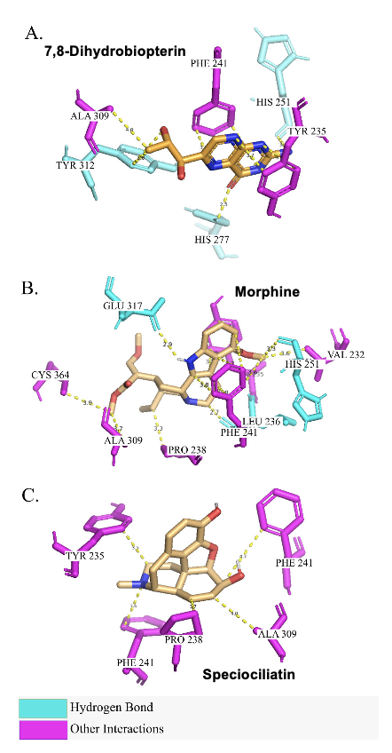
Figure S9. Molecular docking interactions diagram. Molecular docking showing interactions of tryptophan hydroxylase (TPH)’s Native Ligand (7,8 Dihydrobiperin (HBI) (A), Morphine (B), and Speciocilliatin (C) with TPH. Morphine and Speciociliatin were docked to TPH at the catalytic site, which was similar to the binding of HBI.

Tabel S4 Binding Residues of HBI, Morphine, and Speciociliatin to TPH.
Native Ligand (7,8 Dihydrobipterin (HBI) | (Control)  Morphine | Speciociliatin
HIS251 | PRO238 | VAL232
TYR235 | TYR235 | PRO238
HIS277 | TYR312 | CYS364
TYR312 | ALA309 | ALA309
ALA309 | PHE241 | PHE241
PHE241 |  | GLU317
 |  | TYR235
 |  | LEU236
 |  | HIS251
Tabel S5. Binding Energy of HBI, Morphine, and Speciociliatin to TPH.
Native Ligand (7,8 Dihydrobipterin (HBI) | (Control)  Morphine | Speciociliatin
Binding Energy:
-7.8 kcal/mol | -8.0 kcal/mol | -9.0 kcal/mol

Table S6. Docking Results of Targeted Protein (TPH (PDB ID: 1MLW)) with Mitragyna speciosa Korth.
No. | Pubchem ID | Visualization | Binding Affinity (kcal/mol) | Interactions
1 | Speciociliatin  (CID: 15560576) | 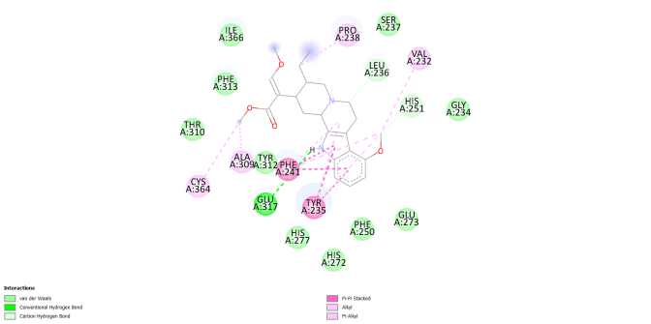 | -9.0 | VAL A:232  PRO A:238  CYS A:364  ALA A:309  PHE A:241  GLU A:317  TYR A:235  LEU A:236  HIS A:251
2 | Paynantheine  (CID: 3037629) | 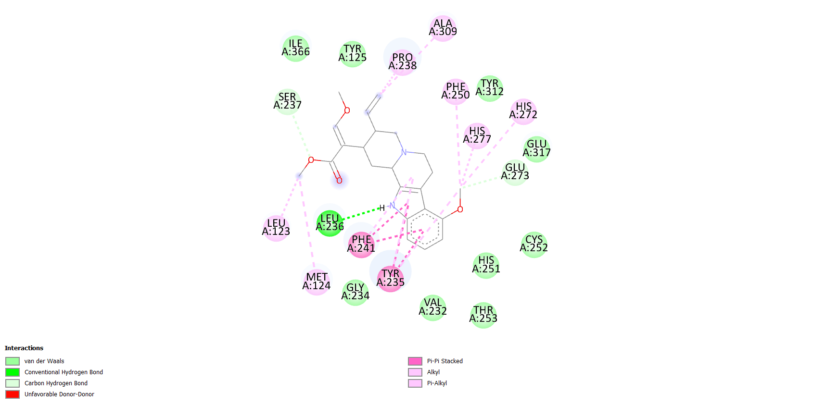 | -8.5 | ALA A:309  PRO A:238  PHE A:250  HIS A:272  HIS A:277  GLU A:273  LEU A:236  PHE A:241  TRY A:235  MET A:124  LEU A:123  SER A:237
3 | Corynantheidine  (CID: 3000341) | 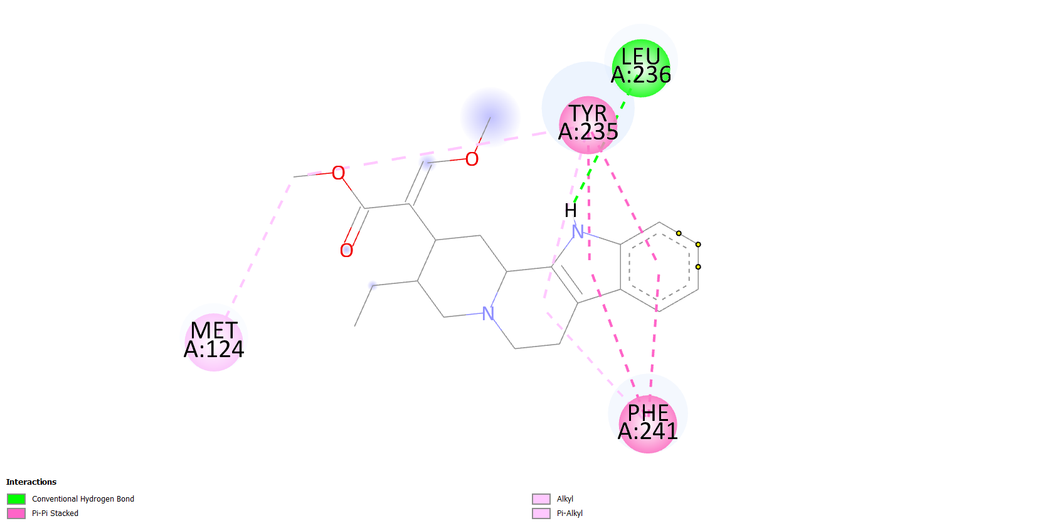 | -8.5 | TYR A:235  LEU A:236  PHE A:241  MET A:124
4 | Speciogynine  (CID: 15560577) | 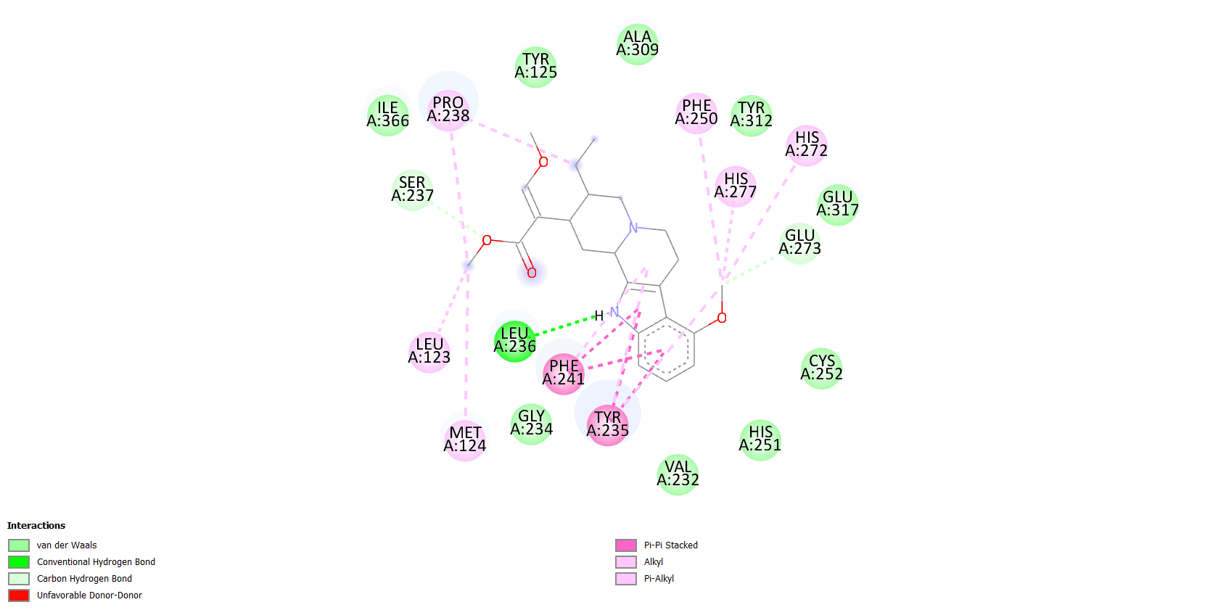 | -8.5 | LEU A:236  PHE A:241  TYR A:235  MET A:124  LEU A:123  PRO A:238  PHE A:250  HIS A:277  HIS A:272  GLU A:273  SER A:237
5 | Mitragynine  (CID: 3034396) | 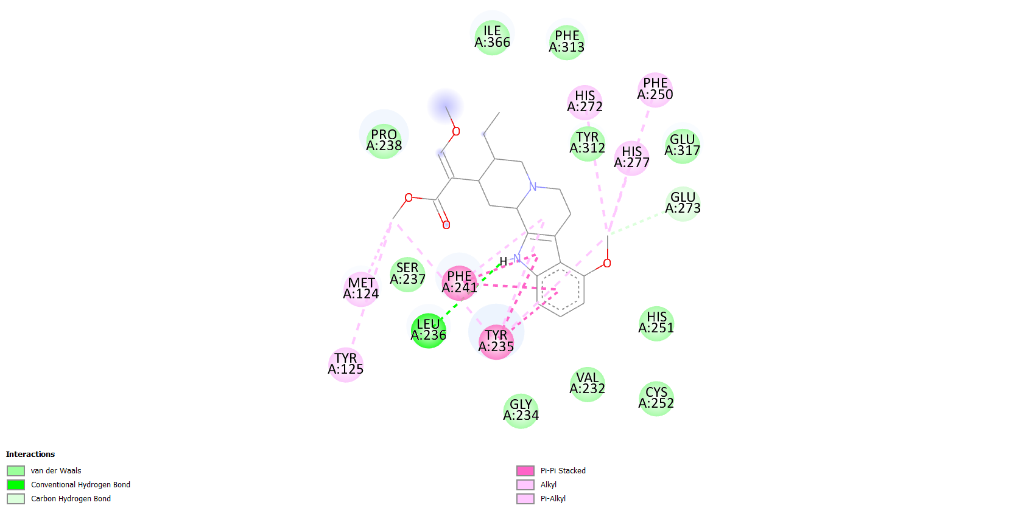 | -8.3 | HIS A:277  PHE A:250  HIS A:272  MET A:124  TYR A:125  PHE A:241  TYR A:235  LEU A:236  GLU A:273
6 | 7-Hydroxymitragynine  (CID: 44301524) | 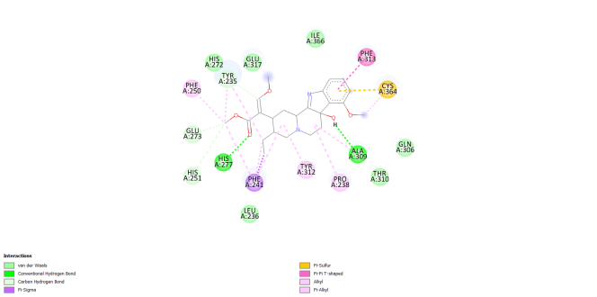 | -7.7 | PHE A: 313  CYS A: 364  ALA A:309  PRO A:238  TYR A:312  PHE A:241  HIS A:277  GLU A:273  HIS A:251  PHE A:250  TYR A:235

