Supplementary Material

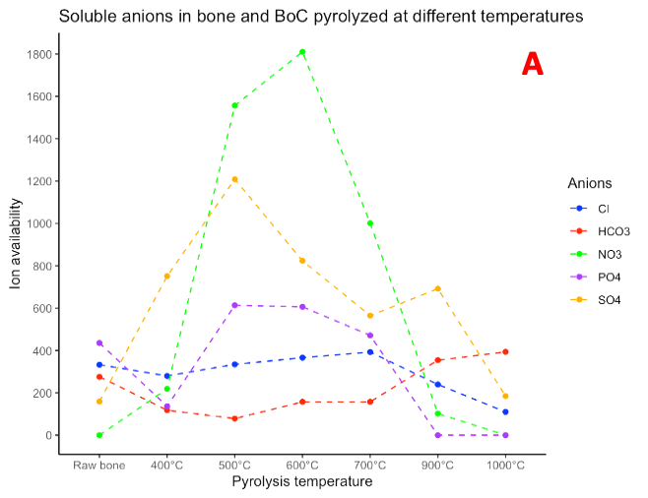

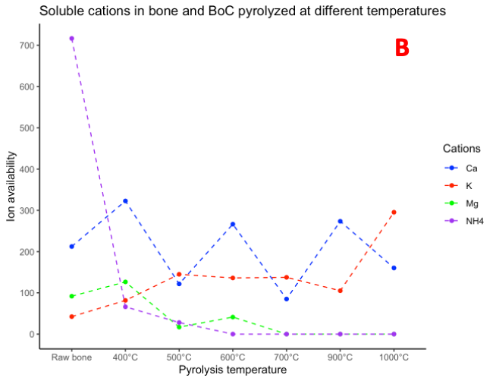
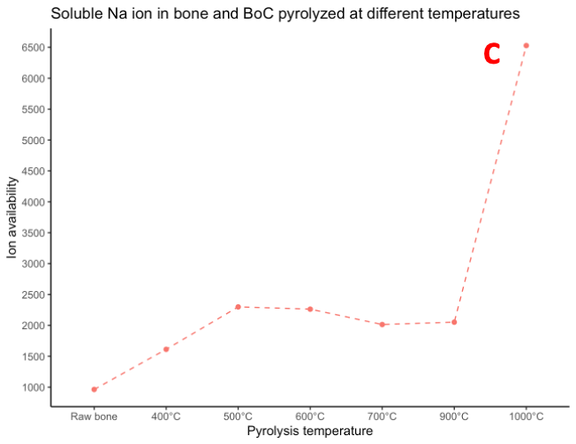
Figure 1. Availability of soluble Cl⁻, HCO₃⁻, NO₃⁻, PO₄³⁻, and SO₄²⁻, anions (A), NH₄⁺, K⁺, Mg²⁺ and Ca²⁺ cations (B) and Na⁺ (C) in bone and BoC pyrolyzed at different temperatures.

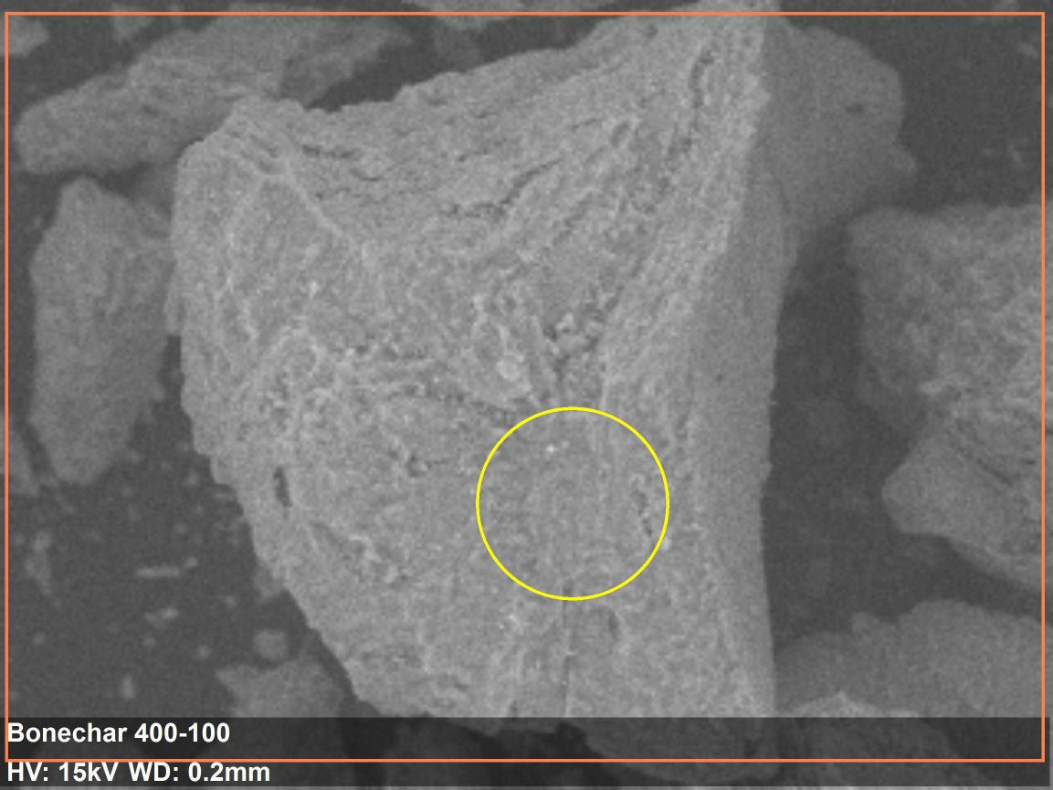

Figure 2. SEM image of BoC produced at 400 °C

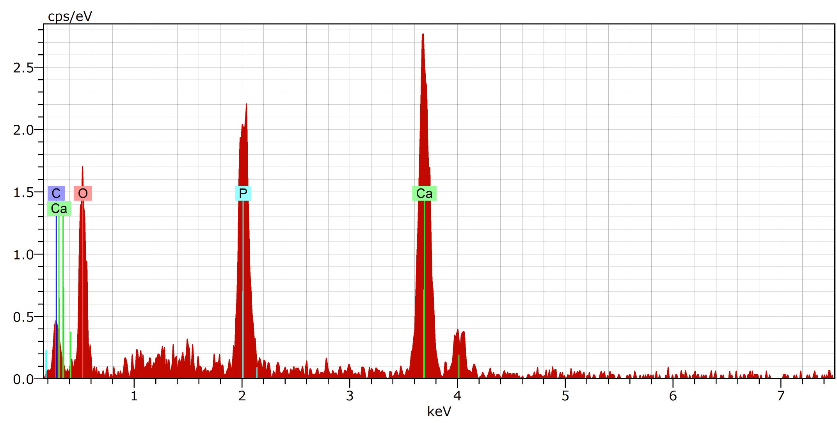
Figure 3. EDS spectrum of BoC produced at 400 °C

Table 1. Semi quantification results of BoC produced at 400 °C

Element | Wt%
O | 47.86
P | 11.34
Ca | 29.11
C | 11.69
Total | 100

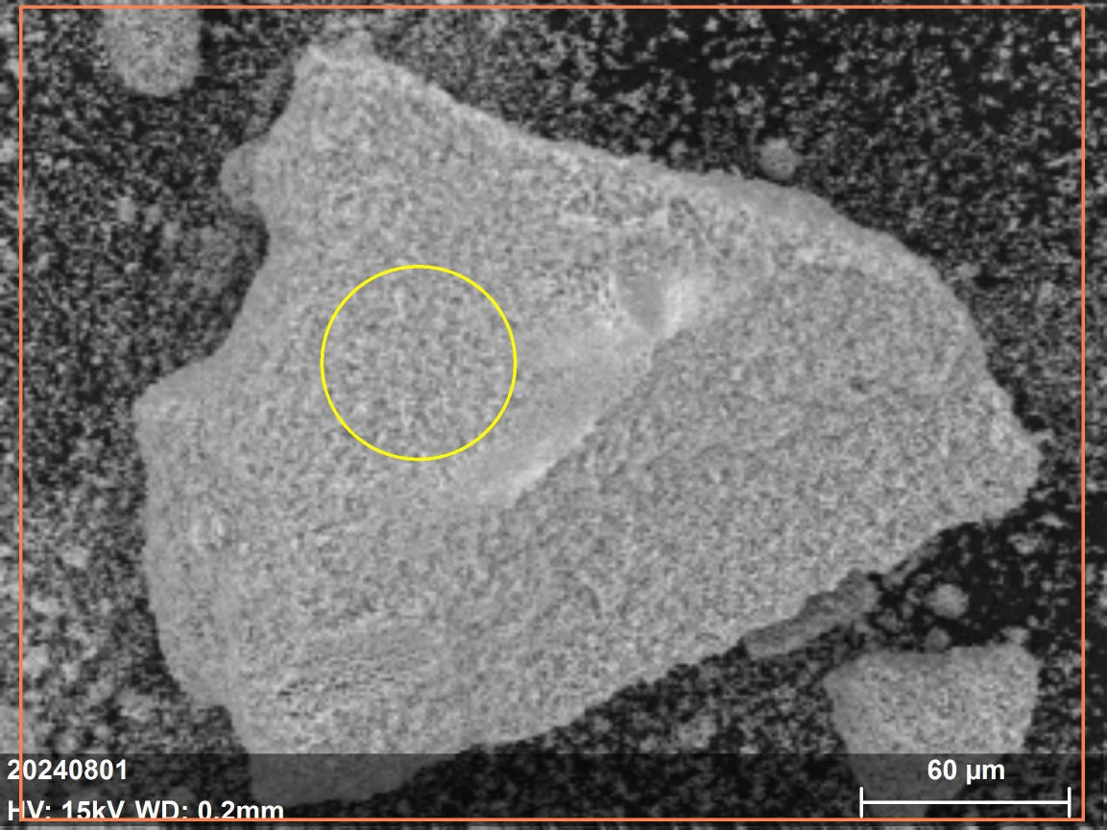

Figure 4. SEM image of BoC produced at 1000 °C

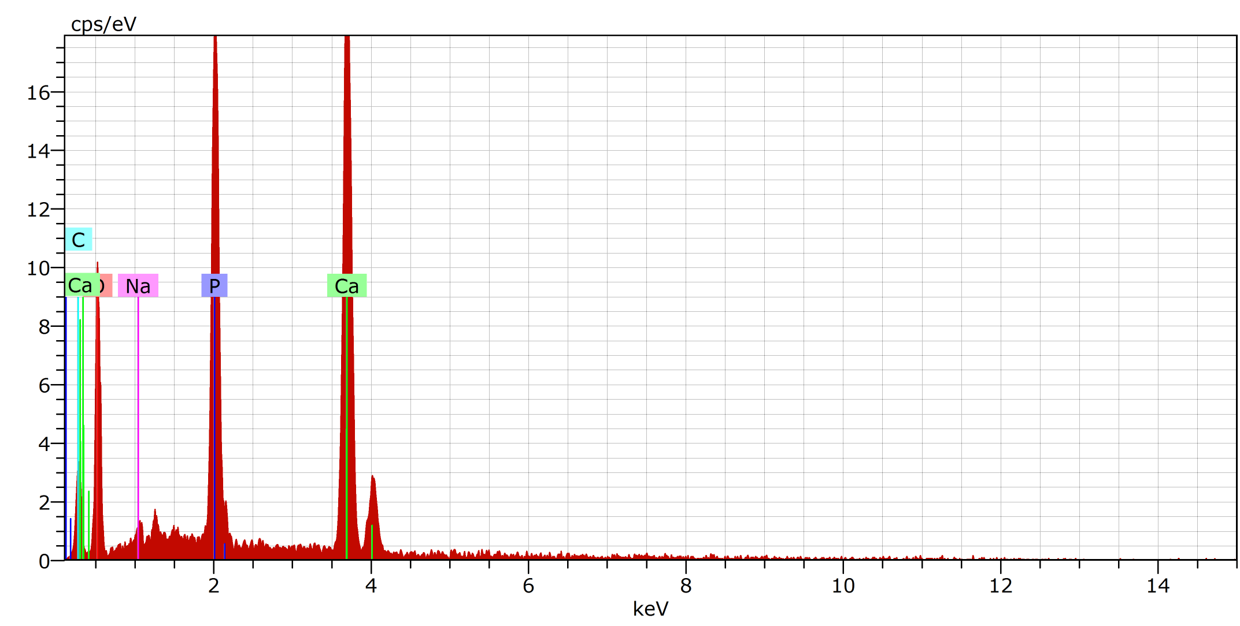
Figure 5. EDS spectrum of BoC produced at 1000 °C
Table 2. Semi quantification results of BoC produced at 1000 °C

Element | Wt%
O | 42.06
Ca | 29.26
P | 13.91
Ca | 13.76
Na | 1.01
Total | 100

