Table S1. Subject-independent testing results for the multiclass classification of all models on the entire Pulsewatch dataset.
 | Index | Model name | Rhythm | Sensitivity | Specificity | Precision | NPV | Accuracy | Micro-AUROC | Macro-AUROC
Previous (retrained) | 1 | 1D VGG-16⁶ (PPG only) | NSR | 97.40 | 91.25 | 95.83 | 91.65 | 94.48 | 98.89 | 95.82
Previous (retrained) | 1 | 1D VGG-16⁶ (PPG only) | AF | 90.21 | 97.67 | 85.73 | 97.34 | 94.76 | 98.89 | 95.82
Previous (retrained) | 1 | 1D VGG-16⁶ (PPG only) | PAC/PVC | 63.34 | 98.09 | 71.27 | 95.44 | 93.03 | 98.89 | 95.82
Previous (retrained) | 2 | 1D VGG-16⁶ (four channels) | NSR | 96.06 | 91.87 | 96.02 | 87.49 | 93.12 | 99.24 | 98.09
Previous (retrained) | 2 | 1D VGG-16⁶ (four channels) | AF | 97.61 | 98.25 | 89.43 | 99.34 | 97.06 | 99.24 | 98.09
Previous (retrained) | 2 | 1D VGG-16⁶ (four channels) | PAC/PVC | 71.32 | 97.77 | 73.37 | 96.39 | 93.88 | 99.24 | 98.09
Previous (retrained) | 3 | 2D DenseNet⁸ (2D TFS) | NSR | 95.31 | 91.33 | 95.73 | 85.97 | 92.38 | 98.72 | 95.86
Previous (retrained) | 3 | 2D DenseNet⁸ (2D TFS) | AF | 89.21 | 97.86 | 86.70 | 97.09 | 94.83 | 98.72 | 95.86
Previous (retrained) | 3 | 2D DenseNet⁸ (2D TFS) | PAC/PVC | 59.43 | 95.83 | 52.82 | 94.80 | 89.50 | 98.72 | 95.86
Ours (1D-Bi-GRU) | 4 | PPG only | NSR | 92.45 | 95.66 | 97.75 | 82.33 | 91.96 | 97.89 | 95.84
Ours (1D-Bi-GRU) | 4 | PPG only | AF | 89.65 | 95.83 | 79.81 | 97.14 | 93.03 | 97.89 | 95.84
Ours (1D-Bi-GRU) | 4 | PPG only | PAC/PVC | 67.47 | 94.96 | 54.64 | 95.77 | 90.08 | 97.89 | 95.84
Ours (1D-Bi-GRU) | 5 | PPG + ACC | NSR | 89.65 | 94.61 | 97.10 | 76.50 | 88.86 | 96.89 | 95.91
Ours (1D-Bi-GRU) | 5 | PPG + ACC | AF | 93.63 | 96.84 | 82.80 | 98.23 | 94.55 | 96.89 | 95.91
Ours (1D-Bi-GRU) | 5 | PPG + ACC | PAC/PVC | 71.03 | 92.56 | 49.47 | 96.13 | 88.62 | 96.89 | 95.91
Ours (1D-Bi-GRU) | 6 | HR only | NSR | 91.01 | 93.16 | 96.42 | 78.91 | 89.74 | 97.64 | 95.29
Ours (1D-Bi-GRU) | 6 | HR only | AF | 90.16 | 97.25 | 85.76 | 97.33 | 94.76 | 97.64 | 95.29
Ours (1D-Bi-GRU) | 6 | HR only | PAC/PVC | 73.47 | 93.35 | 51.60 | 96.46 | 89.30 | 97.64 | 95.29
Ours (1D-Bi-GRU) | 7 | HR + ACC | NSR | 90.52 | 95.15 | 97.40 | 77.68 | 89.60 | 97.76 | 97.03
Ours (1D-Bi-GRU) | 7 | HR + ACC | AF | 97.03 | 97.90 | 88.58 | 99.18 | 96.73 | 97.76 | 97.03
Ours (1D-Bi-GRU) | 7 | HR + ACC | PAC/PVC | 80.90 | 93.31 | 55.09 | 97.44 | 90.46 | 97.76 | 97.03
Ours (1D-Bi-GRU) | 8 | HR + magHR | NSR | 92.11 | 93.40 | 96.61 | 81.64 | 91.08 | 98.10 | 96.35
Ours (1D-Bi-GRU) | 8 | HR + magHR | AF | 93.74 | 97.23 | 87.37 | 98.29 | 95.82 | 98.10 | 96.35
Ours (1D-Bi-GRU) | 8 | HR + magHR | PAC/PVC | 71.99 | 94.56 | 56.35 | 96.34 | 90.61 | 98.10 | 96.35
Ours (1D-Bi-GRU) | 9 | HR + magHR + ACC | NSR | 89.56 | 95.80 | 97.72 | 76.39 | 89.07 | 97.74 | 97.18
Ours (1D-Bi-GRU) | 9 |  | AF | 95.91 | 97.99 | 89.00 | 98.88 | 96.63 | 97.74 | 97.18
Ours (1D-Bi-GRU) | 9 |  | PAC/PVC | 81.98 | 92.22 | 51.69 | 97.54 | 89.39 | 97.74 | 97.18
Ours (1D-Bi-GRU) | 10 | PPG + HR | NSR | 93.15 | 94.38 | 97.14 | 83.73 | 92.25 | 98.11 | 95.15
Ours (1D-Bi-GRU) | 10 | PPG + HR | AF | 91.49 | 97.6 | 87.24 | 97.69 | 95.38 | 98.11 | 95.15
Ours (1D-Bi-GRU) | 10 | PPG + HR | PAC/PVC | 70.85 | 94.56 | 55.57 | 96.19 | 90.38 | 98.11 | 95.15
Ours (1D-Bi-GRU) | 11 | PPG + HR + ACC | NSR | 90.02 | 95.68 | 97.66 | 76.74 | 89.23 | 97.31 | 96.29
Ours (1D-Bi-GRU) | 11 | PPG + HR + ACC | AF | 95.26 | 98.07 | 87.57 | 98.7 | 96.14 | 97.31 | 96.29
Ours (1D-Bi-GRU) | 11 | PPG + HR + ACC | PAC/PVC | 76.43 | 92.12 | 49.43 | 96.8 | 88.59 | 97.31 | 96.29
Ours (1D-Bi-GRU) | 12 | PPG + HR + ACC + magHR (best model) | NSR | 91.30 | 96.18 | 97.98 | 79.62 | 90.81 | 98.19 | 97.68
Ours (1D-Bi-GRU) | 12 | PPG + HR + ACC + magHR (best model) | AF | 97.52 | 98.30 | 90.47 | 99.32 | 97.31 | 98.19 | 97.68
Ours (1D-Bi-GRU) | 12 | PPG + HR + ACC + magHR (best model) | PAC/PVC | 83.52 | 93.60 | 57.48 | 97.79 | 91.23 | 98.19 | 97.68

Table S2. Binary AF/non-AF classification results of all models on the entire Pulsewatch dataset.
 | Index | Model name | Sensitivity | Specificity | Precision | NPV | Accuracy | Micro-AUROC | Macro-AUROC
Previous | 1 | 1D VGG-16⁶ (PPG only) | 90.21 | 97.67 | 85.73 | 97.34 | 94.76 | 98.62 | 98.62
Previous | 2 | 1D VGG-16⁶ (four channels) | 97.61 | 98.25 | 89.43 | 99.34 | 97.06 | 99.67 | 99.65
Previous | 3 | 2D DenseNet⁸ (2D TFS) | 89.21 | 97.86 | 86.70 | 97.09 | 94.83 | 99.01 | 99.01
Ours (1D-Bi-GRU) | 4 | PPG only | 89.65 | 95.83 | 79.81 | 97.14 | 93.03 | 98.37 | 98.37
Ours (1D-Bi-GRU) | 5 | PPG+ACC | 93.63 | 96.84 | 82.80 | 98.23 | 94.55 | 98.79 | 98.78
Ours (1D-Bi-GRU) | 6 | HR only | 90.16 | 97.25 | 85.76 | 97.33 | 94.76 | 98.83 | 98.83
Ours (1D-Bi-GRU) | 7 | HR + ACC | 97.03 | 97.90 | 88.58 | 99.18 | 96.73 | 99.36 | 99.36
Ours (1D-Bi-GRU) | 8 | HR + magHR | 93.74 | 97.23 | 87.37 | 98.29 | 95.82 | 99.13 | 99.12
Ours (1D-Bi-GRU) | 9 | HR + magHR + ACC | 95.91 | 97.99 | 89.00 | 98.88 | 96.63 | 99.38 | 99.38
Ours (1D-Bi-GRU) | 10 | PPG + HR | 91.49 | 97.6 | 87.24 | 97.69 | 95.38 | 98.94 | 98.93
Ours (1D-Bi-GRU) | 11 | PPG + HR + ACC | 95.26 | 98.07 | 87.57 | 98.70 | 96.14 | 99.50 | 99.50
Ours (1D-Bi-GRU) | 12 | PPG + HR + ACC + magHR (best model) | 97.52 | 98.30 | 90.47 | 99.32 | 97.31 | 99.61 | 99.60

Table S3. Macro-AUROC on different methods on all independent testing datasets (Pulsewatch, Simband, MIMIC III).
 | Index | Model name | Macro-AUROC
 |  |  | Pulsewatch | Simband | MIMIC III
Previous (retrained) | 1 | 1D VGG-16⁶ (PPG only) | 95.82 | 92.49 | 86.66
Previous (retrained) | 2 | 1D VGG-16⁶ (four channels) | 98.09 | 93.57 | 86.55
Previous (retrained) | 3 | 2D DenseNet⁸ (2D TFS) | 95.86 | 88.35 | 87.50
Ours | 4 | PPG only | 95.84 | 92.92 | 83.73
Ours | 5 | PPG + ACC | 95.91 | 89.68 | 83.18
Ours | 6 | HR only | 95.29 | 95.95 | 90.83
Ours | 7 | HR + ACC | 97.03 | 94.32 | 92.14
Ours | 8 | HR + magHR | 96.35 | 96.22 | 94.17
Ours | 9 | HR + magHR + ACC | 97.18 | 94.83 | 92.93
Ours | 10 | PPG + HR | 95.15 | 95.00 | 85.22
Ours | 11 | PPG + HR + ACC | 96.29 | 93.79 | 89.40
Ours | 12 | PPG + HR + ACC + magHR (best model) | 97.68 | 96.40 | 92.27

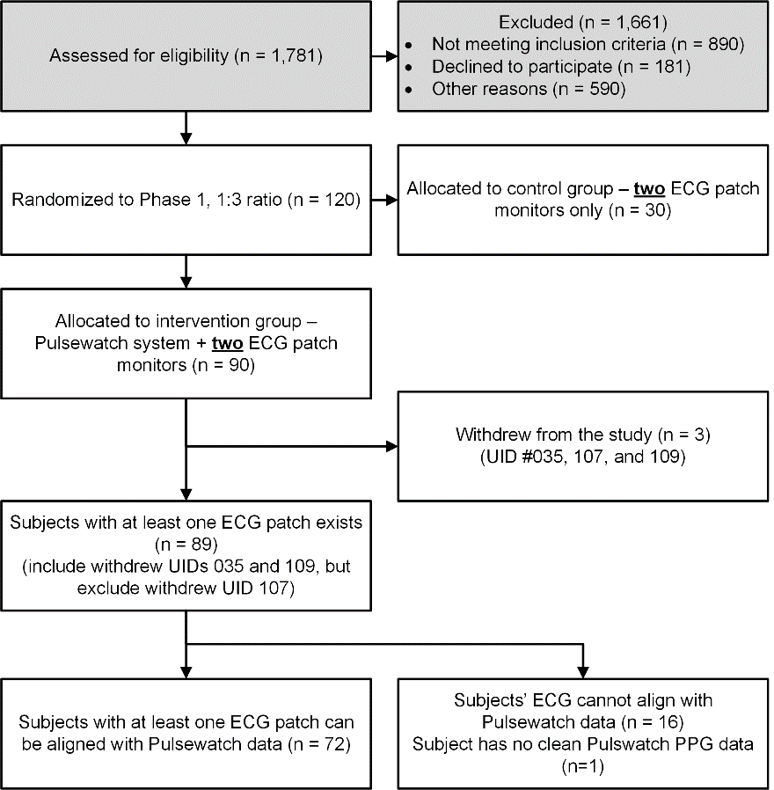
Figure S1. The enrollment information for the Pulsewatch clinical trial.

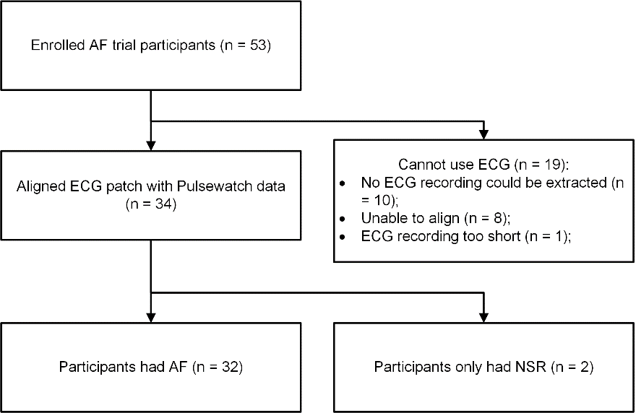
Figure S2. The enrollment information for the Pulsewatch AF trial.

Table S4. Split of the Pulsewatch dataset based on number of segments in each arrhythmia.
 | Fold-1 |  |  |  | Fold-2 |  |  |  | Remaining NSR
No. | UID | NSR | AF | PAC/  PVC | UID | NSR | AF | PAC/  PVC | UID | NSR
1 | 007 | 120 | / | 2 | 002 | 102 | / | 21 | 003 | 3,194
2 | 022 | 4,125 | / | 1 | 005 | 648 | / | 581 | 011 | 78
3 | 024 | 7,116 | / | / | 013 | 7,284 | / | 26 | 012 | 2,706
4 | 026 | 168 | / | 1 | 017 | / | 170 | / | 014 | 1
5 | 037 | 688 | / | / | 021 | 511 | / | 1 | 020 | 2,559
6 | 039 | 3,567 | / | 1 | 028 | 3,463 | / | 6 | 027 | 9,366
7 | 042 | 125 | / | 1 | 029 | 5,448 | / | 1,110 | 030 | 2,024
8 | 053 | 3,506 | / | 34 | 038 | 272 | / | 228 | 035 | 110
9 | 054 | 192 | / | 635 | 045 | 2,950 | / | 106 | 036 | 4,520
10 | 057 | 5,077 | / | / | 052 | 1,568 | / | 2 | 041 | 1,253
11 | 064 | 3,625 | / | 12 | 068 | 3,135 | / | 33 | 044 | 738
12 | 069 | 434 | / | 2 | 070 | 809 | / | 1 | 047 | 1,320
13 | 080 | 6,357 | / | 193 | 073 | 2,066 | / | 23 | 049 | 1,542
14 | 089 | / | / | 4 | 075 | 196 | 13 | 2,110 | 050 | 3
15 | 090 | 1,979 | / | 1 | 078 | 5,332 | / | 1 | 055 | 80
16 | 093 | / | / | 800 | 086 | 10 | / | 67 | 056 | 60
17 | 104 | / | / | 12 | 087 | / | / | 11 | 058 | 1,305
18 | 110 | 12 | 1 | 261 | 100 | 87 | / | 1,485 | 063 | 1,377
19 | 113 | / | / | 4,668 | 112 | 5,480 | / | 524 | 074 | 7
20 | 120 | 18 | / | 13 | 301 | / | 17 | / | 077 | 2,722
21 | 305 | / | 10 | / | 302 | / | 2 | / | 083 | 78
22 | 310 | / | 6 | / | 306 | / | 2 | / | 084 | 3,781
23 | 318 | / | 8 | / | 307 | / | 39 | / | 088 | 1,644
24 | 320 | / | 8 | / | 311 | / | 19 | / | 091 | 1,253
25 | 321 | / | 11 | / | 312 | / | 3 | / | 094 | 109
26 | 322 | / | 7 | / | 319 | / | 13 | / | 098 | 82
27 | 400 | / | 600 | / | 324 | / | 6 | / | 099 | 3,374
28 | 405 | / | 406 | / | 327 | 2 | / | 6 | 101 | 476
29 | 408 | 864 | 50 | 29 | 329 | / | 15 | / | 106 | 531
30 | 409 | / | 584 | / | 402 | / | 2,213 | / | 109 | 615
31 | 413 | / | 4,804 | / | 406 | / | 1,902 | / | 111 | 109
32 | 415 | / | 1,955 | / | 407 | / | 166 | / | 118 | 3,550
33 | 416 | / | 762 | / | 410 | / | 3,525 | / | 119 | 10
34 | 419 | 1,383 | 1,491 | 27 | 414 | / | 2,004 | / | 325 | 14
35 | 422 | / | 103 | / | 420 | / | 165 | /
36 | 423 | / | 1,459 | / | 421 | / | 2,016 | /
Total |  | 39,356 | 12,265 | 6,697 |  | 39,363 | 12,290 | 6,342 |  | 50,591

Table S5. Recording numbers of the randomly selected subject in the external MIMIC-III dataset.
Subject Index | Subject ID in MIMIC III
AF1 | p000946-2120-05-14-08-08
AF2 | p075796-2198-07-25-23-40
AF3 | p022954-2136-02-29-17-52
AF4 | p025117-2202-03-15-20-28
AF5 | p026377-2111-11-17-16-46
NSR1 | p004829-2103-08-30-21-52
NSR2 | p013072-2194-01-22-16-13
NSR3 | p050384-2195-01-30-02-21
NSR4 | p055204-2132-06-30-09-34
NSR5 | p058932-2120-10-13-23-15
PACPVC1 | p007614-2177-01-08-13-21
PACPVC2 | p065656-2121-08-07-04-35
PACPVC3 | p030542-2135-10-17-10-33

