Understanding your biases in collecting organismal VOCs

Journal of Chemical Ecology

Lucas Seybert¹, Christophe Duplais^{1*}

¹Department of Entomology, Cornell AgriTech, Cornell University, Geneva 14464 NY, USA

*Corresponding author: c.duplais@cornell.edu
Appendix S1: Statistical analysis. 3
Table S1. List of adsorbent characteristics commercially available as sorbent tubes. 4
Table S2. Compounds selected for the VOC standard mixture. 5
Table S3. VOC recovery by adsorbent cartridges. 6
Table S4. Total number of features identified in chromatograms of rosemary samples. 7
Figure S1. Comparison of VOC recovery by different vendors and lots of Porapak® Q. 8
Figure S2. Comparison of sample chromatograms of rosemary VOCs. 9

Appendix S1: Statistical Analysis. All statistical analyses were performed in R (v. 4.3.3) with RStudio (2024.09.1) as an environment, using the following packages: multcompView, car, nlme, magrittr, dplyr, tidyr, readxl, emmeans, multcomp, and ggplot2. Code was provided by K. T. Wilcox (Cornell Statistical Consulting Unit) and modified by LS.
Each compound within a dataset was analyzed individually, with adsorbent type (or adsorbent vendor) as the independent variable and compound area/concentration as the dependent variable. KTW advised that the transformation of the data and the type of ANOVA performed should be determined on an compound-by-compound basis based on whether the data fit the assumptions of the statistical test. The variance (SD²) within each adsorbent was calculated, and the smallest and largest variance within a given compound were compared. A traditional ANOVA assumes that the variance is the same for all independent variables; KTW advised that the ratio between the highest and lowest variance should not be much greater than four. For variables where the ratio of variances was >>4, the data was log-transformed and the comparison of the variances was repeated. If the log-transformed variances fit the assumptions of a traditional ANOVA, the ANOVA was performed on the log-transformed data. In many cases, neither the raw nor the transformed data fit the assumption of equal variance, so a Welch’s ANOVA—which does not assume equal variance—was performed.
For all compounds in the VOC standard trials, a Welch’s ANOVA was used. In the rosemary trials, a traditional ANOVA was performed on the raw area counts for d-limonene, β-myrcene, cineole, and terpinolene; an ANOVA was performed on the log-transformed area counts for α-pinene, β-pinene, camphene, and camphor; and a Welch’s ANOVA was performed on the raw area counts for γ-terpinene, endo-borneol, and bornyl acetate. For the vendor comparisons, a traditional ANOVA was used for all compounds, while in the comparisons between lots from a specific vendor, a traditional ANOVA could only be used for hexanal and R-(+)-limonene and a Welch’s ANOVA was required for the remaining compounds.
Regardless of the type of ANOVA used, Tukey’s HSD (p<0.05) was used to determine whether adsorbents differed from one another for a given compound.

Table S1. List of adsorbent characteristics commercially available as sorbent tubes.\

Matrix | Vendor Reference | Name  (Composition) | Polarity | Pore diameter (nm) | Surface area (m²/g)
Charcoal | Orbo 32ª  SKC 226-01 | Activated coconut charcoal | Low | - | 800–1500
Carbon | Orbo 90ª  SKC-80  SKC 226-81 | Carboxen-564  Anasorb 747  (carbon molecular sieves) | Low | 0.9 | 400
Carbon | Orbo 101ª | Carbotrap  (graphitized carbon black) | Low | 10 | 240
Porous polymer | Orbo 403ª  SKC 226-35-03 | Tenax® TA  (poly(2,6-diphenyl-p-phenylene oxide) polymer) | 2-Low | 200 | 35
Porous polymer | Orbo 43  SKC 226-30-04 | Amberlite XAD-2, supelpak 20  (styrene-divinylbenzene copolymer) | 2-Low | 9 | 300
Porous polymer | Orbo 47ª  SKC 226-95  ZST-090 | Amberlite XAD-7, supelpak 70  (aliphatic acrylic polymer) | 5-Moderate | 55 | 75
Porous polymer | SKC 226-107  ZST-020 | Chromosorb 102  (Benzene, diethenyl-, ethenylbenzene copolymer) | 3-Low | 300-400 | 50
Porous polymer | ZST-120ª | Porapak® N, HayeSep N  (DVB-EVB Ethyleneglycol dimethacrylate copolymer) | 7-High | - | 250-350
Porous polymer | SKC 226-114  ZST-125ª | Porapak® P, HayeSep P  (DVB/Styrene copolymer) | 2-Low | 91 | 100-200
Porous polymer | Orbo 1103ª  SKC 226-115ª  ZST-130ª | Porapak® Q, SuperQ^{b}  (DVB/Ethylvinylbenzene copolymer) | 2-Low | 75 | 500-600
Porous polymer | SKC 226-116A  ZST-140 | Porapak® T, HayeSep T  (Ethyleneglycol dimethacrylate copolymer) | 10-High | - | 225-350
Porous polymer | ZST-135 | Porapak® R, HayeSep R  (DVB/Vinyl Methylpyrolidone copolymer) | 5-Moderate | 76 | 450-600

ªSorbent tubes used in this study
^{b}Super Q is Porapak® Q extensively washed with organic solvents and acids to remove residual monomers and impurities. http://www.axialscientific.com/files/alltech_gc_packed.pdf

Table S2. Compounds selected for the VOC standard mixture.

Compound | Structure | Functional group(s) | Category
Hexanal | 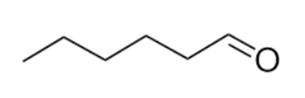 | Aldehyde | C6 volatile
1-Hexanol | 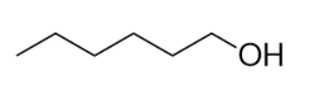 | Alcohol | C6 volatile
3-Hexenyl acetate | 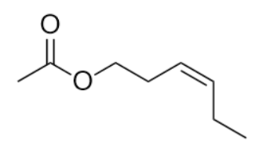 | Este, alkene | C6 volatile
R-(+)-Limonene | 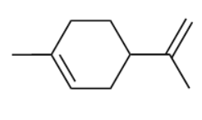 | Alkene | Monoterpene
Linalool oxide | 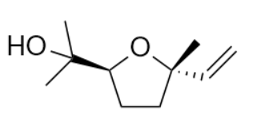 | Alcohol, ether, alkene | Monoterpenoid
Linalool | 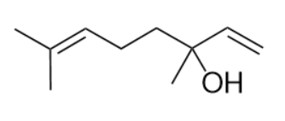 | Alcohol, alkene | Monoterpenoid
2-Phenylethyl alcohol | 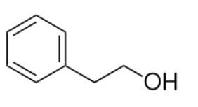 | Phenyl, alcohol | Benzenoid²³
Methyl salicylate | 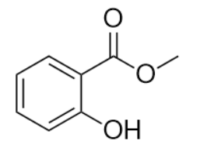 | Alcohol, ketone | Benzenoid
β-Caryophyllene | 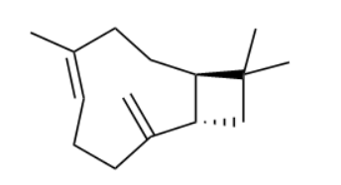 | n/a | Sesquiterpene

Table S3. Mean and standard error of VOC percentage recovery by adsorbent cartridges. Superscripts indicate means that are significantly different from one another (Tukey’s HSD, p < 0.05).

Adsorbent | Hexanal | 1-Hexanol | 3-Hexenyl acetate | R-(+)-  Limonene | Linalool oxides | Linalool | 2-Phenylethyl alcohol | Methyl salicylate | Caryophyllene
Orbo 101 | 67% ± 5%^{A} | 52% ± 4%^{AB} | 73% ± 7%^{AB} | 70% ± 7% ^{AB} | 73% ± 7% ^{AB} | 54% ± 6% ^{AB} | 46% ± 5%^{BC} | 50% ± 6% ^{BC} | 44% ± 5% ^{BC}
Orbo 32 | 51% ± 2%^{A} | 57% ± 1%^{AB} | 60% ± 1%^{B} | 31% ± 1% ^{BC} | 55% ± 6%^{ABC} | 51% ± 1% ^{B} | 32% ± 1% ^{C} | 9% ± 0.4%^{C} | 38% ± 2% ^{B}
Orbo 47 | 55% ± 2%^{A} | 63% ± 2%^{AB} | 61% ± 2% ^{B} | 65% ± 2% ^{AB} | 61% ± 2%^{B} | 49% ± 2%^{B} | 47% ± 2%^{B} | 50% ± 3%^{B} | 38% ± 1%^{B}
Orbo 90 | 23% ± 5%^{BC} | 18% ± 4%^{D} | 21% ± 5%^{C} | 15% ± 3%^{C} | 22% ± 5%^{CD} | 17% ± 4%^{C} | 9% ± 2%^{D} | 5% ± 1%^{C} | 18% ± 4%^{C}
Porapak® N | 59% ± 3%^{A} | 57% ± 8%^{ABC} | 51% ± 10%^{ABC} | 56% ± 8%^{AB} | 52% ± 13%^{ABCD} | 40% ± 11%^{ABC} | 39% ± 12%^{ABCD} | 42% ± 12%^{ABC} | 25% ± 6%^{BC}
Porapak® P | 44% ± 3%^{AB} | 70% ± 3%^{AB} | 81% ± 3%^{A} | 80% ± 4%^{A} | 89% ± 4%^{A} | 81% ± 4%^{A} | 80% ± 4%^{A} | 82% ± 4%^{A} | 79% ± 4%^{A}
Porapak® Q | 43% ± 6%^{AB} | 39% ± 7%^{BCD} | 27% ± 7%^{C} | 31% ± 7%^{C} | 24% ± 7%^{CD} | 20% ± 7%^{C} | 20% ± 6%^{CD} | 19% ± 6%^{C} | 19% ± 5%^{C}
Porapak® R | 54% ± 7%^{AB} | 57% ± 7%^{AB} | 54% ± 7%^{ABC} | 57% ± 6%^{AB} | 53% ± 9%^{ABCD} | 43% ± 9%^{ABC} | 33% ± 7%^{BCD} | 43% ± 9%^{ABC} | 32% ± 7%^{BC}
Tenax® | 6.3% ± 0.4%^{C} | 20.9% ± 0.8%^{CD} | 66% ± 1%^{B} | 20.3%± 0.5%^{C} | 4.0% ± 0.1%^{D} | 23.2%± 0.5%^{C} | 47.0% ± 0.8%^{B} | 63.1% ± 1%^{AB} | 15.8% ± 0.8%^{C}

Table S4. Total number of features identified in chromatograms of rosemary samples collected via adsorbent and TF-SPME. Features were identified in MZmine using parameters described in methods and counted prior to annotation. Features appearing in only one sample from a given treatment were not included.

Material | Number of feature
Porapak® P | 14
Porapak® Q | 8
Tenax® | 8
DVB-TF-SPME | 95

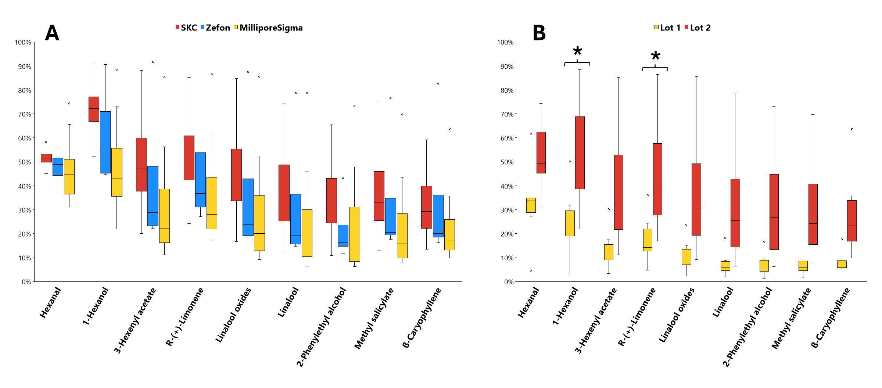
Figure S1. (A) Comparison of VOC recovery using pre-packed Porapak® Q tubes from three different vendors (N=4-10 replicates per vendor). No statistically significant differences were observed between vendors. (B) Comparison of VOC recovery using two different lots of Porapak® Q tubes from MilliporeSigma (N=4-6 replicates per lot). Significantly different recoveries are indicated with a *.
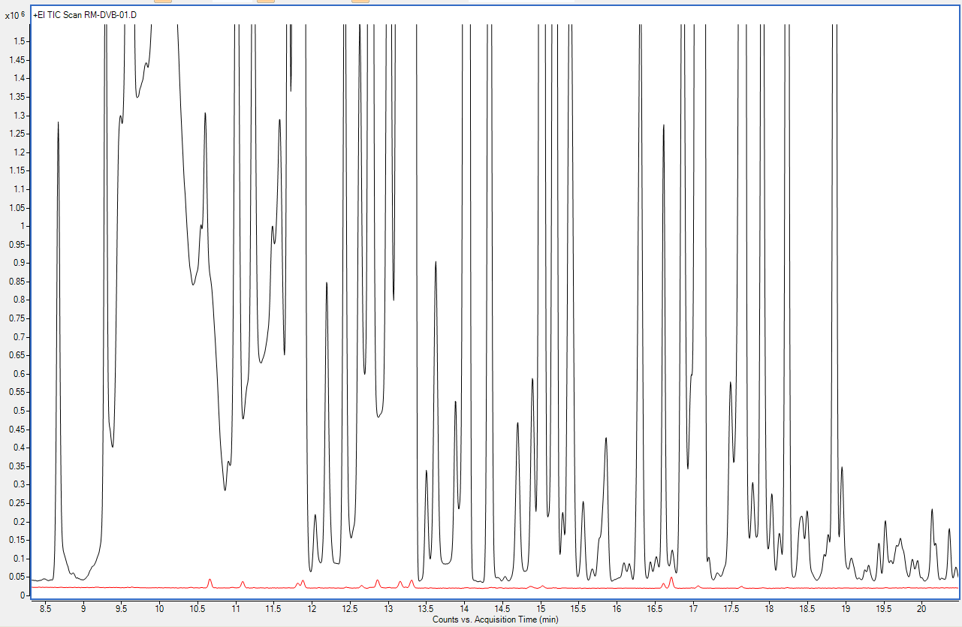

Figure S2. Comparison of sample chromatograms of rosemary VOCs collected using TF-SPME (black) and Porapak® P (red).

