Supplementary Information for:
Reverse globalization suppresses phosphorus trade and aggravates food insufficiency and greenhouse gas intensity

Taoyu Ren ^{a,b}, Qichao Zhu ^{a,b,*}, Xiaoxuan Fu ^{a,b}, Gerard H. Ros ^{c}, Wim de Vries ^{c}, Fusuo Zhang ^{a,b}
ª State Key Laboratory of Nutrient Use and Management, College of Resources and Environmental Sciences, Key Laboratory of Plant-Soil Interactions, Ministry of Education, China Agricultural University, Beijing, China
^{b} National Academy of Agriculture Green Development, China Agricultural University, Beijing, China
^{c} Earth Systems and Global Change, Wageningen University and Research, Wageningen, the Netherlands
* Corresponding author: Qichao Zhu, qichaozhu@126.com

Contents
- Scenario design and model description 2
- Supplementary Figures 6
  - Changes in the P trade and in the corresponding carbon emissions from transportation 6
  - Phosphorus flows through trade in 2021 and 2022 7
  - Phosphorus fertilizer use efficiency in 2021 and 2022 8
  - GHG emissions due to phosphorus transportation in 2021 and 2022 9
  - Global phosphorus fertilizer distribution scheme in S₂ 10
  - Global grain distribution scheme in S₃ 11
- Supplementary References 12

1. Scenario design and model description

Scenario design
To further evaluate the impact of reverse globalization on phosphorus flow and food security, and to explore sustainable phosphorus management and low-carbon trade transportation solutions. We developed four scenarios, representing potential future developments and rationalized situations that could impact food self-sufficiency and the environmental sustainability of phosphorus use in different countries:

S₀: Baseline scenario.
Given that the impact of reverse globalization on phosphorus trade was minimal in 2021, we use data from that year as the baseline scenario.

S₁: Trade suspension.
Given the current high disparity in phosphorus fertilizer use—where areas with high soil phosphorus reserves receive more fertilizer and can maintain crop yields even with short-term cessation of P fertilizer application. In contrast, areas with low soil phosphorus reserves generally apply minimal fertilizer, leading to depletion of soil phosphorus and low crop yields, thus having limited potential for yield reduction¹. We assumed that a short-term cessation of P fertilizer exports will not lead to significant changes in global crop yields. This scenario was based on 2021 crop production data and assesses the FPC and Grain_{ava} of different regions following trade disruptions. Although the interruption of phosphorus fertilizer exported will lead to changes in soil Olsen-P levels across regions, affecting crop phosphorus yield, this took time. Our analysis represented a snapshot in time where the impact on soil phosphorus reserves within one year was thought to be minimal. The same applied to the amount of manure applied and its effects on crop yields².

S₂: Fair and optimized phosphorus fertilizer trade.
The current unequal distribution and application of phosphorus fertilizers resulted in regional phosphorus over-pollution and deficiencies in soil P reserves, as well as intensified greenhouse gas emissions from trade transportation. In response, we recalibrated the P fertilizer demand for each region based on soil P levels and arable land area, adhering to the principle of equal distribution. We then calculated the optimized yields following phosphorus allocation and designed a linear programming model for a trade distribution plan that minimizes emissions. In this scenario, only phosphorus fertilizer trade is conducted, halting agricultural product trade, to explore the feasibility of achieving food self-sufficiency through optimized phosphorus fertilizer distribution.
S_{3:} Fair and optimized phosphorus fertilizer and grain trade.
Even after optimizing phosphorus fertilizer distribution, some regions, such as Singapore and Pakistan, cannot achieve self-sufficiency due to limited arable land and high population density. To achieve the SDG2 Zero Hunger goal, we proposed a more ambitious plan, S3. This involves the demand-based distribution of P fertilizer products and calculating the grain budget (Grain_{budget}, in t) for each region. Grains are then allocated to regions with deficits. To maintain the daily consumption of other agricultural products, it is assumed that the trade model for products, other than grain, remains in the S₀ state.

Model description
Assessment of the regional phosphorus fertilizer demand
Considering the sustainable supply of soil phosphorus reserves, we used data from McDowell et al³ to determine the soil Olsen phosphorus reserves in various regions. We set a soil Olsen phosphorus threshold of 30 mg kg⁻¹, which was sufficient to maintain optimal yields for most crops². In regions exceeding the threshold, we believed that phosphorus fertilizer allocation was unnecessary, as crops could fully meet their phosphorus needs from the soil, maintaining yields at 2021 levels. Studies indicated that in areas with high soil Olsen phosphorus content, reducing or omitting fertilizer application can sustain current yields⁴. This portion defined to region i. Conversely, in regions where the threshold was not met, we did not consider utilizing soil phosphorus for crop production, as these low-phosphorus areas should not further deplete soil phosphorus reserves. Instead, they required phosphorus fertilizers to meet crop needs, which we defined as region j. Furthermore, we assumed that global phosphorus fertilizer production (P_{fer, global}, in tones) remained constant at 2021 levels. We fairly allocated the phosphorus fertilizer demand for region j (P_{fer, demand}, in tones) based on equal application rates per unit of arable land, calculated as follows:
$P_{fer,demand}(i)=0$ (1)
$P_{fer,demand}(j)=Land(j)×\frac{P_{fer,global}}{\sum_{j=1}^{n}{Land\left(j\right)}}$ (2)
Here, land(j) (ha⁻¹) denoted the arable land area in region j for the year 2021. The data is sourced from FAO 2024⁵. It is important to note that, considering the dynamic changes in soil P reserves, this plan was applicable only for short-term agricultural production. Long-term adjustments to P fertilizer demand should have been made according to the annual variations in soil phosphorus reserves across regions, to better achieve sustainable and efficient use of phosphorus resources.

Assessment of the optimized crop P removal, human P and grain consumption
We further calculated the optimized crop P removal (Opt P_{crop}, in t) and P consumption from food (Opt FPC, in g P per capita) for region i and j. To achieve efficient use of phosphorus fertilizer, we employed Best Management Practices (BMPs). Examples include the use of slow-release fertilizers (Sharpley et al., 2015), soil conservation practices (Smith et al., 2018). We set PUE at 70%, which is the efficiency level of advanced agricultural countries, achievable through optimized management practices. We assumed that the change rate in Grain_{ava} (kg per capita) corresponds to the change rate in crop P removal, are calculated as follows:
${Opt P}_{crop}(i)=P_{2021crop}(i)$ (3)
${Opt P}_{crop}(j)=P_{fer,demand}(j)×70\%$ (4)
$Opt FPC={Opt P}_{crop}/POP*$1000000 (5)
$Opt {Grain}_{ava}={Grain}_{ava}*\frac{{Opt P}_{crop}}{P_{2021crop}}$ (6)
Here, P_{2021crop} represented the crop phosphorus removal for the region in 2021. POP represented the population of the region, data was obtained from the United Nations⁶, 1000000 was the unit conversion factor from tons to grams. The definition and calculation of Grain_{ava} could be found in the methods section.
${Grain}_{budget}=\left(Opt {Grain}_{ava}-400\right)*POP$ (7)
Here, 400 represents the per capita grain threshold in kg to ensure food security.

Phosphorus fertilizer trade transportation plan using Linear Programming
This study aims to optimize the global transportation of phosphorus fertilizers to minimize carbon emissions generated during transport. The main steps in model construction are as follows:
Objective Function: We define the GHG emission associated with transporting phosphorus fertilizers from producer region m to consumer region n as C_{m,n} (in tons of CO₂e per ton of P fertilizer). The calculation method can be found in the GHG calculations section of the methods, with a default preference for maritime transport. The objective function seeks to minimize GHG emissions and is expressed as:
$minimize GHG=\sum_{m=1,n=1}^{M,N}{C_{m,n}}×X_{m,n}$ (8)
where X_{m,n} represents the quantity of phosphorus fertilizer transported from producer region m to consumer region n (in tons).

To ensure the model's validity and feasibility, the following constraints are established:
- Production capacity constraints: The total amount transported from each producer region must not exceed its actual production capacity. For producer region m, with total production P_{m}, the constraint is given by:
$\sum_{n=1}^{N}{X_{m,n}≤P_{m} ∀m}$ (9)
The data for P_{m} is sourced from the IFA⁷.
- Demand satisfaction constraints: The demand for phosphorus fertilizer in each consumer region must be met. For consumer region j, with total demand P_{fer, demand}, the constraint is expressed as:
$\sum_{m=1}^{M}{X_{m,n}=P_{fer,demand} ∀n}$ (10)
- Non-negativity Constraints: All transport quantities X_{m,n} must be non-negative, so that:
$X_{m,n}≥0 ∀m,n$ (11)
By constructing the model and preparing the data as described, this study will employ linear programming methods to determine the optimal transportation plan, with the goal of minimizing carbon emissions (Fig S5).
The grain allocation plan is also designed using linear programming, following the method outlined in Scenario S₂. The results are shown in Figure S6. Notably, the phosphorus content of 400 kg of grains exceeds 438 g P per capita; therefore, the allocation scheme prioritizes grain distribution, disregarding phosphorus consumption.

2. Supplementary Figures

  - Changes in the P trade and in the corresponding carbon emissions from transportation.
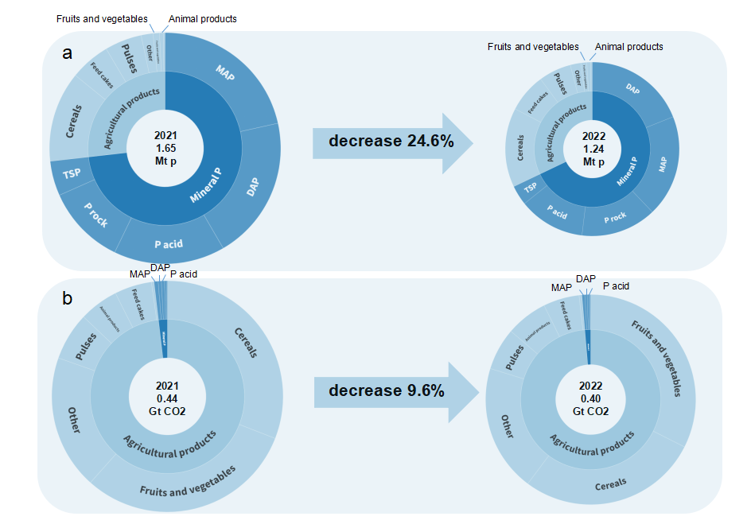
Figure S1. Changes of the mineral and agricultural phosphorus trade (a) and the corresponding carbon emissions from transportation (b) between 2021 and 2022. The size of the circle is determined by the annual trade flux, where the individual components start with the biggest contributor (clockwise).

  - Phosphorus flows through trade in 2021 and 2022

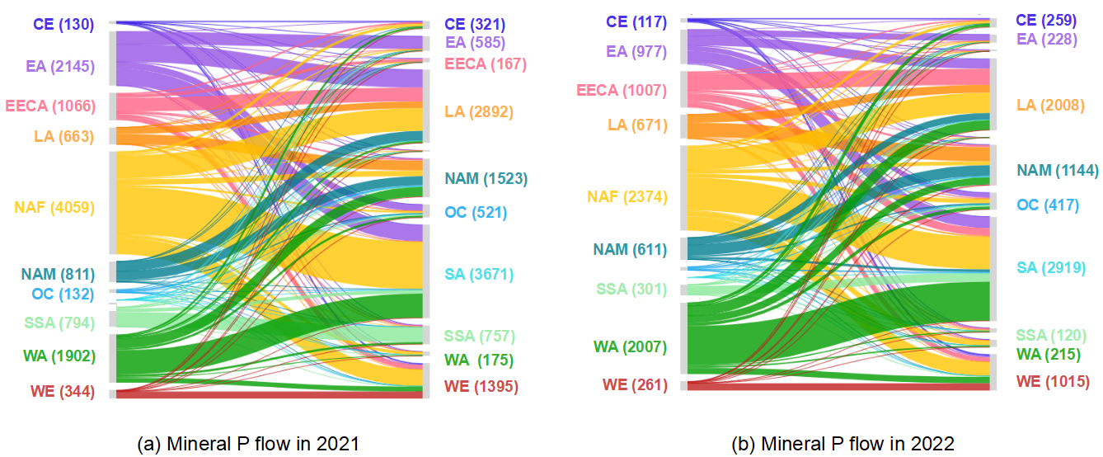
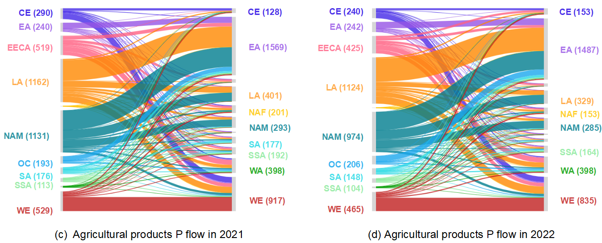
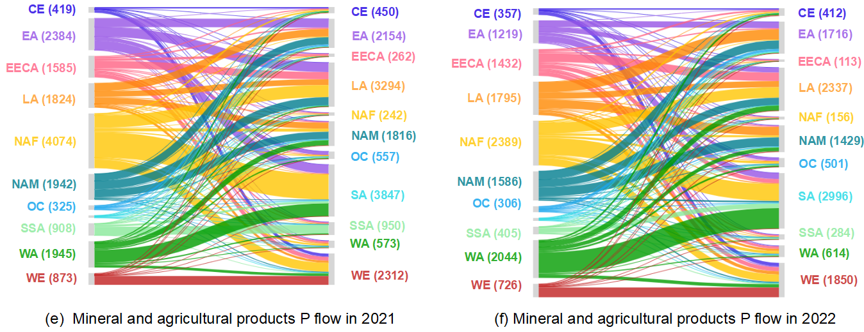
Figure S2. Phosphorus flows through trade of mineral (a, b), agricultural products (c, d) and sum of them (e, f) (in kt P yr⁻¹) among 11 global regions in 2021 (a, c, e) and 2022 (b, d, f). Numbers in the brackets are P trade flows in kilo ton, note that only the trade greater than 100 kt was labeled. CE: Central Europe, EA: East Asia, EECA: Eastern Europe and Central Asia, LA: Latin America, NAF: North Africa, NAM: North America, OC: Oceania, SA: South Asia: SSA: Sub-Saharan Africa, WA: West Asia, WE: West Europe.
  - Phosphorus fertilizer use efficiency in 2021 and 2022.

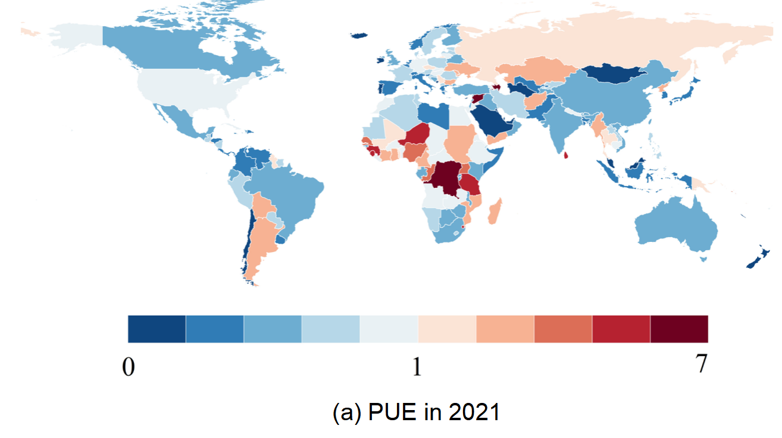
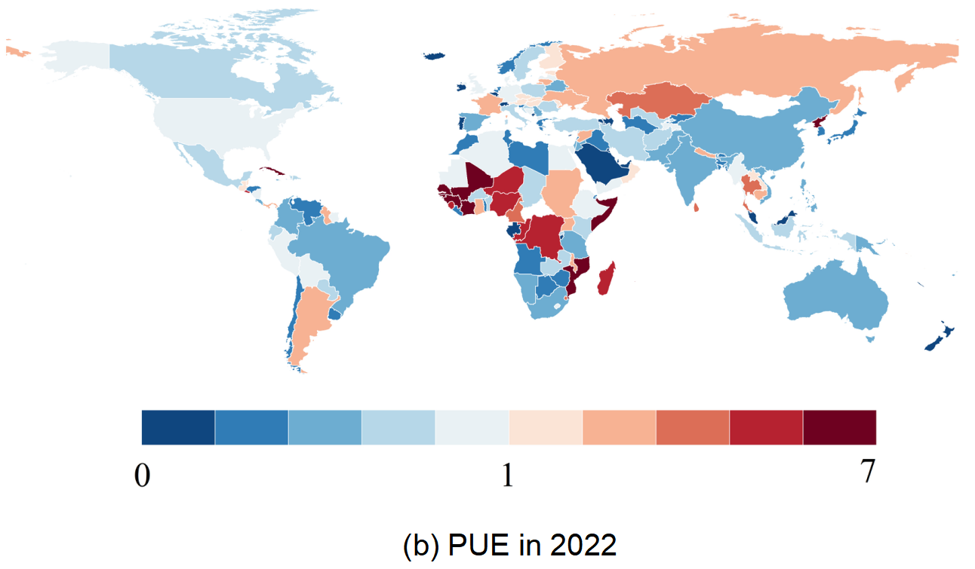

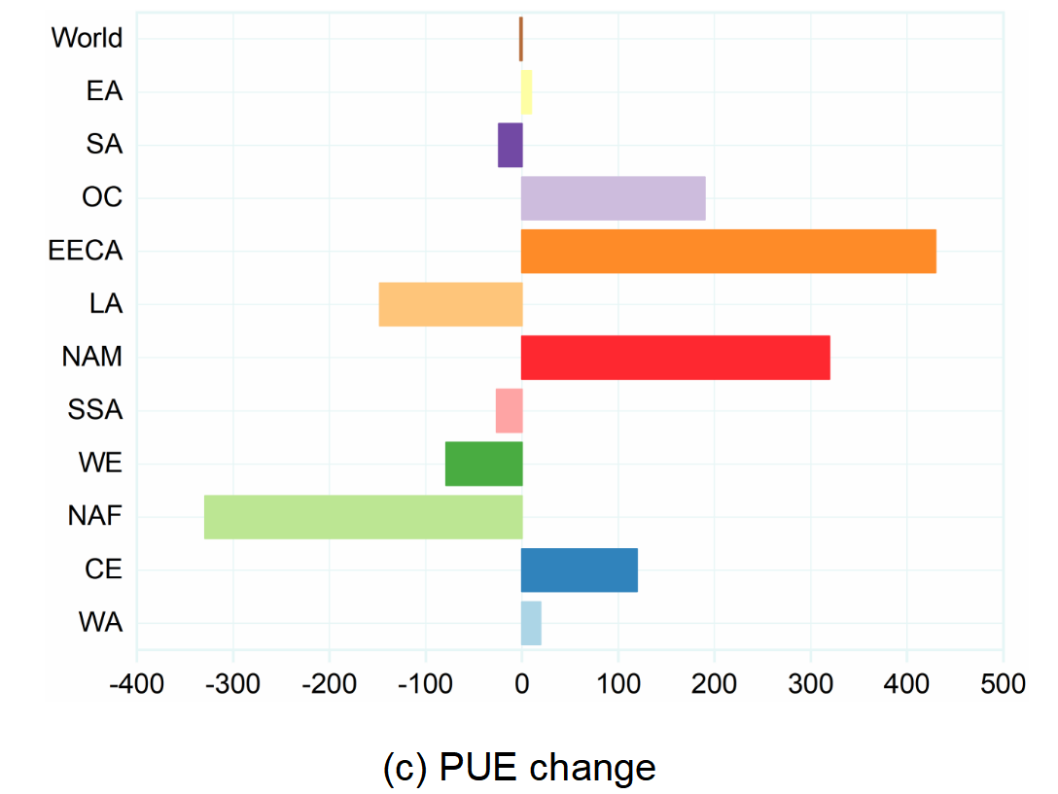
Figure S3. Phosphorus fertilizer use efficiency (PUE) in 2021 (a), 2022 (b) and changes therein (c) among 11 global regions. PUE is defined as the P in harvested crops divided by the P fertilizer application rate.
  - GHG emissions due to phosphorus transportation in 2021 and 2022

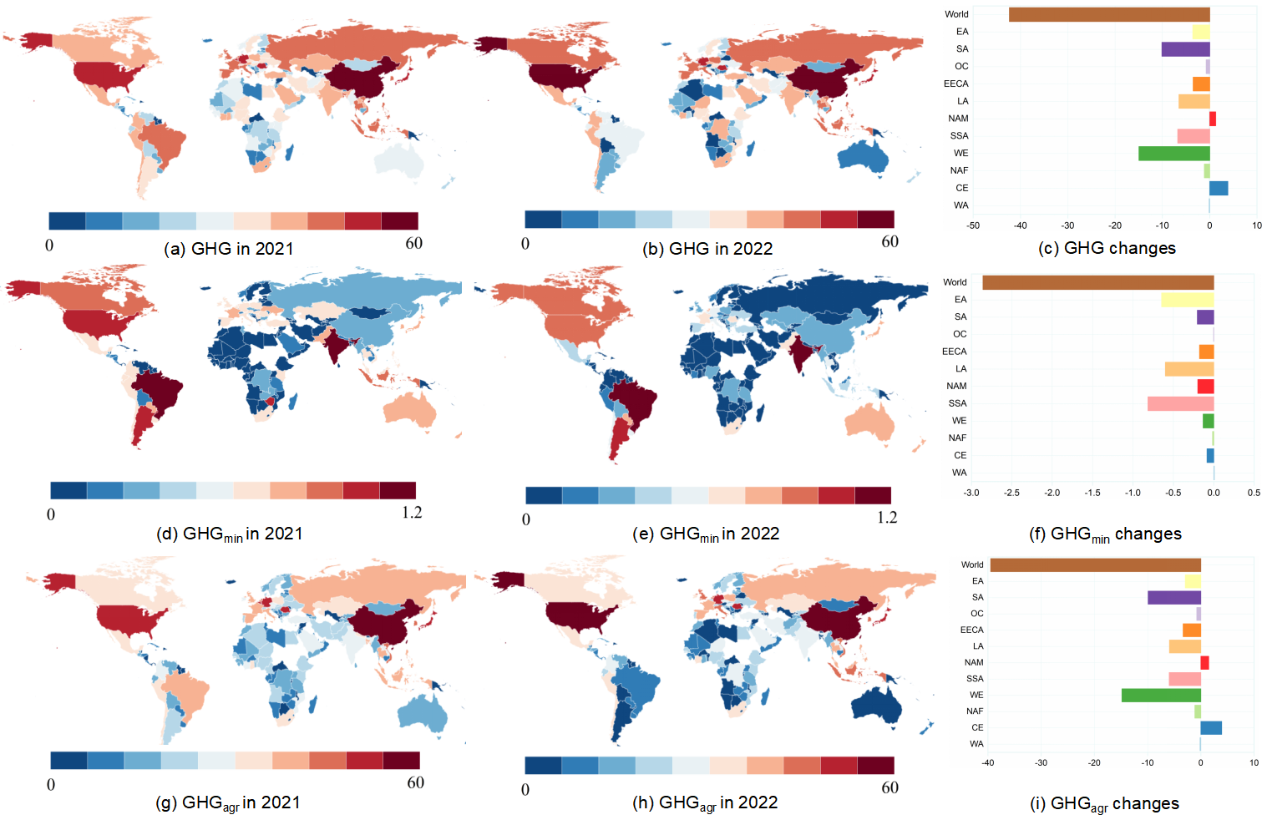
Figure S4. GHG emissions due to phosphorus transportation in 2021 and 2022 (in Mt CO₂ yr⁻¹) of total (a, b), mineral (d, e), and agricultural products (g, h) and the change therein from 2021 to 2022 (c, f, i) among 11 global regions.

  - Global phosphorus fertilizer distribution scheme in S₂

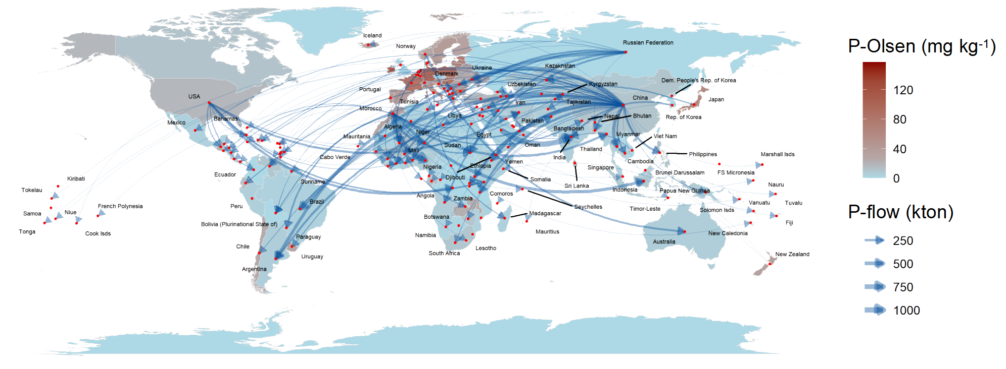
Figure S5. The global net phosphorus fertilizer distribution scheme. The thickness of the arrow represents the amount of phosphorus allocated (in kt P), while the background color of each region indicates the soil Olsen-P content (mg P kg⁻¹).
  - Global grain distribution scheme in S₃

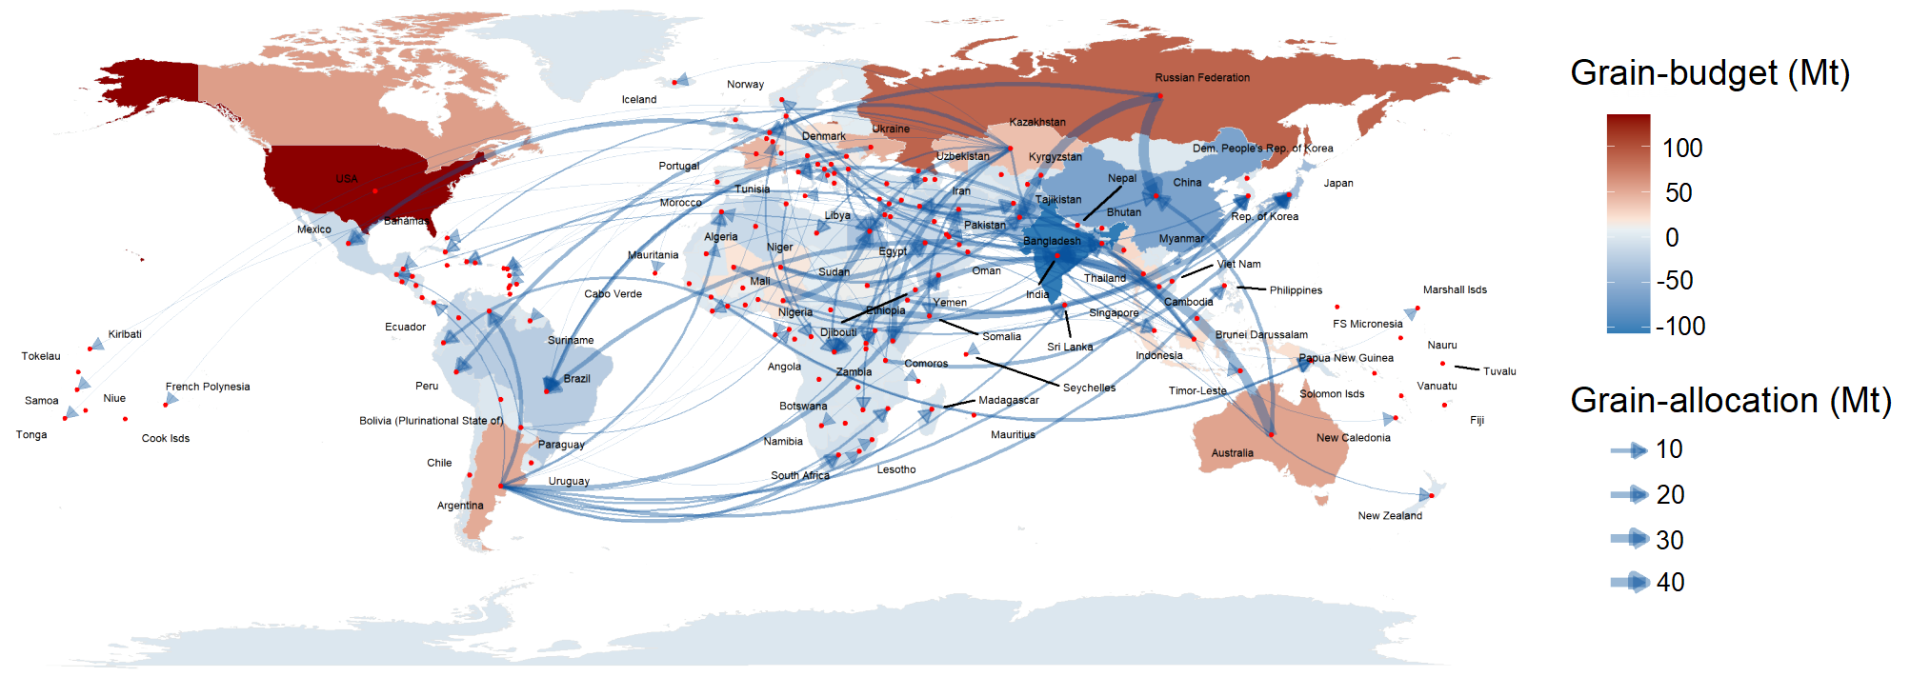
Figure S6. The global grain distribution scheme. The thickness of the arrows represents the amount of grain allocated (in Mt), while the background color of each region shows the Grain_{budget} (in Mt).

- Supplementary References
1. Langhans, C., Beusen, A. H. W., Mogollón, J. & Bouwman A. F. Phosphorus for Sustainable Development Goal target of doubling smallholder productivity. Nat. Sustain. 5, 57–63 (2021).
2. McDowell, R. W., Pletnyakov, P. & Haygarth, P. M. Phosphorus applications adjusted to optimal crop yields can help sustain global phosphorus reserves. Nat. Food 5, 332–339 (2024)
3. McDowell, R. W., Noble, A., Pletnyakov, P. & Haygarth, P. M. A Global Database of Soil Plant Available Phosphorus. Sci. Data 10, 125 (2023).
4. Le Noe, J. et al. The phosphorus legacy offers opportunities for agro-ecological transition. Environ. Res. Lett. 15, 064022 (2020).
5. FAOSTAT Statistics Database, 2024.
6. United Nations, Department of Economic and Social Affairs, Population Division (2022). Probabilistic Population Projections based on the World Population Prospects 2022: http://population.un.org/wpp/
7. IFA Statistics Database, 2024.

