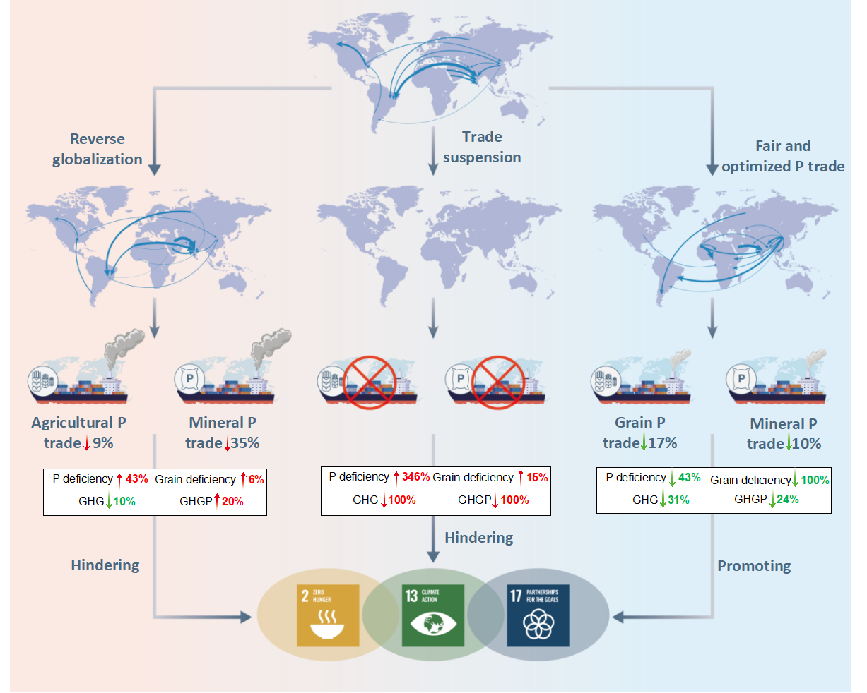
Extended Data Fig. 1. Impact of global P trade on sustainable development through food security, GHG emission and global partnership under different globalization scenarios.

