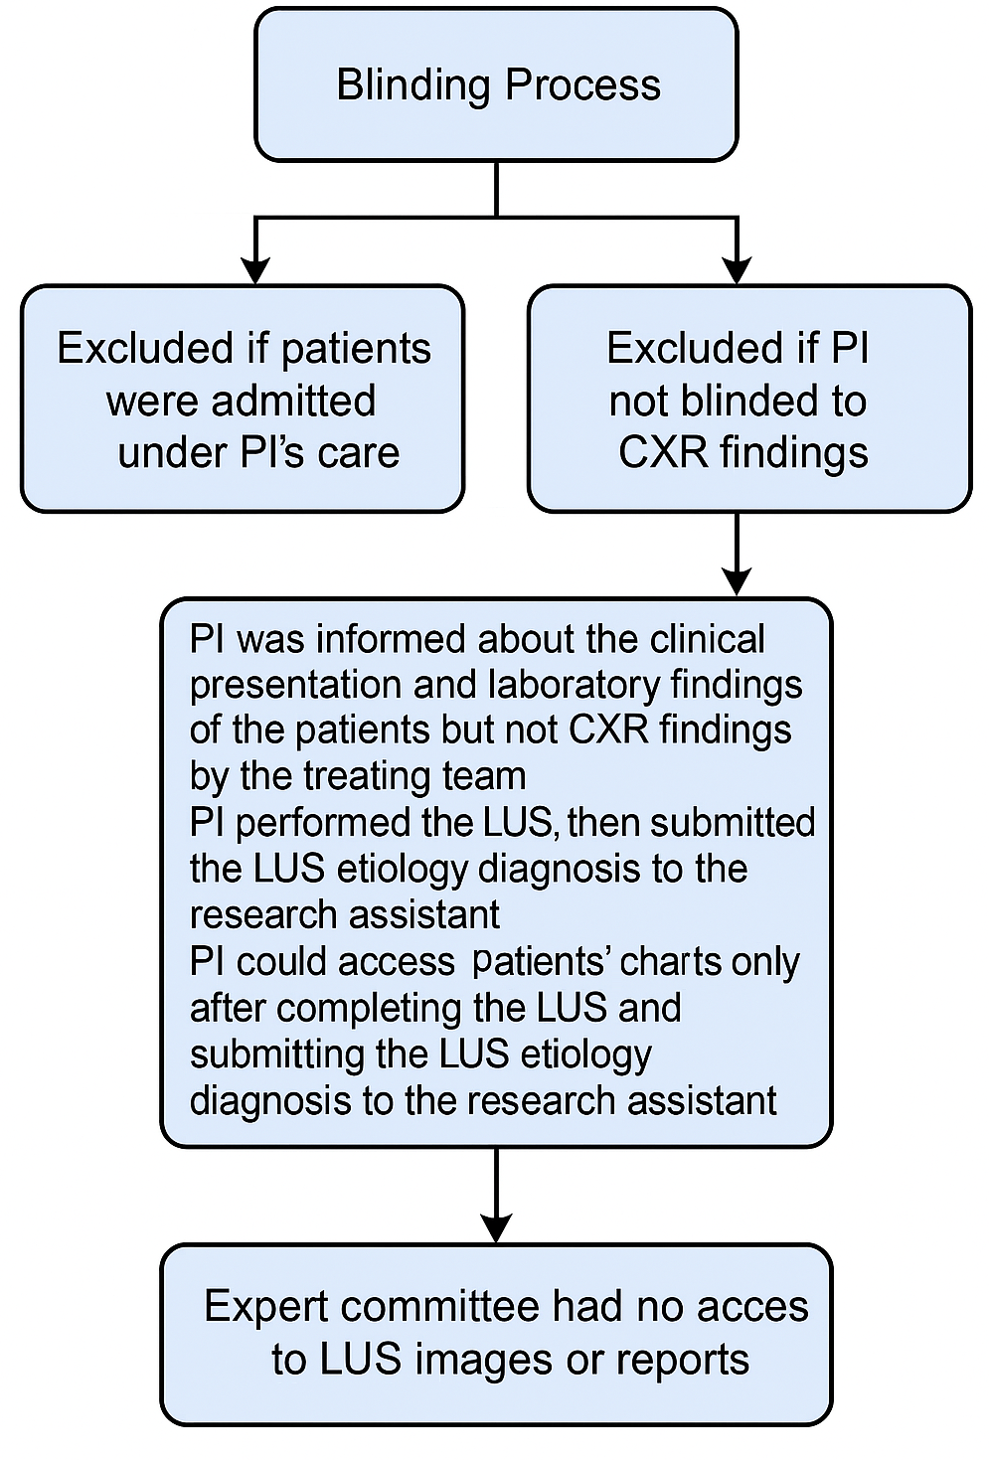
Supplementary Figure S1: Blinding process
PI: principal investigator; CXR: chest x-ray; LUS: lung ultrasound

Marker | Bacterial Infection  Median (IQR) | Viral Infection  Median (IQR) | Asthma  Median (IQR)
CRP (mg/L) | 84.9 (23.5 – 153.1) | 17.1 (3.6 – 75.6) | 13.0 (3.1 – 16.4)
WBC (×10⁹/L) | 13.8 (6.2 – 20.7) | 11.6 (8.6 – 18.0) | 13.4 (10.0 – 14.1)
ANC (×10⁹/L) | 10.3 (3.8 – 17.2) | 5.5 (2.9 – 9.6) | 10.3 (8.1 – 12.6)
NLR | 3.0 (1.6 – 8.8) | 1.1 (0.5 – 2.3) | 9.4 (3.5 – 25.1)
Abbreviations:
CRP = C-reactive protein; WBC = White blood cell count; ANC = Absolute neutrophil count; NLR = Neutrophil-to-lymphocyte ratio; IQR = Interquartile range.
Supplementary Table S2: Laboratory Findings by Final Diagnosis

A | LUS Diagnosis vs Final Diagnosis age < 2 years (n=32)
 | Total Accuracy (95% CI)  n positive = 32  n negative = 0 | Bacterial (95% CI)  n positive = 3  n negative = 29 | Viral (95% CI)  n positive = 28  n negative = 4
Sensitivity | 90.6% (80.5, 100.0) | 66.7% (13.0-100.0) | 92.9% (83.0, 100.0)
Specificity | NA* | 93.1% (83.9, 100.0) | 75% (33,0, 99.9)
Overall agreement | 90.6% (80.5, 100.0) | 90.6% (80.5, 100.0) | 90.6% (80.5, 100.0)

* There were no negative cases to measure specificity
B | LUS Diagnosis vs Final Diagnosis Age ≥ 2 years (n=33)
 | Total Accuracy (95% CI)  n positive = 30  n negative = 3 | Bacterial (95% CI)  n positive = 9  n negative = 24 | Viral (95% CI)  n positive = 15  n negative = 18
Sensitivity | 93.3 (78.7, 100,0) | 100%(71.7, 100.0) | 86.7% (69.0, 100.0)
Specificity | 100 (36.8, 100) | 91.7% (80.6, 100.0) | 100% (84.7, 100.0)
Overall agreement | 93.9% (85.0, 100.0) | 93.9% (85.0, 100.0) | 93.9% (85.0, 100.0)

Supplementary Table S3: Subgroup analysis. (A) age < 2 years. (B) age ≥2 years
LUS: lung ultrasound; CI: confidence interval

