Supplementary information: Stranded assets in EU+UK agriculture during food system transformations

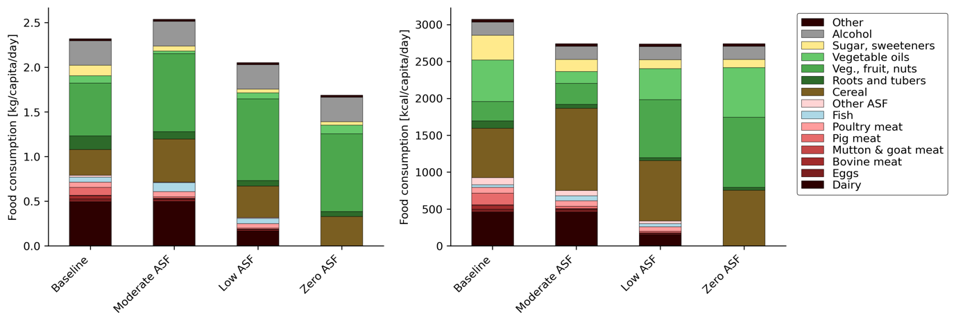
Fig. 1. EU27+UK food intake and dietary changes, excluding food waste (left: mass, right: energy).

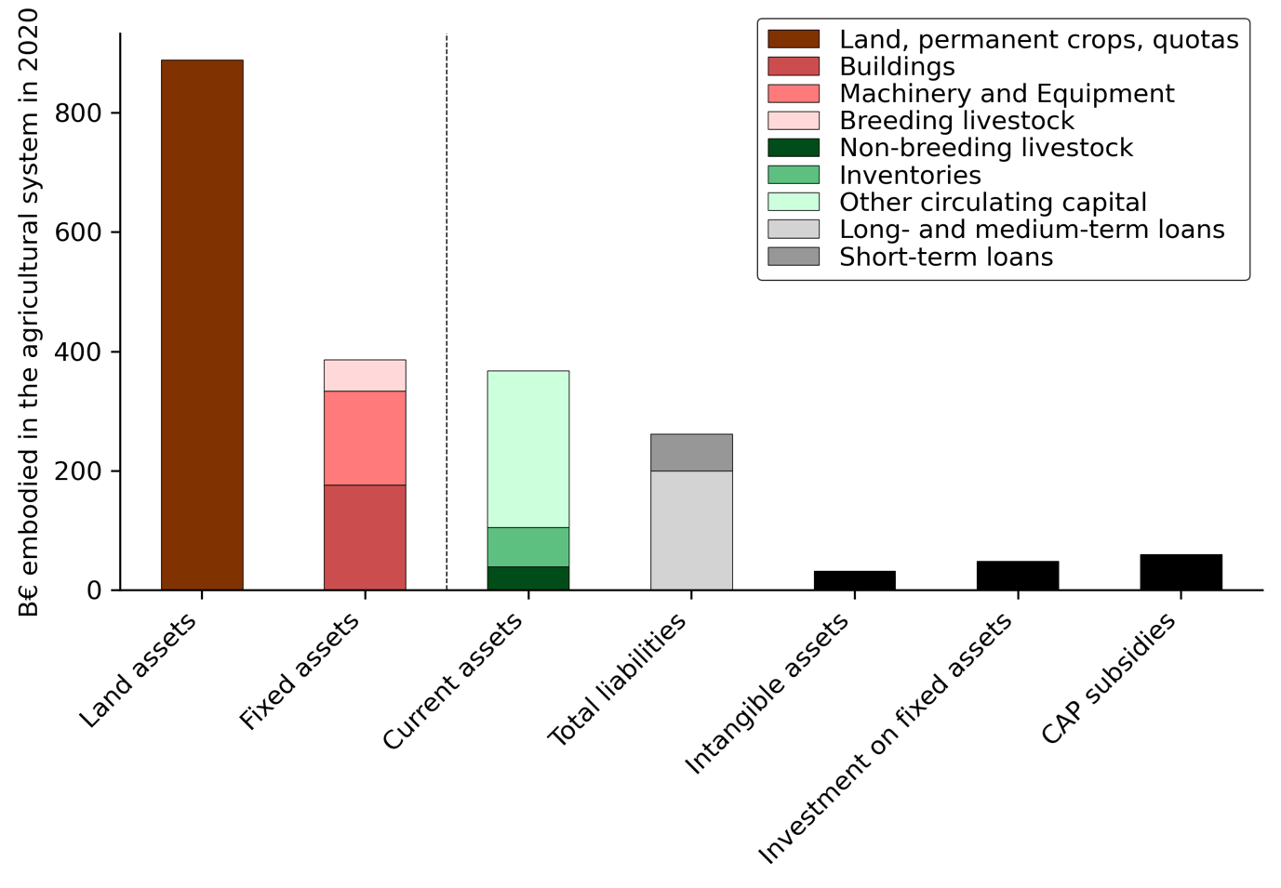
Fig. 2. Overview of asset types embodied in the agricultural system. The land asset includes the value of land, permanent crops and quotas. Fixed assets are divided into buildings, machinery & equipment, and breeding-livestock. Besides fixed-assets, there are current assets, which are faster circulating assets and include breeding livestock, inventories (stocks of products owned by the farm, either used as inputs or available for sale, whether produced or purchased), and other current assets (cash, receivables from business activities, and assets easily sold or payable within a year). Total liabilities are the debt of farm and include short-term and long- and medium-term loans. Intangible assets are either tradable (quotas, rights) or non-tradable (software, licences). CAP subsidies include the entire CAP budget for the EU27+UK.

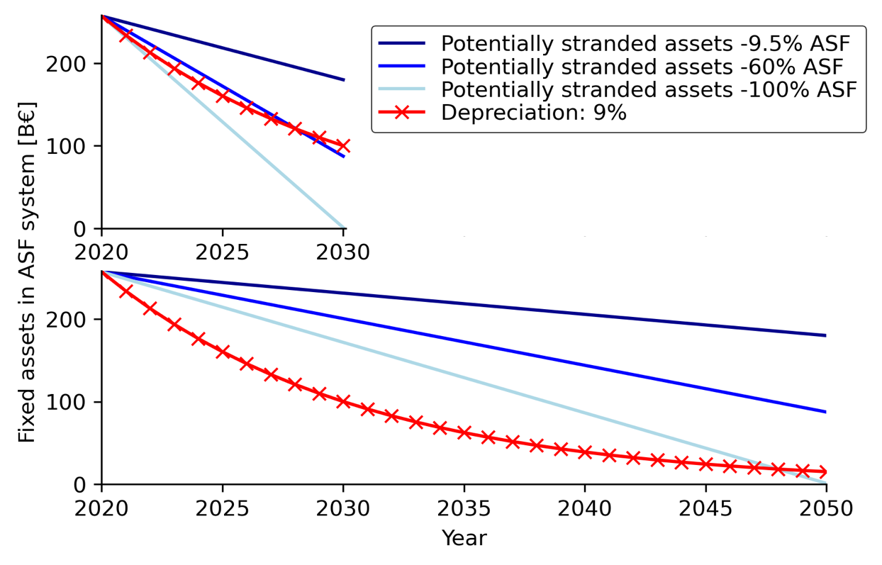
Fig. 3. Linear transition to ASF reductions and depreciation of fixed assets over a timespan of 10 years (upper plot) and 30 years (lower plot).

Fig 4. Methods schematics of the dietary scenario construction, the FADN data reorganization and its integration with FABIO to analyse the socio-economic impact of food consumption.
Table 1. Overview of FADN data
Category: | Subcategory: | Description: | Collected as:
Land asset | Land | Agricultural land, permanent crops, improvements to land, quotas and other prescribed rights (including acquisition costs) and forest land  Agricultural land owned by the holding including land improvements (e.g., fencing, drainage, fixed irrigation equipment) belonging to the holder.  Forest land included stranding timber in owner occupation included in the agricultural holding | “biological assets – plants” + “agricultural land” + “ land improvements” + “forest land including stranded timber” + “intangible assets, tradable”
Fixed assets | Buildings | Farm buildings belonging to the holder whatever the type of occupancy of the land
Fixed assets | Machinery and equipment | Machinery and equipment including tractors, motor cultivators, lorries, vans, cars, major and minor farming equipment.
Fixed assets | Breeding livestock | Breeding livestock including breeding heifers, dairy cows, buffalo dairy cows, non-dairy cows, breeding female sheep, breeding female goats, breeding sows
Depreciation |  | Depreciation of capital assets. Concerns plantations of permanent crops (biological assets, estimated), farm buildings and fixed equipment, land improvements, machinery and equipment and forest plantations. There is no depreciation of land and circulating capital (= short-term assets that can be easily converted to cash within the accounting year). There is depreciation of non-tradable intangible assets. | Recorded in the table as “depreciation of the current year”  Accumulated depreciation is used to valuate assets at closing valuation

