Supplementary Information for

Does addiction skip a generation? Patterns of intergenerational transmission of substance abuse

Olly Kravchenko¹, Lauren Bishop^{2,3}, Ylva B Almquist⁴

¹Centre for Psychiatry Research, Department of Clinical Neuroscience, Karolinska Institutet, Stockholm, Sweden
²Helsinki Institute for Demography and Population Health, Faculty of Social Sciences, University of Helsinki, 00014 Helsinki, Finland
³Max Planck-University of Helsinki Center for Social Inequalities in Population Health, 00014 Helsinki, Finland
⁴Department of Public Health Sciences, Stockholm University, 10691 Stockholm, Sweden

TABLE OF CONTENTS

Variable description and preprocessing 2
S1 Table. List of variables used for the data analysis 6
S2 Table. List of variables used for the data analysis 8
Fig. S1. Frequencies of various SA transmission patterns from G0 to G2 10

Variable description and preprocessing

Data sources differed across the three generations: for G0, only data from the SMS were available; for G1, both SMS and RELINK 53 data; and for G2, only RELINK53 data. Efforts were made to harmonize the measurements and to use as similar data as possible to make the generations comparable. Since G1 is the index generation and the data on the other two generations were collected through linkages with G1, the most data are available for G1 (both through the SMS which makes them comparable to G0 and through RELINK53 which makes them comparable to G2). G1 SA/psychopathology is therefore disproportionately inflated compared to the other two generations. Since RELINK53 contains richer and more reliable register-based data, which are only available for G1 and G2, we decided to only include RELINK53 data for these two generations, and only use the SMS data for G0. Therefore, all the variables available through the SMS were excluded for G1 (i.e., data on the reasons for Child Welfare Committee intervention collected from the Social Register, individual crime and sentencing data from the National Police Register, and Injection Mark Study data). Another reason for choosing to limit data sources in this way is that adding social register variables for G1 may have introduced additional bias: being part of the social welfare system means that the respective variables between G0 and G1 would be highly correlated and may have resulted in inflated associations.

G0 variables
Variables related to G0 SA were obtained from Dependency and Child Welfare Committee data, which were compiled in the Social Register. These data were collected for G1 in relation to their parents and coded in accordance with a detailed manual.

All records were originally divided into three time periods (1953-1959, 1960-1965 and 1966-1972). An incident in any one of the periods was sufficient to be coded as case. All questions were subdivided for father and mother separately.

G0 SA components:
- Incidents of drunkenness of cohort member´s parents (questions pertaining to drunkenness and drink driving incidents)
- Parents´ abuse of alcohol
- Drunk driving (available only for fathers as part of the Criminality of father data material derived from the police registers)

G0 SES was assessed as a possible confounder and is operationalized as “Social class based on father’s occupation in 1953” as reported in the Occupational Register for G0 (the father of the G1 cohort member) and is divided into:

- Upper and upper middle class
- Lower middle class, officials and non-agricultural employees
- Lower middle class, entrepreneurs
- Working class, skilled workers
- Working class, unskilled workers

There are also two separate types of non-response in relation to G0 SES. According to the SMS codebook, the difference between the two types is unknown. Additionally, it is emphasized that there is no clear rank order between the two lower middle classes. Thus, the variable was recoded to merge Lower middle class, officials and non-agricultural employees with Lower middle class, entrepreneurs into one category and the two types of non-response into a category called Missing. The resulting variable thus has four ordered categories (SES classes) and one category indicating missingness.

G1 and G2 variables
For both G1 and G2, data are derived from the National Patient Register, the Cause of Death Register, the Swedish Prescribed Drug Register, and the National Crime Register.

G1 & G2 SA components:
- SA-related hospitalizations (mental disorder diagnoses pertaining to psychoactive substances (ICD-9 codes 303-305, ICD-10 codes F10–F19), injury and poisoning caused by alcohol (ICD-9 codes 800-999), and external cause of injury (e-code) from medical registers related to accidental poisoning by psychoactive substances (E850-E877))
- Causes of death (alcohol- and drug-related diagnoses)
- Medication (medication used in the treatment of alcohol dependence, e.g., naltrexone (ATC codes N07BB) and medication used in the treatment of opioid dependence, e.g., methadone and buprenorphine (ATC codes N07BC))
- Crime data (drunk driving and narcotics crimes)

One caveat regarding drug-related offenses is that all psychoactive drug use is illegal in Sweden; therefore, personal use/possession are not distinguished from intent to supply (drug dealing) and both fall under the narcotics crime category. While such a limitation may result in including people without SA into the analytic sample, this risk is low given that the link between drug use and distribution is very robust, with nonusers very rarely engaging in selling illicit drugs.

G1 Psychopathology components:
- Psychopathology-related hospitalizations (mental disorder diagnoses (ICD-9 codes 290-302 & 306-315) and external cause of injury (e-code) from medical registers related to suicide, suicidal attempt or other self-inflicted damage (E950-E959))
- Causes of death (mental disorders)

The following psychopathology variables that comprise age-related diagnoses were excluded from the analysis as they are very unbalanced between the generations given different age spans: F00-F09 (dementia), F80-F89 (developmental disorders), and F90-F98 (disorders with typical onset during childhood and adolescence).

S1 Table. List of variables used for the data analysis
Generation | Data source | Variable type | Variable name
G0 | Social Register | SA | Incidents of drunkenness of cohort member´s parents, 1953-1959
 | Social Register | SA | Incidents of drunkenness of cohort member´s parents, 1960-1965
 | Social Register | SA | Incidents of drunkenness of cohort member´s parents, 1966-1972
 | Social Register | SA | Parents´ abuse of alcohol, 1953-1959
 | Social Register | SA | Parents´ abuse of alcohol, 1960-1965
 | Social Register | SA | Parents´ abuse of alcohol, 1966-1972
 | Criminality of father | SA | Drunk driving / dangerous driving, before 1953
 | Criminality of father | SA | Drunk driving / dangerous driving, 1953-1959
 | Criminality of father | SA | Drunk driving / dangerous driving, 1959-1972
 | Occupational Register | SES | Social class based on father’s occupation in 1953
G1 & G2 | Patient Register | SA | Alcohol-related diagnosis*, 1973-2019
 | Patient Register | SA | Drug-related diagnosis**, 1973-2019
 | Prescribed Drug Register | SA | Alcohol-related prescription medication (ATC code N07BB), 2004-2019
 | Prescribed Drug Register | SA | Drug-related prescription medication (ATC code N07BC), 2004-2019
 | Cause of Death Register | SA | Alcohol-related diagnosis*, 1973-2019
 | Cause of Death Register | SA | Drug-related diagnosis**, 1973-2019
 | Patient Register | Psych | Psychopathology-related diagnosis***, 1973-2019
 | Cause of Death Register | Psych | Psychopathology-related diagnosis***, 1973-2019
 | Crime Register | SA | Drunk driving penalty codes (19510649, 004, 004A), 1973-2017
 | Crime Register | SA | Narcotics crime penalty codes (19680064, 20001225, 006), 1973-2017

Continues on the next page

*Alcohol-related diagnostic codes included in SA variables:
ICD-8: 291, 303, 979, 980, 5710, 5711, 5712
ICD-9: 291, 303, 3050, 3575, 4255, 5353, 5710, 5711, 5712, 5713, 5714, 980
ICD-10: F10, K70, T51, E244, G312, G621, G721, I426, K292, K852, K860, 0354, R780, Z502, Z714, Z721, X45, Y15, X65, Y90, Y91
E-code: 980,9, 980X

**Drug-related diagnostic codes included in SA variables:
ICD-8: 304, 853, 854, 950, 965, 967, 970, 971, 977, 980, 994, 2943
ICD-9: 292, 304, 305X, 8500, 8541, 8542, 8552, 8508, 8588, 9500, 9504, 9800, 9804, 9650, 9685, 9696, 9697
ICD-10: F11, F12, F13, F14, F15, F16, F18, F19, 0355, P044, Z503, Z715, Z722, X41, X42, X44, X61, X62, X64, Y11, Y12, Y14, T400, T401, T402, T403, T405, T406, T407, T408, T409, T436

***Psychopathology-related diagnostic codes included in SA variables:
ICD-8: 290, 292, 293, 29400, 29410, 29420, 29440, 29480, 29499, 295, 296, 297, 298, 299, 300, 301, 302, 305, 306, 307, 308, 309, 31
ICD-9: 290, 293, 294, 295, 296, 297, 298, 299, 300, 301, 302, 306, 307, 308, 309, 31
ICD-10: F0, F2, F3, F4, F5, F6, F7, F8, F9, X6, X7, X80, X81, X82, X83, X84
E-code: 95
S2 Table. Descriptive statistics for the total sample and stratified by generation.

 | Generations (n=29,115)
 | G0 (n=11,338) | % | G1 (n=11,338) | % | G2 (n=24,929) | %
Dead |  |  | 1697 |  | 481
Sex |  |  | Male 5,540  Female 5,798 |  | Male 12,848  Female 12,081
Birth year | 1896-1942 |  | 1953 |  | 1968-2016  (mean 1983,  sd 6.38)
Substance abuse |  |  | 1,447 | 9.91 | 2,550 | 10.23
Medication prescription |  |  | 616 | 4.22 | 434 | 1.74
Alcohol medication prescription |  |  | 562 | 3.85 | 383 | 1.54
Narcotics medication prescription |  |  | 64 | 0.44 | 57 | 0.23
Alcohol-attributable mortality |  |  | 214 | 1.46 | 21 | 0.08
Narcotics-attributable mortality |  |  | 104 | 0.71 | 36 | 0.14
Alcohol or narcotics hospitalization |  |  | 1,231 | 8.43 | 1,317 | 5.28
Alcohol hospitalization |  |  | 955 | 6.54 | 943 | 3.78
Narcotics hospitalization |  |  | 565 | 3.87 | 593 | 2.38
Driving under the influence of alcohol or other drugs |  |  | 608 | 4.16 | 740 | 2.97
Narcotics crime |  |  | 389 | 2.66 | 1,106 | 4.44
Psychopathology |  |  | 899 | 6.15 | 1,256 | 5.04
Psychopathology-attributable mortality |  |  | 118 | 0.81 | 67 | 0.27
Psychopathology hospitalization |  |  | 1,479 | 10.12 | 1,727 | 6.93
F20-F29 (schizophrenia) |  |  | 267 | 1.83 | 186 | 0.75
F30-F39 (mood disorders) |  |  | 592 | 4.05 | 660 | 2.65
F40-F49 (neurotic disorders) |  |  | 654 | 4.48 | 654 | 2.62
F50-F59 (eating disorders) |  |  | 108 | 0.74 | 146 | 0.59
F60-F69 (personality disorders) |  |  | 200 | 1.37 | 193 | 0.77
F99-F99 (unspecified disorders) |  |  | 81 | 0.55 | 36 | 0.14
External causes hospitalization |  |  | 449 | 3.07 | 496 | 1.99
Substance abuse | 2,154 | 7.40
Incidents of drunkenness | 355 | 2.43
Abuse of alcohol | 477 | 3.27
Drunk driving / dangerous driving | 458 | 3.14
Psychopathology | 716 | 4.90
Father / mother showing symptoms of mental illness or psychiatric problems
Father | 316 | 2.16
Mother | 477 | 3.27
Both | 77 | 0.53
SES
- Upper and upper middle class | 1,977 | 13.53
- Lower middle class, officials, non-agricultural employees and entrepreneurs | 5,385 | 36.86
- Working class, skilled workers | 4,018 | 27.51
- Working class, unskilled workers | 2,711 | 18.56
Missing (non-response) | 517 | 3.54
*Discrepancies between total numbers stem from some cohort members belonging to more than one subgroup

Fig. S1. Frequencies of various SA transmission patterns from G0 to G2.

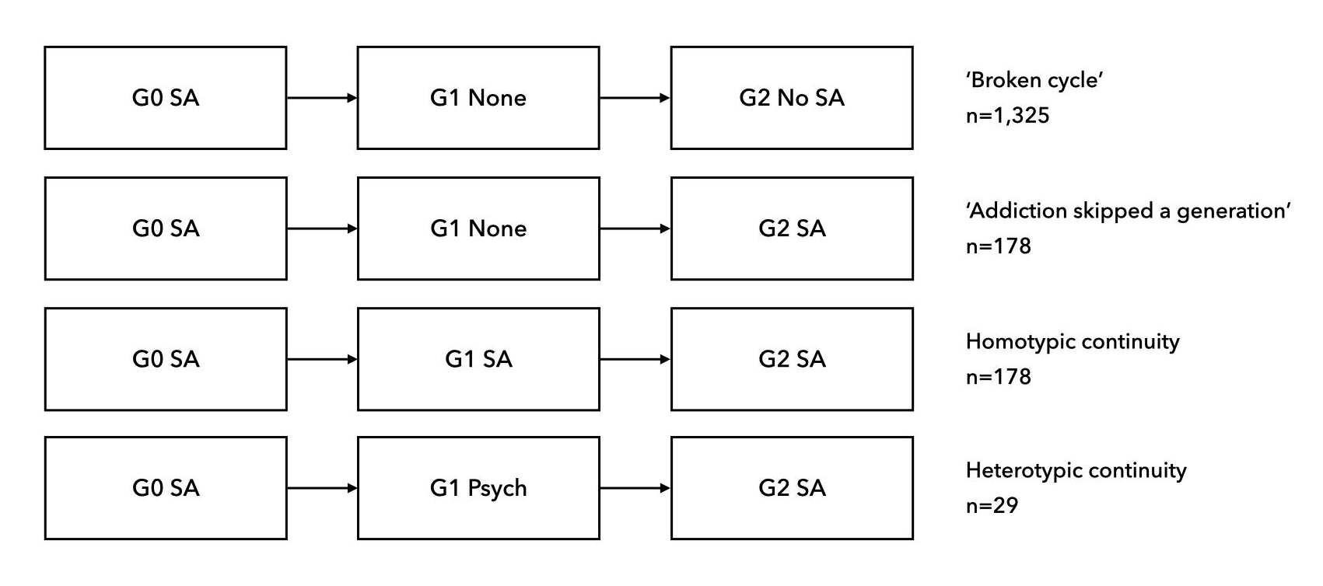

G0, Generation 0 (grandparents); G1, Generation 1 (parents); G2, Generation 2 (grandchildren); SA, substance abuse; None, No substance abuse & No Psychopathology; Psych, psychopathology

The Swedish Institute for Social Research. (2007). The Stockholm Metropolitan Study (SMS). Project Metropolitan - Codebook II. Retrieved May 12, 2023, from https://www.su.se/polopoly_fs/1.615369.1654199294!/menu/standard/file/Codebook_II.pdf
Johnson BD. Patterns of drug distribution: implications and issues. Subst Use Misuse 2003; 38(11-13): 1789-1806. https://doi.org/10.1081/ja-120024241

