Supplementary information for
Mechanics of plant epidermal cell wall: Effect of anisotropic alignment of cellulose microfibrils in the junction region

Jongcheol Lee¹, Jessica Sohyun Kim¹, Jingyi Yu², Jihyeong Ryu¹, Juseok Choi¹, Daniel J. Cosgrove², Hojae Yi^{3,*}, and Seong H. Kim^{1,*}

¹Department of Chemical Engineering and Materials Research Institute, Pennsylvania State University, University Park, Pennsylvania 16802, USA;
²Department of Biology, Pennsylvania State University, University Park, Pennsylvania 16802, USA;
³Department of Agricultural and Biological Engineering, Pennsylvania State University, University Park, Pennsylvania 16802, USA;
*corresponding authors; Email: huy1@psu.edu, shk10@psu.edu

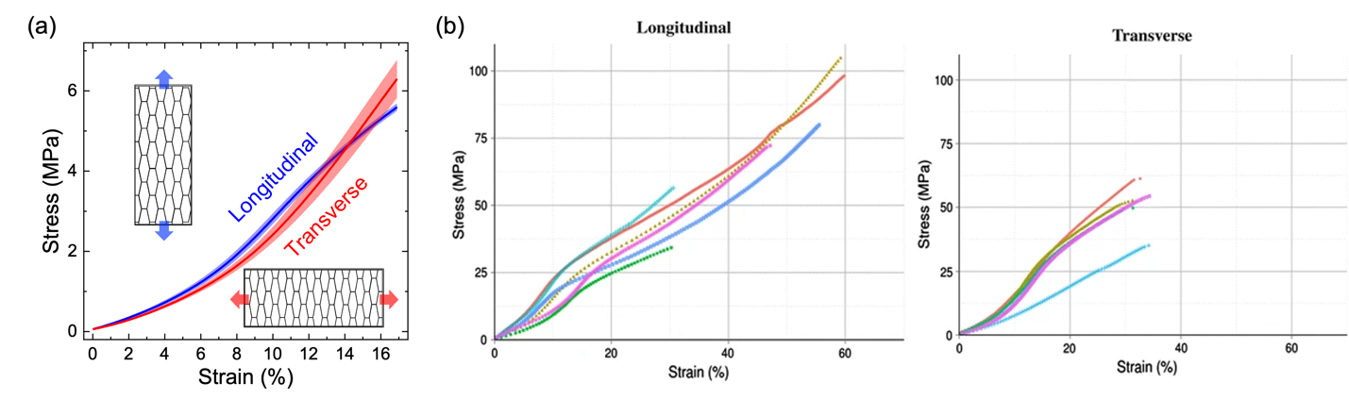
Fig. S1 Anisotropic stress-strain responses of the abaxial epidermis of onion fifth scale in uniaxial tensile tests. In both a and b, the tensile stretch directions were the same as the direction of peeling during the sample preparation. In b, different colors indicate different samples (n=5). The a was adapted with permission from (Lee et al. 2023). Copyright 2023 American Chemical Society. b was reprinted from (Zamil et al. 2017), with permission from Springer Nature.

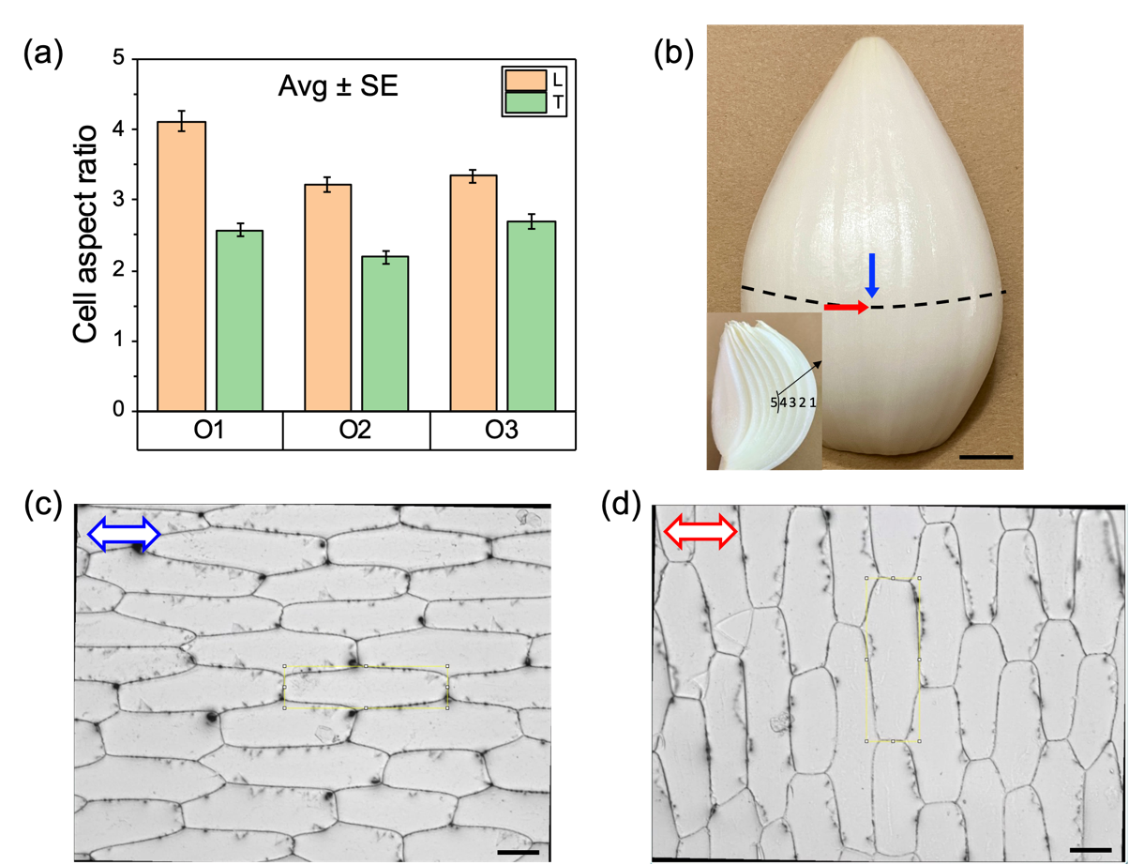
Fig. S2 a Cell aspect ratios of onion epidermis peeled in the longitudinal (L) and transverse (T) directions. The number of pairs of peels are 5, 5 and 7 for onion 1, 2 and 3 (O1, O2, and O3), and 10 cells near the center of each image were analyzed. Thus, the total number of cells analyzed are 50, 50, and 70, respectively. The p values for each onion were calculated to be 1.9 × 10⁻¹², 1.7 × 10⁻¹⁰, and 1.9 × 10⁻⁵, respectively. The overall cell aspect ratio was measured to be 3.5 ± 0.9 and 2.5 ± 0.8 for longitudinally and transversely peeled epidermis, respectively (Mean ± SD, n=170, p=1.0 × 10⁻⁵). b Picture of fifth scale onion. The longitudinal and transverse peeling directions were marked with blue and red arrows, respectively. The inset shows numbered onion scales. Scale bar = 1 cm. c,d Optical micrographs of the fifth scale onion abaxial epidermis, peeled in the longitudinal (c) and transverse (d) directions. The yellow boxes surrounding cells are examples of the rectangular ROI (Region of Interest) used to measure the aspect ratio in ImageJ. The scale bars = 100 𝜇m.

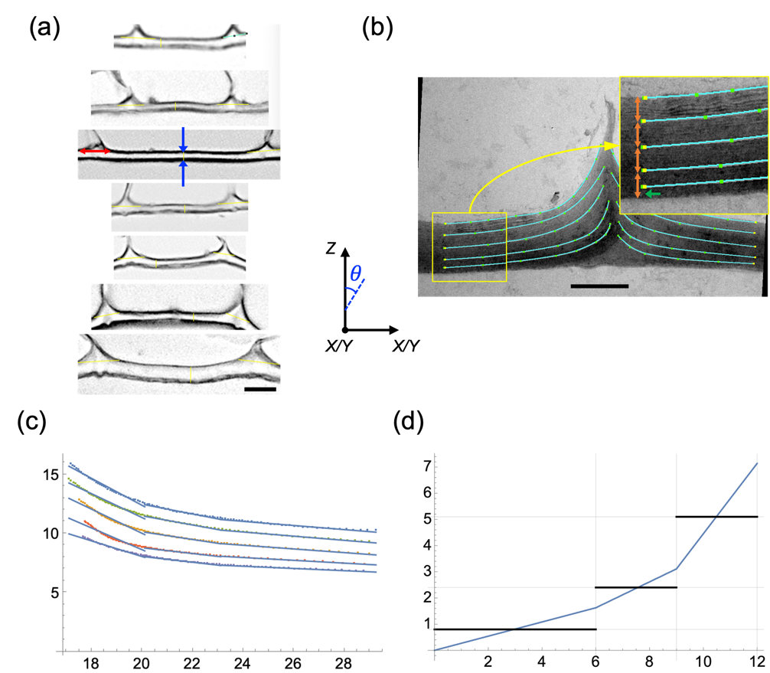
Fig. S3 Geometrical measurement of onion outermost epidermal cell walls. a Optical images of cross-sectioned epidermal cell walls. The ratio of the width of the junction region (red arrow; n=14) to the face region thickness (indicated by blue arrows; n=7) was calculated to be 3.4. The thickness of the face region in the model in Fig. 2 was determined to be 7 𝜇m, based on our measurement (5.7 𝜇m, n=7) and a previous study (7.5 𝜇m, n=27) by Huang et al.(Huang et al. 2018) Then, the width of the junction region in the model was determined to be 24 𝜇m, based on the assumption that the thickness of the face wall is 7 𝜇m, using the ratio of 3.4. This width was further divided into FE, E1, and E2 regions with 6 𝜇m, 3 𝜇m, and 3 𝜇m, respectively, as in Fig. 2. b The curvature measurement of the protruding cell walls and microfibril lamellae. Five curved lines were drawn starting at face regions, following the lamellae lines in TEM images. The top four starting points were chosen to divide the wall thickness into quarters (orange arrows in the inset), and the bottom starting point was at above the cuticle (green arrow in the inset). Scale bar = 5 𝜇m. c The five curved line profiles were linear fitted in the FE (6 𝜇m), E1 (3 𝜇m), and E2 (3 𝜇m) regions to calculate the tilt angles. All the five lines were averaged to determine the tilt angles of cellulose microfibrils. d The top line was additionally used to calculate the average thickness of the FE, E1, and E2 regions. The optical and TEM image were reprinted with permission from (Lee et al. 2023). Copyright 2023 American Chemical Society.

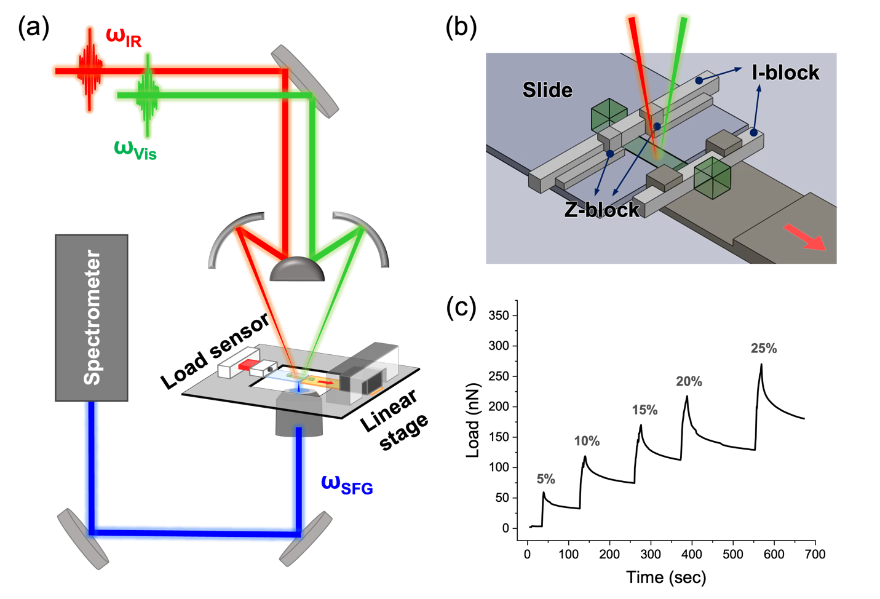
Fig. S4 In-situ SFG analysis with custom-built extensometer. a Extensometer configuration in the SFG microscopy system. b An onion epidermis specimen fixed with Z-blocks and I-blocks. c A representative load curve during the cross-polarization microscopy and microscopic SFG studies, showing stress relaxation right after stepwise increase in strain (marked at each increment).

Table S1 Summarized results of geometrical measurement and dimensions used in the model. The numbers in parentheses are the number of specimens analyzed.
Mean ± SD (n) | F | FE | E1 | E2
Width, W (𝜇m) | - | 6 | 3 | 3
Top surface angle (deg) | - | 75.1 ± 8.1 (8) | 64.3 ± 9.5 (10) | 37.2 ± 4.7 (10)
Thickness, T (𝜇m) | 7 | 7.8 | 9.4 | 12.1
Tilt angle, 𝜃 (deg) | - | 79.0 ± 6.1 (38) | 69.9 ± 7.7 (50) | 42.3 ± 9.4 (50)
Tilt angle, 𝜃 (deg) used | 90 | 79 | 70 | 42
Distribution of fibers, 𝜅 | 0.33 | 0.3 | 0.2 | 0.1

Table S2 Average stress at 15% and average RMSE values at 13% of multiple tests with different parameters (C₁₀, k₁, and k₂) in the HGO model. The parameters in test #14 were selected as “reference” parameters considering the average stress value and the RMSE compared to experimental data.
Test# | C₁₀  [MPa] | D  [MPa⁻¹] | k₁  [MPa] | k₂  [-] | kappa, 𝜅 | Avg Stress  at 15% | Avg RMSE
1 | 2.2 | 0.01 | 100 | 30 | F : 0.33  FE : 0.3  E1 : 0.2  E2 : 0.1 | 0.000 | 0.485
2 | 2.2 | 0.01 | 100 | 60 | F : 0.33  FE : 0.3  E1 : 0.2  E2 : 0.1 | 2.247 | 0.802
3 | 2.2 | 0.01 | 100 | 120 | F : 0.33  FE : 0.3  E1 : 0.2  E2 : 0.1 | 4.133 | 0.468
4 | 2.2 | 0.01 | 120 | 30 | F : 0.33  FE : 0.3  E1 : 0.2  E2 : 0.1 | 4.418 | 0.379
5 | 2.2 | 0.01 | 120 | 60 | F : 0.33  FE : 0.3  E1 : 0.2  E2 : 0.1 | 4.469 | 0.373
6 | 2.2 | 0.01 | 120 | 120 | F : 0.33  FE : 0.3  E1 : 0.2  E2 : 0.1 | 4.567 | 0.362
7 | 2.2 | 0.01 | 140 | 30 | F : 0.33  FE : 0.3  E1 : 0.2  E2 : 0.1 | 4.832 | 0.352
8 | 2.2 | 0.01 | 140 | 60 | F : 0.33  FE : 0.3  E1 : 0.2  E2 : 0.1 | 4.890 | 0.354
9 | 2.2 | 0.01 | 140 | 120 | F : 0.33  FE : 0.3  E1 : 0.2  E2 : 0.1 | 5.004 | 0.34
10 | 2.6 | 0.01 | 100 | 30 | F : 0.33  FE : 0.3  E1 : 0.2  E2 : 0.1 | 4.372 | 0.37
11 | 2.6 | 0.01 | 100 | 60 | F : 0.33  FE : 0.3  E1 : 0.2  E2 : 0.1 | 4.416 | 0.364
12 | 2.6 | 0.01 | 100 | 120 | F : 0.33  FE : 0.3  E1 : 0.2  E2 : 0.1 | 4.505 | 0.353
13 | 2.6 | 0.01 | 120 | 30 | F : 0.33  FE : 0.3  E1 : 0.2  E2 : 0.1 | 4.790 | 0.354
14* | 2.6 | 0.01 | 120 | 60 | F : 0.33  FE : 0.3  E1 : 0.2  E2 : 0.1 | 4.842 | 0.338
15 | 2.6 | 0.01 | 120 | 120 | F : 0.33  FE : 0.3  E1 : 0.2  E2 : 0.1 | 4.945 | 0.338
16 | 2.6 | 0.01 | 140 | 30 | F : 0.33  FE : 0.3  E1 : 0.2  E2 : 0.1 | 5.209 | 0.369
17 | 2.6 | 0.01 | 140 | 60 | F : 0.33  FE : 0.3  E1 : 0.2  E2 : 0.1 | 5.269 | 0.368
18 | 2.6 | 0.01 | 140 | 120 | F : 0.33  FE : 0.3  E1 : 0.2  E2 : 0.1 | 5.386 | 0.357
19 | 3.0 | 0.01 | 100 | 30 | F : 0.33  FE : 0.3  E1 : 0.2  E2 : 0.1 | 2.602 | 0.36
20 | 3.0 | 0.01 | 100 | 60 | F : 0.33  FE : 0.3  E1 : 0.2  E2 : 0.1 | 4.947 | 0.348
21 | 3.0 | 0.01 | 100 | 120 | F : 0.33  FE : 0.3  E1 : 0.2  E2 : 0.1 | 4.871 | 0.794
22 | 3.0 | 0.01 | 120 | 30 | F : 0.33  FE : 0.3  E1 : 0.2  E2 : 0.1 | 5.157 | 0.39
23 | 3.0 | 0.01 | 120 | 60 | F : 0.33  FE : 0.3  E1 : 0.2  E2 : 0.1 | 5.211 | 0.365
24 | 3.0 | 0.01 | 120 | 120 | F : 0.33  FE : 0.3  E1 : 0.2  E2 : 0.1 | 5.317 | 0.355
25 | 3.0 | 0.01 | 140 | 30 | F : 0.33  FE : 0.3  E1 : 0.2  E2 : 0.1 | 5.581 | 0.422
26 | 3.0 | 0.01 | 140 | 60 | F : 0.33  FE : 0.3  E1 : 0.2  E2 : 0.1 | 5.643 | 0.386
27 | 3.0 | 0.01 | 140 | 120 | F : 0.33  FE : 0.3  E1 : 0.2  E2 : 0.1 | 5.764 | 0.39

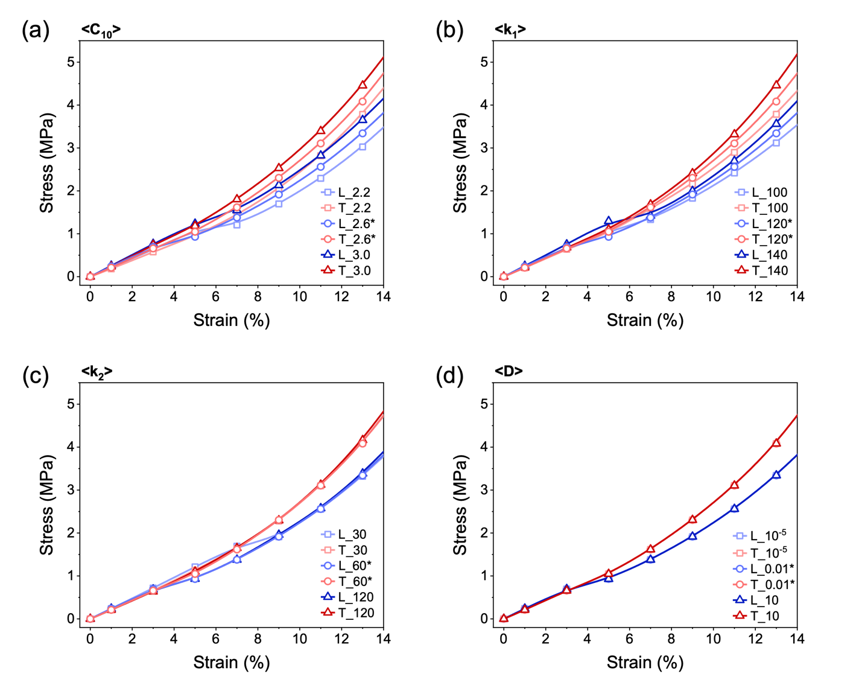
Fig. S5 Stress-strain curves of the M4 case with varying C₁₀ (a), k₁ (b), k₂ (c), and D (d) while keeping other three parameters fixed in the HGO model. The curves with asterisk are with the “reference parameters”; C₁₀ = 2.6, k₁ = 120, k₂ = 60, and D=0.01.

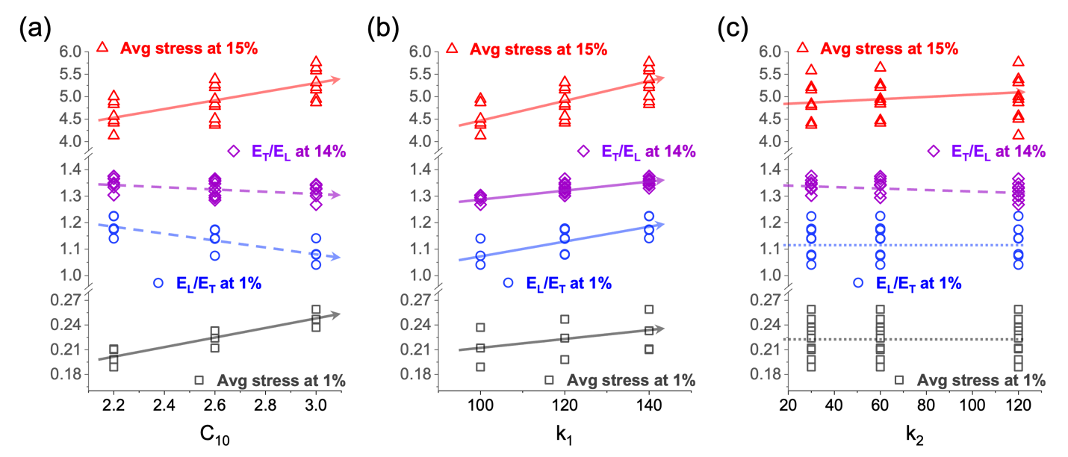
Fig. S6 Effects of HGO model parameters (C₁₀, k₁, k₂) on the mechanical properties of M4 at small and large strains. The slope ratios at 1% and 14% are local E_{L}/E_{T} and E_{T}/E_{L}, respectively. The solid and dashed arrows represent the positive and negative correlation (p < 0.01), respectively, and the flat dotted lines represent little correlation (p> 0.05). Detailed multiple linear regression result is in Table S2.

Table S3 Multiple linear regression beta coefficients (𝛽) values. **p < .001, *p < .01
Variables | Avg Stress at 1%  (n=27) | E_{L}/E_{T} at 1%  (n=27) | Avg Stress at 15%  (n=24) | E_{T}/E_{L} at 14%  (n=23)
C₁₀ | 6.05 × 10⁻²** | -1.16 × 10⁻¹** | 9.58 × 10⁻¹** | -4.05 × 10⁻²**
k₁ | 5.29 × 10⁻⁴** | 2.35 × 10⁻³** | 2.09 × 10⁻²** | 1.48 × 10⁻³**
k₂ | 1.21 × 10⁻⁶ | 3.81 × 10⁻⁶ | 1.65 × 10⁻³** | -1.94 × 10⁻⁴*
R² | 0.999 | 0.985 | 0.995 | 0.919

Table S4 Modulus ratio at small strains and secant (0-15% strain) modulus values at large strains for the model M1, M2, M3, and M4. $E^{s}$ represents the secant modulus. LS and TS represent the longitudinal and transverse stretches, respectively. The modulus unit is MPa.
Model | E_{L}/E_{T}  at 1% | $E_{LS}^{s}$  (0–15%) | $E_{TS}^{s}$  (0–15%) | $E_{TS}^{s}-E_{LS}^{s}$  (0–15%)
M1 | 1.00 | 23 | 23 | -
M2 | 0.85 | 22 | 26 | 4
M3 | 0.84 | 21 | 27 | 6
M4 | 1.14 | 29 | 36 | 7

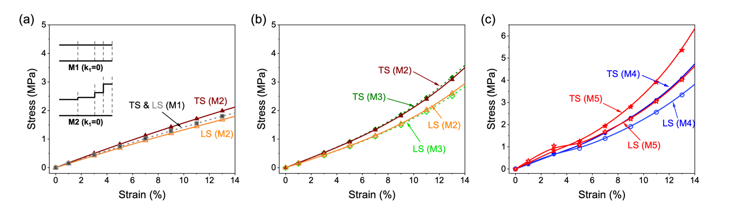
Fig. S7 a Stress-strain curve when k₁=0 in the HGO model, which is equivalent to the Neo-Hookean model. b Comparison between the M2 and M3 cases of the HGO model shown in Fig. 3b and c of the main text, respectively. c Comparison between M4 and M5. The model M5 has the same fiber structure as M4, but M5 has higher degrees of preferential alignment of fibers; kappa = 0.05, 0.1, 0.15, and 0.33 for E1, E2, FE, and F regions, respectively.
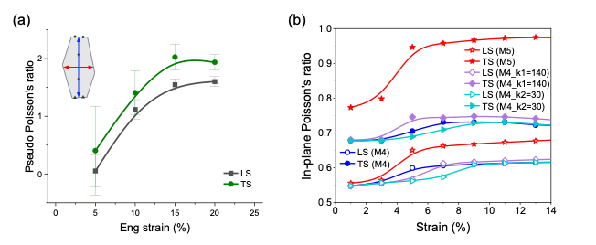
Fig. S8 a In-plane Poisson’s ratio of single cells from onion epidermis. The insets show how the longitudinal and transverse lengths of single cells were measured, and in-plane Poisson’s ratio was calculated as $\frac{- transverse strain}{longitudinal strain}$ and $\frac{- longitudinal strain}{transverse strain}$ for the longitudinal (LS) and transverse (TS) stretch, respectively. n=20 and 25 for LS and TS, respectively. The error bars are standard error. The large standard error at small strains and its decrease as the strain increases are due to the Poisson ratio calculation; dividing by a small number of strain results in a large Poisson’s ratio resulting in the large deviation. The strain along the stretch direction in the single cell level under 5% tissue level engineering strain was small. The trend is consistent with a previous publication by Jingyi et al.(Yu et al. 2024) b in-plane Poisson’s ratio of model M5 and M4 with different parameters.

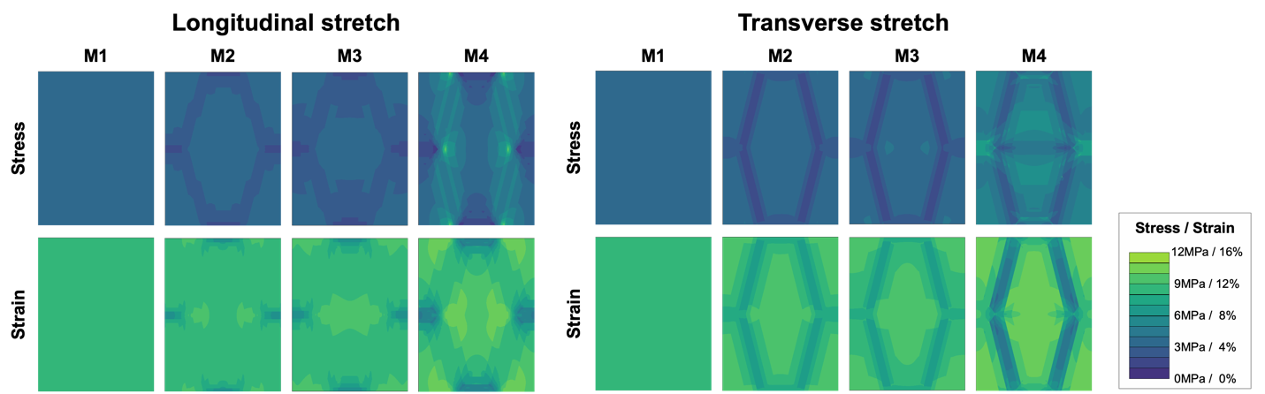
Fig. S9 Maximum principal stress and strain map of the different models (M1, M2, M3, and M4) at 15% strain.

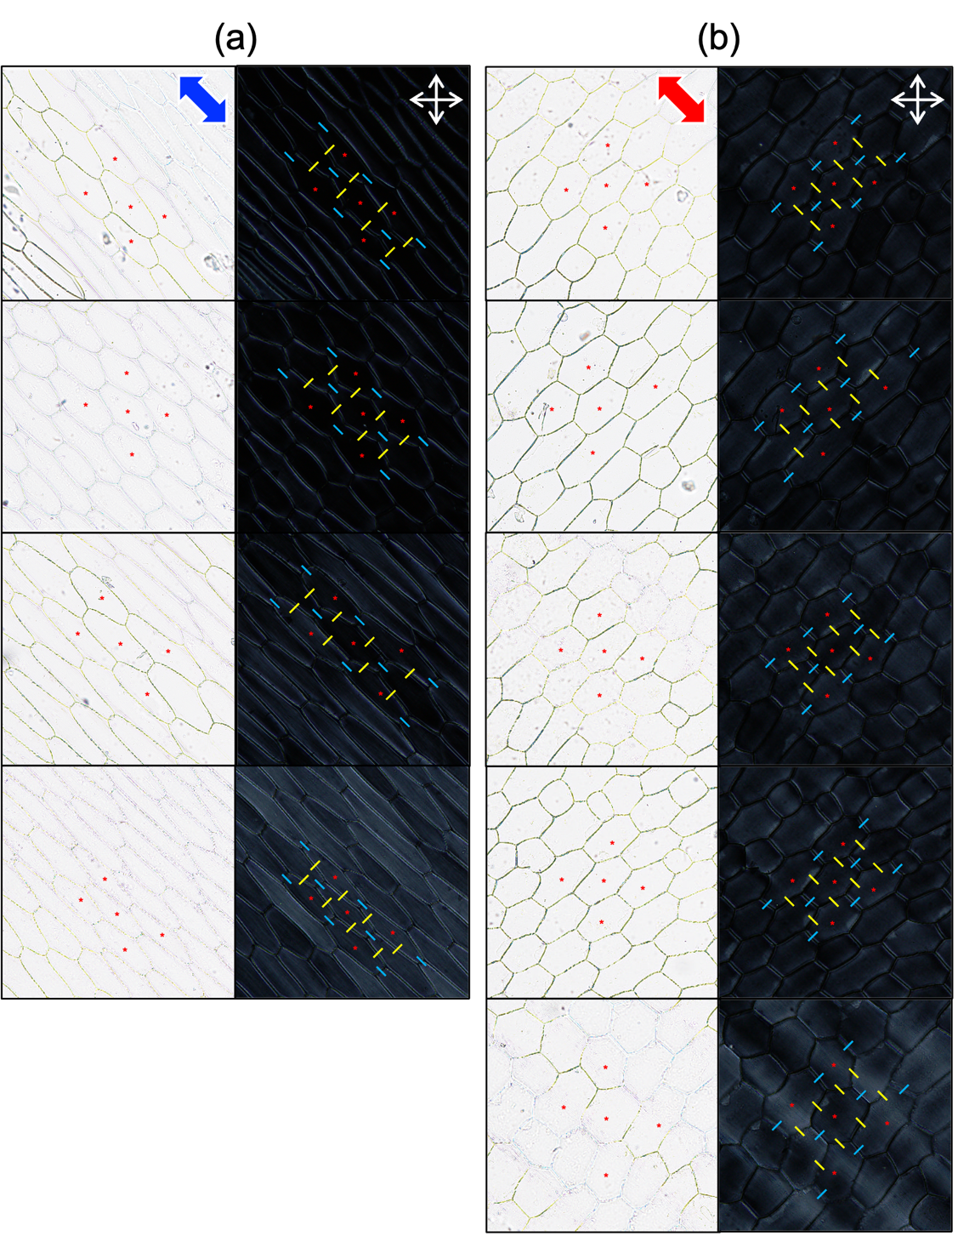
Fig. S10 Optical and cross-polarization images of onion epidermis at 10% tensile strain. The blue and red arrows represent the stretch directions, and the white double-sided arrows are the polarizer directions. The blue and yellow lines are the paths across the transverse and longitudinal edge regions for the CP intensity line profiles. The five cells with the red asterisks and eight longitudinal and transverse edges around them were chosen for analysis. The CP intensity line profiles were obtained over the blue and yellow straight lines at ±45° across the transverse and longitudinal edges, respectively. n=8 for each.

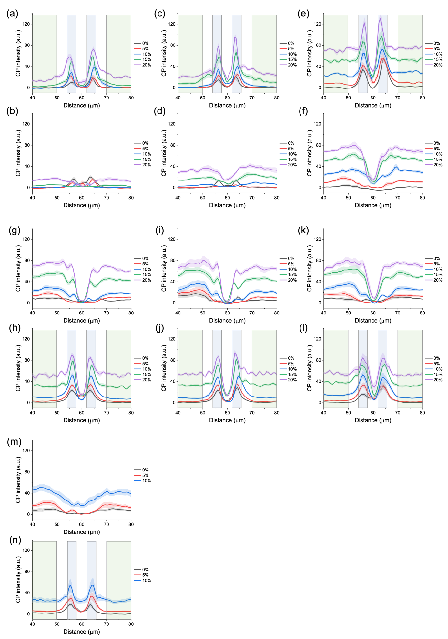
Fig. S11 CP intensity line profiles across the longitudinal (LE) and transverse (TE) edges in longitudinal stretch (LS) and transverse stretch (TS). a-f The line profiles across the longitudinal edge (a,c,e; LE-LS) and across the transverse edge (b,d,f; TE-LS) in the longitudinal stretch, respectively. g-n The line profiles across the longitudinal edge (g,i,k,m; LE-TS) and across the transverse edge (h,j,l,n; TE-TS) in the transverse stretch, respectively. n=8 for each curve. The shades around the curves are the standard errors. The blue (the distance between 54 - 58.2 𝜇m and 61.7 – 66 𝜇m) and green (the distance between 40-50 𝜇m and 70-80 𝜇m) shaded areas were averaged to calculate the average CP intensity in the edge and face regions in Fig. 5.

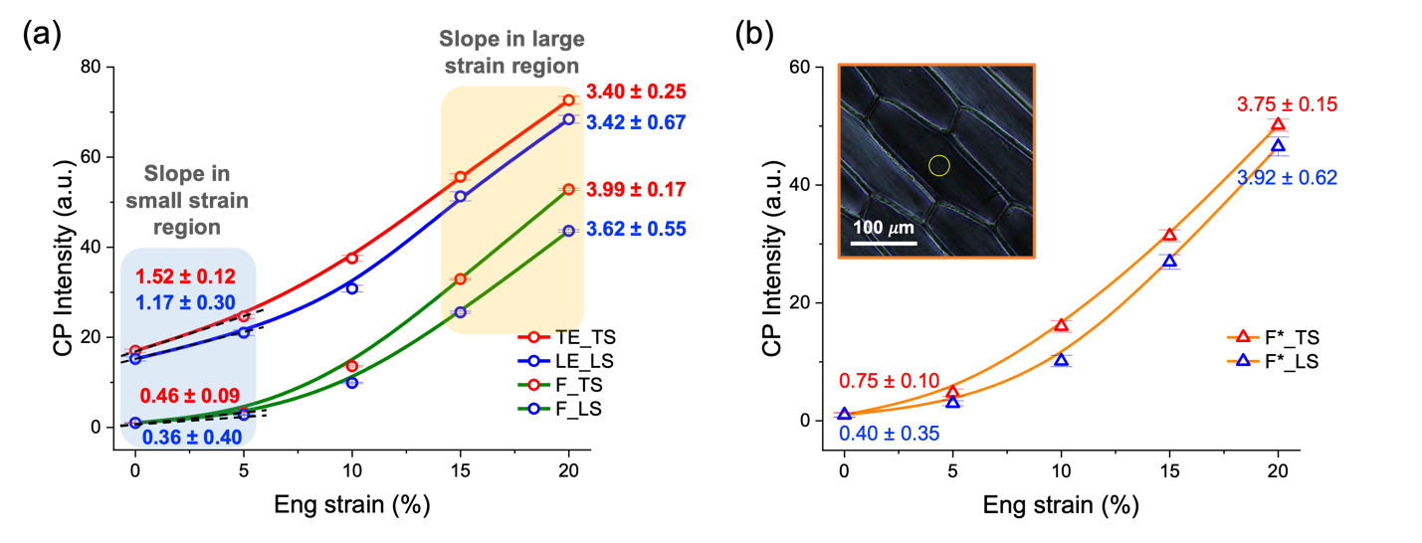

Fig. S12 Cross-polarization (CP) intensity changes in the edge and face regions at different strains. a The edge and face region intensities were averaged over the two peaks (the blue area in Fig. S11; the distance between 54 - 58.2 𝜇m and 61.7 – 66 𝜇m) and over the face region near the edges (the green area in Fig. S11; the distance between 40-50 𝜇m and 70-80 𝜇m) in the CP line profiles, respectively. The slopes in the face region (0 – 5% strain) showed significant difference from those in the edge region (p = 0.0084, ANOVA, F_{(3,14)}=5.83). b Cross-polarization (CP) intensity changes in the face region at the cell center (F*). The yellow circle in the inset shows the region of interest (ROI) where the CP intensity was measured. The slopes are small at the small strain (0 – 5%) as in the face region near the edge region in a. The slopes in the face region (0 – 5% strain) showed significant difference from those in the edge region (p = 0.0145, ANOVA, F_{(3,14)}=5.01).

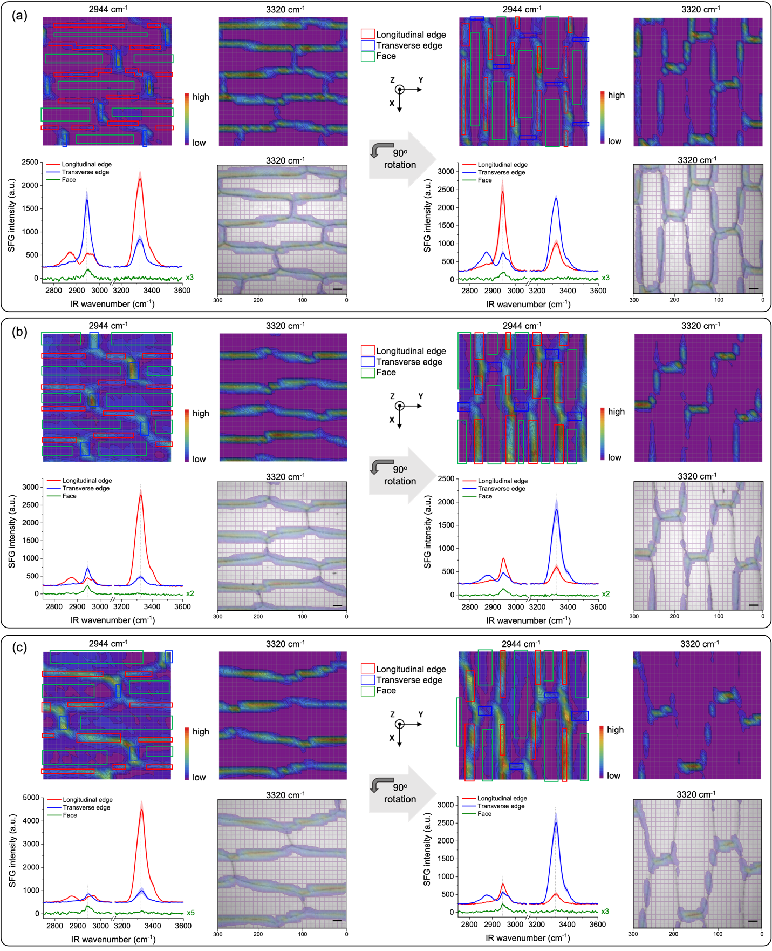
Fig. S13 Microscopic SFG analysis of hydrated onion epidermal cell wall in D₂O with SSP polarization combination. The top row shows the SFG hyperspectral images at 2944 cm⁻¹ and 3320 cm⁻¹ when the long cell axis is horizontal (left) and vertical (right). The laser incident plane is in the XZ plane, which is the vertical direction in the SFG images. The bottom row shows the averaged SFG spectra of the longitudinal (LE; in red) and transverse (TE; in blue) edge regions and face (in green) regions, with the semi-transparent SFG images at 3320 cm⁻¹ superimposed on the micrograph of the scanned area. Pixels within the color-coded boxes on the SFG images were averaged. The three replicates (a,b,c) are from different onions (n=3).

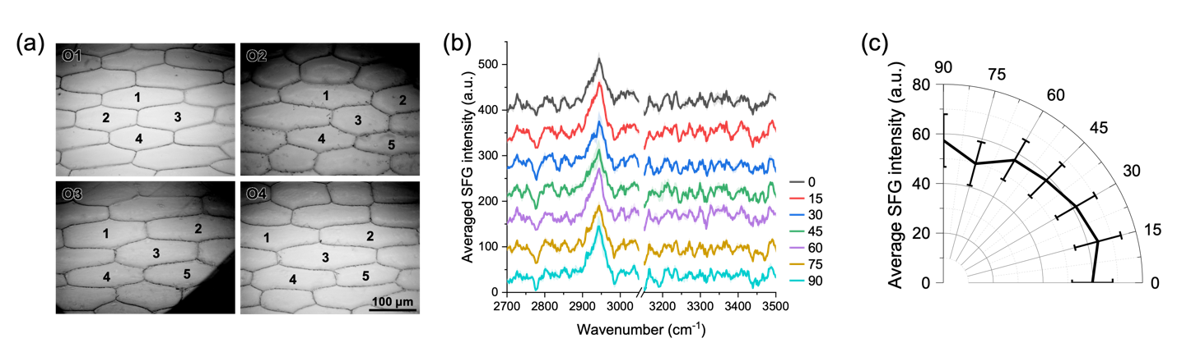
Fig. S14 Azimuth angle dependent SFG analysis at the cell center in the face region. a The center of the numbered cells (4-5) of the epidermis hydrated in D₂O was analyzed through SFG microscopy system (15× objective, spatial resolution of ~7.9 𝜇m × ~5.4 𝜇m). The four epidermises are from different onions (O1, O2, O3, and O4). b The averaged SFG spectra at the center of the face region in O1 at 0, 15, …, 90 azimuth angles. The shades are standard errors. c The azimuth angle dependent SFG intensities at 2944 cm⁻¹ averaged over the 19 cells from the four different onions. The error bar is standard error. PPS polarization combination was used for the SFG analysis.

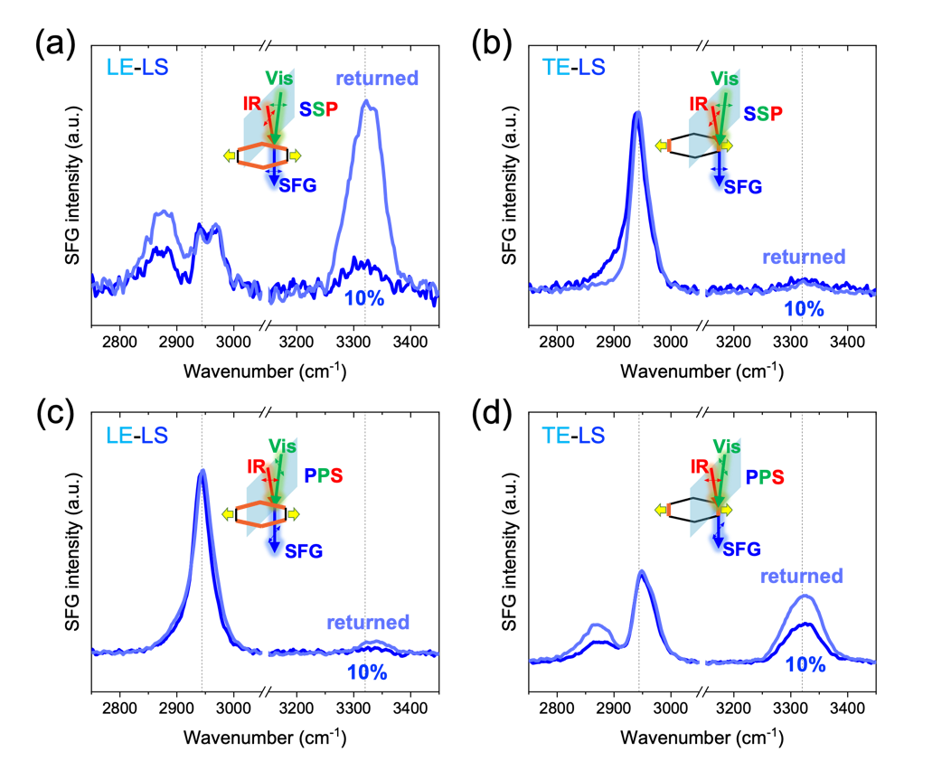
Fig. S15 Microscopic SFG study of hydrated onion epidermis in D₂O upon returning to the original position after 10% strain extension. a-d SFG spectra were averaged over multiple pixels in the junction regions in SFG hyperspectral images. The 0% and 10% spectra were presented in Fig. 6.

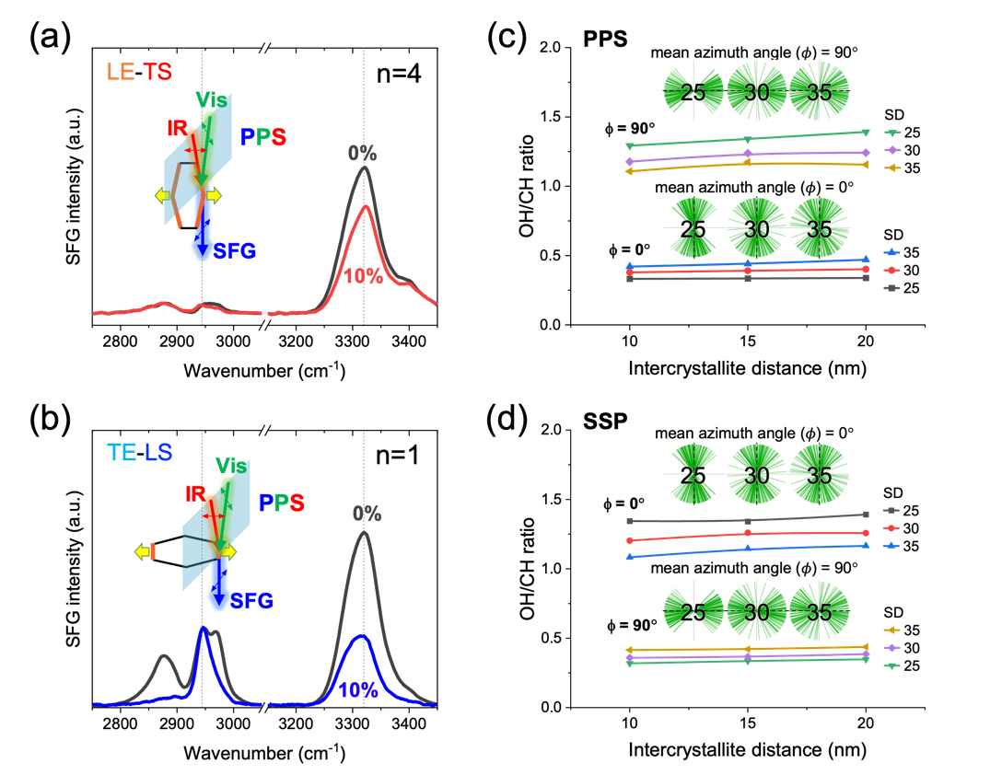
Fig. S16 Microscopic SFG study of hydrated onion epidermis in D₂O upon tensile stretch (small-spot analysis) and the simulated SFG intensity OH/CH ratio. a,b replicate of the SFG point analysis of multiple junction regions presented in Fig. 6. c,d theoretical SFG OH/CH ratio calculation results with various intercrystallite distances and orientational distributions (SD). The intercrystallite distance represents the distance between cellulose microfibrils and the inset shows a visualized distributions of fibers with different standard distribution (SD) values.

Huang S, Makarem M, Kiemle SN, Zheng Y, He X, Ye D, Gomez EW, Gomez ED, Cosgrove DJ, Kim SH (2018) Dehydration-induced physical strains of cellulose microfibrils in plant cell walls. Carbohydr Polym 197:337-348. https://doi.org/10.1016/j.carbpol.2018.05.091
Lee J, Choi J, Feng L, Yu J, Zheng Y, Zhang Q, Lin Y-T, Sah S, Gu Y, Zhang S, Cosgrove DJ, Kim SH (2023) Regiospecific Cellulose Orientation and Anisotropic Mechanical Property in Plant Cell Walls. Biomacromolecules 24 (11):4759-4770. https://doi.org/10.1021/acs.biomac.3c00538
Yu J, Del Mundo JT, Freychet G, Zhernenkov M, Schaible E, Gomez EW, Gomez ED, Cosgrove DJ (2024) Dynamic Structural Change of Plant Epidermal Cell Walls under Strain. Small 20 (30):2311832. https://doi.org/https://doi.org/10.1002/smll.202311832
Zamil MS, Yi H, Puri VM (2017) A multiscale FEA framework for bridging cell-wall to tissue-scale mechanical properties: the contributions of middle lamella interface and cell shape. J Mater Sci 52 (13):7947-7968. https://doi.org/10.1007/s10853-017-0999-4

