Appendix A: Results for an extended number of AC covariance parameter settings
In the following, we discuss results for a broader range of parameter settings. First, we considered a more extensive set of combinations between the AC covariance parameters g (cultural transmission) and b (sibling interaction). Second, we considered different values of A, while keeping C and E constant. Last, we considered a specific set of values for the A, C and E components based on a previous paper (de Zeeuw et al 2016) to demonstrate power given a specific phenotype and sample.
First, we varied the path coefficients for the two sources of AC covariance g (cultural transmission) and b (sibling interaction) which we increment in steps of .01 for values from 0 to .1. We first present results for when the true model only includes one source of AC covariance. Fig. 1 shows the results for power estimates when cultural transmission is zero (g = 0), Fig. 2 shows the results for when sibling interaction is zero (b = 0). Table 1 shows power estimates and Table 2 shows parameter estimates for this broader range of parameter estimates.
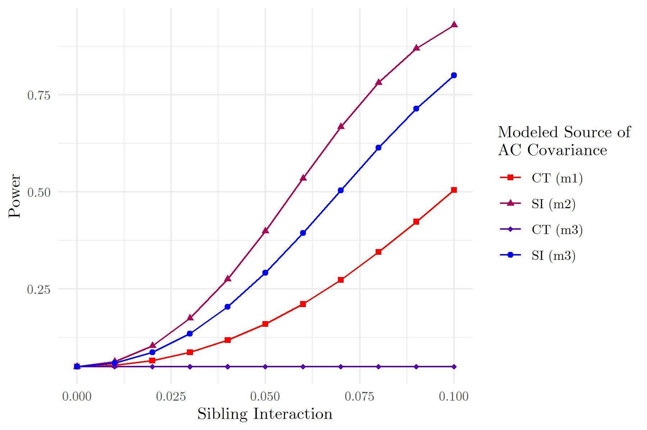
Fig. 1 Power Estimates for one Factor (0 ≤ SI ≤ 0.1, CT = 0) With 11 Levels (MZ & DZ Sample). CT = cultural transmission, SI = sibling interaction, m1 = model only assuming CT, m2 = model only assuming SI, m3 = model assuming both CT and SI
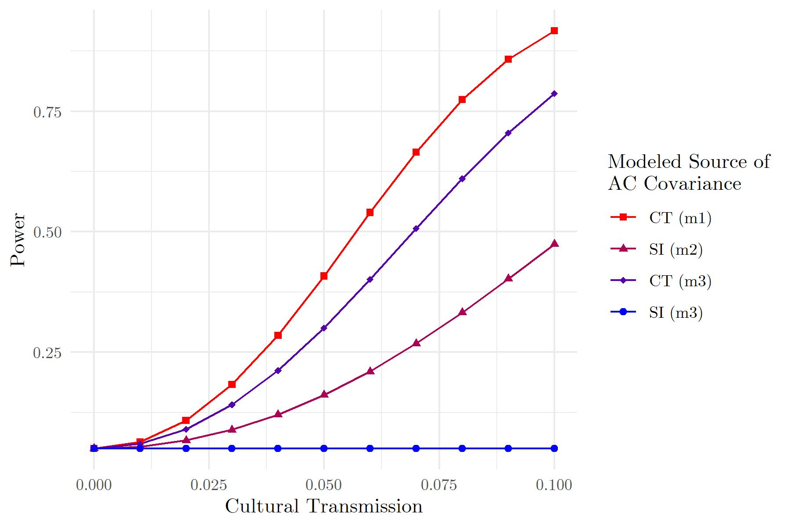
Fig. 2 Power Estimates for one Factor (0 ≤ CT ≤ 0.1, SI = 0) With 11 Levels (MZ & DZ Sample). CT = cultural transmission, SI = sibling interaction, m1 = model only assuming CT, m2 = model only assuming SI, m3 = model assuming both CT and SI.
Table 1
OpenMx Power for 121 Cells (PGS R² = 10%)
g | b | p1 | p2 | p3 | p4 | p5 | p6 | p7 | p8 | MZ s²_{Ph} | DZ s²_{Ph}
0 | 0 | 0.05 | 0.05 | 0.05 | 0.05 | 0.05 | 0.05 | 0.05 | 0.05 | 0% | 0%
0 | 0.01 | 0.054 | 0.063 | 0.05 | 0.059 | 0.055 | 0.06 | 0.05 | 0.055 | 1% | 1%
0 | 0.02 | 0.066 | 0.104 | 0.05 | 0.087 | 0.07 | 0.089 | 0.05 | 0.069 | 3% | 1%
0 | 0.03 | 0.087 | 0.175 | 0.05 | 0.135 | 0.095 | 0.139 | 0.05 | 0.093 | 4% | 2%
0 | 0.04 | 0.118 | 0.275 | 0.05 | 0.204 | 0.131 | 0.211 | 0.05 | 0.127 | 5% | 3%
0 | 0.05 | 0.16 | 0.399 | 0.05 | 0.292 | 0.179 | 0.302 | 0.05 | 0.171 | 7% | 3%
0 | 0.06 | 0.211 | 0.535 | 0.05 | 0.394 | 0.237 | 0.409 | 0.05 | 0.225 | 8% | 4%
0 | 0.07 | 0.273 | 0.667 | 0.05 | 0.504 | 0.307 | 0.522 | 0.05 | 0.287 | 9% | 5%
0 | 0.08 | 0.345 | 0.781 | 0.05 | 0.614 | 0.384 | 0.634 | 0.05 | 0.356 | 11% | 6%
0 | 0.09 | 0.423 | 0.869 | 0.05 | 0.714 | 0.466 | 0.735 | 0.05 | 0.43 | 12% | 7%
0 | 0.1 | 0.505 | 0.929 | 0.05 | 0.8 | 0.55 | 0.819 | 0.05 | 0.506 | 14% | 7%
0.01 | 0 | 0.064 | 0.054 | 0.06 | 0.05 | 0.058 | 0.054 | 0.054 | 0.05 | 1% | 1%
0.01 | 0.01 | 0.084 | 0.083 | 0.06 | 0.059 | 0.076 | 0.077 | 0.054 | 0.055 | 3% | 2%
0.01 | 0.02 | 0.112 | 0.141 | 0.06 | 0.087 | 0.104 | 0.12 | 0.054 | 0.069 | 4% | 3%
0.01 | 0.03 | 0.15 | 0.228 | 0.06 | 0.135 | 0.143 | 0.184 | 0.054 | 0.093 | 5% | 3%
0.01 | 0.04 | 0.199 | 0.342 | 0.06 | 0.203 | 0.193 | 0.268 | 0.054 | 0.126 | 7% | 4%
0.01 | 0.05 | 0.257 | 0.474 | 0.059 | 0.29 | 0.254 | 0.37 | 0.054 | 0.17 | 8% | 5%
0.01 | 0.06 | 0.324 | 0.609 | 0.059 | 0.391 | 0.325 | 0.481 | 0.054 | 0.223 | 9% | 6%
0.01 | 0.07 | 0.398 | 0.733 | 0.059 | 0.501 | 0.403 | 0.594 | 0.054 | 0.284 | 11% | 6%
0.01 | 0.08 | 0.477 | 0.833 | 0.059 | 0.61 | 0.485 | 0.699 | 0.054 | 0.352 | 12% | 7%
0.01 | 0.09 | 0.558 | 0.905 | 0.059 | 0.711 | 0.569 | 0.79 | 0.054 | 0.426 | 14% | 8%
0.01 | 0.1 | 0.638 | 0.951 | 0.059 | 0.797 | 0.649 | 0.862 | 0.054 | 0.501 | 15% | 9%
0.02 | 0 | 0.108 | 0.067 | 0.09 | 0.05 | 0.084 | 0.067 | 0.067 | 0.05 | 3% | 3%
0.02 | 0.01 | 0.144 | 0.112 | 0.09 | 0.059 | 0.115 | 0.102 | 0.066 | 0.055 | 4% | 3%
0.02 | 0.02 | 0.189 | 0.186 | 0.089 | 0.087 | 0.156 | 0.159 | 0.066 | 0.069 | 5% | 4%
0.02 | 0.03 | 0.244 | 0.289 | 0.089 | 0.134 | 0.209 | 0.236 | 0.066 | 0.092 | 7% | 5%
0.02 | 0.04 | 0.307 | 0.415 | 0.088 | 0.201 | 0.272 | 0.332 | 0.066 | 0.125 | 8% | 5%
0.02 | 0.05 | 0.378 | 0.55 | 0.088 | 0.288 | 0.344 | 0.441 | 0.066 | 0.168 | 9% | 6%
0.02 | 0.06 | 0.454 | 0.68 | 0.087 | 0.388 | 0.423 | 0.554 | 0.065 | 0.22 | 11% | 7%
0.02 | 0.07 | 0.533 | 0.791 | 0.087 | 0.497 | 0.505 | 0.662 | 0.065 | 0.281 | 12% | 8%
0.02 | 0.08 | 0.611 | 0.875 | 0.086 | 0.606 | 0.587 | 0.759 | 0.065 | 0.349 | 14% | 9%
0.02 | 0.09 | 0.686 | 0.933 | 0.086 | 0.707 | 0.665 | 0.837 | 0.065 | 0.421 | 15% | 9%
0.02 | 0.1 | 0.755 | 0.967 | 0.085 | 0.794 | 0.737 | 0.897 | 0.065 | 0.496 | 17% | 10%
0.03 | 0 | 0.183 | 0.089 | 0.141 | 0.05 | 0.126 | 0.088 | 0.087 | 0.05 | 4% | 4%
0.03 | 0.01 | 0.234 | 0.151 | 0.14 | 0.059 | 0.171 | 0.137 | 0.087 | 0.055 | 5% | 5%
0.03 | 0.02 | 0.294 | 0.241 | 0.139 | 0.086 | 0.226 | 0.207 | 0.086 | 0.068 | 7% | 5%
0.03 | 0.03 | 0.361 | 0.357 | 0.138 | 0.133 | 0.291 | 0.296 | 0.086 | 0.092 | 8% | 6%
0.03 | 0.04 | 0.434 | 0.489 | 0.137 | 0.2 | 0.364 | 0.401 | 0.085 | 0.124 | 9% | 7%
0.03 | 0.05 | 0.511 | 0.623 | 0.135 | 0.286 | 0.442 | 0.513 | 0.085 | 0.167 | 11% | 8%
0.03 | 0.06 | 0.588 | 0.744 | 0.134 | 0.386 | 0.524 | 0.623 | 0.084 | 0.218 | 12% | 8%
0.03 | 0.07 | 0.662 | 0.84 | 0.133 | 0.494 | 0.605 | 0.725 | 0.084 | 0.278 | 14% | 9%
0.03 | 0.08 | 0.732 | 0.91 | 0.132 | 0.602 | 0.681 | 0.81 | 0.084 | 0.345 | 15% | 10%
0.03 | 0.09 | 0.794 | 0.954 | 0.131 | 0.703 | 0.751 | 0.877 | 0.083 | 0.416 | 17% | 11%
0.03 | 0.1 | 0.847 | 0.979 | 0.13 | 0.79 | 0.812 | 0.925 | 0.083 | 0.49 | 18% | 12%
0.04 | 0 | 0.285 | 0.12 | 0.212 | 0.05 | 0.186 | 0.118 | 0.116 | 0.05 | 5% | 5%
0.04 | 0.01 | 0.349 | 0.198 | 0.21 | 0.059 | 0.243 | 0.18 | 0.115 | 0.055 | 7% | 6%
0.04 | 0.02 | 0.419 | 0.304 | 0.208 | 0.086 | 0.31 | 0.263 | 0.114 | 0.068 | 8% | 7%
0.04 | 0.03 | 0.493 | 0.43 | 0.206 | 0.133 | 0.384 | 0.362 | 0.113 | 0.091 | 10% | 8%
0.04 | 0.04 | 0.568 | 0.564 | 0.204 | 0.199 | 0.463 | 0.472 | 0.112 | 0.123 | 11% | 8%
0.04 | 0.05 | 0.641 | 0.692 | 0.202 | 0.284 | 0.543 | 0.584 | 0.112 | 0.165 | 12% | 9%
0.04 | 0.06 | 0.711 | 0.8 | 0.2 | 0.383 | 0.622 | 0.689 | 0.111 | 0.216 | 14% | 10%
0.04 | 0.07 | 0.774 | 0.881 | 0.198 | 0.491 | 0.697 | 0.78 | 0.11 | 0.275 | 15% | 11%
0.04 | 0.08 | 0.829 | 0.936 | 0.196 | 0.599 | 0.764 | 0.854 | 0.109 | 0.341 | 17% | 12%
0.04 | 0.09 | 0.875 | 0.969 | 0.194 | 0.699 | 0.822 | 0.909 | 0.109 | 0.412 | 18% | 13%
0.04 | 0.1 | 0.911 | 0.986 | 0.192 | 0.786 | 0.871 | 0.946 | 0.108 | 0.485 | 20% | 14%
0.05 | 0 | 0.408 | 0.161 | 0.3 | 0.05 | 0.261 | 0.156 | 0.152 | 0.05 | 7% | 7%
0.05 | 0.01 | 0.479 | 0.254 | 0.297 | 0.059 | 0.329 | 0.232 | 0.151 | 0.054 | 8% | 8%
0.05 | 0.02 | 0.552 | 0.372 | 0.294 | 0.086 | 0.404 | 0.325 | 0.149 | 0.068 | 10% | 8%
0.05 | 0.03 | 0.624 | 0.504 | 0.291 | 0.132 | 0.483 | 0.432 | 0.148 | 0.09 | 11% | 9%
0.05 | 0.04 | 0.693 | 0.636 | 0.288 | 0.198 | 0.563 | 0.543 | 0.147 | 0.122 | 12% | 10%
0.05 | 0.05 | 0.756 | 0.754 | 0.285 | 0.281 | 0.64 | 0.651 | 0.146 | 0.163 | 14% | 11%
0.05 | 0.06 | 0.812 | 0.848 | 0.282 | 0.38 | 0.712 | 0.748 | 0.145 | 0.214 | 15% | 12%
0.05 | 0.07 | 0.86 | 0.914 | 0.279 | 0.487 | 0.777 | 0.828 | 0.143 | 0.272 | 17% | 12%
0.05 | 0.08 | 0.899 | 0.956 | 0.276 | 0.595 | 0.833 | 0.89 | 0.142 | 0.337 | 18% | 13%
0.05 | 0.09 | 0.93 | 0.98 | 0.273 | 0.695 | 0.879 | 0.934 | 0.141 | 0.407 | 20% | 14%
0.05 | 0.1 | 0.953 | 0.992 | 0.27 | 0.783 | 0.915 | 0.962 | 0.14 | 0.48 | 21% | 15%
0.06 | 0 | 0.54 | 0.21 | 0.401 | 0.05 | 0.35 | 0.203 | 0.196 | 0.05 | 8% | 8%
0.06 | 0.01 | 0.61 | 0.318 | 0.396 | 0.059 | 0.425 | 0.29 | 0.194 | 0.054 | 10% | 9%
0.06 | 0.02 | 0.677 | 0.445 | 0.392 | 0.086 | 0.503 | 0.393 | 0.192 | 0.068 | 11% | 10%
0.06 | 0.03 | 0.74 | 0.578 | 0.388 | 0.131 | 0.582 | 0.503 | 0.19 | 0.09 | 13% | 11%
0.06 | 0.04 | 0.797 | 0.704 | 0.384 | 0.196 | 0.657 | 0.613 | 0.189 | 0.121 | 14% | 11%
0.06 | 0.05 | 0.846 | 0.809 | 0.38 | 0.279 | 0.727 | 0.714 | 0.187 | 0.162 | 15% | 12%
0.06 | 0.06 | 0.887 | 0.887 | 0.376 | 0.377 | 0.79 | 0.8 | 0.185 | 0.211 | 17% | 13%
0.06 | 0.07 | 0.92 | 0.939 | 0.372 | 0.484 | 0.843 | 0.869 | 0.184 | 0.269 | 18% | 14%
0.06 | 0.08 | 0.945 | 0.971 | 0.368 | 0.591 | 0.886 | 0.919 | 0.182 | 0.334 | 20% | 15%
0.06 | 0.09 | 0.964 | 0.987 | 0.364 | 0.691 | 0.92 | 0.953 | 0.18 | 0.403 | 22% | 16%
0.06 | 0.1 | 0.977 | 0.995 | 0.36 | 0.779 | 0.946 | 0.974 | 0.179 | 0.475 | 23% | 17%
0.07 | 0 | 0.665 | 0.268 | 0.507 | 0.05 | 0.446 | 0.258 | 0.246 | 0.05 | 10% | 10%
0.07 | 0.01 | 0.727 | 0.387 | 0.502 | 0.059 | 0.524 | 0.355 | 0.244 | 0.054 | 11% | 11%
0.07 | 0.02 | 0.784 | 0.519 | 0.497 | 0.085 | 0.601 | 0.463 | 0.241 | 0.067 | 13% | 11%
0.07 | 0.03 | 0.834 | 0.649 | 0.492 | 0.13 | 0.674 | 0.573 | 0.239 | 0.089 | 14% | 12%
0.07 | 0.04 | 0.876 | 0.764 | 0.487 | 0.195 | 0.742 | 0.678 | 0.237 | 0.12 | 16% | 13%
0.07 | 0.05 | 0.91 | 0.855 | 0.482 | 0.277 | 0.802 | 0.77 | 0.234 | 0.16 | 17% | 14%
0.07 | 0.06 | 0.937 | 0.918 | 0.477 | 0.374 | 0.852 | 0.845 | 0.232 | 0.209 | 19% | 15%
0.07 | 0.07 | 0.957 | 0.958 | 0.472 | 0.48 | 0.894 | 0.902 | 0.23 | 0.266 | 20% | 16%
0.07 | 0.08 | 0.972 | 0.981 | 0.468 | 0.587 | 0.926 | 0.941 | 0.228 | 0.33 | 22% | 17%
0.07 | 0.09 | 0.983 | 0.992 | 0.463 | 0.687 | 0.95 | 0.967 | 0.225 | 0.398 | 23% | 18%
0.07 | 0.1 | 0.989 | 0.997 | 0.458 | 0.775 | 0.967 | 0.983 | 0.223 | 0.47 | 25% | 19%
0.08 | 0 | 0.774 | 0.332 | 0.61 | 0.05 | 0.544 | 0.318 | 0.302 | 0.05 | 11% | 11%
0.08 | 0.01 | 0.823 | 0.46 | 0.605 | 0.059 | 0.62 | 0.423 | 0.299 | 0.054 | 13% | 12%
0.08 | 0.02 | 0.866 | 0.592 | 0.6 | 0.085 | 0.691 | 0.533 | 0.296 | 0.067 | 14% | 13%
0.08 | 0.03 | 0.901 | 0.715 | 0.594 | 0.13 | 0.756 | 0.64 | 0.293 | 0.089 | 16% | 14%
0.08 | 0.04 | 0.929 | 0.817 | 0.589 | 0.193 | 0.813 | 0.737 | 0.29 | 0.119 | 17% | 15%
0.08 | 0.05 | 0.951 | 0.892 | 0.583 | 0.275 | 0.862 | 0.819 | 0.287 | 0.159 | 19% | 16%
0.08 | 0.06 | 0.968 | 0.942 | 0.578 | 0.372 | 0.9 | 0.882 | 0.284 | 0.207 | 20% | 17%
0.08 | 0.07 | 0.979 | 0.972 | 0.573 | 0.477 | 0.931 | 0.928 | 0.281 | 0.263 | 22% | 17%
0.08 | 0.08 | 0.987 | 0.988 | 0.567 | 0.583 | 0.953 | 0.958 | 0.279 | 0.326 | 23% | 18%
0.08 | 0.09 | 0.992 | 0.995 | 0.562 | 0.683 | 0.97 | 0.977 | 0.276 | 0.394 | 25% | 19%
0.08 | 0.1 | 0.996 | 0.998 | 0.557 | 0.771 | 0.981 | 0.989 | 0.273 | 0.464 | 27% | 20%
0.09 | 0 | 0.858 | 0.402 | 0.705 | 0.05 | 0.638 | 0.384 | 0.362 | 0.05 | 13% | 13%
0.09 | 0.01 | 0.893 | 0.533 | 0.7 | 0.059 | 0.708 | 0.493 | 0.358 | 0.054 | 14% | 14%
0.09 | 0.02 | 0.923 | 0.662 | 0.694 | 0.085 | 0.77 | 0.602 | 0.355 | 0.067 | 16% | 15%
0.09 | 0.03 | 0.946 | 0.774 | 0.689 | 0.129 | 0.825 | 0.703 | 0.351 | 0.088 | 17% | 16%
0.09 | 0.04 | 0.963 | 0.861 | 0.683 | 0.192 | 0.87 | 0.79 | 0.348 | 0.118 | 19% | 16%
0.09 | 0.05 | 0.976 | 0.922 | 0.678 | 0.273 | 0.907 | 0.86 | 0.344 | 0.157 | 20% | 17%
0.09 | 0.06 | 0.985 | 0.96 | 0.672 | 0.369 | 0.936 | 0.912 | 0.341 | 0.205 | 22% | 18%
0.09 | 0.07 | 0.991 | 0.982 | 0.667 | 0.473 | 0.957 | 0.948 | 0.337 | 0.26 | 24% | 19%
0.09 | 0.08 | 0.994 | 0.992 | 0.661 | 0.579 | 0.972 | 0.971 | 0.334 | 0.322 | 25% | 20%
0.09 | 0.09 | 0.997 | 0.997 | 0.656 | 0.679 | 0.982 | 0.985 | 0.33 | 0.389 | 27% | 21%
0.09 | 0.1 | 0.998 | 0.999 | 0.65 | 0.767 | 0.989 | 0.993 | 0.327 | 0.459 | 28% | 22%
0.1 | 0 | 0.917 | 0.474 | 0.787 | 0.05 | 0.724 | 0.453 | 0.424 | 0.05 | 15% | 15%
0.1 | 0.01 | 0.94 | 0.605 | 0.782 | 0.058 | 0.784 | 0.562 | 0.42 | 0.054 | 16% | 15%
0.1 | 0.02 | 0.959 | 0.725 | 0.776 | 0.084 | 0.836 | 0.667 | 0.416 | 0.067 | 18% | 16%
0.1 | 0.03 | 0.972 | 0.824 | 0.771 | 0.128 | 0.879 | 0.759 | 0.412 | 0.088 | 19% | 17%
0.1 | 0.04 | 0.982 | 0.897 | 0.766 | 0.191 | 0.913 | 0.836 | 0.408 | 0.117 | 21% | 18%
0.1 | 0.05 | 0.989 | 0.945 | 0.761 | 0.271 | 0.94 | 0.894 | 0.404 | 0.156 | 22% | 19%
0.1 | 0.06 | 0.993 | 0.973 | 0.755 | 0.366 | 0.96 | 0.936 | 0.4 | 0.203 | 24% | 20%
0.1 | 0.07 | 0.996 | 0.988 | 0.75 | 0.469 | 0.974 | 0.963 | 0.396 | 0.257 | 25% | 21%
0.1 | 0.08 | 0.998 | 0.995 | 0.745 | 0.575 | 0.984 | 0.98 | 0.392 | 0.318 | 27% | 22%
0.1 | 0.09 | 0.999 | 0.998 | 0.739 | 0.675 | 0.99 | 0.99 | 0.388 | 0.385 | 29% | 23%
0.1 | 0.1 | 0.999 | 0.999 | 0.734 | 0.763 | 0.994 | 0.995 | 0.384 | 0.454 | 30% | 24%
Note. p1-p4 are power results for the MZ&DZ sample, p5-p8 are power results for the DZ-only sample. p1&p5 = power for CT in model that only accounts for CT, p2&p6 = power for SI in model that only accounts for SI, p3&p7 = power for CT in a regression that accounts for CT and SI, p4&p8 = power for SI in a regression that accounts for CT and SI, MZ s²_{Ph} = percentage of variance inflation due to AC covariance for MZ twins, DZ s²_{Ph} = percentage of variance inflation due to AC covariance for DZ twins.
Table 2
OpenMx Parameter Estimates for 121 Cells (PGS R² = 10%)
g | b | e1 | e2 | e3 | e4 | e5 | e6 | e7 | e8 | MZ s²_{Ph} | DZ s²_{Ph}
0 | 0 | 0 | 0 | 0 | 0 | 0 | 0 | 0 | 0 | 0% | 0%
0 | 0.01 | 0.005 | 0.01 | 0 | 0.01 | 0.008 | 0.01 | 0 | 0.01 | 1% | 1%
0 | 0.02 | 0.011 | 0.02 | 0 | 0.02 | 0.015 | 0.02 | 0 | 0.02 | 3% | 1%
0 | 0.03 | 0.016 | 0.03 | 0 | 0.03 | 0.023 | 0.03 | 0 | 0.03 | 4% | 2%
0 | 0.04 | 0.022 | 0.04 | 0 | 0.04 | 0.031 | 0.04 | 0 | 0.04 | 5% | 3%
0 | 0.05 | 0.028 | 0.05 | 0 | 0.05 | 0.039 | 0.05 | 0 | 0.05 | 7% | 3%
0 | 0.06 | 0.033 | 0.06 | 0 | 0.06 | 0.047 | 0.06 | 0 | 0.06 | 8% | 4%
0 | 0.07 | 0.04 | 0.07 | 0 | 0.07 | 0.055 | 0.07 | 0 | 0.07 | 9% | 5%
0 | 0.08 | 0.045 | 0.08 | 0 | 0.08 | 0.063 | 0.08 | 0 | 0.08 | 11% | 6%
0 | 0.09 | 0.051 | 0.09 | 0 | 0.09 | 0.071 | 0.09 | 0 | 0.09 | 12% | 7%
0 | 0.1 | 0.058 | 0.1 | 0 | 0.1 | 0.079 | 0.1 | 0 | 0.1 | 14% | 7%
0.01 | 0 | 0.01 | 0.006 | 0.01 | 0 | 0.01 | 0.007 | 0.01 | 0 | 1% | 1%
0.01 | 0.01 | 0.015 | 0.016 | 0.01 | 0.01 | 0.018 | 0.017 | 0.01 | 0.01 | 3% | 2%
0.01 | 0.02 | 0.021 | 0.026 | 0.01 | 0.02 | 0.025 | 0.027 | 0.01 | 0.02 | 4% | 3%
0.01 | 0.03 | 0.026 | 0.036 | 0.01 | 0.03 | 0.033 | 0.037 | 0.01 | 0.03 | 5% | 3%
0.01 | 0.04 | 0.032 | 0.046 | 0.01 | 0.04 | 0.041 | 0.047 | 0.01 | 0.04 | 7% | 4%
0.01 | 0.05 | 0.038 | 0.056 | 0.01 | 0.05 | 0.049 | 0.056 | 0.01 | 0.05 | 8% | 5%
0.01 | 0.06 | 0.043 | 0.066 | 0.01 | 0.06 | 0.057 | 0.067 | 0.01 | 0.06 | 9% | 6%
0.01 | 0.07 | 0.05 | 0.076 | 0.01 | 0.07 | 0.065 | 0.077 | 0.01 | 0.07 | 11% | 6%
0.01 | 0.08 | 0.056 | 0.086 | 0.01 | 0.08 | 0.073 | 0.087 | 0.01 | 0.08 | 12% | 7%
0.01 | 0.09 | 0.062 | 0.096 | 0.01 | 0.09 | 0.081 | 0.097 | 0.01 | 0.09 | 14% | 8%
0.01 | 0.1 | 0.068 | 0.106 | 0.01 | 0.1 | 0.089 | 0.107 | 0.01 | 0.1 | 15% | 9%
0.02 | 0 | 0.02 | 0.012 | 0.02 | 0 | 0.02 | 0.013 | 0.02 | 0 | 3% | 3%
0.02 | 0.01 | 0.025 | 0.022 | 0.02 | 0.01 | 0.028 | 0.023 | 0.02 | 0.01 | 4% | 3%
0.02 | 0.02 | 0.031 | 0.032 | 0.02 | 0.02 | 0.035 | 0.033 | 0.02 | 0.02 | 5% | 4%
0.02 | 0.03 | 0.036 | 0.042 | 0.02 | 0.03 | 0.043 | 0.043 | 0.02 | 0.03 | 7% | 5%
0.02 | 0.04 | 0.042 | 0.052 | 0.02 | 0.04 | 0.051 | 0.053 | 0.02 | 0.04 | 8% | 5%
0.02 | 0.05 | 0.048 | 0.062 | 0.02 | 0.05 | 0.059 | 0.063 | 0.02 | 0.05 | 9% | 6%
0.02 | 0.06 | 0.054 | 0.072 | 0.02 | 0.06 | 0.067 | 0.073 | 0.02 | 0.06 | 11% | 7%
0.02 | 0.07 | 0.06 | 0.081 | 0.02 | 0.07 | 0.075 | 0.083 | 0.02 | 0.07 | 12% | 8%
0.02 | 0.08 | 0.066 | 0.092 | 0.02 | 0.08 | 0.083 | 0.093 | 0.02 | 0.08 | 14% | 9%
0.02 | 0.09 | 0.072 | 0.102 | 0.02 | 0.09 | 0.091 | 0.103 | 0.02 | 0.09 | 15% | 9%
0.02 | 0.1 | 0.078 | 0.112 | 0.02 | 0.1 | 0.1 | 0.113 | 0.02 | 0.1 | 17% | 10%
0.03 | 0 | 0.03 | 0.017 | 0.03 | 0 | 0.03 | 0.02 | 0.03 | 0 | 4% | 4%
0.03 | 0.01 | 0.035 | 0.027 | 0.03 | 0.01 | 0.038 | 0.03 | 0.03 | 0.01 | 5% | 5%
0.03 | 0.02 | 0.041 | 0.037 | 0.03 | 0.02 | 0.045 | 0.04 | 0.03 | 0.02 | 7% | 5%
0.03 | 0.03 | 0.047 | 0.047 | 0.03 | 0.03 | 0.053 | 0.05 | 0.03 | 0.03 | 8% | 6%
0.03 | 0.04 | 0.052 | 0.057 | 0.03 | 0.04 | 0.061 | 0.06 | 0.03 | 0.04 | 9% | 7%
0.03 | 0.05 | 0.058 | 0.067 | 0.03 | 0.05 | 0.069 | 0.07 | 0.03 | 0.05 | 11% | 8%
0.03 | 0.06 | 0.064 | 0.077 | 0.03 | 0.06 | 0.077 | 0.08 | 0.03 | 0.06 | 12% | 8%
0.03 | 0.07 | 0.07 | 0.087 | 0.03 | 0.07 | 0.085 | 0.09 | 0.03 | 0.07 | 14% | 9%
0.03 | 0.08 | 0.076 | 0.097 | 0.03 | 0.08 | 0.093 | 0.1 | 0.03 | 0.08 | 15% | 10%
0.03 | 0.09 | 0.082 | 0.107 | 0.03 | 0.09 | 0.102 | 0.11 | 0.03 | 0.09 | 17% | 11%
0.03 | 0.1 | 0.089 | 0.117 | 0.03 | 0.1 | 0.11 | 0.12 | 0.03 | 0.1 | 18% | 12%
0.04 | 0 | 0.04 | 0.023 | 0.04 | 0 | 0.04 | 0.027 | 0.04 | 0 | 5% | 5%
0.04 | 0.01 | 0.045 | 0.033 | 0.04 | 0.01 | 0.048 | 0.037 | 0.04 | 0.01 | 7% | 6%
0.04 | 0.02 | 0.051 | 0.043 | 0.04 | 0.02 | 0.055 | 0.047 | 0.04 | 0.02 | 8% | 7%
0.04 | 0.03 | 0.057 | 0.053 | 0.04 | 0.03 | 0.063 | 0.057 | 0.04 | 0.03 | 10% | 8%
0.04 | 0.04 | 0.062 | 0.063 | 0.04 | 0.04 | 0.071 | 0.067 | 0.04 | 0.04 | 11% | 8%
0.04 | 0.05 | 0.068 | 0.073 | 0.04 | 0.05 | 0.079 | 0.077 | 0.04 | 0.05 | 12% | 9%
0.04 | 0.06 | 0.074 | 0.083 | 0.04 | 0.06 | 0.087 | 0.087 | 0.04 | 0.06 | 14% | 10%
0.04 | 0.07 | 0.08 | 0.093 | 0.04 | 0.07 | 0.095 | 0.097 | 0.04 | 0.07 | 15% | 11%
0.04 | 0.08 | 0.086 | 0.103 | 0.04 | 0.08 | 0.104 | 0.107 | 0.04 | 0.08 | 17% | 12%
0.04 | 0.09 | 0.093 | 0.113 | 0.04 | 0.09 | 0.112 | 0.117 | 0.04 | 0.09 | 18% | 13%
0.04 | 0.1 | 0.099 | 0.123 | 0.04 | 0.1 | 0.12 | 0.127 | 0.04 | 0.1 | 20% | 14%
0.05 | 0 | 0.05 | 0.029 | 0.05 | 0 | 0.05 | 0.033 | 0.05 | 0 | 7% | 7%
0.05 | 0.01 | 0.055 | 0.039 | 0.05 | 0.01 | 0.058 | 0.043 | 0.05 | 0.01 | 8% | 8%
0.05 | 0.02 | 0.061 | 0.049 | 0.05 | 0.02 | 0.065 | 0.053 | 0.05 | 0.02 | 10% | 8%
0.05 | 0.03 | 0.067 | 0.059 | 0.05 | 0.03 | 0.073 | 0.063 | 0.05 | 0.03 | 11% | 9%
0.05 | 0.04 | 0.072 | 0.069 | 0.05 | 0.04 | 0.081 | 0.073 | 0.05 | 0.04 | 12% | 10%
0.05 | 0.05 | 0.078 | 0.079 | 0.05 | 0.05 | 0.089 | 0.083 | 0.05 | 0.05 | 14% | 11%
0.05 | 0.06 | 0.084 | 0.089 | 0.05 | 0.06 | 0.097 | 0.093 | 0.05 | 0.06 | 15% | 12%
0.05 | 0.07 | 0.09 | 0.099 | 0.05 | 0.07 | 0.106 | 0.103 | 0.05 | 0.07 | 17% | 12%
0.05 | 0.08 | 0.097 | 0.109 | 0.05 | 0.08 | 0.114 | 0.113 | 0.05 | 0.08 | 18% | 13%
0.05 | 0.09 | 0.103 | 0.119 | 0.05 | 0.09 | 0.122 | 0.123 | 0.05 | 0.09 | 20% | 14%
0.05 | 0.1 | 0.11 | 0.129 | 0.05 | 0.1 | 0.131 | 0.133 | 0.05 | 0.1 | 21% | 15%
0.06 | 0 | 0.06 | 0.035 | 0.06 | 0 | 0.06 | 0.04 | 0.06 | 0 | 8% | 8%
0.06 | 0.01 | 0.065 | 0.045 | 0.06 | 0.01 | 0.068 | 0.05 | 0.06 | 0.01 | 10% | 9%
0.06 | 0.02 | 0.071 | 0.055 | 0.06 | 0.02 | 0.076 | 0.06 | 0.06 | 0.02 | 11% | 10%
0.06 | 0.03 | 0.077 | 0.065 | 0.06 | 0.03 | 0.083 | 0.07 | 0.06 | 0.03 | 13% | 11%
0.06 | 0.04 | 0.083 | 0.075 | 0.06 | 0.04 | 0.091 | 0.08 | 0.06 | 0.04 | 14% | 11%
0.06 | 0.05 | 0.089 | 0.085 | 0.06 | 0.05 | 0.099 | 0.09 | 0.06 | 0.05 | 15% | 12%
0.06 | 0.06 | 0.095 | 0.094 | 0.06 | 0.06 | 0.108 | 0.1 | 0.06 | 0.06 | 17% | 13%
0.06 | 0.07 | 0.101 | 0.105 | 0.06 | 0.07 | 0.116 | 0.11 | 0.06 | 0.07 | 18% | 14%
0.06 | 0.08 | 0.107 | 0.114 | 0.06 | 0.08 | 0.124 | 0.12 | 0.06 | 0.08 | 20% | 15%
0.06 | 0.09 | 0.113 | 0.124 | 0.06 | 0.09 | 0.132 | 0.13 | 0.06 | 0.09 | 22% | 16%
0.06 | 0.1 | 0.12 | 0.134 | 0.06 | 0.1 | 0.141 | 0.14 | 0.06 | 0.1 | 23% | 17%
0.07 | 0 | 0.07 | 0.04 | 0.07 | 0 | 0.07 | 0.047 | 0.07 | 0 | 10% | 10%
0.07 | 0.01 | 0.076 | 0.05 | 0.07 | 0.01 | 0.078 | 0.057 | 0.07 | 0.01 | 11% | 11%
0.07 | 0.02 | 0.081 | 0.06 | 0.07 | 0.02 | 0.086 | 0.067 | 0.07 | 0.02 | 13% | 11%
0.07 | 0.03 | 0.087 | 0.071 | 0.07 | 0.03 | 0.094 | 0.077 | 0.07 | 0.03 | 14% | 12%
0.07 | 0.04 | 0.093 | 0.08 | 0.07 | 0.04 | 0.102 | 0.087 | 0.07 | 0.04 | 16% | 13%
0.07 | 0.05 | 0.099 | 0.09 | 0.07 | 0.05 | 0.11 | 0.097 | 0.07 | 0.05 | 17% | 14%
0.07 | 0.06 | 0.105 | 0.1 | 0.07 | 0.06 | 0.118 | 0.107 | 0.07 | 0.06 | 19% | 15%
0.07 | 0.07 | 0.111 | 0.11 | 0.07 | 0.07 | 0.126 | 0.117 | 0.07 | 0.07 | 20% | 16%
0.07 | 0.08 | 0.117 | 0.121 | 0.07 | 0.08 | 0.134 | 0.127 | 0.07 | 0.08 | 22% | 17%
0.07 | 0.09 | 0.124 | 0.131 | 0.07 | 0.09 | 0.143 | 0.137 | 0.07 | 0.09 | 23% | 18%
0.07 | 0.1 | 0.13 | 0.14 | 0.07 | 0.1 | 0.151 | 0.147 | 0.07 | 0.1 | 25% | 19%
0.08 | 0 | 0.08 | 0.046 | 0.08 | 0 | 0.08 | 0.053 | 0.08 | 0 | 11% | 11%
0.08 | 0.01 | 0.086 | 0.056 | 0.08 | 0.01 | 0.088 | 0.063 | 0.08 | 0.01 | 13% | 12%
0.08 | 0.02 | 0.092 | 0.066 | 0.08 | 0.02 | 0.096 | 0.073 | 0.08 | 0.02 | 14% | 13%
0.08 | 0.03 | 0.097 | 0.076 | 0.08 | 0.03 | 0.104 | 0.083 | 0.08 | 0.03 | 16% | 14%
0.08 | 0.04 | 0.103 | 0.086 | 0.08 | 0.04 | 0.112 | 0.093 | 0.08 | 0.04 | 17% | 15%
0.08 | 0.05 | 0.109 | 0.096 | 0.08 | 0.05 | 0.12 | 0.103 | 0.08 | 0.05 | 19% | 16%
0.08 | 0.06 | 0.116 | 0.106 | 0.08 | 0.06 | 0.128 | 0.113 | 0.08 | 0.06 | 20% | 17%
0.08 | 0.07 | 0.122 | 0.116 | 0.08 | 0.07 | 0.136 | 0.123 | 0.08 | 0.07 | 22% | 17%
0.08 | 0.08 | 0.128 | 0.126 | 0.08 | 0.08 | 0.144 | 0.133 | 0.08 | 0.08 | 23% | 18%
0.08 | 0.09 | 0.134 | 0.136 | 0.08 | 0.09 | 0.153 | 0.143 | 0.08 | 0.09 | 25% | 19%
0.08 | 0.1 | 0.141 | 0.147 | 0.08 | 0.1 | 0.161 | 0.153 | 0.08 | 0.1 | 27% | 20%
0.09 | 0 | 0.09 | 0.052 | 0.09 | 0 | 0.09 | 0.06 | 0.09 | 0 | 13% | 13%
0.09 | 0.01 | 0.096 | 0.062 | 0.09 | 0.01 | 0.098 | 0.07 | 0.09 | 0.01 | 14% | 14%
0.09 | 0.02 | 0.101 | 0.072 | 0.09 | 0.02 | 0.106 | 0.08 | 0.09 | 0.02 | 16% | 15%
0.09 | 0.03 | 0.107 | 0.082 | 0.09 | 0.03 | 0.114 | 0.09 | 0.09 | 0.03 | 17% | 16%
0.09 | 0.04 | 0.113 | 0.092 | 0.09 | 0.04 | 0.122 | 0.1 | 0.09 | 0.04 | 19% | 16%
0.09 | 0.05 | 0.119 | 0.102 | 0.09 | 0.05 | 0.13 | 0.11 | 0.09 | 0.05 | 20% | 17%
0.09 | 0.06 | 0.125 | 0.112 | 0.09 | 0.06 | 0.138 | 0.12 | 0.09 | 0.06 | 22% | 18%
0.09 | 0.07 | 0.132 | 0.122 | 0.09 | 0.07 | 0.146 | 0.13 | 0.09 | 0.07 | 24% | 19%
0.09 | 0.08 | 0.138 | 0.132 | 0.09 | 0.08 | 0.155 | 0.14 | 0.09 | 0.08 | 25% | 20%
0.09 | 0.09 | 0.144 | 0.142 | 0.09 | 0.09 | 0.163 | 0.15 | 0.09 | 0.09 | 27% | 21%
0.09 | 0.1 | 0.151 | 0.152 | 0.09 | 0.1 | 0.172 | 0.16 | 0.09 | 0.1 | 28% | 22%
0.1 | 0 | 0.1 | 0.058 | 0.1 | 0 | 0.1 | 0.067 | 0.1 | 0 | 15% | 15%
0.1 | 0.01 | 0.106 | 0.068 | 0.1 | 0.01 | 0.108 | 0.077 | 0.1 | 0.01 | 16% | 15%
0.1 | 0.02 | 0.111 | 0.078 | 0.1 | 0.02 | 0.116 | 0.087 | 0.1 | 0.02 | 18% | 16%
0.1 | 0.03 | 0.117 | 0.088 | 0.1 | 0.03 | 0.124 | 0.097 | 0.1 | 0.03 | 19% | 17%
0.1 | 0.04 | 0.124 | 0.098 | 0.1 | 0.04 | 0.132 | 0.107 | 0.1 | 0.04 | 21% | 18%
0.1 | 0.05 | 0.129 | 0.108 | 0.1 | 0.05 | 0.14 | 0.117 | 0.1 | 0.05 | 22% | 19%
0.1 | 0.06 | 0.136 | 0.117 | 0.1 | 0.06 | 0.148 | 0.127 | 0.1 | 0.06 | 24% | 20%
0.1 | 0.07 | 0.142 | 0.127 | 0.1 | 0.07 | 0.157 | 0.137 | 0.1 | 0.07 | 25% | 21%
0.1 | 0.08 | 0.149 | 0.137 | 0.1 | 0.08 | 0.165 | 0.147 | 0.1 | 0.08 | 27% | 22%
0.1 | 0.09 | 0.155 | 0.147 | 0.1 | 0.09 | 0.173 | 0.157 | 0.1 | 0.09 | 29% | 23%
0.1 | 0.1 | 0.162 | 0.157 | 0.1 | 0.1 | 0.182 | 0.167 | 0.1 | 0.1 | 30% | 24%
Note. e1-e4 are estimates for the MZ&DZ sample, e5-e8 are estimates for the DZ-only sample. e1&e5 = estimates for CT in model that only accounts for CT, e2&e6 = estimates for SI in model that only accounts for SI, e3&e7 = estimates for CT in a regression that accounts for CT and SI, e4&e8 = power for SI in a regression that accounts for CT and SI, MZ s²_{Ph} = percentage of variance inflation due to covAV for MZ twins, DZ s²_{Ph} = percentage of variance inflation due to AC covariance for DZ twins.
Here, we present results for a varying set of values of a² (.4 ≤ a² ≤ 1) while keeping the c² and e² the same as before (c² = e² = .3). Standardized and unstandardized variance components are displayed in Fig. 3. Results show that power to detect cultural transmission generally decreases as a² increases. Similar to previous results, power for the cultural transmission-only model (Fig. 4) and the sibling interaction-only model (Fig. 5) depends on the strength of both cultural transmission and sibling interaction, which is undesirable. The combined model resolves this issue, so that the power to detect cultural transmission only depends on the parameter for cultural transmission (Fig. 6) and the power to detect sibling interaction only depends on the parameter for sibling interaction (Fig. 7).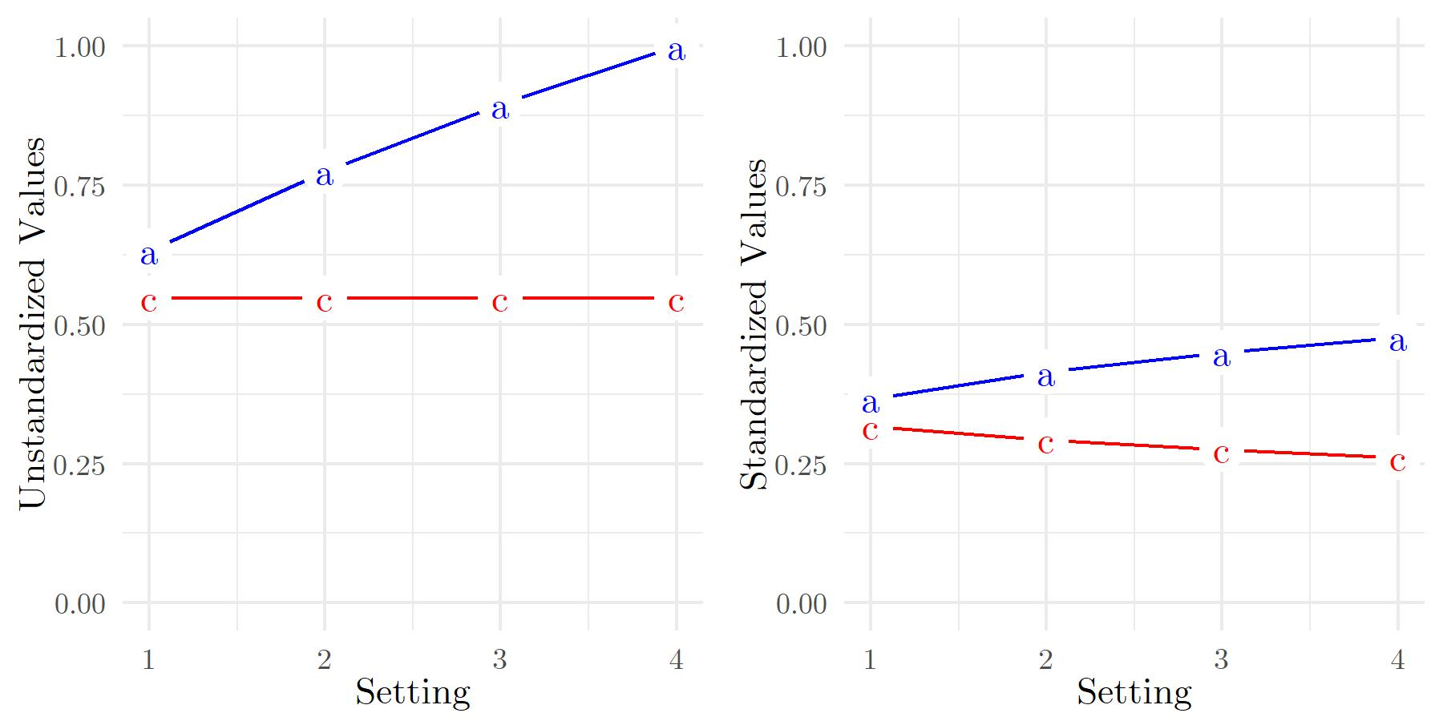
Fig. 3 Unstandardized and standardized a² and c² variance components for four Levels of a². a – additive genetic variance, c – shared environment variance. For readability, we did not plot the unique environment variance (e) since, for the chosen settings, the values for c and e are identical.
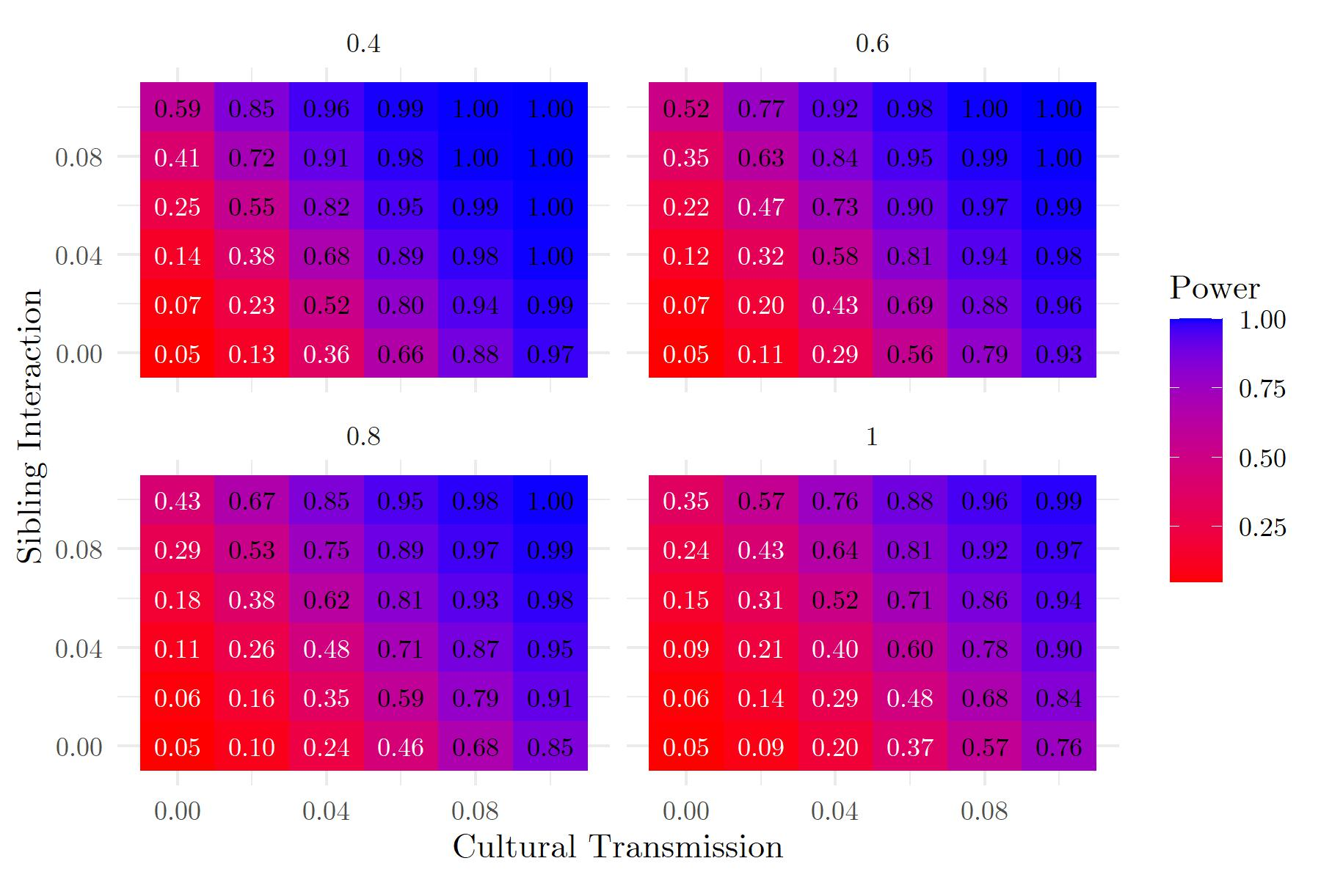
Fig. 4 Power Estimates for four Levels of a² in a design with two Factors (0 ≤ CT ≤ 0.1, 0 ≤ SI ≤ 0.1) With 6x6 Levels (Cultural Transmission Only).
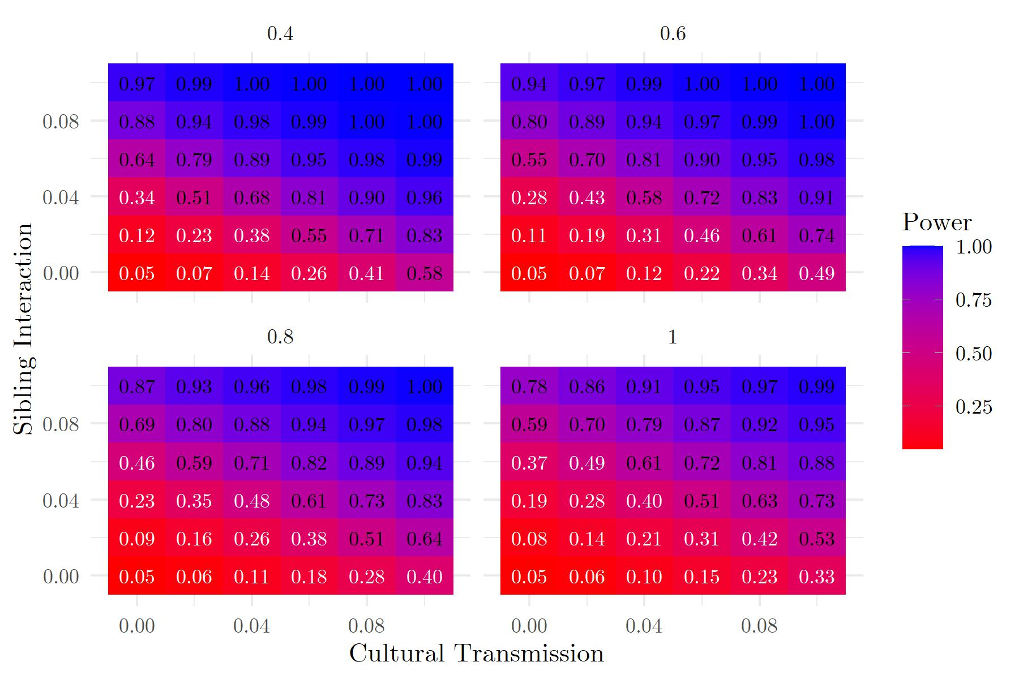
Fig. 5 Power Estimates for four Levels of a² in a design with two Factors (0 ≤ CT ≤ 0.1, 0 ≤ SI ≤ 0.1) With 6x6 Levels (Sibling Interaction Only).
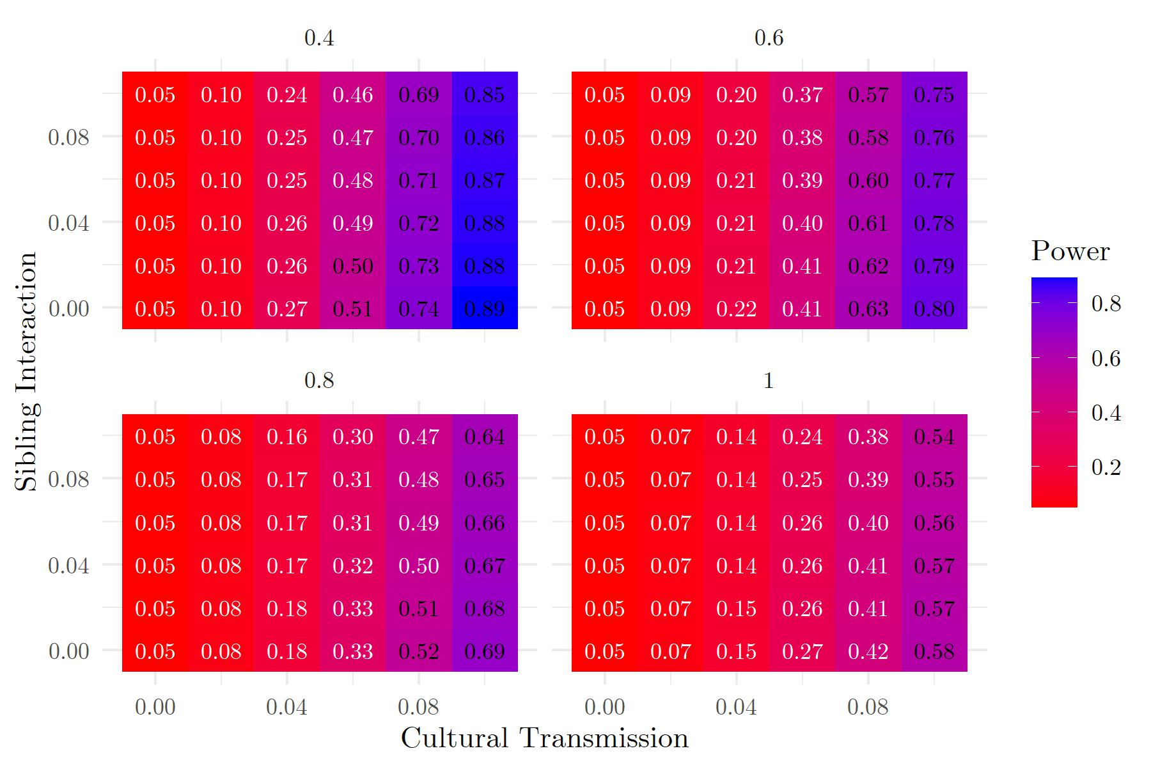
Fig. 6 Power Estimates for four Levels of a² in a design with two Factors (0 ≤ CT ≤ 0.1, 0 ≤ SI ≤ 0.1) With 6x6 Levels (Cultural Transmission Combined Model).
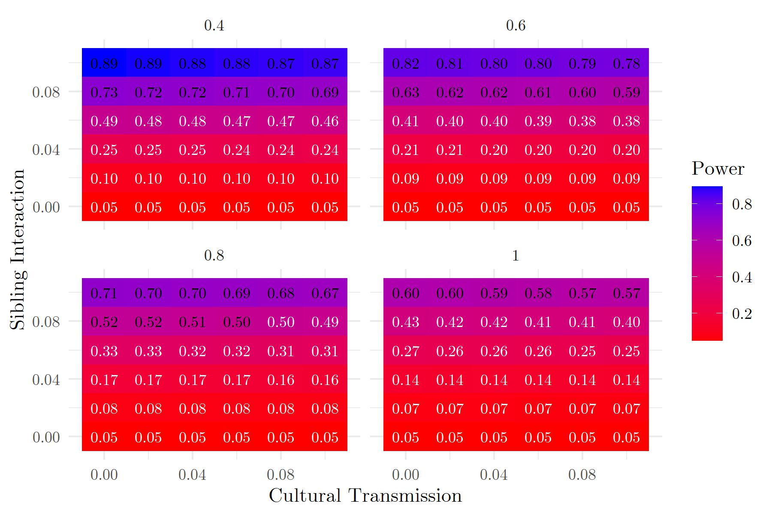
Fig. 7 Power Estimates for four Levels of a² in a design with two Factors (0 ≤ CT ≤ 0.1, 0 ≤ SI ≤ 0.1) With 6x6 Levels (Sibling Interaction Combined Model).
Lastly, we consider a study on educational achievement to demonstrate what power results for a concrete example might look like. The study tested heritability in a sample of twins using results of a Dutch nationwide test of educational attainment, the Cito score, as a phenotype (de Zeeuw et al 2016). We run the OpenMx simulation for a sample of 2451 MZ and 4569 DZ twins and assuming variances a² = .74, c² = .08, e² = .18. We make the bold assumption that, in addition to the phenotypic information used in the original study, we have access to genotypic information on these twin pairs and their parents. We assume the explained variance of a recent PGS for educational attainment to determine the PGS effect size (~12%; Lee et al 2018) and take a power of 80% for the combined model to be sufficient. We then increment the parameters g and b in steps of .01 to determine when power first exceeds 80%. The results are displayed in Table 3. These results demonstrate two crucial points: First, there is a relatively large difference in the power results for the cultural transmission-only and the sibling interaction-only model compared to the combined model. That is, we need much larger effect sizes to detect both parameters in the combined model. Second, the effect sizes that amount to sufficient power in the combined model here mean that AC covariance makes up an (unrealistically) large portion of the overall phenotypic variance.
Table 1
Power Estimates in Factorial Design With two Factors (CT, SI).
CT | SI | CT(m1) | SI(m2) | CT(m3) | SI(m3) | MZ s²_{Ph} | DZ s²_{Ph}
0 | 0 | 0.05 | 0.05 | 0.05 | 0.05 | 0.00% | 0.00%
0.05 | 0.05 | 0.835 | 0.840 | 0.287 | 0.302 | 18.45% | 14.15%
0.1 | 0.1 | 1 | 1 | 0.723 | 0.785 | 39.41% | 30.81%
0.11 | 0.11 | 1 | 1 | 0.788 | 0.850 | 43.90% | 34.44%
0.12 | 0.12 | 1 | 1 | 0.841 | 0.899 | 48.49% | 38.17%
Note. CT = cultural transmission, SI = sibling interaction, m1 = model only assuming CT, m2 = model only assuming SI, m3 = model assuming both CT and SI, MZ s²_{Ph} = percentage of variance inflation due to covAV for MZ twins, DZ s²_{Ph} = percentage of variance inflation due to AC covariance for DZ twins.
Appendix B: Results for GEE regression
We performed GEE analyses using the same settings as for SEM in OpenMx. Namely the same ACE variances (a² = .4, c² = .3, e² = .3), sample size (n_{MZ} = n_{DZ} = 4,000 pairs), varying g and b in a 3x3 design (settings: 0, 0.05, 0.), and four settings for the predictive power of the PGS (settings: 2%, 5%, 10%, 15%). We used the geeglm() function of the geepack package and chose the working correlation structure corstr = ‘exchangeable’.
Differences between the two methods were negligible, with power to detect cultural transmission being slightly higher for both methods. This suggests that GEE is a suitable alternative for SEM. However, SEM allows us to fit an ACE model to the residual covariance matrices which is not possible in GEE.
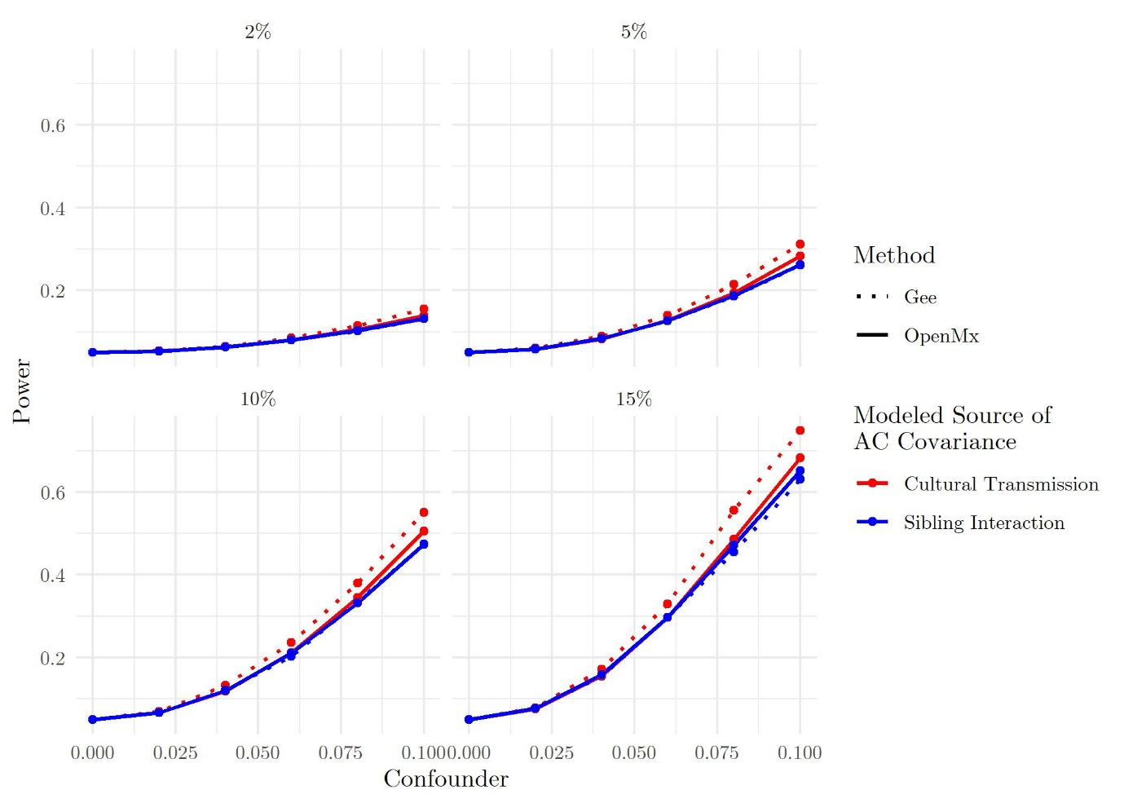
Fig. 8 Type I Error Rate in the MZ & DZ Sample for OpenMx vs. GEE Regression. The figure contrasts the statistical power to detect cultural transmission and sibling interaction when the model applied to the data does not match the data-generating model for two different modeling techniques: SEM using OpenMx and GLM using GEE regression. The four panels differ in the strength of the PGS. The PGS's strength is defined as the percentage of additive genetic variance that is captured by the PGS (so explicitly not the percentage of phenotypic variance captured by the PGS). The red lines show the power to detect cultural transmission, and the blue lines show the power to detect sibling interaction. The solid lines show analyses done with OpenMx, and the dotted lines show analyses done with GEE. Confounder = effect size of the true source of AC covariance in the data-generating model, Power = statistical power to detect the source of AC covariance in the model applied to the data.
Table 3
GEE Regression Power Estimates
g | b | PGS | p1 | p2 | p3 | p4 | p5 | p6 | p7 | p8 | MZ s²_{Ph} | DZ s²_{Ph}
0 | 0 | 0.02 | 0.05 | 0.05 | 0.05 | 0.05 | 0.05 | 0.05 | 0.05 | 0.05 | 0% | 0%
0.05 | 0 | 0.02 | 0.12 | 0.07 | 0.1 | 0.05 | 0.09 | 0.07 | 0.07 | 0.05 | 7% | 7%
0.1 | 0 | 0.02 | 0.32 | 0.13 | 0.23 | 0.05 | 0.2 | 0.13 | 0.12 | 0.05 | 15% | 15%
0 | 0.05 | 0.02 | 0.07 | 0.12 | 0.05 | 0.09 | 0.07 | 0.1 | 0.05 | 0.07 | 7% | 3%
0.05 | 0.05 | 0.02 | 0.23 | 0.22 | 0.09 | 0.1 | 0.18 | 0.18 | 0.07 | 0.07 | 14% | 11%
0.1 | 0.05 | 0.02 | 0.48 | 0.35 | 0.21 | 0.09 | 0.35 | 0.3 | 0.12 | 0.07 | 22% | 19%
0 | 0.1 | 0.02 | 0.15 | 0.33 | 0.05 | 0.23 | 0.15 | 0.25 | 0.05 | 0.14 | 14% | 7%
0.05 | 0.1 | 0.02 | 0.37 | 0.46 | 0.09 | 0.22 | 0.31 | 0.36 | 0.07 | 0.13 | 21% | 15%
0.1 | 0.1 | 0.02 | 0.64 | 0.62 | 0.2 | 0.21 | 0.5 | 0.5 | 0.11 | 0.12 | 30% | 24%
0 | 0 | 0.05 | 0.05 | 0.05 | 0.05 | 0.05 | 0.05 | 0.05 | 0.05 | 0.05 | 0% | 0%
0.05 | 0 | 0.05 | 0.22 | 0.1 | 0.17 | 0.05 | 0.15 | 0.1 | 0.1 | 0.05 | 7% | 7%
0.1 | 0 | 0.05 | 0.64 | 0.25 | 0.49 | 0.05 | 0.42 | 0.24 | 0.23 | 0.05 | 15% | 15%
0 | 0.05 | 0.05 | 0.11 | 0.23 | 0.05 | 0.17 | 0.12 | 0.17 | 0.05 | 0.11 | 7% | 3%
0.05 | 0.05 | 0.05 | 0.48 | 0.45 | 0.16 | 0.16 | 0.38 | 0.38 | 0.1 | 0.1 | 14% | 11%
0.1 | 0.05 | 0.05 | 0.85 | 0.71 | 0.47 | 0.16 | 0.68 | 0.61 | 0.22 | 0.1 | 22% | 19%
0 | 0.1 | 0.05 | 0.31 | 0.66 | 0.05 | 0.49 | 0.3 | 0.52 | 0.05 | 0.29 | 14% | 7%
0.05 | 0.1 | 0.05 | 0.76 | 0.86 | 0.16 | 0.48 | 0.65 | 0.73 | 0.1 | 0.26 | 21% | 15%
0.1 | 0.1 | 0.05 | 0.96 | 0.96 | 0.43 | 0.47 | 0.87 | 0.88 | 0.21 | 0.25 | 30% | 24%
0 | 0 | 0.1 | 0.05 | 0.05 | 0.05 | 0.05 | 0.05 | 0.05 | 0.05 | 0.05 | 0% | 0%
0.05 | 0 | 0.1 | 0.41 | 0.16 | 0.3 | 0.05 | 0.27 | 0.16 | 0.16 | 0.05 | 7% | 7%
0.1 | 0 | 0.1 | 0.92 | 0.47 | 0.77 | 0.05 | 0.74 | 0.45 | 0.43 | 0.05 | 15% | 15%
0 | 0.05 | 0.1 | 0.17 | 0.4 | 0.05 | 0.29 | 0.17 | 0.3 | 0.05 | 0.17 | 7% | 3%
0.05 | 0.05 | 0.1 | 0.76 | 0.74 | 0.28 | 0.28 | 0.63 | 0.64 | 0.14 | 0.16 | 14% | 11%
0.1 | 0.05 | 0.1 | 0.99 | 0.95 | 0.76 | 0.28 | 0.95 | 0.91 | 0.4 | 0.16 | 22% | 19%
0 | 0.1 | 0.1 | 0.56 | 0.93 | 0.05 | 0.79 | 0.56 | 0.81 | 0.05 | 0.49 | 14% | 7%
0.05 | 0.1 | 0.1 | 0.97 | 0.99 | 0.28 | 0.81 | 0.93 | 0.97 | 0.14 | 0.5 | 21% | 15%
0.1 | 0.1 | 0.1 | 1 | 1 | 0.73 | 0.77 | 0.99 | 1 | 0.38 | 0.45 | 30% | 24%
0 | 0 | 0.15 | 0.05 | 0.05 | 0.05 | 0.05 | 0.05 | 0.05 | 0.05 | 0.05 | 0% | 0%
0.05 | 0 | 0.15 | 0.58 | 0.22 | 0.44 | 0.05 | 0.38 | 0.22 | 0.21 | 0.05 | 7% | 7%
0.1 | 0 | 0.15 | 0.99 | 0.65 | 0.92 | 0.05 | 0.9 | 0.64 | 0.59 | 0.05 | 15% | 15%
0 | 0.05 | 0.15 | 0.26 | 0.58 | 0.05 | 0.41 | 0.27 | 0.46 | 0.05 | 0.24 | 7% | 3%
0.05 | 0.05 | 0.15 | 0.91 | 0.9 | 0.41 | 0.4 | 0.8 | 0.81 | 0.2 | 0.23 | 14% | 11%
0.1 | 0.05 | 0.15 | 1 | 0.99 | 0.91 | 0.39 | 0.99 | 0.98 | 0.57 | 0.22 | 22% | 19%
0 | 0.1 | 0.15 | 0.73 | 0.98 | 0.05 | 0.92 | 0.73 | 0.94 | 0.05 | 0.66 | 14% | 7%
0.05 | 0.1 | 0.15 | 1 | 1 | 0.38 | 0.92 | 0.98 | 1 | 0.18 | 0.65 | 21% | 15%
0.1 | 0.1 | 0.15 | 1 | 1 | 0.89 | 0.91 | 1 | 1 | 0.53 | 0.61 | 30% | 24%
Note. p1-p4 are power results for the MZ&DZ sample, p5-p8 are power results for the DZ-only sample. p1&p5 = power for CT in model that only accounts for CT, p2&p6 = estimate for SI in model that only accounts for SI, p3&p7 = power for CT in a regression that accounts for CT and SI, p4&p8 = power for SI in a regression that accounts for CT and SI, MZ s²_{Ph} = percentage of variance inflation due to covAC for MZ twins, DZ s²_{Ph} = percentage of variance inflation due to AC covariance for DZ twins.
Table 4
GEE Regression Parameter Estimates
g | b | PGS | e1 | e2 | e3 | e4 | e5 | e6 | e7 | e8 | MZ s²_{Ph} | DZ s²_{Ph}
0 | 0 | 0.02 | 0 | 0 | 0 | 0 | 0 | 0 | 0 | 0 | 0% | 0%
0.05 | 0 | 0.02 | 0.05 | 0.06 | 0.05 | 0 | 0.05 | 0.07 | 0.05 | 0 | 7% | 7%
0.1 | 0 | 0.02 | 0.1 | 0.11 | 0.1 | 0 | 0.1 | 0.13 | 0.1 | 0 | 15% | 15%
0 | 0.05 | 0.02 | 0.03 | 0.1 | 0 | 0.1 | 0.04 | 0.1 | 0 | 0.1 | 7% | 3%
0.05 | 0.05 | 0.02 | 0.08 | 0.16 | 0.05 | 0.1 | 0.09 | 0.17 | 0.05 | 0.1 | 14% | 11%
0.1 | 0.05 | 0.02 | 0.13 | 0.21 | 0.1 | 0.1 | 0.14 | 0.23 | 0.1 | 0.1 | 22% | 19%
0 | 0.1 | 0.02 | 0.06 | 0.2 | 0 | 0.2 | 0.08 | 0.2 | 0 | 0.2 | 14% | 7%
0.05 | 0.1 | 0.02 | 0.11 | 0.26 | 0.05 | 0.2 | 0.13 | 0.27 | 0.05 | 0.2 | 21% | 15%
0.1 | 0.1 | 0.02 | 0.17 | 0.31 | 0.1 | 0.2 | 0.18 | 0.33 | 0.1 | 0.2 | 30% | 24%
0 | 0 | 0.05 | 0 | 0 | 0 | 0 | 0 | 0 | 0 | 0 | 0% | 0%
0.05 | 0 | 0.05 | 0.05 | 0.06 | 0.05 | 0 | 0.05 | 0.07 | 0.05 | 0 | 7% | 7%
0.1 | 0 | 0.05 | 0.1 | 0.11 | 0.1 | 0 | 0.1 | 0.13 | 0.1 | 0 | 15% | 15%
0 | 0.05 | 0.05 | 0.03 | 0.1 | 0 | 0.1 | 0.04 | 0.1 | 0 | 0.1 | 7% | 3%
0.05 | 0.05 | 0.05 | 0.08 | 0.16 | 0.05 | 0.1 | 0.09 | 0.17 | 0.05 | 0.1 | 14% | 11%
0.1 | 0.05 | 0.05 | 0.13 | 0.21 | 0.1 | 0.1 | 0.14 | 0.23 | 0.1 | 0.1 | 22% | 19%
0 | 0.1 | 0.05 | 0.06 | 0.2 | 0 | 0.2 | 0.08 | 0.2 | 0 | 0.2 | 14% | 7%
0.05 | 0.1 | 0.05 | 0.11 | 0.26 | 0.05 | 0.2 | 0.13 | 0.27 | 0.05 | 0.2 | 21% | 15%
0.1 | 0.1 | 0.05 | 0.17 | 0.31 | 0.1 | 0.2 | 0.18 | 0.33 | 0.1 | 0.2 | 30% | 24%
0 | 0 | 0.1 | 0 | 0 | 0 | 0 | 0 | 0 | 0 | 0 | 0% | 0%
0.05 | 0 | 0.1 | 0.05 | 0.06 | 0.05 | 0 | 0.05 | 0.07 | 0.05 | 0 | 7% | 7%
0.1 | 0 | 0.1 | 0.1 | 0.11 | 0.1 | 0 | 0.1 | 0.13 | 0.1 | 0 | 15% | 15%
0 | 0.05 | 0.1 | 0.03 | 0.1 | 0 | 0.1 | 0.04 | 0.1 | 0 | 0.1 | 7% | 3%
0.05 | 0.05 | 0.1 | 0.08 | 0.16 | 0.05 | 0.1 | 0.09 | 0.17 | 0.05 | 0.1 | 14% | 11%
0.1 | 0.05 | 0.1 | 0.13 | 0.21 | 0.1 | 0.1 | 0.14 | 0.23 | 0.1 | 0.1 | 22% | 19%
0 | 0.1 | 0.1 | 0.06 | 0.2 | 0 | 0.2 | 0.08 | 0.2 | 0 | 0.2 | 14% | 7%
0.05 | 0.1 | 0.1 | 0.11 | 0.26 | 0.05 | 0.2 | 0.13 | 0.27 | 0.05 | 0.2 | 21% | 15%
0.1 | 0.1 | 0.1 | 0.16 | 0.31 | 0.1 | 0.2 | 0.18 | 0.33 | 0.1 | 0.2 | 30% | 24%
0 | 0 | 0.15 | 0 | 0 | 0 | 0 | 0 | 0 | 0 | 0 | 0% | 0%
0.05 | 0 | 0.15 | 0.05 | 0.06 | 0.05 | 0 | 0.05 | 0.07 | 0.05 | 0 | 7% | 7%
0.1 | 0 | 0.15 | 0.1 | 0.11 | 0.1 | 0 | 0.1 | 0.13 | 0.1 | 0 | 15% | 15%
0 | 0.05 | 0.15 | 0.03 | 0.1 | 0 | 0.1 | 0.04 | 0.1 | 0 | 0.1 | 7% | 3%
0.05 | 0.05 | 0.15 | 0.08 | 0.16 | 0.05 | 0.1 | 0.09 | 0.17 | 0.05 | 0.1 | 14% | 11%
0.1 | 0.05 | 0.15 | 0.13 | 0.21 | 0.1 | 0.1 | 0.14 | 0.23 | 0.1 | 0.1 | 22% | 19%
0 | 0.1 | 0.15 | 0.06 | 0.2 | 0 | 0.2 | 0.08 | 0.2 | 0 | 0.2 | 14% | 7%
0.05 | 0.1 | 0.15 | 0.11 | 0.26 | 0.05 | 0.2 | 0.13 | 0.27 | 0.05 | 0.2 | 21% | 15%
0.1 | 0.1 | 0.15 | 0.16 | 0.31 | 0.1 | 0.2 | 0.18 | 0.33 | 0.1 | 0.2 | 30% | 24%
Note. e1 is single-twin regression, e2-e5 are estimates for the DZ-only sample, e6-e9 are estimates for the MZ&DZ sample. e2&e6 = estimates for CT in model that only accounts for CT, e3&e7 = estimates for SI in model that only accounts for SI, e4&e8 = estimates for CT in a regression that accounts for CT and SI, e5&e9 = power for SI in a regression that accounts for CT and SI, MZ s²_{Ph} = percentage of variance inflation due to covAC for MZ twins, DZ s²_{Ph} = percentage of variance inflation due to AC covariance for DZ twins.
Appendix C: Effect size measures
The effect size measures represent the increase in total phenotypic variance due to AC covariance. This measure is calculated separately for MZ and DZ twins. The phenotypic variance of each twin can be derived using the expectation of the phenotypes of the twins. Given that all variables are mean centered we have:
$$σ_{PhT1}^{2}=E\left[Ph_{T1}∙Ph_{T1}\right]$$
Based on the model, the formulas for the phenotype are:
$$Ph_{T1}=a∙\left(½A_{M}+½A_{F}+zA_{T1}\right)+c∙C+e∙E_{T1}+g∙A_{M}+g∙A_{F}+b∙\left(½A_{M}+½A_{F}+zA_{T2}\right)$$
After simplifying, the total phenotypic variance for MZ twins can be expressed as follows:
$$σ_{Ph}^{2}\left(MZ\right) =2∙{\left(g+\frac{a}{2}+\frac{b}{2}\right)}^{2}∙var\left(A\right)+\left(a∙\frac{var\left(A\right)}{2}+b∙\frac{var\left(A\right)}{2}\right)∙a+\left(a∙\frac{var\left(A\right)}{2}+b∙\frac{var\left(A\right)}{2}\right)∙b+c^{2}∙var\left(C\right)+e^{2}∙var\left(E\right)$$
Based on the model, the formulas for the phenotype that need to be inserted are:
$${Ph}_{T1}=a∙\left(½A_{M}+½A_{F}+zA_{T1}\right)+c∙C+e∙E_{T1}+g∙A_{M}+g∙A_{F}+b∙\left(½A_{M}+½A_{F}+zA_{T2}\right)$$
After inserting this expression into the formula for variance and simplifying, the total phenotypic variance for MZ twins can be expressed as follows:
$$σ_{Ph}^{2}\left(MZ\right) =2∙{\left(g+\frac{a}{2}+\frac{b}{2}\right)}^{2}∙var\left(A\right)+\left(a∙\frac{var\left(A\right)}{2}+b∙\frac{var\left(A\right)}{2}\right)∙a+\left(a∙\frac{var\left(A\right)}{2}+b∙\frac{var\left(A\right)}{2}\right)∙b+c^{2}∙var\left(C\right)+e^{2}∙var\left(E\right)$$
And the total phenotypic variance for DZ twins is:
$$σ_{Ph}^{2}\left(DZ\right)=2∙{\left(g+\frac{a}{2}+\frac{b}{2}\right)}^{2}∙var\left(A\right)+a^{2}∙\frac{var\left(A\right)}{2}+b^{2}∙\frac{var\left(A\right)}{2}+c^{2}×var\left(C\right)+e^{2}×var\left(E\right)$$
If b = g = 0, meaning covAC = 0, the total phenotypic variance for both MZ and DZ twins is:
$$σ_{Ph}^{2}\left(MZ\right)=σ_{P}h^{2}\left(DZ\right)=a^{2}∙var\left(A\right)+c^{2}∙var\left(C\right)+e^{2}∙var\left(E\right)$$
These two variances are the basis of the effect size measure. Subtracting the phenotypic variance without AC covariance from the total phenotypic variance yields the remaining variance that is attributable to AC covariance. So, the effect size measures can be expressed as the following ratios:
$$effec{t\left(covAC\right)}_{MZ}=\frac{\left(2g^{2}+b^{2}+ab\right)∙var\left(A\right)}{a^{2}∙var\left(A\right)+c^{2}∙var\left(C\right)+e^{2}∙var\left(E\right)}=\frac{\left(2g^{2}+b^{2}+ab\right)∙var\left(A\right)}{σ_{Ph}^{2}}$$
$$effec{t\left(covAC\right)}_{DZ}=\frac{\left(2g^{2}+b^{2}\right)∙var\left(A\right)}{a^{2}∙var\left(A\right)+c^{2}∙var\left(C\right)+e^{2}∙var\left(E\right)}=\frac{\left(2g^{2}+b^{2}\right)∙var\left(A\right)}{σ_{Ph}^{2}}$$
The numerators show why these measures differ in the presence of sibling interaction but not in the presence of cultural transmission – the effect size measures are equal when b = 0 but when b ≠ 0 the measures differ by $\frac{ab ∙ var\left(A\right)}{σ_{Ph}^{2}}$.
Similarly to the effect size measures for overall AC covariance, we can also calculate a measure for the proportion of overall phenotypic variance that is accounted for by the polygenic score. As previously stated, this effect can be expressed as:
$$effect\left(PGS\right)=\frac{σ_{PGS}^{2}}{σ_{Ph}^{2}}$$
To calculate the variance of the PGS $σ_{PGS}^{2}$ we separate the total variance of A into a part that can be explained by the PGS, var(A₂), and a residual part, var(A₁). The variance of the polygenic score can then be expressed as:
$$σ_{PRS}^{2} = 2 ∙{\left(g+\frac{a}{2}+\frac{b}{2}\right)}^{2} ∙ var\left(A_{2}\right) +a^{2}∙ \frac{var\left(A_{2}\right)}{2}+b^{2}∙ \frac{var\left(A_{2}\right)}{2}$$
The decompositions of $σ_{Ph}^{2}$for MZ and DZ twins remains the same as described above. We provide a reference for how much of the phenotypic variances is accounted for by the PGS in the table below (Table 5).
Table 5
Proportion of Phenotypic Variance Accounted for by PGS (predictive power: 10%) in Factorial Design With two Factors (CT, SI) Each With 3 Levels (9 Cells).
CT | SI | % MZ s²_{PGS} | % DZ s²_{PGS}
0.00 | 0.00 | 4.00% | 4.00%
0.05 | 0.00 | 4.38% | 4.38%
0.10 | 0.00 | 4.77% | 4.77%
0.00 | 0.05 | 4.07% | 4.20%
0.00 | 0.10 | 4.16% | 4.41%
0.05 | 0.05 | 4.45% | 4.58%
0.10 | 0.05 | 4.83% | 4.96%
0.05 | 0.10 | 4.54% | 4.79%
0.10 | 0.10 | 4.91% | 5.16%
Note. CT = cultural transmission, SI = sibling interaction, % MZ s²_{PGS} = percentage of phenotypic variance accounted for by PGS for MZ twins, % DZ s²_{PGS} = percentage of phenotypic variance accounted for by PGS for DZ twins. We have marked instances of only one source of AC covariance in bold.
Appendix D: Power Analyses Using the R Package gnomesims
The analyses presented in this paper may be replicated using the R package gnomesims (pronounced ‘genome sims’), which was written to perform genomic simulations. This package allows to calculate the power and effect sizes required to detect the two sources of AC covariance discussed in this paper: cultural transmission and sibling interaction. Its primary purpose is to compute power and effect sizes for simulated data sets based on specified characteristics (ACE decomposition, strength of PGS, AC covariance etc.), allowing for both a priori and post-hoc power analyses using either OpenMx or GEE. The package is available on Github (https://github.com/josefinabernardo/gnomesims) which includes instructions for installation. A detailed vignette and documentation for all functions are available on the package website under: https://josefinabernardo.github.io/gnomesims/.

