Additional material
Consumption of ultra-processed foods and drinks and colorectal, breast and prostate cancer in the Multicase-control Study (MCC)-Spain
Dora Romaguera^{1,2,a,b}, Sílvia Fernández-Barrés^{1,3,4,b}, Esther Gracia-Levadán^{1,3,4}, Eva Vendrell⁵, Mikel Azpiri⁶, Emma Ruiz-Moreno^{4,7}, Vicente Martín^{4,8,9}, Inés Gómez-Acebo^{4,107}, Mireia Obón^{4,11,12}, Amaia Molinuevo⁶, Ujué Fresán^{4,13}, Ana Molina-Barceló¹⁴, Rocío Olmedo-Requena^{4,15,16}, Adonina Tardón^{4,17}, Juan Alguacil^{4,18}, Marta Solans^{4,19}, Jose Mª Huerta^{4,20}, José Manuel Ruiz-Dominguez²¹, Nuria Aragonés^{4,22}, Tania Fernández-Villa^{8,9}, Trinidad Dierssen-Sotos^{4,10}, Victor Moreno^{4,11,12,23}, Marcela Guevara^{4,13,24}, Mercedes Vanaclocha-Espi¹⁴, Macarena Lozano-Lorca¹⁵, Guillermo Fernández-Tardón^{17,25}, Gemma Castaño-Vinyals^{1,3,4,26} ,Beatriz Pérez-Gómez^{4,7}, Antonio J Molina^{8,9}, Javier Llorca^{4,10}, Leire Gil⁶, Jesús Castilla^{4,13,24}, Marina Pollán^{4,7}, Manolis Kogevinas^{1,3,4,26}, Pilar Amiano^{4,6}.

ªCorresponding
^{b}Joint first authorship

ª^{b}Dora Romaguera dora.romaguera@isglobal.org
1 Instituto de Salud Global de Barcelona (ISGlobal), Barcelona, Spain
2 Instituto de Investigación Sanitaria Illes Balears (IdISBa), Spain; CIBER Fisiopatología de la Obesidad y Nutrición (CIBEROBN), Spain.

^{b}Sílvia Fernández-Barrés silvia.fernandez@isglobal.org
1 Instituto de Salud Global de Barcelona (ISGlobal), Barcelona, Spain;
3 Universitat Pompeu Fabra (UPF), Barcelona, Spain
4 Consortium for Biomedical Research in Epidemiology and Public Health (CIBERESP), Madrid, Spain

Esther Gracia-Levadán esthergrala@gmail.com
1 Instituto de Salud Global de Barcelona ISGlobal, Barcelona, Spain;
3 Universitat Pompeu Fabra (UPF), Barcelona, Spain
4 Consortium for Biomedical Research in Epidemiology and Public Health (CIBERESP), Madrid, Spain

Eva Vendrell evavendrell5@gmail.com
5-Faculty of Health Sciences, Universitat Oberta de Catalunya (Open University of Catalonia, UOC), 08018
Barcelona, Spain

Mikel Azpiri koor-tolosa@euskadi.eus
6-Public Health Division of Gipuzkoa, Biodonostia Research Institute, San Sebastian, Spain

Emma Ruiz-Moreno e.ruiz@externos.isciii.es
4-Consortium for Biomedical Research in Epidemiology and Public Health (CIBERESP), Madrid, Spain
7-Cancer & Environmental Epidemiology Unit, Department of Epidemiology of Chronic Diseases, National Centre for Epidemiology, Carlos III Institute of Health, Madrid, Spain.

Vicente Martín vicente.martin@unileon.es
4-Consortium for Biomedical Research in Epidemiology and Public Health (CIBERESP), Madrid, Spain
8-The Research Group in Gene - Environment and Health Interactions (GIIGAS) / Institut of Biomedicine (IBIOMED), Universidad de León, León, Spain
9- Faculty of Health Sciences, Department of Biomedical Sciences, Area of Preventive Medicine and Public Health, Universidad de León, Spain.

Inés Gómez-Acebo ines.gomez@unican.es
4-Consortium for Biomedical Research in Epidemiology and Public Health (CIBERESP), Madrid, Spain
10-Universidad de Cantabria – IDIVAL, Santander, Spain

Mireia Obón mobon@iconcologia.net
4-Consortium for Biomedical Research in Epidemiology and Public Health (CIBERESP), Madrid, Spain
11-Oncology Data Analytics Program (ODAP), Catalan Institute of Oncology (ICO), L’Hospitalet del Llobregat, Barcelona, Spain.
12-Bellvitge Biomedical Research Institute - IDIBELL, L'Hospitalet de Llobregat, Barcelona, Spain.

Amaia Molinuevo au-molinuevo@euskadi.eus
6 -Biodonostia Research Institute, San Sebastian, Spain

Ujué Fresan ujue.fresan.salvo@navarra.es
4-Consortium for Biomedical Research in Epidemiology and Public Health (CIBERESP), Madrid, Spain
13-Navarra Public Health Institute, Pamplona, Spain

Ana Molina-Barceló molina_anabar@gva.es
14 Cancer and Public Health Area, FISABIO – Public Health. Valencia, Spain

Rocío Olmedo-Requena rocioolmedo@ugr.es
4-Consortium for Biomedical Research in Epidemiology and Public Health (CIBERESP), Madrid, Spain
15-Department of Preventive Medicine and Public Health. School of Medicine. University of Granada
16 -Instituto de Investigación Biosanitaria de Granada ibs.GRANADA
Spain

Adonina Tardón atardon@uniovi.es
4-Consortium for Biomedical Research in Epidemiology and Public Health (CIBERESP), Madrid, Spain
17 -Department of Medicine, University of Oviedo, Oviedo, Spain.

Juan Alguacil juan.alguacil@dbasp.uhu.es
4-Consortium for Biomedical Research in Epidemiology and Public Health (CIBERESP), Madrid, Spain
18-Centro de Investigación en Recursos Naturales, Salud y Medio Ambiente (RENSMA), Universidad de Huelva, Huelva, Spain.

Marta Solans martasolans@gmail.com
4 Consortium for Biomedical Research in Epidemiology and Public Health (CIBERESP), Madrid, Spain
19 Research Group on Statistics, Econometrics and Health (GRECS), University of Girona, Girona, Spain

Jose Mª Huerta jmhuerta.carm@gmail.com
4-Consortium for Biomedical Research in Epidemiology and Public Health (CIBERESP), Madrid, Spain
20-Department of Epidemiology, Murcia Regional Health Council, IMIB-Arrixaca, Murcia, Spain.

José Manuel Ruiz-Dominguez jmruizdominguez@gmail.com
21-Department of Urology, Hospital Germans Trias i Pujol, Badalona, Spain

Nuria Aragonés nuria.aragones@salud.madrid.org
4-Consortium for Biomedical Research in Epidemiology and Public Health (CIBERESP), Madrid, Spain
22-Epidemiology Section, Public Health Division, Department of Health, Madrid, Spain

Tania Fernández-Villa tferv@unileon.es
8 The Research Group in Gene - Environment and Health Interactions (GIIGAS) / Institut of Biomedicine (IBIOMED), Universidad de León, León, Spain
9 - Faculty of Health Sciences, Department of Biomedical Sciences, Area of Preventive Medicine and Public Health, Universidad de León, Spain

Trinidad Dierssen-Sotos dierssent@unican.es
4-Consortium for Biomedical Research in Epidemiology and Public Health (CIBERESP), Madrid, Spain
10 Universidad de Cantabria – IDIVAL, Santander, Spain

Victor Moreno v.moreno@iconcologia.net
4-Consortium for Biomedical Research in Epidemiology and Public Health (CIBERESP), Madrid, Spain
11- Oncology Data Analytics Program (ODAP), Catalan Institute of Oncology (ICO), L’Hospitalet del Llobregat, Barcelona, Spain
12 -ONCOBELL Program, Bellvitge Biomedical Research Institute (IDIBELL), L'Hospitalet de Llobregat, Barcelona, Spain.
23 -Department of Clinical Sciences, Faculty of Medicine, University of Barcelona, Barcelona, Spain

Marcela Guevara mp.guevara.eslava@navarra.es
4-Consortium for Biomedical Research in Epidemiology and Public Health (CIBERESP), Madrid, Spain
13-Navarra Public Health Institute, Pamplona, Spain
24 -IdiSNA, Navarra Institute for Health Research, Pamplona, Spain

Mercedes Vanaclocha-Espi vanaclocha_mer@gva.es
14 Cancer and Public Health Area, FISABIO – Public Health. Valencia, Spain.

Macarena Lozano-Lorca macarenalozano@ugr.es
15 -Department of Preventive Medicine and Public Health. School of Medicine. University of Granada

Guillermo Fernández-Tardón, gfernanta@gmail.com
17- Department of Medicine, University of Oviedo, Oviedo, Spain.
25-Instituto de Investigación Sanitaria del Principado de Asturias. ISPA

Gemma Castaño-Vinyals gemma.castano@isglobal.org
1 Instituto de Salud Global de Barcelona (ISGlobal), Barcelona, Spain
3-Universitat Pompeu Fabra (UPF), Barcelona, Spain
4-Consortium for Biomedical Research in Epidemiology and Public Health (CIBERESP), Madrid, Spain
26-IMIM (Hospital del Mar Medical Research Institute), Barcelona, Spain.

Beatriz Pérez-Gómez bperez@isciii.es
4-Consortium for Biomedical Research in Epidemiology and Public Health (CIBERESP), Madrid, Spain
7- Cancer & Environmental Epidemiology Unit, Department of Epidemiology of Chronic Diseases, National Centre for Epidemiology, Carlos III Institute of Health, Madrid, Spain.

Antonio J Molina ajmolt@unileon.es
8-The Research Group in Gene - Environment and Health Interactions (GIIGAS) / Institut of Biomedicine (IBIOMED), Universidad de León, León, Spain
9- Faculty of Health Sciences, Department of Biomedical Sciences, Area of Preventive Medicine and Public Health, Universidad de León, Spain

Javier Llorca javier.llorca@unican.es
4-Consortium for Biomedical Research in Epidemiology and Public Health (CIBERESP), Madrid, Spain
10 Universidad de Cantabria – IDIVAL, Santander, Spain

Leire Gil l-gil@euskadi.eus
6 -Public Health Division of Gipuzkoa, San Sebastian, Biodonostia Research Institute, San Sebastian, Spain

Jesús Castilla jcastilc@navarra.es
4-Consortium for Biomedical Research in Epidemiology and Public Health (CIBERESP), Madrid, Spain
13 -Navarra Public Health Institute, Pamplona, Spain
24 -IdiSNA, Navarra Institute for Health Research, Pamplona, Spain

Marina Pollán mpollan@isciii.es
4-Consortium for Biomedical Research in Epidemiology and Public Health (CIBERESP), Madrid, Spain
7 -Cancer & Environmental Epidemiology Unit, Department of Epidemiology of Chronic Diseases, National Centre for Epidemiology, Carlos III Institute of Health, Madrid, Spain.

Manolis Kogevinas manolis.kogevinas@isglobal.org
1 Instituto de Salud Global de Barcelona (ISGlobal), Barcelona, Spain
3 -Universitat Pompeu Fabra (UPF), Barcelona, Spain
4-Consortium for Biomedical Research in Epidemiology and Public Health (CIBERESP), Madrid, Spain
26-IMIM (Hospital del Mar Medical Research Institute), Barcelona, Spain. .

Pilar Amiano epicss-san@euskadi.eus
4-Consortium for Biomedical Research in Epidemiology and Public Health (CIBERESP), Madrid, Spain
6-Public Health Division of Gipuzkoa, Biodonostia Research Institute, San Sebastian, Spain

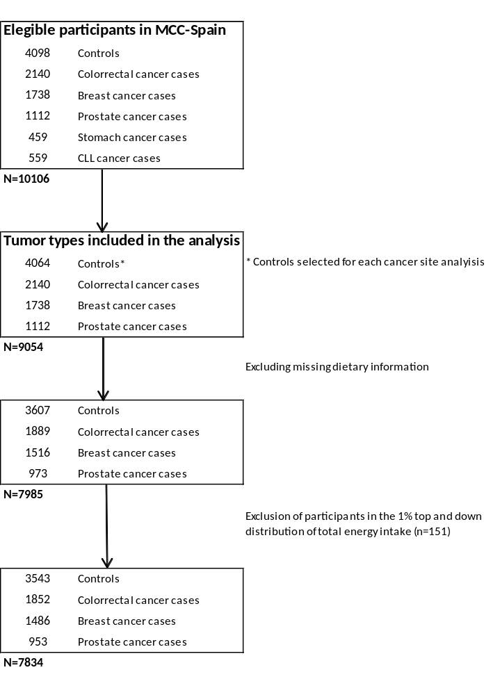

Additional Figure 1: Flow chart of study population selection

Additional Table 1: Classification of foods according to the NOVA definition
We classified the foods and drinks of the MCC-Spain food frequency questionnaire based on the degree of processing.

Food groups | Items included in the MCC-Spain Food frequency questionnaire
Group 1  Unprocessed or minimum processed foods | Whole milk and skimmed milk, whole and skimmed yogurts, meat (chicken, turkey, pork, beef, lamb, rabbit), liver, offal, fish, seafood, fresh vegetables, homemade gazpacho and vegetable puree, legumes, fresh fruits, nuts, potatoes, rice, pasta, natural fruit juices, sparkling water and coffee.
Group 2  Processed culinary ingredients | Salt, olive oil, sunflower oil, butter, lard and sugar.
Group 3  Processed foods | Bacon, cured ham, canned fish and seafood, cured fish, canned fruits, canned vegetables, fruits in syrup, olives, dry fruits, condensed milk, cheeses, white bread, whole grain bread, jam, wine, beers and champagne.
Group 4  Ultra-processed foods and drinks | Processed meats (sausages, hamburgers, meat balls, ham, cold meats, hot dog, pâté), croquettes, crab sticks, pastries, kebab, soya milk, custard, milkshakes, ice creams, breakfast cereals, wholegrain breakfast cereals, breadsticks, ravioli, pizza, instant soup, mayonnaise (normal and light), tomato sauce, cream, other sauces, margarine, cookies, pastries, churros, chocolate, chocolate powder, turrón (nougat), mantecado, chips, spirits, sugar-sweetened beverages, non-sugar sweetened beverages, packed fruit juices, tomato juice, tiger nut milk, soda water, saccharin and sweeteners.

We created a working group including dietitians-nutritionists and nutrition experts to classify all the foods into the four NOVA groups[1]. In case of doubts for specific foods and beverages, we reached a consensus based on the food composition table used, the labels of the products and also information of usual consumption from external sources[2][3].
For example, for the consumption of burgers and meatballs they can be artisanal or industrial, we assumed that were industrial, and they were classified as ultra-processed foods (because they have added ingredients as sulphites and flavors).
Regarding the consumption of nuts, according to the Spanish household consumption database, raw walnuts are the most consumed nuts, for this reason we categorized nuts as non-processed foods (G1)[4].
In the MCC food frequency questionnaire, we could not distinguish between plain yogurt and sweetened and flavored yogurt. We considered yogurt to be unprocessed or minimum processed foods (G1).
Recipes based on vegetables (as Gazpacho and vegetable puree) were considered as minimally process foods (G1), as we assumed that they were homemade, ready to eat recipes (with no preservation purposes). However, for the tomato sauce item, we considered as ultra-processed food (G4), based on the data of the household consumption database, since industrial fried tomato sauce is more consumed that plain tomato sauce[5].
Wholegrain breakfast cereals could be also minimally processed (G1), such as wholegrain oats or commercial wholegrain cereals that include sugar and other multiple ingredients and are, therefore, ultra-processed (G4). In this population, we considered all breakfast cereals to be commercial cereals.

Additional Table 2: Characteristics of study population according to their group control vs case in the MCC-Study.
 | Colorectal cancer |  |  | Breast cancer |  |  | Prostate cancer
 | Control  N=3447 | Case  N=1852 | p-value | Control  N=1652 | Case  N=1486 | p-value | Control  N=1283 | Case  N=953 | p-value
 | mean (sd) / N (%) | mean (sd) / N (%) |  | mean (sd) / N (%) | mean (sd) / N (%) |  | mean (sd) / N (%) | mean (sd) / N (%)
Age (years) | 63.2 (11.7) | 66.8 (10.6) | <0.001 | 59.0 (13.0) | 56.2 (12.4) | <0.001 | 66.4 (8.59) | 66.0 (7.28) | 0.178
Sex |  |  | <0.001
Male | 1781 (51.7%) | 1183 (63.9%) |  | - | - |  | - | -
Female | 1666 (48.3%) | 669 (36.1%) |  | - | - |  | - | -
BMI (kg/m²) | 26.6 (4.40) | 27.6 (4.47) | <0.001 | 25.7 (4.83) | 25.9 (4.62) | 0.398 | 27.5 (3.79) | 27.6 (3.72) | 0.327
Education level |  |  | <0.001 |  |  | 0.072 |  |  | <0.001
Less than primary | 604 (17.5%) | 578 (31.2%) |  | 272 (16.5%) | 209 (14.1%) |  | 232 (18.1%) | 218 (22.9%)
Primary | 1120 (32.5%) | 715 (38.6%) |  | 500 (30.3%) | 491 (33.0%) |  | 419 (32.7%) | 380 (39.9%)
High school | 992 (28.8%) | 373 (20.1%) |  | 520 (31.5%) | 492 (33.1%) |  | 356 (27.7%) | 209 (21.9%)
University | 731 (21.2%) | 186 (10.0%) |  | 360 (21.8%) | 294 (19.8%) |  | 276 (21.5%) | 146 (15.3%)
Tobacco smoking |  |  | <0.001 |  |  | 0.004 |  |  | 0.180
Never smoker | 1522 (44.3%) | 766 (41.6%) |  | 991 (60.1%) | 822 (55.5%) |  | 345 (27.0%) | 288 (30.3%)
Former smoker | 1204 (35.1%) | 747 (40.6%) |  | 330 (20.0%) | 294 (19.8%) |  | 662 (51.7%) | 459 (48.3%)
Current smoker | 709 (20.6%) | 329 (17.9%) |  | 329 (19.9%) | 366 (24.7%) |  | 273 (21.3%) | 204 (21.5%)
Family historyª |  |  | <0.001 |  |  | <0.001 |  |  | <0.001
Yes | 2960 (90.9%) | 1415 (82.3%) |  | 1441 (90.9%) | 1232 (85.0%) |  | 1108 (93.1%) | 746 (81.3%)
No | 297 (9.12%) | 304 (17.7%) |  | 144 (9.09%) | 218 (15.0%) |  | 82 (6.89%) | 172 (18.7%)
Physical activity |  |  | <0.001 |  |  | 0.398 |  |  | 0.616
Inactive | 1316 (38.6%) | 949 (51.2%) |  | 628 (38.3%) | 613 (41.3%) |  | 519 (41.0%) | 366 (38.4%)
Moderately active | 501 (14.7%) | 214 (11.6%) |  | 305 (18.6%) | 256 (17.2%) |  | 160 (12.6%) | 129 (13.5%)
Active | 416 (12.2%) | 159 (8.59%) |  | 214 (13.1%) | 190 (12.8%) |  | 143 (11.3%) | 117 (12.3%)
Very active | 1178 (34.5%) | 530 (28.6%) |  | 491 (30.0%) | 427 (28.7%) |  | 443 (35.0%) | 341 (35.8%)
Use of NSAIDs/aspirin |  |  | <0.001
Yes | 1334 (38.7%) | 604 (32.6%) |  | - | - |  | - | -
No | 2000 (58.0%) | 1184 (63.9%) |  | - | - |  | - | -
Missing | 113 (3.28%) | 64 (3.46%) |  | - | - |  | - | -
Use of OC |  |  |  |  |  | 0.527
Never | - | - |  | 832 (50.8%) | 772 (52.0%) |  | - | -
Ever | - | - |  | 805 (49.2%) | 712 (48.0%) |  | - | -
Use of HRT |  |  |  |  |  | 0.008
Never | - | - |  | 1456 (88.1%) | 1347 (90.6%) |  | - | -
Ever | - | - |  | 125 (7.57%) | 104 (7.00%) |  | - | -
Missing |  |  |  | 71 (4.30%) | 35 (2.36%) |  | - | -
Menopause |  |  |  |  |  | <0.001
Postmenopause | - | - |  | 1175 (71.2%) | 953 (64.2%) |  | - | -
Premenopause | - | - |  | 476 (28.8%) | 532 (35.8%) |  | - | -
Menarche |  |  |  |  |  | <0.001
< 13 years | - | - |  | 667 (40.4%) | 630 (42.4%) |  | - | -
≥ 13 years | - | - |  | 925 (56.0%) | 837 (56.3%) |  | - | -
Missing |  |  |  | 60 (3.63%) | 19 (1.28%)
Age of first delivery |  |  |  |  |  | 0.328
< 20 years | - | - |  | 537 (32.6%) | 454 (30.8%) |  | - | -
20-24 years | - | - |  | 58 (3.53%) | 59 (4.00%) |  | - | -
25-29 years | - | - |  | 407 (24.7%) | 345 (23.4%) |  | - | -
> 29 years | - | - |  | 333 (20.2%) | 301 (20.4%) |  | - | -
Nulliparous | - | - |  | 310 (18.8%) | 317 (21.5%) |  | - | -
Number of children |  |  |  |  |  | 0.001
Nulliparous | - | - |  | 310 (18.8%) | 317 (21.4%) |  | - | -
1-2 children | - | - |  | 917 (55.6%) | 869 (58.6%) |  | - | -
≥ 3 children | - | - |  | 421 (25.5%) | 298 (20.1%) |  | - | -
Energy intake (kcal/day) | 1896 (560) | 2000 (622) | <0.001 | 1769 (509) | 1852 (532) | <0.001 | 2009 (592) | 2059 (604) | 0.048
Ethanol intake (g/day) | 11.0 (15.9) | 12.0 (19.3) | 0.056 | 4.97 (8.18) | 5.16 (9.29) | 0.545 | 17.3 (19.7) | 17.0 (19.6) | 0.794
Fiber (g/day)/1000 kcal | 12.1 (3.97) | 11.4 (3.58) | <0.001 | 12.8 (4.14) | 12.3 (4.15) | 0.002 | 11.3 (3.65) | 11.1 (3.55) | 0.262
Energy density (g/kcal) | 1.41 (0.31) | 1.44 (0.30) | 0.001 | 1.37 (0.31) | 1.41 (0.31) | <0.001 | 1.47 (0.30) | 1.48 (0.29) | 0.602
Saturated fatty acids (% total EI) | 10.9 (2.38) | 11.1 (2.31) | 0.008 | 11.2 (2.37) | 11.4 (2.34) | 0.054 | 10.7 (2.30) | 10.8 (2.34) | 0.397
Simple carbohydrate (% total EI) | 22.5 (5.98) | 22.1 (5.98) | 0.068 | 23.6 (6.16) | 23.4 (6.00) | 0.294 | 21.4 (5.73) | 21.3 (5.43) | 0.898
G1: Unprocessed or minimally processed food consumption (%)^{b} | 68.6 (13.5) | 67.0 (14.2) | <0.001 | 72.8 (12.0) | 71.0 (12.6) | <0.001 | 63.8 (13.3) | 63.4 (13.5) | 0.532
G2: Processed culinary ingredient consumption (%) | 1.73 (1.13) | 1.76 (1.15) | 0.412 | 1.86 (1.20) | 1.92 (1.17) | 0.165 | 1.53 (1.00) | 1.51 (1.00) | 0.664
G3: Processed food consumption (%) | 16.5 (10.3) | 17.2 (11.3) | 0.047 | 11.9 (6.93) | 12.4 (7.83) | 0.069 | 21.3 (11.5) | 21.2 (11.5) | 0.801
G4: Ultra-processed food and drink consumption (%) | 13.2 (10.5) | 14.1 (10.9) | 0.003 | 13.4 (10.8) | 14.7 (11.2) | 0.001 | 13.4 (9.78) | 13.9 (10.1) | 0.240
MCC, Multi-case-control Spain study; NSADs, nonsteroidal anti-inflammatory drugs; OC, oral contraceptive use; HRT, hormone replacement therapy use; EI: Total daily energy intake ªOnly first degree colorectal cancers, breast cancer or prostate cancer. ^{b}Calculated as daily g within each group/total daily g, multiplied by 100.

Additional Figure 2: Contribution of each food group to ultra-processed food and drink consumption in controls

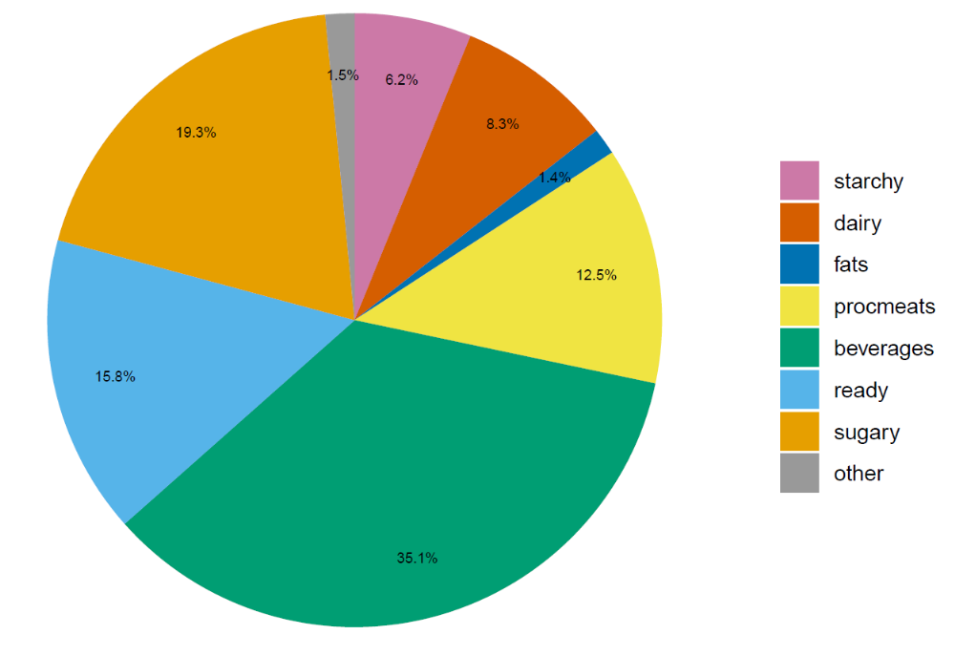

Additional Table 3: Association between ultra-processed foods and drinks consumption and colorectal, breast and prostate cancer in the MCC-Spain Study (stratified analysis)
 |  | 10%  increase |  | Low | Medium | High
 | Control/Case | OR (95% CI) | P for interaction | OR (95% CI) | OR (95% CI) | OR (95% CI) | P for trend
Colorectal cancer
Ageª |  |  | 0.587
22 to 59 years | 1152/431 | 1.08 (0.97, 1.19) |  | Ref | 1.24 (0.87,1.77) | 1.20 (0.85,1.69) | 0.397
59to 69 years | 1099/592 | 1.03 (0.92,1.15) |  | Ref | 0.94 (0.72,1.22) | 1.13 (0.86,1.47) | 0.377
69 to 85 years | 1148/819 | 1.17 (1.06,1.30) |  | Ref | 1.16 (0.91,1.47) | 1.46 (1.14,1.86) | 0.003
Smoking^{b} |  |  | 0.384
Never | 1506/766 | 1.15 (1.05, 1.27) |  | Ref | 1.13 (0.89, 1.43) | 1.36 (1.07, 1.73) | 0.013
Former-current | 1893/1076 | 1.07 (0.99, 1.16) |  | Ref | 1.06 (0.87, 1.31) | 1.22 (0.99, 1.50) | 0.059
Educational level^{c} |  |  | 0.120
Less than secondary | 1707/1288 | 1.07 (0.99, 1.16) |  | Ref | 0.95 (0.78, 1.15) | 1.20 (0.99, 1.45) | 0.070
Secondary and more | 1692/554 | 1.17 (1.07, 1.29) |  | Ref | 1.38 (1.05, 1.81) | 1.47 (1.12, 1.93) | 0.007
Physical activity^{d} |  |  | 0.069
Inactive | 1811/1157 | 1.08 (1.00, 1.17) |  | Ref | 0.92 (0.75, 1.14) | 1.20 (0.98, 1.47) | 0.064
Active | 1588/685 | 1.17 (1.06, 1.29) |  | Ref | 1.36 (1.07, 1.72) | 1.44 (1.13, 1.84) | 0.003
Fruit &vegetable^{e} |  |  | 0.003
<median | 1688/968 | 1.01 (0.94, 1.10) |  | Ref | 1.10 (0.87, 1.38) | 1.04 (0.82, 1.31) | 0.823
≥ median | 1711/874 | 1.19 (1.08, 1.32) |  | Ref | 0.95 (0.76, 1.18) | 1.41 (1.12, 1.77) | 0.005
Breast cancer
Age^{f} |  |  | 0.567
22 to 59 years | 825/907 | 1.05 (0.96,1.14) |  | Ref | 1.26 (0.96,1.65) | 1.32 (1.00,1.73) | 0.063
59 to 69 years | 389/345 | 0.97 (0.81,1.17) |  | Ref | 0.99 (0.68,1.43) | 1.02 (0.68,1.53) | 0.936
69 to 85 years | 414/219 | 1.12 (0.92,1.37) |  | Ref | 0.99 (0.64,1.54) | 1.17 (0.72,1.91) | 0.553
Smoking^{g} |  |  | 0.004
Never | 981/815 | 0.93 (0.84, 1.04) |  | Ref | 1.06 (0.83, 1.34) | 0.99 (0.76, 1.28) | 0.930
Former-current | 647/656 | 1.15 (1.04, 1.28) |  | Ref | 1.25 (0.91, 1.71) | 1.50 (1.09, 2.06) | 0.011
Educational level^{h} |  |  | 0.219
Less than secondary | 762/693 | 0.97 (0.87, 1.09) |  | Ref | 0.94 (0.71, 1.26) | 0.97 (0.87, 1.09) | 0.690
Secondary and more | 866/778 | 1.09 (0.99, 1.20) |  | Ref | 1.28 (0.98, 1.69) | 1.43 (1.09, 1.89) | 0.013
Physical activity^{i} |  |  | 0.101
Inactive | 929/860 | 1.01 (0.92, 1.11) |  | Ref | 1.00 (0.77, 1.29) | 0.98 (0.76, 1.28) | 0.904
Active | 699/611 | 1.10 (0.98, 1.25) |  | Ref | 1.24 (0.93, 1.64) | 1.48 (1.10, 2.01) | 0.011
Fruit & vegetable^{j} |  |  | 0.395
<median | 747/729 | 1.00 (0.91, 1.11) |  | Ref | 1.22 (0.90, 1.66) | 1.06 (0.77, 1.44) | 0.946
≥ median | 881/742 | 1.05 (0.93, 1.19) |  | Ref | 1.04 (0.81, 1.33) | 1.25 (0.94, 1.65) | 0.129
Prostate cancer
Age^{k} |  |  | 0.298
22 to 59 years | 236/168 | 0.99 (0.81,1.21) |  | Ref | 0.80 (0.42,1.53) | 0.72 (0.38,1.35) | 0.308
59 to 69 years | 538/476 | 1.10 (0.95,1.28) |  | Ref | 1.09 (0.78,1.52) | 1.42 (1.01,1.99) | 0.040
69 to 85 years | 488/307 | 0.97 (0.82,1.15) |  | Ref | 0.82 (0.57,1.19) | 0.93 (0.63,1.38) | 0.717
Smoking^{l} |  |  | 0.654
Never | 338/288 | 1.06 (0.88, 1.28) |  | Ref | 1.04 (0.68, 1.61) | 1.10 (0.71, 1.71) | 0.663
Former-current | 924/663 | 1.00 (0.89, 1.12) |  | Ref | 0.93 (0.71, 1.22) | 1.03 (0.78, 1.37) | 0.782
Educational level^{m} |  |  | 0.901
Less than secondary | 646/596 | 0.99 (0.87, 1.12) |  | Ref | 0.86 (0.64, 1.15) | 0.98 (0.72, 1.33) | 0.930
Secondary and more | 616/355 | 1.09 (0.94, 1.26) |  | Ref | 1.10 (0.77, 1.59) | 1.22 (0.84, 1.77) | 0.294
Physical activity^{n} |  |  | 0.794
Inactive | 677/495 | 1.03 (0.91, 1.16) |  | Ref | 0.81 (0.59, 1.11) | 0.99 (0.71, 1.37) | 0.923
Active | 585/456 | 0.99 (0.84, 1.15) |  | Ref | 1.11 (0.80, 1.54) | 1.10 (0.78, 1.55) | 0.594
Fruit & vegetableº |  |  | 0.361
<median | 720/539 | 0.96 (0.85, 1.09) |  | Ref | 1.01 (0.73, 1.40) | 0.98 (0.70, 1.36) | 0.859
≥ median | 542/412 | 1.10 (0.93, 1.30) |  | Ref | 0.89 (0.64, 1.23) | 1.21 (0.84, 1.74) | 0.354
ªLogistic regression adjusted for sex, study area, educational level, body mass index, physical activity, smoking, nonsteroidal anti-inflammatory drugs, family history of colorectal cancer, total energy intake, and ethanol intake.
^{b}Logistic regression adjusted for sex, age, study area, educational level, body mass index, physical activity, nonsteroidal anti-inflammatory drugs, family history of colorectal cancer, total energy intake, and ethanol intake.
^{c}Logistic regression adjusted for sex, age, study area, body mass index, physical activity, smoking, nonsteroidal anti-inflammatory drugs, family history of colorectal cancer, total energy intake, and ethanol intake.
^{d}Logistic regression adjusted for sex, age, study area, educational level, body mass index, smoking, nonsteroidal anti-inflammatory drugs, family history of colorectal cancer, total energy intake, and ethanol intake.
^{e}Logistic regression adjusted for sex, age, study area, educational level, body mass index, physical activity, smoking, nonsteroidal anti-inflammatory drugs, family history of colorectal cancer, total energy intake, and ethanol intake.
^{f}Logistic regression adjusted for study area, educational level, body mass index, physical activity, smoking, hormone replacement therapy use, oral contraceptive use, family history of breast cancer, age at menarche, age first pregnancy, number of children, menopausal status, total energy intake, and ethanol intake.
^{g}Logistic regression adjusted for age, study area, educational level, body mass index, physical activity, hormone replacement therapy use, oral contraceptive use, family history of breast cancer, age at menarche, age first pregnancy, number of children, menopausal status, total energy intake, and ethanol intake.
^{h}Logistic regression adjusted for age, study area, body mass index, physical activity, smoking, hormone replacement therapy use, oral contraceptive use, family history of breast cancer, age at menarche, age first pregnancy, number of children, menopausal status, total energy intake, and ethanol intake.
^{i}Logistic regression adjusted for age, study area, educational level, body mass index, smoking, hormone replacement therapy use, oral contraceptive use, family history of breast cancer, age at menarche, age first pregnancy, number of children, menopausal status, total energy intake, and ethanol intake.
^{j}Logistic regression adjusted for age, study area, educational level, body mass index, physical activity, smoking, hormone replacement therapy use, oral contraceptive use, family history of breast cancer, age at menarche, age first pregnancy, number of children, menopausal status, total energy intake, and ethanol intake.
^{k}Logistic regression adjusted for study area, educational level, body mass index, physical activity, smoking, family history of prostate cancer, total energy intake, and ethanol intake.
^{l}Logistic regression adjusted for age, study area, educational level, body mass index, physical activity, family history of prostate cancer, total energy intake, and ethanol intake.
^{m}Logistic regression adjusted for age, study area, body mass index, physical activity, smoking, family history of prostate cancer, total energy intake, and ethanol intake.
^{n}Logistic regression adjusted for age, study area, educational level, body mass index, smoking, family history of prostate cancer, total energy intake, and ethanol intake.
ºLogistic regression adjusted for age, study area, educational level, body mass index, physical activity, smoking, family history of prostate cancer, total energy intake, and ethanol intake.

References

1. Monteiro CA, Cannon G, Moubarac JC, Levy RB, Louzada MLC, Jaime PC. The un Decade of Nutrition, the NOVA food classification and the trouble with ultra-processing. Public Health Nutr. 2018. p. 5–17.
2. Palma I Cantós D FA. Tablas de Composición de Alimentos por Medidas Caseras de Consumo Habitual en España. CESNID. Madrid: McGraw-Hill Interamerican; 2008.
3. [Base de datos de consumo en hogares] - Alimentación - magrama.gob.es [Internet]. [cited 2019 Aug 6]. Available from: https://www.mapa.gob.es/app/consumo-en-hogares/consulta11.asp
4. De, Gobierno de España. Ministerio de Agricultura y pesca alimentación y medio ambiente. Base de datos de consumo en hogares. Consumo frutos secos.
5. Gobierno de España. Ministerio de Agricultura y pesca alimentación y medio ambiente. Base de datos de consumo en hogares. Consumo de frutas y hortalizas transformadas.

