Mapping Global Risk of Bat and Rodent Borne Disease Outbreaks to Anticipate Emerging Threats

Supplementary material

The global distributions of bat- and rodent-borne diseases developed in this study can be downloaded in its native 5 minutes per arc second resolution from https://github.com/soushie13/Insights-for-Preventing-Disease-X/tree/main

The distribution raster and some of the other covariates used can soon be visualized and downloaded from https://mood-platform.avia-gis.com/core

All data including geographical occurrence points, list of included articles/reports from which the data points were extracted, model evaluation (AUC, convergence plots) can be accessed through the GitHub repository: https://github.com/soushie13/Insights-for-Preventing-Disease-X/tree/main

Data collection

Criteria for considering occurrence
The first outbreak a particular pathogen at each unique geographical location, i.e. village, town, city, or district (at/of a 10km radius), was taken as an outbreak occurrence point. The only oldest outbreak was included. In cases of some bat-borne diseases (European Lyssavirus 1 and 2), a single case was considered an occurrence. In currently endemic areas of a disease, only the first event was considered. No imported cases were considered.

Inclusion Criteria
Studies or reports or organizational websites with geographic coordinates or precise location of city/town/village or in some cases human settlement at a specific distance from National Park.

Exclusion Criteria
Only outbreaks in humans were considered. Studies that mentioned a region or area such as a National Park without mentioning the precise location or name of the village or town were excluded.

Search strategy
We searched for peer-reviewed reports for outbreaks of bat- and rodent-borne viral diseases (listed in the main text) by reviewing three electronic databases: Web of Science (https://www.webofscience.com), PubMed (https://pubmed.ncbi.nlm.nih.gov), and Google Scholar (https://scholar.google.com). We also searched organizational websites reported disease outbreaks, WHO Disease Outbreak News (DONs; https://www.who.int/emergencies/disease-outbreak-news) and CDC Current Outbreak List (https://www.cdc.gov/outbreaks/index.html).
Search date: The literature search was conducted from the 1st January 2024 to the 25th February 2024.
Time period: January 1960 —December 2023

The difference in data collection timeframes for bat- and rodent-borne diseases reflects variations in documented emergence patterns rather than methodological inconsistencies.

Comprehensiveness of the Search
• Search is not limited to the English language.
• Three bibliographic electronic databases were searched.
• Reports from organizations relevant outbreak monitoring, such as
WHO DON and CDC outbreak list were included.
• Forward citation chasing the selected literature to ensure the comprehensiveness of the search.

The literature included in the study can be found in the GitHub respository under data_sources.xlsx
Figure S1: PRISMA diagram outlining the data collection strategy. 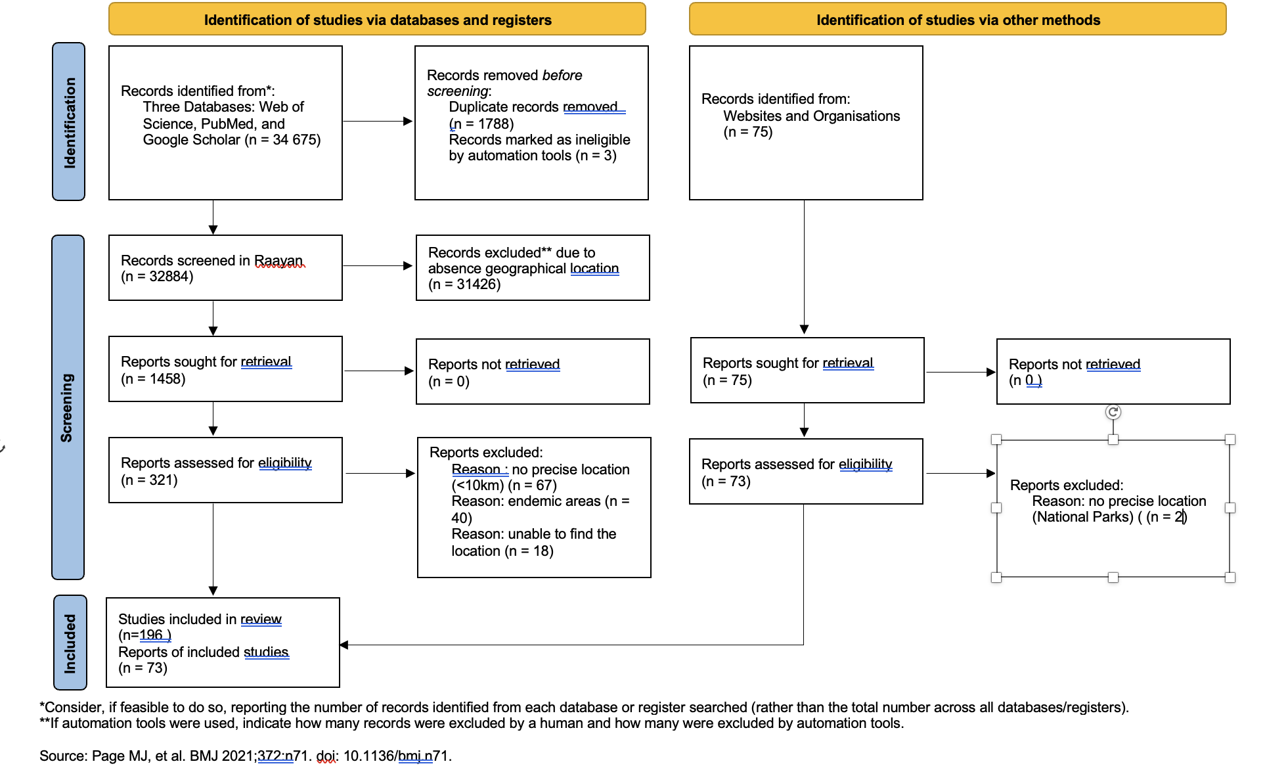

Table S1: List of reported human outbreaks of bat-borne and rodent-borne zoonoses included in this study.

Pathogen | Family | Disease | Number of outbreak points in included in the study
Bat-borne diseases
MERS-CoV | Coronaviridae | Middle Eastern Respiratory Syndrome | 16
SARS-CoV1 | Coronaviridae | Severe Acute Respiratory Syndrome | 4
SARS-CoV2 | Coronaviridae | COVID-19 | 1
Ebola Virus | Filoviridae | Ebola Virus Disease | 32
Marburg Virus | Filoviridae | Marburg Virus Disease | 14
Měnglà virus | Filoviridae | Mengla Virus Disease | 1
Langya henipavirus | Paramyoviridae | Langya Virus Infection | 1
Menangle pararubulavirus | Paramyoviridae | Menangle Virus Infection | 1
Nipah virus | Paramyoviridae | Nipah Virus Infection | 24
Hendra virus | Paramyoviridae | Hendra Virus Infection | 5
Mòjiāng virus | Paramyoviridae | Mòjiāng virus pneumonia | 1
Australian bat lyssavirus | Rhabdoviridae | Bat rabies | 3
Duvenhage lyssavirus | Rhabdoviridae | Bat rabies | 3
European bat 1 lyssavirus | Rhabdoviridae | Bat rabies | 2
European bat 2 lyssavirus | Rhabdoviridae | Bat rabies | 8
Rodent-borne diseases
Lassa Virus | Arenaviridae | Lassa Fever | 23
Lujo Virus | Arenaviridae | Lujo Haemorrhagic Fever | 1
Chapare Virus | Arenaviridae | Chapare hemorrhagic fever | 2
Guanarito Virus | Arenaviridae | Guanarito hemorrhagic fever | 1
Junin Virus | Arenaviridae | Junin hemorrhagic fever | 2
Machupo Virus | Arenaviridae | Machupo hemorrhagic fever | 8
Sabia Virus | Arenaviridae | Sabia hemorrhagic fever | 3
Whitewater Arroyo virus | Arenaviridae | Whitewater Arroyo hemorrhagic fever | 2
Andes orthohantavirus | Hantaviridae | Hantavirus Pulmonary Syndrome | 2
Black Creek Canal orthohantavirus | Hantaviridae | Hantavirus Pulmonary Syndrome | 1
Choclo orthohantavirus | Hantaviridae | Hantavirus Pulmonary Syndrome | 7
Dobrava-Belgrade orthohantavirus | Hantaviridae | Hemorrhagic fever with renal syndrome | 25
Hantaan orthohantavirus | Hantaviridae | Korean hemorrhagic fever | 1
Laguna Negra orthohantavirus | Hantaviridae | Hantavirus Pulmonary Syndrome | 7
Prospect Hill orthohantavirus | Hantaviridae | Hantavirus Pulmonary Syndrome | 1
Puumala orthohantavirus | Hantaviridae | Hemorrhagic fever with renal syndrome | 11
Seoul orthohantavirus | Hantaviridae | Hemorrhagic fever with renal syndrome | 9
Sin Nombre orthohantavirus | Hantaviridae | Hantavirus Pulmonary Syndrome | 5
Thailand virus-related hantavirus | Hantaviridae | Hemorrhagic fever with renal syndrome | 6
Lesser known strains of orthohantavirus causing HPS/HFRS  (eg. Sochi, Tula genotypes of DOBV, Saaremaa, etc) | Hantaviridae | Hantavirus Pulmonary Syndrome or  Hemorrhagic fever with renal syndrome | 33
Table S2: List of locations of bat-borne disease emergence events in humans
Year | Country | Town/village | y | x
1976 | South Sudan | Nzara | 4.633031 | 28.24863100 | SUDV
1976 | Zaire | Yambuku | 2.81667 | 22.2333 | EBOV
1979 | South Sudan | Nzara | 4.633031 | 28.24863100 | SUDV
1994 | Gabon | Makokou | 0.566667 | 12.866667 | EBOV
1995 | Zaire | Kikwit | -5.038611 | 18.818056 | EBOV
1996 | Gabon | Mayibout 2 | 1.168600412 | 13.16653489 | EBOV
1997 | Gabon | Booue | -0.1 | 11.933333 | EBOV
2000 | Uganda | Rwot-Obillo | 2.899421989 | 32.22891817 | SUDV
2001 | Gabon | Mekambo | 1.010279035 | 13.9516315 | EBOV
2002 | Republic of Congo | Yembelangoye | -0.19 | 14.345 | EBOV
2003 | Republic of Congo | Mbomo village | 0.493742157 | 14.67872268 | EBOV
2004 | south Sudan | Yambio town | 4.575884038 | 28.39791061 | SUDV
2005 | Republic of Congo | Etombi | 0.023198156 | 14.89057669 | EBOV
2007 | Democratic republic of Congo | Ndongo 2 | -5.223909594 | 21.42030166 | EBOV
2007 | Uganda | Bundibugyo | 0.708198728 | 30.06199708 | BDBV
2008 | Democratic republic of Congo | Mweka | -4.848548992 | 21.56453055 | EBOV
2011 | Uganda | Nakisamata village | 0.64847 | 32.72498 | SUDV
2012 | Uganda | Kibale | 0.789957865 | 31.07737498 | SUDV
2012 | Democratic republic of Congo | Isiro | 2.760106023 | 27.63122084 | BDBV
2012 | Uganda | Nyimbwa | 0.62010922 | 32.53455627 | SUDV
2013 | Guinea | Meliandou | 8.616038923 | -10.06116103 | EBOV
2014 | democratic republic of Congo | Ikanamongo Village | -0.423716691 | 20.58726183 | EBOV
2017 | democratic republic of Congo | Likali | 3.362214311 | 23.88497413 | EBOV
2018 | democratic republic of Congo | Ikoko-Impenge | -0.736329225 | 18.42126917 | EBOV
2018 | democratic republic of Congo | Mangina | 0.605101918 | 29.30920385 | EBOV
2020 | democratic republic of Congo | Mbandaka | 0.039565514 | 18.27347942 | EBOV
2021 | democratic republic of Congo | Benia | 0.022375777 | 28.66952231 | EBOV
2021 | Guinea | Gouecke | 8.028159602 | -8.721712582 | EBOV
2021 | democratic republic of Congo | beni | 0.493561786 | 29.45579395 | EBOV
2022 | Uganda | Madudu | 0.685486955 | 31.48144639 | SUDV
2022 | Democratic republic of Congo | Beni | 0.493561786 | 29.45579395 | EBOV
2023 | Democratic republic of Congo | Mbandaka | 0.04059228 | 18.26991011 | EBOV
1980 | Kenya | Kitum Cave | 1.032378484 | 34.75814964 | MARV
1987 | Kenya | Kitum Cave | 1.032378484 | 34.75814964 | RAVV
1998 | Democratic republic of Congo | Goroumbwa | 3.100221339 | 29.58356215 | MARV & RAVV
2004 | Angola | Uige | -7.608487222 | 15.06585302 | MARV
2007 | Uganda | Kitaka mines | 0.227685303 | 30.37429637 | MARV & RAVV
2008 | Uganda | Python cave | -0.358195879 | 29.92673444 | MARV
2008 | Uganda | Python cave | -0.358195879 | 29.92673444 | MARV
2012 | Uganda | Kitwe | -0.127433727 | 30.50537942 | MARV
2014 | Uganda | Mpigi | 0.228397164 | 32.32001886 | MARV
2017 | Uganda | Tulwo | 1.385047306 | 34.64138286 | MARV
2021 | Guinea | Temessadou M Boke | 8.53501354 | -10.22959439 | MARV
2022 | Ghana | Ashanti region | 6.257876467 | -1.531725046 | MARV
2023 | Equatorial Guinea | Nsock Nsomo | 1.128886251 | 11.2674021 | MARV
2023 | Tanzania | Goziba Island | -1.471818317 | 32.61009214 | MARV
2009 | Democratic Republic of Congo | Mangala | -4.650072888 | 18.93759898 | BASV
1996 | Australia | Rockhampton | -23.34373237 | 150.5398431 | Australian bat lyssavirus
1996 | Australia | Mackay | -21.1430338 | 149.1815197 | Australian bat lyssavirus
2012 | Australia | Whitsundays | -20.27545095 | 148.9984774 | Australian bat lyssavirus
1969 | Nigeria | Ibadan | 7.411258122 | 3.894205068 | Mokola lyssavirus
1971 | Nigeria | Ibadan | 7.40874606 | 3.871960254 | Mokola lyssavirus
1970 | South Africa | NW Province | -25.7476754 | 26.75573712 | Duvenhage lyssavirus
2006 | South Africa | NW Province | -25.38446179 | 26.5450554 | Duvenhage lyssavirus
2007 | Kenya | camp | -3.191479713 | 38.47345725 | Duvenhage lyssavirus
2002 | United Kingdom | Guthrie | 56.64410445 | -2.708746283 | European bat 2 lyssavirus
1998 | Malaysia | Ipoh | 4.726213405 | 101.0949881 | Nipah
2001 | India | Siliguri | 26.71092766 | 88.42774411 | Nipah
2001 | Bangladesh | Chandpur | 23.84674827 | 88.64662108 | Nipah
2003 | Bangladesh | Bil Joania | 24.80702489 | 88.63525765 | Nipah
2004 | Bangladesh | Kazipara | 23.86936788 | 89.37781868 | Nipah
2004 | Bangladesh | Fairidpur | 23.637393 | 89.76052135 | Nipah
2005 | Bangladesh | Basail | 24.22886259 | 90.0514558 | Nipah
2007 | India | Belechuapara | 23.81467458 | 88.56680905 | Nipah
2007 | Bangladesh | Haripur | 25.84414124 | 88.1360684 | Nipah
2007 | Bangladesh | Sadar Kushtia | 23.84352999 | 89.09612448 | Nipah
2008 | Bangladesh | Manikganj | 23.74820629 | 89.71692527 | Nipah
2010 | Bangladesh | Bhanga | 23.403281 | 89.98188996 | Nipah
2011 | Bangladesh | Hatibandha | 26.14025923 | 89.13675786 | Nipah
2018 | India | Peramba | 11.56410411 | 75.75874759 | Nipah
2019 | India | Vavakkad | 10.16665194 | 76.20870352 | Nipah
2021 | India | Chathamangalam | 11.29115403 | 75.91531978 | Nipah
2023 | Bangladesh | Natore | 24.40921163 | 88.9729078 | Nipah
2023 | India | Maruthonkara | 11.65119487 | 75.80144435 | Nipah
2023 | Bangladesh | Pabna | 24.00634524 | 89.27561379 | Nipah
2023 | Bangladesh | Rajshahi | 24.39926437 | 88.61699253 | Nipah
2023 | Bangladesh | Shariatpur | 23.21995573 | 90.34718399 | Nipah
2023 | Bangladesh | Rajbari | 23.76934532 | 89.66095119 | Nipah
2023 | Bangladesh | Narsingdi | 23.97416703 | 90.73601786 | Nipah
2023 | Bangladesh | Naogoan | 24.75838636 | 88.94765812 | Nipah
2012 | China | Tongguan | 23.28924003 | 101.3734947 | Mojiang
2018 | China | Langya | 35.07685626 | 118.8269416 | Langya
1994 | Australia | Hendra | -27.41993839 | 153.0752767 | Hendra
1994 | Australia | Mackay | -21.14409669 | 149.1768331 | Hendra
2004 | Australia | Cairns | -16.8758878 | 145.7336655 | Hendra
2008 | Australia | Redland | -27.58446545 | 153.2605878 | Hendra
2009 | Australia | Cawarral | -23.24939317 | 150.6750369 | Hendra
1997 | Australia | Menangle | -34.14528902 | 150.7225295 | Menangle
2012 | Saudi Arabia | Jeddah | 21.55025872 | 39.25129536 | MERS-CoV
2014 | UAE | Al Ain City | 24.20877193 | 55.67219829 | MERS-CoV
2015 | Saudi Arabia | Hofuf | 25.36024833 | 49.60300125 | MERS-CoV
2014 | Yemen | Sana a | 15.32275329 | 44.17965205 | MERS-CoV
2014 | Saudi Arabia | Najran | 17.5781076 | 44.23749031 | MERS-CoV
2022 | Saudi Arabia | Taif | 21.28318423 | 40.45228273 | MERS-CoV
2022 | Saudi Arabia | Muhayil | 18.54355662 | 42.05190738 | MERS-CoV
2015 | Saudi Arabia | Riyadh | 24.81851756 | 46.73442778 | MERS-CoV
2014 | Saudi Arabia | Wadi adDawasir | 20.44453573 | 44.81116321 | MERS-CoV
2014 | Saudi Arabia | Al-Kharj | 24.16357655 | 47.32280047 | MERS-CoV
2002 | China | Shunde | 22.87054999 | 113.1616816 | SARS-CoV1
2002 | China | Shenzhen | 22.53764723 | 114.0512269 | SARS-CoV1
2002 | China | Zhaoqing | 23.05743399 | 112.461819 | SARS-CoV1
2002 | China | Zhongshan | 22.52417514 | 113.3884878 | SARS-CoV1
2019 | China | Wuhan | 30.61779553 | 114.2635439 | SARS-CoV2
2015 | Saudi Arabia | Buraydah | 26.34665338 | 43.96375992 | MERS-CoV
2015 | Saudi Arabia | Tayma | 27.62123507 | 38.5291913 | MERS-CoV
2015 | Saudi Arabia | Khobar | 26.22526864 | 50.19758995 | MERS-CoV
2022 | Qatar | Al Shahaniyah | 25.41340026 | 51.18973252 | MERS-CoV
2015 | Qatar | Doha | 25.2727208 | 51.50535554 | MERS-CoV
2014 | Yemen | Shibam | 15.92026469 | 48.63562701 | MERS-CoV
1996 | United Kingdom | Newhaven | 50.78844819 | 0.048975784 | European bat 2 lyssavirus
2016 | Finland | Inkoo | 60.0459297 | 24.00686452 | European bat 2 lyssavirus
2019 | france | Limoges | 45.99142356 | 1.362385614 | European bat 1 lyssavirus
1954 | germany | Hamburg | 53.46802723 | 9.94359456 | European bat 1 lyssavirus
2004 | United Kingdom | Staines | 51.4266725 | -0.50181133 | European bat 2 lyssavirus
2007 | germany | Bad Buchau | 48.07742657 | 9.615838974 | European bat 2 lyssavirus
2015 | Norway | Valdres | 60.97231335 | 9.282654088 | European bat 2 lyssavirus
Table S3: List of locations of rodent-borne disease outbreak emergence events in humans

Year | Country | Town/village | y | x
1958 | Argentina | Junin | -34.58362242 | -60.95458078 | Junin
1959 | Bolivia | San Joaquin | -13.04235473 | -64.67029105 | Machupo
2007 | Bolivia | Magdalena | -13.2339213 | -64.19984642 | Machupo
2008 | Bolivia | Huacaraje | -13.54999999 | -63.74997855 | Machupo
1994 | Bolivia | Magdalena | -13.25868418 | -64.0540558 | Machupo
1994 | Bolivia | Magdalena | -13.25868418 | -64.0540558 | Machupo
1994 | Bolivia | Popona | -14.77655484 | -64.84214424 | Machupo
2008 | Bolivia | San Ramon | -13.26243262 | -64.61556245 | Machupo
1993 | Bolivia | San Ramon | -13.26243262 | -64.61556245 | Machupo
2003 | Bolivia | Samuzabeti | -16.81488428 | -65.57145166 | Chapare
2019 | Bolivia | Guanay | -15.49596434 | -67.88108921 | Chapare
1990 | Brazil | Jardim Sabia | -23.60270846 | -46.8992028 | Sabia
2019 | Brazil | Sorocaba | -23.49123959 | -47.49382517 | Sabia
2019 | Brazil | Assis | -22.64051616 | -50.41513681 | Sabia
1989 | Venezuela | Guanarito | 8.696722932 | -69.20910417 | Guanarito
1969 | Nigeria | Lassa | 10.68205527 | 13.27183388 | Lassa
2008 | Zambia | Lusaka | -15.42552314 | 28.41931052 | Lujo
1999 | USA | Whitewater | 33.92502146 | -116.6341096 | WWAV
2000 | USA | Arroyo Grande | 35.11900944 | -120.5825848 | WWAV
1958 | Argentina | O higgins | -34.58251145 | -60.69995041 | Junin
1995 | Argentina | El Bolson | -41.96701008 | -71.53510449 | Andes orthohantavirus
1995 | USA | Black Creek Canal | 25.55061577 | -80.35140688 | Black Creek Canal orthohantavirus
1997 | USA | Lehigh County | 40.67527851 | -75.6999894 | Monongahela virus
1997 | USA | Cresco | 41.156094 | -75.28015437 | Monongahela virus
1993 | USA | Navajo | 35.88803384 | -109.0313026 | Sin Nombre orthohantavirus
1995 | USA | Blue River | 38.94350922 | -94.56175797 | Blue River virus
1951 | South Korea | Hantan River | 38.00728959 | 127.0166693 | Hantaan orthohantavirus
1985 | Slovenia | Dobrava | 45.85522373 | 14.96944427 | Dobrava-Belgrade orthohantavirus
1994 | South Korea | Seoul | 37.54316319 | 126.9928289 | Seoul orthohantavirus
1980 | Finland | Puumala | 61.52356343 | 28.17826617 | Puumala orthohantavirus
1999 | Thailand | Bangkok | 13.76274007 | 100.5315671 | Thailand virus-related hantavirus
1997 | Paraguay | Filadelfia | -22.3520162 | -60.03281605 | Laguna Negra Virus
1997 | Paraguay | Fortin Toledo | -22.22277204 | -60.43688122 | Laguna Negra Virus
1997 | Paraguay | Montania | -21.98029502 | -60.04819975 | Laguna Negra Virus
1997 | Paraguay | San Lowen | -22.30637333 | -59.90301479 | Laguna Negra Virus
1997 | Paraguay | Monte Palma | -22.6058255 | -59.53078634 | Laguna Negra Virus
1997 | Paraguay | Estancia Carau | -22.96817162 | -59.46226147 | Laguna Negra Virus
2015 | Sri Lanka | Kandy | 7.296066642 | 80.63394772 | Thailand virus-related hantavirus
2015 | Sri Lanka | Kegalle | 7.256847412 | 80.34443369 | Thailand virus-related hantavirus
2013 | Sri Lanka | Polonnaruwa | 7.948400147 | 81.00782146 | Thailand virus-related hantavirus
1952 | Bosnia | Fojnica | 43.96221138 | 17.89897855 | Dobrava-Belgrade orthohantavirus
1961 | Serbia | Fruska Gora | 45.15721112 | 19.71440802 | Dobrava-Belgrade orthohantavirus
1954 | Slovenia | Pohorje | 46.31474485 | 15.98532472 | Dobrava-Belgrade orthohantavirus
1967 | Bosnia | Foca | 43.50541405 | 18.77908917 | Dobrava-Belgrade orthohantavirus
1967 | Croatia | Plitvice | 44.86435052 | 15.58341477 | Dobrava-Belgrade orthohantavirus
1995 | Bosnia | Tuzla | 44.53865762 | 18.67859605 | Dobrava-Belgrade orthohantavirus
2002 | Croatia | Ivanovac | 45.48283851 | 18.63820754 | Dobrava-Belgrade orthohantavirus
1983 | Greece | Tsepelovo | 39.90495493 | 20.81983789 | Puumala orthohantavirus
1982 | Swedan | Dalarna | 61.33727962 | 14.16304563 | Puumala orthohantavirus
1995 | France | Alsace | 48.40727827 | 7.499540525 | Puumala orthohantavirus
1984 | Germany | Baden Wuttemberg | 48.44705382 | 8.437356384 | Puumala orthohantavirus
2022 | Panama | Tonosi | 7.406977927 | -80.44201592 | Choclo
2022 | Panama | La Villa de los Santos | 7.943510352 | -80.40425802 | Choclo
2022 | Panama | Las Tablas | 7.769755817 | -80.27530265 | Choclo
2022 | Panama | Pese | 7.908489132 | -80.61340313 | Choclo
2022 | Panama | Ocu | 7.942829125 | -80.77535367 | Choclo
2022 | Panama | Nata | 8.335902623 | -80.51944975 | Choclo
2022 | Panama | Penonome | 8.518853122 | -80.35735981 | Choclo
2012 | USA | Curry Village | 37.73825849 | -119.5766075 | HPS
2012 | USA | High Sierra Camps | 37.90949293 | -119.4190343 | HPS
2016 | USA | Grand Forks | 47.92441901 | -97.03108242 | HPS
2000 | Bolivia | Bermejo | -22.7315974 | -64.33897596 | Bermejo
2011 | Brazil | Castelo dos Sonhos | -8.315698906 | -55.09986164 | Castelo dos Sonhos
2012 | Brazil | Araraquara | -21.78399688 | -48.1876002 | Araraquara
2008 | Brazil | Juquitiba | -23.9316288 | -47.07032525 | Juquitiba
2011 | Brazil | Careiro da Varzea | -3.197660186 | -59.82521817 | Rio mamore
1996 | Bolivia | Rio mamore | -16.83590021 | -64.79439735 | Rio mamore
2011 | Uruguay | Lechiguanas | -33.43399938 | -59.69995966 | Lechiguanas
1990 | Venezuela | Cano Delgadito | 8.791670513 | -69.45028521 | Cano Delgadito
1993 | Louisana | La | 32.40112368 | -92.0363685 | Bayou
1974 | China | Longquan | 28.06874722 | 119.1410307 | Gou
1964 | India | Thottapalayam | 12.93394541 | 79.13440888 | Thottapalayam
1990 | Russia | Kurkino | 53.43529067 | 38.66021344 | Dobrava-Belgrade orthohantavirus
2000 | Russia | Lipetsk | 52.60709133 | 39.57719981 | Dobrava-Belgrade orthohantavirus
2006 | Russia | Dobrinka | 52.03946505 | 40.5674934 | Dobrava-Belgrade orthohantavirus
2006 | Russia | Lavrovka | 52.23763837 | 40.77077523 | Dobrava-Belgrade orthohantavirus
2008 | Russia | Sochi | 43.60071628 | 39.73269806 | Sochi genotype Dobrava-Belgrade orthohantavirus
2012 | Germany | Heidelbery | 49.40777657 | 8.680587493 | Puumala orthohantavirus
2014 | Russia | Krasnodar | 44.99416204 | 39.07360434 | Sochi genotype Dobrava-Belgrade orthohantavirus
2004 | Germany | Rostock | 54.08827744 | 12.11398675 | Saaremaa orthohantavirus
2004 | Germany | Kiel | 54.31834505 | 10.12874268 | Saaremaa orthohantavirus
2004 | Germany | Lubeck | 53.86479448 | 10.68849904 | Saaremaa orthohantavirus
2004 | Germany | Greifswald | 54.08650798 | 13.37443963 | Saaremaa orthohantavirus
2004 | Germany | Gustrow | 53.7945177 | 12.17880007 | Saaremaa orthohantavirus
2004 | Germany | Potsdam | 52.40019454 | 13.06058422 | Dobrava-Belgrade orthohantavirus
2004 | Germany | Neuruppin | 52.92146714 | 12.80601571 | Dobrava-Belgrade orthohantavirus
2004 | Germany | Hamburg | 53.54920286 | 9.961526322 | Dobrava-Belgrade orthohantavirus
2004 | Germany | Bradenburg | 52.41335896 | 12.55090805 | Dobrava-Belgrade orthohantavirus
2004 | Germany | Demmin | 53.90990657 | 13.02662868 | Dobrava-Belgrade orthohantavirus
2004 | Germany | Magdeburg | 52.11877529 | 11.63147428 | Dobrava-Belgrade orthohantavirus
2004 | Germany | Cottbus | 51.75669949 | 14.33775997 | Dobrava-Belgrade orthohantavirus
2004 | Germany | Altenburg | 50.98327328 | 12.434879 | Dobrava-Belgrade orthohantavirus
2004 | Germany | Chemnitz | 50.82866401 | 12.91793666 | Dobrava-Belgrade orthohantavirus
2004 | Germany | Fulda | 50.55362519 | 9.668717939 | Dobrava-Belgrade orthohantavirus
2021 | France | Saint Claude | 46.38518948 | 5.861601336 | Puumala orthohantavirus
2015 | France | Melun | 48.53020334 | 2.658756307 | Tula genotype dobv
2014 | France | Dijon | 47.3182403 | 5.027234621 | Seoul orthohantavirus
2015 | France | Erize-Saint-Dizier | 48.81459837 | 5.282478659 | Seoul orthohantavirus
2016 | France | Turckheim | 48.08531798 | 7.27790737 | Seoul orthohantavirus
2016 | Netherlands | Arnhem | 51.96824761 | 5.899766257 | Prospect Hill orthohantavirus
1982 | USA | Prospect Hill | 36.24937881 | -79.19105666 | Seoul orthohantavirus
2006 | Honduras | Catacamas | 14.85377917 | -85.89934476 | Catacamas orthohantavirus
2002 | Bolivia | Concepcion | -16.13060999 | -62.0286165 | Laguna Negra Virus
2011 | Peru | Iquitos | -3.697699385 | -73.2791828 | Andes orthohantavirus
2008 | French Guinea | Maripa | 3.816127477 | -51.88849259 | Maripa virus
2008 | South Korea | Muju-gun | 35.93528195 | 127.7134028 | Muju virus
1996 | Brazil | Flexal | -20.28522058 | -40.38043902 | Flexal
1975 | Colombia | Pichinde | 3.435043237 | -76.61661101 | Pichinde
2019 | Guinea | Kissidougou | 9.19985205 | -10.10158366 | Lassa
1972 | Guinea | Bambaya | 9.287642071 | -10.41957199 | Lassa
1972 | Guinea | Dandou | 9.193570789 | -9.900960409 | Lassa
1972 | Guinea | Telekoro | 9.450037756 | -10.70942269 | Lassa
1972 | Guinea | Yende | 8.887804627 | -10.17021056 | Lassa
1972 | Liberia | Zorzor | 7.776762949 | -9.428498902 | Lassa
1935 | Nigeria | Makurdi | 7.697293293 | 8.557313059 | Lassa
1952 | Nigeria | Rahama | 10.8890221 | 8.127271154 | Lassa
1956 | Sierra Leonne | Segbwema | 7.99806311 | -10.9492425 | Lassa
1970 | Nigeria | Vom | 9.730105036 | 8.791919393 | Lassa
1970 | Sierra Leonne | Panguma | 8.025108086 | -11.75764718 | Lassa
1970 | Sierra Leonne | Tongo | 8.218621981 | -11.05707933 | Lassa
1974 | Nigeria | Onitsha | 6.1469769 | 6.775936016 | Lassa
1975 | Nigeria | Zonkwa | 9.873458613 | 8.03517117 | Lassa
1972 | Liberia | Zigida | 8.033930793 | -9.482991075 | Lassa
2011 | Ghana | Village near Manso Nkwanta | 6.465652253 | -1.902848762 | Lassa
2011 | Ghana | Manso Nkwanta | 6.469283278 | -1.886539489 | Lassa
2016 | Benin | Kassoula | 9.092292701 | 2.539596444 | Lassa
2016 | Togo | Sandori | 10.29055223 | 0.449662105 | Lassa
2017 | Benin | Tchaourou | 8.878076064 | 2.753311364 | Lassa
2017 | Burkina Faso | Ouargaye | 11.50081736 | 0.052305154 | Lassa
2009 | Mali | Soromba | 11.42275992 | -7.771723196 | Lassa
1980 | Finland | Pieksämäki | 62.30036582 | 27.14701929 | Puumala orthohantavirus
1995 | Croatia | Slunj | 45.11612865 | 15.58268335 | Dobrava-Belgrade orthohantavirus
2018 | Swedan | Sorby | 59.25996431 | 15.22998921 | Puumala orthohantavirus
2018 | Swedan | Ballingslov | 56.21529443 | 13.84644434 | Puumala orthohantavirus
2016 | China | Gao'an | 28.40683436 | 115.3435734 | Seoul orthohantavirus
2016 | China | Yifeng | 28.36744012 | 114.7488238 | Seoul orthohantavirus
2016 | China | Shanggao | 28.22530427 | 114.8896843 | Seoul orthohantavirus
2016 | China | Fengxin | 28.67539836 | 115.37887 | Seoul orthohantavirus
2001 | Denmark | Fuenen | 55.32076083 | 10.25563784 | Saaremaa orthohantavirus
2007 | Poland | Lutowiska | 49.25278787 | 22.6857742 | Saaremaa orthohantavirus
2006 | Poland | Przysietnica | 49.73113266 | 22.06216707 | Puumala orthohantavirus
2006 | Poland | Bukowsko | 49.47907899 | 22.06156459 | Dobrava-Belgrade orthohantavirus
2007 | Poland | Odrzechowa | 49.54461637 | 21.97459403 | Dobrava-Belgrade orthohantavirus
1994 | Canada | Fort St John | 56.23839333 | -120.8328255 | Sin Nombre orthohantavirus
1994 | Canada | onoway | 53.70909566 | -114.1803936 | Sin Nombre orthohantavirus
1994 | Canada | Vallyview | 55.06410042 | -117.2839435 | Sin Nombre orthohantavirus
1994 | Canada | Camrose | 53.01147979 | -112.8303112 | Sin Nombre orthohantavirus
2020 | Sri Lanka | Dambulla | 7.847442583 | 80.65087381 | Thailand virus-related hantavirus
2020 | Sri Lanka | Ududumbara | 7.315476387 | 80.87830064 | Thailand virus-related hantavirus
2011 | Madagascar | Anjozorobe | -18.40214399 | 47.8799333 | Anjozorobe

Environmental and demographic covariates

Descriptions of the covariates

Table S4: Definitions of the various covariates used in the study.

Covariate | Model | Definition
Climatic covariates
Minimum temperature | Bat and Rodent | Monthly average climate data for minimum temperature in Celsius.
Total precipitation | Bat and Rodent | Monthly average climate data for total precipitation measured in mm.
Environmental covariates
Altitude | Bat and Rodent | Elevation data derived from the SRTM elevation data
Bat occurrence | Bat | The bat occurrence raster represent the number of bat species per pixel based on aggregated species distribution data from two sources (IUCN and biodiversitymapping.org).
Cropland distribution | Rodent | FGGD land cover occurrence maps are global raster datalayers where each pixel in each map contains a value representing the percentage of the area belonging to Cropland land cover type.
Global Human Modification of Terrestrial Systems | Bat and Rodent | Global Human Modification of Terrestrial Systems data set provides a cumulative measure of the human modification of terrestrial lands across the globe at a 1-km resolution.
Mammal richness index | Bat and Rodent | The 2015 Release of the Global Mammal Richness Grids data set of the Gridded Species Distribution collection are aggregations of the presence grids data for the entire class, individual families, and International Union for the Conservation of Nature (IUCN) Red List status categories
Rodent occurence | Rodent | The rodent occurrence raster represent the number of rodent species per pixel based on aggregated species distribution data from two sources (IUCN and biodiversitymapping.org).
Forest cover loss proxy for deforestation | Bat and Rodent | ‘Forest Cover Loss’ is defined as a stand-replacement disturbance, or a change from a forest to non-forest state, during the period 2000–2019.
Demographic covariates
Accessibility to the nearest city | Bat and Rodent | Global map of travel times to cities with more than 50,000 people in the year 2015.
Bushmeat activities | Bat | Geographically synthesized bushmeat data a global scale.
Human Population density | Bat and Rodent | The Gridded Population of the World, Version 4 (GPWv4): Population Density, Revision 11 consists of estimates of human population density (number of persons per square kilometer) based on counts consistent with national censuses and population registers, for the year 2020.

Background layer- Pseudo-absence points

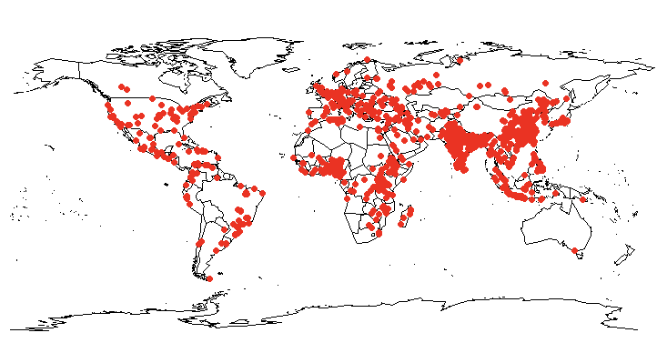

Figure S2: Distribution of pseudo-absence points that were intentionally weighed to reflect the density of more populated areas. The same set of points was used in all models in our study.

We used occurrence data obtained from our literature search, supplemented by 1,000 randomly generated pseudo-absence points that were intentionally weighed to reflect the density of more populated areas. This approach aimed to mitigate reporting bias, which can arise not only from human population density but also from variations in surveillance efforts and underreporting across different regions.

Modelling of bat-borne diseases
We used three modeling algorithms for the model fitting: Random Forest (RF), boosted regression tree (BRT), and Bayesian binomial model. Only models with >0.5 AUC and maxTSS were selected. The models were also compared with a geographic null model to assess the predictive power of covariates. The geographic null model was generated by drawing a convex hull around the presence points.

We used two cross-validation techniques, k-fold CV and environmental CV, to estimate the prediction ability of the model on unseen data and prevent overfitting of the model. The k-fold CV creates random clusters while environmental CV approach uses clustering methods to specify sets of similar environmental conditions based on the input covariates. Occurrence data corresponding to these clusters are assigned to a fold. Clustering of the predictor covariate data and occurrence data are done using kmeans.
In this study, we used 4-folds or clusters of the occurrence and background datapoints for both approaches. With 80% of the datapoints (observation and background) used as the training dataset, and the remaining 20% data attributed to the validation dataset. The eight predictor variables were used as covariates to define the environmental conditions for the environmental block CV.
Models with an AUC or maxTSS less than 0.5 following cross-validation were excluded.

Random Forest -Bat borne diseases.
For model optimization using hyperparameter tuning, we used Random search using different combinations of tunable parameters. For RF, the tunable parameters (hyperameters) are:
mtry (number of variables randomly sampled as candidates at each split), ntrees (number of trees to grow), and node size. The parameters were later confirmed using individual grid searches.

Random Search: Node Size and ntrees
We tested the combination of node sizes (1–10) and ntrees up to 500 and evaluated the model performance using using AUC and TSS for a single hyperparameter. The final model parameters: ntree = 500, nodesize = 5, mtry = 2.

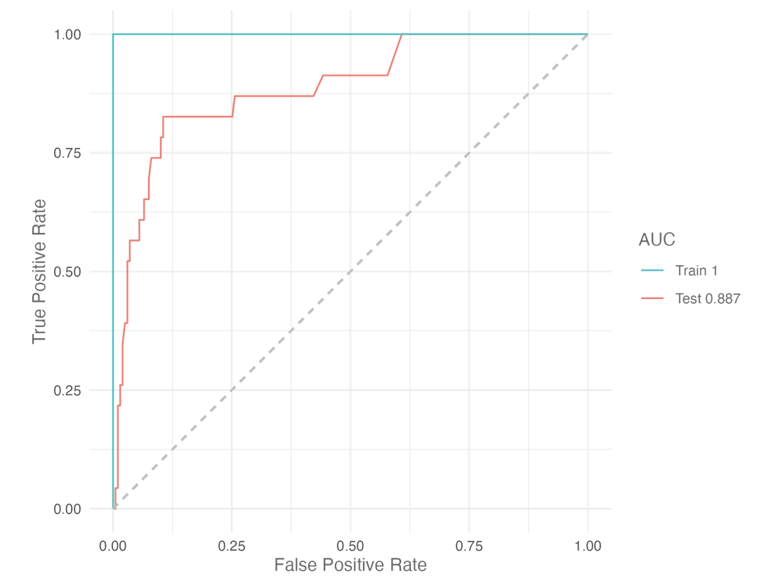

Figure S3: ROC curve of Random Forest model for bat-borne disease distribution

Table S5: Variable importance of Random Forest model for bat-borne disease distribution
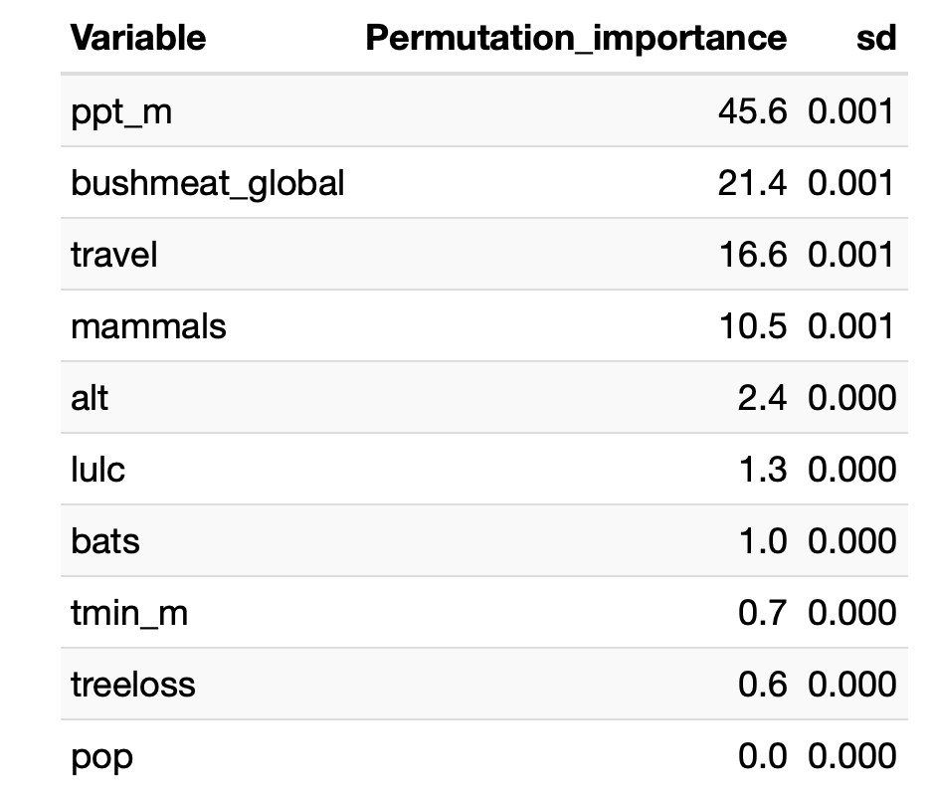

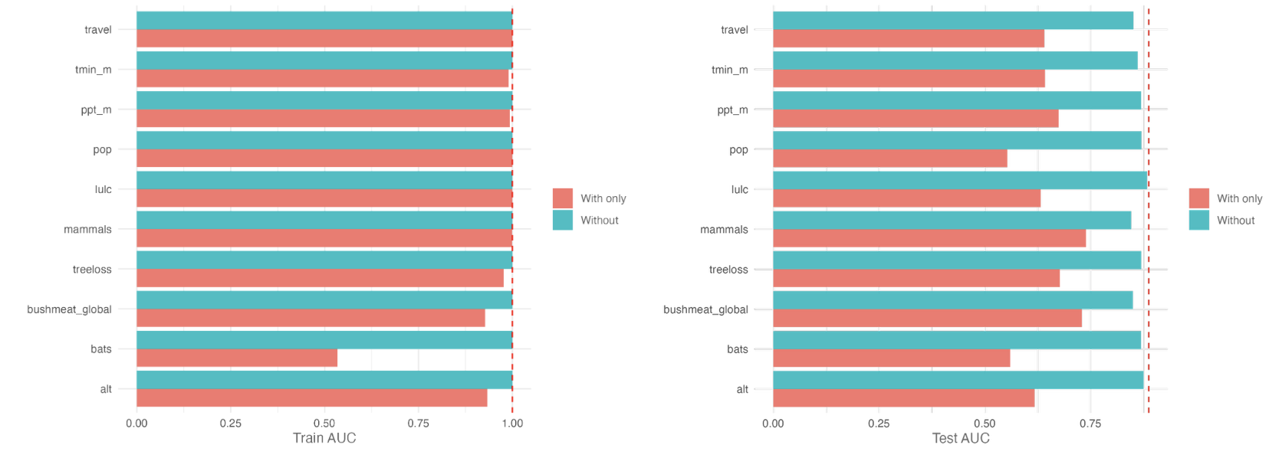
Figure S4: Jackknife test of Random Forest model for bat-borne disease distribution

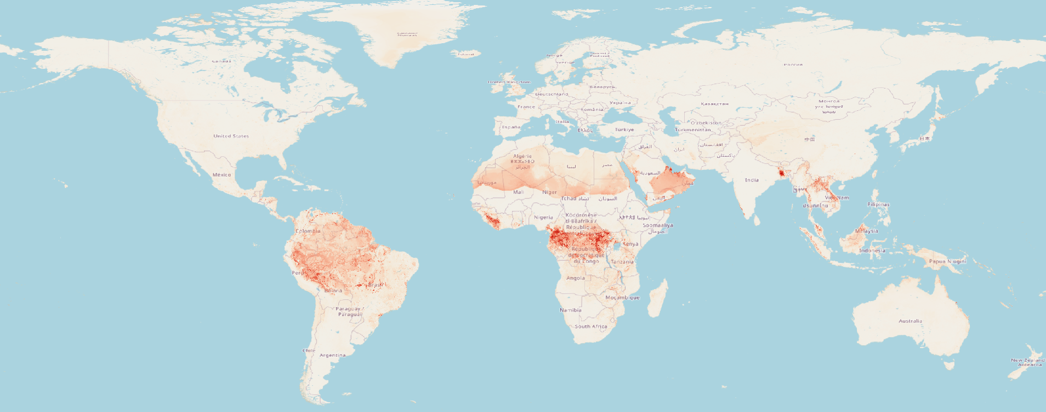

Figure S5: Prediction of distribution of bat-borne disease using the RF model
BRT – Bat borne diseases

For BRT, the tunable parameters are: distribution, n.trees (maximum number of grown trees), interaction depth, shrinkage, bag fraction. We set the distribution to “bernolli,” bag fraction = 0.5, shrinkage = 1, and interaction depth = 1. We used grid search to tune, n.trees and interaction depth. Final BRT model parameters: n.trees = 1000, learning.rate = 0.0025, bag.fraction = 0.5

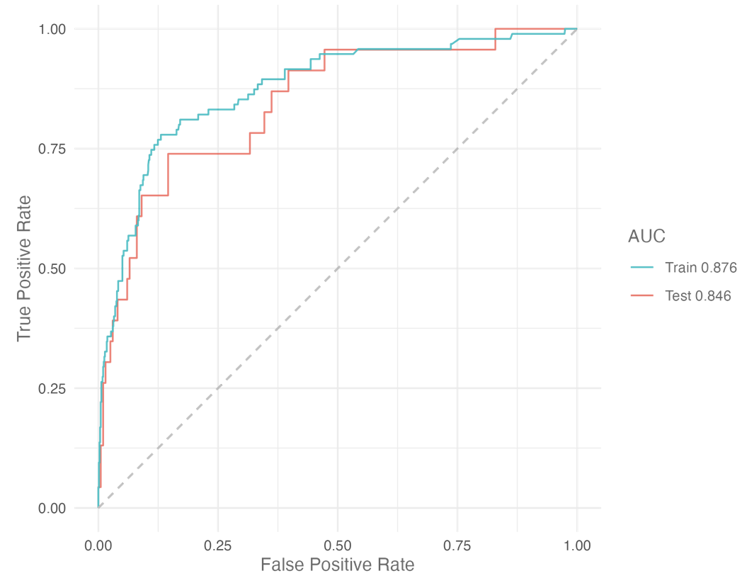
Figure S6: ROC curve of BRT model for bat-borne disease distribution

Table S6: Variable importance of BRT model for bat-borne disease distribution
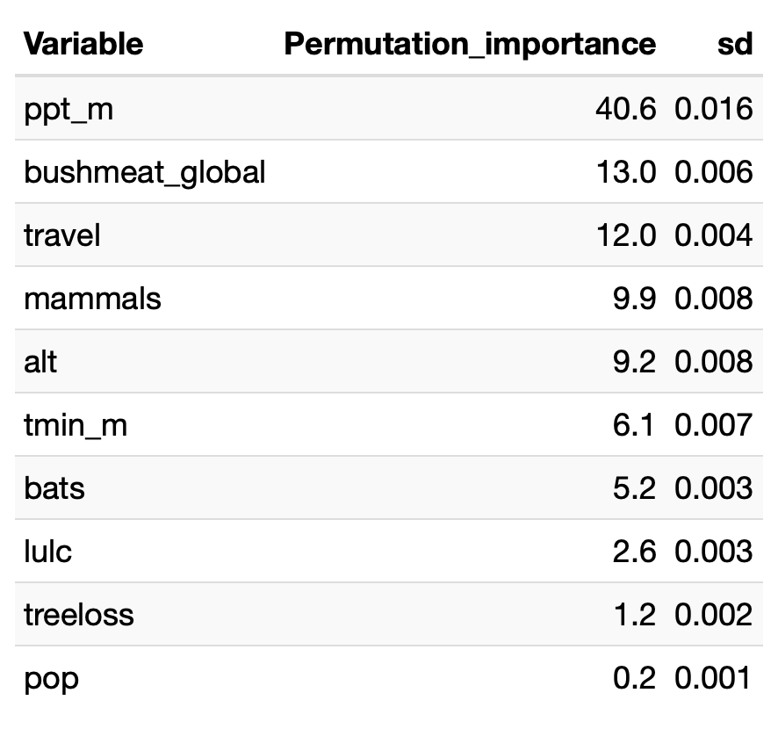

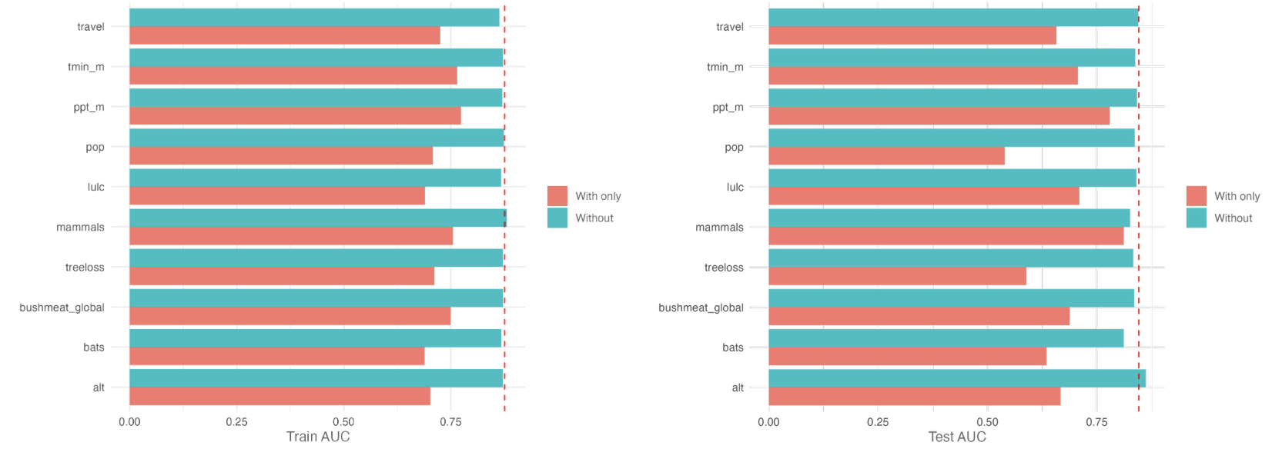
Figure S7: Jackknife test of BRT model for bat-borne disease distribution

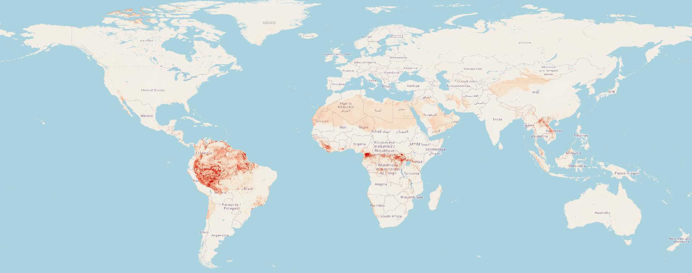

Figure S8: Prediction of distribution of bat-borne disease using the BRT model

Differences in distribution of bat-borne diseases between the RF an BRT

The RF model captured high-risk regions in Bangladesh and in the Central and West Africa while the BRT model predictions were focused on South America and Central Africa.
Bayesian Binomial – Bat borne diseases
Iterations = 2001:3996
Thinning interval = 5
Number of chains = 2
Sample size per chain = 400
Quantiles for each variable:

2.5% 25% 50% 75%
beta.(Intercept) -2.757490 -2.59082 -2.50903 -2.416903
beta.alt -0.253628 -0.08889 0.01932 0.109514
beta.bats -0.003462 0.19764 0.30176 0.396957
beta.bushmeat_global 0.284322 0.39124 0.45114 0.514646
beta.treeloss -0.162908 -0.03116 0.03564 0.103352
beta.mammals -0.289591 -0.04824 0.06372 0.177562
beta.lulc -0.351827 -0.17944 -0.08514 0.008124
beta.pop -0.515170 -0.26097 -0.15006 -0.049284
beta.ppt_m -0.062630 0.10744 0.18535 0.265916
beta.tmin_m 0.020274 0.21716 0.33086 0.469977
beta.travel -0.244198 -0.04503 0.04151 0.123064
Deviance 647.379481 651.16621 654.37431 657.699578
97.5%
beta.(Intercept) -2.2498
beta.alt 0.3247
beta.bats 0.6001
beta.bushmeat_global 0.6237
beta.treeloss 0.2188
beta.mammals 0.3712
beta.lulc 0.1649
beta.pop 0.1161
beta.ppt_m 0.4159
beta.tmin_m 0.7214
beta.travel 0.2596
Deviance 665.9078

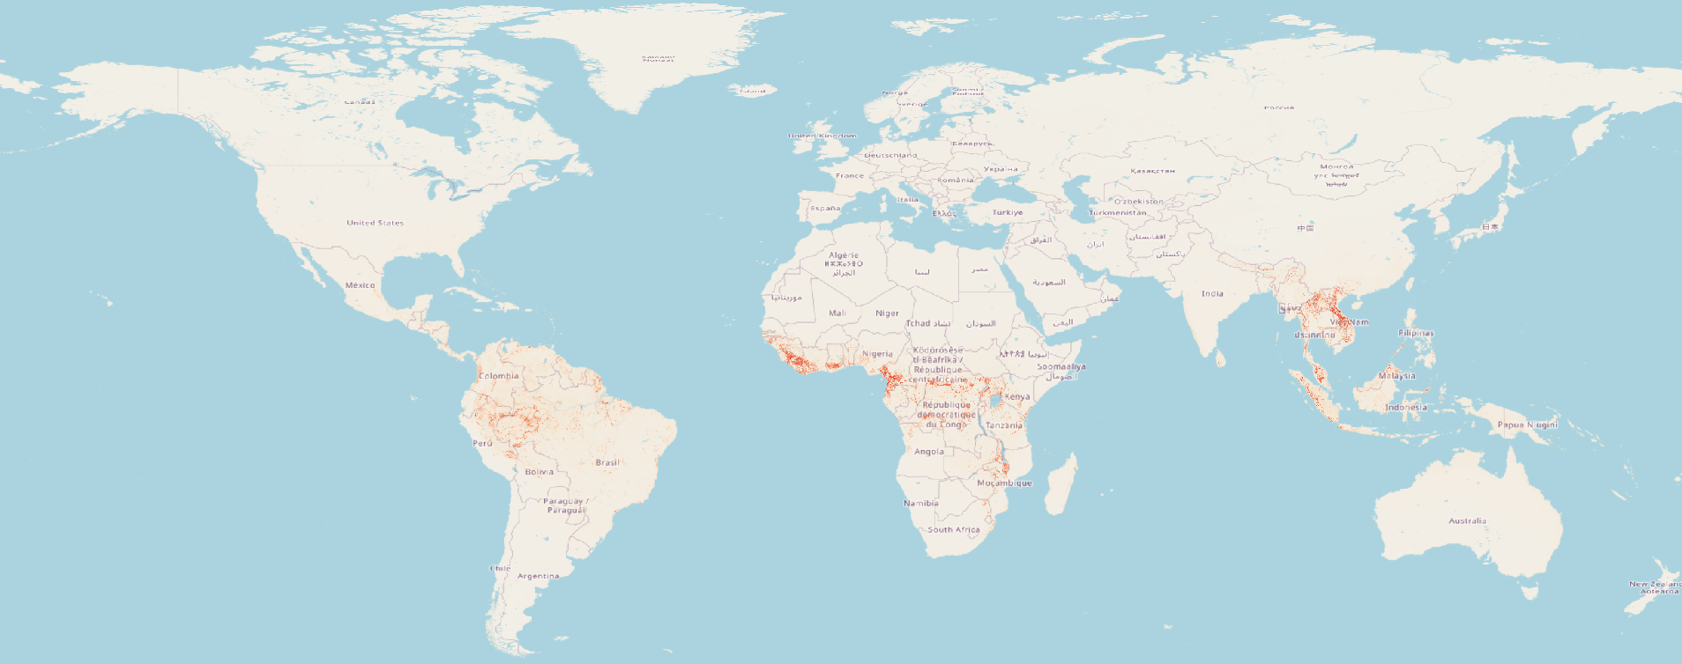

Figure S9: Prediction of distribution of bat-borne disease using the Bayesian Binomial model

Random Forest -Rodent borne diseases.
For model optimization using hyperparameter tuning, we used Random search using different combinations of tunable parameters. For RF, the tunable parameters (hyperameters) are:
mtry (number of variables randomly sampled as candidates at each split), ntrees (number of trees to grow), and node size. The parameters were later confirmed using individual grid searches.

Random Search: Node Size and ntrees
We tested the combination of node sizes (1–10) and ntrees up to 500 and evaluated the model performance using using AUC and TSS for a single hyperparameter. The final model parameters: ntree = 500, nodesize = 10, mtry = 2.

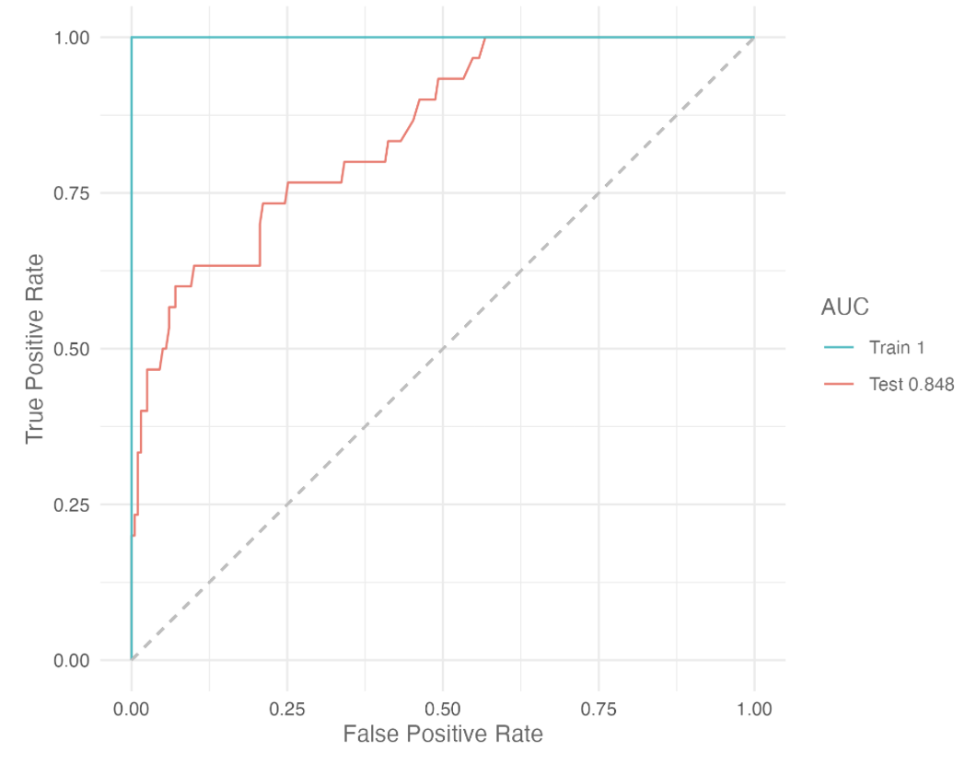

Figure S10: ROC curve of RF model for rodent-borne disease distribution

Table S7: Variable importance of RF model for rodent-borne disease distribution
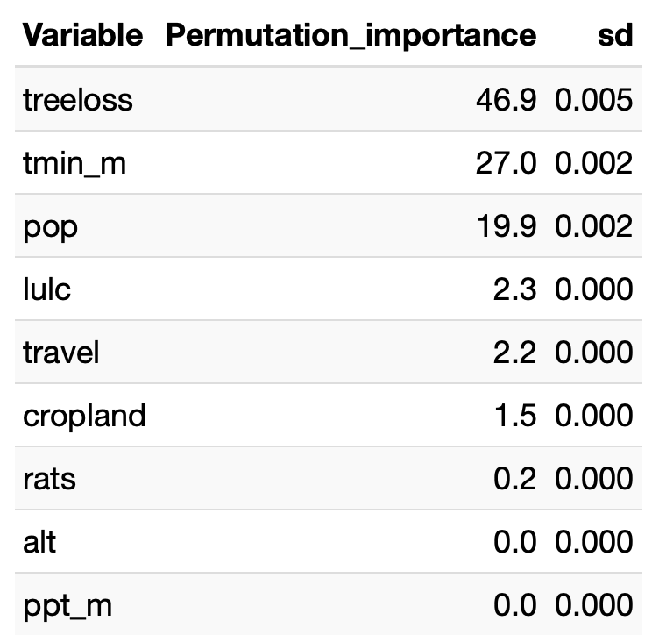

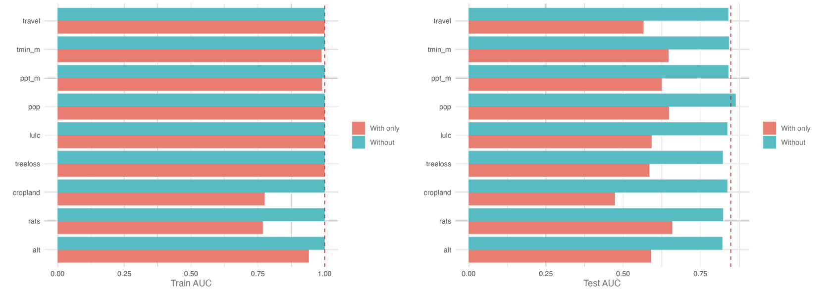
Figure S11: Jackknife test of RF model for rodent-borne disease distribution

Figure S12: Prediction of distribution of rodent-borne disease using the RF model

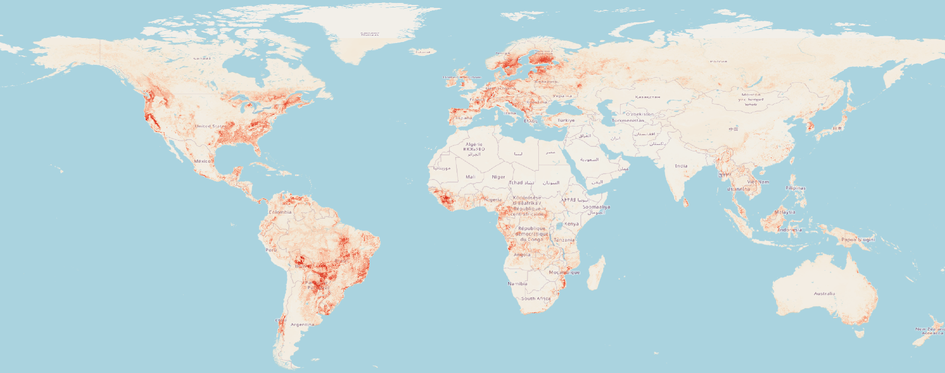

BRT – Rodent borne diseases

For BRT, the tunable parameters are: distribution, n.trees (maximum number of grown trees), interaction depth, shrinkage, bag fraction. We set the distribution to “bernolli,” bag fraction = 0.5, shrinkage = 1, and interaction depth = 1. We used grid search to tune, n.trees and interaction depth. Final BRT model parameters: n.trees = 500, learning.rate = 0.05, bag.fraction = 0.5

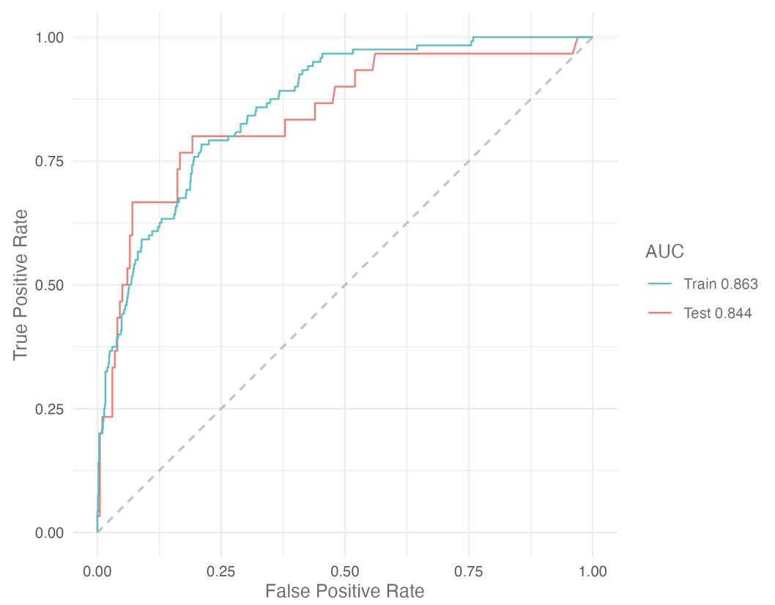
Figure S13: ROC curve of BRT model for rodent-borne disease distribution

Table S8: Variable importance of BRT model for rodent-borne disease distribution

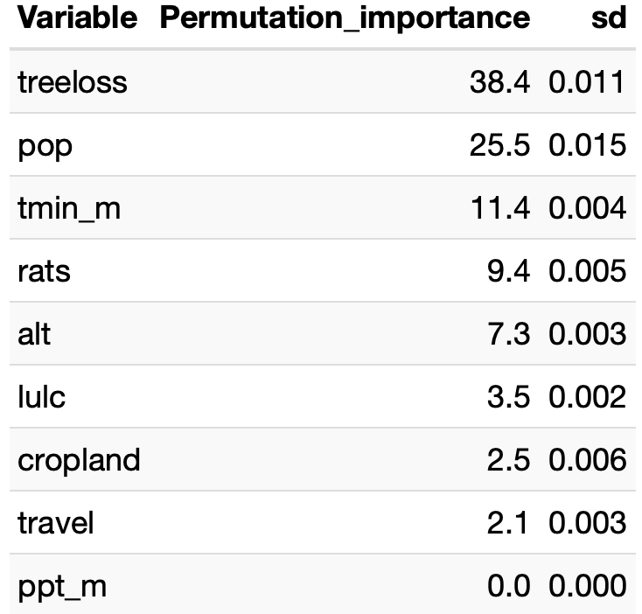

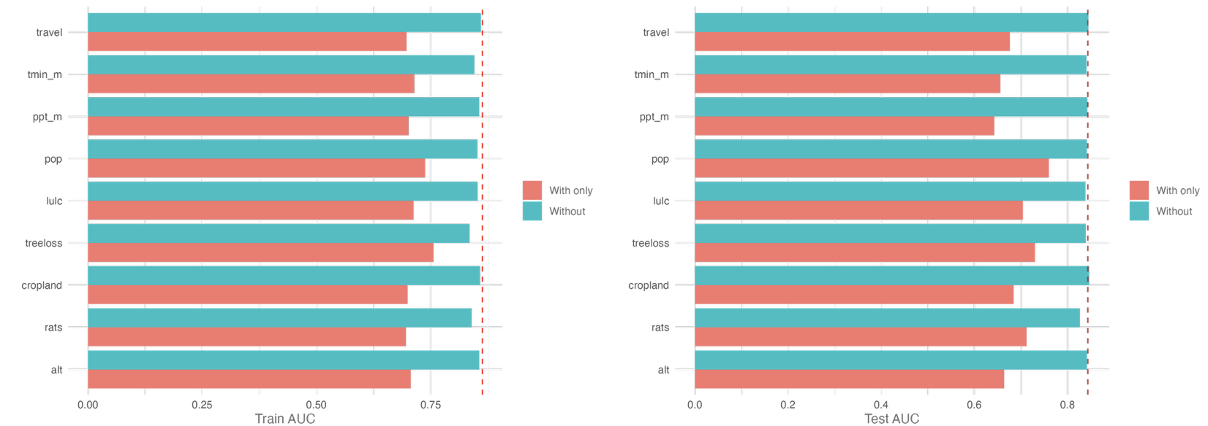
Figure S14: Jackknife test of BRT model for rodent-borne disease distribution

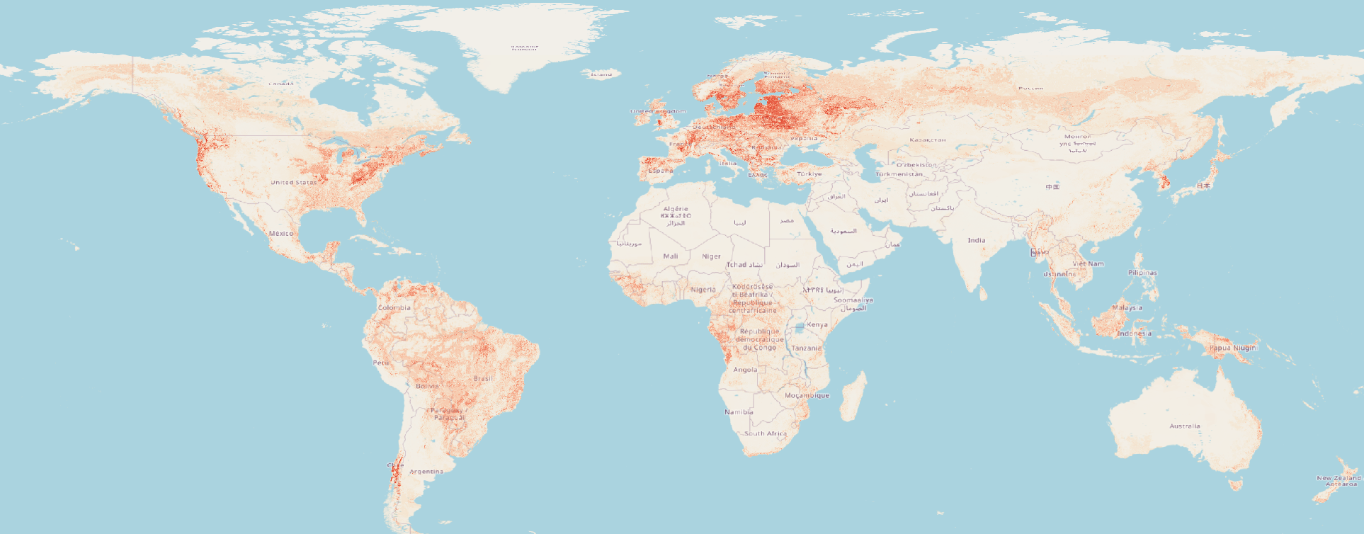
Figure S15: Prediction of distribution of rodent-borne disease using the BRT model

Differences in distribution of rodent-borne diseases between the RF an BRT

The RF model captured high-risk regions in the Americas and Europe while the BRT model predictions were focused on Europe.

Bayesian Binomial – Rodent borne diseases
Iterations = 2001:3996
Thinning interval = 5
Number of chains = 2
Sample size per chain = 400
Quantiles for each variable:

2.5% 25% 50% 75%
beta.(Intercept) -3.00389 -2.71456 -2.59205 -2.46629
beta.alt -0.87093 -0.67197 -0.57837 -0.49187
beta.rats 0.11129 0.24261 0.31706 0.38745
beta.cropland -0.83708 -0.63325 -0.53307 -0.42997
beta.treeloss -0.11804 -0.02222 0.03557 0.09272
beta.lulc -0.51165 -0.34405 -0.25862 -0.16963
beta.pop -2.36203 -1.57542 -1.24568 -0.96637
beta.ppt_m -0.08958 0.07109 0.14730 0.23279
beta.tmin_m -0.59486 -0.44664 -0.37373 -0.30317
beta.travel -1.67003 -1.03273 -0.80737 -0.59888
Deviance 765.85719 769.38261 772.06842 775.40319
97.5%
beta.(Intercept) -2.26676
beta.alt -0.32740
beta.rats 0.53488
beta.cropland -0.25070
beta.treeloss 0.20475
beta.lulc -0.01181
beta.pop -0.44684
beta.ppt_m 0.38807
beta.tmin_m -0.17013
beta.travel -0.27786
Deviance 783.24622

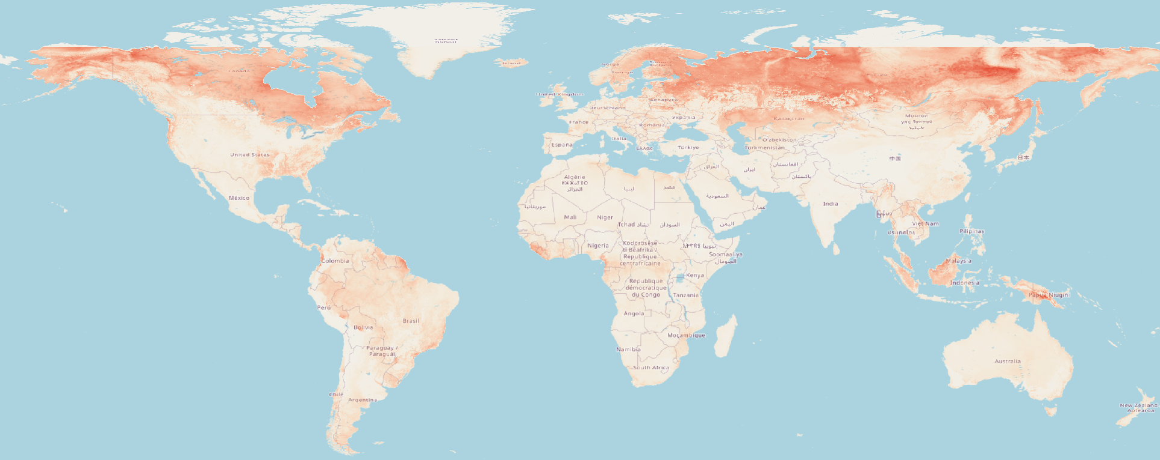
Figure S16: Prediction of distribution of rodent-borne disease using the Bayesian Binomial model

Ensemble modeling

In the final ensemble model for the distribution of bat- and rodent-borne activities, the metacovariates (RF, BRT, and Bayesian Binomial) were statistically significant and relevant to the final distributions.

The MCMC trace and density plots for binomial model in a hierarchical Bayesian framework with spatial autocorrelation (rho) with 4,000 iterations and 2 chains (2,000 per chain). We used non-informative priors with a large variance except for the spatial random effects, for which a uniform (min = 0, max = 10) weak informative prior was used for the parameter inference.

Except for rho, the chains of the other parameters show convergence with regular density plots. While spatial autocorrelation parameter shows some areas of non-convergence with a slight irregularity in the density distribution, which is expected in the autocorrelation parameter. This is confirmed with the Gelman-Rubin’s convergence metric. Overall, the Gelman-Rubin’s convergence diagnostic is 1.1 for the key parameters, thereby confirming convergence and the validity of the model.

The intrinsic conditional autoregressive model (iCAR) was calculated using:
pi = Normal (ui, Vp/ni)
Where ui = mean of pi in the neighborhood of cell i; Vp = variance of the spatial random effects; ni = number of neighbors for cell i. The iCAR used a spatial structure of the eight nearest neighboring pixels (Queen approach) to account for spatial correlation
Ensemble model : Binomial icar bat-borne disease model

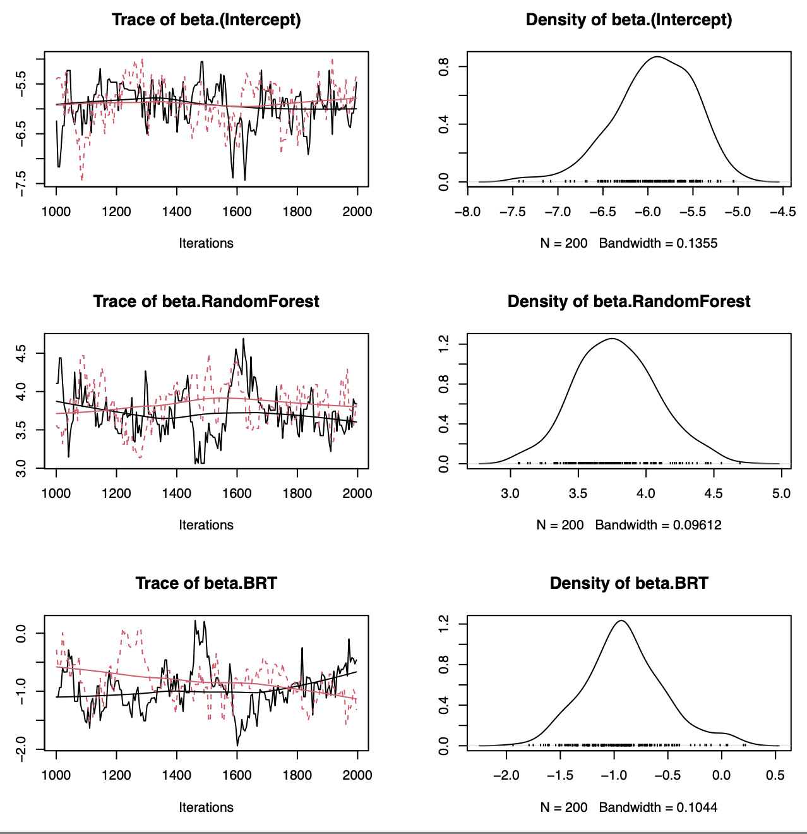
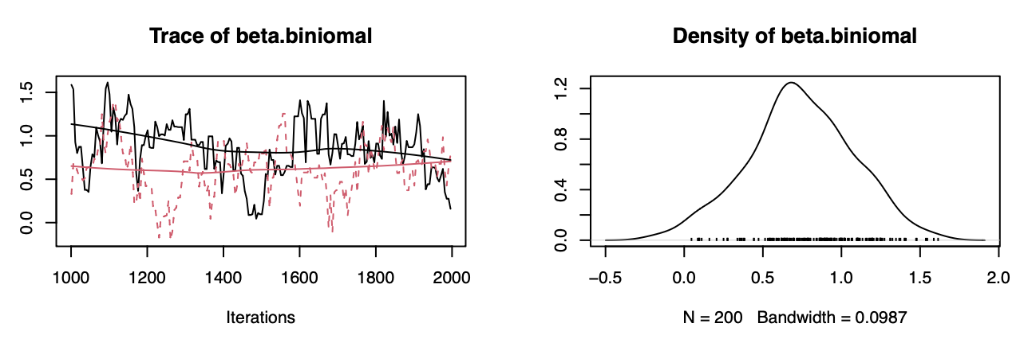

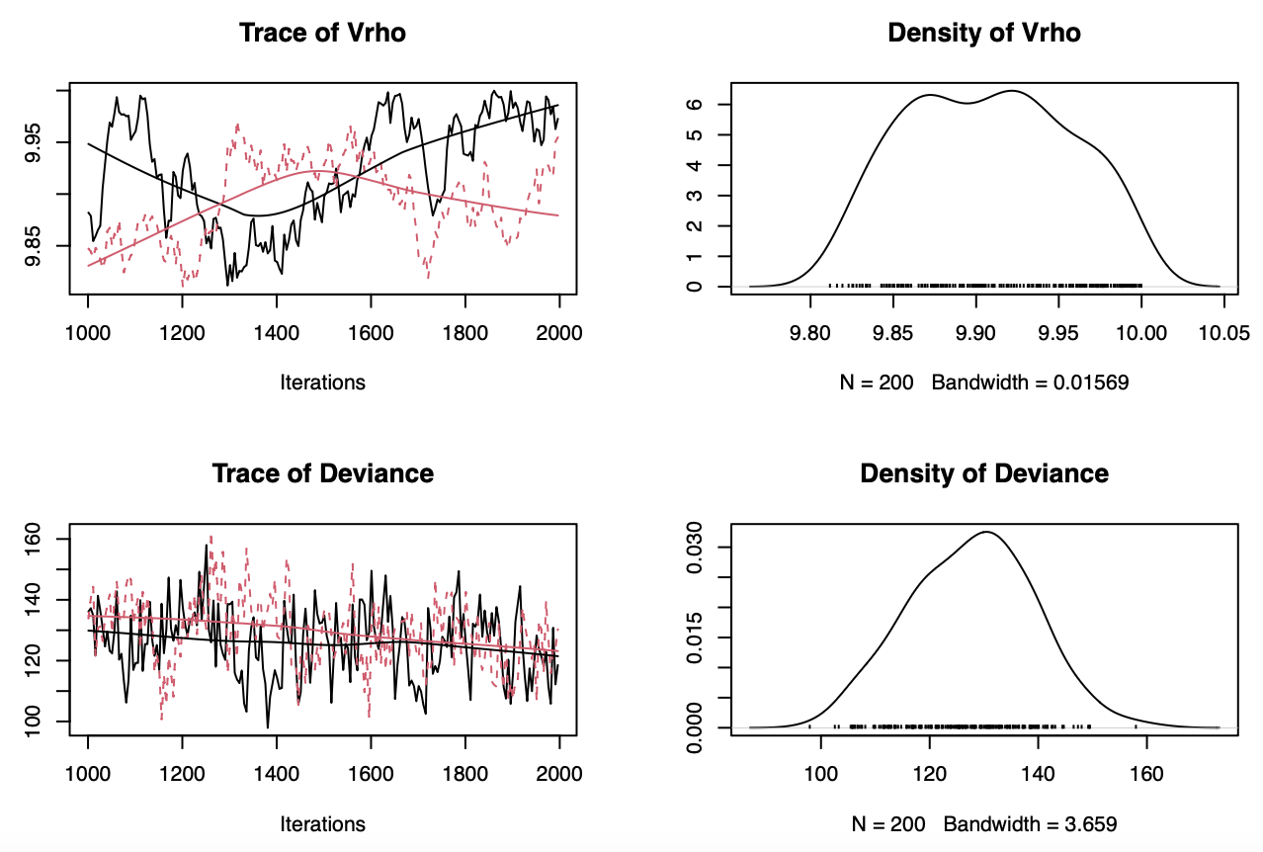
Figure S17: Binomial icar MCMC trace of bat-borne disease model

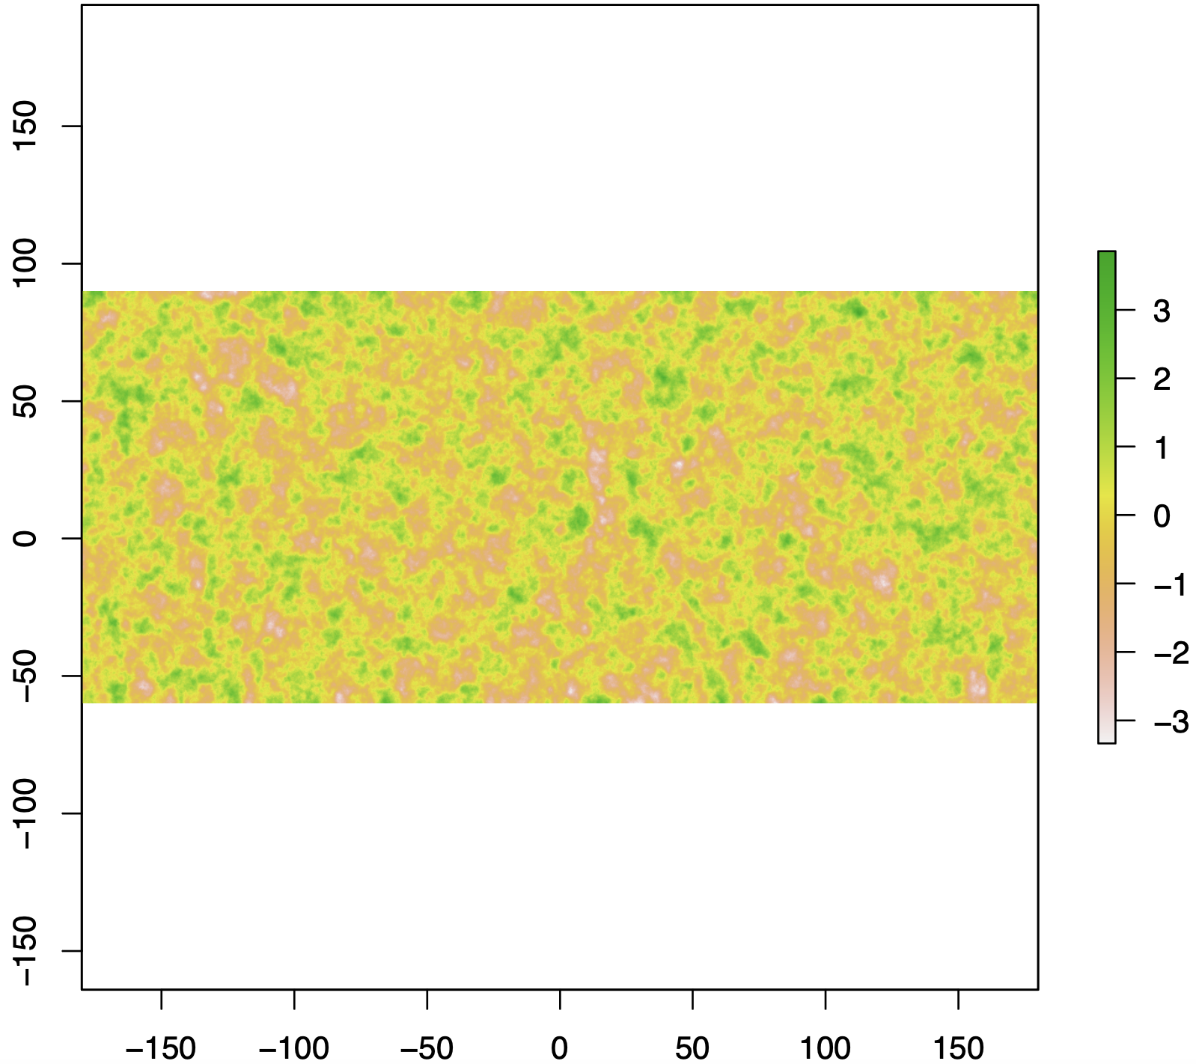

Figure S18: Binomial icar bat-borne disease model- Random effects

Table S9: The highest mean probabilities for bat-borne diseases with the Standard Deviation (SD), Minimum (min) and Maximum (Max) by country.

Country | Continent | Mean | SD | Min | Max
Bahrain | Asia | 0.82 | 0.07 | 0.73 | 0.92
Equatorial Guinea | Africa | 0.76 | 0.28 | 0.05 | 0.99
Gabon | Africa | 0.56 | 0.27 | 0.01 | 0.99
Liberia | Africa | 0.56 | 0.30 | 0.01 | 0.99
Congo | Africa | 0.44 | 0.31 | 0 | 0.99
Sierra Leone | Africa | 0.41 | 0.37 | 0 | 0.99
Lao People's Democratic Republic | Asia | 0.35 | 0.28 | 0 | 0.96
Cameroon | Africa | 0.34 | 0.35 | 0 | 0.99
Malaysia | Asia | 0.33 | 0.28 | 0 | 0.99
Uganda | Africa | 0.31 | 0.30 | 0 | 0.99
Qatar | Asia | 0.29 | 0.24 | 0 | 0.98
Democratic Republic of the Congo | Africa | 0.29 | 0.27 | 0 | 0.99

Ensemble model : Binomial icar rodent-borne disease model

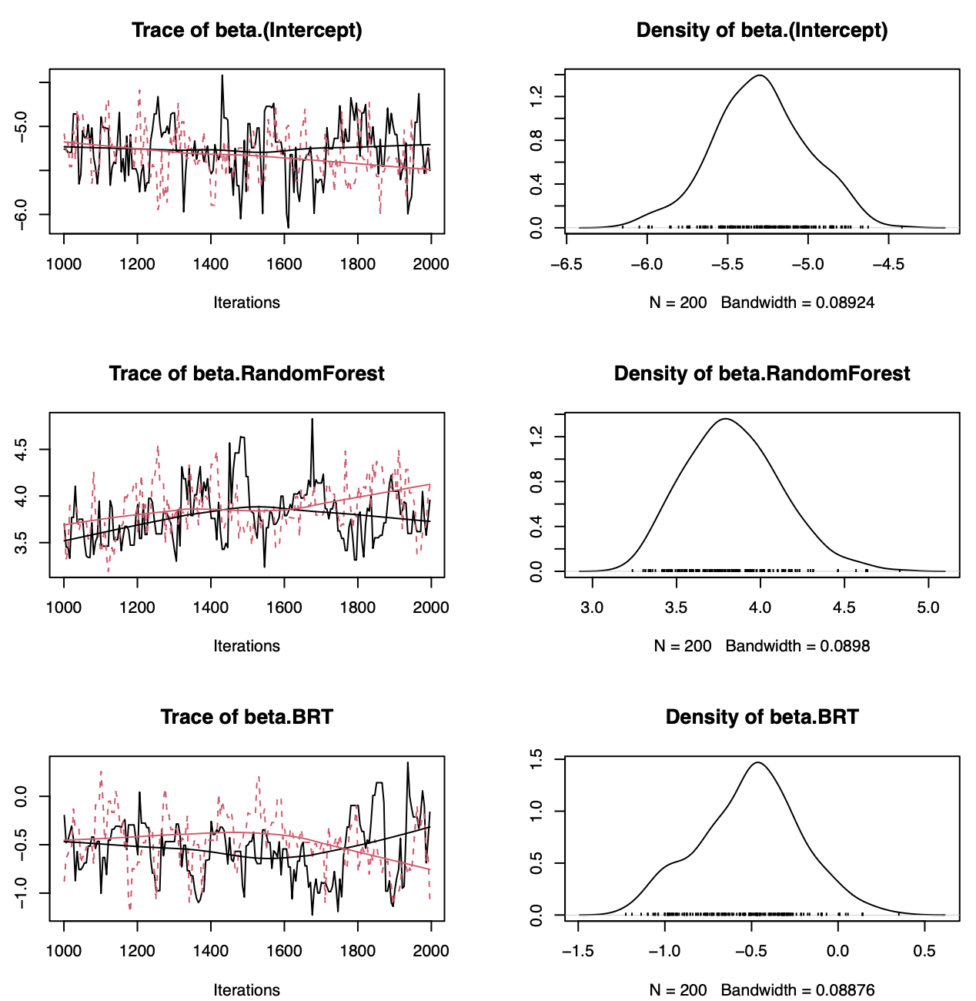
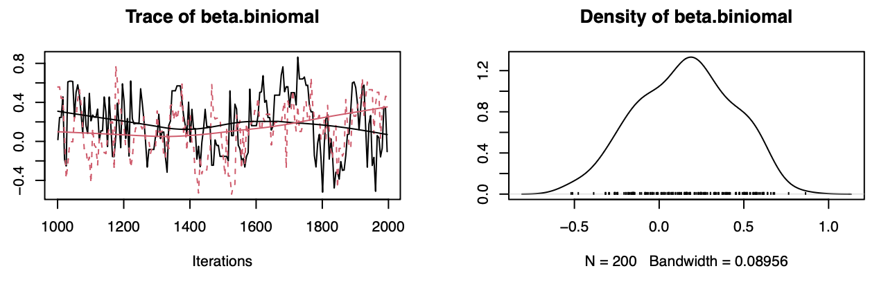

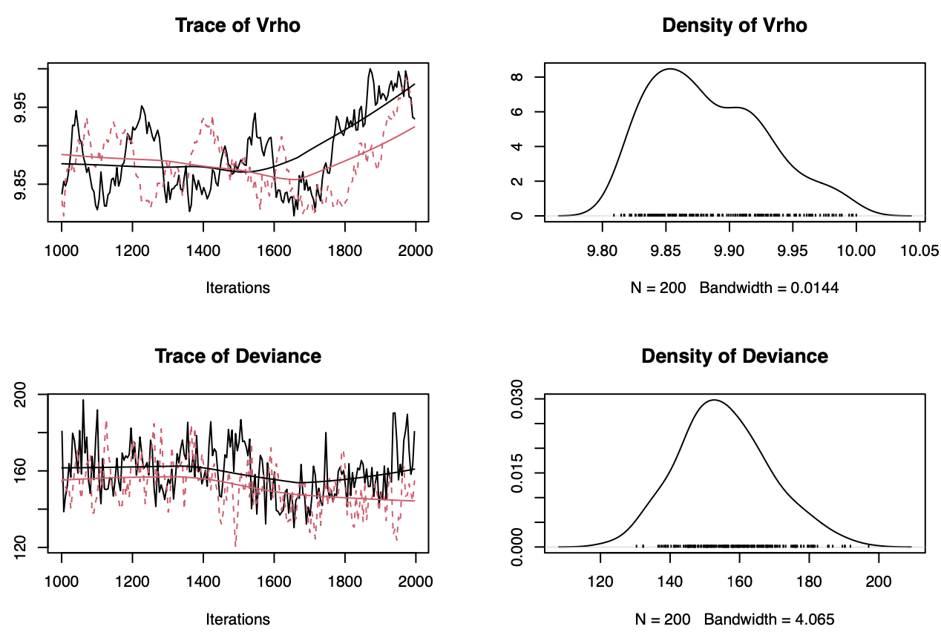
Figure S19: Binomial icar MCMC trace of rodent-borne disease model

Figure S20: Binomial icar rodent-borne disease model- Random effects

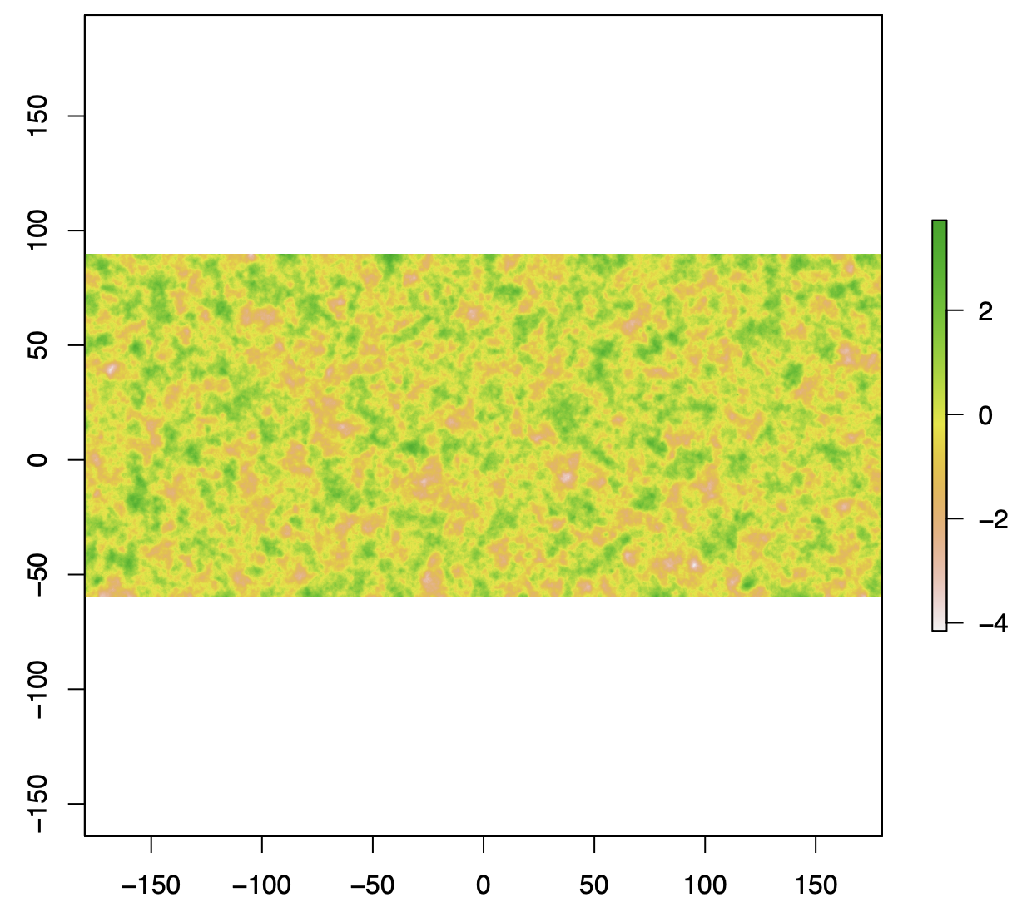

Table S10: The highest mean probabilities for rodent-borne diseases with the Standard Deviation (SD), Minimum (min) and Maximum (Max) by country.

Country | Continent | Mean | SD | Min | Max
Montenegro | Europe | 0.49 | 0.29 | 0 | 0.96
Sierra Leone | Africa | 0.40 | 0.33 | 0.01 | 0.99
Liberia | Africa | 0.39 | 0.24 | 0.01 | 0.99
Sri Lanka | Asia | 0.38 | 0.28 | 0.01 | 0.99
Bosnia & Herzegovina | Europe | 0.36 | 0.23 | 0 | 0.99
Guinea | Africa | 0.31 | 0.31 | 0 | 0.99
Bolivia | Americas | 0.30 | 0.28 | 0 | 0.99
Paraguay | Americas | 0.30 | 0.26 | 0 | 0.99
Finland | Europe | 0.29 | 0.28 | 0 | 0.95
Sweden | Europe | 0.24 | 0.28 | 0 | 0.97

Simulation methods for improved reporting
Improved reporting refers to a hypothetical scenario where underreporting biases are reduced through enhanced surveillance, increased diagnostic capacity, and systematic data collection. In our simulations, this is modeled by adjusting reporting probabilities to better reflect potential disease presence in under-surveyed regions. We defined different levels of potential reporting improvements, where data collaboration, improved data quality or reporting frequency improves by 10%, 25%, and 50%. We decreased the values in the uncertainty raster by a fixed percentage (10%, 25%, and 50%) to simulate various scenarios of better reporting.

New Probability Range = Probability ± (1.96× Updated Uncertainty)

Using the updated uncertainty rasters, we calculated the new lower and upper confidence intervals (CI), to then calculate the new probability of bat- and rodent- borne diseases with increased reporting. We re-ran the ensemble modelling with the new probability raster as one of the meta-covariates (along with the RF, BRT and Bayesian Binomial raster). We compared the new maxTSS of the new ensemble with the original model.

The assumption that uncertainty is reduced with improved reporting is based on the rationale that better reporting leads to more precise and accurate data, which in turn reduces spatial uncertainty in disease occurrence. By using exact coordinates and not generalized or centroid locations, we hope to reduce the underlying limitations. Nevertheless, uncertainty can persist due to factors such as clustering, imprecise location data, and reporting biases.

Table S11: The area of high-risk (km2) for bat-borne diseases calculated from the Ensemble model and the Ensemble model with 50% reduction in uncertainty in Europe.

Name | Region | High-risk areas in Ensemble (km2) | High-risk areas in Ensemble50  (km2)
Albania | Southern Europe | 173 | 0
Andorra | Southern Europe | 3 | 0
Austria | Western Europe | 532 | 0
Azores Islands | Southern Europe | 16 | 0
Belarus | Eastern Europe | 1489 | 0
Belgium | Western Europe | 327 | 0
Bosnia & Herzegovina | Southern Europe | 170 | 0
Bulgaria | Eastern Europe | 147 | 0
Croatia | Southern Europe | 422 | 0
Czech Republic | Eastern Europe | 386 | 0
Denmark | Northern Europe | 1354 | 0
Estonia | Northern Europe | 1464 | 0
Faroe Islands | Northern Europe | 207 | 0
Finland | Northern Europe | 5447 | 100
France | Western Europe | 6466 | 100
Germany | Western Europe | 1980 | 0
Gibraltar | Southern Europe | 0 | 0
Greece | Southern Europe | 947 | 0
Guernsey | Northern Europe | 1 | 0
Holy See | Southern Europe | 0 | 0
Hungary | Eastern Europe | 790 | 0
Iceland | Northern Europe | 3067 | 0
Ireland | Northern Europe | 2776 | 0
Isle of Man | Northern Europe | 45 | 0
Italy | Southern Europe | 1759 | 0
Jersey | Northern Europe | 2 | 0
Latvia | Northern Europe | 1533 | 0
Liechtenstein | Western Europe | 1 | 0
Lithuania | Northern Europe | 638 | 0
Luxembourg | Western Europe | 118 | 0
Madeira Islands | Southern Europe | 2 | 0
Malta | Southern Europe | 1 | 0
Moldova, | Eastern Europe | 23 | 0
Monaco | Western Europe | 0 | 0
Montenegro | Southern Europe | 45 | 0
Netherlands | Western Europe | 697 | 0
Norway | Northern Europe | 5826 | 0
Poland | Eastern Europe | 4047 | 0
Portugal | Southern Europe | 598 | 0
Romania | Eastern Europe | 385 | 0
Russian Federation | Eastern Europe | 107604 | 100
San Marino | Southern Europe | 0 | 0
Serbia | Southern Europe | 212 | 0
Slovakia | Eastern Europe | 254 | 0
Slovenia | Southern Europe | 97 | 0
Spain | Southern Europe | 2665 | 0
Svalbard and Jan Mayen Islands | Northern Europe | 685 | 0
Sweden | Northern Europe | 7268 | 0
Switzerland | Western Europe | 494 | 0
The former Yugoslav Republic of Macedonia | Southern Europe | 49 | 0
U.K. | Northern Europe | 30753 | 600
Ukraine | Eastern Europe | 4160 | 0
Total |  | 198125 | 900

Table 12: The area of high-risk (km2) for rodent-borne diseases calculated from the Ensemble model and the Ensemble model with 50% reduction in uncertainty in the Balkan countries.

Name | Region | High-risk areas in Ensemble (km2) | High-risk areas in Ensemble50  (km2)
Albania | Southern Europe | 2100 | 7916
Bosnia & Herzegovina | Southern Europe | 2800 | 17935
Bulgaria | Eastern Europe | 0 | 5084
Croatia | Southern Europe | 2100 | 14113
Greece | Southern Europe | 600 | 14366
Montenegro | Southern Europe | 3300 | 7440
North Macedonia + Kosovo | Southern Europe | 0 | 1632
Romania | Eastern Europe | 0 | 13811
Serbia | Southern Europe | 2800 | 14995
Slovenia | Southern Europe | 900 | 9029
Total |  | 14600 | 106125

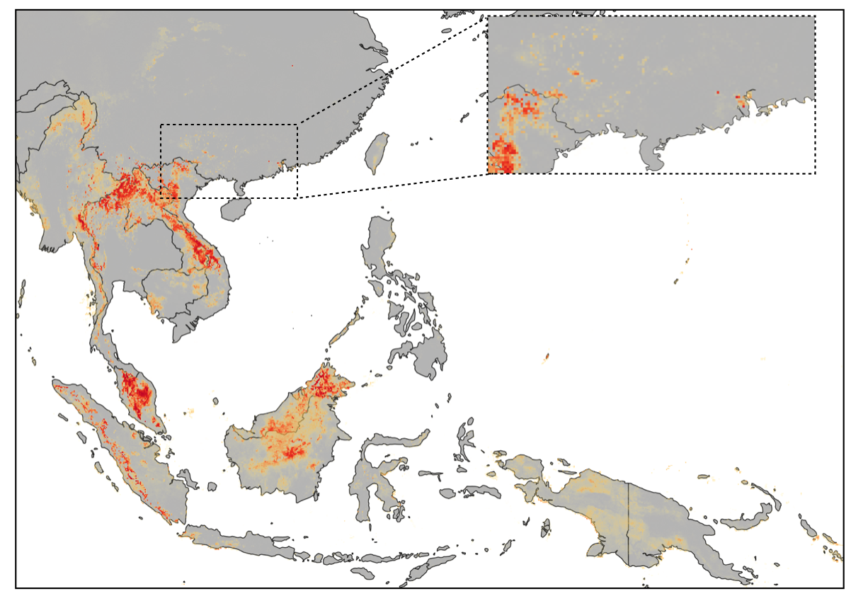

Figure S21: High-risk areas of bat-borne diseases in Southeast Asia and Southern China.

Comparison of risk maps with outbreak patterns from historical data

To further validate the predictive accuracy of our model, we have now compared our results with known outbreak patterns from historical data. This comparison allowed us to assess how well our model can identify high-risk areas for bat- and rodent-borne diseases, particularly in regions where notable zoonotic events have occurred. To go beyond deviance-based comparisons and assess whether high predicted risk aligns with actual outbreak locations, we extracted risk values at outbreak locations, compared with randomly sampled locations, and conducted Wilcoxon tests for significance. This has added another layer of validation. These steps help confirm that outbreaks systematically occur in high-risk regions predicted by the model, rather than just improving fit compared to a uniform spatial distribution.

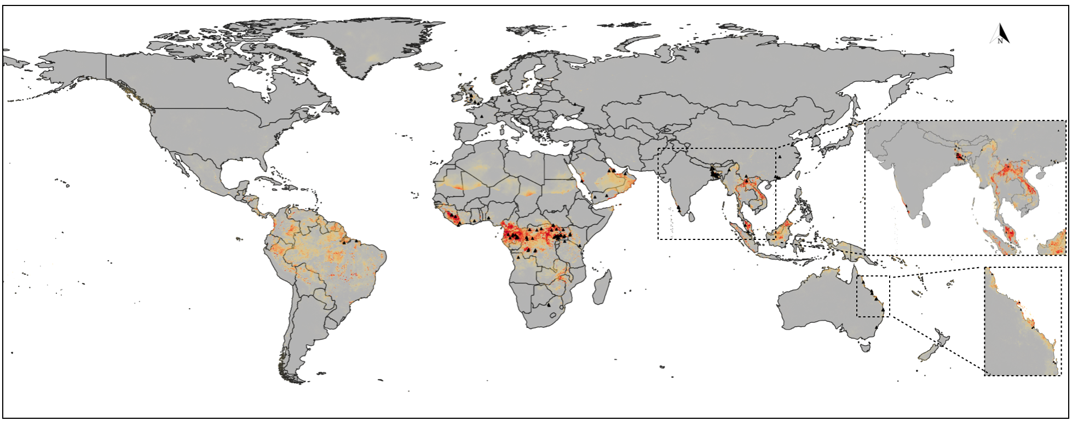
Figure S22: Risk map from the bat ensemble model along with outbreak patterns from historical data.

Wilcoxon rank sum test with continuity correction

W = 116810,
p-value < 2.2e-16
Alternative hypothesis: true location shift is greater than 0

The highly significant p-value suggests that actual bat risk is significantly higher than randomly sampled risk values. This supports the validity of the model risk prediction, i.e. the bat outbreak locations are not randomly distributed but align with higher-risk areas identified by your model.

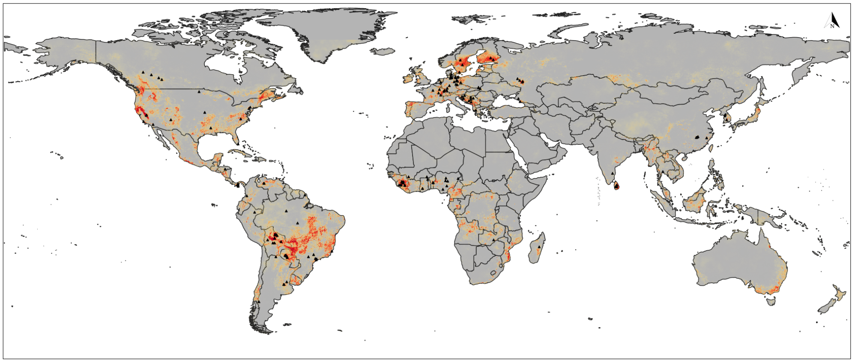
Figure S23: Risk map from the rodent ensemble model along with outbreak patterns from historical data.

Wilcoxon rank sum test with continuity correction

W = 143499,
p-value < 2.2e-16
alternative hypothesis: true location shift is greater than 0

The highly significant p-value suggests that actual bat risk is significantly higher than randomly sampled risk values. This supports the validity of the model risk prediction, i.e. the bat outbreak locations are not randomly distributed but align with higher-risk areas identified by your model.

Potential interactions between covariates (temperature and precipitation)
The AUC results of the Random forest models with and without interaction between temperature and precipitation suggest that adding interaction terms had a negligible impact on model performance.
- Model without interaction: AUC = 0.9784
- Model with interaction: AUC = 0.9777

Interpretation:
- Since both AUC values are nearly identical, the interaction terms do not significantly improve the model’s ability to discriminate between presence and absence.
- This could mean that:
  - The interactions are not crucial in explaining the variance in your data.
  - The main effects of the predictors already capture most of the patterns in disease risk.

