Table S1. Estimated parameter values (median and quantiles) for parameter sets that gave the highest 10% of predicted overall cases in 2024 indicating a resurgence in 2024.
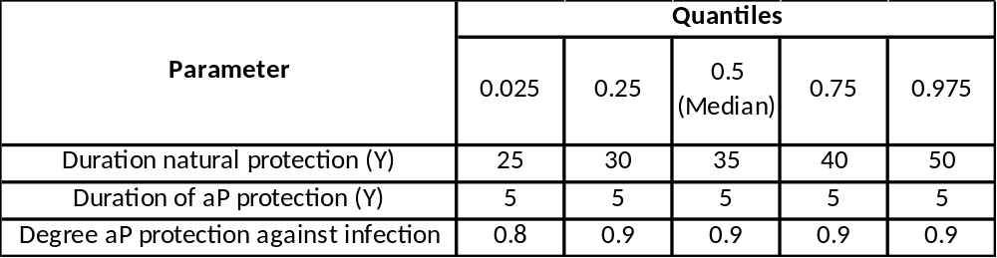

Table S2. Estimated parameter values (median and quantiles) for parameter sets that gave less than one overall case in 2024 indicating a resurgence later than 2024.
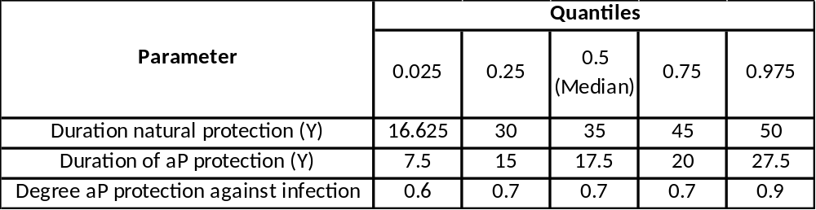

Figure S1. Model outputs for overall pertussis notifications from 2006 to 2054 under the existing aP primary and pre-school booster schedule without the reduced population mixing during the COVID-19 pandemic. A: without any drop in coverage and B: with a 10% drop in coverage for the primary and pre-school booster doses from January 2020 to December 2022. Graphs show the median as a black line (minimum to maximum range in the pink shaded area) of the predicted annual pertussis notifications using the best fitting parameter sets from Choi et al (11).
Table S3. Medians (minimum to maximum range in brackets) of notified pertussis cases between 2015 and 2034 in England under the current vaccination schedule from the long-term simulation results of the pertussis transmission dynamic model by age group, with parameter sets that gave the highest 10% of predicted overall cases in 2024, and the mixing patterns adjusted according to the scaling matrix during the COVID-19 (12)
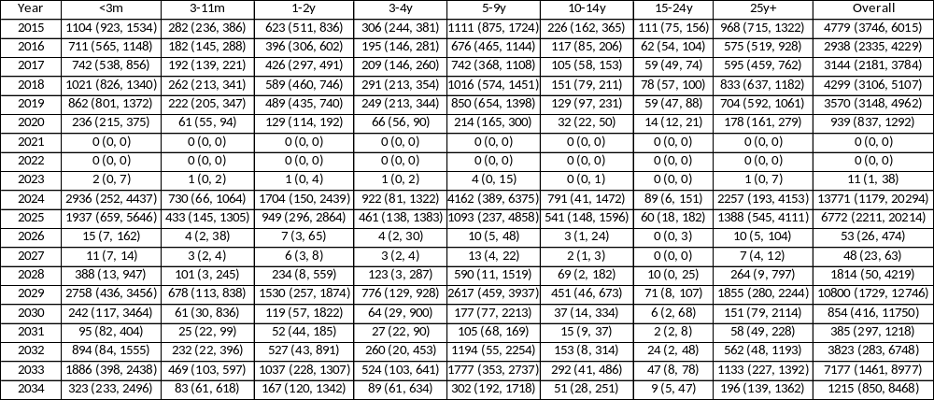

Table S4. Medians (minimum to maximum range in brackets) of notified pertussis cases between 2015 and 2034 in England from the long-term simulation results of the pertussis transmission dynamic model by age group with parameter sets that gave the highest 10% of predicted overall cases in 2024, and the mixing patterns adjusted according to the scaling matrix during the COVID-19 (12) assuming the introduction of two additional booster doses at the age of 18 month and 14 years from the beginning of 2014.
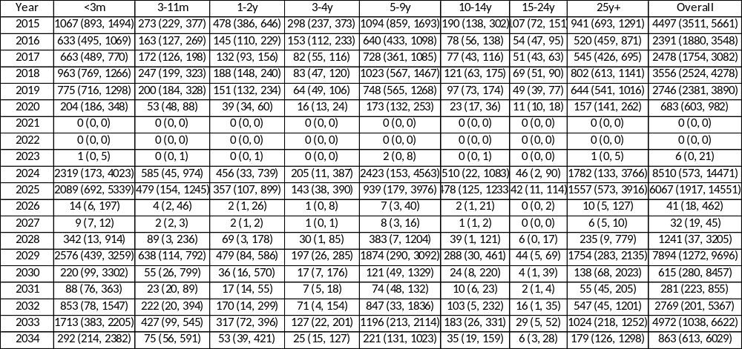

Table S5. Medians (minimum to maximum range in brackets) of notified pertussis cases between 2015 and 2034 in England from the long-term simulation results of the pertussis transmission dynamic model by age group, with parameter sets that gave the highest 10% of predicted overall cases in 2024, in England and the mixing patterns adjusted according to the scaling matrix during the COVID-19 (12). Current programme until 2024 with the introduction of two additional booster doses at the age of 18 month and 14 years from the beginning of 2025.
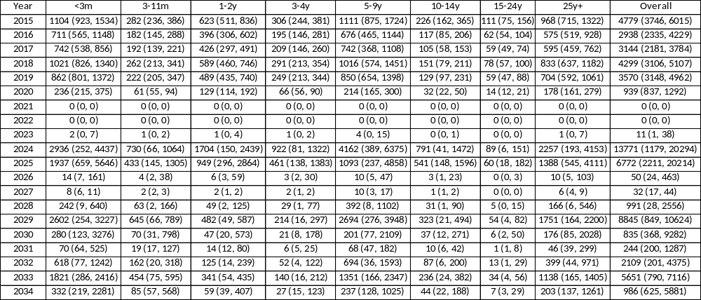

Table S6. Predicted averted cases by age group compared with existing UK schedule if an 18 month and 14 year acellular pertussis vaccine boosters had been introduced in England in 2014 by age group
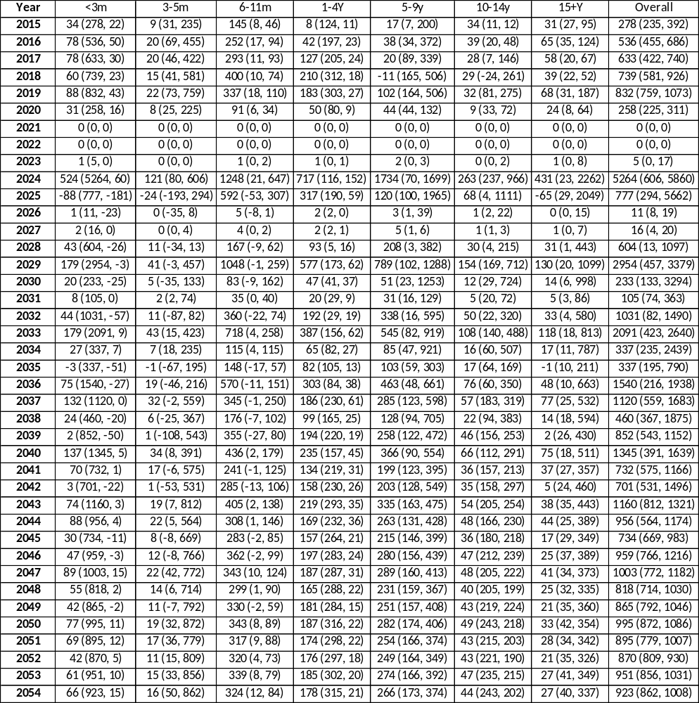

Table S7. Predicted averted cases by age group compared with existing UK schedule if an 18 month and 14 year acellular pertussis vaccine boosters were to be introduced in England in 2025
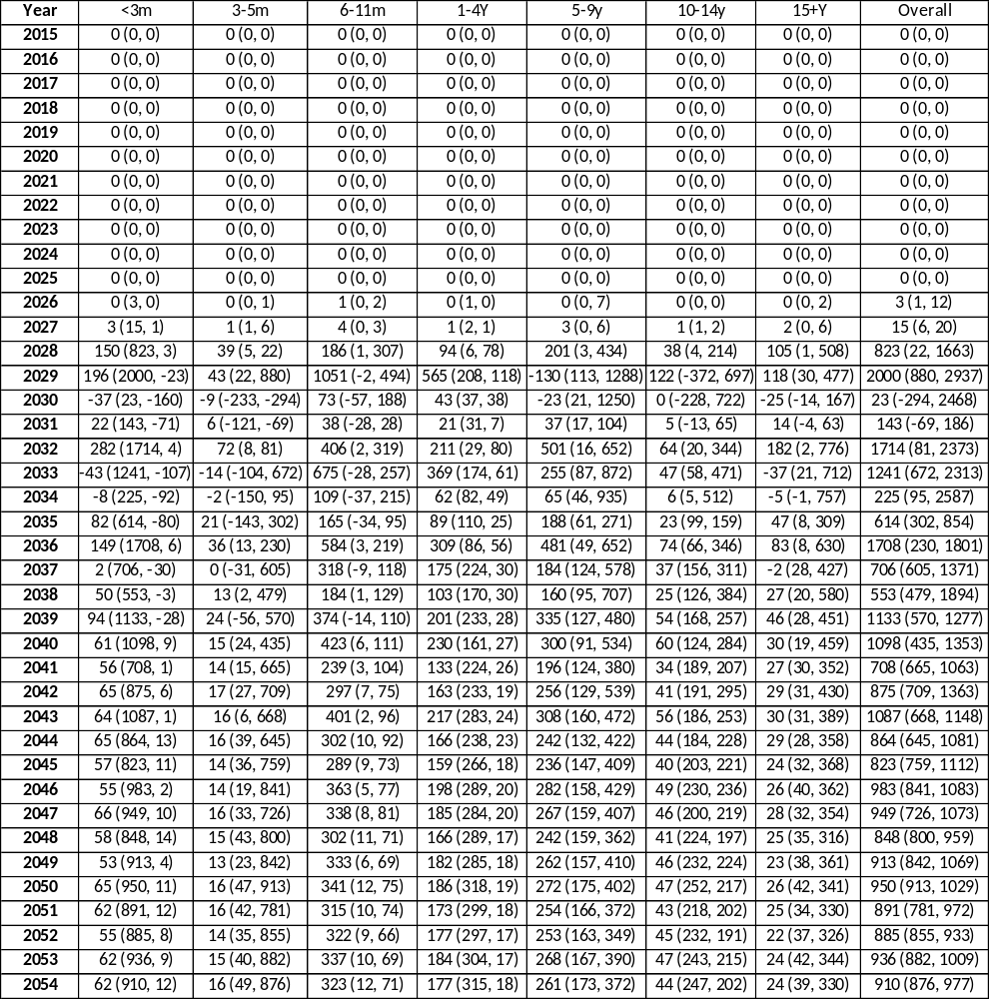

Figure S2. Model outputs for pertussis notifications from S1 and S2 compartments in Fig 1 between 2006 and 2054 in England by age group under the existing aP primary and pre-school booster schedule with the reduced population mixing during the COVID-19 pandemic. Graphs show the median as a black line (minimum to maximum range in the pink shaded area) of the predicted annual pertussis notifications with restriction of parameter sets to those that generate a resurgence in 2024 (n=66). (This is the same as Fig 3 when the S1 and S2 are combined.)

