Extended data figures
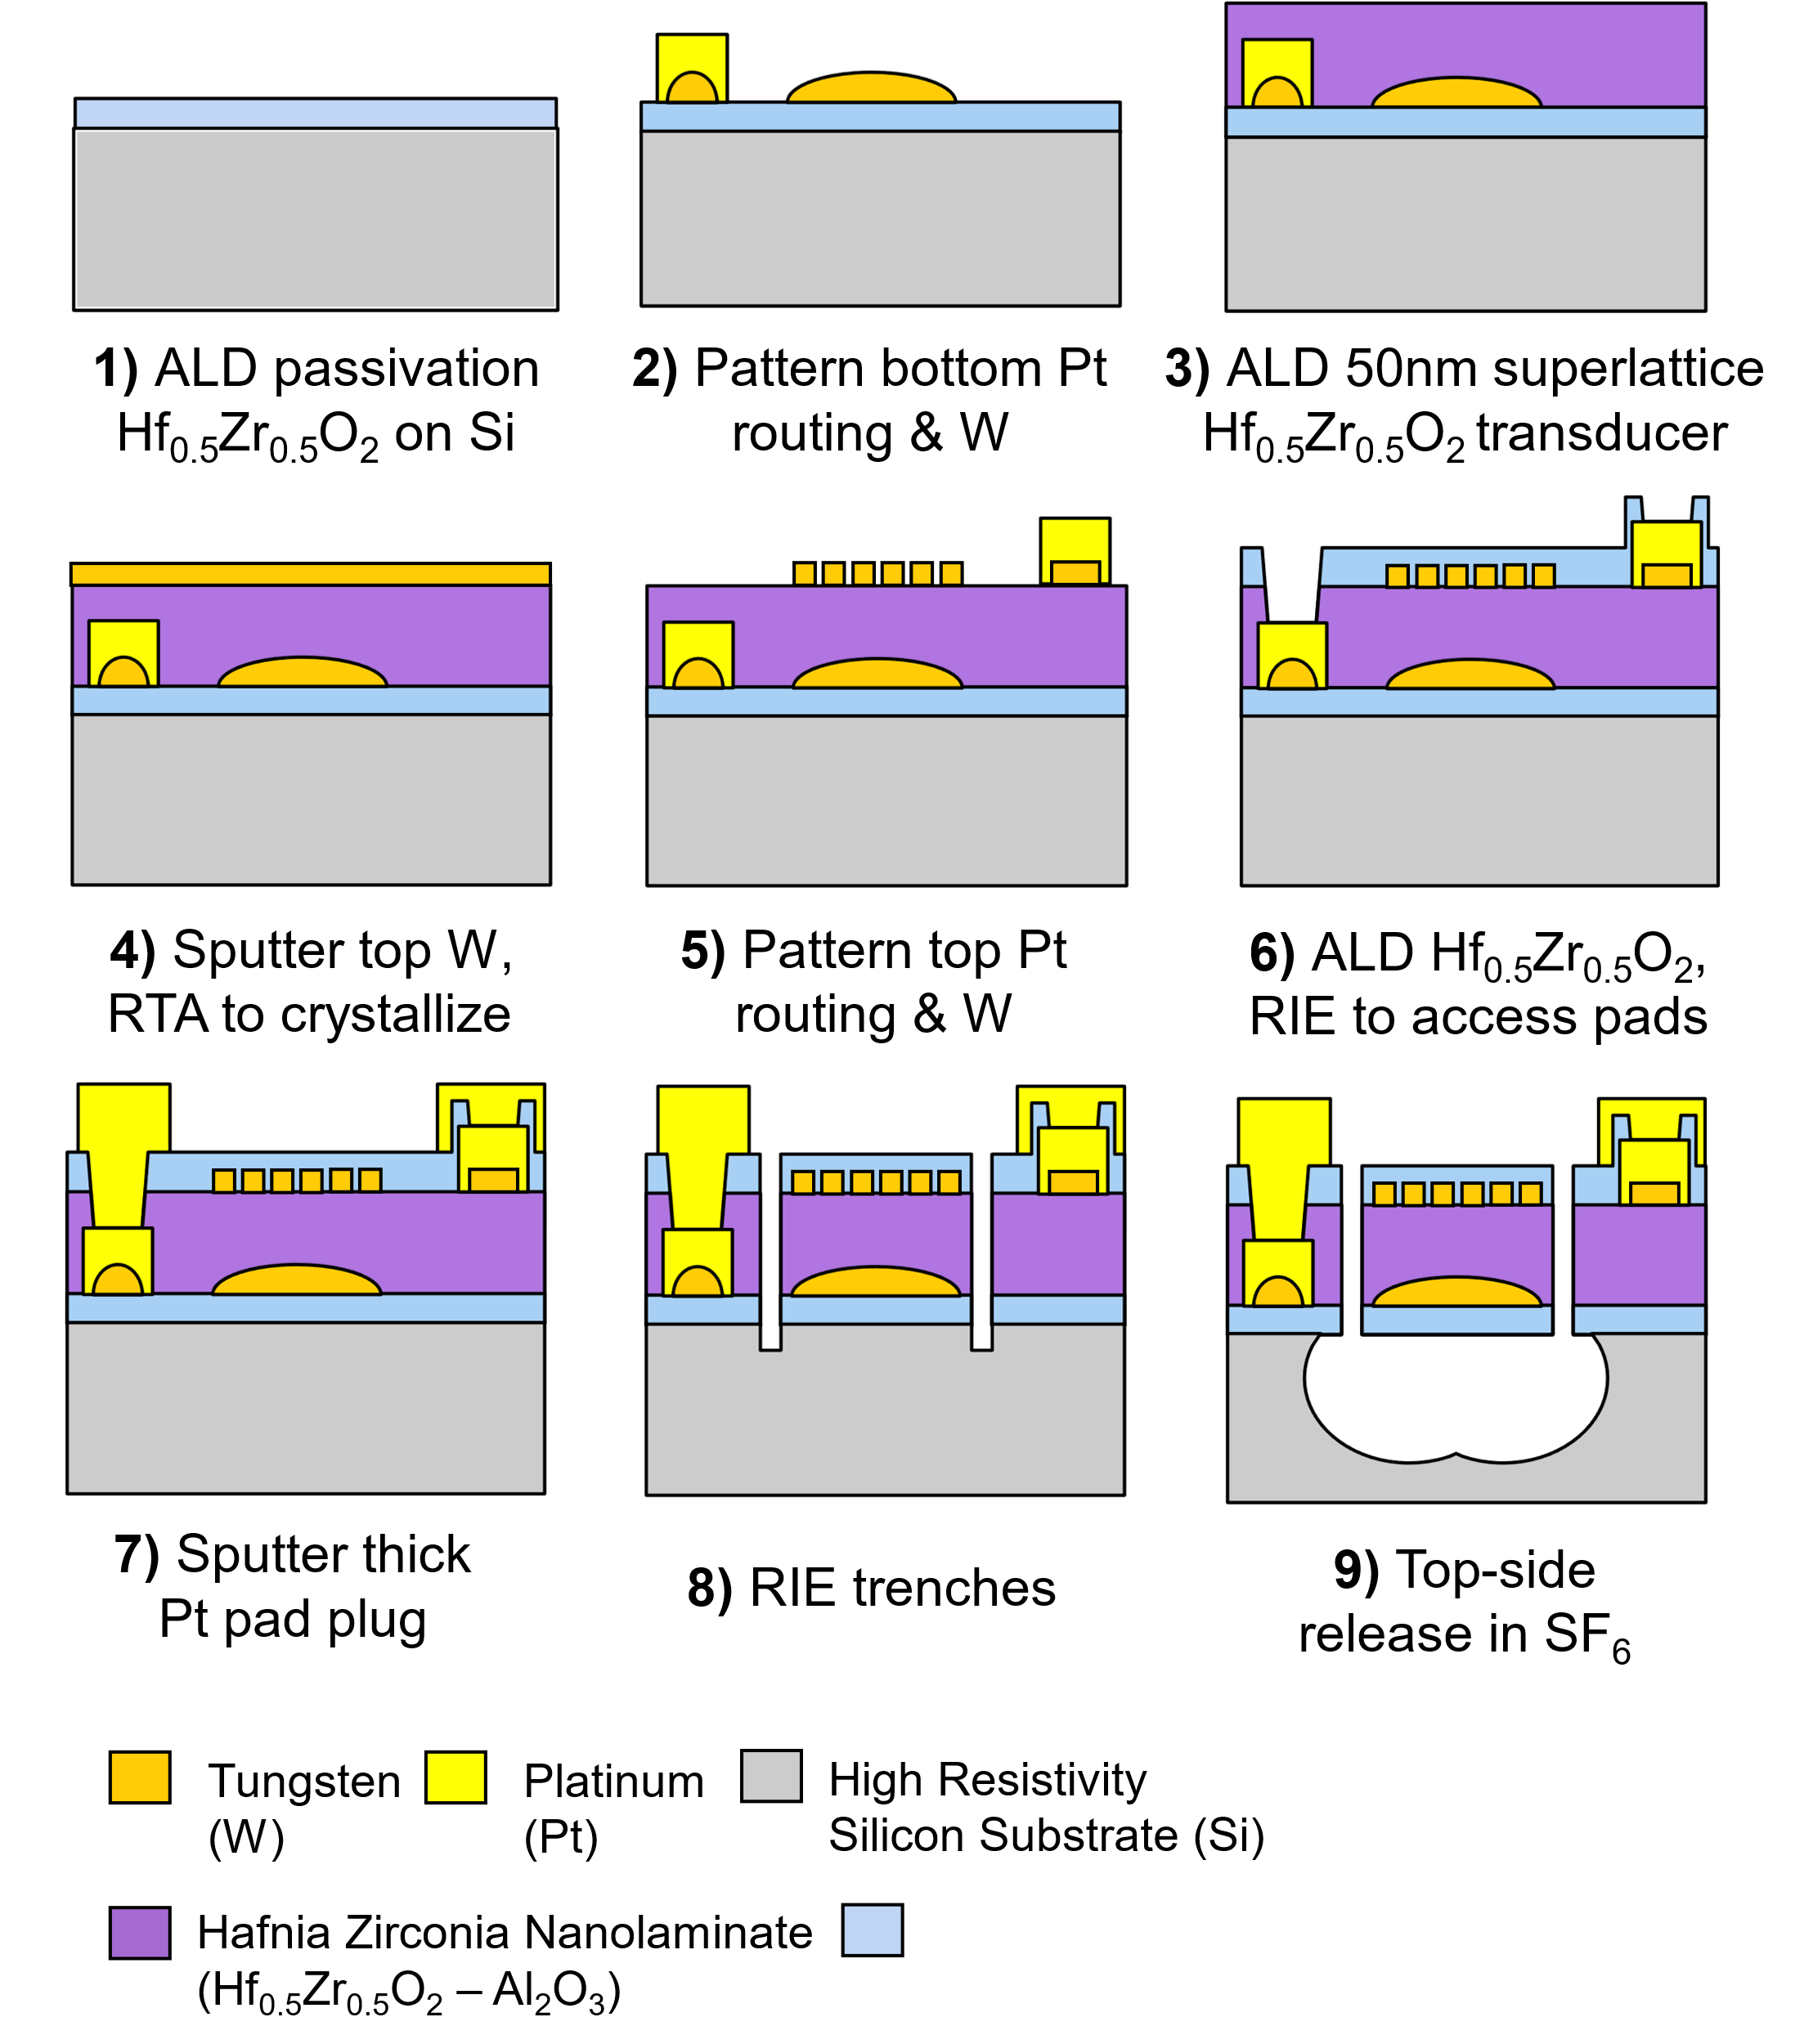
Extended Data Fig.1 | Nine step fabrication process used to realize HZO and HZO-SiO₂ nanomechanical resonators. The fabrication process consists of successive deposition and patterning of SiO₂, HZO-Al₂O₃, W, and Pt layers to realize two- or three-port nanomechanical resonators to operate in bulk acoustic wave modes. After deposition of HZO-Al₂O₃ and W layers, rapid thermal annealing is used for crystallization if ferroelectric transducer in polar orthorhombic phase. In HZO resonators, metal-ferroelectric-metal stack is sandwiched between HZO passivation layers that also serve to protect W electrodes from oxidation. In HZO-SiO₂ resonators, HZO passivation layers are replaced by SiO₂ layers. After deposition and patterning of different layers, the resonators are released from substrate by dry etching of silicon substrate.
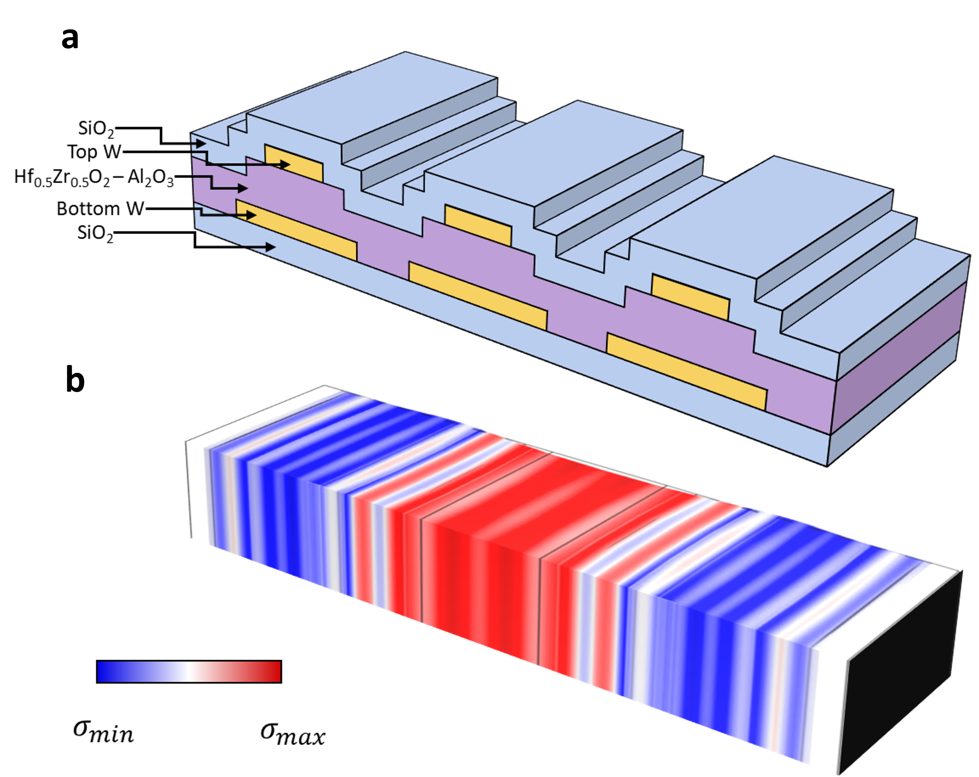

Extended Data Fig.2 | Simulation of BAW HZO-SiO₂ resonator operated in WE₃ mode. a, Schematic cross-section of HZO-SiO2 resonator, used for COMSOL modeling. b, COMSOL-simulated vibration mode-shape of the WE₃ mode. The color code represent in-plane longitudinal stress in width direction of the resonator.

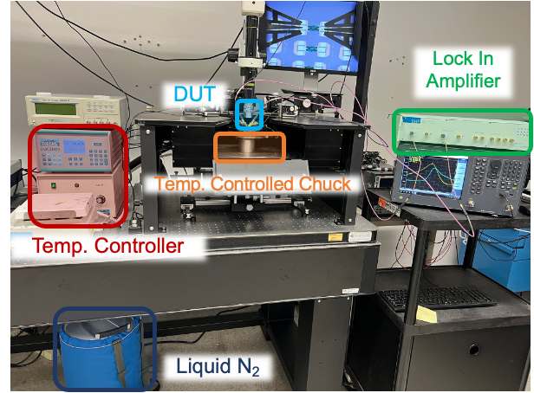

Extended Data Fig.3 | Resonator and clock measurement setup. Resonators and clock s are measured using an RF probe station with temperature-controlled chuck. The measurement setup consists of a controller unit controlling chuck temperature with resistive heating and liquid nitrogen lines, a liquid nitrogen cannister, RF vector network analyzer, UHF lock-in amplifier, and ferroelectric tester.

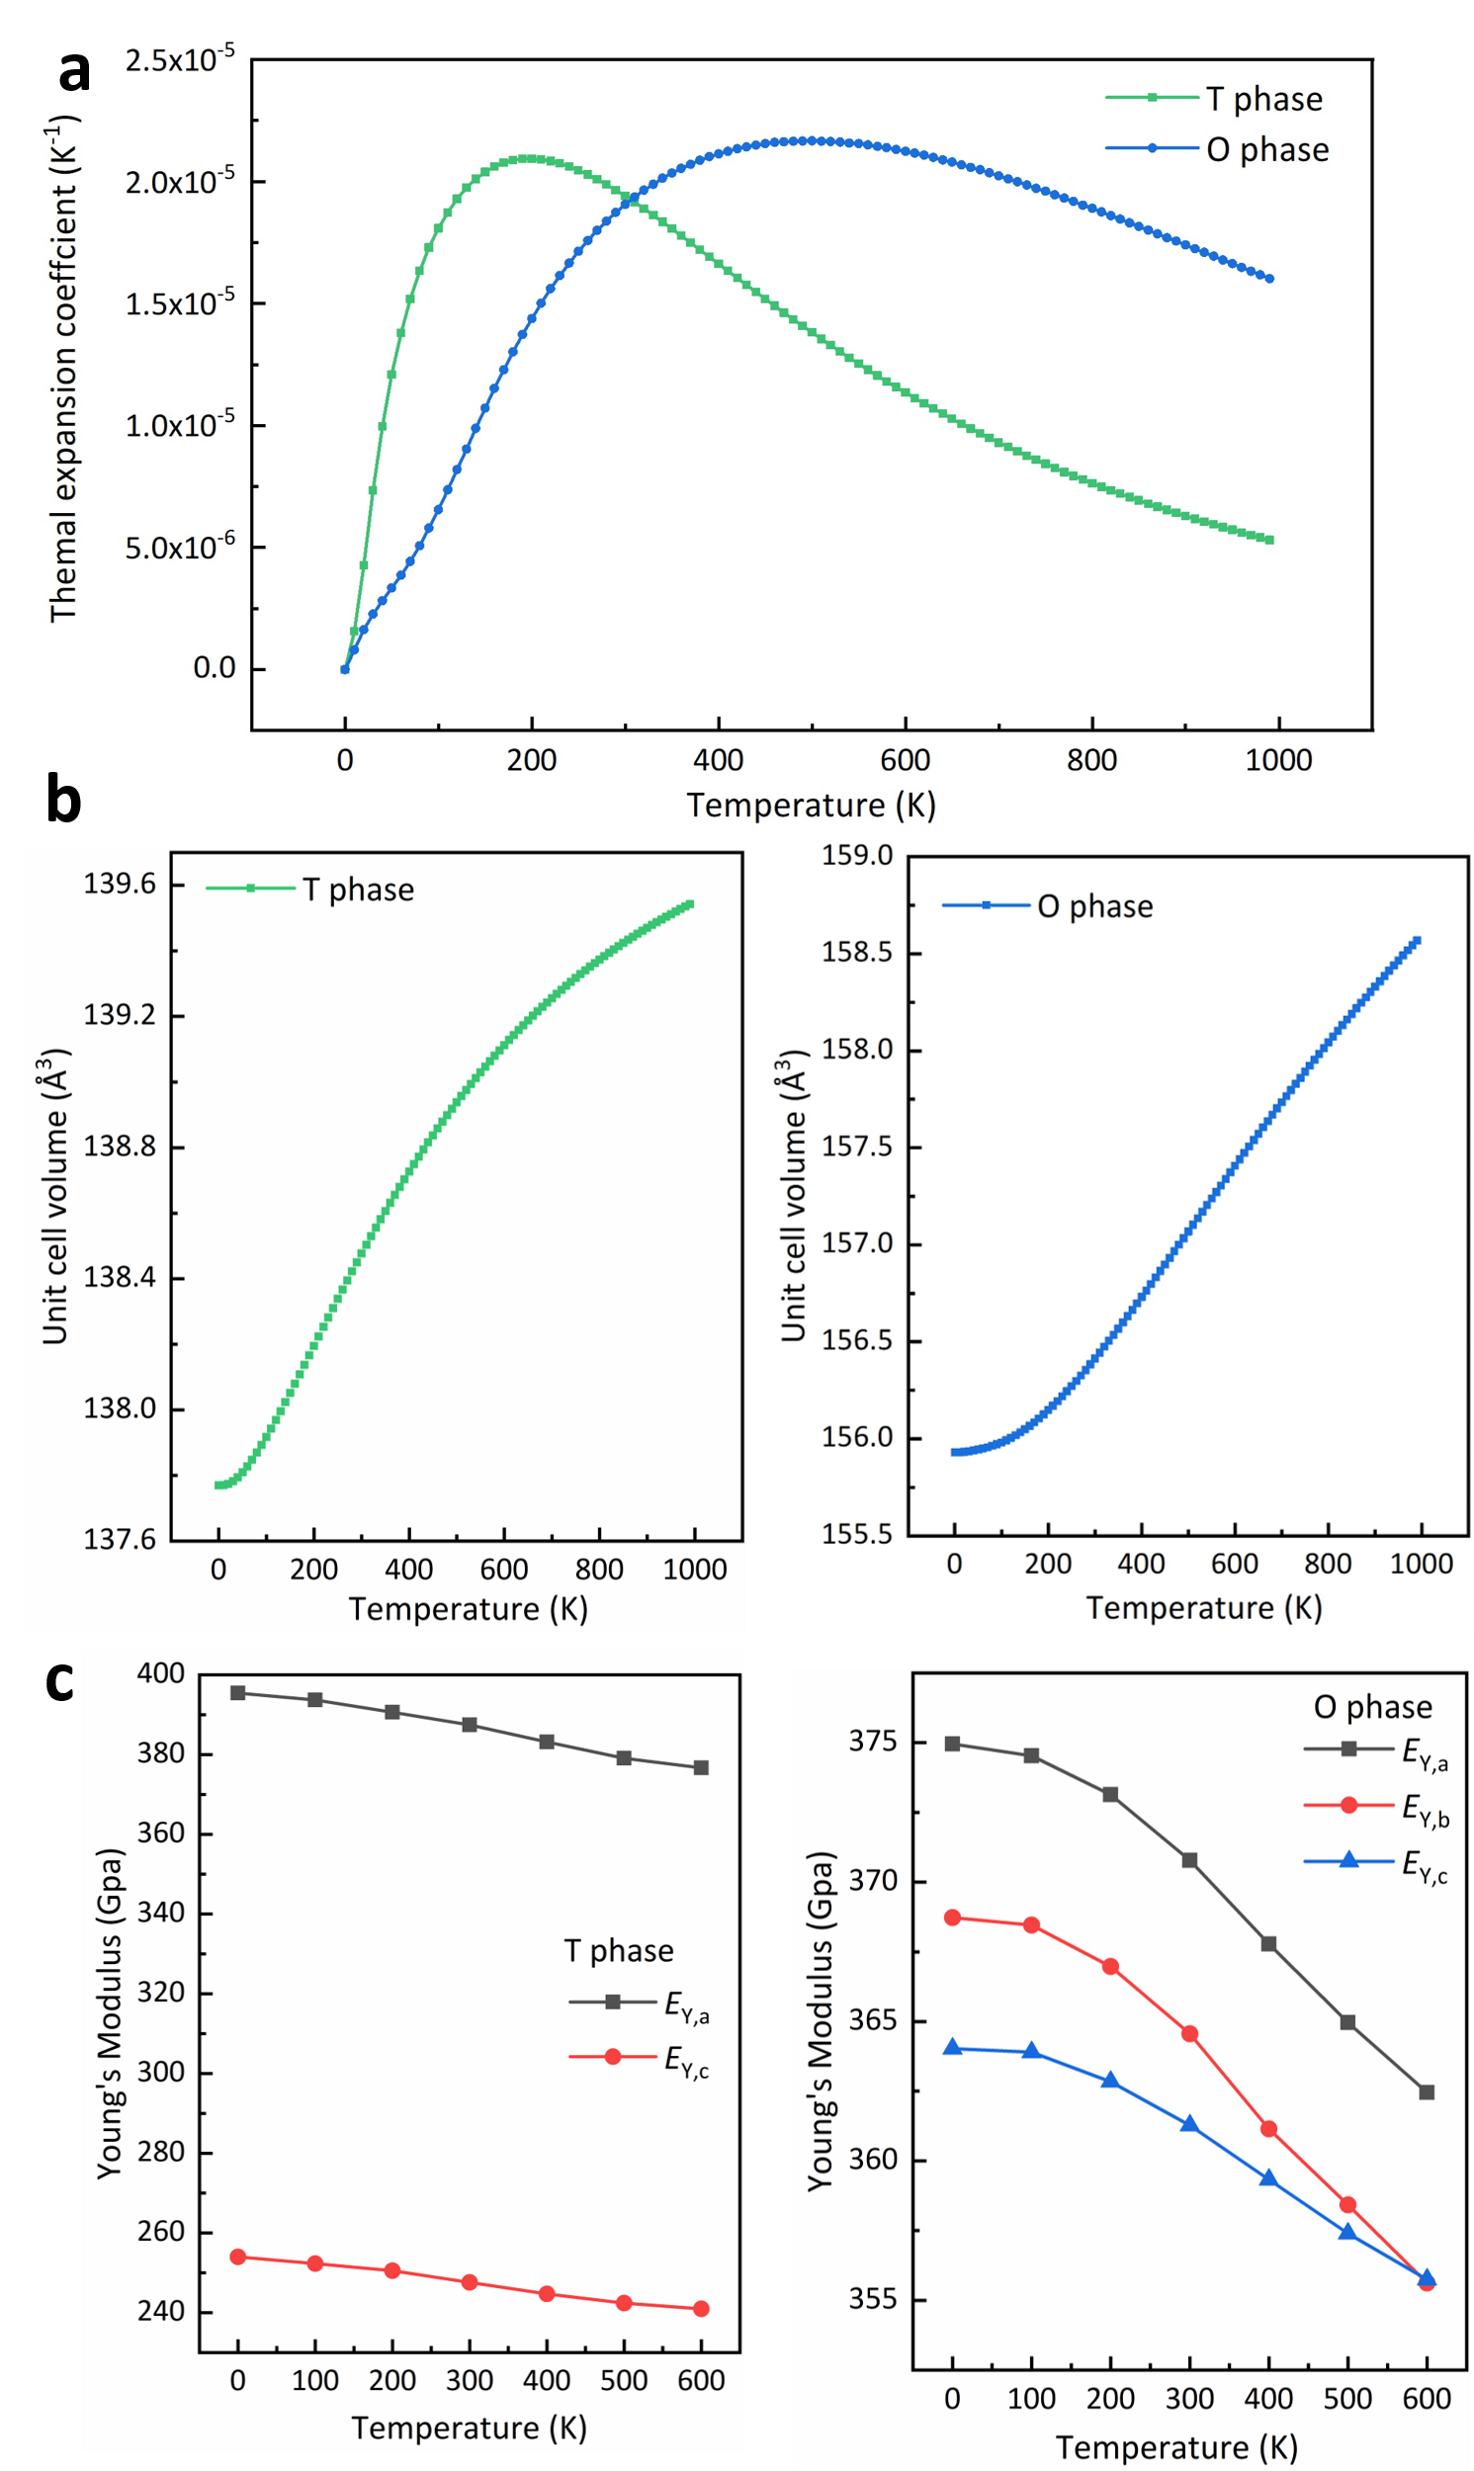

Extended Data Fig.4 | Ab-initio calculated stiffness constants of HZO. a, Thermal expansion coefficient, b, Unit cell volume, and c, Young’s Modulus of orthorhombic and tetragonal phases of HZO with 50% Zr content.
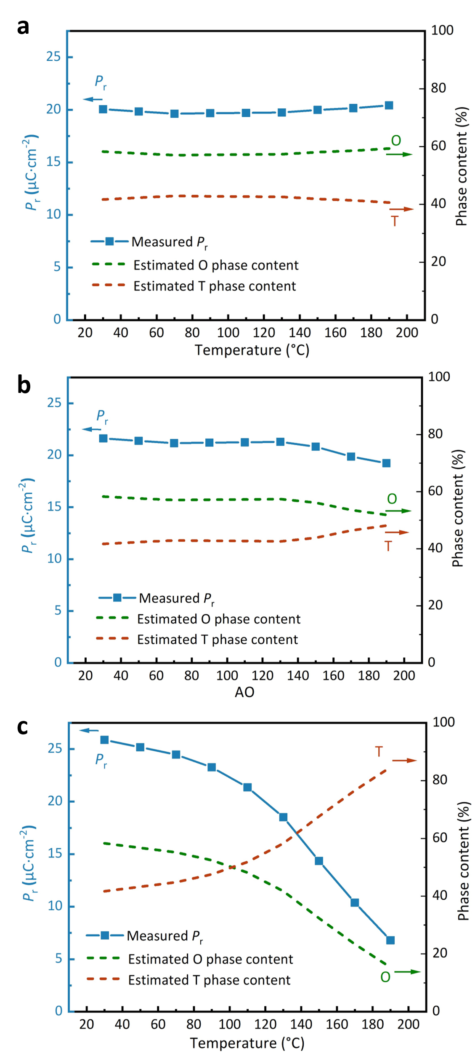
Extended Data Fig.5 | Temperature dependence of remanent polarization. Temperature-dependent remanent polarization of HZO films with different Zr contents of a, 50%, b, 40%, and c, 67%, extracted from PUND tests on non-released capacitors.

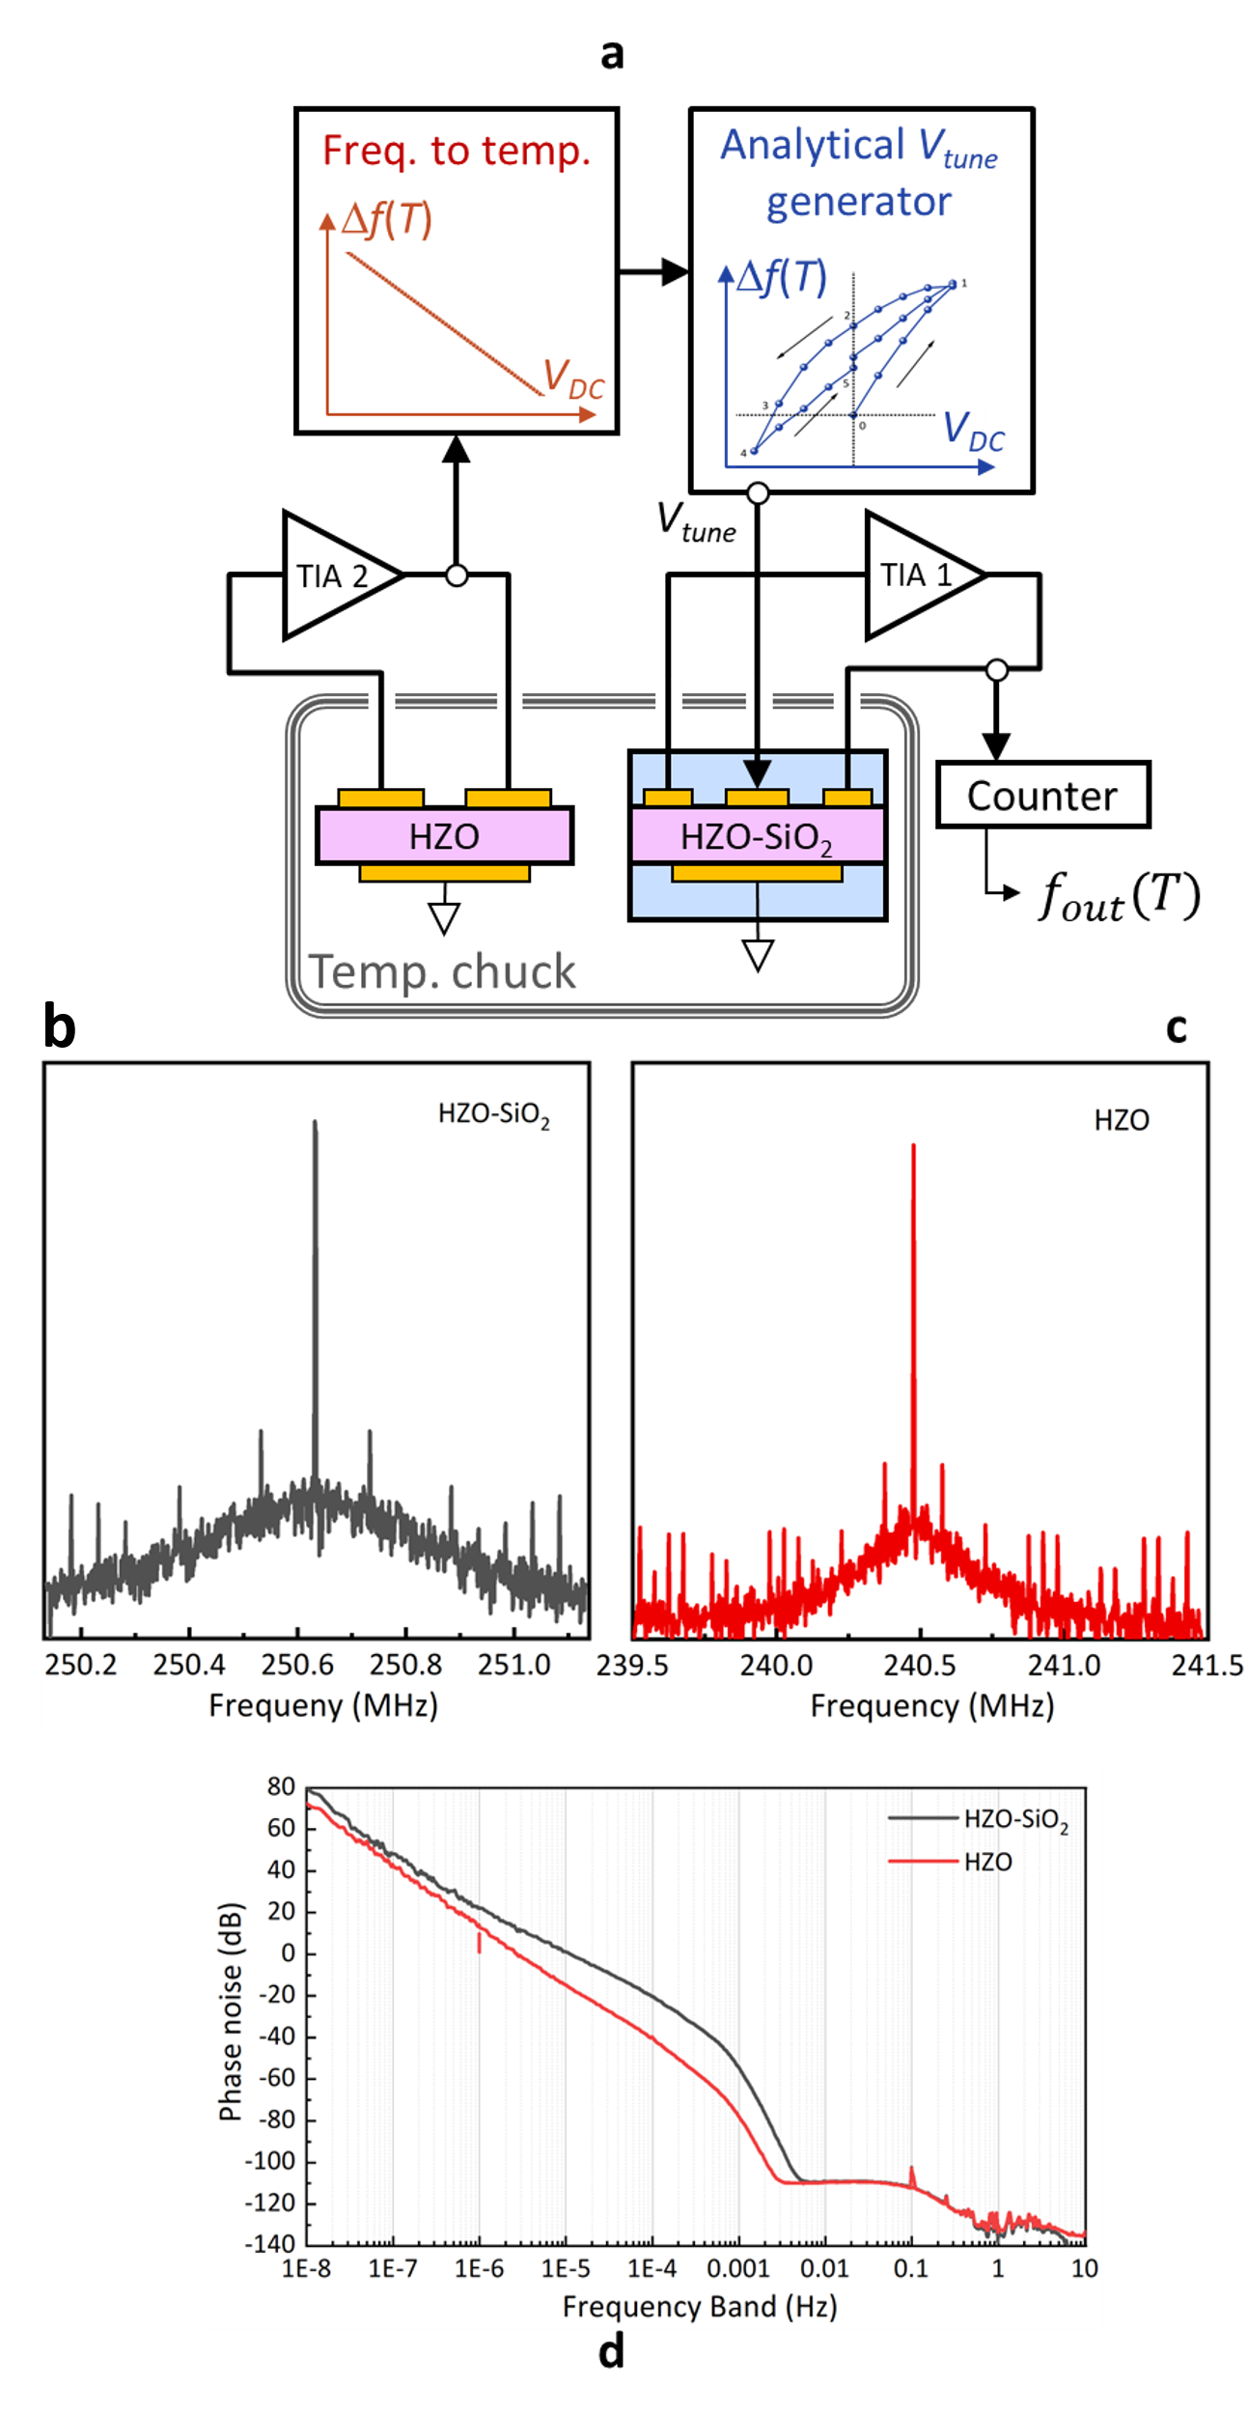
Extended Data Fig.6 | HZO-SiO₂ stable nanomechanical clock. a, Schematic diagram of clock system, consisting of two oscillators locked around HZO and HZO-SiO₂ resonators that are placed on a common interposer. The HZO oscillator serves for real-time temperature sensing, enabling calculation of the required DC tuning voltage for compensation of residual frequency drifts in HZO-SiO₂ oscillator. The temperature-to-voltage scaling function is created using LabOne interface in lock-in amplifier, based on the measured frequency-tuning characteristic. Measured b-c, spectrum and d, phase-noise of the HZO and HZO-SiO₂ oscillators, at room temperature.

Extended data Table 1| Measured Characteristic of Resonator Groups.
Composition | Number | f₀ (MHz) | Q | IL (dB) | TCF₁ (ppm/$℃$) | TCF₂ (ppb/$℃^{2}$)
Hf_{0.5}Zr_{0.5}O₂ | 1 | 238.92 | 844 | −45.39 | -73.87 | -3.13
Hf_{0.5}Zr_{0.5}O₂ | 2 | 239.15 | 794 | −46.16 | -73.46 | -3.69
Hf_{0.5}Zr_{0.5}O₂ | 3 | 239.91 | 738 | −45.81 | -74.71 | -6.79
Hf_{0.5}Zr_{0.5}O₂ | 4 | 239.49 | 736 | −46.40 | -73.14 | -2.14
Hf_{0.5}Zr_{0.5}O₂ | 5 | 239.76 | 742 | −45.91 | -74.22 | -3.53
Hf_{0.5}Zr_{0.5}O₂ | 6 | 238.57 | 798 | −45.66 | -72.68 | -2.81
Hf_{0.5}Zr_{0.5}O₂ | 7 | 238.91 | 788 | −45.77 | -73.32 | -6.23
Hf_{0.5}Zr_{0.5}O₂ | 8 | 239.22 | 801 | −45.92 | -73.33 | -4.50
Hf_{0.5}Zr_{0.5}O₂ | 9 | 239.26 | 802 | −45.75 | -71.88 | -3.50
Hf_{0.5}Zr_{0.5}O₂ | 10 | 238.83 | 767 | −45.94 | -74.38 | -4.68
Hf_{0.33}Zr_{0.67}O₂ | 1 | 239.69 | 708 | −41.00 | -75.23 | 21.40
Hf_{0.33}Zr_{0.67}O₂ | 2 | 239.15 | 679 | −42.67 | −75.99 | 21.86
Hf_{0.33}Zr_{0.67}O₂ | 3 | 239.51 | 787 | −42.67 | −74.81 | 21.92
Hf_{0.33}Zr_{0.67}O₂ | 4 | 239.07 | 715 | −42.69 | −75.08 | 21.60
Hf_{0.33}Zr_{0.67}O₂ | 5 | 238.37 | 810 | −42.67 | −76.77 | 22.46
Hf_{0.33}Zr_{0.67}O₂ | 6 | 239.29 | 724 | −42.67 | −74.48 | 23.51
Hf_{0.33}Zr_{0.67}O₂ | 7 | 238.68 | 732 | −42.66 | −74.82 | 20.91
Hf_{0.33}Zr_{0.67}O₂ | 8 | 239.11 | 792 | −42.68 | −74.98 | 22.23
Hf_{0.33}Zr_{0.67}O₂ | 9 | 239.6 | 748 | −42.67 | −76.32 | 21.50
Hf_{0.33}Zr_{0.67}O₂ | 10 | 239.52 | 695 | −42.66 | −75.52 | 22.61

Extended data Table 2| Key parameters used in COMSOL simulation.
Material Property | Value
$E_{W}$ ⁵³ | 430 Gpa
${TCE}_{1,W}$ ⁵³ | -77.6 ppm/$℃$
${TCE}_{2,W}$ ⁵³ | -28.6 ppb/$℃^{2}$
$ν_{W}$ ⁵⁴ | 0.26
$α_{1,W}$ ⁵⁵ | 4.5 ppm/⁰C
$E_{{SiO}_{2}}$ ⁵⁶ | 60 GPa
$ν_{{SiO}_{2}}$ ⁵⁶ | 0.25
$α_{1,{SiO}_{2}}$ ⁵⁶ | 2.67 ppm/⁰C
${TCE}_{1,{SiO}_{2}}$ ⁵⁷ | 163 ppm/⁰C
$E_{HZO, Transducer}$ ³⁴ | 320 GPa
$E_{HZO, Passivation}$ ³⁴ | 285.43 GPa
$ν_{HZO}$ ⁵⁸ | 0.29
$α_{1,HZO}$ ⁵⁹ | 4.5 ppm/⁰C
$E_{Hf_{0.54}Zr_{0.46}O_{2}}$ ⁵⁸ | 264$±$8 Gpa
$E_{Hf_{0.21}Zr_{0.79}O_{2}}$ ⁵⁸ | 259$±$7 Gpa

