Neutral | 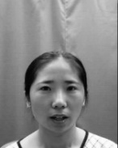 | 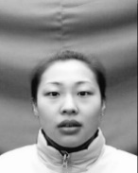 | 
Accuracy  (number) | 73.3%  (22) | 73.3%  (22) | 96.7%  (29)
Anger | 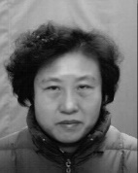 |  | 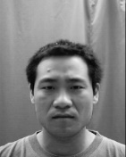
Accuracy (Number) | 70.0%  (21) | 76.7%  (23) | 70.0%  (21)
Happyniss | 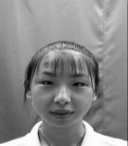 |  | 
Accuracy (Number) | 70.0%  (21) | 76.7%  (23) | 96.7%  (29)
Supplementary 1. The accuracy of FER for screening. To determine the faces to be used for testing, a preliminary screening process was conducted involving healthy volunteers. A group of 30 healthy college students (18 males and 12 females, with a mean age of 25.3 years ± 4.458) were tasked with classifying facial images, and only those images with an accuracy rate exceeding 70% were selected for further analysis (see supplementary). To ensure the random presentation of the photographs, a Python program was developed to display them alongside a background screen intermittently.

