Graphical abstract- Predicting Next-Day Rainfall Using Machine Learning Techniques

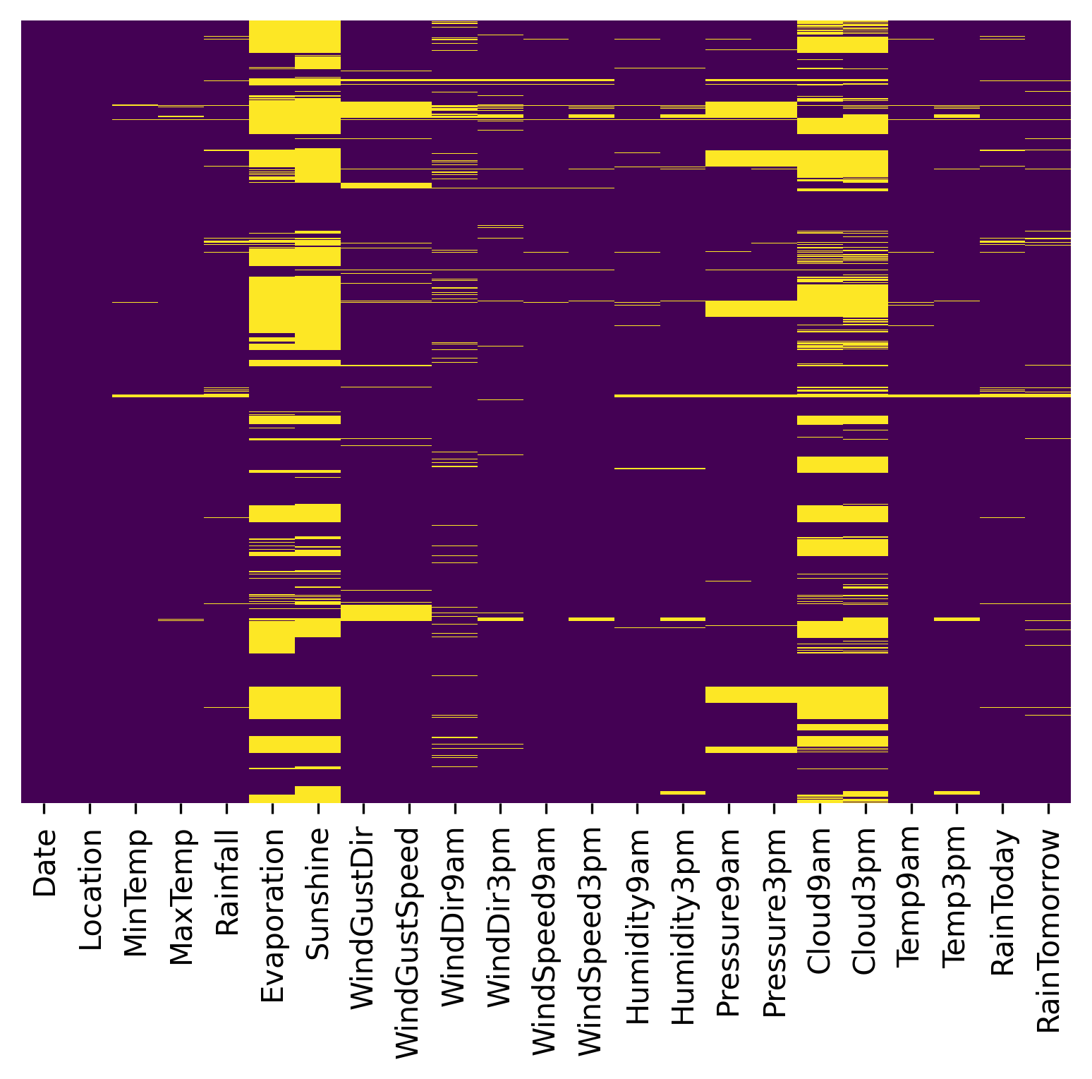  (a) Heatmap of missing values | 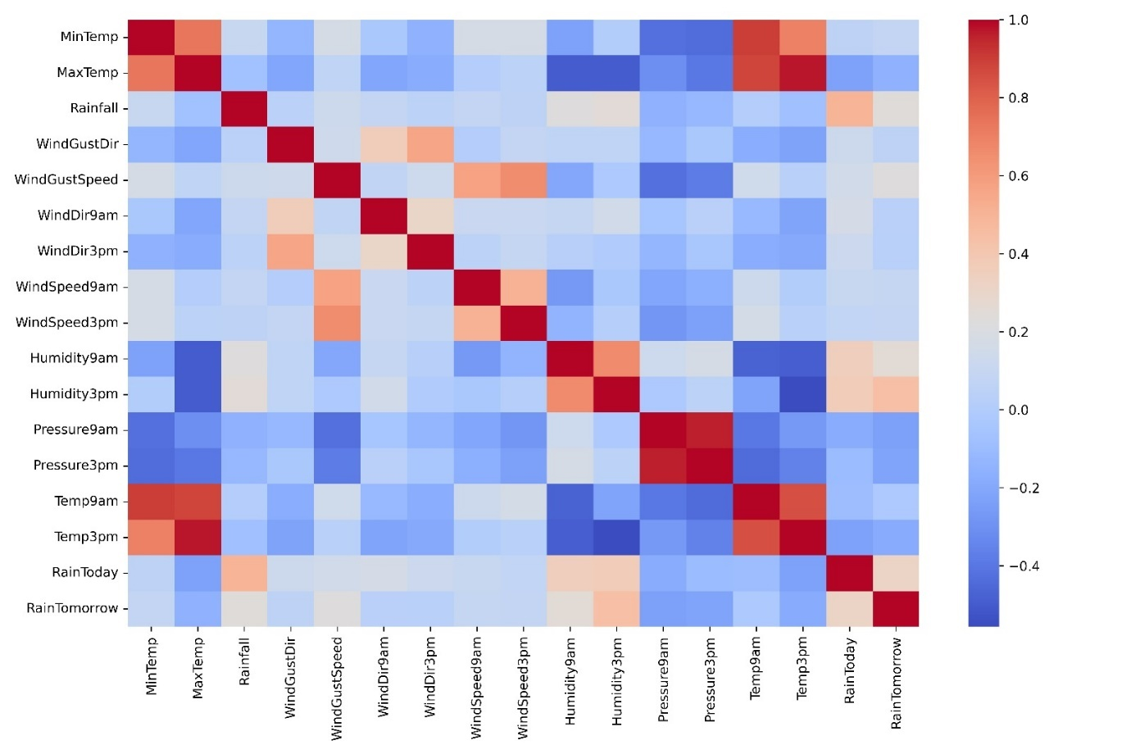  (b) Correlation heatmap
Figure 1: Dataset characteristics

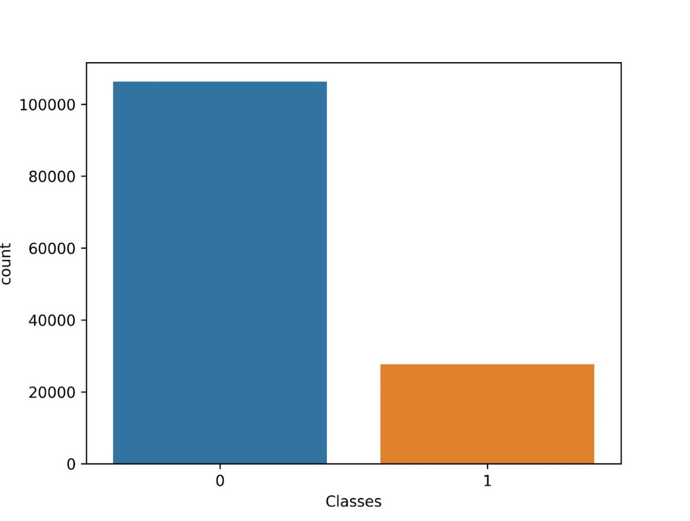
Figure 2 Distribution of the classes in the filtered data set

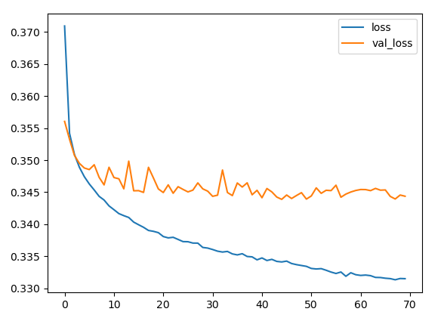
Figure 3 Loss curve against number of epochs for training under AN

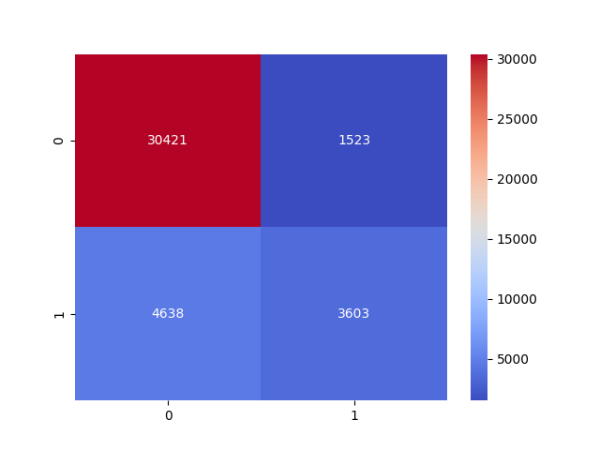  - Logistic regression | 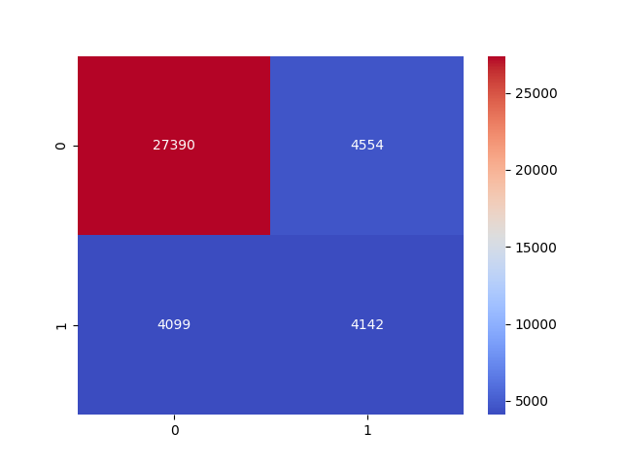  - Decision tree
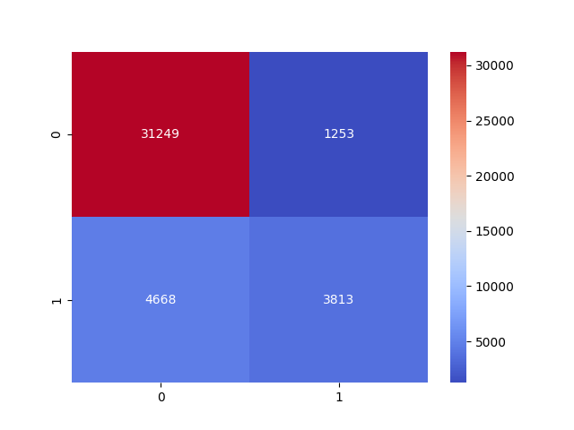  - Random forest | 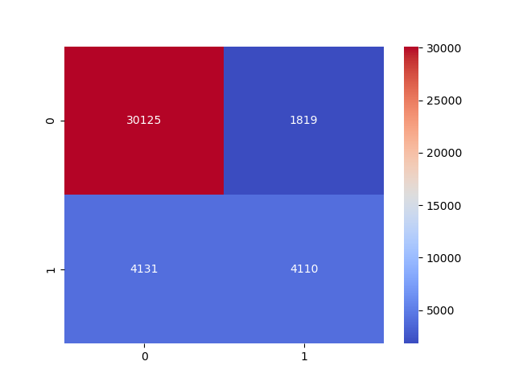  - ANN
Figure 4 Confusion Matrix
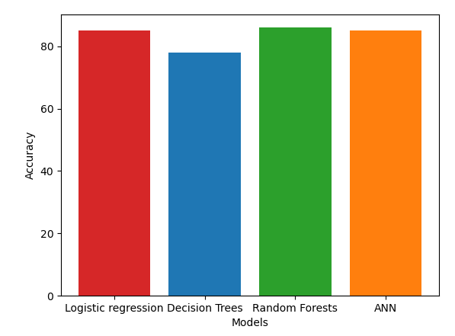  (a) Model accuracies  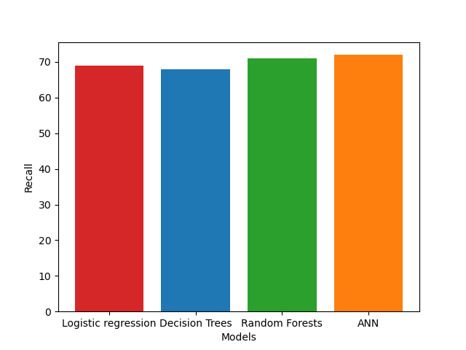  (c) Model Recall | 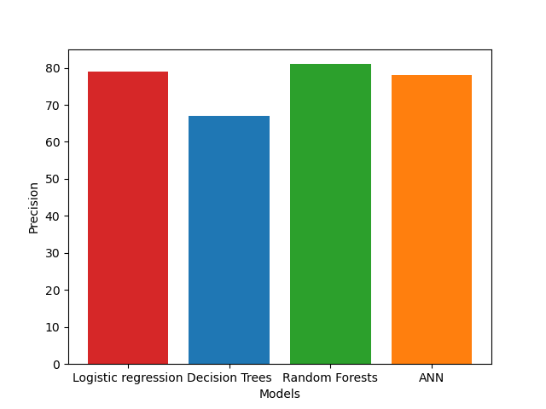  (b) Model Precision  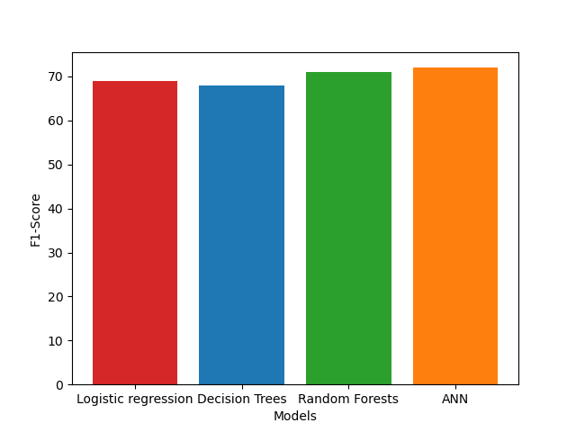  (d) Model F1 score
Figure 5: Model performances

