Supplemental Table 1. Immunofluorescence - Primary antibodies
Antibody | Company | Catalogue No. | Host | Dilution
Anti-CD31Monoclonal (MEC 13.3) | BD Pharmingen | 557355 | Rat | 1:100
Anti-SOX9 antibody [EPR14335-78] | abcam | ab185966 | Rabbit | 1:200
Anti-CD34 antibody [EP373Y] | abcam | ab81289 | Rabbit | 1:100
Anti-GFP | Invitrogen | A10262 | Chicken | 1:300
Anti-Glucose Transporter GLUT1 antibody [EPR3915] | abcam | ab115730 | rabbit | 1:100
Anti-HIF-1 alpha antibody [EPR16897] | abcam | ab179483 | rabbit | 1:100

Supplemental Table 2. Immunofluorescence - Secondary antibodies
Antibody | Company | Catalog No. | Channel | Dilution
Goat anti-Rat | Thermo Fisher | A11077 | 568 | 1:500
Goat anti-Rat | Thermo Fisher | A21247 | 647 | 1:500
Goat anti-Rabbit | abcam | ab175471 | 568 | 1:500
Goat anti-Rabbit | abcam | ab175696 | 568 | 1:500
Goat anti-Chicken | Thermo Fisher | A11039 | 488 | 1:500
Goat anti-Rabbit | Thermo Fisher | A32733 | 647 | 1:500

Supplemental Table 3. Flow cytometry - Endothelial Hierarchy antibodies
Protein Target | Conjugated Fluorophore | Antibody Dilution | Manufactured Company
Endogenous YFP (induced by tamoxifen administration) | YFP | NA | NA
Rat Anti-Mouse VEGFR2 (FLK1) | PE | 1:25 | BD Biosciences, NJ, USA
Rat Anti-Mouse CD31 (PECAM1) | PE-Cy7 | 1:100 | BD Biosciences, NJ, USA
Rat Anti-Mouse CD34 | Alexa Fluor 647 | 1:25 | BD Biosciences, NJ, USA
Rat Anti - Mouse Lineage Cocktail (anti-mCD3, anti-mLy-6G, anti-mCD11b, anti-mCD45R, anti-mTer-119) | Pacific Blue | 1:100 | BioLegend, CA, USA
Rat Anti - Mouse Lineage Cocktail (anti-mCD3, anti-mLy-6G, anti-mCD11b, anti-mCD45R, anti-mTer-119) | PerCP-Cy5.5 | 1:100 | BD Biosciences, NJ, USA

Supplemental Table 4. FACS Sorting - Antibodies
Protein Target | Conjugated Fluorophore | Antibody Dilution | Manufactured Company
Endogenous YFP (induced by tamoxifen administration) | YFP | NA | NA
mCherry | PE | NA | NA
FVS 700 | AF700 | 1:16000 | BD Biosciences, NJ, USA
Rat Anti - Mouse Lineage Cocktail (anti-mCD3, anti-mLy-6G, anti-mCD11b, anti-mCD45R, anti-mTer-119) | Pacific Blue | 1:100 | BD Biosciences, NJ, USA

Supplemental table 5. PCR - Mouse Primers
Target | Forward Primer | Reverse Primer
Sox9 | CTCCGGTAGCAAAGGCGTTTAG | CGCTGGTATTCAGGGAGGTACA

Supplemental Table 6. Human Melanoma Cell Lines
Cell line | Mutations | Details
WM164 | BRAF V600E | Human melanoma  Metastatic site (right upper arm)  Male (22 y) stage IV ¹⁴
MM96 | BRAF V600E  CDKN2A (Wild Type)  PTEN (Wild Type) | Human Melanoma  Derived from metastatic site: lymph node  Female (66Y) ¹⁵
DO4 | NRAS Q61L  CDKN2A (Homozygous Deletion)  PTEN (Wild Type) | Human Melanoma ¹⁵

Supplementary Table 7 – qPCR Primers
Target | Forward Primer | Reverse Primer
Hsb34 | TGCATCAGTACCCCATTCTATCA | AAGGTGTAATCCGTCTCCACAGA
Sox9 | AGCGAACGCACATCAAGAC | CTGTAGGCGATCTGTTGGGG

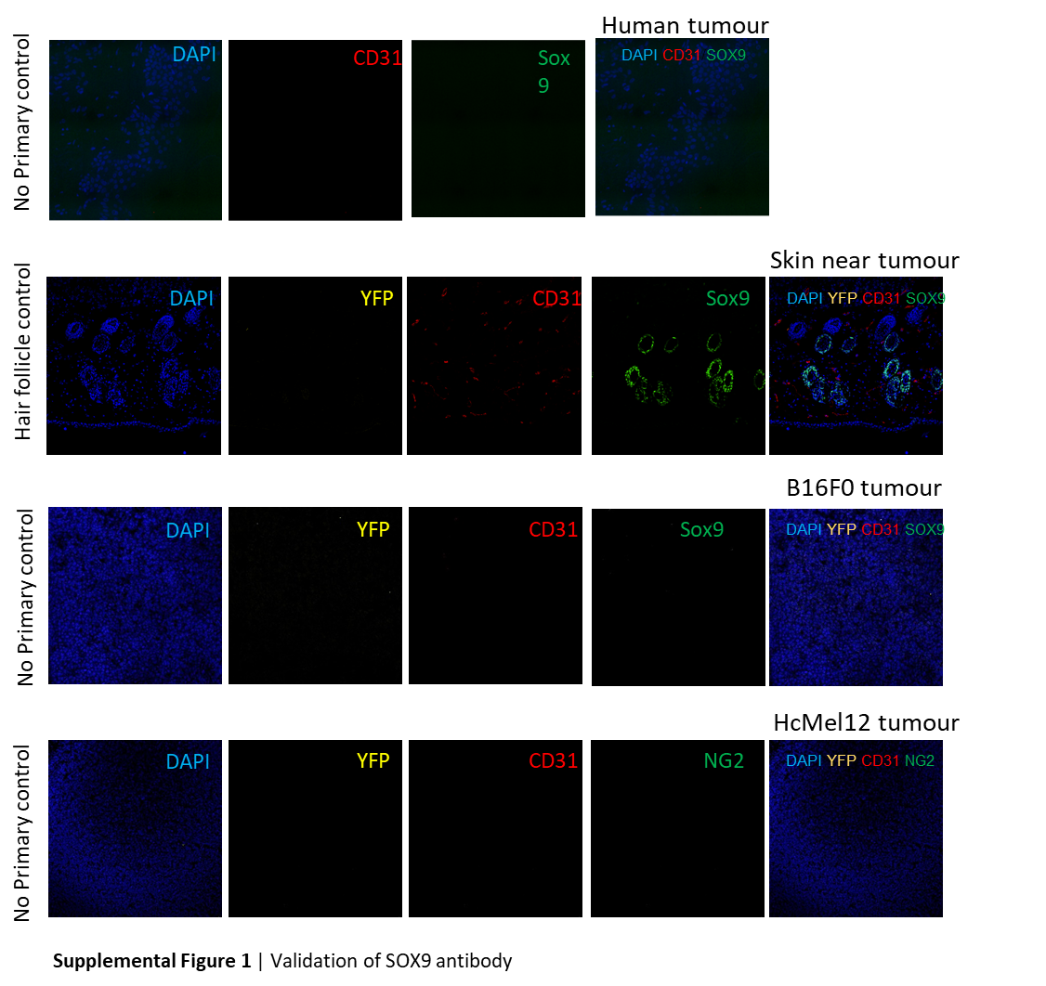
Supplemental Figures

