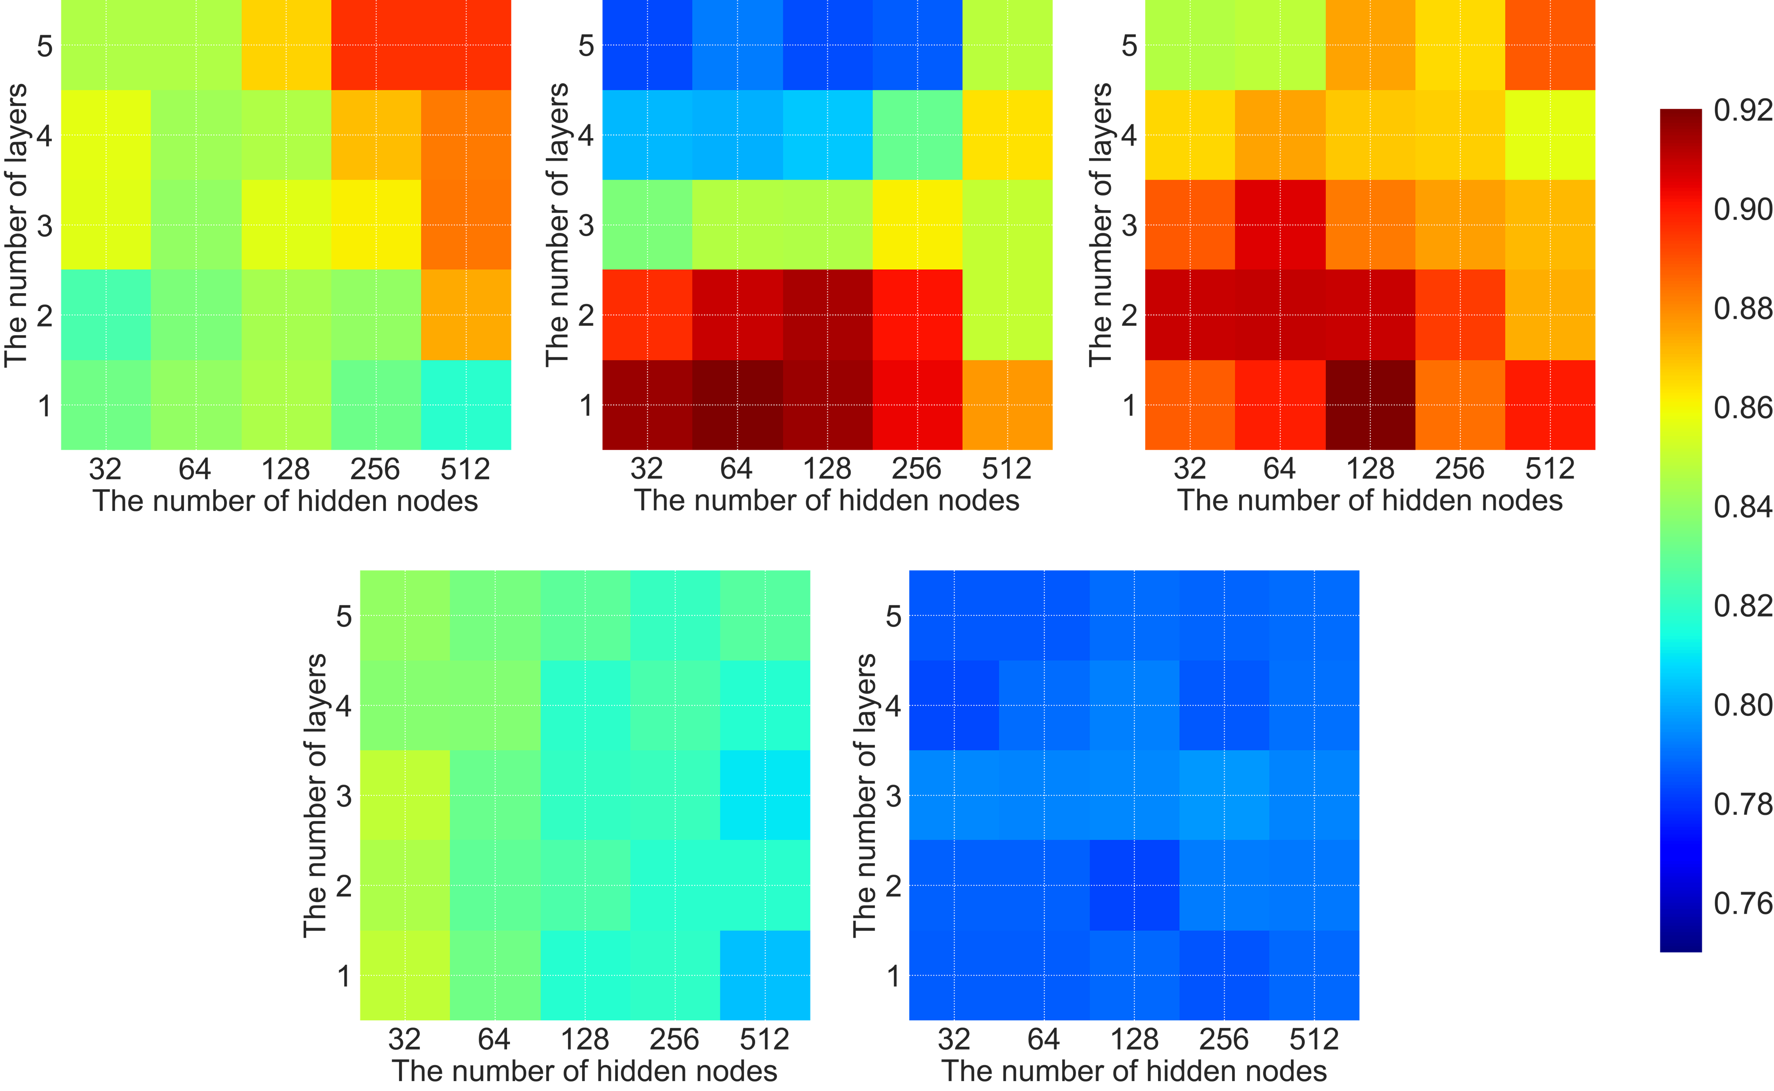
Supplementary Figure 1. Performance heatmaps of all models in the development process

Supplementary Table 1. Performance for detecting peptic ulcer. All sensitivities are fixed to 0.9
 | AUROC | P-value | AUPRC | Sensitivity | Specificity | Precision | F1-score
Internal validation
Tree-based model
Random forest | 0.834  (0.788-0.881) | n/a | 0.145  (0.099-0.191) | 0.909  (0.904-0.913) | 0.512  (0.504-0.520) | 0.012  (0.010-0.014) | 0.023  (0.021-0.026)
GBM | 0.860  (0.816-0.903) | 0.0308 | 0.130  (0.086-0.173) | 0.909  (0.904-0.913) | 0.490  (0.482-0.498) | 0.011  (0.010-0.013) | 0.022  (0.020-0.025)
RNN-based model
Simple RNN | 0.896  (0.860-0.933) | 0.2648 | 0.184  (0.147-0.220) | 0.909  (0.904-0.913) | 0.692  (0.685-0.699) | 0.018  (0.016-0.021) | 0.036  (0.033-0.039)
LSTM | 0.937  (0.921-0.954) | 0.0139 | 0.164  (0.148-0.181) | 0.909  (0.904-0.913) | 0.805  (0.798-0.811) | 0.029  (0.026-0.032) | 0.056  (0.052-0.060)
GRU | 0.941  (0.923-0.959) | 0.0130 | 0.090  (0.072-0.108) | 0.909  (0.904-0.913) | 0.870  (0.865-0.875) | 0.043  (0.040-0.046) | 0.082  (0.077-0.086)
Attention-based model
Transformer | 0.834  (0.786-0.881) | 0.9934 | 0.188  (0.140-0.236) | 0.909  (0.904-0.913) | 0.473  (0.465-0.481) | 0.011  (0.009-0.013) | 0.021  (0.019-0.024)
RETAIN | 0.765  (0.709-0.820) | 0.3016 | 0.057  (0.002-0.113) | 0.909  (0.904-0.913) | 0.176  (0.170-0.182) | 0.007  (0.006-0.008) | 0.014  (0.012-0.016)
External validation
Tree-based model
Random forest | 0.807  (0.782-0.832) | n/a | 0.106  (0.081-0.131) | 0.901  (0.898-0.904) | 0.406  (0.401-0.410) | 0.011  (0.010-0.012) | 0.021  (0.020-0.022)
GBM | 0.839  (0.816-0.861) | 0.0048 | 0.074  (0.051-0.096) | 0.901  (0.898-0.904) | 0.526  (0.521-0.530) | 0.013  (0.012-0.014) | 0.026  (0.025-0.028)
RNN-based model
Simple RNN | 0.882  (0.863-0.901) | <0.0001 | 0.112  (0.093-0.132) | 0.901  (0.898-0.904) | 0.607  (0.603-0.611) | 0.016  (0.015-0.017) | 0.031  (0.030-0.033)
LSTM | 0.908  (0.894-0.922) | <0.0001 | 0.155  (0.141-0.170) | 0.901  (0.898-0.904) | 0.739  (0.735-0.743) | 0.024  (0.022-0.025) | 0.046  (0.044-0.048)
GRU | 0.964  (0.957-0.970) | <0.0001 | 0.225  (0.218-0.231) | 0.904  (0.902-0.907) | 0.899  (0.896-0.901) | 0.059  (0.057-0.061) | 0.111  (0.108-0.114)
Attention-based model
Transformer | 0.814  (0.786-0.842) | 0.7930 | 0.189  (0.161-0.216) | 0.901  (0.898-0.904) | 0.361  (0.357-0.365) | 0.010  (0.009-0.011) | 0.019  (0.018-0.021)
RETAIN | 0.780  (0.752-0.807) | 0.1823 | 0.057  (0.029-0.084) | 0.901  (0.898-0.904) | 0.396  (0.392-0.401) | 0.010  (0.010-0.011) | 0.021  (0.019-0.022)
*Bold indicates the best and underline indicates the second best.
*P-values were calculated using the DeLong method.
*Abbreviations: AUROC=area under the receiver operating characteristic curve, AUPRC=area under the precision-recall curve, GBM=gradient boosting machine, RNN=recurrent neural network, LSTM=long short-term memory, GRU=gated recurrent unit

Supplementary Table 2. Concept IDs (SNOMED) of peptic ulcers used in the study
Diseases | Concept IDs | Diseases | Concept IDs
Esophageal ulcer | 25844 | Gastric ulcer, acute with hemorrhage | 4231580
Dieulafoy's ulcer | 198798 | Chronic or unspecified duodenal ulcer with hemorrhage | 4232181
Duodenal obstruction | 434085 | Acute duodenal ulcer with perforation | 4265479
Peptic ulcer | 4027663 | Gastric ulcer | 4265600
Acute duodenal ulcer with hemorrhage | 4027729 | Peptic ulcer bleeding | 4271696
Chronic duodenal ulcer without hemorrhage or perforation | 4028242 | Gastric ulcer, chronic | 4318534
Peptic ulcer, acute with hemorrhage | 4046500 | Gastric ulcer, acute | 4319441
Peptic ulcer, acute | 4057060 | Perforation, peptic ulcer | 4338225
Duodenal ulcer scar with obstruction | 4057074 | Gastric ulcer scar | 4340787
Gastric ulcer, acute with perforation | 4057953 | Gastric erosion, chronic | 4341234
Acute gastric mucosal lesion | 4087594 | Cushing's ulcer of duodenum | 4341240
Peptic ulcer, chronic | 4134146 | Curling's ulcers of stomach | 36683388
Gastric erosion, chronic with hemorrhage | 4143871 | Helicobacter pylori-positive duodenal ulcer | 37110314
Peptic ulcer, chronic with perforation | 4146517 | Cushing's ulcer of stomach | 42538071
Chronic or unspecified gastric ulcer with perforation | 4150681 | Helicobacter pylori-positive gastric ulcer | 45757062
Duodenal perforation | 4156639 | Erosive gastritis | 45757242
Gastric ulcer, acute with hemorrhage and perforation | 4169592 | Hematemesis | 26727
Chronic or unspecified duodenal ulcer with perforation | 4173408 | Gastrointestinal hemorrhage | 192671
Peptic ulcer, chronic with hemorrhage | 4174044 | Hematochezia | 443530
Peptic ulcer, acute with perforation | 4194543 | Melena | 4103703
Duodenal ulcer without helicobacter pylori | 4198381 | Gastric outlet obstruction | 4216750
Gastric ulcer, chronic with hemorrhage | 4211001 | Gastric perforation | 4340781
* Bold indicates complicated peptic ulcer.

Supplementary Table 3. Concept IDs (RxNorm) of NSAIDs used in the study
NSAIDs | Drug name | Concept ID
Oxicam | Meloxicam | 19103397, 19103398
 | Piroxicam | 1146847, 19019665, 19022024
Salicylic acid | Aspirin | 1112896, 1113143, 1718409, 19021575, 19059056, 42483115, 42949808, 42949815
Acetic acid | Aceclofenac | 19029394, 35856180, 42926507, 42926777
 | Indomethacin | 1178665
 | Ketorolac | 19133853, 46287424
 | Diclofenac | 42707518
Propionic acid | Naproxen | 1115126, 19019273, 19060300, 40992339
 | Ibuprofen | 19019050, 19019072, 19078461, 35887295, 42923605, 42948430
 | Celecoxib | 1118091, 19029024, 19029025
 | Loxoprofen | 19106551
 | Ketoprofen | 19101779, 41339997, 43842952

Supplementary Table 4. Concept IDs (RxNorm) of other drugs used in the study
Drug group | Drug name | Concept ID
Anticoagulation | Apixaban | 43013026, 43013029, 43013030
 | Enoxaparine | 40160973, 40160989, 43286599, 43286713
 | Dabigatran | 35606208, 40228154
Antiplatelet | Clopidogrel | 19075601, 42949808, 42949815
 | Cilostazol | 1350311, 1350332, 1350335, 2061565, 42926306, 42926362, 42935771, 42935832
Steroid | Triamcinolone | 2022428, 19019891, 19019892, 19019893, 21158208, 40085539, 41051895, 41330793, 41353315, 42629020, 43753628
 | Dexamethasone | 1518258, 21140183, 36282892, 36895323, 40160930, 42479180, 42918030, 42918064, 42919616, 42920795, 43751837
 | MethylPrednisolone | 1506426, 1506430, 35606533, 35606538, 36895129, 41178645, 41481149, 41481403, 42917274, 43521245, 43521260, 44208595
 | Prednisolone | 1550775, 2022371, 2034053, 35781236, 35782103, 42917659, 43829030
 | Hydrocortisone | 975168, 975193, 975505, 2021908, 2026650, 19026511, 21117513, 21156799, 35604734, 35885856, 41478043, 41487478, 42917277, 43286238
 | Betamethasone | 920828, 21039240, 36897449, 41328951, 41502217, 42917334, 42917855
H2 blocker | Famotidine | 19077241
 | Cimetidine | 997341, 42944094, 2073468, 2033070, 42922401, 19081086, 42922400, 2073465, 42944157
 | Lafutidine | 42961124
P-CAB | Tegoprazan | 2012376
Proton pump inhibitors | Pantoprazole | 41271459, 41302588, 948080
 | Lansoprazole | 19095273, 19095231, 19133802, 19039961
 | Omeprazole | 21161812, 19101746, 19101745, 19081766, 19081767, 904455, 40992339, 904454, 19112920
 | Rabeprazole | 40834416, 41021231, 35152933
 | Ilaprazole | 42961063
 | Dexlansoprazole | 19039961, 19133802
*Abbreviations: P-CAB=potassium-competitive acid blocker

Supplementary Table 5. Concept IDs (LOINC) of laboratory items (measurements) used in the study
Laboratory items (Measurement) | Concept ID
Hemoglobin | 3000963
Platelet | 3024929
BUN | 3013682
Creatinine | 3016723

Supplementary Table 6. Concept IDs (SNOMED) of surgeries (procedures) used in the study
Surgery (Procedure) | Concept ID
Gastrectomy | 4070372, 4070869, 4071534, 4071537, 4131021, 4144927, 4174035, 4222325, 4233414, 4239077, 4310408, 44809029, 46270977, 46272798, 4131021
Pancreaticoduodenectomy | 4020329, 4022013, 4020330, 4117192, 4144849

