Supplementary Information

Hardness Augmentation Engineering of TiFe₂ with Doping Design and Single-crystal Realization
Xinyang Tan^{1,} *, Hongxiong Liu^{2, 3,} *, Tingping Hou^{1, †}, Sicong Zhu¹, Gengping Jiang¹, Dong Zhang¹, Junwen Duan¹, Xuan Liang¹, Kaiming Wu^{1, ‡}, Wuming Liu^{2, †‡}
¹ The State Key Laboratory of Refractories and Metallurgy, Joint International Research Laboratory of Refractories and Metallurgy, Ministry of Education, China, Hubei Province Key Laboratory of Systems Science in Metallurgical Process, International Research Institute for Steel Technology, Collaborative Innovation Center for Advanced Steels, Wuhan University of Science and Technology, Wuhan 430081, P. R. China
² Beijing National Laboratory for Condensed Matter Physics and Institute of Physics, Chinese Academy of Sciences, Beijing 100190, China
³ Center of Materials Science and Optoelectronics Engineering, University of Chinese Academy of Sciences, Beijing 100190, China
*These authors contributed equally to this work: Xinyang Tan, Hongxiong Liu, email: tanxinyang@wust.edu.cn; lhx@iphy.ac.cn
†Corresponding author: houtingping@wust.edu.cn
‡Corresponding author: wukaiming@wust.edu.cn
†‡Corresponding author: wliu@iphy.ac.cn

S1. Calculation of ATAT disorder structures based on cluster expansion technique
For a ternary Ti_{x}Fe_{11-x}Si (x=3 or 4) substitutional alloy, many properties are dependent on the configuration. In order to support the rationality of ordered calculations, the cluster expansion (CE) ¹ technique based on calculation of Automated Toolbox for Alloy Theory (ATAT) ^{2,3} disorder structures was adopted to determine a substitution of an atomic type. The ATAT which integrates various of simulate calculation codes usually be combination with first-principle calculations to calculate the thermodynamic properties of solid alloys. The cluster expansion (CE) method is a disordered simulation calculating method in ATAT that provides a general framework for calculation modeling of multicomponent materials to describe disordered configurations, which has been widely used for theoretical research various material properties and systems with different properties⁴⁻⁷.
The process of CE disordered calculation is illustrated in Fig. S1. MAPS code, full name is “Massachusetts Institute of Technology ab-initio phase stability”, is a completely independent subsystem in the entire calculating environment, which is usually adopted to improve the accuracy of cluster expansion and to find the best cluster expansion. This paper developed one 12-atom general structure for substituting the system which silicon atoms randomly replace Fe and Ti atoms. In Fig. S1, there are two main input files, lat.in and vasp.wrap. The random state lat.in file that generated by MAPS based on the provided lattice geometry contains lattice constants, atomic coordinate and other lattice information. And vasp.wrap file is the first-principles calculation parameter file, which produced from the Ab-initio code parameters. Subsystems generate the other input files for VASP calculation from the two mainly input files. After one round calculation completes, MAPS reads the energy of the structure and saves the information of this structure in a folder, then generates a new structure for the next round of calculation. Finally, the best disordered configurations can be identified from multiple structure folders. The main purpose of this article is to investigate the impact of the behavior of Si substitutes Fe or Ti at different positions in the system. Therefore, we only use CE to verify the rationality of ordered calculations.
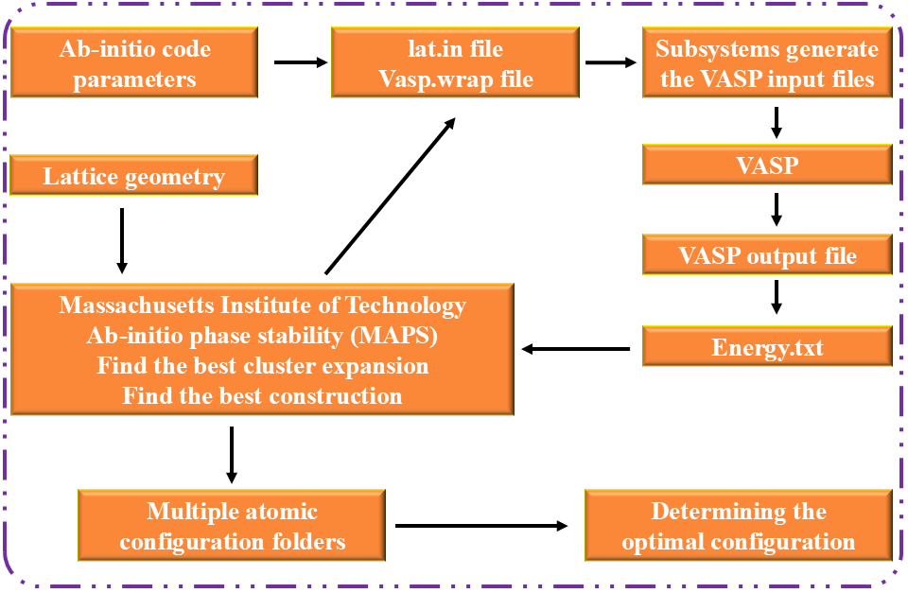
Fig. S1 Flow chart of the ATAT disorder calculation.
Based on the disordered arrangement and ordered substitution, the total energies of the ternary alloy compounds have been calculated and the results are presented in Table S1. The structures with ordered substitutions were more stable than those with disordered substitutions. Thus, ordered substitutions have been chosen in the present study for a systematic study of the ternary systems where Si occupies different Wyckoff positions.
Table S1 Total energy of Ti_{x}Fe_{11-x}Si (x=3 or 4) in ordered and disordered substitution
Compounds | Ordered or disordered substitution | Total energy (eV)
TiFe₂ | Ordered | -100.600
TiFe₂ | Disordered | -100.123
Ti_{x}Fe_{11-x}Si | Ordered | -97.946
Ti_{x}Fe_{11-x}Si | Disordered | -97.145

S2. Single-crystal preparation method
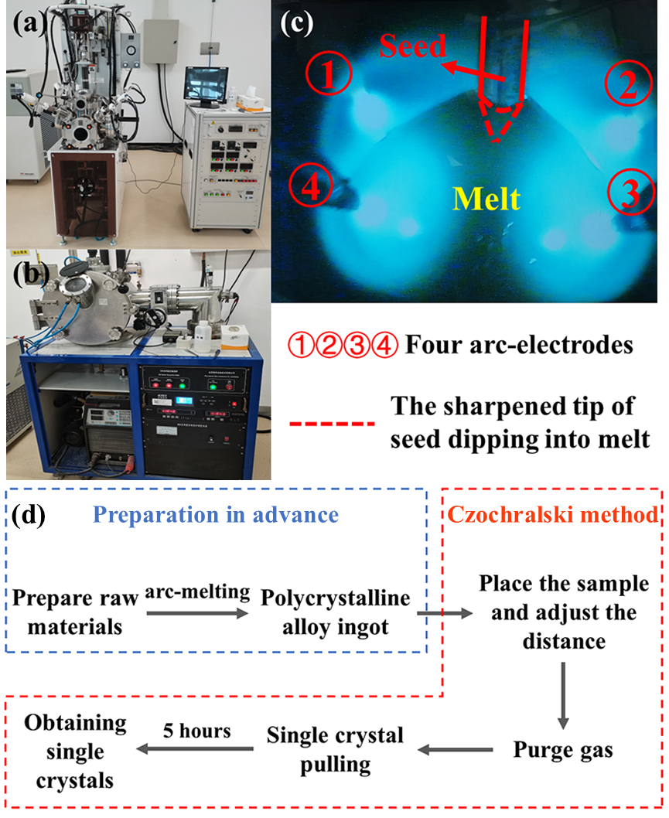
Fig. S2 (a) The four arc high-temperature single-crystal growth furnace; (b) WK-Ⅱ Vacuum-Arc-Melting-Furnace; (c) Melting polycrystalline button and pulling up (The red dashed line represents the tip of the seed rod, which is also the contact surface between the melt and the seed rod); (d) Experimental process.
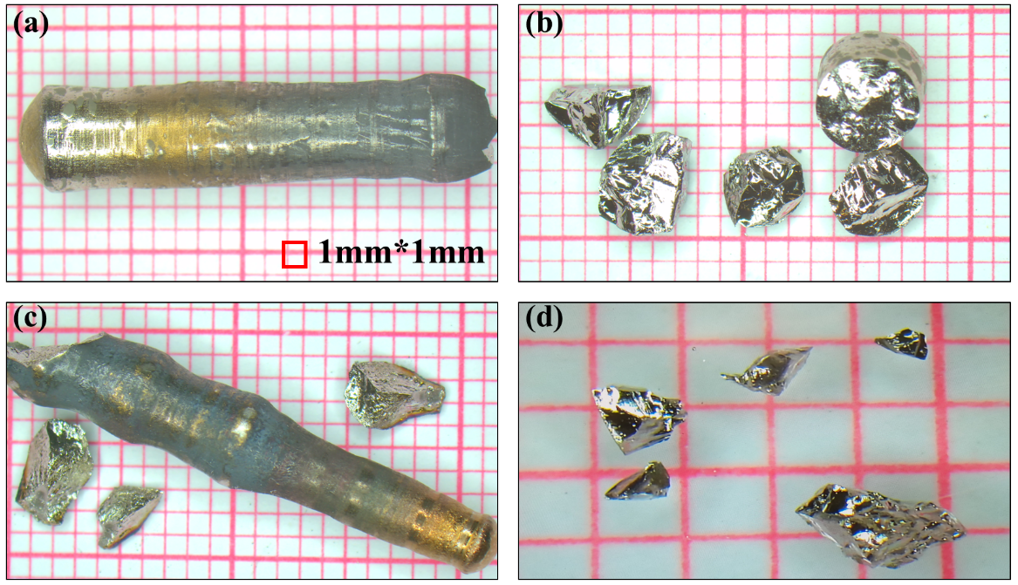
Fig. S3 (a) (b)Single crystal of Ti₄Fe₇Si grown by the Czochralski technique; (c) (d) Single crystal of TiFe₂.
To grow a single crystal of a given compound, 6 g - 8 g of starting materials were used in the form of elemental components and weighed in appropriate proportions. The prepared raw materials were placed in a vacuum-arc-melting-furnace (Fig. S2b) for an initial fusion, and a TiFe₂ polycrystalline alloy ingot with a volume of approximately 1 cm³ was obtained. The alloy ingot was, thereafter, placed in the center of a copper crucible in a four arc furnace chamber, which acted as an anode in melting the raw materials.
As the next step, the distances between the four needle-shaped electrodes were adjusted. These electrodes surrounded the crucible with the raw materials to ensure a uniform distribution of the solution temperature. They could also prevent an uneven heating and cracking of the alloy ingot during arc striking. Thereafter, the oxygen was removed from the chamber by performing vacuuming repeatedly, and an argon gas was finally introduced into the chamber. The argon gas was injected until the pressure inside the chamber was slightly higher than the atmospheric pressure. There was also a separate electrode and a crucible containing a piece of titanium metal inside the cavity.
To further improve the purity of the internal atmosphere in the cavity, traces of oxygen could be absorbed by melting the titanium metal throughout the entire experimental process. The four arc melting alloy ingot was ignited at the same time. After the homogenization of the melt for a certain period of time, the tip of a tungsten seed rod was immersed in the melt. This seed rod was during the growth process lifted from the melt with an adjusted slow lifting speed. During this lifting procedure, the melt was attached to the base of the rod (and to the growing material) to form a single crystal, which gradually grew larger (Fig. S2c). The adjustment of the speed of the furnace bed and substrate ensured that the melt was heated evenly and, thereby, an improved high-quality single crystal could be produced. The entire growth process took at least 5 hours.
S3. Energy calculations of TiFe₂, Ti₄Fe₇Si−a, Ti₄Fe₇Si−h and Ti₃Fe₈Si
The formation enthalpy was expressed as in Equation S1:
$∆H=H_{tot}-xH\left(Ti\right)-yH\left(Fe\right)-zH(Si)$ (Equation S1)
Where the H_{tot} represents the enthalpy of TiFe₂, Ti₄Fe₇Si−a, Ti₄Fe₇Si−h and Ti₃Fe₈Si per formula unit (f.u.). x, y, z are atom numbers of Ti, Fe and Si in these compounds. H_{(Fe)}, H_{(Ti)} and H_{(Si)} represent the enthalpies of bcc-Fe, hcp-Ti and fcc-Si per atom, respectively. Similarly, the ∆E of compounds during the displacement reaction is defined as in Equations S2-3:
$∆E=E\left({Ti}_{4}{Fe}_{8-n}{Si}_{n}\right)-\left[E(Ti{Fe}_{2})-nE\left(Fe\right)+nE(Si)\right]$ (Equation S2)
or$∆E=E\left({Ti}_{4-n}{Fe}_{8}{Si}_{n}\right)-\left[E(Ti{Fe}_{2})-nE\left(Ti\right)+nE(Si)\right]$ (Equation S3)
Without considering the zero-point vibration energy, the reaction energy (ΔE) is equal to the formation enthalpy (ΔH) at T = 0 K and P = 0 Pa⁸.
The black square in Fig. S4 represents the results obtained by theoretical calculations, whereas the smooth curve has been fitted using the Birch-Munagahan equation of state⁹. It was found that all calculated results were aligned with the fitted curve.
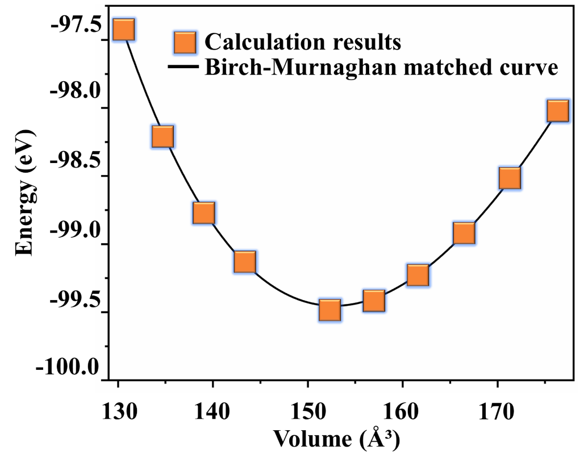
Fig. S4 The changes in total energy of Ti₄Fe₇Si-a at different volumes.
S4. Mechanical performance parameter calculation
The elastic constants are essential parameters for the calculations of the elastic properties of a material. These parameters characterize the mechanical stability of a material, as well as its dislocation movements and atomic bonding forces. They are also used to calculate various modulus values of crystalline structures, thereby providing a basis for the understanding and prediction of material mechanical properties (such as wear resistance and brittleness) ^{10,11}. The elastic constants C_{ij} of the TiFe₂ Laves phases have in the present study been calculated in a study of the mechanical stabilities of these phases¹². The calculated C_{ij} values are presented in Table S2. For the hexagonal C14 and C36 structures, the stability criteria is:
$C_{11}>\left|C_{12}\right|,C_{44}>0,C_{66}>0$; $\left(C_{11}+C_{12}\right)C_{33}-2C_{13}^{2}>0$ (Equation S5)
The elastic constants of TiFe2, Ti4Fe7Si−a, Ti4Fe7Si−h and Ti3Fe8Si are all consistent with the above inequality, indicating that the four structures were mechanically stable.
Table S2 Elastic constants C_{ij} of TiFe₂ and TiFe₂ alloyed with Si
Compound | Elastic constant/GPa
Compound | C₁₁ | C₁₂ | C₁₃ | C₃₃ | C₄₄ | C₆₆
TiFe₂ | 329.09 | 175.15 | 245.44 | 462.18 | 69.85 | 76.97
TiFe₂¹³ | 344.8 | 140.5 | 119.4 | 342.9 | 82.9 | 97.4
PtFe₂¹⁴ | 263.53 | 107.79 | 111.69 | 343.48 | 59.44 | 77.87
ZrW₂¹⁵ | 317.86 | 167.25 |  |  | 93.42
Ti₄Fe₇Si-a | 325.04 | 118.92 | 94.07 | 318.13 | 65.13 | 103.06
Ti₄Fe₇Si-h | 284.87 | 107.68 | 86.33 | 312.32 | 79.93 | 94.27
Ti₃Fe₈Si | 249.23 | 101.16 | 86.72 | 87.36 | 52.51 | 74.28

The Voigt approximation B_{V} (G_{V}) and Reuss approximation B_{R} (G_{R}) are the bottom and the top limits, respectively. The average of the limit values is represented by the Hill approximation (B_{H} (G_{H})) sd ¹⁶⁻¹⁸. The bulk B, shear G, Young's modulus E and Poisson's ratio σ are typically obtained by the expressions (Equations S5-9):
$B_{V}=B_{R}=\frac{1}{3}\left(C_{11}+2C_{12}\right)$ (Equation S5)
$G_{V}=\frac{1}{5}\left(C_{11}-C_{12}+3C_{44}\right)$ (Equation S6)
$G_{R}=\frac{5\left(C_{11}-C_{12}\right)C_{44}}{4C_{44}+3\left(C_{11}-C_{12}\right)}$ (Equation S7)
$E=\frac{9G_{H}B_{H}}{3B_{H}+G_{H}}$ (Equation S8)
$σ=\frac{3B_{H}-2G_{H}}{2\left(3B_{H}+G_{H}\right)}$ (Equation S9)
The study of the elastic anisotropy of a material is of large importance for the understanding of the generation and extension of microcracks in the material, and of the improvement of its properties^{19,20}. In the present study, the universal anisotropy index A^{U} has been used for the characterization of the elastic anisotropies of TiFe₂ and ternary compounds of titanium, iron, and silicon. As proposed by Ranganathan and Ostojia-Starzewski²¹, A^{U} is the numerical value that estimates the elastic anisotropy of the unit cell. Anisotropic factors A^{U} was calculated by the following Equation 10:
$A^{U}=5\frac{G_{V}}{G_{R}}+\frac{B_{V}}{B_{R}}-6$ (Equation S10)
The material is isotropic if the value of A^{U} is 0 ²⁰. Otherwise it is elastically anisotropic. Table 2 shows the calculated values of the anisotropy index for the present samples. The elastic anisotropy index of TiFe₂ was 0.011. When an atom in the initial lattice was replaced with a Si atom, the elastic anisotropy value of the material increased by varying degrees depending on the replacement site. The order of calculated A^{U} values for the ternary alloys was: Ti₄Fe₇Si-a (0.257) > Ti₃Fe₈Si (0.142) > Ti₄Fe₇Si-h (0.013). This implied that Ti₄Fe₇Si-h had the smallest elastic anisotropy while Ti₄Fe₇Si-a had the largest one.
S5 The analysis of electronic properties
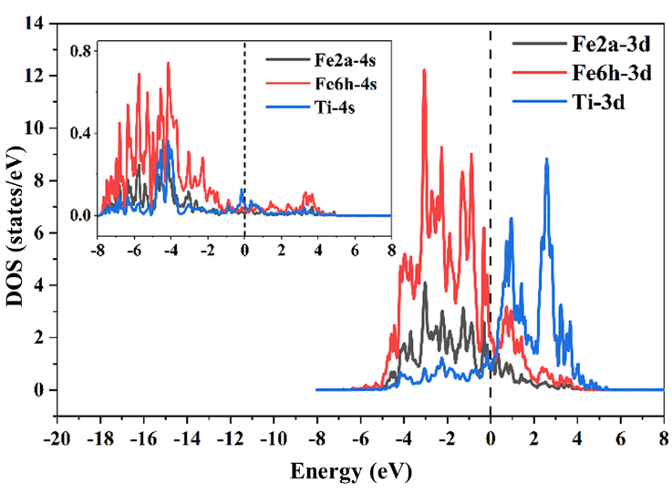
Fig. S6 PDOS of Fe (2a), Fe (6h) and Ti in 3d and 4s orbitals.
Fig. S6 shows the PDOSs for the 3d orbitals of the Fe (2a), Fe (6h), and Ti (4f) atoms, while the inserted image shows the PDOSs for the 4s orbitals of these atoms. The overlaps of the PDOSs clearly showed that the covalent bonds mainly originated from strong hybridizations between Fe (6h)-3d and Ti-3d orbitals (in the energy range of 0 eV to 2 eV) and between Fe(6h)-3d and Fe(2a)-3d orbitals (in the energy range of -4 eV to 0 eV). There were also weak metallic bonds between the Ti and Fe atoms. The total number of electrons in the 4s orbitals below Ef (0 eV) was less than 5% of the total number of electrons in the 3d orbitals. Thus, the effect of the 4s electrons on the magnetic properties of the samples could be ignored.
The electron density maps on the $\left(\text{11}\overline{\text{2}}\text{0}\right)$ crystalline planes of all four intermetallic compounds are shown in Fig. S7. It was found that there was an obvious electron delocalization between the metal atoms, which indicated a metallic bonding. Also, there were much higher electron densities in the core regions of the Fe and Ti atoms, which usually contributeed to a less extent to the bonding. Moreover, there was an obvious overlap of electron densities between the Fe (6h) and Fe (2a) atoms, and the shapes of the electron clouds were slightly deformed. This indicated that a covalent bond was formed between neighbouring Fe atoms. In addition, high density regions could also be found between the Fe (6h) (or Si) atom and its nearest Ti atoms, proving that the Fe-Ti bonding had both a covalent and a somewhat ionic feature.
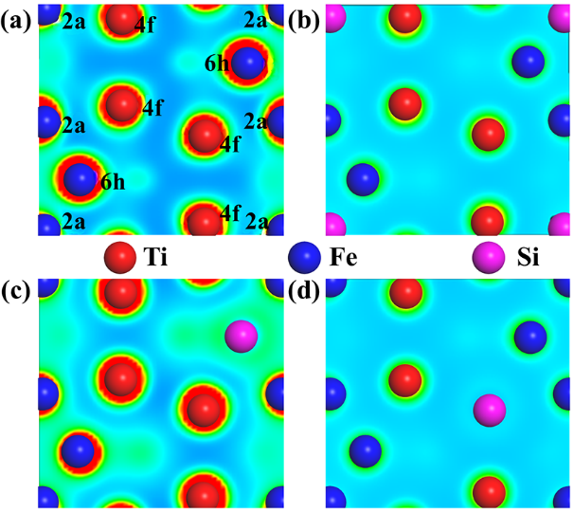
Fig. S7 Total electron density maps of TiFe₂ and three Ti-Fe-Si compounds.
(a) TiFe₂; (b) Ti₄Fe₇Si-a; (c) Ti₄Fe₇Si-h; (d) Ti₃Fe₈Si.
References
1. Sanchez, J. M., Ducastelle, F., & Gratias, D. Generalized cluster description of multicomponent systems. Physica A 128, 334-350 (1984).
2. Van de Walle, A., Asta, M., & Ceder, G. The Alloy Theoretic Automated Toolkit A User Guide. Calphad 26, 539-553 (2002).
3. The Alloy Theoretic Automated Toolkit (http://cms.northwestern.edu/atat/, 2001).
4. Jiang, C., Sordelet, D. J. & Gleeson, B. First-principles study of phase stability in pseudobinary(Ni_{1-x}Pt_{x})₃Alalloys. Phys. Rev. B 72, 184203 (2005).
5. Tsuppayakorn-Aek, P. et al. Lattice dynamic stability and electronic structures of ternary hydrides La_{1-x}Y_{x}H₃ via first-principles cluster expansion. RSC Adv. 12, 26808-26814 (2022).
6. Walle, A. & Ceder, G. Automating first-principles phase diagram calculations. J. Phase Equilib. Diff. 23, 348-359 (2002).
7. Xu, X. & Jiang, H. Cluster expansion based configurational averaging approach to bandgaps of semiconductor alloys. J. Chem. Phys. 150, 034102 (2019).
8. Lv, Z. Q., Wang, B., Sun, S. H. & Fu, W. T. Effect of atomic sites on electronic and mechanical properties of (Fe, Mo)₆C carbides. J. Alloys Compd. 649, 1089-1093 (2015).
9. Murnaghan, F. D. The Compressibility of Media under Extreme Pressures. PNAS 30, 244-247 (1944).
10. Zhang, D. et al. The structural, magnetic, electronic, and mechanical properties of orthogonal/hexagonal MC (M = Fe and Cr) carbides from first-principles calculations. Vacuum 203, 111175 (2022).
11. Zheng, P. et al. Determination of the site preference on the structure, magnetism and mechanical anisotropy properties of Mo-containing alloy carbide M₆C (M=Fe, Mo). J. Phys. Condens. Matter. 34, 28 (2022).
12. Mouhat, F. & Coudert, F. X. Necessary and sufficient elastic stability conditions in various crystal systems. Phys. Rev. B 90, 224104 (2014).
13. Nong, Z. S., Cui, P. C., Zhu, J. C. & Zhao, R. D. Alloying effects of V on stability, elastic and electronic properties of TiFe₂ via first-principles calculations. J. Cent. South Univ. 24, 1551-1559 (2017).
14. Cheng, T. M., Yu, G. L. & Zhang, X. X. The stability and properties of the PtFe₂ Laves phases. Phys. B Condens. Matt. 645, 414268 (2022).
15. Wu, J., Zhang, B. & Zhan, Y. Intrinsic Properties and Structure of AB₂ Laves Phase ZrW₂. Metall. Mater. Trans. A 48, 3082-3089 (2017).
16. Reuss, A. Berechnung der Fließgrenze von Mischkristallen auf Grund der Plastizitätsbedingung für Einkristalle. ZAMM-Z. Angew. Math. Me. 9, 49-58 (1929).
17. Hill, R. The elastic behaviour of a crystalline aggregate. Proc. Phys. Soc. A 65, 6 (1952).
18. Voigt, W. Lehrbuch der Kristallphysik. (Teubner Verlag, Wiesbaden, 1928).
19. Li, D. et al. Insight into the elastic anisotropy and thermodynamics properties of Tantalum borides. Vacuum 169, 108883 (2019).
20. Wu, Y. et al. Insights to electronic structures, elastic properties, fracture toughness, and thermal properties of M₂₃C₆ carbides. Int. J. Refract. Hard Met. 109, 105985 (2022).
21. Ranganathan, S. I. & Ostoja-Starzewski, M. Universal elastic anisotropy index. Phys. Rev. Lett. 101, 055504 (2008).

