Extended Data
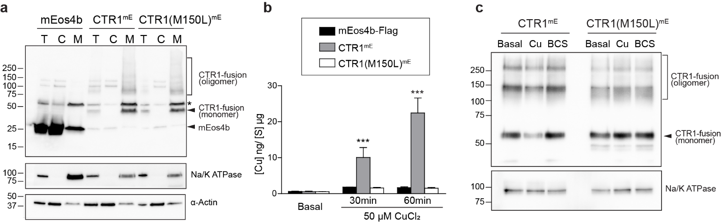
Extended Data Fig. 1 | Characterization of CTR1 fusion proteins. a, Immunoblotting of CTR1-mEos4b fusion proteins overexpressed in COS7 cells shows no significant cleavage. COS7 cells expressing soluble mEos4b-Flag (mEos4b), CTR1mE, or CTR1(M150L)^{mE} proteins were fractionated into total (T), cytosolic (C), and membrane (M) fractions. Equal amounts of protein from each fraction were resolved by immunoblotting using an anti-Flag antibody. A duplicate membrane was probed with Na/K ATPase and α-Actin to serve as markers for the plasma membrane and cytosol, respectively. The asterisk (*) denotes a non-specific band. b, Intracellular copper levels in HEK293 cells expressing mEos4b-Flag, CTR1mE or CTR1(M150L)^{mE}, measured by ICP-MS. Cells overexpressing CTR1mE show significantly higher copper uptake, indicating proper copper transport function of CTR1mE. c, Immunoblot of surface biotinylated CTR1mE and CTR1(M150L)^{mE} under basal, copper-stressed (Cu), and copper-deficient (BCS) conditions. Reduced surface CTR1mE levels upon copper treatment indicate effective endocytosis, which is absent in CTR1(M150L)^{mE}. Data are representative of three independent experiments. Graph in (B) shows mean ± SEM. Two-way ANOVA, ***p<0.001. See also Supplementary Table 3.

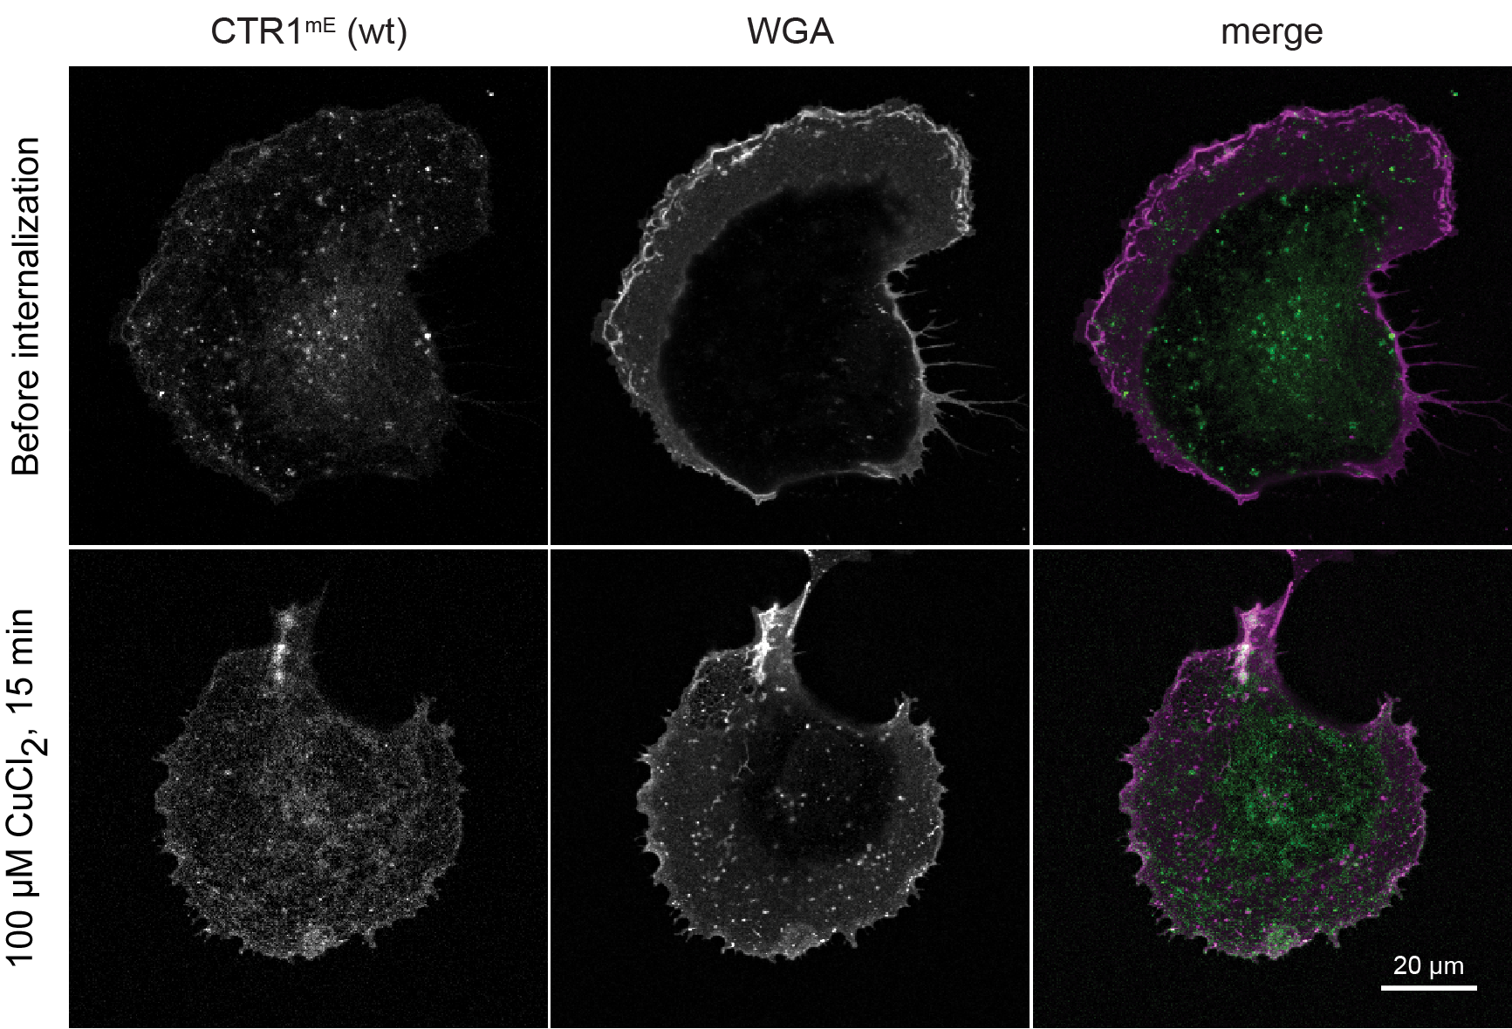

Extended Data Fig. 2 | WGA-surface labeling tracks Cu-induced endocytosis of CTR1. The confocal image of COS7 cells overexpressing CTR1mE before and after treatment with 100 μM CuCl₂ for 15 minutes. Cells were labeled with Alexa647-WGA to visualize membrane trafficking. The images depict CTR1mE (left), WGA labeling (middle), and a merged image (right) with CTR1mE in green and WGA in magenta. The increase of WGA intracellular puncta and colocalization with CTR1mE indicates effective copper-induced endocytosis.

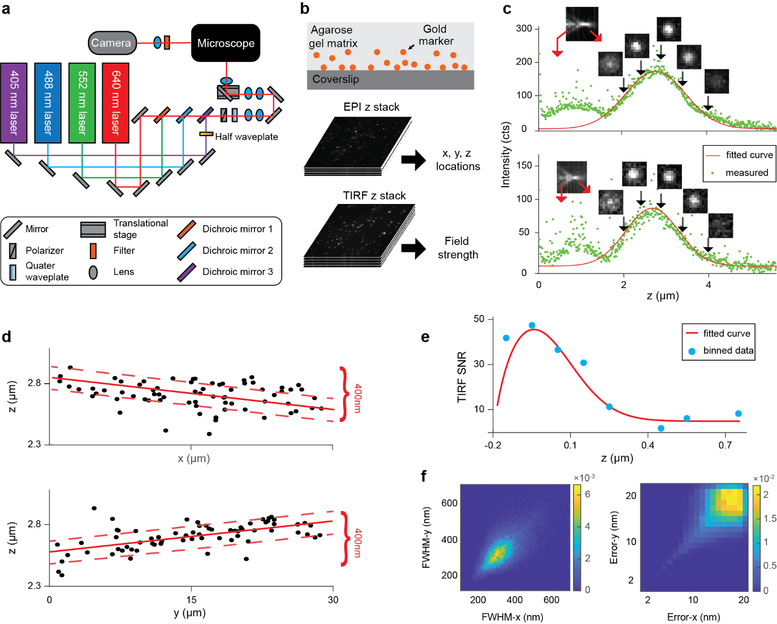

Extended Data Fig. 3 | Microscope setup and TIRF depth calibration. a, Schematic of the multi-color TIRF microscopy setup. 405 nm, 488 nm, 552 nm, and 640 nm lasers were coaxially aligned and directed into the backport of the microscope. The laser power is controlled using half-wave plates and polarizers, and the light is focused through a high numerical aperture objective to excite the samples. b, Illustration of the raisin-cake scanning method. Top: Sample preparation for TIRF depth determination using gold nanospheres embedded in an agarose gel matrix on a coverslip. Bottom: Workflow for determining TIRF depth. EPI-z scanning is used to obtain the x, y, and z locations of gold markers, while TIRF-z scanning is used to identify the strongest evanescent field strength. c, Intensity versus z-position of two example gold markers, determined using EPI-z scanning. Insets show the PSF or example images of the corresponding gold markers at different z positions. d, Correcting for coverslip tilt by gold nanospheres z locations. x-z (top) and y-z (bottom) scatter plots indicat a 400 nm tilt of the coverslip. e, Averaged signal-to-noise ratio (SNR) of all gold markers as a function of z-position, averaged over 10 nm bins after tilt correction. The data is fitted with a Gaussian convoluted with a single-exponential decay to determine the evanescent field penetration depth of 50 nm. f, Heat maps display the FWHM and localization error distributions, indicating the system's resolution and accuracy.

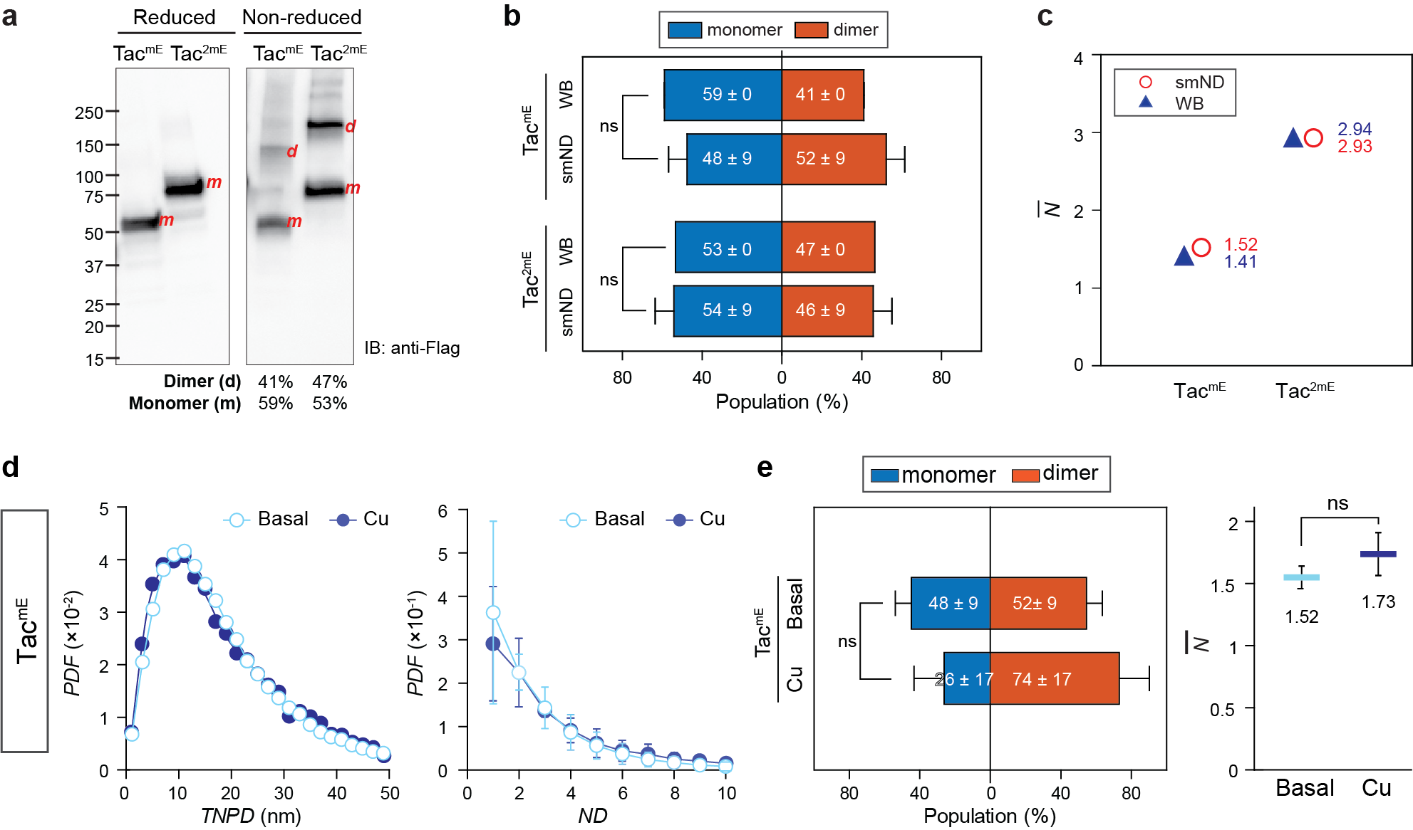
Extended Data Fig. 4 | Validation of smND assay and $\overline{\text{N}}$ as a metric for evaluating oligomeric state composition by using membrane-anchored TacmE and Tac2mE. a, Non-reduced immunoblotting analysis of TacmE and Tac^{2mE} overexpressed in COS7, showing their oligomeric populations as 59% monomers and 41% dimers for TacmE, and 54% monomers and 46% dimers for Tac^{2mE} with no significant cleavage. Equal amounts of the total protein were resolved in both non-reduced and reduced SDS-PAGE, and then the full-length proteins were detected by using anti-Flag antibody. The corresponding percentages of the monomer (m) and dimer (d) populations within each fusion protein were quantified by the band intensities from the non-reduced gel. b, Comparison of oligomer populations of Tac-fusion proteins extracted from immunoblotting and smND analysis. The immunoblotting and the smND data of TacmE and Tac^{2mE} were collected under basal and copper-stressed conditions, showing no significant (ns) differences in Tac oligomeric state distributions. c, Comparison of $\overline{\text{N}}$ of TacmE and Tac^{2mE} extracted from the oligomer populations in immunoblotting (triangle) and smND analysis (circle). d, Probability density functions of TNPD (left) and ND (right) results of TacmE under basal (open circle) and Cu-stressed conditions (close circle) showed no significant differences. e, Extracted dimer populations and the corresponding $\overline{\text{N}}$values of TacmE remained statistically unchanged between basal and Cu-treated conditions, confirming that the oligomeric state of the mE tag is not affected by Cu treatment. Panels c, d, and e are shown as mean ± SEM.

