Appendix 1: Explanation of Algorithm
Algorithm 1 calculated the patient’s birth year based on their age at the time of data extraction. The algorithm initially assumed the patient was born in the 20th century and calculated the corresponding age. If this age was not close to the age given at the extraction, the algorithm inferred that the patient was born in the 21st century. Conversely, if the age matched, the patient was confirmed to have been born in the 20th century.

Appendix 2: Explanation of Mentioned Diagnoses and Procedures
Diagnoses (ICD-10) |  | Procedures (NOMESCO)
Code | Explanation | Code | Explanation
I609 | unspecified subarachnoid hemorrhage | AAF20 | revision of shunt of ventricle of brain
C79.3 | secondary malignant neoplasm of brain and cerebral meninges | NAG70 | interlaminary fusion of cervical spine with fixation
T85.0 | mechanical complication of ventricular intracranial shunt | AAD11 | evacuation of chronic subdural hematoma with burr hole
D33.9 | benign neoplasm in unspecified part of central nervous system | AAD12 | evacuation of chronic subdural hematoma with craniotomy
G20 | parkinson's disease | AAD05 | evacuation of acute subdural hematoma
S01.0 | open wound of scalp | AAE10 | transsphenoidal total or partial excision of intracranial lesion
S06.5 | traumatic subdural hemorrhage | QAB05 | revision of wound of skin of head or neck
D43.0 | neoplasm of uncertain or unknown behavior | ABC60 | decompression of cervical spinal cord
G93.1 | anoxic brain damage | AAD10 | evacuation of chronic subdural hematoma
M50.0 | cervical disc disorder with myelopathy | AAF05 | ventriculoperitoneal shunt
I62.0 | nontraumatic subdural hemorrhage | ABC16 | microsurgical excision of lumbar intervertebral disc displacement
G91.0 | communicating hydrocephalus | ABC21 | anterior decompression of cervical spine with insertion of interbody fixating implant
G91.2 | normal-pressure hydrocephalus | ABC36 | decompression of lumbar nerve roots
M51.1 | lumbar and other intervertebral disc disorders with radiculopathy | AAB10 | microsurgical excision of cervical intervertebral disc displacement
M50.1 | cervical disc disorder with radiculopathy | ABC26 | open discectomy of lumbar spine
C71.0 | malignant neoplasm of cerebrum, except lobes and ventricles | AAK10 | repair of dura
D32.0 | benign neoplasm of cerebral meninges | AAB00 | extirpation of intracranial lesion
I67.1 | cerebral aneurysm, unruptured | AAY00B | endovascular occlusion of intracranial aneurism
M48.0 | spinal stenosis | ABC56 | decompression of lumbar spinal cord and nerve roots
I60.9 | subarachnoid hemorrhage, unspecified | AAF02 | external drainage of ventricle of brain
D35.2 | benign neoplasm, pituitary gland
D33.3 | benign neoplasm, cranial nerves
G91.1 | obstructive hydrocephalus
Appendix 1. This table contains explanations of the mentioned procedures (NOMESCO) and diagnoses (ICD-10) in our study.

Appendix 3: Flow Chart of Inclusion Process
Total surgeries
n = 11,686

Error in national ID
n = 35
Date of birth not retrievable
n = 1,179
Non-invasive neurosurgery
n = 2,369
Non-geriatric patients
n = 5,591

Excluded
n = 9,174
Included
n = 2,512

Appendix 2. This figure shows the process of inclusion in our retrospective analysis.

Appendix 4: Proportion of Geriatric Patients by Age Group
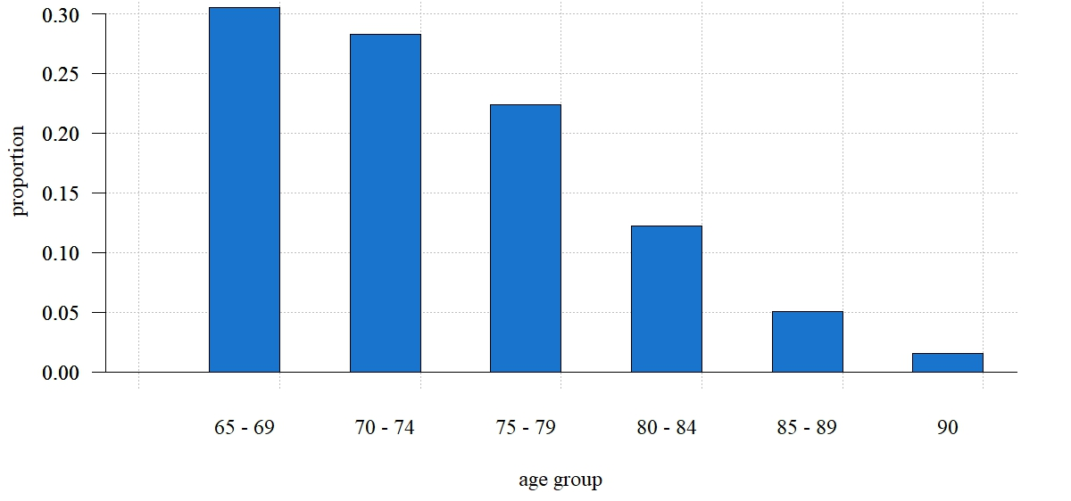
Appendix 3. This bar plot shows the age distribution of geriatric patients treated at Haukeland University Hospital, Department of Neurosurgery, between 1st January 2018 and 31st December 2023. Each bar represents the proportion of geriatric patients in each age group by the total number of geriatric patients. The p-value for the slope coefficient was 0.00038.

Appendix 5: Number of Geriatric Patients by Year
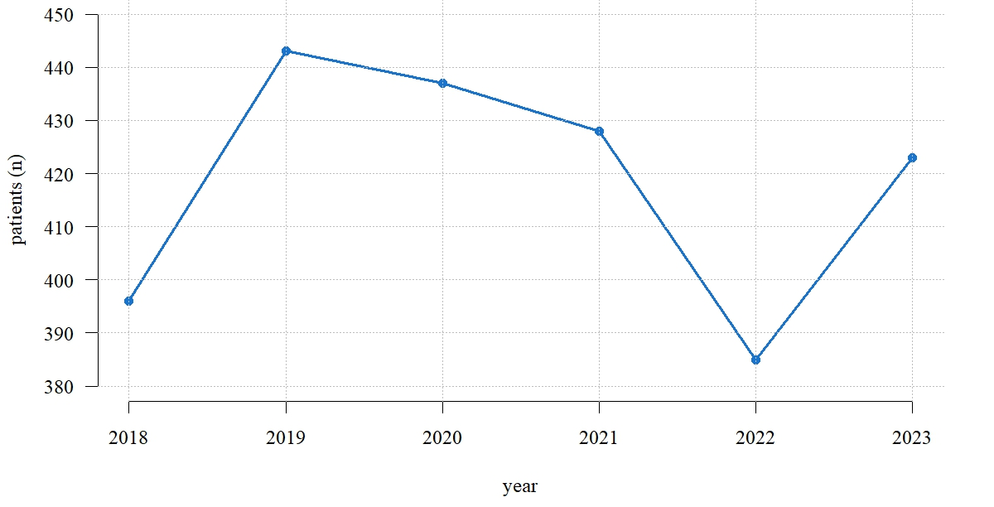
Appendix 4. The blue line shows the total number of geriatric patients each year at Haukeland University Hospital, Department of Neurosurgery, between 1st January 2018 and 31st December 2023.

Appendix 6: Most Common Geriatric Neurosurgical Procedures (NOMESCO)
# |  | 65 – 69 | 70 – 74 | 75 – 79 | 80 – 84 | 85 – 89 | ≥ 90 | ≥ 65 | 18 - 64
1 | procedure | ABC16 | ABC56 | ABC56 | AAD10 | AAD10 | AAD10 | ABC56 | ABC16
1 | n | 87 | 89 | 82 | 55 | 28 | 11 | 303 | 1284
1 | % | 7,22 % | 8,43 % | 10,47 % | 15,28 % | 22,58 % | 55,00 % | 8,54 % | 14,97 %
2 | procedure | AAB10 | ABC36 | AAD10 | AAF05 | ABC56 | AAD11 | ABC36 | ABC21
2 | n | 82 | 78 | 65 | 45 | 16 | 3 | 262 | 778
2 | % | 6,80 % | 7,39 % | 8,30 % | 12,50 % | 12,90 % | 15,00 % | 7,38 % | 9,07 %
3 | procedure | ABC36 | AAK10 | AAF05 | ABC56 | AAF05 | AAD12 | AAD10 | ABC36
3 | n | 80 | 68 | 65 | 41 | 14 | 2 | 254 | 680
3 | % | 6,64 % | 6,44 % | 8,30 % | 11,39 % | 11,29 % | 10,00 % | 7,16 % | 7,93 %
4 | procedure | ABC56 | AAB10 | ABC36 | ABC36 | ABC36 | AAF05 | AAF05 | ABC26
4 | n | 75 | 64 | 65 | 27 | 12 | 2 | 228 | 532
4 | % | 6,22 % | 6,06 % | 8,30 % | 7,50 % | 9,68 % | 10,00 % | 6,43 % | 6,20 %
5 | procedure | AAK10 | ABC16 | AAB10 | AAF20 | ABC16 | AAE10 | ABC16 | AAB10
5 | n | 73 | 59 | 44 | 12 | 6 | 1 | 205 | 479
5 | % | 6,06 % | 5,59 % | 5,62 % | 3,33 % | 4,84 % | 5,00 % | 5,78 % | 5,58 %
6 | procedure | AAY00B | AAD10 | ABC16 | AAF02 | AAD11 | QAB05 | AAB10 | AAK10
6 | n | 55 | 57 | 44 | 10 | 5 | 1 | 200 | 370
6 | % | 4,56 % | 5,40 % | 5,62 % | 2,78 % | 4,03 % | 5,00 % | 5,64 % | 4,31 %
7 | procedure | AAF02 | AAF05 | AAK10 | AAK10 | AAB00 | NA | AAK10 | AAB00
7 | n | 50 | 57 | 34 | 10 | 3 | NA | 188 | 272
7 | % | 4,15 % | 5,40 % | 4,34 % | 2,78 % | 2,42 % | NA | 5,30 % | 3,17 %
8 | procedure | AAB00 | AAB00 | AAF02 | AAB10 | AAK10 | NA | AAB00 | AAY00B
8 | n | 45 | 54 | 25 | 9 | 3 | NA | 129 | 242
8 | % | 3,73 % | 5,11 % | 3,19 % | 2,50 % | 2,42 % | NA | 3,64 % | 2,82 %
9 | procedure | AAF05 | AAF02 | AAB00 | ABC16 | AAY00B | NA | AAF02 | ABC56
9 | n | 45 | 40 | 23 | 9 | 3 | NA | 127 | 211
9 | % | 3,73 % | 3,79 % | 2,94 % | 2,50 % | 2,42 % | NA | 3,58 % | 2,46 %
10 | procedure | ABC21 | AAY00B | AAE10 | ABC60 | NAG70 | NA | AAY00B | AAF02
10 | n | 43 | 32 | 18 | 8 | 3 | NA | 110 | 183
10 | % | 3,57 % | 3,03 % | 2,30 % | 2,22 % | 2,42 % | NA | 3,10 % | 2,13 %
Table 2. This table presents the ten most common neurosurgical procedures (using the NOMESCO classification of surgical procedures) in geriatric patients at Haukeland University Hospital in the period 1st January 2018 to 31st December 2023 per age group and in total. The data is presented as both absolute number of procedures (n) and percentage (%) of the total number of procedures. For comparison, the table also presents the top ten most common neurosurgical procedures in adults aged 18 to 65.

Appendix 7: Duration of Surgery by Age in Individual Surgeries
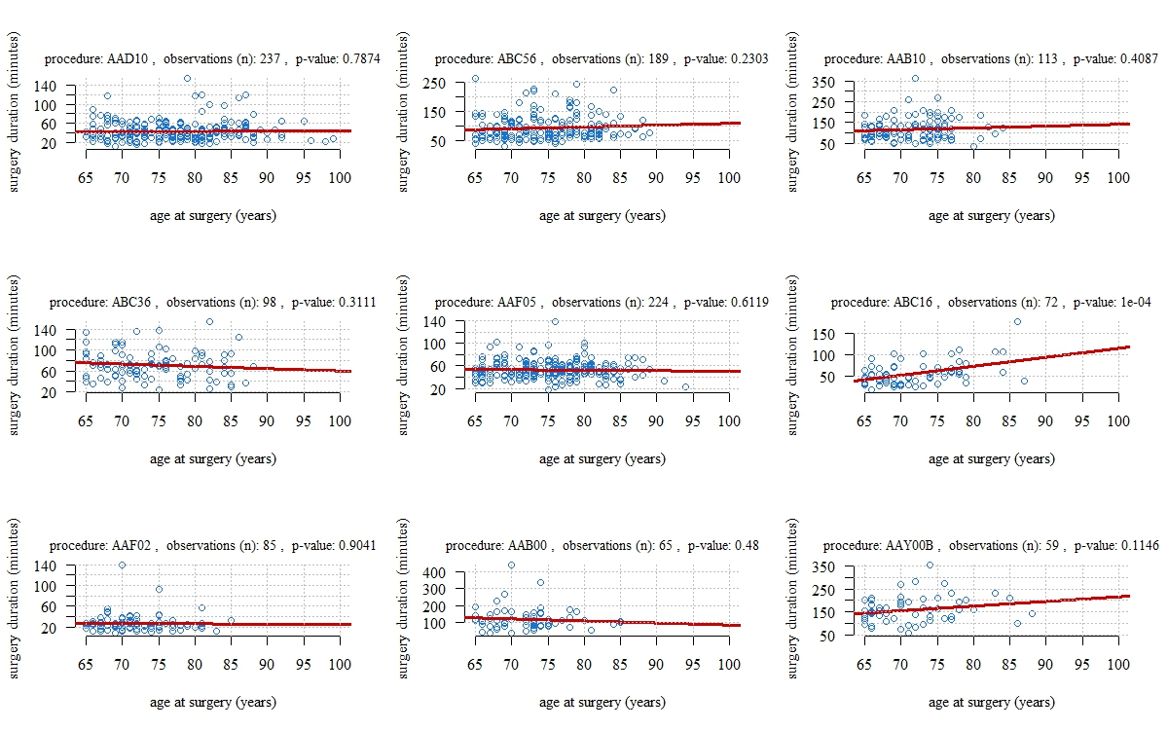
Appendix 6. This figure shows the duration of surgery in minutes by age for the nine most common procedures in geriatric patients, except AAK10, for all patients at Haukeland University Hospital, Department of Neurosurgery, between the dates of 1st January 2018 and 31st December 2023. Every blue point represents one patient with a corresponding age and surgery duration. The red line is a regression line predicting the relationship between age at surgery and surgery duration for each surgery.

