Supplementary Materials

Supplementary Table 1. Datasets used in Supplementary figures in addition to the datasets listed in Table 1.

Data set name | Variables | Resolution | Period analyzed in this study | Reference No.
ERSST, version 5 | SST | 2.0°×2.0°, monthly | January 1950-September 2024 | 721
MODIS Cloud Properties Product (MCD06) | Total cloud ratio and low cloud ratio | 1.0°×1.0°, monthly | July 2002 – September 2024 | 732
MODIS standard atmosphere product (MOD08 & MYD08) | Aerosol optical thickness | 1.0°×1.0°, monthly | July 2002 – October 2024 | 74,753, 4

Supplementary Table 2. Heat content changes in the global atmosphere and ocean and integrated TOA net radiation over the globe (in ZJ), with contribution ratio in the tropics (30S-30N) indicated in the parentheses. For the atmospheric heat content (AHC), the value is estimated as the RMES of AHC between the present study and that used by von Schuckman et al. (2023). Their AHC data is provided though World Data Center for Climate as globally integrated, annually sampled, and ENSO removed AHC. For the ocean heat content (OHC) values in the 0-100 m and 100-300 m depth ranges, the values listed after the '±' represent one standard deviation as estimated from four ocean reanalysis and analysis products. For TOA net radiation integrated over the globe for a one-year period, its standard deviation is based on monthly error estimates between Terra and Aqua observations. The OHC below 300 m is estimated by the difference between the time integration of TOA net radiation and 0-300 m OHC change. The value shown after the '±' for OHC below 300 m includes the uncertainty associated with discrepancy between the TOA net radiation and OHC change estimated from satellite observation of sea-surface height and gravity.

 | 2010 Feb  - 2009 Feb | 2015 Dec  - 2014 Dec | 2023 Nov  - 2022 Nov
AHC Change | 2.8±0.2 (82%) | 1.9±0.2 (126%) | 4.7±0.2 (72%)
0-100 m OHC Change | 27.9±1.0 (107%) | 29.6±2.0 (84%) | 43.5±1.3 (95%)
100-300 m OHC Change | -24.2±4.4 (83%) | -21.5±1.2 (117%) | -29.0±2.8 (102%)
OHC Change below 300 m | 3.8±7.8 | 6.6±5.6 | 10.4±5.7
Time integration of TOA Net Radiation | 10.3±1.4 | 16.6±1.4 | 29.6±1.4

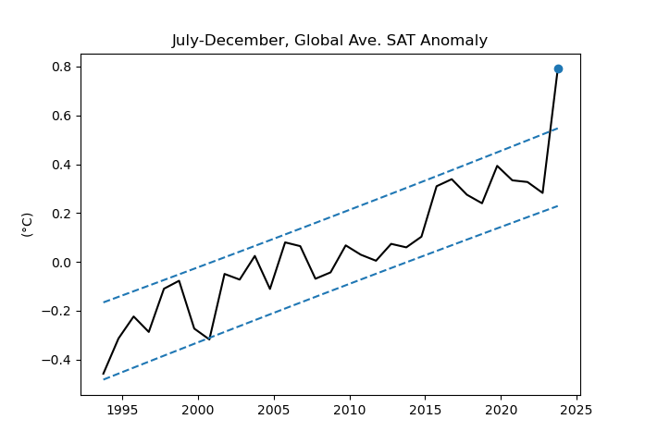
Supplementary Fig. 1. Illustration of the AB-test applied to global Surface Air Temperature (SAT) anomalies for July-December. Dashed lines delineate the expected data range at 90% confidence, based on the linear trend from 1993 to 2022. Values surpassing the upper limit of this range are within the top 5%, thus deemed significant at the 5% level in a one-sided test. The linear trend is calculated using data up to one year prior to the year being tested (2022 for testing 2023 data in this instance). When we test the data in 2022, the trend is estimated using the data for 1993-2021.

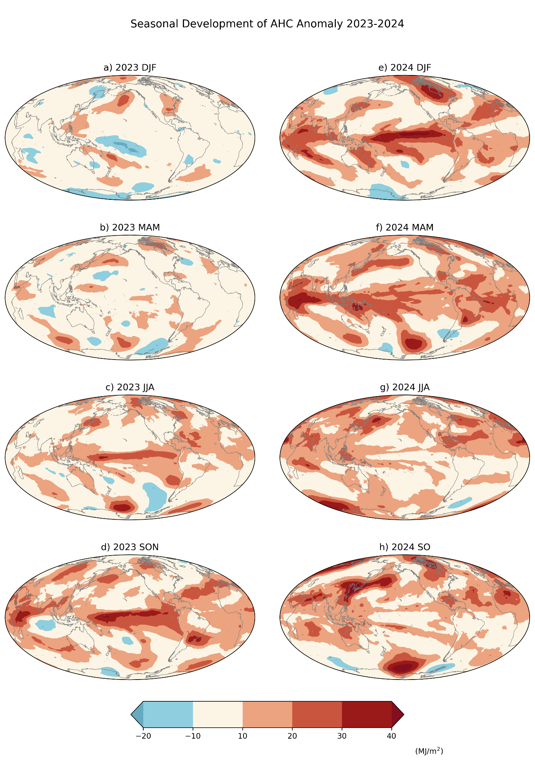
Supplementary Fig. 2: AHC anomaly evolution from 2023 DJF to 2024 JJA.

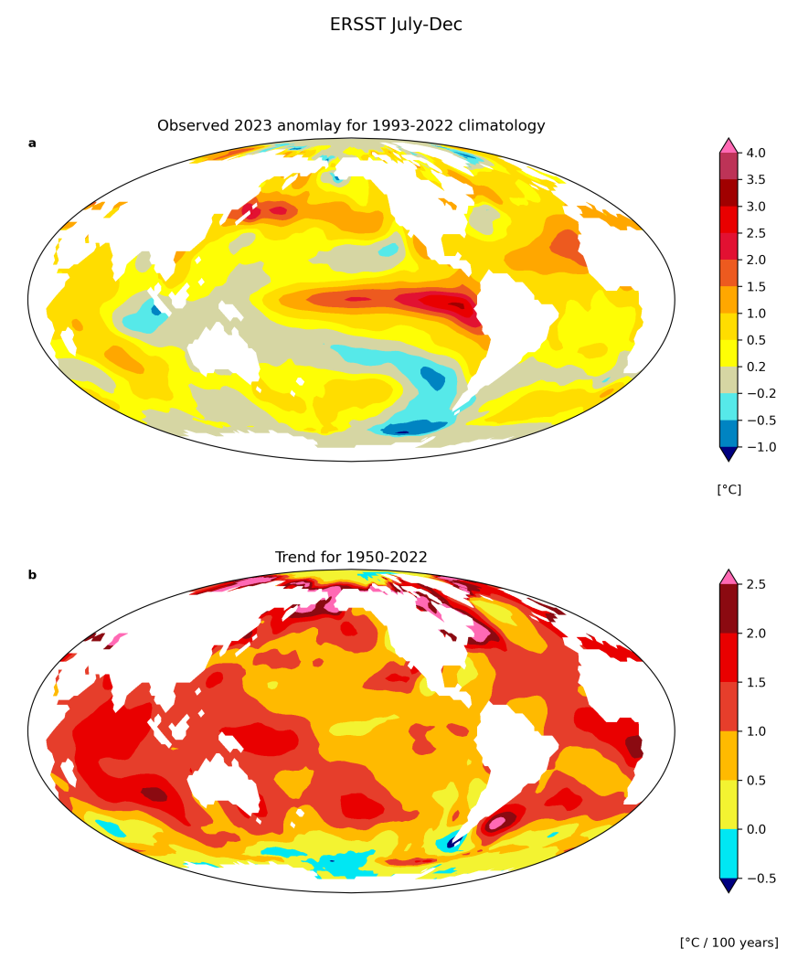
Supplementary Fig. 3. Comparison of 2023 anomaly and trend for 1950-2022 period for July-December season based on Extended and Reconstructed SST version 5⁷².¹

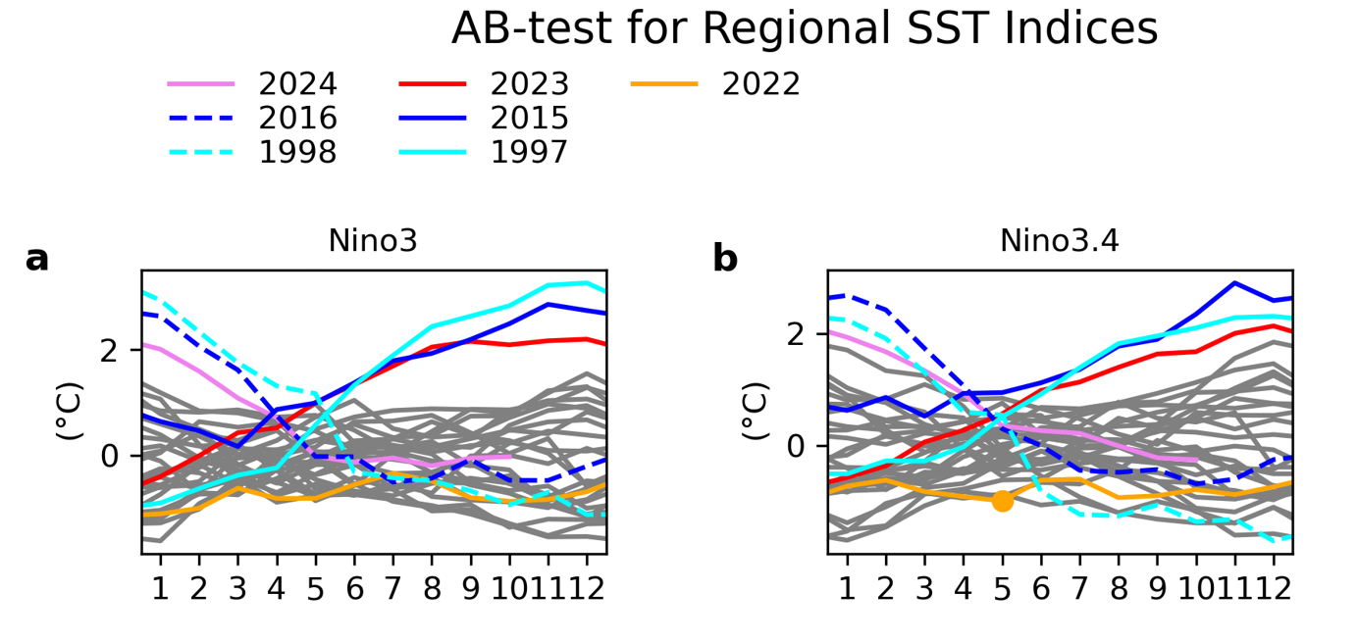
Supplementary Fig. 4. AB-test for (a) Nino3 and (b) Nino3.4 indices. These indices are calculated from OI-SST.
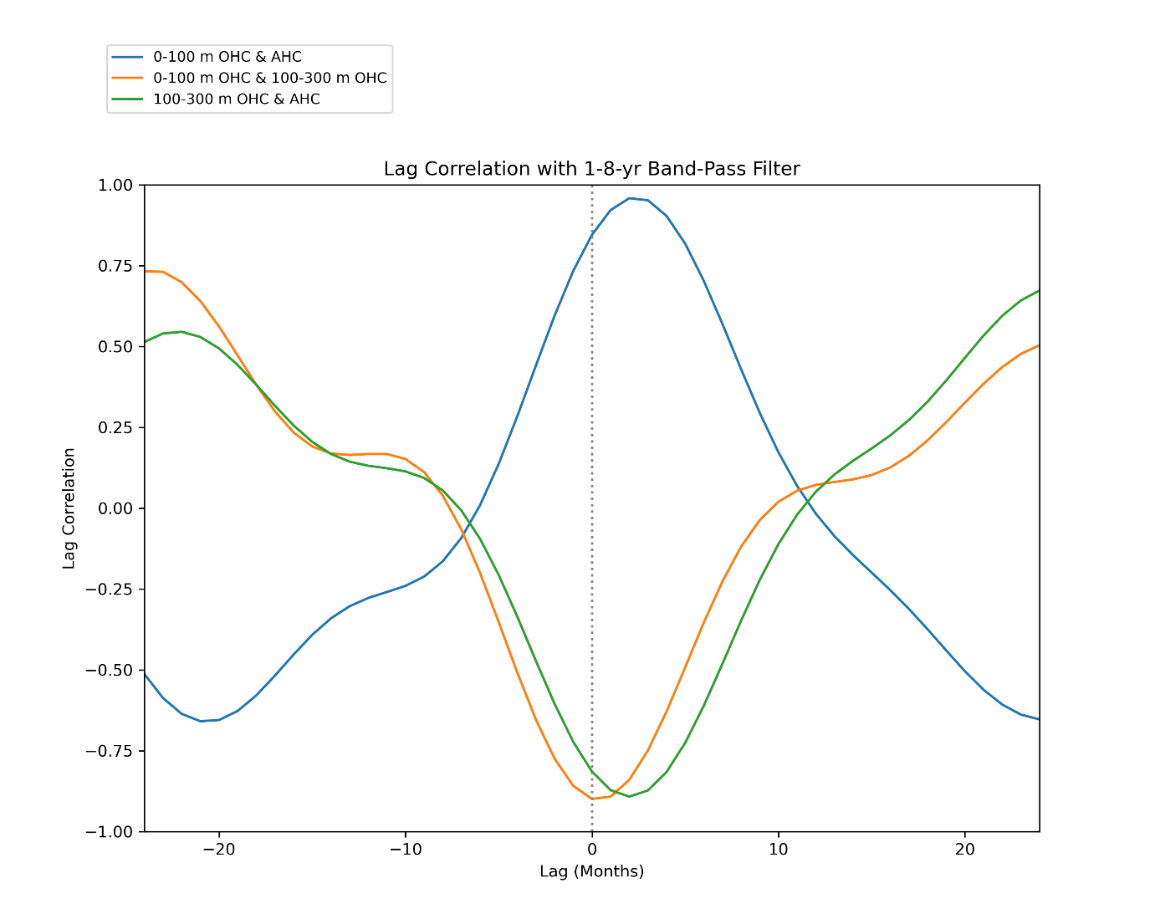
Supplementary Fig. 5. Lag correlation between near-surface (0-100 m) OHC, subsurface (100-300 m) OHC, and AHC with a band-pass filter, which extracts an interannual (one-to-eight year period) component. Positive lags correspond to the first variable shown in legend leading the second variable.

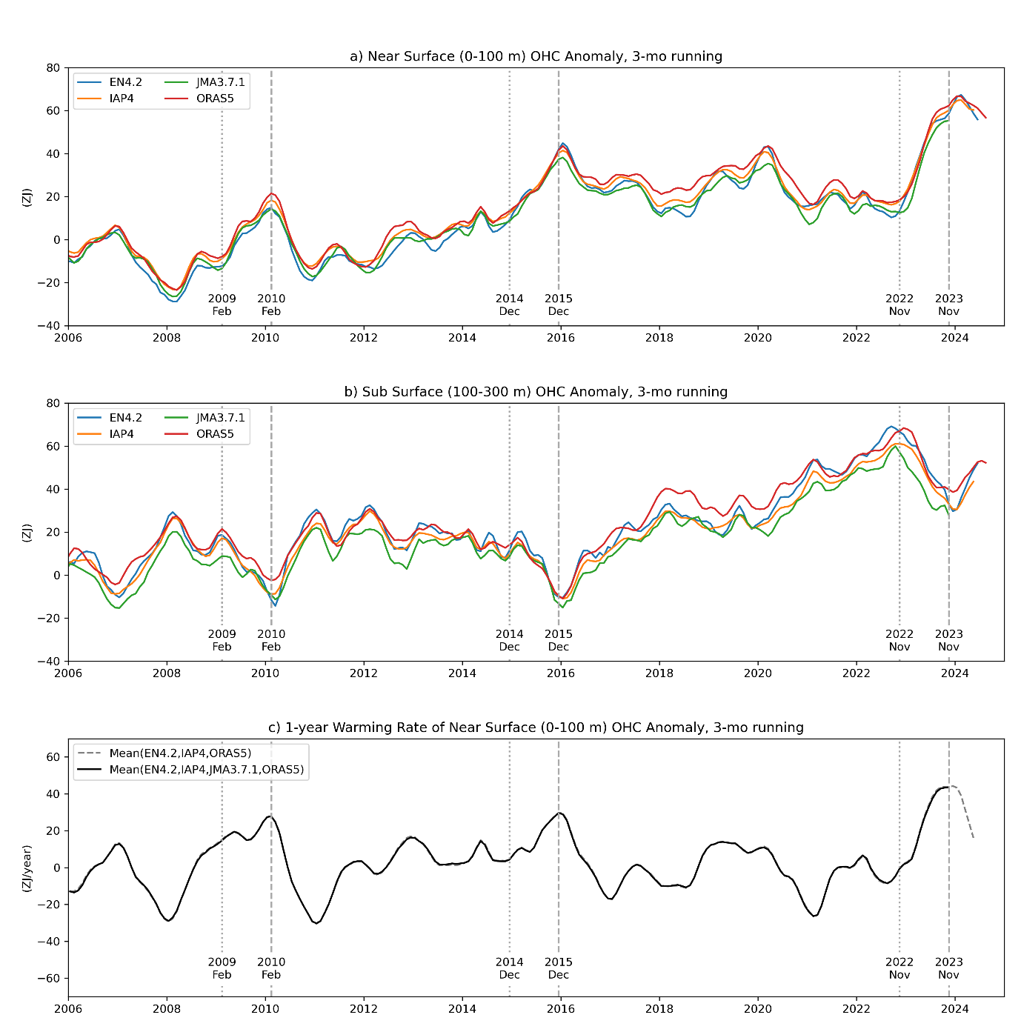

Supplementary Fig. 6. (a) 0-100 m and (b) 100-300 m OHC of four products, and (c) 1-year warming rate of the 0-100 m OHC. The vertical dotted and dashed lines in each panel indicate the one-year period during which the heat budget analysis of Fig. 4 is conducted.

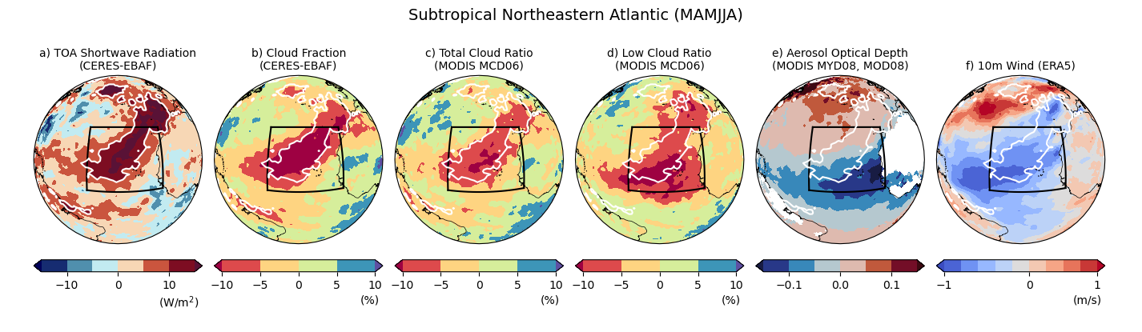
Supplementary Fig. 7: (a) Anomalies of TOA shortwave radiation, (b) cloud fraction observed by CERES-EBAF, (c) total cloud ratio, (d) low cloud ratio, (e) aerosol optical depth observed by MODIS, and (f) 10-m scalar wind speed of ERA5 2023 MAMJJA. The white contours are 10 W/m² of TOA shortwave radiation. Panel (a) and (b) are also shown in Fig. 4, but are reproduced here for the convenience of readers. The cloud data of MODIS are taken from MCD06 dataset and aerosol optical depth is taken from MYD08 and MOD08 datasets.
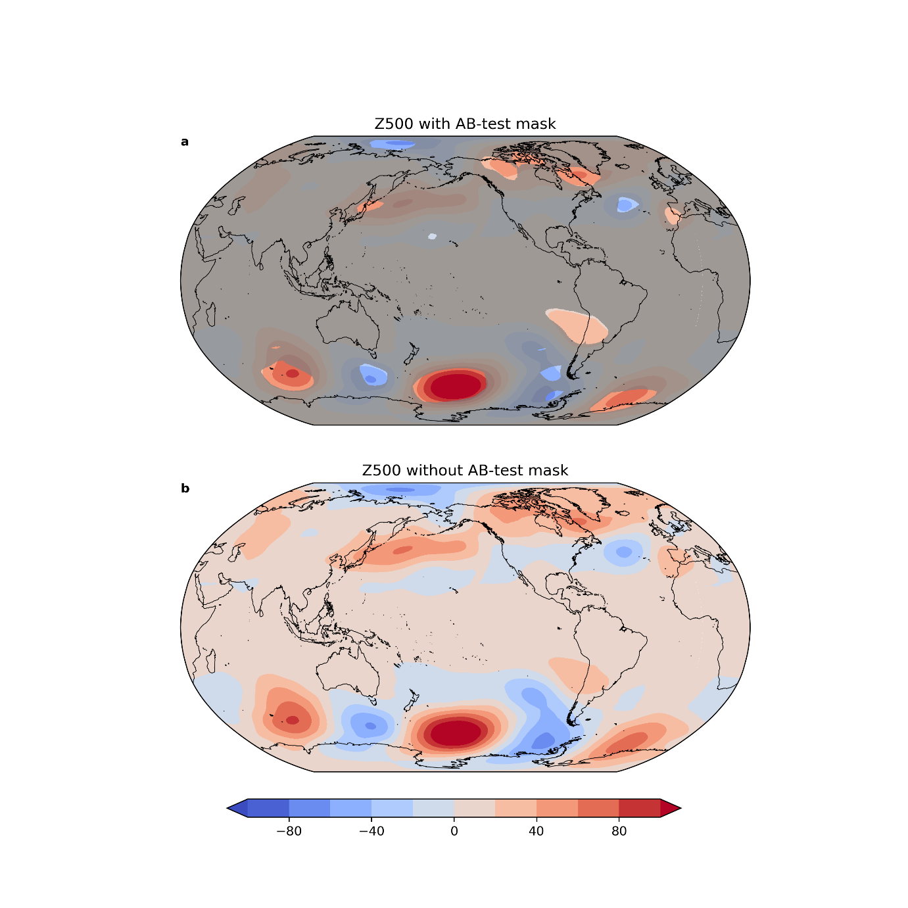
Supplementary Fig. 8: 500 hPa (left) geopotential height anomalies from March to August in 2023 with (top) and without (bottom) the AB-test masks. Anomalies are relative to the 1993-2022 climatology. In the top panel, the values that do not pass the AB-test are shown with the grey overlapping shading. The wave number three pattern around Antarctica is evident. This figure also suggests the propagation from the high latitude southeastern South Pacific to lower latitude toward South America, and propagation from the Labrador Sea, crossing the North Atlantic to Spain with a hint of North Atlantic Oscillation.

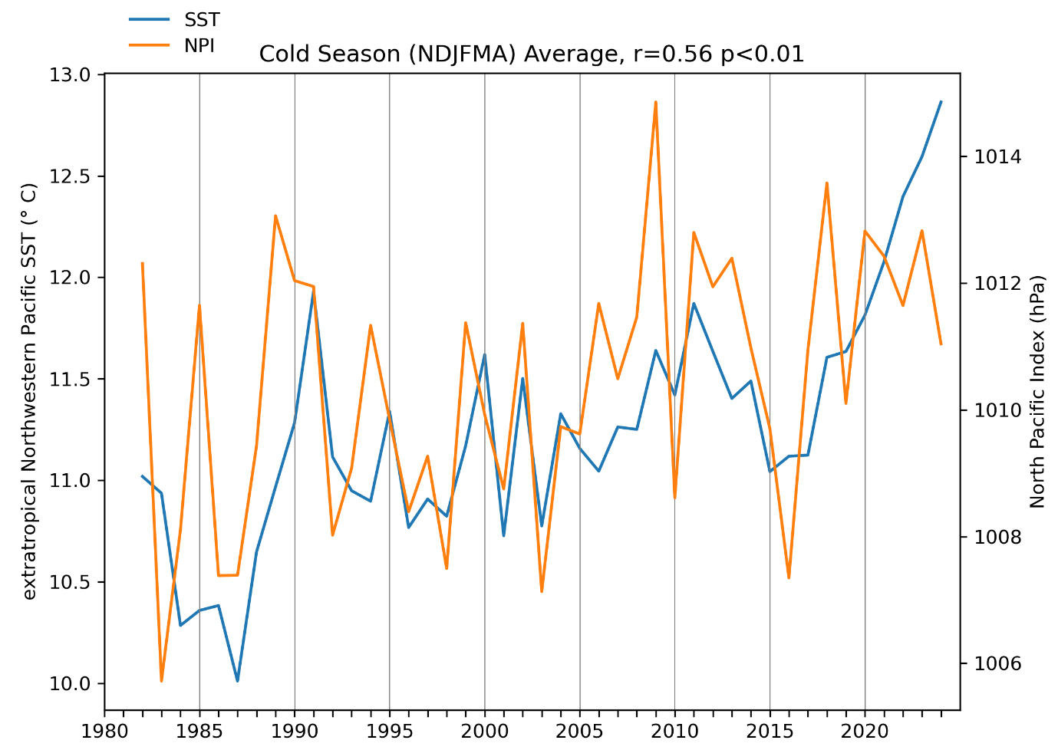Supplementary Fig. 9: SST averaged over extratropical Northwestern Pacific and North Pacific Index for cold season (November-April). The North Pacific Index represents the Aleutian Low strength and is defined as the SLP averaged over 30°-65°N, 160°E-140°W⁷⁶.⁵ The year in the figure corresponds to the January year of the NDJFMA.
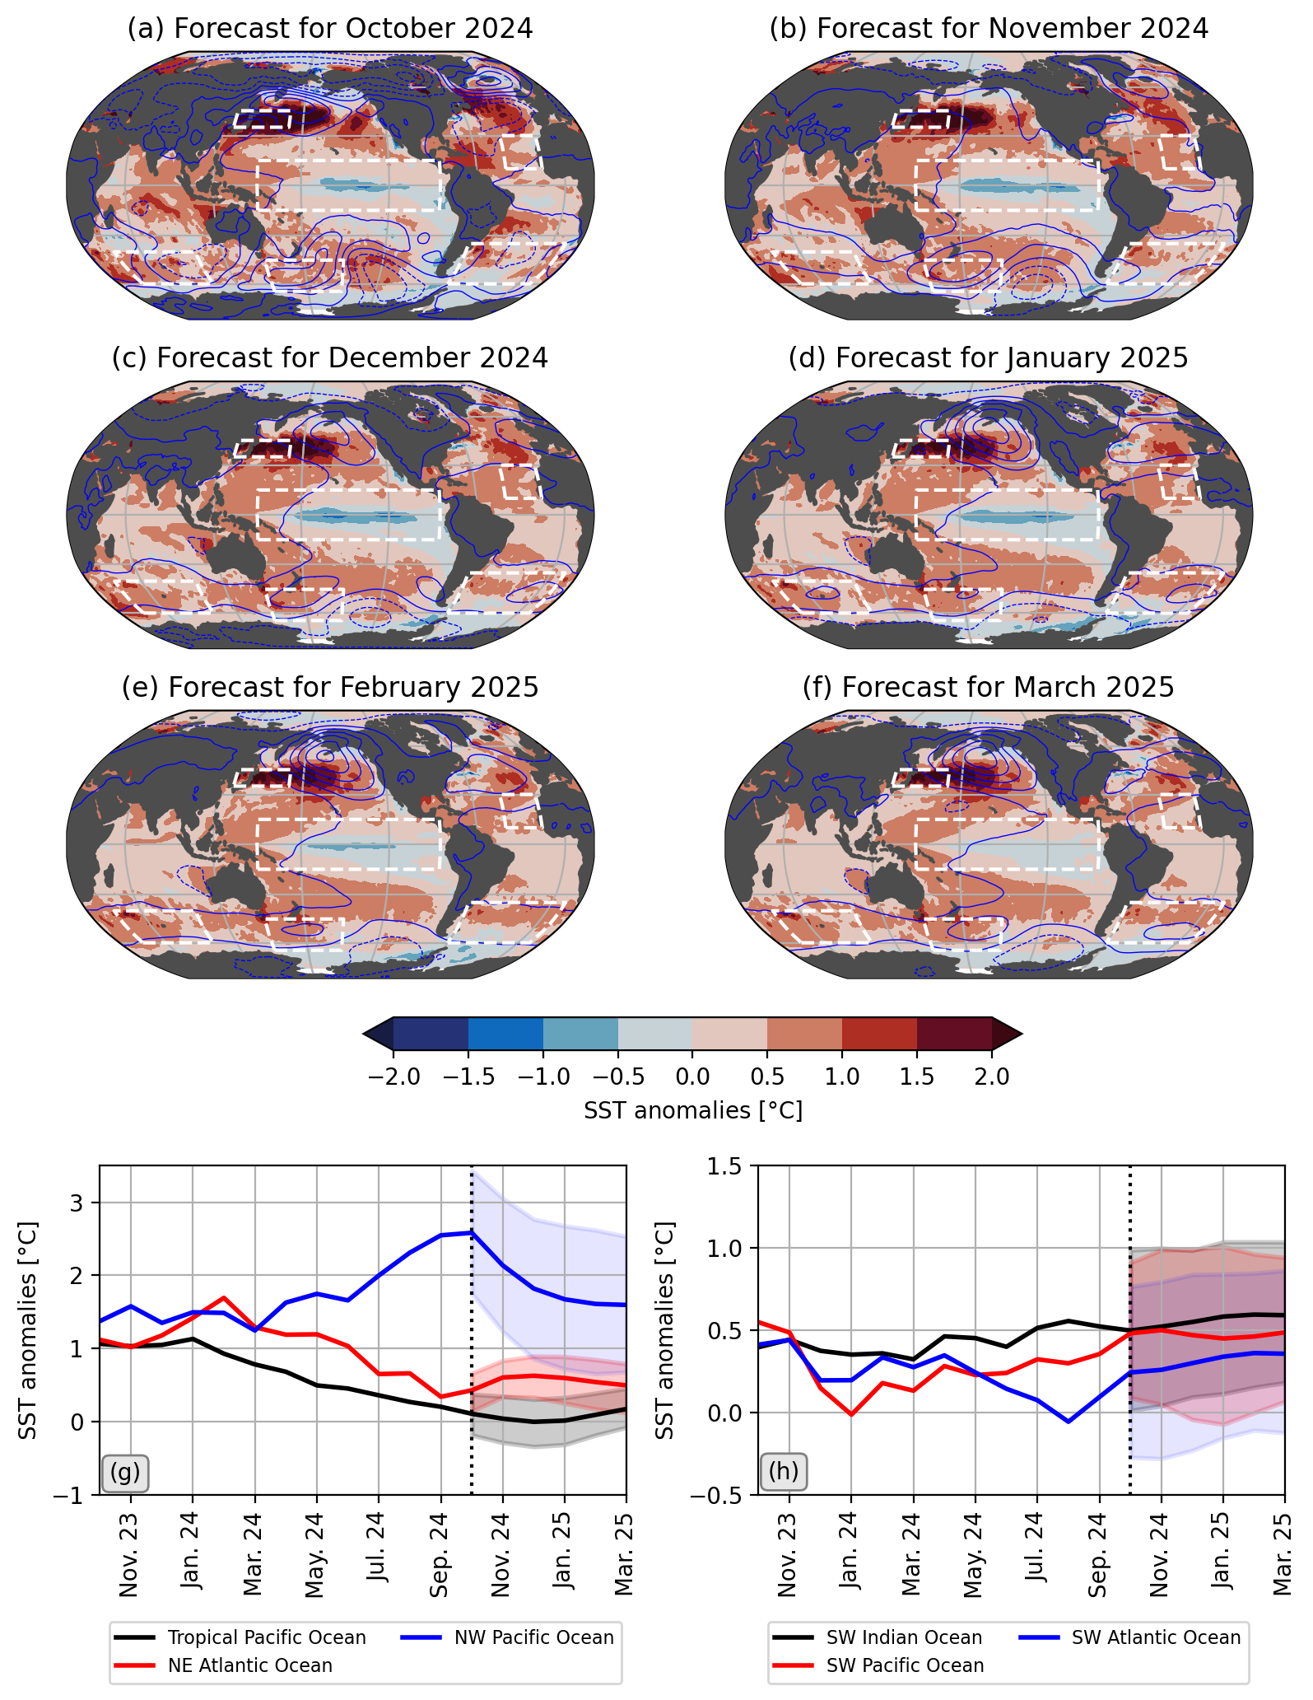
Supplementary Fig. 10: (a-f) C3S multi-model mean forecasted SST anomalies for the upcoming 6 months (October 2024 to March 2025). Blue contours represent multi-model mean sea-level pressure anomalies, with a contour interval off 1 hPa (negative anomalies are represented by dashed contours). (g, h) Area-averaged anomalies for selected regions (white boxes in (a-f)) are shown by color-coded solid lines. Reanalysis period is to the left of vertical dashed line while the forecast period to right where the shading represents the multi-model spread.

References for Supplementary Materials
- Huang, B. et al. NOAA Extended Reconstructed Sea Surface Temperature (ERSST), Version 5. NOAA National Centers for Environmental Information https://doi.org/10.7289/V5T72FNM (2017).
- Platnick, S. et al. The MODIS Cloud Optical and Microphysical Products: Collection 6 Updates and Examples From Terra and Aqua. IEEE Trans. Geosci. Remote Sensing 55, 502–525 (2017).
- Platnick, S., Hubanks, P., Meyer, K. & King, M. D. MYD08_M3 MODIS/Aqua Aerosol Cloud Water Vapor Ozone Monthly L3 Global 1Deg CMG. NASA Level 1 and Atmosphere Archive and Distribution System Distributed Active Archive Center https://doi.org/10.5067/MODIS/MYD08_M3.006 (2015).
- Platnick, S., Hubanks, P., Meyer, K. & King, M. D. MOD08_M3 MODIS/Terra Aerosol Cloud Water Vapor Ozone Monthly L3 Global 1Deg CMG. NASA Level 1 and Atmosphere Archive and Distribution System Distributed Active Archive Center https://doi.org/10.5067/MODIS/MOD08_M3.006 (2015).
- Trenberth, K. E. & Hurrell, J. W. Decadal atmosphere-ocean variations in the Pacific. Climate Dynamics 9, 303–319 (1994).

Data Availability
Extended and Reconstructed SST:
https://psl.noaa.gov/data/gridded/data.noaa.ersst.v5.html
MODIS MCD06 data: https://ladsweb.modaps.eosdis.nasa.gov/archive/allData/62/MCD06COSP_M3_MODIS
MODIS MOD08 data: https://ladsweb.modaps.eosdis.nasa.gov/archive/allData/61/MOD08_M3/
MODIS MYD08 data: https://ladsweb.modaps.eosdis.nasa.gov/archive/allData/61/MYD08_M3/

