Table 1. Chemical structures and bioactivities of compounds 10a-h
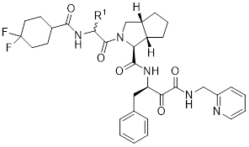
Chemical modifications in R¹.
Compd | R¹ | M^{pro} (nM) | TMPRSS2 (μM)
E87 | 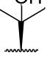 | 368.6±5.0 | 15.21±5.90
10a | 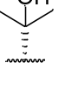 | 596.8±1.5 | 223.98±20.16
10b | H | 528.8±8.3 | >500
10c | 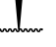 | 85.3±1.2 | 38.04±8.92
10d | 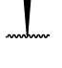 | 175.5±3.5 | 96.24±16.38
10e | 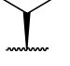 | 556.4±1.3 | 49.28±3.73
10f | 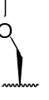 | 66.5±1.0 | 45.51±4.59
10g | 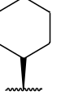 | 82.7±1.7 | 11.22±0.96
10h | 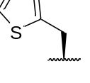 | 301.6±1.4 | 27.73±1.48

Table 2. Chemical structures and bioactivities of compounds 10g and 13a-h.
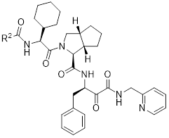
Chemical modifications in R².
Compd | R² | M^{pro} (nM) | TMPRSS2 (μM)
10g | 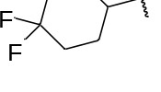 | 82.7±1.7 | 11.22±0.96
13a | 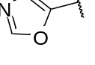 | 37.9±1.3 | 32.66±1.23
13b | 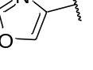 | 42.8±1.6 | 50.13±2.79
13c | 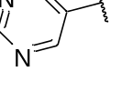 | 120.4±1.1 | 52.97±0.02
13d | 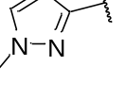 | 38.8±1.4 | 52.66±4.81
13e | 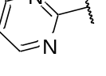 | 19.2±0.9 | 167.00±1.93
13f | 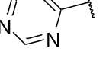 | 27.3±1.2 | 238.88±7.63
13g | 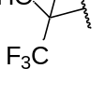 | 105.3±4.0 | >500
13h | 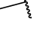 | 61.3±0.5 | 431.82±0.12

Table 3. Chemical structures and bioactivities of compounds 10g and 18a-j.
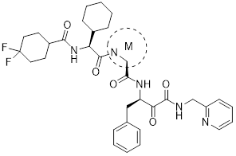
Chemical modifications in M.
Compd | M | M^{pro} (nM) | TMPRSS2 (μM)
10g | 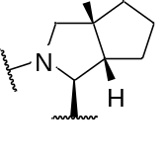 | 82.7±1.7 | 11.22±0.96
18a | 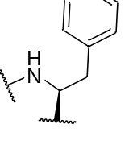 | 19.1±0.3 | >500
18b | 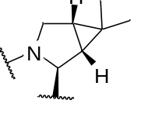 | 148.9±2.4 | 30.53±7.81
18c | 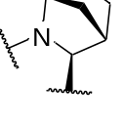 | 48.2±4.0 | 40.81±0.05
18d | 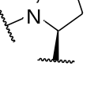 | 34.2±1.2 | 38.39±0.69
18e | 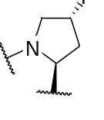 | 233.3±2.2 | 3.42±0.08
18f | 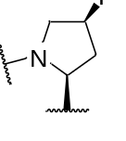 | 47.3±0.5 | 15.09±0.16
18g | 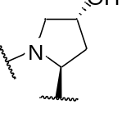 | 104.1±2.0 | 6.22±1.45
18h | 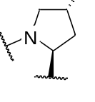 | 204.8±2.5 | 10.73±0.17
18i | 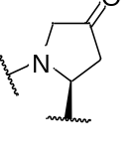 | 1040±100 | 3.06±1.02
18j | 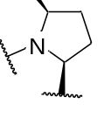 | 240.9±7.5 | 5.03±0.28

Table 4. Chemical structures and bioactivities of compounds 18e and 24a-d.
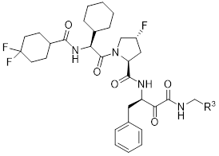
Chemical modifications in R³.
Compd | R³ | M^{pro} (nM) | TMPRSS2 (μM)
18e | 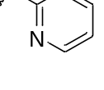 | 233.3±2.2 | 3.42±0.08
24a | 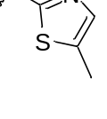 | 159.2±1.9 | 18.70±3.63
24b | 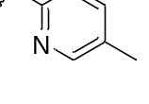 | 155.7±1.0 | 3.69±0.81
24c | 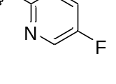 | 69.4±0.8 | 61.03±3.02
24d(TMP1) | 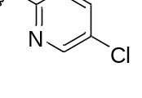 | 312.5±5.7 | 1.28±0.43
Table 5. Pharmacokinetics of oral delivery of TMP1 in BALB/c mice and Beagle dogs*.
Compd. | Animal | Admin. | T_{1/2} | T_{max} | C_{max} | AUC_{(0~t)} | AUC_{(0~∞）} | MTR_{(0~t)} | CLz | Vz | F
Compd. | Animal | Admin. | (h) | (h) | (μg/L) | (μg/L*h) | (μg/L*h) | (h) | ( L/h/kg ) | (L/ kg) | %
TMP1 | BALB/c Mice | i.v. | 0.56 ± 0.21 | 0.08  ± 0.01 | 785.37 ± 117.02 | 329.61 ± 51.56 | 329.90 ± 51.79 | 0.43 ± 0.11 | 1.54 ± 0.24 | 1.20 ± 0.32 | -
TMP1 | BALB/c Mice | (0.5 mg/kg)
TMP1 | BALB/c Mice | p.o.  (100 mg/kg)** | 2.22 ± 0.37 | 3.33 ± 1.16 | 8028.86 ± 2542.35 | 51072.79 ± 31482.58 | 51118.64 ± 31475.82 | 4.91 ± 1.63 | - | - | 77.47 ± 47.76
TMP1 | Beagle Dog | i.v. | 0.89 ± 0.20 | 0.08 ± 0.00 | 332.21 ± 20.63 | 208.19 ± 25.00 | 221.23 ± 19.24 | 0.72 ± 0.23 | 4.52 ± 0.42 | 5.81± 1.02 | -
TMP1 | Beagle Dog | (1 mg/kg)
TMP1 | Beagle Dog | p.o. | 2.04 ± 0.69 | 4.00 ± 0.00 | 1342.38 ± 428.69 | 6870.06 ±1678.00 | 7815.57 ± 1175.56 | 4.20 ± 0.26 | - | - | 132.00 ± 32.24
TMP1 | Beagle Dog | (25 mg/kg)***
* Data are shown as mean ± SD, n = 3.
** Mice were orally treated with 100 mg/kg TMP1 in combination with 20 mg/kg ritonavir.
** Dogs were orally treated with 25 mg/kg TMP1 in combination with 4 mg/kg ritonavir.

Table 6. Selectivity of the bispecific inhibitor against different human proteases.
Host protease | Inhibition  (%) | STD  (%) | Concentration  (μM) | Type | SI for M^{pro} | SI for TMPRSS2
Calpain 1 | 4.89 | 8.63 | 100 | Cys | 323 | >78
Caspase-2 | 21.67 | 5.64 | 100 | Cys | 323 | >78
Chymotrypsin | -14.65 | 22.65 | 50 | Ser | 161 | >39
Cathepsin L | 19.89 | 2.69 | 100 | Cys | 323 | >78
Cathepsin D | 0.66 | 2.03 | 100 | Aps | 323 | >78
Neutrophil Elastase | 6.37 | 1.14 | 100 | Ser | 323 | >78
Thrombin | 30.86 | 2.12 | 100 | Ser | 323 | >78

Cys, cysteine protease; Ser, serine protease; Aps, aspartic protease; STD, standard deviation; SI, selection index.

