Supplementary Information
Title:
An orally available M^{pro}/TMPRSS2 bispecific inhibitor with potent anti-coronavirus efficacy in vivo
Authors:
Huiping Shuai^{1,13}, Jingxin Qiao^{2,13}, Chaemin Yoon^{1,13}, Guo Zhang^{2,13}, Yuxin Hou^{3,4,13}, Xiaoyan Xia^{2,13}, Lei Wang^{1,13}, Xinyue Deng^{2,13}, Yifei Wang², Qingquan Li^{5,6}, Lianzhao Du¹, Yuanchen Liu¹, Minmin Zhou¹, Hoi Ting Wong¹, Huan Liu¹, Bingjie Hu¹, Yan Chen², Zhen Fang², Ziyi Xia², Yue Chai¹, Jialu Shi¹, Yang Wang¹, Tianrenzheng Zhu¹, Honglei Zhang^{1,7}, Shuofeng Yuan^{1,8,9}, Jie Zhou^{1,8}, Jasper Fuk-Woo Chan^{1,3,8,9,10,11}, Kwok-Yung Yuen^{1,3,8,9,10,11}, Chunfu Xu^{5,6}, Jian Lei^{2,14}, Shengyong Yang^{2,14}, Hin Chu^{1,8,9,12,14}
Affiliations:
¹State Key Laboratory of Emerging Infectious Diseases, Department of Microbiology, School of Clinical Medicine, Li Ka Shing Faculty of Medicine, The University of Hong Kong, Pokfulam, Hong Kong Special Administrative Region, China.
² Department of Biotherapy, Cancer Center and State Key Laboratory of Biotherapy, and National Clinical Research Center for Geriatrics, West China Hospital, Sichuan University, Chengdu, Sichuan, China.
³Guangzhou Laboratory, Guangdong Province, China.
⁴Guangzhou Medical University, Guangzhou, China
⁵National Institute of Biological Sciences, Beijing, China.
⁶Tsinghua Institute of Multidisciplinary Biomedical Research, Tsinghua University, Beijing, China.
⁷ College of Veterinary Medicine, Henan Agricultural University, Zhengzhou, China.
⁸Centre for Virology, Vaccinology and Therapeutics, Hong Kong Science and Technology Park, Hong Kong Special Administrative Region, China.
⁹Department of Infectious Disease and Microbiology, The University of Hong Kong-Shenzhen Hospital, Shenzhen, Guangdong Province, China.
¹⁰Academician Workstation of Hainan Province, Hainan Medical University-The University of Hong Kong Joint Laboratory of Tropical Infectious Diseases, Haikou, Hainan Province, China.
¹¹Department of Microbiology, Queen Mary Hospital, Pokfulam, Hong Kong Special Administrative Region, China.
¹²Materials Innovation Institute for Life Sciences and Energy (MILES), HKU-SIRI, Shenzhen, China.
¹³These authors contributed equally
¹⁴Co-corresponding authors

#Correspondence:
Hin Chu (hinchu@hku.hk), State Key Laboratory of Emerging Infectious Diseases, Department of Microbiology, School of Clinical Medicine, Li Ka Shing Faculty of Medicine, The University of Hong Kong, Pokfulam, Hong Kong Special Administrative Region, China.
Shengyong Yang (yangsy@scu.edu.cn), State Key Laboratory of Biotherapy and Cancer Center and National Clinical Research Center for Geriatrics, West China Hospital, Sichuan University, Chengdu, Sichuan, 610041, China.
Jian Lei (leijian@scu.edu.cn), State Key Laboratory of Biotherapy and National Clinical Research Center for Geriatrics, West China Hospital, Sichuan University, Chengdu, Sichuan, 610041, China.

List of Supplementary Information
Supplementary Figure 1. In vitro toxicity of TMP1.
Supplementary Figure 2. Tissue distribution of TMP1 in the mice upon oral delivery.
Supplementary Figure 3. In vivo toxicity of TMP1.
Supplementary Figure 4. Inhibition of the enzymatic activity of SARS-CoV-2 M^{pro} by nirmatrelvir and TMPRSS2 by camostat and FOY-251.
Supplementary Figure 5. Viral antigen expression and histological changes in MERS-CoV-infected mice.
Supplementary Figure 6. Molecular docking of TMP1 with wildtype and mutated TMPRSS2.
Supplementary Figure 7. Binding modes between the nine coronavirus main proteases and TMP1.
Supplementary Figure 8. Comparison of the crystal structures of SARS-CoV Omicron Mpro in complex with nirmatrelvir and with TMP1.
Supplementary Figure 9. Viral antigen expression and histological changes in rSARS-CoV-2 NSP5-E166V-infected mice.
Supplementary Table 1. Primers used for viral load quantification.
Supplementary Table 2. Primers used for cloning.
Supplementary Table 3. Crystallization data collection and structure refinement statistics.

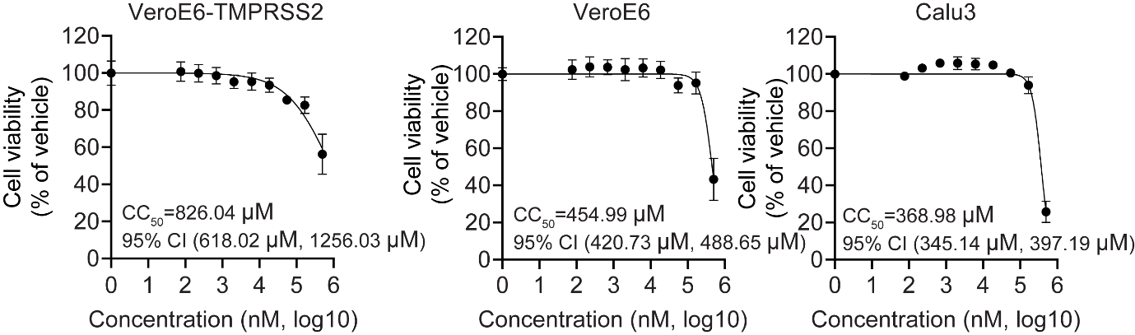
Supplementary Figure 1. In vitro toxicity of TMP1. Cytotoxicity of TMP1 in VeroE6-TMPRSS2, VeroE6 and Calu3 is measured at 48 hpi. with luminescence-based cell viability assay. Luminescence signals are normalized with solvent controls.

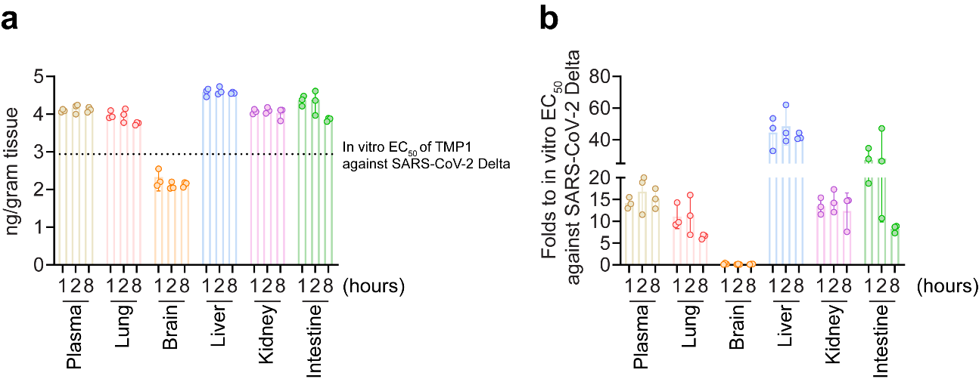
Supplementary Figure 2. Tissue distribution of TMP1 in the mice upon oral delivery. 8-week-old male BALB/c mice (n=3) were orally delivered with 100 mg/kg/dose TMP1, 100 mg/kg/dose nirmatrelvir (NRV) or 20 mg/kg/dose camostat. 20 mg/kg/dose ritonavir (RTV) was also included as metabolic enhancer for combined treatment. Plasma, lung, brain, liver, kidney and intestine tissues were sampled and homogenized at 1, 2 and 8 hours post oral delivery for measurement of the drug concentration with liquid chromatography-mass spectrometry (LC-MS). (a) TMP1 concentration in the plasma, lung, brain, liver, kidney and intestine tissue homogenates. Dashed line represents the equivalent concentration of the in vitro EC₅₀ of TMP1 against SARS-CoV-2 Delta variant determined by plaque assays. (b) TMP1 concentration in the plasma, lung, brain, liver, kidney and intestine tissue homogenates were normalized with the equivalent concentration of the in vitro EC₅₀ of TMP1 against SARS-CoV-2 Delta variant determined by plaque assays.

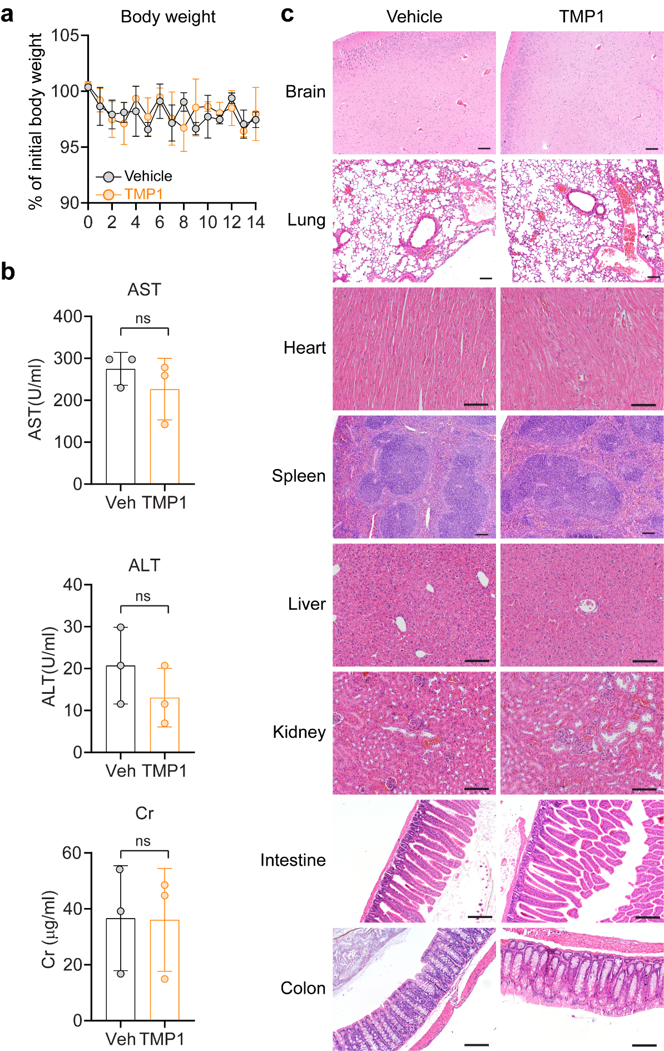
Supplementary Figure 3. In vivo toxicity of TMP1. Female 6- to 8-week-old K18-hACE2 transgenic mice were orally treated with 150mg/kg/dose TMP1 or solvent only twice per day from day 0 to day 3. (a) Body weight of the treated mice was measured daily. (b) Blood was drawn from mice 24 h post the last dose of treatment and analysed for the concentration of aspartate transaminase (AST), aspartate transaminase (ALT) and creatine (Cr) in the plasma. (c) Histological analysis of major organ tissues harvested on day 14 post treatment with H&E staining. Scale bar represents 100 µm. Statistical significance was determined with two-tailed Student’s t-tests in (b). ns, not-statistically significant.

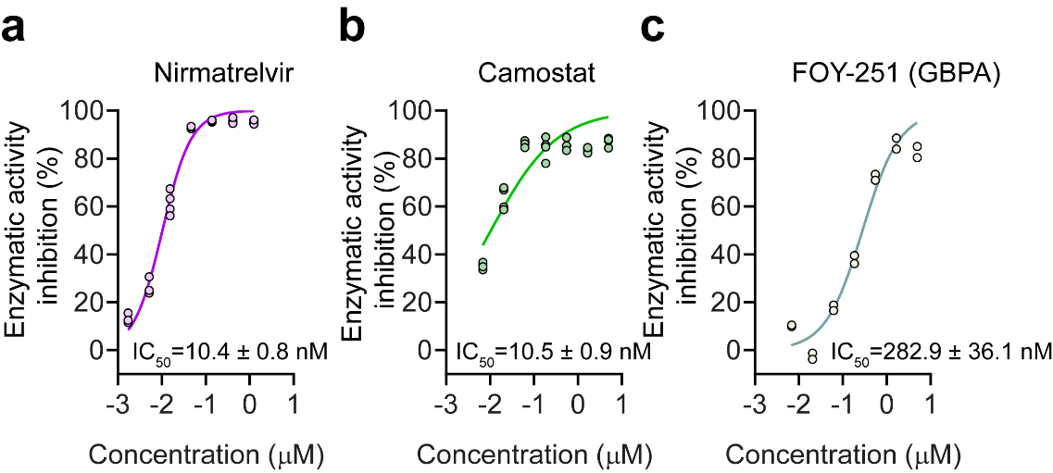
Supplementary Figure 4. Inhibition of the enzymatic activity of SARS-CoV-2 M^{pro} by nirmatrelvir and TMPRSS2 by camostat and FOY-251. (a) Enzymatic activity of the recombinant M^{pro} was measured with or without the treatment of Nirmatrelvir by fluorescence resonance energy transfer (FRET) assay. Enzymatic activity of the recombinant TMPRSS2 was measured with or without the treatment of (b) camostat and (c) FOY-251 by FRET assays.

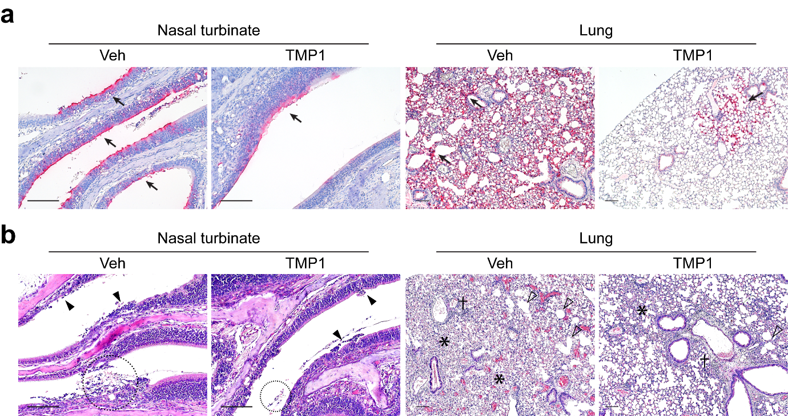
Supplementary Figure 5. Viral antigen expression and histological changes in MERS-CoV-infected mice. 10- to 14-week-old hDPP4-KI mice were intranasally infected with 5000 PFU of mouse-adapted MERS-CoV (MERS-CoV_{MA}). One day prior to infection, mice were orally treated with 150 mg/kg/dose TMP1 in combination with 20 mg/kg/dose RTV (n=5). Control mice were treated with vehicle only (n=5). (a) Representative images of MERS-CoV_{MA} nucleocapsid (N) protein expression (black arrow) in nasal turbinate and lung tissues of the infected mice at 3 dpi. by IHC staining. Scale bar represents 100 µm. (b) Representative images of the nasal turbinate and lung tissues of the MERS-CoV_{MA}-infected mice at 3 dpi. by H&E staining. Black arrowhead, nasal epithelial desquamation; dashed circle, necrotic cell debris in nasal cavity; cross, perivascular infiltration; asterisk, alveolar septa thickening. Scale bar represents 100 µm.

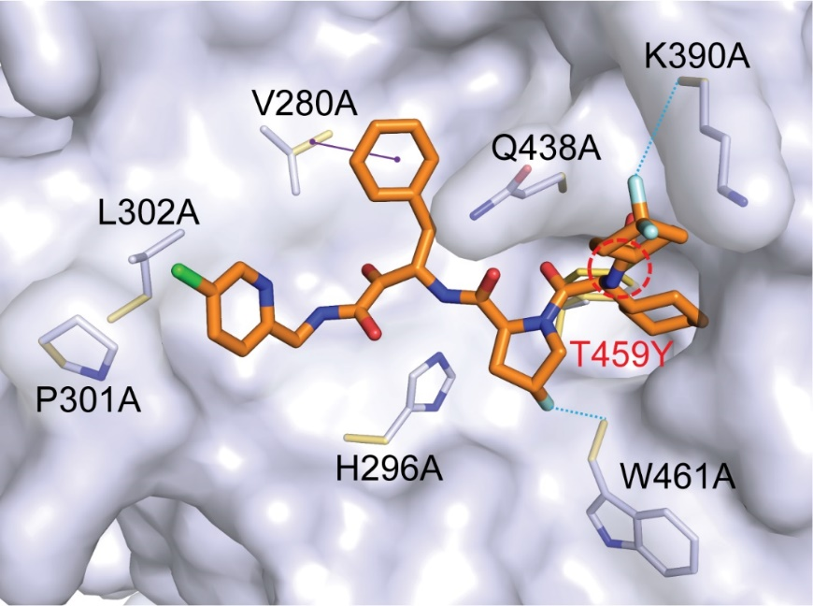
Supplementary Figure 6. Molecular docking of TMP1 with wildtype and mutated TMPRSS2. Structure of the wildtype TMPRSS2 (TMPRSS2_{WT}) and TMPRSS2 mutants were overlaid. The TMPRSS2_{WT} is shown in surface. TMP1 is shown in orange stick. The sidechains are shown as blue-white (wildtype) and yellow (mutations) sticks, respectively. Only interactions between mutated TMPRSS2 and TMP1 are shown. π-alkyl interaction is represented as purple solid line. Halogen (F) interaction is represented as blue dashed line. Steric clash is represented as red dashed circle.

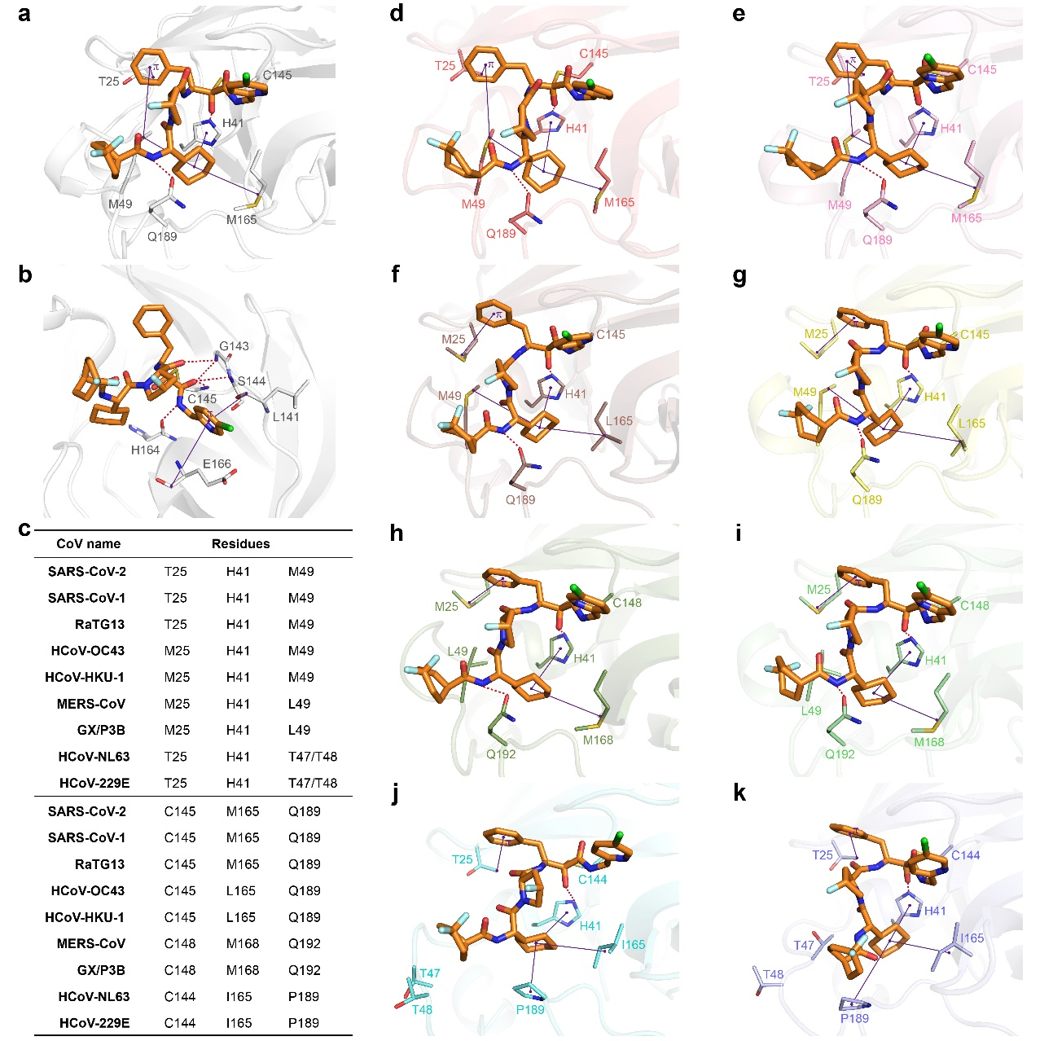
Supplementary Figure 7. Binding modes between the nine coronavirus main proteases and TMP1. (a-b) Interactions between TMP1 and the sidechains (a) or the mainchains (b) of SARS-CoV-2 main protease (PDB ID: 9IZB). (c) Six key residues from the aligned sequences of the main proteases of nine coronaviruses. (d-e) Predicted binding modes between TMP1 (in orange) and the main proteases of SARS-CoV-1 (d), RaTG13 (e), HCoV-OC43 (f), HCoV-HKU-1 (g), MERS-CoV (h), GX/P3B (i), HCoV-NL63 (j) and HCoV-229E (k). Six key residues were shown as sticks. Hydrogen bonds are represented as red dashed lines. Alkyl/π-alkyl interactions are represented as purple solid lines.
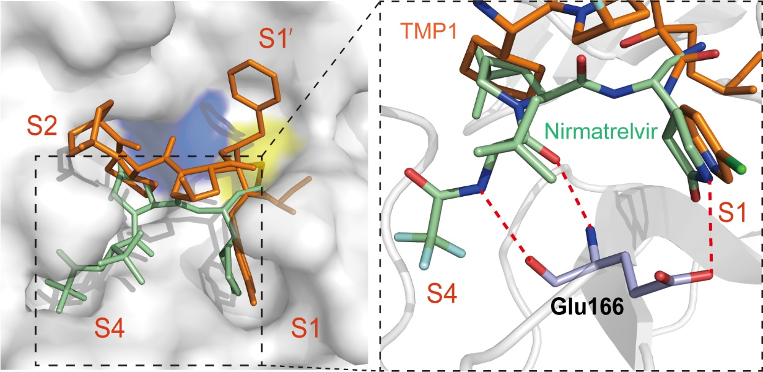
Supplementary Figure 8. Comparison of the crystal structures of SARS-CoV Omicron M^{pro} in complex with nirmatrelvir and with TMP1. Crystal structure of SARS-CoV-2 Omicron M^{pro} in complex with TMP1 and nirmatrelvir. Left panel, crystallization of TMP1 (orange) and nirmatrelvir (in green) in complex with SARS-CoV-2 Omicron M^{pro} (PDB: 9IZB, grey). The H41 (blue) and C145 (yellow) catalytic dyad was shown. Right panel, close-up view of the substrate binding pocket of M^{pro}. The key residues involved in M^{pro} binding with TMP1 and nirmatrelvir were displayed by sticks. Key amino acid E166 engaged in nirmatrelvir-resistance was shown. The hydrogen bonds were displayed as red dashed lines.

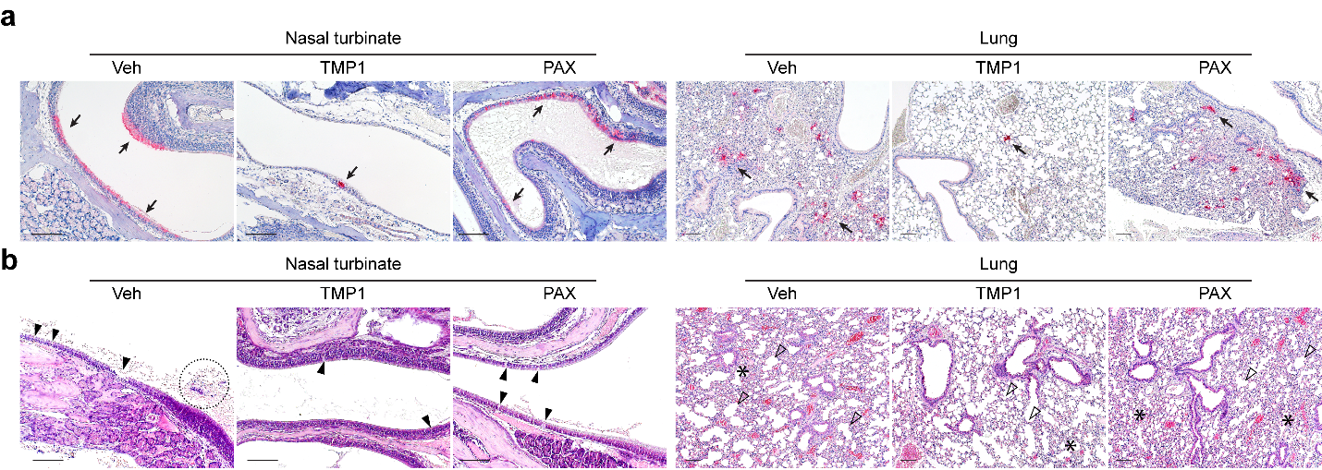
Supplementary Figure 9. Viral antigen expression and histological changes in rSARS-CoV-2 NSP5-E166V-infected mice. 8- to 12-week-old K18-hACE2 transgenic mice were challenged with 5000 PFU rSARS-CoV-2-NSP5-E166V. One day prior to infection, mice were orally treated with 100 mg/kg/dose TMP1 in combination with 20 mg/kg/dose RTV (n=4). Control mice were treated with vehicle only (n=4). Mice were treated twice per day until sample harvest at 3 dpi. (a) Representative images of rSARS-CoV-2-NSP5-E166V nucleocapsid (N) protein expression (black arrow) in nasal turbinate and lung tissues infected mice at 3 dpi. by IHC staining. Scale bar represents 100 µm. (b) Representative images of the nasal turbinate and lung tissues of the rSARS-CoV-2-NSP5-E166V-infected mice at 3 dpi. by H&E staining. Black arrowhead, loss of nasal epithelium integrity; dashed circle, necrotic cell debris in nasal cavity; open arrowhead, alveolar wall damage; asterisk, alveolar septa thickening. Scale bar represents 100 µm.

Supplementary Table 1. Primers used for viral load quantification.
Species/Virus | Gene | Sequence (5’-3’)
SARS-CoV-2 | SarbeCoV-sgE | F | CGATCTCTTGTAGATCTGTTCTC
SARS-CoV-2 | SarbeCoV-sgE | R | ATATTGCAGCAGTACGCACACA
SARS-CoV-2 | SarbeCoV-sgE | Probe | FAM- ACACTAGCCATCCTTACTGCGCTTCG -BBQ
SARS-CoV-2 | NP | F | GCGTTCTTCGGAATGTCG
SARS-CoV-2 | NP | R | TTGGATCTTTGTCATCCAATTTG
SARS-CoV-1 | NP | F | ACCAGAATGGAGGACGCAATG
SARS-CoV-1 | NP | R | GCTGTGAACCAAGACGCAGTATTAT
MERS-CoV | NP | F | CAAAACCTTCCCTAAGAAGGAAAAG
MERS-CoV | NP | R | GCTCCTTTGGAGGTTCAGACAT
HCoV-229E | NP | F | TCCTTCAAGTGACAGAAACCAT
HCoV-229E | NP | R | CCTGAGGCTTRTCAAAACCTAAA
Human | GAPDH | F | ATTCCACCCATGGCAAATTC
Human | GAPDH | R | CGCTCCTGGAAGATGGTGAT
K18-hACE2 mice | GAPDH | F | CATCACTGCCACCCAGAAGACTG
K18-hACE2 mice | GAPDH | R | ATGCCAGTGAGCTTCCCGTTCAG
Hamster | β-actin | F | ACGGCCAGGTCATCACTATTG
Hamster | β-actin | R | CAAGAAGGAAGGCTGGAAAAG

Supplementary Table 2. Primers used for cloning.
Primer name |  | Primer sequence (5′ to 3′)
TMPRSS2 | Fwd | TGCCTTTGCGGCGGATGAATTCATGGCTTTGAACTC
TMPRSS2 | Rev | TCTCGACAAGCTTTTAGTGGTGGTGGTGGTGGTGGCC
TMPRSS2 250SRQSR255↓IVGGE 1st PCR | Fwd | CTCAAGCCGCGATGACAAGATTGTGGGCGGCGAGAGC
TMPRSS2 250SRQSR255↓IVGGE 1st PCR | Rev | CGCCCACAATCTTGTCATCGCGGCTTGAGTTCAAGTTG
TMPRSS2 250DDDDK255↓IVGGE 2nd PCR | Fwd | CTTGAACTCAGACGACGATGACAAGATTGTGGGCGGCGAGAG
TMPRSS2 250DDDDK255↓IVGGE 2nd PCR | Rev | CTTGTCATCGTCGTCTGAGTTCAAGTTGACCCCGCAGGCTA
TMPRSS2 V280A | Fwd | ACGTCCACGCCTGCGGAGGCTCCATCATCACCCCCGAGT
TMPRSS2 V280A | Rev | GCCTCCGCAGGCGTGGACGTTCTGGACGTGCAGGCTGAC
TMPRSS2 H296A | Fwd | ACAGCCGCCGCCTGCGTGGAAAAACCTCTTAACAATCCA
TMPRSS2 H296A | Rev | TCCACGCAGGCGGCGGCTGTCACGATCCACTCGGGGGTG
TMPRSS2 P301A | Fwd | GTGGAAAAAGCTCTTAACAATCCATGGCATTGGACGGCA
TMPRSS2 P301A | Rev | ATTGTTAAGAGCTTTTTCCACGCAGTGGGCGGCTGTCAC
TMPRSS2 L302A | Fwd | GAAAAACCTGCCAACAATCCATGGCATTGGACGGCATTTGCG
TMPRSS2 L302A | Rev | TGGATTGTTGGCAGGTTTTTCCACGCAGTGGGCGGCTGTCAC
TMPRSS2 K390A | Fwd | ACCGAGGAGGCAGGGAAGACCTCAGAAGTGCTGAACGCTGCC
TMPRSS2 K390A | Rev | GGTCTTCCCTGCCTCCTCGGTGGCCCCCCACCCGGAAATCCA
TMPRSS2 Q438A | Fwd | GATTCTTGCGCGGGTGACAGTGGAGGGCCTCTGGTCACTTCG
TMPRSS2 Q438A | Rev | ACTGTCACCCGCGCAAGAATCGACGTTCCCCTGCAGGAAGCC
TMPRSS2 T459Y | Fwd | ATAGGGGATTACAGCTGGGGTTCTGGCTGTGCCAAAGCTTAC
TMPRSS2 T459Y | Rev | ACCCCAGCTGTAATCCCCTATCAGCCACCAGATATTGTTCTT
TMPRSS2 W461A | Fwd | GATACAAGCGCGGGTTCTGGCTGTGCCAAAGCTTACAGA
TMPRSS2 W461A | Rev | GCCAGAACCCGCGCTTGTATCCCCTATCAGCCACCAGAT

Supplementary Table 3. Crystallization data collection and structure refinement statistics.
 | M^{pro}-TMP1
Data collection
Space group | C₂
Cell dimensions
a, b, c (Å) | 112.38, 53.87, 44.37
α, β, γ (°) | 90.00, 101.21, 90.00
Resolution (Å) | 55.12-2.61 (2.72- 2.61)
CC1/2 ¹ | 0.997 (0.918)
Rmerge² | 0.103 (0.484)
Rpim ³ | 0.046 (0.212)
I /σI | 9.7 (2.4)
Completeness (%) | 99.7 (99.3)
Redundancy | 5.9 (6.1)
Refinement
Resolution (Å) | 55.12-2.61
No. reflections | 47321
Rwork ⁴ / Rfree | 0.194/0.253
No. atoms
Protein | 2317
Ligand | 50
Water | 91
B-factors
Protein | 52.11
Ligand | 49.28
Water | 48.61
R.m.s. deviations
Bond lengths (Å) | 0.009
Bond angles (°) | 1.321
Ramachandran plot (%)  Favored region  Allowed region  Outlier region  PDB code | 93.98  6.02  0.00  91ZB
¹ CC1/2 is the correlation coefficient determined by two random half data sets. (Karplus et al., 2012)
² $R_{merge}= \sum_{hkl}{\sum_{i=1}^{n}{\left|I_{i}\left(hkl\right)-\overline{I}\left(hkl\right)\right|}}/\sum_{hkl}{\sum_{i=1}^{n}{I_{i}}}\left(hkl\right)$.
³ $R_{pim}= \sum_{hkl}{\sqrt{1/{\left(n-1\right)}}}\sum_{i=1}^{n}{\left|I_{i}\left(hkl\right)-\overline{I}\left(hkl\right)\right|/\sum_{hkl}{\sum_{i=1}^{n}{I_{i}\left(hkl\right)}}}$. (Weiss et al., 1997)
⁴ $R_{work}= \sum_{hkl}{\left|F_{o}\left(hkl\right)-F_{c}\left(hkl\right)\right|/\sum_{hkl}{{|F}_{o}\left(hkl\right)|}}$. Rfree was calculated for a test set of reflections (~ 5.0%) omitted from the refinement.

