Supplementary Information

Synthesis of Graphene Nanosheets Containing Ultra-Narrow Nonplanar Nanopores on Surfaces

Tianchen Qin^{†1}, Fei Gao^{†2}, Yulun Wu¹, Baiyao Liang¹, Lei Hu¹, Weishan Yang¹, Honghe Ding¹, Jun Hu¹, Qian Xu¹, Dezhou Guo*³, Tao Wang*⁴, Junfa Zhu*¹

¹National Synchrotron Radiation Laboratory, Department of Chemical Physics and Key Laboratory of Surface and Interface Chemistry and Energy Catalysis of Anhui Higher Education Institutes, University of Science and Technology of China, Hefei 230029, P. R. China

²Donostia International Physics Center, San Sebastián 20018, Spain

³State Key Laboratory of Explosion Science and Technology, Beijing Institute of Technology, Beijing 100081, P. R. China

⁴State Key Laboratory of Organometallic Chemistry, Shanghai Institute of Organic Chemistry, University of Chinese Academy of Sciences, Chinese Academy of Sciences, Shanghai, 200032, P. R. China

Content
1. Experimental and computational methods
2. Schematic of reaction pathway of dissymmetric dehalogenation and non-selective dehalogenation
3. Scanning probe microscopy and spectroscopy data, synchrotron radiation photoemission spectroscopy data, and theoretical calculations

1. Experimental and computational methods

All STM experiments were conducted in a two-chamber UHV system with a base pressure better than 2×10⁻¹⁰ mbar. The single crystal Au(111) was purchased from MaTeck, Germany, with an alignment better than 0.1° with respect to the surface normal. The Au(111) was cleaned with several cycles of Ar⁺ sputtering and annealing at 800 K. For sample preparation, the TBBFY precursor was evaporated from a Kentax cell at 523 K. Note that the Kentax evaporator was located in a chamber separated from the preparation chamber by a gate valve. STM measurements were obtained at 9.2 K using SPM-INFINITY (Omicron GmbH). STS measurements were conducted at 9.8 K using the same instrument, lock-in amplitude, 20 mV; oscillation frequency, 713.3 Hz; current for dI/dV maps: 1 nA. SRPES experiments were conducted at the Catalysis and Surface Science Endstation of the National Synchrotron Radiation Laboratory, Hefei, China. The SRPE spectra were acquired at an emission angle of 50° with respect to the surface normal. Br 3d and C 1s spectra were collected with photon energies of 180 and 380 eV, respectively. The chosen emission angle and photon energy aim to render the SRPES surface-sensitive.
2,7-Dibromo-9-(2,7-dibromo-9H-fluoren-9-ylidene)-9H-fluorene (TBBFY) precursor was purchased from Jilin Chinese Academy of Sciences - Yanshen Technology Co., Ltd. with a nominal purity of 98+%.

Structural optimization and electronic properties calculations were performed using ab initio density functional theory (DFT) plane-wave package VASP¹. The projected-augmented wave (PAW)^{2,3} and the general gradient approximation (GGA)^{4,5} in PBE form and vdW-optB88⁶ for exchange-correlation energy were used. The K-point mesh of 2 × 3 × 1 was employed. A plane-wave cutoff of 400 eV was used to expand the wave function. Spin polarization was also considered in all calculations. All atoms were allowed to relax until the forces on each atom converge to less than 0.02 eV/Å for isolated molecule and 0.04 eV/Å for molecule on Au(111) surface.

The transition-state calculations were carried out with the climbing image nudge elastic band (CINEB) method by finding the saddle points and minimum energy paths^{7,8}. A number of intermediate images were optimized along the reaction pathway, with the constraints implemented by adding spring forces along the band between images and projecting out the component of the force because of the potential perpendicular to the band. The number of images was adjusted specifically for transition-state calculation such that the tangent along the path was well described. Typically, three to four images were used in these calculations.

2. Schematic of reaction pathway of dissymmetric dehalogenation and non-selective dehalogenation

After the dissymmetric dehalogenation of molecules, C−C coupling exhibits regioselectivity, resulting in a singular coupling mode during lateral fusion. This pathway facilitates the high-quality synthesis of the targeted two-dimensional nanoporous graphene. In contrast, non-selective dehalogenation engenders multiple equivalent C−C coupling modes, ultimately yielding defective products.
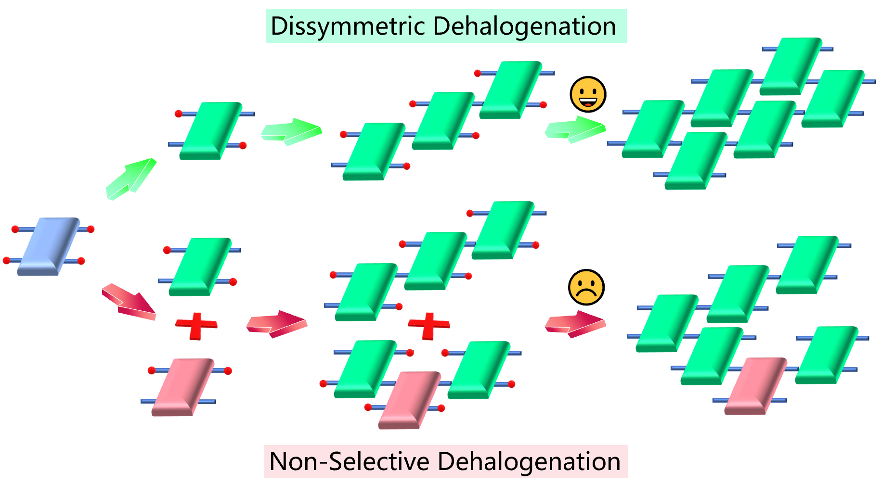
Figure S1. Schematic of reaction pathway of dissymmetric dehalogenation and non-selective dehalogenation.
3. Scanning probe microscopy and spectroscopy data, synchrotron radiation photoemission spectroscopy data, and theoretical calculations

1) Structural model of self-assembly structure of intact TBBFY on Au(111)
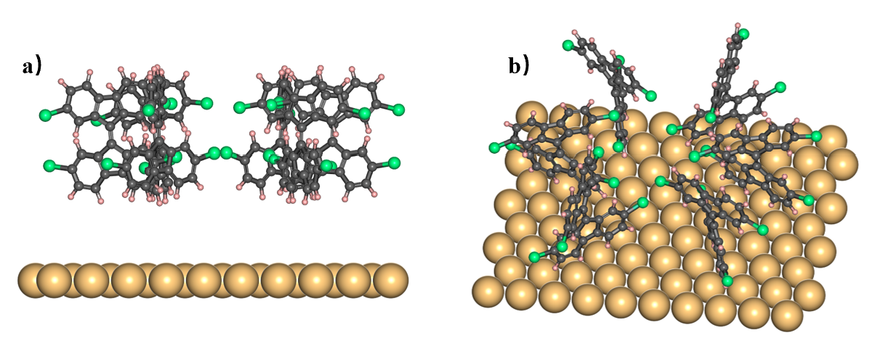
Figure S2. DFT-optimized front (a) and side (b) views of the adsorption model of self-assembly structure of intact TBBFY on Au(111). Color code: C, black; surface Au, golden; H, pink; Br, green.

2) STM images of chiral polymer chains overlaid with the corresponding chemical structures
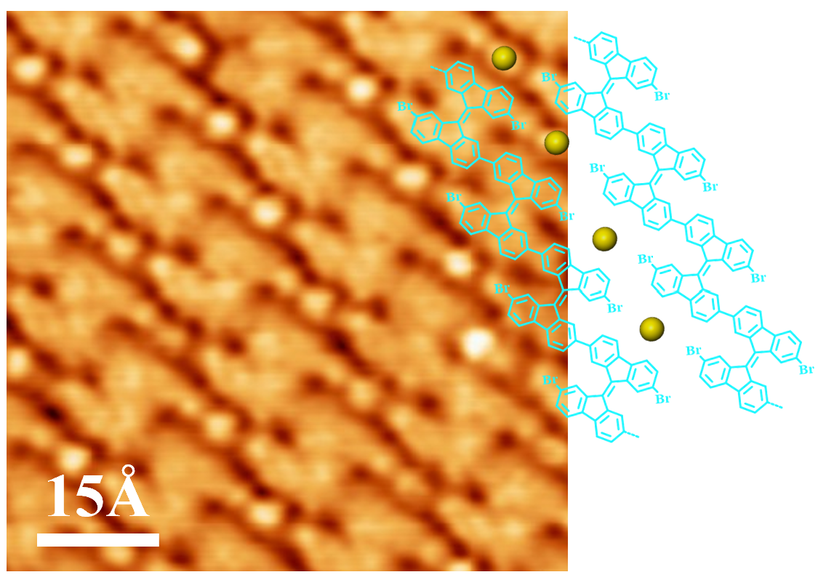
Figure S3. High-resolution STM images of chiral polymer chains obtained after depositing TBBFY onto Au(111) at RT and subsequently annealing to 390 K. Tunneling parameters: U= −420.1 mV, I= 180 pA. Corresponding molecular models are attached in STM image, where the golden balls represent Au adatoms.

3) STM images and the reaction pathway of chiral oligomer chains after depositing TBBFY onto Au(111) at RT and subsequent annealing to 350 K
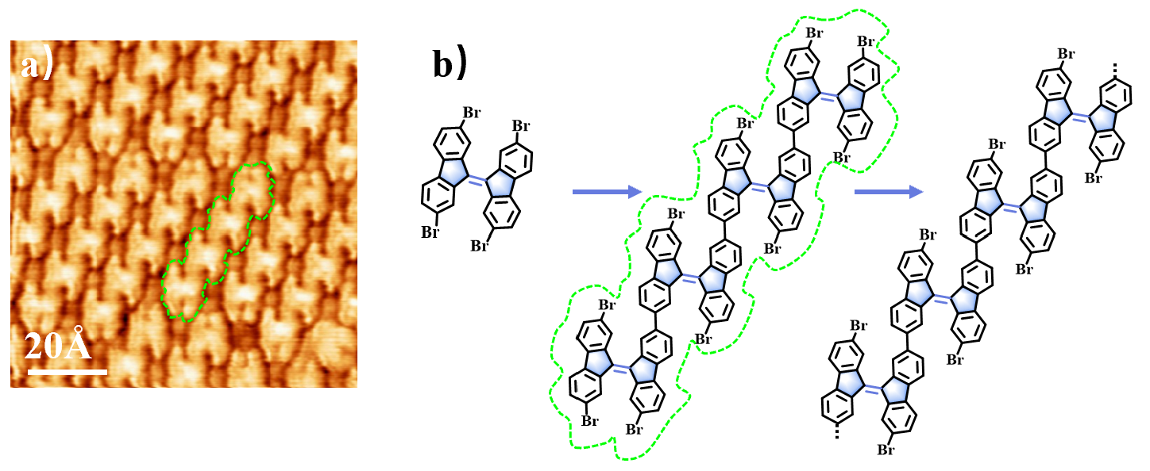
Figure S4. a) High-resolution STM images of chiral oligomer chains after depositing TBBFY at RT and subsequent annealing to 350 K. Tunneling parameters: U= −410.1 mV, I= 190 pA. b) Detailed reaction pathway of the formation of chiral oligomer chains.

4) Zoom-in dI/dV spectra measured on porous [32]annulene graphene nanosheet
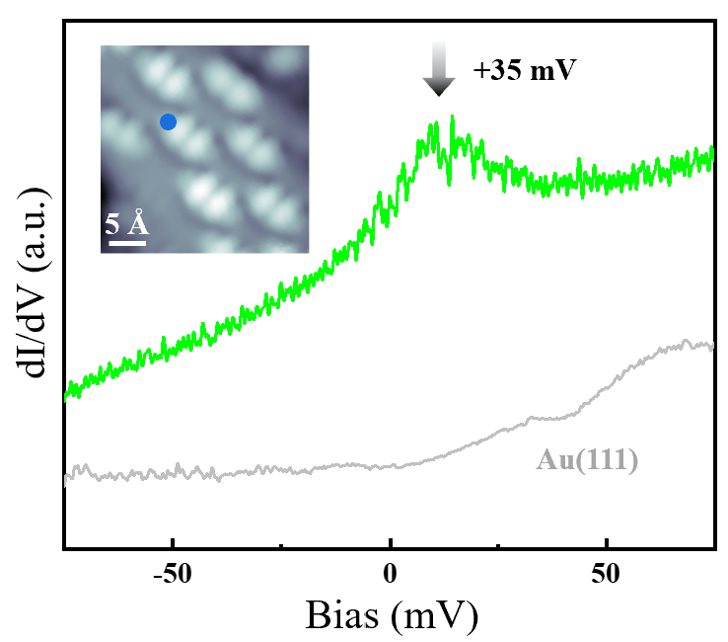
Figure S5. zoom-in dI/dV spectra measured on porous [32]annulene graphene nanosheet at the positions as marked with blue point in the inset STM image (−1126.0 mV, 3000 pA).

5) Additional dI/dV maps of porous [32]annulene graphene nanosheet
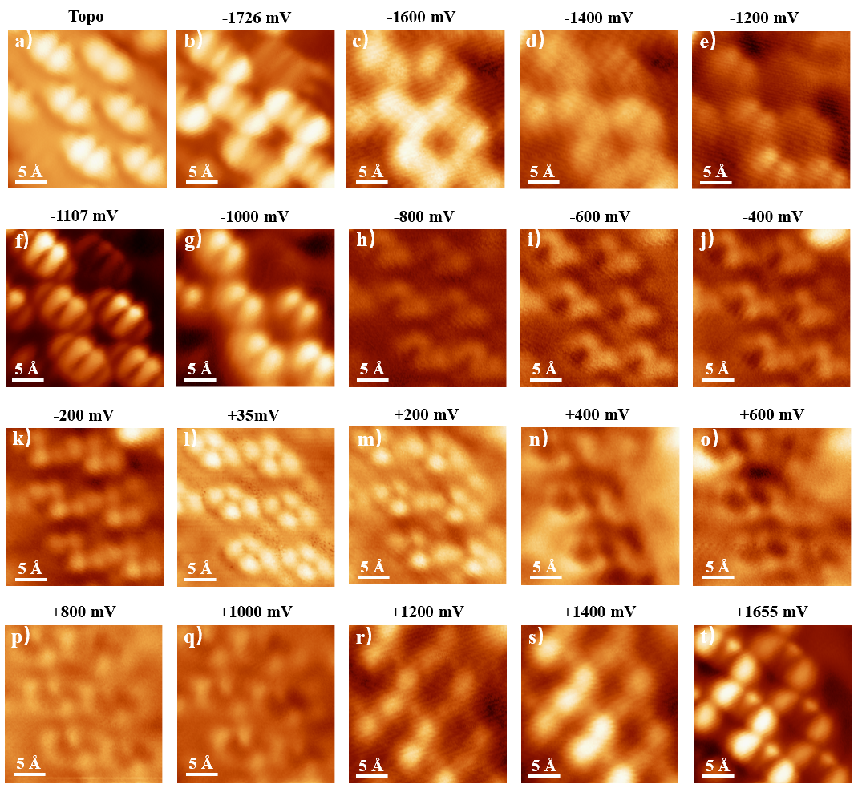
Figure S6. Constant-current dI/dV maps at different energies of porous [32]annulene graphene nanosheet on Au(111). (a) STM image of porous [32]annulene graphene networks. Tunneling parameters: U= −1126.0 mV, I= 3000 pA. (b-t) Bias-dependent conduction maps at different energies.

6) DFT optimized structural model of porous [32]annulene graphene nanosheet on Au(111)
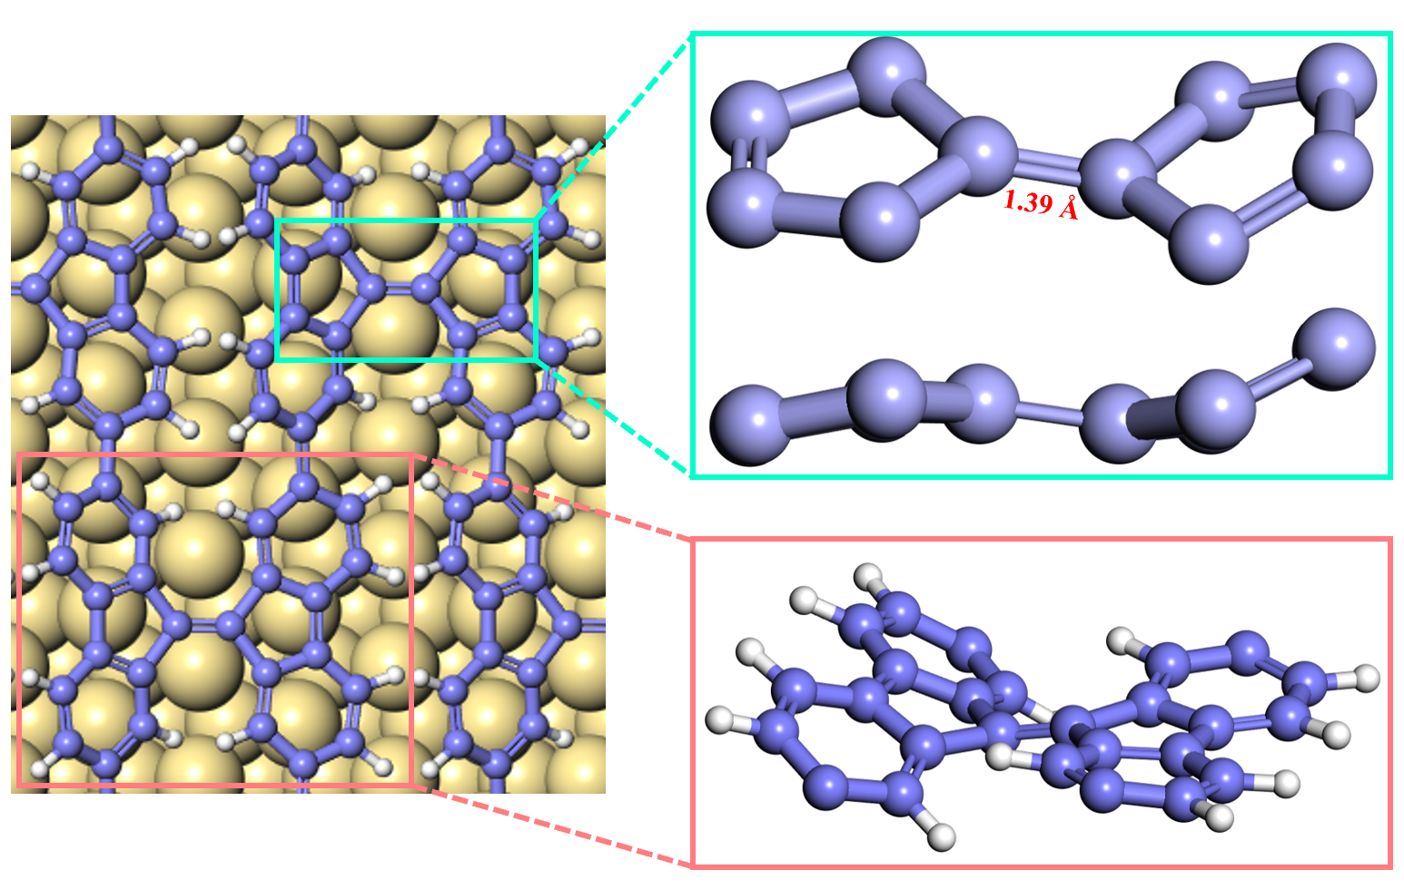
Figure S7. DFT-optimized top, side and front views of the adsorption model of porous [32]annulene graphene nanosheet on Au(111). Color code: C, purple; surface Au, golden; H, white.

7) Phase transformation from chiral polymer chain to porous [32]annulene graphene nanosheet and from porous [32]annulene graphene nanosheet to porous [46]annulene graphene nanosheet

At 470 K, while chiral polymer chains are still the major product, a few porous [32]annulene graphene networks start appearing which becomes dominating at 480 K.

At 500 K, the transformation from porous [32]annulene graphene networks to porous [46]annulene graphene networks occurs, where both structures coexist within a same domain. Further annealing at 510 K leads to full transformation.

Therefore, because of the strong inherent strain of porous [32]annulene graphene network, the temperature window for its high-quality production is only from 480-490 K.
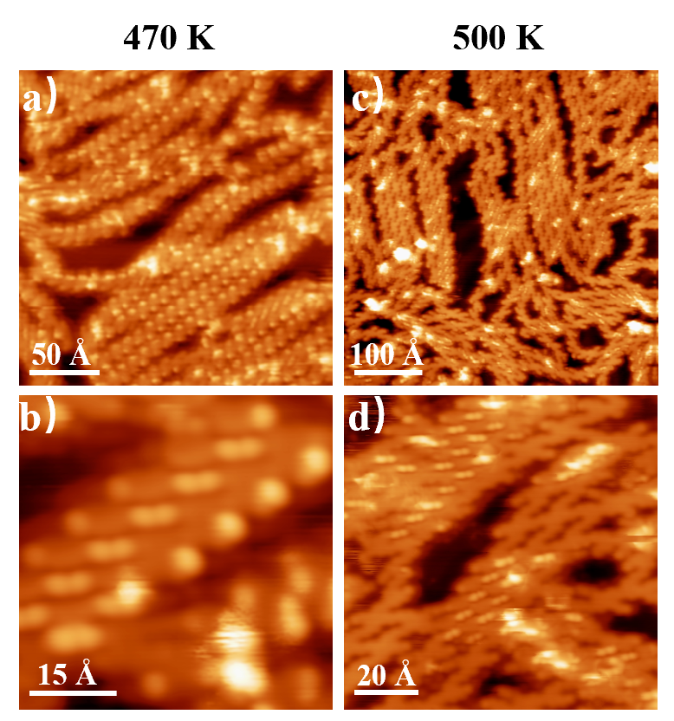
Figure S8. (a,b) Overview and zoom-in STM images of products after depositing TBBFY at RT and subsequent annealing to 470 K. Tunneling parameters: U= −735.0 mV, I= 120 pA. (c,d) Overview and zoom-in STM images of products after annealing the sample of in Fig. S8a to 500 K. Tunneling parameters: U= −912.1 mV, I= 150 pA.

8) Electronic structures of porous [46]annulene graphene networks.
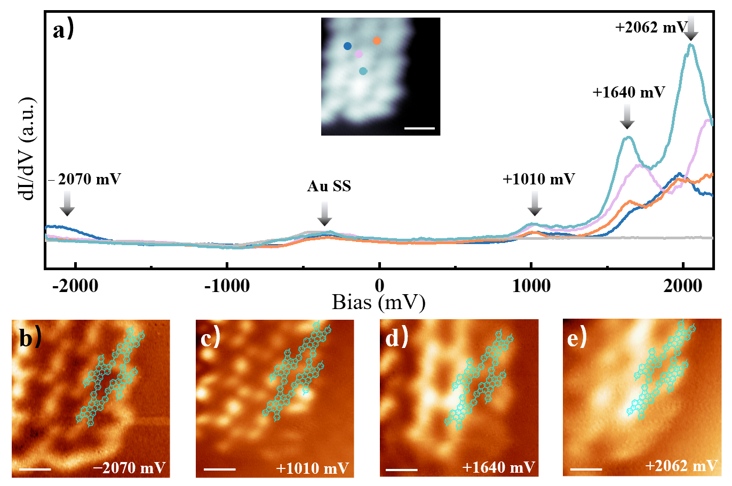
Figure S9. (a) Point dI/dV spectra of porous [46]annulene graphene networks taken at the positions marked with corresponding-colored dots in the inset STM image (−1100.0 mV, 2000 pA). (b-e) Constant-current dI/dV maps taken at −2070 (b), +1010 (c), +1640 (d), and +2062 mV (e) using a metallic tip. Corresponding molecular models are attached in dI/dV maps. All scale bars, 10 Å.

References:
1. Kresse, G. & Hafner, J. Ab initio molecular dynamics for liquid metals. Phys. Rev. B 47, 558 (1993).
2. Vanderbilt, D. Soft self-consistent pseudopotentials in a generalized eigenvalue formalism. Phys. Rev. B 41, 7892 (1990).
3. Blöchl, P. E. Projector augmented-wave method. Phys. Rev. B 50, 17953 (1994).
4. Wang, Y. & Perdew, J. P. Correlation hole of the spin-polarized electron gas, with exact small-wave-vector and high-density scaling. Phys. Rev. B 44, 13298 (1991).
5. Perdew, J. P., Burke, K. & Ernzerhof, M. Generalized gradient approximation made simple. Phys. Rev. Lett. 77, 3865 (1996).
6. Klimeš, J. , Bowler, D. R., & Michaelides, A. Chemical accuracy for the van der Waals density functional. J. Phys.: Condens. Matter 22, 022201 (2010).
7. Henkelman, G., Jonsson, H. Improved Tangent Estimate in the Nudged Elastic Band Method for Finding Minimum Energy Paths and Saddle Points. J. Chem. Phys. 113, 9978-9985 (2000).
8. Henkelman, G.; Uberuaga, B. P.; Jonsson, H. A. A Climbing Image Nudged Elastic Band Method for Finding Saddle Points and Minimum Energy Paths. J. Chem. Phys. 113, 9901-9904 (2000).

