Supplementary materials

Increased N₂O production from soil organic matter following a simulated fall-freeze-thaw cycle: Effects of fall urea addition, soil moisture, and history of manure applications

Sisi Lin¹; Guillermo Hernandez-Ramirez^{1*}
1. Department of Renewable Resources, University of Alberta
* Corresponding author: Guillermo Hernandez Ramirez
Address:
426 Earth Sciences Building, Department of Renewable Resources Department, Faculty of Agricultural Life and Environmental Sciences, University of Alberta
Edmonton, AB, Canada T6G 2E3
E-mail: ghernand@ualberta.ca
Phone: +1-7804922428
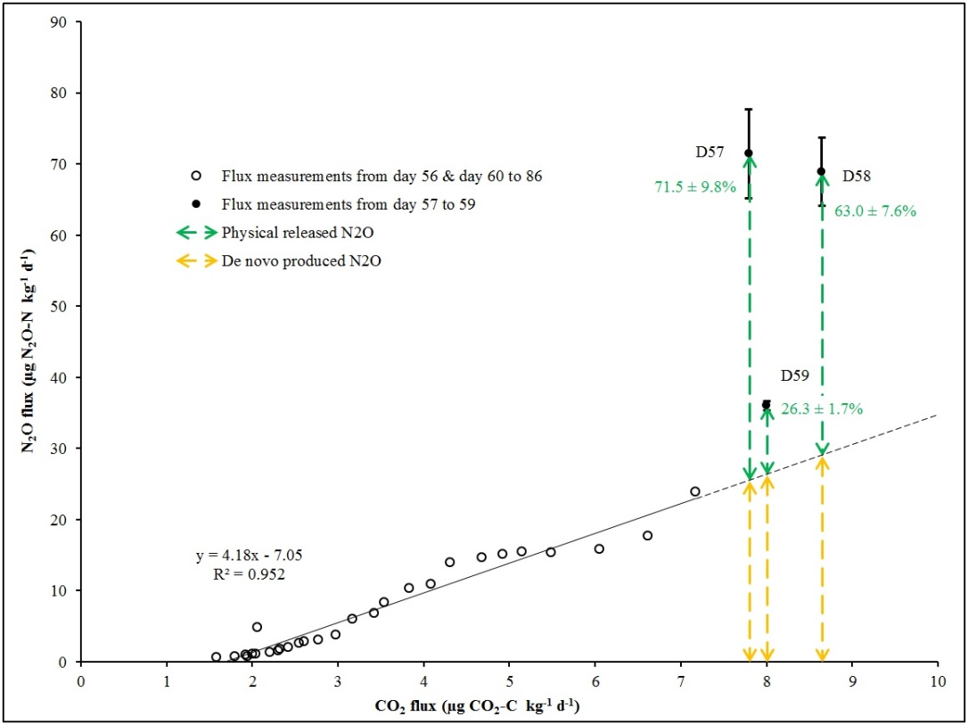
Supplementary Fig.1. Correlation between N₂O and CO₂ fluxes after thawing (days 56 to 86). These flux data are also shown in Fig. 1 as time series. The linear regression model was evaluated for most of the measurement days (hollow circles), with the exceptions of Days 57, 58 and 59 (solid points) which corresponded to the Days 1, 2 and 3 after thawing. There is a decoupled response of N₂O and CO₂ productions to thawing in these initial three days with disproportionally higher N₂O production than CO₂ production. The shown percentages with standard errors (in green) correspond to the N₂O produced attributable to physical release (estimations derived from extrapolating the shown linear regression equation as indicated by the dotted linear projection).

