Supplemental Materials

Supplemental Table 1. Baseline characteristics of participants stratified by gender.
Baseline characteristics at 2011 | Men (N=4902) | Women (N=5295) | P-value
Demographic
Age (years) | 60.7±9.8 | 59.4±11.2 | <0.001
Married, n(%) | 4113 (83.9) | 3838 (72.5) | <0.001
Education ≥High school, n(%) | 763 (15.6) | 548 (10.4) | <0.001
Current smoker, n(%) | 2747 (56.4) | 327 (6.2) | <0.001
Current drinker, n(%) | 2621 (53.9) | 632 (12.0) | <0.001
Physical measurements and anthropometrics
Systolic blood pressure (mmHg) | 132.4±29.2 | 132.7±32.7 | 0.590
Diastolic blood pressure (mmHg) | 76.5±12.5 | 75.6±11.7 | <0.001
Pulse (beat per minute) | 72.2±11.2 | 72.7±10.0 | 0.019
Body mass index (kg/m²) | 22.8±3.5 | 23.9±4.1 | <0.001
Laboratory
Hemoglobin (g/dL) | 15.2±2.1 | 13.7±2.0 | <0.001
Triglyceride (mg/dL) | 126.8±107.6 | 140.1±101.7 | <0.001
Total cholesterol (mg/dL) | 188.4±36.7 | 198.2±38.7 | <0.001
LDL-C (mg/dL) | 113.0±34.1 | 120.2±35.1 | <0.001
HDL-C (mg/dL) | 50.8±16.3 | 51.3±14.5 | 0.131
eGFR (ml/min/1.72m2) | 79.8±24.8 | 80.3±28.1 | 0.408
FBG (mg/dL) | 110.4±35.4 | 109.7±35.6 | 0.457
HbA1c (%) | 5.2±0.8 | 5.3±0.8 | 0.012
C-reactive protein (mg/l)* | 1.1 (0.6, 2.4) | 1.0 (0.5, 2.2) | 0.002
Self-reported comorbidity
Hypertension, n(%) | 1137 (23.2) | 1434 (27.1) | <0.001
Diabetes mellitus, n(%) | 243 (5.0) | 335 (6.3) | 0.003
Dyslipidemia, n(%) | 434 (8.9) | 539 (10.2) | 0.023
Stroke, n(%) | 107 (2.2) | 126 (2.4) | 0.506
Heart disease, n(%) | 495 (10.1) | 776 (14.7) | <0.001
Liver disease, n(%) | 235 (4.8) | 181 (3.4) | <0.001
Lung disease or asthma, n(%) | 811 (16.5) | 642 (12.1) | <0.001
Kidney disease, n(%) | 382 (7.8) | 329 (6.2) | 0.002
Memory-related disease, n(%) | 98 (2.0) | 85 (1.6) | 0.134
Stomach or digestive disease, n(%) | 1041 (21.2) | 1342 (25.3) | <0.001
Malignant tumor, n(%) | 42 (0.9) | 66 (1.3) | 0.055
Arthritis and rheumatism | 1545 (31.5) | 2054 (38.8) | <0.001
Psychiatric disease | 80 (1.6) | 117 (2.2) | 0.034
Age-adjusted Charlson Comorbidity Index | 2.7±1.7 | 2.7±1.8 | 0.314
Number of comorbidity | 1.4±1.4 | 1.6±1.5 | <0.001
LDL-C, low density lipoprotein cholesterol; HDL-C, high density lipoprotein cholesterol; eGFR, estimated glomerular filtration rate; FBG, fasting blood glucose; HbA1c, hemoglobin A1c.
* Present as median (interquartile range)

Supplemental Table 2. Baseline characteristics of participants stratified by social isolation score.
Baseline characteristics at 2011 | Social isolation score |  |  |  |  | P-value
Baseline characteristics at 2011 | 0 (N=3820) | 1 (N=4253) | 2 (N=1508) | 3 (N=491) | 4 (N=125) | P-value
Demographic
Age (years) | 57.0±9.3 | 60.3±10.5 | 64.7±11.3 | 65.0±10.9 | 66.6±10.1 | <0.001
Male, n(%) | 1907 (49.9) | 2085 (49.0) | 631 (41.8) | 222 (45.2) | 57 (45.6) | <0.001
Married, n(%) | 3820 (100) | 3637 (85.5) | 494 (32.8) | 0 (0) | 0 (0) | <0.001
Education ≥High school, n(%) | 744 (19.5) | 410 (9.6) | 114 (7.6) | 37 (7.5) | 6 (4.8) | <0.001
Current smoker, n(%) | 1158 (30.7) | 1315 (31.0) | 419 (28.0) | 147 (30.1) | 35 (28.0) | 0.276
Current drinker, n(%) | 1324 (35.3) | 1356 (31.9) | 409 (27.4) | 128 (26.2) | 36 (28.8) | <0.001
Physical measurements and anthropometrics
Systolic blood pressure (mmHg) | 129.6±27.4 | 133.3±33.2 | 136.1±32.5 | 135.1±31.5 | 139.9±25.7 | <0.001
Diastolic blood pressure (mmHg) | 75.9±11.8 | 76.1±12.3 | 76.0±12.4 | 75.6±11.1 | 78.3±13.5 | 0.316
Pulse (beat per minute) | 71.9±10.2 | 72.6±10.7 | 73.1±11.1 | 73.5±10.7 | 72.8±9.2 | 0.001
Body mass index (kg/m²) | 24.0±3.8 | 23.3±3.8 | 22.4±4.0 | 22.2±3.6 | 22.2±3.4 | <0.001
Laboratory
Hemoglobin (g/dL) | 14.5±2.0 | 14.4±2.3 | 14.2±2.4 | 14.5±2.7 | 14.3±2.1 | 0.038
Triglyceride (mg/dL) | 140.9±107.8 | 130.8±105.9 | 127.8±94.7 | 120.0±94.1 | 126.8±105.3 | <0.001
Total cholesterol (mg/dL) | 194.3±37.9 | 193.5±38.1 | 193.0±38.3 | 190.4±38.3 | 187.1±35.2 | 0.236
LDL-C (mg/dL) | 117.2±35.2 | 116.9±34.4 | 116.4±34.6 | 114.1±35.0 | 108.4±35.9 | 0.146
HDL-C (mg/dL) | 49.9±15.0 | 51.5±15.5 | 52.2±15.2 | 53.7±16.6 | 53.6±19.4 | <0.001
eGFR (ml/min/1.72m2) | 85.5±26.7 | 79.5±26.2 | 71.8±24.9 | 70.9±23.5 | 68.5±22.1 | <0.001
FBG (mg/dL) | 110.0±37.4 | 110.6±36.7 | 108.7±28.8 | 110.6±31.0 | 107.2±23.6 | 0.631
HbA1c (%) | 5.3±0.8 | 5.3±0.8 | 5.2±0.7 | 5.2±0.7 | 5.2±0.5 | 0.130
C-reactive protein (mg/l)* | 1.0 (0.6, 2.2) | 1.1 (0.6, 2.2) | 1.0 (0.5, 2.5) | 1.1 (0.5, 2.3) | 1.4 (0.8, 4.2) | 0.075
Self-reported comorbidity
Hypertension, n(%) | 929 (24.3) | 1090 (25.6) | 393 (26.1) | 129 (26.3) | 30 (24.0) | 0.562
Diabetes mellitus, n(%) | 241 (6.3) | 233 (5.5) | 76 (5.0) | 23 (4.7) | 5 (4.0) | 0.209
Dyslipidemia, n(%) | 458 (12.0) | 350 (8.2) | 111 (7.4) | 43 (8.8) | 11 (8.8) | <0.001
Stroke, n(%) | 69 (1.8) | 104 (2.5) | 44 (2.9) | 13 (2.7) | 3 (2.4) | 0.116
Heart disease, n(%) | 442 (11.6) | 539 (12.7) | 204 (13.5) | 70 (14.3) | 16 (12.8) | 0.200
Liver disease, n(%) | 171 (4.5) | 170 (4.0) | 46 (3.1) | 21 (4.3) | 8 (6.4) | 0.113
Lung disease or asthma, n(%) | 467 (12.2) | 610 (14.3) | 254 (16.8) | 100 (20.4) | 22 (17.6) | <0.001
Kidney disease, n(%) | 258 (6.8) | 313 (7.4) | 101 (6.7) | 31 (6.3) | 8 (6.4) | 0.767
Memory-related disease, n(%) | 43 (1.1) | 80 (1.9) | 33 (2.2) | 21 (4.3) | 6 (4.8) | <0.001
Stomach or digestive disease, n(%) | 888 (23.3) | 1008 (23.7) | 343 (22.8) | 113 (23.0) | 31 (24.8) | 0.939
Malignant tumor, n(%) | 55 (1.4) | 39 (0.9) | 11 (0.7) | 2 (0.4) | 1 (0.8) | 0.045
Arthritis and rheumatism | 1237 (32.4) | 1538 (36.2) | 588 (39.0) | 186 (37.9) | 50 (40.0) | <0.001
Psychiatric disease | 50 (1.3) | 75 (1.8) | 44 (2.9) | 23 (4.7) | 5 (4.0) | <0.001
Age-adjusted Charlson Comorbidity Index | 2.3±1.7 | 2.7±1.8 | 3.2±1.7 | 3.3±1.7 | 3.5±1.6 | <0.001
Number of comorbidity | 1.4±1.4 | 1.5±1.4 | 1.5±1.4 | 1.7±1.5 | 2.3±1.8 | <0.001
LDL-C, low density lipoprotein cholesterol; HDL-C, high density lipoprotein cholesterol; eGFR, estimated glomerular filtration rate; FBG, fasting blood glucose; HbA1c, hemoglobin A1c.
* Present as median (interquartile range)

Supplemental Table 3. The weighted association between gender and all-cause mortality among participants with varying social isolation statuses.
 | Crude IRR & 95% CI (Women vs Men) | P-value | Multi-adjusted IRR & 95% CI (Women vs Men) | P-value
Overall participants | 0.68 (0.60, 0.78) | <0.001 | 0.73 (0.60, 0.88) | 0.001
Social isolation score
0 | 0.37 (0.28, 0.49) | <0.001 | 0.40 (0.27, 0.59) | <0.001
1 | 0.75 (0.61, 0.92) | 0.006 | 0.80 (0.62, 1.04) | 0.095
2 | 0.78 (0.60, 1.01) | 0.060 | 0.81 (0.57, 1.15) | 0.236
≥3 | 0.71 (0.46, 1.11) | 0.135 | 0.90 (0.47, 1.70) | 0.740
Social isolation status
Non-social isolation | 0.60 (0.51, 0.71) | <0.001 | 0.66 (0.53, 0.81) | <0.001
Social isolation | 0.76 (0.61, 0.96) | 0.022 | 0.82 (0.60, 1.11) | 0.205
IRR, incidence rate ratio; CI, confidence interval.
The numbers in bold font indicate significance.

Supplemental Table 4. Variance inflation factor of the adjusted covariates.
Covariate | VIF
Social isolation | 1.09
Gender | 2.19
Age | 1.86
Educational attainment | 1.05
Smoking status | 1.84
Drinking status | 1.37
Systolic blood pressure | 1.14
Pulse rate | 1.04
Body mass index | 1.01
Hemoglobin | 1.20
LDL-C | 1.07
HDL-C | 1.34
Triglyceride | 1.35
eGFR | 1.74
C-reactive protein | 1.02
Fasting blood glucose | 1.71
Hemoglobin A1c | 1.63
Hypertension | 1.23
Diabetes mellitus | 1.22
Dyslipidemia | 2.13
Stroke | 1.06
Heart disease | 1.14
Chronic lung disease or asthma | 1.08
Chronic liver disease | 1.05
Chronic kidney disease | 1.06
Memory-related disease | 1.05
Psychiatric disease | 1.02
Stomach or digestive disease | 1.10
Arthritis or rheumatism | 1.08
Malignant tumor | 1.01
Mean VIF | 1.26
VIF, variance inflation factor; LDL-C, low density lipoprotein cholesterol; HDL-C, high density lipoprotein cholesterol; eGFR, estimated glomerular filtration rate; HbA1c, hemoglobin A1c.

Supplemental Figure 1. Study flowchart.
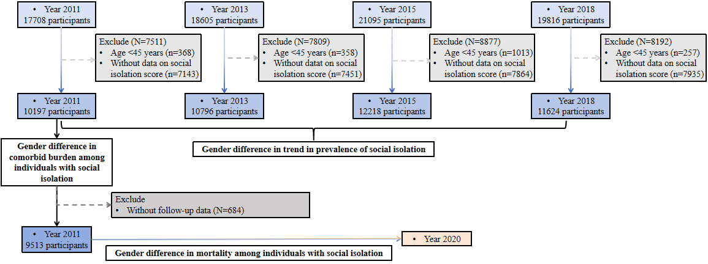

Supplemental Figure 2. Weighted trend in the prevalence of social isolation among overall participants.
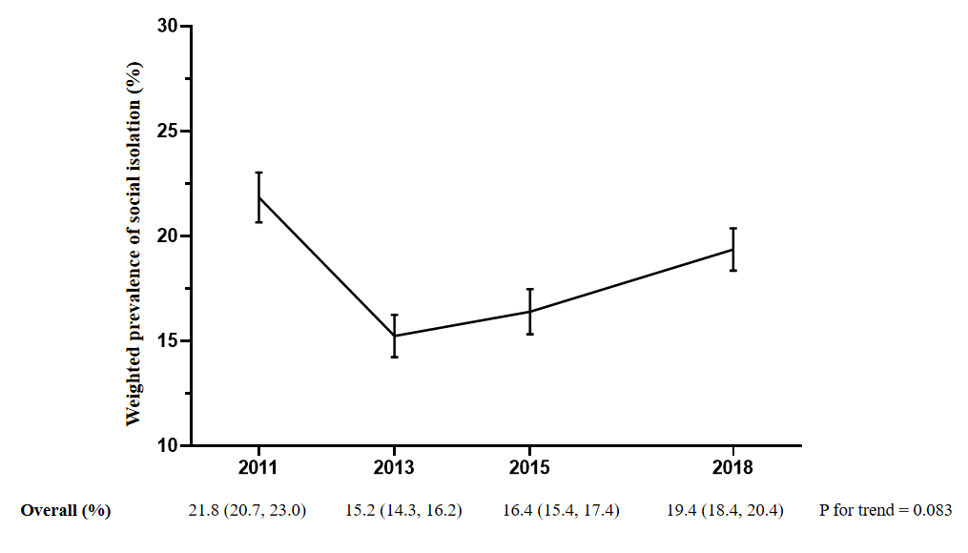

Supplemental Figure 3. Comparisons of the prevalence in individual social isolation components between men and women.
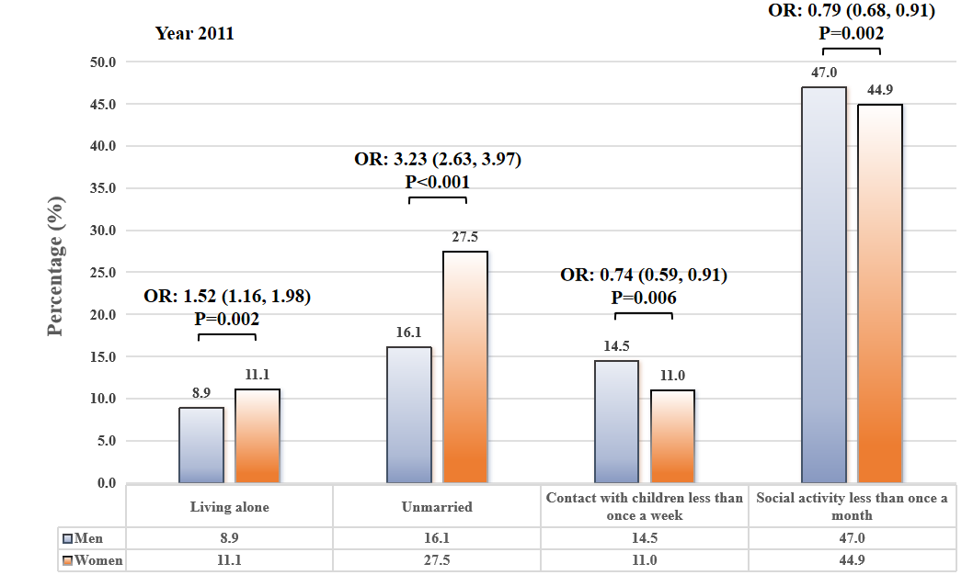
Note: The male group served as the reference. Multivariables logistic regression model was conducted to compare the prevalence in individual social isolation components between men and women, with adjustment for the identical covariates included in the Poisson regression models .
OR: odds ratio.

Supplemental Figur 4. Weighted trend in the mean social isolation score among overall participants (A) and stratified by gender (B).
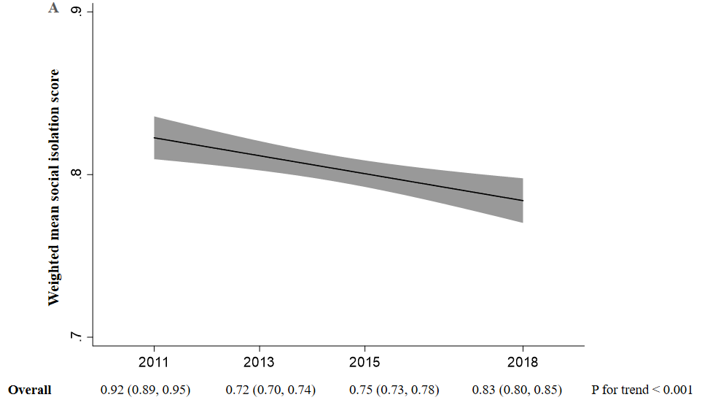
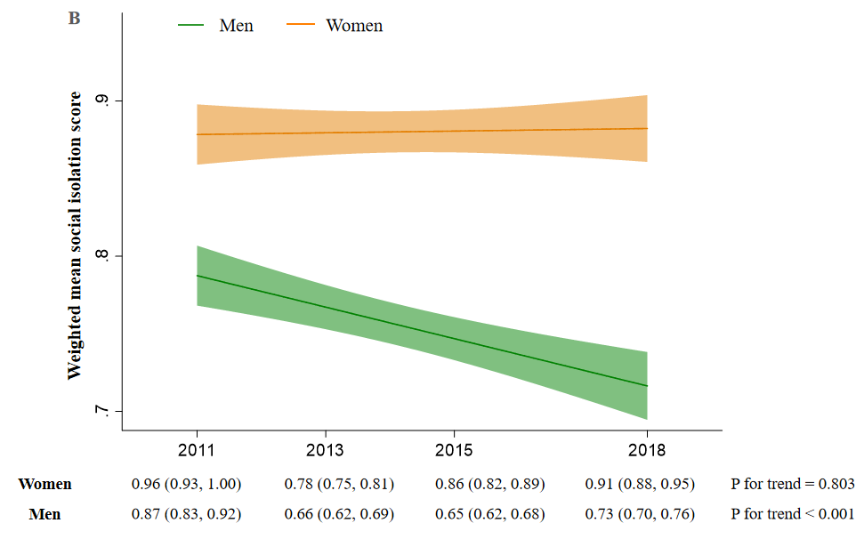

Supplemental Figure 5. Weighted linear relationship between age-adjusted Charlson Comorbidity Index (A), number of comorbidity (B) and the social isolation scores among overall participants.
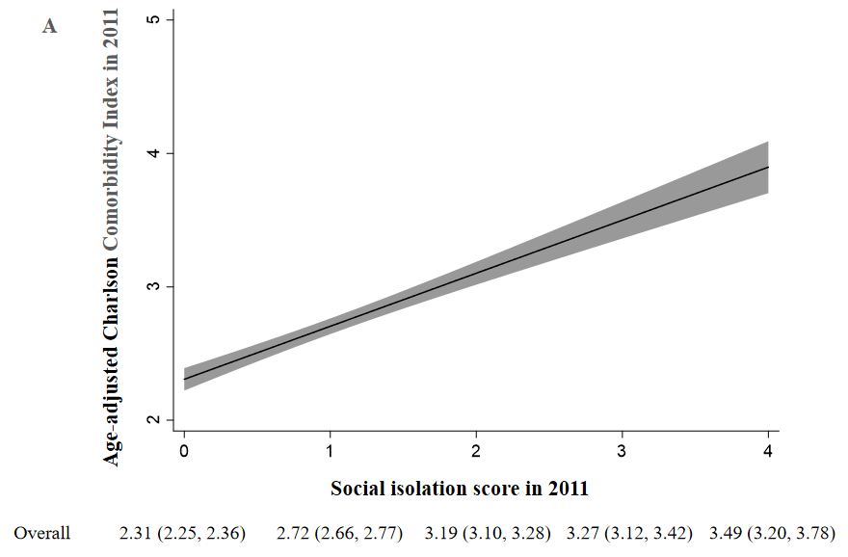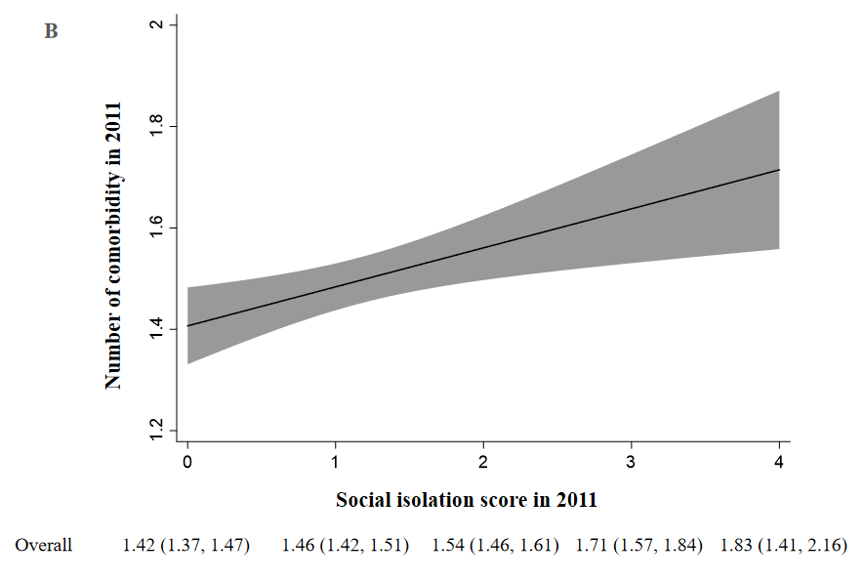
Supplemental Figure 6. The residuals plot (A and C) and histogram of residuals (B and D) for the relationships with age-adjusted Charlson Comorbidity Index and the number of comorbidity.
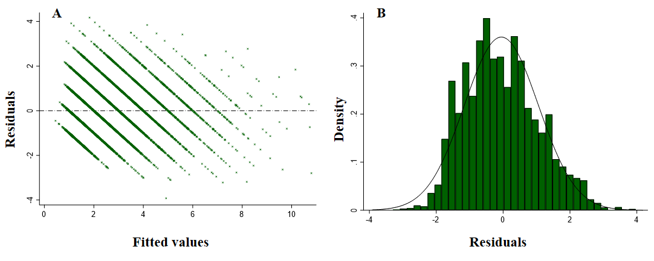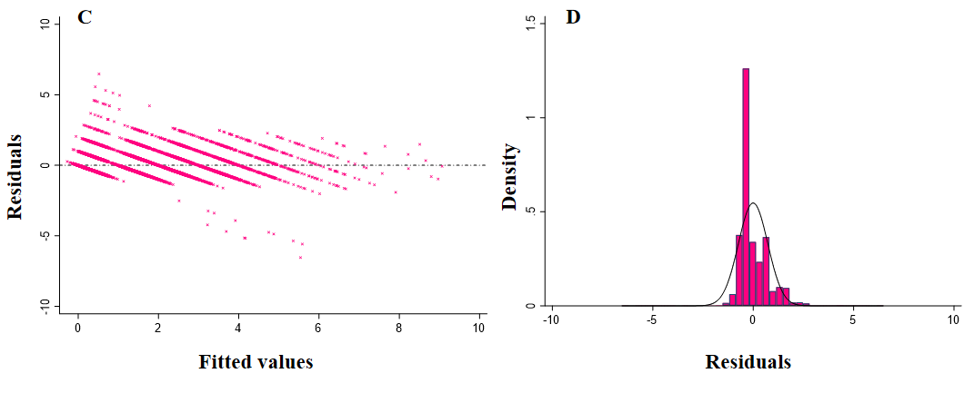
- Residuals plot for the relationships with the age-adjusted Charlson Comorbidity Index;
- Histogram of residuals for the relationships with the age-adjusted Charlson Comorbidity Index;
- Residuals plot for the relationships with the number of comorbidity;
- Histogram of residuals for the relationships with the number of comorbidity.

Supplemental Figure 7. Weighted trends in the age-adjusted Charlson Comorbidity Index (A) and the number of comorbidities (B) among overall participants with and without social isolation.
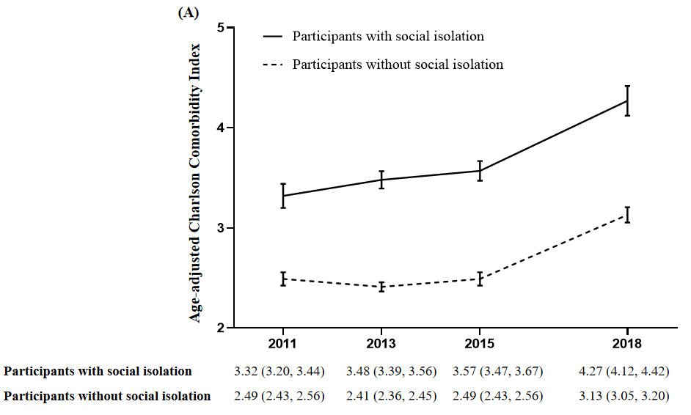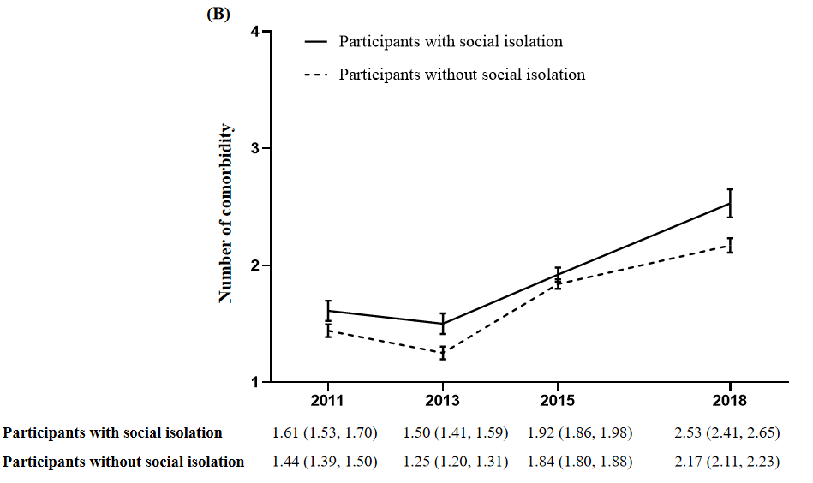

Supplemental Figure 8. Weighted prevalence of each component of the comorbidity among men and women with and without social isolation.
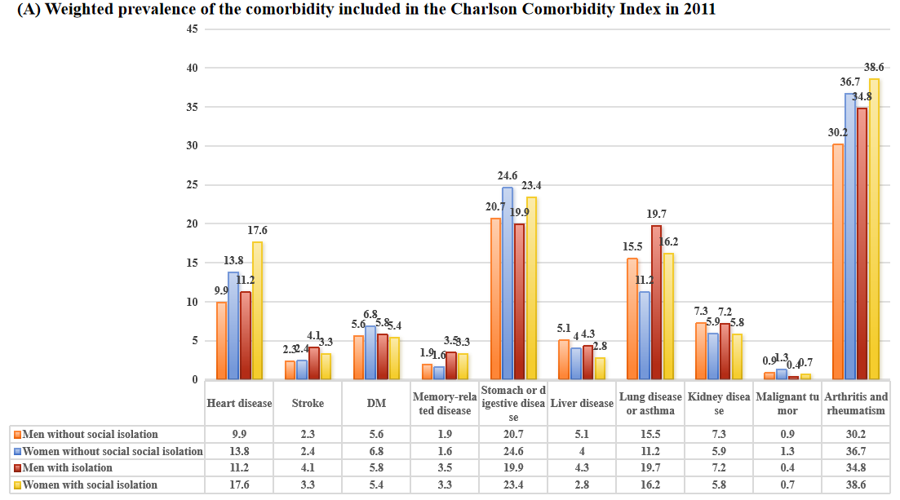
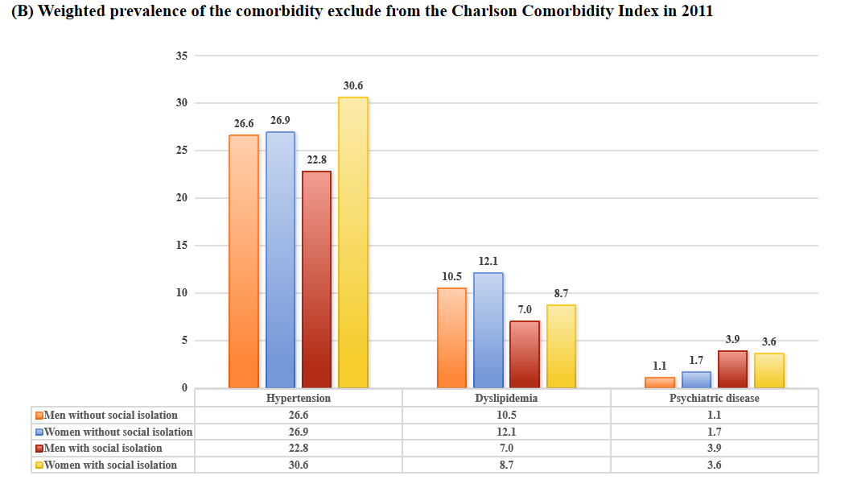
DM, diabetes mellitus.

Supplemental Figure 9. Weighted population attributable fractions of social isolation for mortality (A) and the absolute number of mortality attributed to social isolation (B).
