Supplementary Figures:

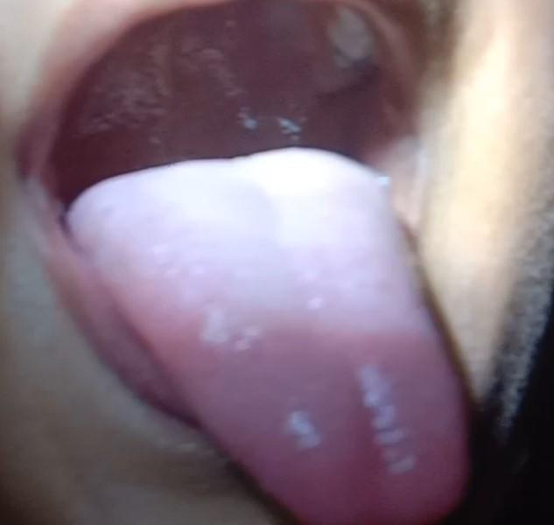

Figure 1: Grayish patch marked by an arrow on the palate of an infected five-year-old child (After twenty days of hospitalization)

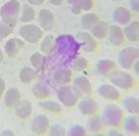
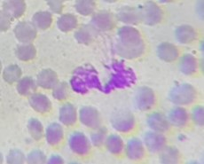
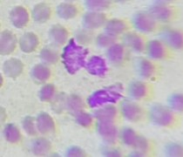
a
b
c

Figure 2: Smudge cells (450X magnification and photographed with a mobile camera and screenshots were cropped and enlarged to show details)

