Supplementary Information
Development of a quantitative PMA-16S rRNA gene sequencing workflow for absolute abundance measurements of seawater microbial communities
Marie C. Thomas^{1,2}, Gretel Waugh^{1,2}, Katarina Damjanovic², Inka Vanwonterghem^{1,3}, Nicole S. Webster^{1,2,4}, Andrew P. Negri² & Heidi M. Luter^{2,5}
¹Australian Centre for Ecogenomics, School of Chemistry and Molecular Biosciences, University of Queensland, Brisbane, QLD 4072, Australia
²Australian Institute of Marine Science, Townsville, QLD 4810, Australia
³Commonwealth Scientific and Industrial Research Organisation, Brisbane, QLD 4102, Australia
⁴Institute for Marine and Antarctic Studies, University of Tasmania, Hobart, TAS 7050, Australia
⁵AIMS@JCU, Research Division, James Cook University, Townsville, QLD 4811, Australia

Corresponding author: Marie Thomas
Email: marie.thomas@student.uq.edu.au
Supplementary Tables
Table S1. Statistical output of Analysis of Variance (ANOVA) and post-hoc Tukey's Honest Significant Difference (HDS) test used to compare DNA yield variances between samples treated with varying propidium monoazide (PMA) concentrations. Statistically significant differences (p < 0.05) are highlighted in grey.
ANOVA test
term | df | sumsq | meansq | F-statistic | p-value
PMA | 7 | 14.618 | 2.088 | 23.309 | 2.922e-07***
Residuals | 16 | 1.433 | 0.090
Turkey’s HSD test
term | contrast | estimate | conf.low | conf.high | adj.p-value
PMA | 1.25-0 | -1.94333333 | -2.7894121 | -1.0972545 | 1.334417e-05
PMA | 2.5-0 | -2.55900000 | -3.4050788 | -1.7129212 | 3.322015e-07
PMA | 5-0 | -2.21333333 | -3.0594121 | -1.3672545 | 2.428055e-06
PMA | 15-0 | -2.12000000 | -2.9660788 | -1.2739212 | 4.307464e-06
PMA | 25-0 | -2.45466667 | -3.3007455 | -1.6085879 | 5.928344e-07
PMA | 50-0 | -2.15000000 | -2.9960788 | -1.3039212 | 3.576245e-06
PMA | 100-0 | -2.51733333 | -3.3634121 | -1.6712545 | 4.177696e-07
PMA | 2.5-1.25 | -0.61566667 | -1.4617455 | 0.2304121 | 2.547876e-01
PMA | 5-1.25 | -0.27000000 | -1.1160788 | 0.5760788 | 9.465062e-01
PMA | 15-1.25 | -0.17666667 | -1.0227455 | 0.6694121 | 9.948615e-01
PMA | 25-1.25 | -0.51133333 | -1.3574121 | 0.3347455 | 4.582514e-01
PMA | 50-1.25 | -0.20666667 | -1.0527455 | 0.6394121 | 9.871356e-01
PMA | 100-1.25 | -0.57400000 | -1.4200788 | 0.2720788 | 3.271270e-01
PMA | 5-2.5 | 0.34566667 | -0.5004121 | 1.1917455 | 8.381641e-01
PMA | 15-2.5 | 0.43900000 | -0.4070788 | 1.2850788 | 6.309040e-01
PMA | 25-2.5 | 0.10433333 | -0.7417455 | 0.9504121 | 9.998202e-01
PMA | 50-2.5 | 0.40900000 | -0.4370788 | 1.2550788 | 7.027238e-01
PMA | 100-2.5 | 0.04166667 | -0.8044121 | 0.8877455 | 9.999997e-01
PMA | 15-5 | 0.09333333 | -0.7527455 | 0.9394121 | 9.999145e-01
PMA | 25-5 | -0.24133333 | -1.0874121 | 0.6047455 | 9.698607e-01
PMA | 50-5 | 0.06333333 | -0.7827455 | 0.9094121 | 9.999939e-01
PMA | 100-5 | -0.30400000 | -1.1500788 | 0.5420788 | 9.063002e-01
PMA | 25-15 | -0.33466667 | -1.1807455 | 0.5114121 | 8.580679e-01
PMA | 50-15 | -0.03000000 | -0.8760788 | 0.8160788 | 1.000000e+00
PMA | 100-15 | -0.39733333 | -1.2434121 | 0.4487455 | 7.297593e-01
PMA | 50-25 | 0.30466667 | -0.5414121 | 1.1507455 | 9.053708e-01
PMA | 100-25 | -0.06266667 | -0.9087455 | 0.7834121 | 9.999943e-01
PMA | 100-50 | -0.36733333 | -1.2134121 | 0.4787455 | 7.953967e-01

Table S2. Statistical output of Analysis of Variance (ANOVA) and post-hoc Tukey's Honest Significant Difference (HDS) test used to compare 16S rRNA gene copy number variances between samples treated with propidium monoazide (PMA) concentrations. Statistically significant differences (p < 0.05) are highlighted in grey.
ANOVA test
term | df | sumsq | meansq | F-statistic | p-value
PMA | 7 | 7.172e+10 | 1.025e+10 | 9.819 | 9.076e-05***
Residuals | 16 | 1.670e+10 | 1.043e+09
Turkey’s HSD test
term | contrast | estimate | conf.low | conf.high | adj.p-value
PMA | 1.25-0 | -69458.18 | -160772.82 | 21856.458 | 0.2134152669
PMA | 2.5-0 | -132546.53 | -223861.16 | -41231.891 | 0.0024341395
PMA | 5-0 | -146232.96 | -237547.59 | -54918.321 | 0.0009038861
PMA | 15-0 | -80284.78 | -171599.42 | 11029.857 | 0.1071218303
PMA | 25-0 | -177588.69 | -268903.33 | -86274.053 | 0.0001034728
PMA | 50-0 | -119457.61 | -210772.25 | -28142.972 | 0.0063790023
PMA | 100-0 | -163013.92 | -254328.55 | -71699.280 | 0.0002778246
PMA | 2.5-1.25 | -63088.35 | -154402.99 | 28226.288 | 0.3076228663
PMA | 5-1.25 | -76774.78 | -168089.42 | 14539.858 | 0.1349912539
PMA | 15-1.25 | -10826.60 | -102141.24 | 80488.036 | 0.9998615132
PMA | 25-1.25 | -108130.51 | -199445.15 | -16815.874 | 0.0147357524
PMA | 50-1.25 | -49999.43 | -141314.07 | 41315.207 | 0.5718967725
PMA | 100-1.25 | -93555.74 | -184870.37 | -2241.101 | 0.0426178837
PMA | 5-2.5 | -13686.43 | -105001.07 | 77628.207 | 0.9993543629
PMA | 15-2.5 | 52261.75 | -39052.89 | 143576.385 | 0.5214498091
PMA | 25-2.5 | -45042.16 | -136356.80 | 46272.475 | 0.6830265248
PMA | 50-2.5 | 13088.92 | -78225.72 | 104403.556 | 0.9995166585
PMA | 100-2.5 | -30467.39 | -121782.03 | 60847.248 | 0.9335864935
PMA | 15-5 | 65948.18 | -25366.46 | 157262.815 | 0.2621860783
PMA | 25-5 | -31355.73 | -122670.37 | 59958.905 | 0.9239165257
PMA | 50-5 | 26775.35 | -64539.29 | 118089.986 | 0.9651688048
PMA | 100-5 | -16780.96 | -108095.60 | 74533.678 | 0.9976462350
PMA | 25-15 | -97303.91 | -188618.55 | -5989.274 | 0.0325389209
PMA | 50-15 | -39172.83 | -130487.47 | 52141.808 | 0.8043877794
PMA | 100-15 | -82729.14 | -174043.77 | 8585.500 | 0.0908575961
PMA | 50-25 | 58131.08 | -33183.56 | 149445.718 | 0.3981784829
PMA | 100-25 | 14574.77 | -76739.86 | 105889.410 | 0.9990325940
PMA | 100-50 | -43556.31 | -134870.94 | 47758.329 | 0.7153850734

Table S3. Statistical output of Analysis of Variance (ANOVA) and post-hoc Tukey's Honest Significant Difference (HDS) test used to compare cell counts and 16S rRNA gene copy numbers of samples treated with varying propidium monoazide (PMA) concentrations. Statistically significant differences (p < 0.05) are highlighted in grey.
ANOVA
term | df | sumsq | meansq | F-statistic | p-value
method | 7 | 3100.386 | 442.912 | 5.259 | 0.002885**
Residuals | 16 | 1347.480 | 84.218
Turkey’s HSD test
term | contrast | estimate | conf.low | conf.high | adj.p-value
method | FC-ddpcr_1.25 | -3.958784 | -29.90067 | 21.98310 | 0.9992749
method | FC-ddpcr_2.5 | 14.935981 | -11.00591 | 40.87787 | 0.5145688
method | FC-ddpcr_5 | 19.035025 | -6.90686 | 44.97691 | 0.2467286
method | FC-ddpcr_15 | -0.716251 | -26.65814 | 25.22564 | 0.99999999
method | FC-ddpcr_25 | 28.425970 | 2.48408 | 54.36786 | 0.0266391
method | FC-ddpcr_50 | 11.015891 | -14.92600 | 36.95778 | 0.8118171
method | FC-ddpcr_100 | 24.060870 | -1.88102 | 50.00276 | 0.0794431
Table S4. Statistical output of Kruskal-Wallis rank sum test and post-hoc Dunn's Kruskal-Wallis multiple comparisons test with Benjamini-Hochberg correction used to compare differences in the observed number of amplicon sequence variants (ASVS) and Shannon diversity of seawater sample mixtures with defined ratios of intact and heat-killed cells.
Observed number of ASVs
method | Kruskal-Wallis chi-squared | df | p-value
RMP | 4.7222 | 5 | 0.4507
QMP-ddPCR | 9.5739 | 5 | 0.08825
QMP-FC |  | 5 | 0.06016
Shannon diversity
method | Kruskal-Wallis chi-squared | df | p-value
RMP | 10.263 | 5 | 0.06811
QMP-ddPCR | 12.228 | 5 | 0.03179*
QMP-FC |  | 5 | 0.03929*
Dunn's Kruskal-Wallis test
comparison | method | Z | p-value | adj.p-value
0 - 100 | QMP-ddPCR | 2.905933 | 0.003662 | 0.027462
0 - 20 | QMP-ddPCR | 1.758854 | 0.078602 | 0.235807
100 - 20 | QMP-ddPCR | -1.14708 | 0.251349 | 0.342749
0 - 40 | QMP-ddPCR | 1.147079 | 0.251349 | 0.377024
100 - 40 | QMP-ddPCR | -1.75885 | 0.078602 | 0.294759
20 - 40 | QMP-ddPCR | -0.61178 | 0.540686 | 0.675858
0 - 60 | QMP-ddPCR | 0 | 1 | 1
100 - 60 | QMP-ddPCR | -2.90593 | 0.003662 | 0.054924
20 - 60 | QMP-ddPCR | -1.75885 | 0.078602 | 0.393012
40 - 60 | QMP-ddPCR | -1.14708 | 0.251349 | 0.418915
0 - 80 | QMP-ddPCR | 1.300023 | 0.193593 | 0.362987
100 - 80 | QMP-ddPCR | -1.60591 | 0.108294 | 0.270734
20 - 80 | QMP-ddPCR | -0.45883 | 0.646355 | 0.745794
40 - 80 | QMP-ddPCR | 0.152944 | 0.878443 | 0.941188
60 - 80 | QMP-ddPCR | 1.300023 | 0.193593 | 0.414843
0 - 100 | QMP-FC | 2.829461 | 0.004663 | 0.03497
0 - 20 | QMP-FC | 1.60591 | 0.108294 | 0.270734
100 - 20 | QMP-FC | -1.22355 | 0.221122 | 0.473832
0 - 40 | QMP-FC | 1.147079 | 0.251349 | 0.342749
100 - 40 | QMP-FC | -1.68238 | 0.092495 | 0.346855
20 - 40 | QMP-FC | -0.45883 | 0.646355 | 0.745794
0 - 60 | QMP-FC | -0.07647 | 0.939044 | 1
100 - 60 | QMP-FC | -2.90593 | 0.003662 | 0.054924
20 - 60 | QMP-FC | -1.68238 | 0.092495 | 0.277484
40 - 60 | QMP-FC | -1.22355 | 0.221122 | 0.368536
0 - 80 | QMP-FC | 1.147079 | 0.251349 | 0.377024
100 - 80 | QMP-FC | -1.68238 | 0.092495 | 0.462474
20 - 80 | QMP-FC | -0.45883 | 0.646355 | 0.807944
40 - 80 | QMP-FC | 0 | 1 | 1
60 - 80 | QMP-FC | 1.223551 | 0.221122 | 0.414603

Table S5. Statistical output of permutational multivariate analysis of variance (PERMANOVA) and multivariate homogeneity of group dispersions (PERMDISP2) testing the effect of increasing heat-killed cells on the seawater microbial community composition (9999 permutations). Sequencing data were rarefied to the lowest sample sequencing depth (RMP).
PERMANOVA
term | Df | SumOfSqs | R2 | F | Pr(>F)
nat_hk_ratio | 5 | 0.109681 | 0.53106 | 2.7179 | 1e-04***
Residuals | 12 | 0.096851 | 0.46894
Total | 17 | 0.206532 | 1.00000
PERMDISP
term | Df | Sum Sq | Mean Sq | F value | Pr(>F)
Groupe | 5 | 0.011725 | 0.00234500 | 8.2814 | 0.001369**
Residuals | 12 | 0.003398 | 0.00028316

Table S6. Statistical output of permutational multivariate analysis of variance (PERMANOVA) and multivariate homogeneity of group dispersions (PERMDISP2) testing the effect of increasing heat-killed cells on the seawater microbial community composition (9999 permutations). Sequencing data were rarefied to an even sampling depth based on the ratio between sequencing depth and 16S rRNA gene copy numbers estimated with droplet digital PCR (QMP-ddPCR anchoring) or cell counts measured using slow cytometry (QMP-FC anchoring).
PERMANOVA QMP-ddPCR anchoring
term | Df | SumOfSqs | R2 | F | Pr(>F)
nat_hk_ratio | 5 | 1.68819 | 0.84787 | 13.376 | 1e-04***
Residuals | 12 | 0.30291 | 0.15213
Total | 17 | 1.99109 | 1.00000
PERMDISP QMP-ddPCR anchoring
term | Df | Sum Sq | Mean Sq | F value | Pr(>F)
Groupe | 5 | 0.035092 | 0.0070185 | 0.865 | 0.5318
Residuals | 12 | 0.097368 | 0.0081140
PERMANOVA QMP-FC anchoring
term | Df | SumOfSqs | R2 | F | Pr(>F)
nat_hk_ratio | 5 | 2.9020 | 0.90823 | 23.753 | 1e-04***
Residuals | 12 | 0.2932 | 0.09177
Total | 17 | 3.1952 | 1.00000
PERMDISP QMP-FC anchoring
term | Df | Sum Sq | Mean Sq | F value | Pr(>F)
Groupe | 5 | 0.14633 | 0.0292656 | 5.0466 | 0.01013*
Residuals | 12 | 0.06959 | 0.0057991

Supplementary Figures
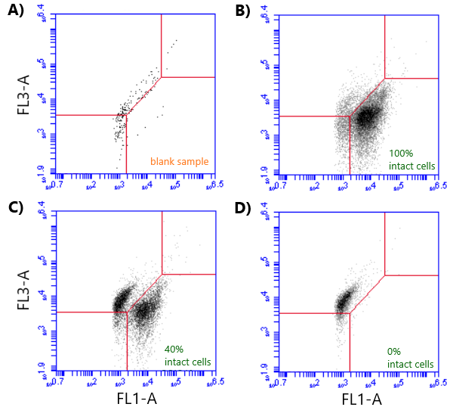
Figure S1. Fixed gating strategy for measuring microbial loads in seawater samples using a BD Accuri C6 flow cytometer. A threshold value of 1,000 was applied on the FL1 channel for all samples. The flow rate was set at 35 μl min⁻¹ and the acquisition rate did not exceed 10,000 events s⁻¹. Each panel indicates events registered in a standardised 50 µL volume of sample. Cell counts were defined as events registered in the % intact gating area. (A) FL1-A/FL3-A acquisition plot of a blank sample (sterile artificial seawater) stained with SYBR Green (SG). (B) Density plot of FL1-A/FL3-A count acquisition of a natural seawater sample stained with SG and propidium iodide (PI). (C) Density plot of FL1-A/FL3-A count acquisition of mixed 60:40 heat:natural seawater sample stained with SGPI. (D) Density plot of FL1-A/FL3-A count acquisition of heat-killed seawater sample stained with SGPI.
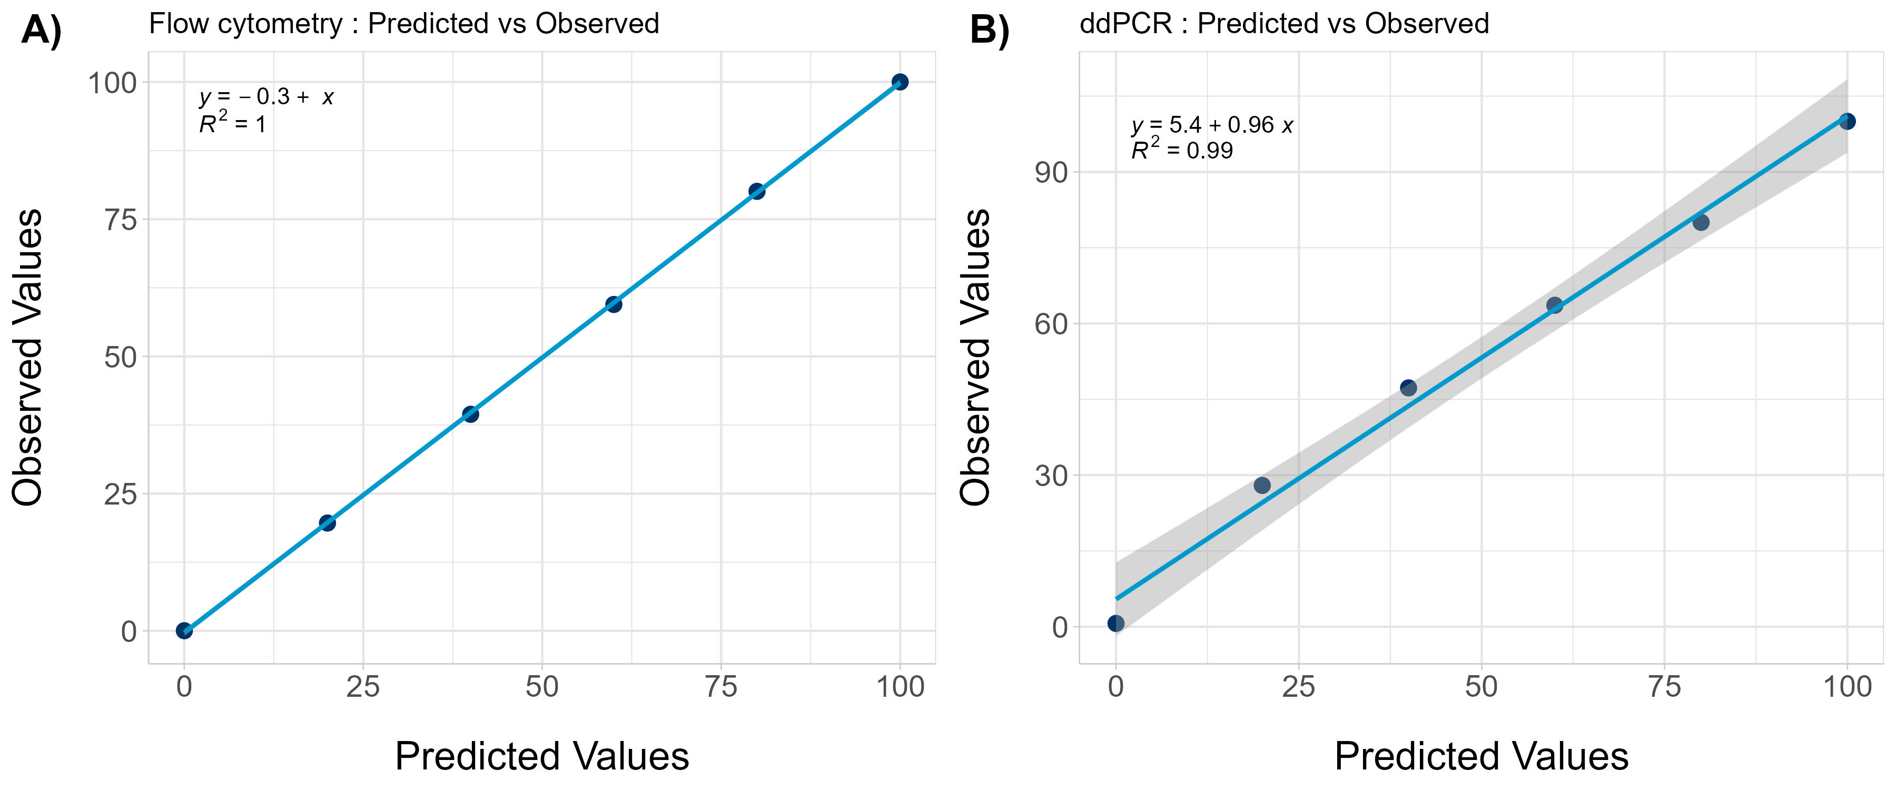
Figure S2. Linear regression analyses of predicted versus observed average counts (relative to 100% natural seawater). (A) Cells mL⁻¹ estimated using flow cytometry. (B) 16S rRNA gene copies mL⁻¹ measured with droplet digital PCR.
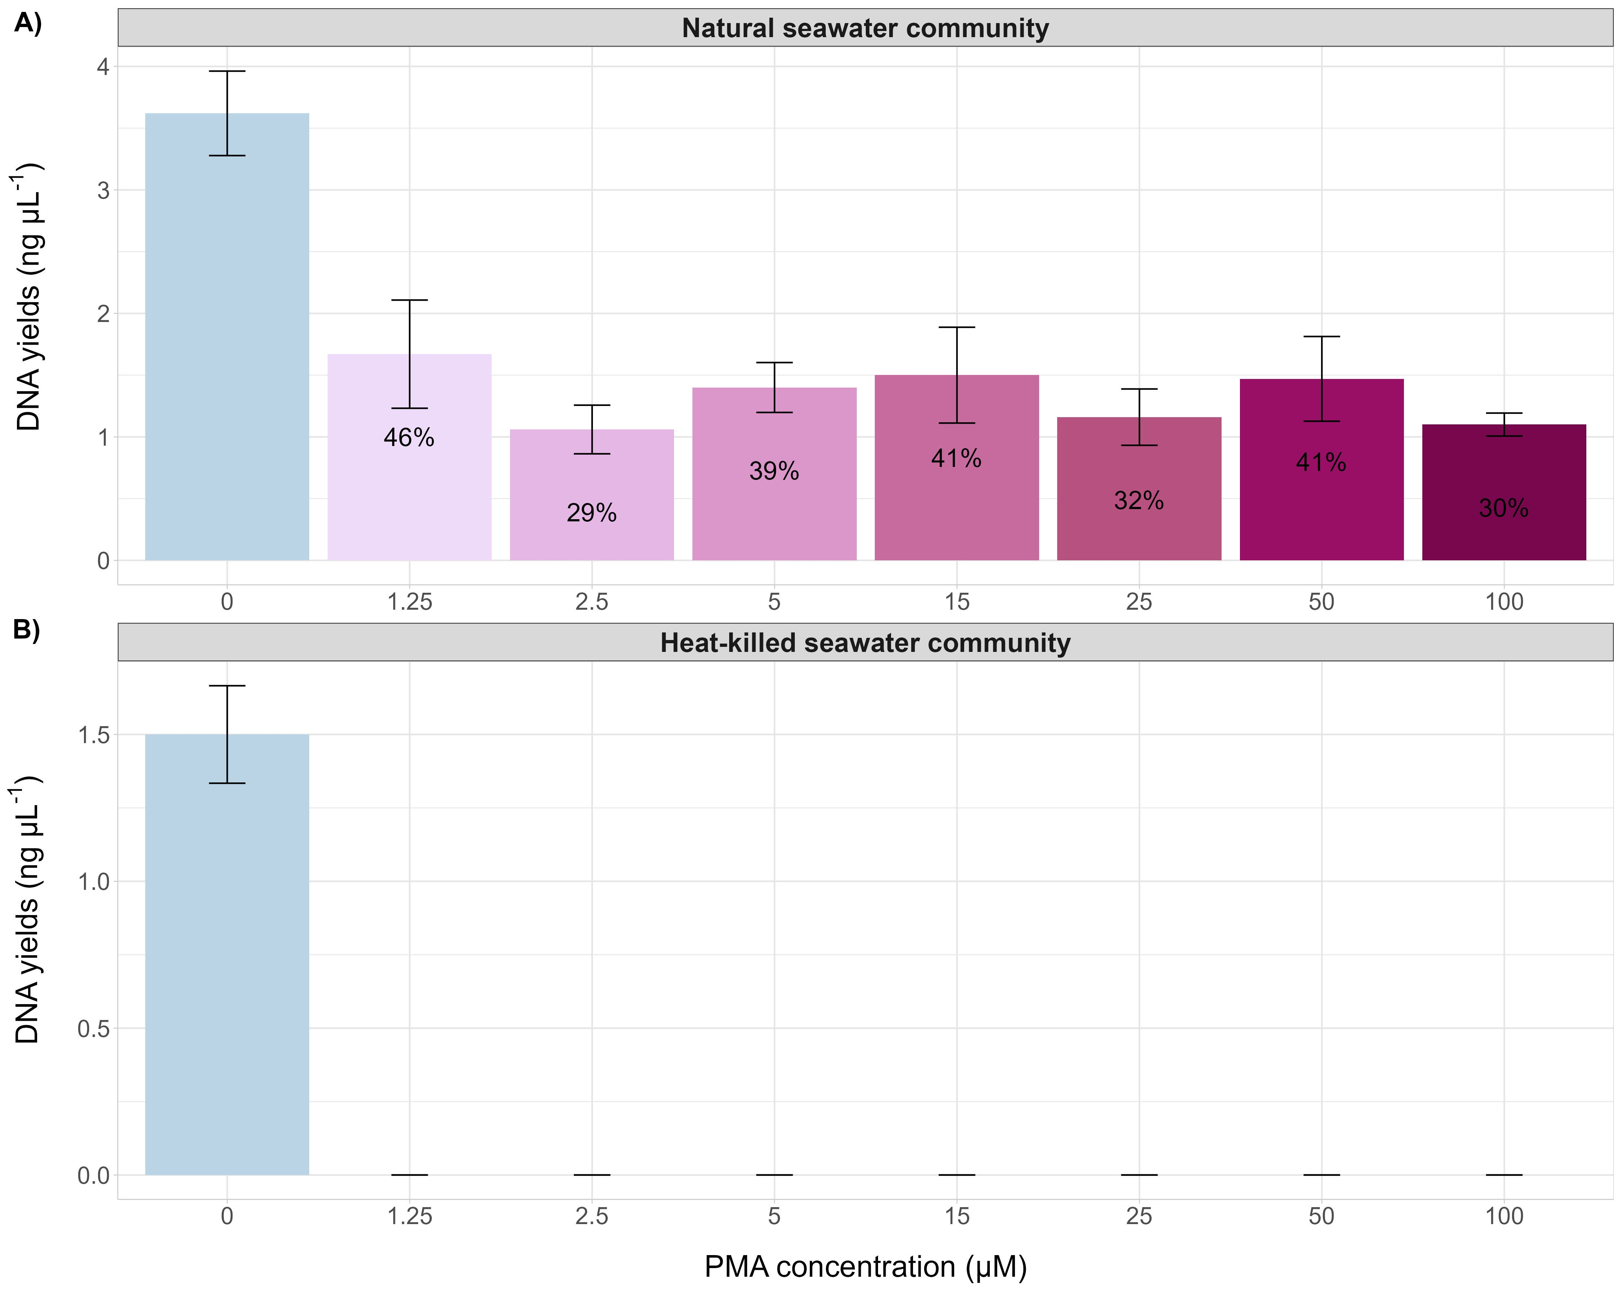
Figure S3. Seawater microbial communities treated with a range of propidium monoazide (PMA) concentrations (0, 1.25, 2.5, 5, 15, 25, and 100 µM). (A) Bar plot showing average DNA yields (ng µL⁻¹) ± SD measured by Qubit in natural seawater communities treated with varying PMA concentrations (n = 3 replicates). (B) Bar plot displaying average DNA yields (ng µL⁻¹) ± SD measured by Qubit in heat-killed seawater communities treated with different PMA concentrations (DNA yields from heat-killed seawater communities treated with PMA were too low to quantify).
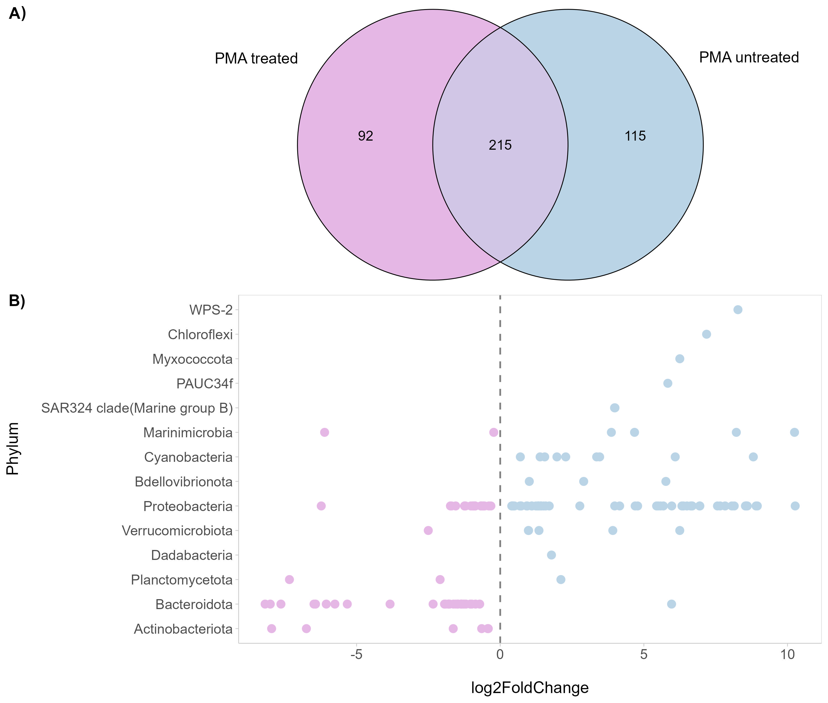
Figure S4. (A) Venn diagram showing unique and shared amplicon sequence variants (ASVs) of propidium monoazide (PMA, 2.5 µM) treated samples versus PMA untreated samples. (B) Differential abundance analysis (log2-fold-change) of ASVs (grouped by phyla) between PMA-treated and PMA-untreated samples.
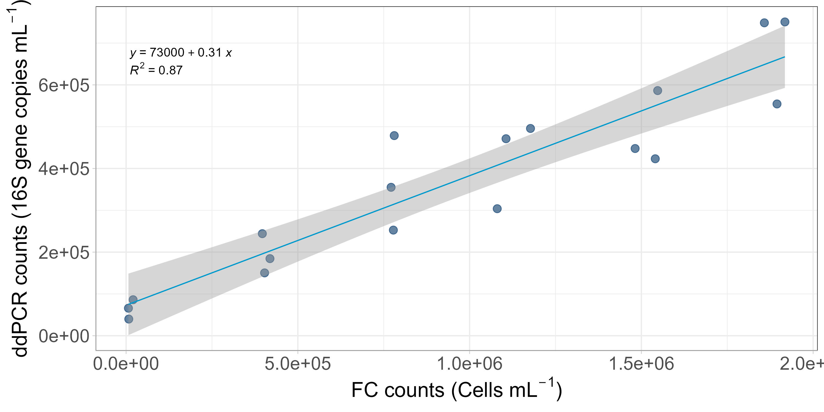
Figure S5. Linear regression analyses of cells mL⁻¹ versus 16S rRNA gene copies mL^{-1.}.
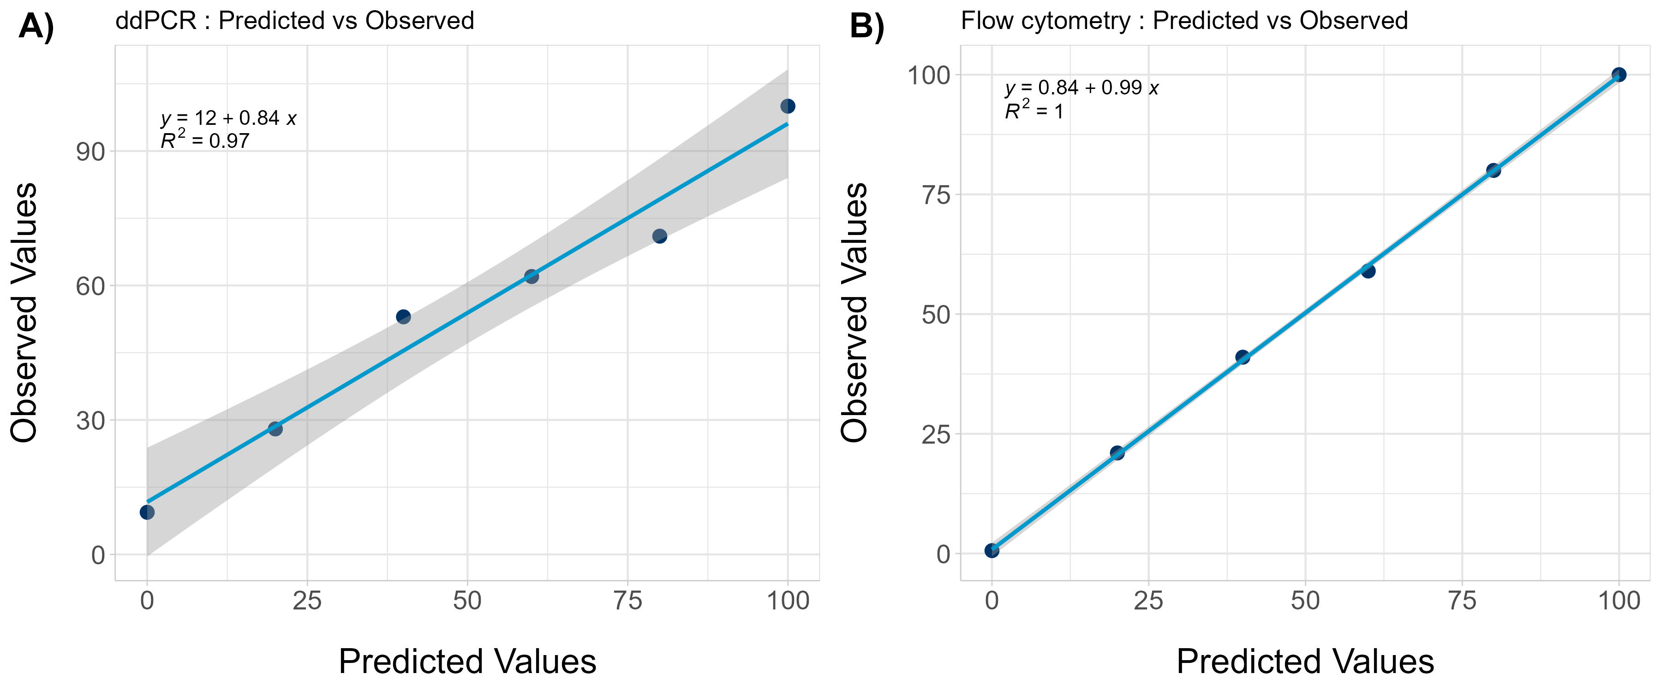
Figure S6. Linear regression analyses of predicted versus observed average counts (relative to 100% intact cells). (A) Cells mL⁻¹ estimated using flow cytometry. (B) 16S rRNA gene copies mL⁻¹ measured with droplet digital PCR.
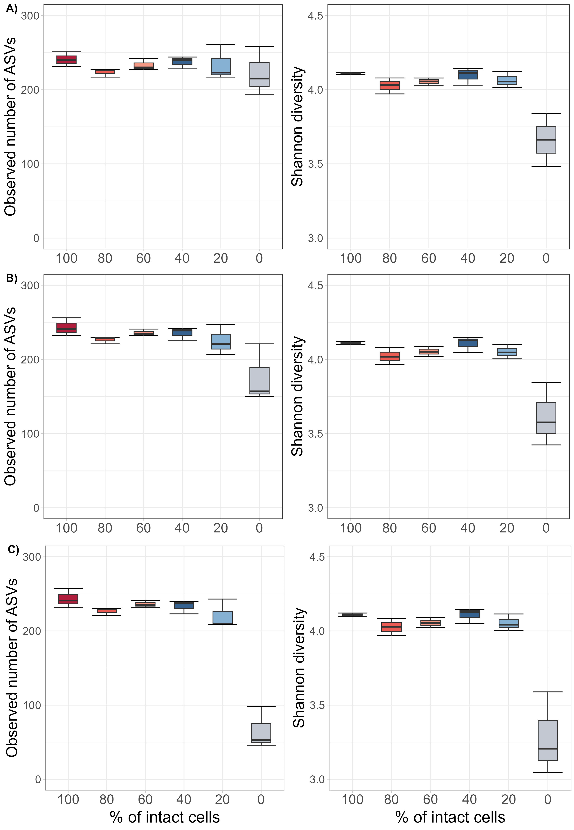
Figure S7. Boxplots illustrating alpha diversity (observed number of amplicon sequence variants (ASVs) and Shannon diversity index) of microbial communities in seawater sample mixtures with defined ratios of intact and heat-killed cells. (A) Relative microbiome profiling. (B) Quantitative microbiome profiling anchored to 16S rRNA gene copy numbers. (C) Quantitative microbiome profiling anchored to cell counts. The box represents the interquartile range (25th to 75th percentiles), the horizontal line within the box indicates the median, and the whiskers extend to the 10th and 90th percentiles (n = 3 replicates).

