Adsorption and dehydration reaction of ethanol to ethylene on isomorphous B, Al, and Ga substitution of H-ZSM-5 zeolite: An embedded ONIOM study
Nattida Maeboonruan¹, Bundet Boekfa^{1,2*}, Thana Maihom¹, Piti Treesukol¹, Kanokwan Kongpatpanich³, Supawadee Namuangruk⁴, Michael Probst⁵ and Jumras Limtrakul³
¹Department of Chemistry, Faculty of Liberal Arts and Science, Kasetsart University Kamphaeng Saen Campus, Nakhon Pathom 73140, Thailand
² Center for Advanced Studies in Nanotechnology for Chemical, Food and Agricultural Industries, Kasetsart University Institute for Advanced Studies, Kasetsart University,
Bangkok 10900, Thailand
³School of Molecular Science and Engineering, Vidyasirimedhi Institute of Science and Technology (VISTEC), Rayong 21210, Thailand.
⁴National Nanotechnology Center (NANOTEC), National Science and Technology Development Agency, Pathum Thani 12120, Thailand
⁵Institute of Ion Physics and Applied Physics, University of Innsbruck, Innsbruck 6020, Austria
*e-mail: bundet.b@ku.ac.th

Supporting information

1. H-[B]-ZSM-5, H-[Al]-ZSM-5 and H-[Ga]-ZSM-5 zeolites
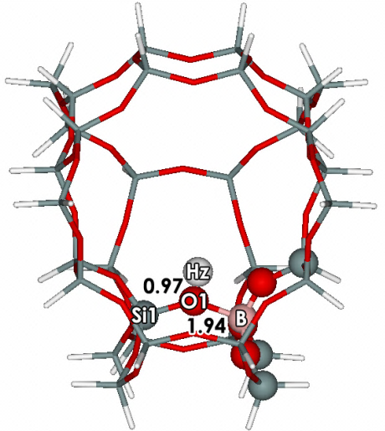 | 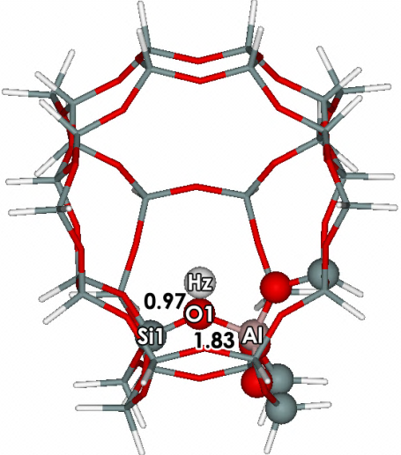 | 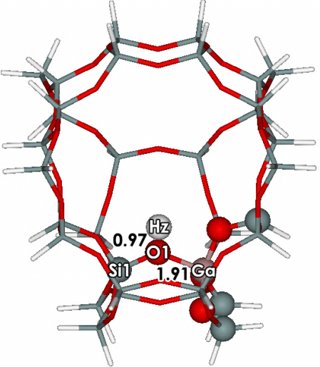
(a) | (b) | (c)
Figure S1: Optimized structures of (a) B-ZSM-5, (b) Al-ZSM-5 and (c) Ga-ZSM-5 zeolites determined by the ONIOM (5T:34T) scheme. The 5T cluster (ball-stick) is treated at the MP2/6-31G(d,p) level of theory, whereas 34T cluster is treated with the M06-2X/6-31G(d,p) density functional. Distances are given in Å.

Table S1: Selected structural parameters for the H-ZSM-5 zeolites isomorphously substituted with B, Al and Ga. The geometries are optimized with ONIOM 5T:34T MP2/6-31G (d,p):M06-2X/6-31G(d,p) scheme.
 | B-ZSM-5 | Al-ZSM-5 | Ga-ZSM-5
Distance (Å)
Si1-O1 | 1.65 | 1.66 | 1.66
(B,Al,Ga)Hz | 2.34 | 2.36 | 2.42
(B,Al,Ga)-O1 | 1.94 | 1.83 | 1.91
(B,Al,Ga)-Oavg | 1.54 | 1.72 | 1.79
O1-Hz | 0.97 | 0.97 | 0.97
Angle (º)
Si1-O1-Hz | 115.88 | 116.64 | 117.36
Si1-O1-(B,Al,Ga) | 138.57 | 130.35 | 129.72
(B,Al,Ga)-O1-Hz | 102.03 | 111.21 | 110.01

2. Adsorption of ethanol on H-[B]-ZSM-5, H-[Al]-ZSM-5 and H-[Ga]-ZSM-5 zeolites
2.1 Optimized structures of the adsorption complexes
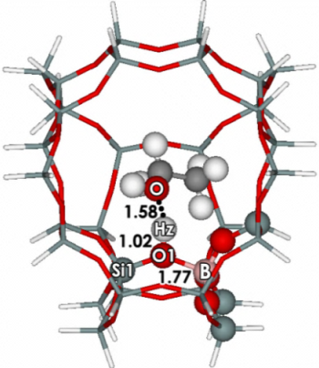 | 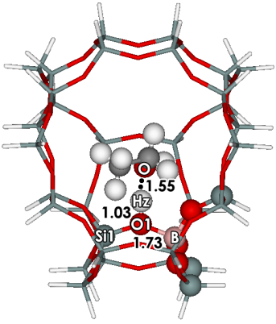 | 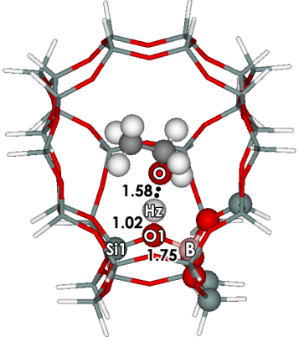
(a) | (b) | (c)
Figure S2: Optimized structures after adsorption of ethanol: (a) one hydrogen bonded (side on, AD-B-1A), (b) doubly hydrogen bonded (end at zigzag chanel, AD-B-1B) and (c) one hydrogen bonded (end at intersection region, AD-B-1C) on B-ZSM-5 zeolites from ONIOM 5T:34T MP2/6-31G(d,p):M06-2X/6-31G(d,p) calculations. Distances are in Å.
Table S2: Selected Data for the optimized structural parameters for the adsorption of ethanol on B-ZSM-5 zeolite. One hydrogen bonded (side on, AD-B-1A), doubly hydrogen bound (end at zigzag chanel, AD-B-1B) and one hydrogen bonded (end at intersection region, AD-B-1C) from ONIOM 5T:34T MP2/6-31G (d,p):M06-2X/6-31G(d,p) calculations.
 | AD-B-1A |  | AD-B-1B |  | AD-B-1C
Distance (Å)
Si1-O1 | 1.66 |  | 1.67 |  | 1.67
BHz | 2.29 |  | 2.27 |  | 2.27
B-O1 | 1.77 |  | 1.73 |  | 1.75
B-Oavg | 1.51 |  | 1.50 |  | 1.51
O1-Hz | 1.02 |  | 1.03 |  | 1.02
HzO | 1.58 |  | 1.55 |  | 1.58
Angle (º)
Si1-O1-B | 137.31 |  | 137.38 |  | 136.90
Si1-Hz-O | 123.26 |  | 139.60 |  | 141.78
B-Hz-O | 144.68 |  | 131.77 |  | 125.50
O1-Hz-O | 167.11 |  | 177.70 |  | 170.48
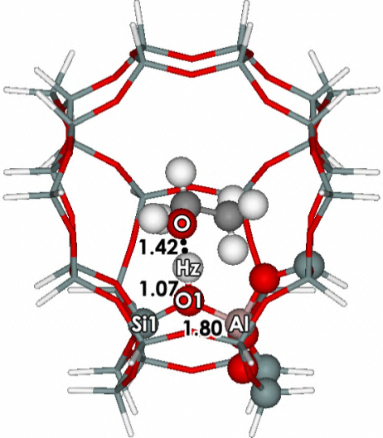 |  | 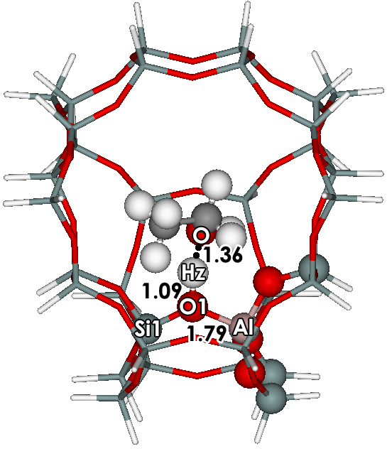 |  | 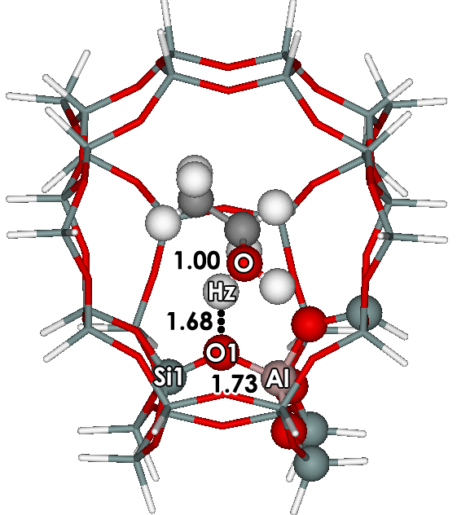
(a) |  | (b) |  | (c)
Figure S3: Optimized structures for the adsorption of ethanol (a) one hydrogen bonded (side on, AD-Al-1A), (b) doubly hydrogen bound (end at zigzag chanel, AD-Al-1B) and (c) one hydrogen bonded (end at intersection region, AD-Al-1C) on Al-ZSM-5 zeolites with ONIOM 5T:34T MP2/6-31G(d,p):M06-2X/6-31G(d,p). Distances are given in Å.
Table S3: Selected Data for the optimized structural parameters for the adsorption of ethanol on Al-ZSM-5 zeolite namely: one hydrogen bonded (side on, AD-Al-1A), double hydrogen bonded (end at zigzag chanel, AD-Al-1B) and one hydrogen bonded (end at intersection region, AD-Al-1C) calculated using the ONIOM 5T:34T MP2/6-31G (d,p):M06-2X/6-31G(d,p) scheme.
 | AD-Al-1A |  | AD-Al-1B |  | AD-Al-1C
Distance (Å)
Si1-O1 | 1.64 |  | 1.64 |  | 1.59
AlHz | 2.44 |  | 2.44 |  | 2.88
Al-O1 | 1.80 |  | 1.79 |  | 1.73
Al-Oavg | 1.72 |  | 1.72 |  | 1.72
O1-Hz | 1.07 |  | 1.09 |  | 1.68
HzO | 1.42 |  | 1.36 |  | 1.00
Angle (º)
Si1-O1-Al | 127.57 |  | 127.54 |  | 128.19
Si1-Hz-O | 132.26 |  | 151.91 |  | 170.86
Al-Hz-O | 144.27 |  | 126.53 |  | 107.22
O1-Hz-O | 173.23 |  | 169.01 |  | 139.92
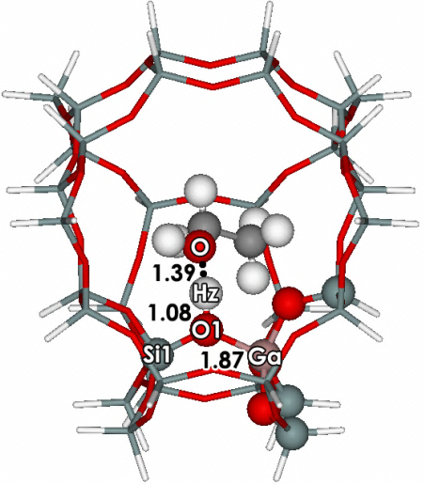 |  | 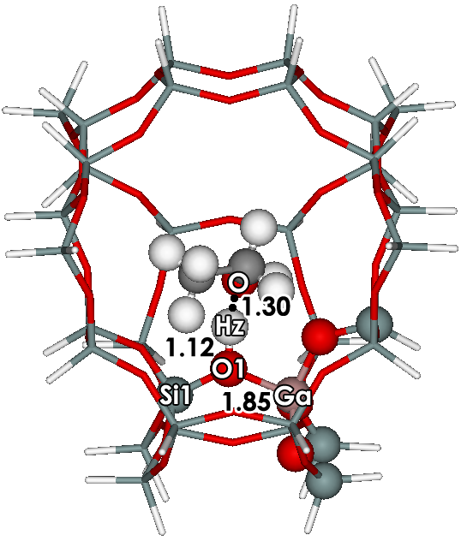 |  | 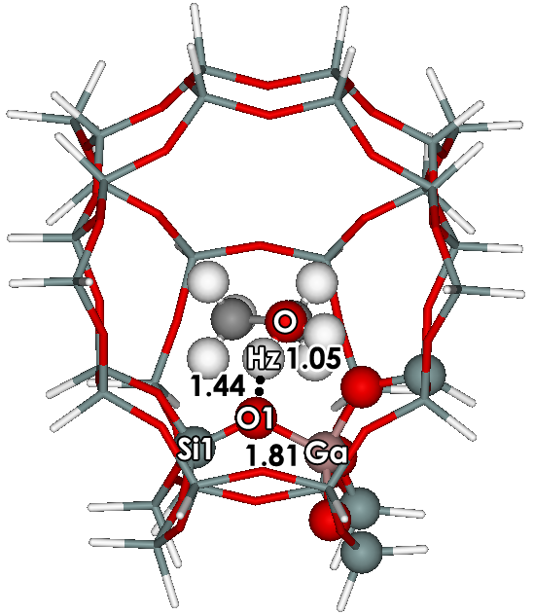
(a) |  | (b) |  | (c)
Figure S4: Optimized structures for the adsorption of ethanol (a) one hydrogen bonded (side on, AD-Ga-1A), (b) double hydrogen bonded (end at zigzag chanel, AD-Ga-1B) and (c) one hydrogen bonded (end at intersection region, AD-Ga-1C) on Ga-ZSM-5 zeolites with ONIOM 5T:34T MP2/6-31G(d,p):M06-2X/6-31G(d,p). Distances are in Å.
Table S4: Selected Data for the optimized structural parameters for the adsorption of ethanol on Ga-ZSM-5 zeolite: one hydrogen bond (side on, AD-Ga-1A), doubly hydrogen bound (end at zigzag chanel, AD-Ga-1B) and one hydrogen bonded (end at intersection region, AD-Ga-1C) obtained from ONIOM 5T:34T MP2/6-31G (d,p):M06-2X/6-31G(d,p) calculations.
 | AD-Ga-1A | AD-Ga-1B | AD-Ga-1C
Distance (Å)
Si1-O1 | 1.63 | 1.63 | 1.60
GaHz | 2.50 | 2.51 | 2.61
Ga-O1 | 1.87 | 1.85 | 1.81
Ga-Oavg | 1.78 | 1.78 | 1.78
O1-Hz | 1.08 | 1.12 | 1.44
HzO | 1.39 | 1.30 | 1.05
Angle (º)
Si1-O1-Ga | 127.01 | 125.83 | 126.16
Si1-Hz-O | 132.28 | 153.18 | 166.79
Ga-Hz-O | 143.49 | 126.43 | 115.38
O1-Hz-O | 172.74 | 169.34 | 157.01

2.2 Adsorption energies
Table S5: Adsorption energies of ethanol on the H-[B]-ZSM-5 zeolit: one hydrogen bond (side on, AD-B-1A), doubly hydrogen bound (end at zigzag chanel, AD-B-1B) and one hydrogen bond (end at intersection region, AD-B-1C) ) obtained from ONIOM 5T:34T MP2/6-31G (d,p):M06-2X/6-31G(d,p) calculations. Energies are given in kcal/mol.
 | AD-B-1A | AD-B-1B | AD-B-1C
ONIOM (MP2:M06-2X) ª | -20.4 | -23.6 | -22.9
MP2 ^{b} | -14.5 | -16.5 | -16.7
Framework ^{c} | -5.9 | -7.1 | -6.2
ONIOM (MP2:M06-2X) ^{d} | -17.2 | -20.0 | -19.2
MP2 ^{e} | -12.5 | -13.9 | -13.7
Framework ^{c} | -4.7 | -6.1 | -5.5
Embedded ONIOM ^{f} | -19.0 | -23.1 | -21.6
MP2 ^{g} | -14.9 | -16.7 | -15.8
Framework ^{c} | -4.1 | -6.4 | -5.8
ª ONIOM(MP2/6-31G(d,p):M06-2X/6-31G(d,p) model 5T:34T
^{b} MP2/6-31G(d,p)//ONIOM(MP2/6-31G(d,p):M06-2X/6-31G(d,p) model 5T//5T:34T
^{c} E_{ONIOM} – E_{high level}
^{d} ONIOM(MP2/6-311+G(2df,2p):M06-2X/6-311+G(2df,2p))//ONIOM(MP2/6-31G(d,p):M06-2X/6-31G(d,p) model 5T:34T
^{e} MP2/6-311+G(2df,2p)//ONIOM(MP2/6-31G(d,p):M06-2X/6-31G(d,p) model 5T//5T:34T
^{f} ONIOM(MP2/6-311+G(2df,2p):M06-2X/6-311+G(2df,2p))//ONIOM(MP2/6-31G(d,p):M06-2X/6-31G(d,p) with charge model 5T:34T
^{g} MP2/6-311+G(2df,2p)//ONIOM(MP2/6-31G(d,p):M06-2X/6-31G(d,p) with charge model 5T//5T:34T

Table S6: Adsorption energies of ethanol on the H-[Al]-ZSM-5 zeolite namely: one hydrogen bond (side on, AD-Al-1A), double hydrogen bonded (end at zigzag chanel, AD-Al-1B) and one hydrogen bonded (end at intersection region, AD-Al-1C) ) obtained from ONIOM 5T:34T MP2/6-31G (d,p):M06-2X/6-31G(d,p) calculations. Energies are given in kcal/mol.
 | AD-Al-1A | AD-Al-1B | AD-Al-1C
ONIOM (MP2:M06-2X) ª | -24.3 | -30.0 | -30.4
MP2 ^{b} | -16.4 | -22.2 | -19.6
Framework ^{c} | -7.9 | -7.8 | -10.8
ONIOM (MP2:M06-2X) ^{d} | -21.3 | -26.0 | -25.7
MP2 ^{e} | -14.7 | -19.3 | -16.8
Framework ^{c} | -6.6 | -6.7 | -8.9
Embedded ONIOM ^{f} | -23.3 | -29.8 | -28.1
MP2 ^{g} | -17.1 | -22.2 | -18.9
Framework ^{c} | -6.2 | -7.6 | -9.2
ª ONIOM(MP2/6-31G(d,p):M06-2X/6-31G(d,p) model 5T:34T
^{b} MP2/6-31G(d,p)//ONIOM(MP2/6-31G(d,p):M06-2X/6-31G(d,p) model 5T//5T:34T
^{c} E_{ONIOM} – E_{high level}
^{d} ONIOM(MP2/6-311+G(2df,2p):M06-2X/6-311+G(2df,2p))//ONIOM(MP2/6-31G(d,p):M06-2X/6-31G(d,p) model 5T:34T
^{e} MP2/6-311+G(2df,2p)//ONIOM(MP2/6-31G(d,p):M06-2X/6-31G(d,p) model 5T//5T:34T
^{f} ONIOM(MP2/6-311+G(2df,2p):M06-2X/6-311+G(2df,2p))//ONIOM(MP2/6-31G(d,p):M06-2X/6-31G(d,p) with charge model 5T:34T
^{g} MP2/6-311+G(2df,2p)//ONIOM(MP2/6-31G(d,p):M06-2X/6-31G(d,p) with charge model 5T//5T:34T

Table S7: Adsorption energies of ethanol on the H-[Ga]-ZSM-5 zeolite: one hydrogen bond (side on, AD-GaAl-1A), doubly hydrogen bound (end at zigzag chanel, AD-Ga-1B) and one hydrogen bonded (end at intersection region, AD-Ga-1C) ) obtained from ONIOM 5T:34T MP2/6-31G (d,p):M06-2X/6-31G(d,p) calculations. Energies are given in kcal/mol.
 | AD-Ga-1A | AD-Ga-1B | AD-Ga-1C
ONIOM (MP2:M06-2X) ª | -26.4 | -31.8 | -33.0
MP2 ^{b} | -18.0 | -23.3 | -24.4
Framework ^{c} | -8.4 | -8.5 | -8.6
ONIOM (MP2:M06-2X) ^{d} | -20.9 | -25.7 | -25.1
MP2 ^{e} | -14.2 | -18.6 | -18.0
Framework ^{c} | -6.7 | -7.1 | -7.1
Embedded ONIOM ^{f} | -23.2 | -29.4 | -27.7
MP2 ^{g} | -16.8 | -21.6 | -20.2
Framework ^{c} | -6.4 | -7.8 | -7.5
ª ONIOM(MP2/6-31G(d,p):M06-2X/6-31G(d,p) model 5T:34T
^{b} MP2/6-31G(d,p)//ONIOM(MP2/6-31G(d,p):M06-2X/6-31G(d,p) model 5T//5T:34T
^{c} E_{ONIOM} – E_{high level}
^{d} ONIOM(MP2/6-311+G(2df,2p):M06-2X/6-311+G(2df,2p))//ONIOM(MP2/6-31G(d,p):M06-2X/6-31G(d,p) model 5T:34T
^{e} MP2/6-311+G(2df,2p)//ONIOM(MP2/6-31G(d,p):M06-2X/6-31G(d,p) model 5T//5T:34T
^{f} ONIOM(MP2/6-311+G(2df,2p):M06-2X/6-311+G(2df,2p))//ONIOM(MP2/6-31G(d,p):M06-2X/6-31G(d,p) with charge model 5T:34T
^{g} MP2/6-311+G(2df,2p)//ONIOM(MP2/6-31G(d,p):M06-2X/6-31G(d,p) with charge model 5T//5T:34T

3. Adsorptions of ethylene on H-[B]-ZSM-5, H-[Al]-ZSM-5 and H-[Ga]-ZSM-5 zeolites
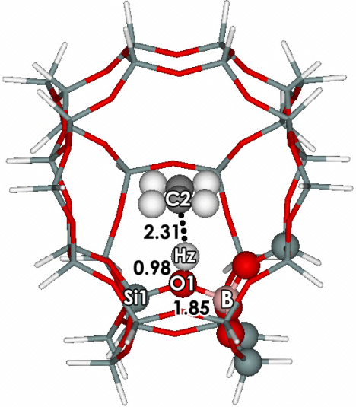 | 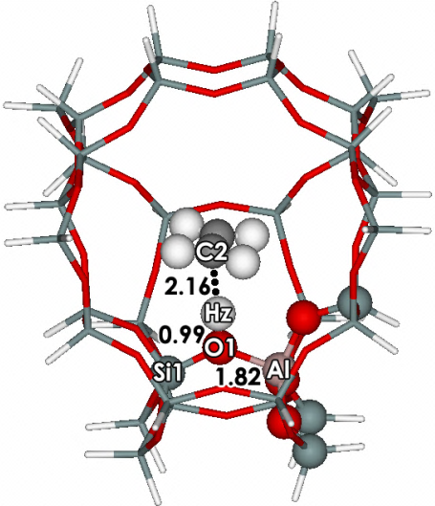 | 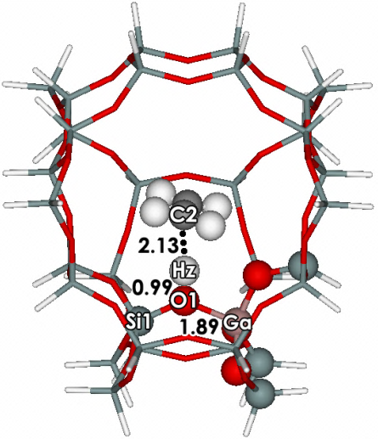
(a) | (b) | (c)
Figure S5: Optimized structures of ethylene adsorption on (a) B-ZSM-5, (b) Al-ZSM-5 and (c) Ga-ZSM-5 zeolites ) obtained from ONIOM 5T:34T MP2/6-31G (d,p):M06-2X/6-31G(d,p) calculations. Distances are given in Å.
Table S8: Selected Data for the optimized structural parameters for the adsorption of ethylene on the H-ZSM-5 zeolites isomorphously substituted with B, Al and Ga from ONIOM 5T:34T MP2/6-31G (d,p):M06-2X/6-31G(d,p) calculations.
 | B-ZSM-5 | Al-ZSM-5 | Ga-ZSM-5
Distance (Å)
Si1-O1 | 1.66 | 1.66 | 1.65
(B,Al,Ga)Hz | 2.33 | 2.41 | 2.46
(B,Al,Ga)-O1 | 1.85 | 1.82 | 1.89
(B,Al,Ga)-Oavg | 1.52 | 1.72 | 1.78
O1-Hz | 0.98 | 0.99 | 0.99
HzC1 | 2.31 | 2.16 | 2.13
HzC2 | 2.37 | 2.20 | 2.16
C1-C2 | 1.34 | 1.34 | 1.34
Angle (º)
Si1-O1-(B,Al,Ga) | 138.26 | 129.37 | 128.75
Si1-Hz-C2 | 127.28 | 133.97 | 136.49
(B,Al,Ga)-Hz-C2 | 136.37 | 136.17 | 134.57
O1-Hz-C2 | 158.36 | 159.57 | 159.12

Table S9: Adsorption energies of ethylene on the H-[B]-ZSM-5, H-[Al]-ZSM-5 and H-[Ga]-ZSM-5 zeolites from ONIOM 5T:34T MP2/6-31G (d,p):M06-2X/6-31G(d,p) calculations. Energies are given in kcal/mol.
 | B-ZSM-5 | Al-ZSM-5 | Ga-ZSM-5
ONIOM (MP2:M06-2X) ª | -10.7 | -13.2 | -14.3
MP2 ^{b} | -6.7 | -8.9 | -9.9
Framework ^{c} | -4.0 | -4.3 | -4.4
ONIOM (MP2:M06-2X) ^{d} | -10.2 | -12.9 | -12.8
MP2 ^{e} | -6.4 | -8.9 | -9.0
Framework ^{c} | -3.7 | -4.0 | -3.8
Embedded ONIOM ^{f} | -11.6 | -14.7 | -14.5
MP2 ^{g} | -7.6 | -10.2 | -10.3
Framework ^{c} | -4.0 | -4.5 | -4.2
ª ONIOM(MP2/6-31G(d,p):M06-2X/6-31G(d,p) model 5T:34T
^{b} MP2/6-31G(d,p)//ONIOM(MP2/6-31G(d,p):M06-2X/6-31G(d,p) model 5T//5T:34T
^{c} E_{ONIOM} – E_{high level}
^{d} ONIOM(MP2/6-311+G(2df,2p):M06-2X/6-311+G(2df,2p))//ONIOM(MP2/6-31G(d,p):M06-2X/6-31G(d,p) model 5T:34T
^{e} MP2/6-311+G(2df,2p)//ONIOM(MP2/6-31G(d,p):M06-2X/6-31G(d,p) model 5T//5T:34T
^{f} ONIOM(MP2/6-311+G(2df,2p):M06-2X/6-311+G(2df,2p))//ONIOM(MP2/6-31G(d,p):M06-2X/6-31G(d,p) with charge model 5T:34T
^{g} MP2/6-311+G(2df,2p)//ONIOM(MP2/6-31G(d,p):M06-2X/6-31G(d,p) with charge model 5T//5T:34T

4. Dehydration reactions of ethanol to ethylene on H-[B]-ZSM-5, H-[Al]-ZSM-5 and H-[Ga]-ZSM-5 zeolites
4.1 H-[B]-ZSM-5 zeolite
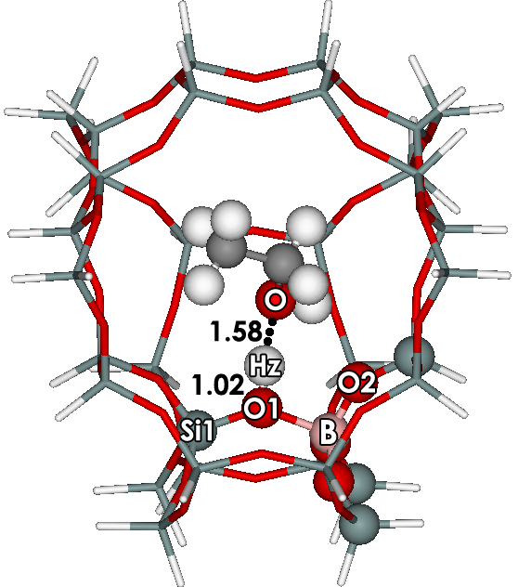 | 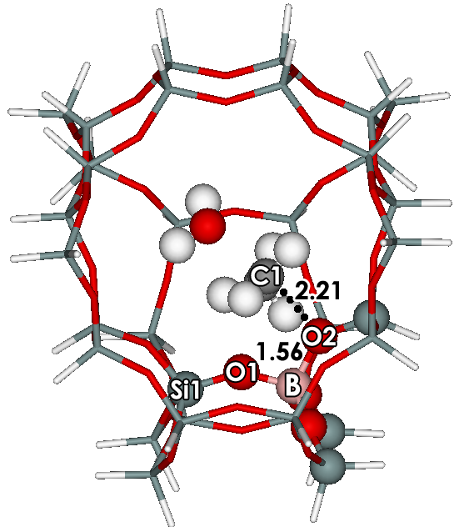
AD-B-1C | TS1-B
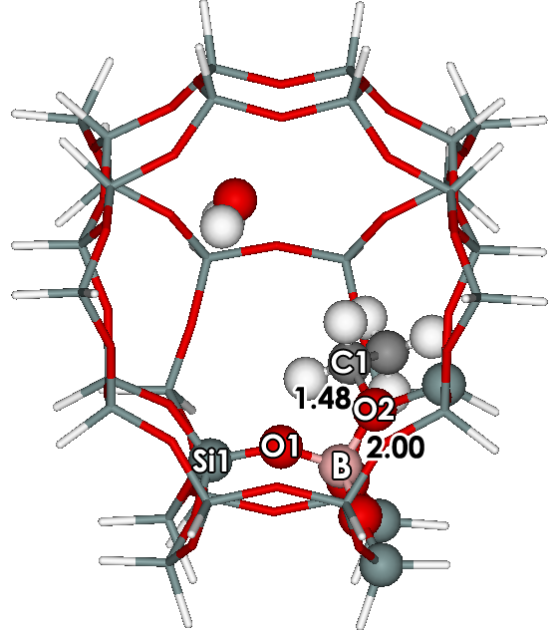 | 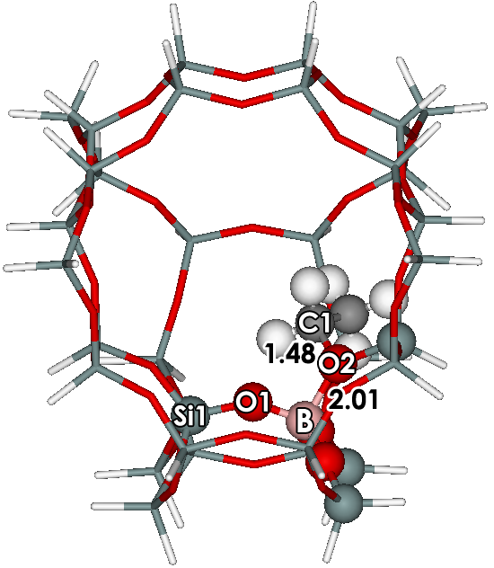
IN1-B | IN2-B
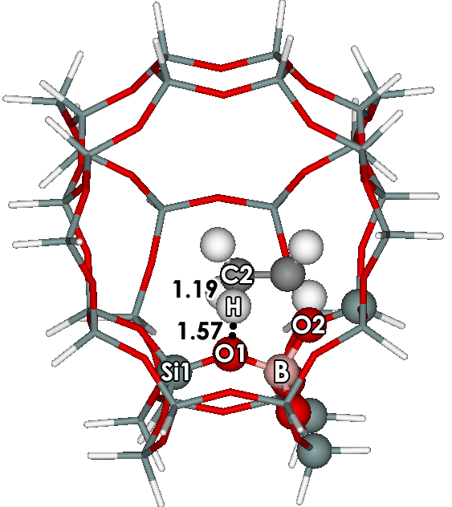 | 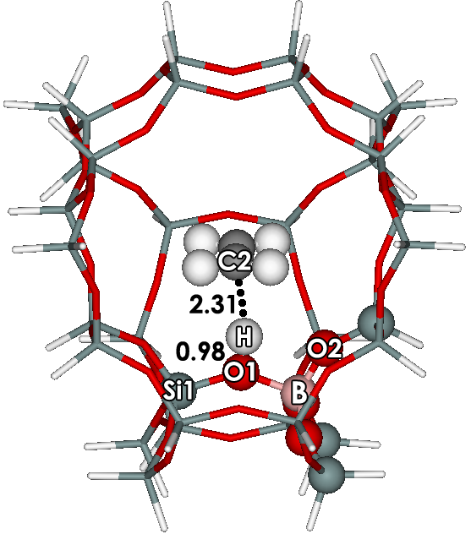
TS2-B | PR-B
Figure S6: Structures in the stepwise mechanism obtained from ONIOM 5T:34T MP2/6-31G (d,p):M06-2X/6-31G(d,p) calculations. Distances are given in Å.

Table S10 Selected structural parameters and energies for the stepwise mechanism on the H-[B]-ZSM-5 zeolites.
 | AD-B-1C | TS1-B | IN1-B | IN2-B | TS2-B | PR-B
Distance (Å)
Si1-O1 | 1.67 | 1.60 | 1.61 | 1.62 | 1.63 | 1.66
Si2-O2 | 1.62 | 1.64 | 1.67 | 1.67 | 1.64 | 1.62
B-Hz | 2.27 | 4.94 | 6.28 | - | - | -
B-O1 | 1.75 | 1.48 | 1.40 | 1.40 | 1.52 | 1.85
B-O2 | 1.44 | 1.56 | 2.00 | 2.01 | 1.54 | 1.42
Hz-O | 1.58 | 0.97 | 0.96 | - | - | -
O1-Hz | 1.02 | 3.85 | 5.25 | - | - | -
O1-H | 3.71 | 2.83 | 4.01 | 4.01 | 1.57 | 0.99
C1-C2 | 1.51 | 1.48 | 1.51 | 1.51 | 1.40 | 1.34
C1-O2 | 3.48 | 2.21 | 1.48 | 1.48 | 2.25 | 3.59
C1-O | 1.45 | 2.10 | 4.84 | - | - | -
C2-H | 1.09 | 1.09 | 1.09 | 1.09 | 1.19 | 2.31
Angle (º)
Si1-O1-B | 136.90 | 145.07 | 135.50 | 153.52 | 140.71 | 138.26
Si2-O2-B | 145.23 | 138.00 | 134.01 | 133.96 | 140.82 | 143.25

Table S11: Relative energies of ethylene on the H-[B]-ZSM-5 zeolites from ONIOM 5T:34T MP2/6-31G (d,p):M06-2X/6-31G(d,p) calculations. Energies are given in kcal/mol. Total Activation energy are in parenthesis.
 | AD-B-1C | TS1-B | IN1-B | IN2-B | TS2-B | PR-B
ONIOM ª | -22.9 | 20.3 | -11.4 | 0.0 | 42.6 | 9.4
 |  | (43.2) |  |  | (42.6)
MP2 ^{b} | -16.7 | 36.0 | 0.8 | 1.3 | 45.7 | 13.4
 |  | (52.7) |  |  | (44.4)
Framework ^{c} | -6.3 | -15.7 | -12.2 | -0.4 | -3.1 | -4.0
ONIOM ^{d} | -19.2 | 23.8 | -8.5 | -0.4 | 40.2 | 5.2
 |  | (43.0) |  |  | (40.6)
MP2 ^{b} | -13.7 | 35.6 | -1.0 | -0.4 | 43.4 | 8.9
 |  | (49.3) |  |  | (43.8)
Framework ^{c} | -5.5 | -11.8 | -7.4 | 0.0 | -3.2 | -3.7
Embedded ONIOM ^{f} | -21.6 | 20.7 | -11.8 | -2.8 | 36.1 | 3.8
 |  | (42.3) |  |  | (38.9)
MP2 ^{g} | -15.8 | 30.0 | -2.1 | -1.0 | 38.7 | 7.7
 |  | (45.8) |  |  | (39.7)
Framework ^{c} | -5.9 | -9.3 | -9.7 | -1.8 | -2.6 | -4.0
ª ONIOM(MP2/6-31G(d,p):M06-2X/6-31G(d,p) model 5T:34T
^{b} MP2/6-31G(d,p)//ONIOM(MP2/6-31G(d,p):M06-2X/6-31G(d,p) model 5T//5T:34T
^{c} E_{ONIOM} – E_{high level}
^{d} ONIOM(MP2/6-311+G(2df,2p):M06-2X/6-311+G(2df,2p))//ONIOM(MP2/6-31G(d,p):M06-2X/6-31G(d,p) model 5T:34T
^{e} MP2/6-311+G(2df,2p)//ONIOM(MP2/6-31G(d,p):M06-2X/6-31G(d,p) model 5T//5T:34T
^{f} ONIOM(MP2/6-311+G(2df,2p):M06-2X/6-311+G(2df,2p))//ONIOM(MP2/6-31G(d,p):M06-2X/6-31G(d,p) with charge model 5T:34T
^{g} MP2/6-311+G(2df,2p)//ONIOM(MP2/6-31G(d,p):M06-2X/6-31G(d,p) with charge model 5T//5T:34T

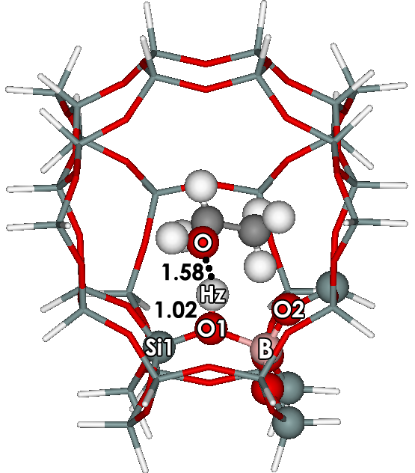 | 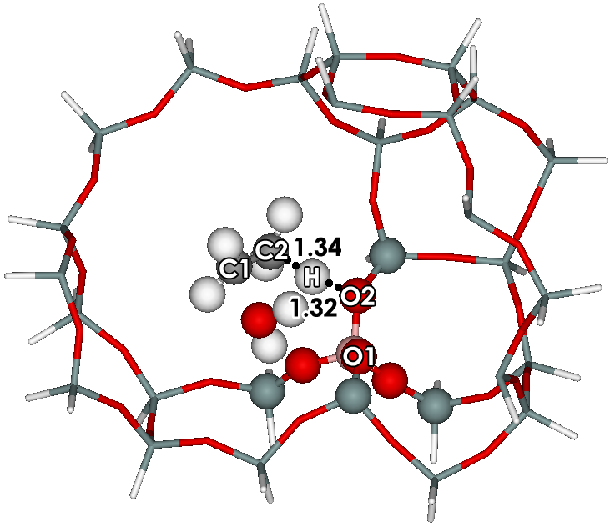
AD-B-1A | TSc-B
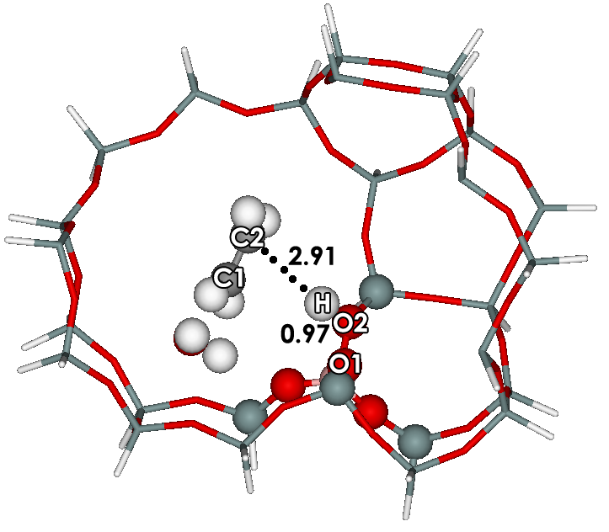 | 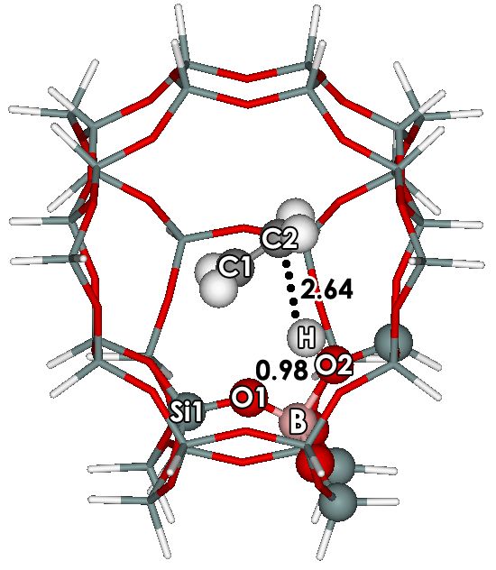
INc-B | PRc-B
Figure S7: Structures in the concerted mechanism obtained from ONIOM 5T:34T MP2/6-31G (d,p):M06-2X/6-31G(d,p) calculations. Distances are given in Å

Table S12 Selected structural parameters and energies for the concerted mechanism on the H-[B]-ZSM-5 zeolites.
 | AD-B-1A | TSc-B | INc-B | PRc-B
Distance (Å)
Si1-O1 | 1.66 | 1.62 | 1.61 | 1.62
Si2-O2 | 1.62 | 1.67 | 1.66 | 1.65
B-Hz | 2.29 | 3.05 | 3.52 | -
B-O1 | 1.77 | 1.46 | 1.40 | 1.41
B-O2 | 1.42 | 1.60 | 1.98 | 1.97
Hz-O | 1.58 | 0.97 | 0.97 | -
O1-Hz | 1.02 | 2.38 | 3.47 | -
O2-H | 2.82 | 1.32 | 0.97 | 0.98
C1-C2 | 1.51 | 1.39 | 1.34 | 1.34
C1-O | 1.45 | 2.11 | 3.38 | -
C2-H | 1.09 | 1.34 | 2.91 | 2.64
Angle (º)
Si1-O1-B | 137.31 | 140.43 | 133.87 | 133.22
Si2-O2-B | 146.74 | 140.18 | 141.80 | 141.39

Table S13 Relative energies of ethylene on the H-[B]-ZSM-5 zeolites from ONIOM 5T:34T MP2/6-31G (d,p):M06-2X/6-31G(d,p) calculations. Energies are given in kcal/mol. Total Activation energy are in parenthesis.
 | AD-B-1A | TSc-B | INc-B | PRc-B
ONIOM ª | -20.4 | 33.3 | 0.0 | 9.6
 |  | (53.7)
MP2 ^{b} | -14.5 | 38.2 | 11.4 | 15.5
 |  | (52.7)
Framework ^{c} | -5.8 | -4.9 | -11.4 | -5.9
ONIOM ^{d} | -17.2 | 35.0 | 0.6 | 5.9
 |  | (52.2)
MP2 ^{b} | -12.5 | 38.1 | 8.5 | 11.1
 |  | (50.6)
Framework ^{c} | -4.8 | -3.1 | -7.9 | -5.2
Embedded ONIOM ^{f} | -19.0 | 29.5 | -4.4 | 4.9
 |  | (48.5)
MP2 ^{g} | -14.9 | 33.5 | 6.7 | 11.8
 |  | (48.4)
Framework ^{c} | -4.1 | -4.0 | -11.1 | -6.9
ª ONIOM(MP2/6-31G(d,p):M06-2X/6-31G(d,p) model 5T:34T
^{b} MP2/6-31G(d,p)//ONIOM(MP2/6-31G(d,p):M06-2X/6-31G(d,p) model 5T//5T:34T
^{c} E_{ONIOM} – E_{high level}
^{d} ONIOM(MP2/6-311+G(2df,2p):M06-2X/6-311+G(2df,2p))//ONIOM(MP2/6-31G(d,p):M06-2X/6-31G(d,p) model 5T:34T
^{e} MP2/6-311+G(2df,2p)//ONIOM(MP2/6-31G(d,p):M06-2X/6-31G(d,p) model 5T//5T:34T
^{f} ONIOM(MP2/6-311+G(2df,2p):M06-2X/6-311+G(2df,2p))//ONIOM(MP2/6-31G(d,p):M06-2X/6-31G(d,p) with charge model 5T:34T
^{g} MP2/6-311+G(2df,2p)//ONIOM(MP2/6-31G(d,p):M06-2X/6-31G(d,p) with charge model 5T//5T:34T

4.2 Dehydration reaction of ethanol to ethylene on H-[Al]-ZSM-5 zeolite

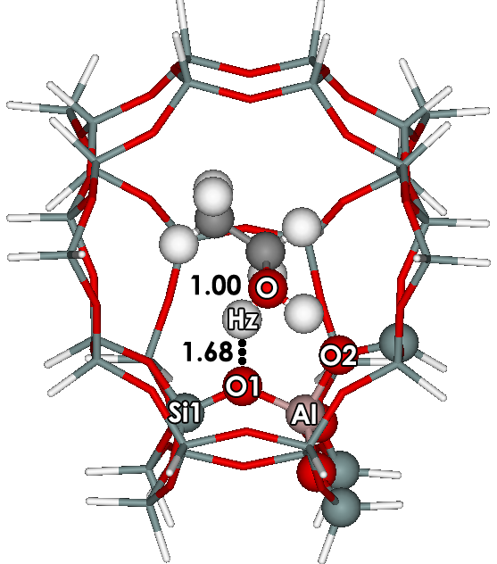 | 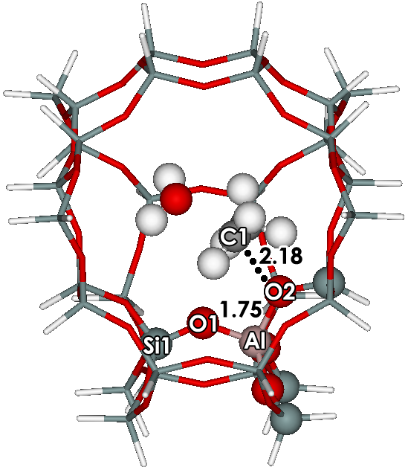
AD-Al-1C | TS1-Al
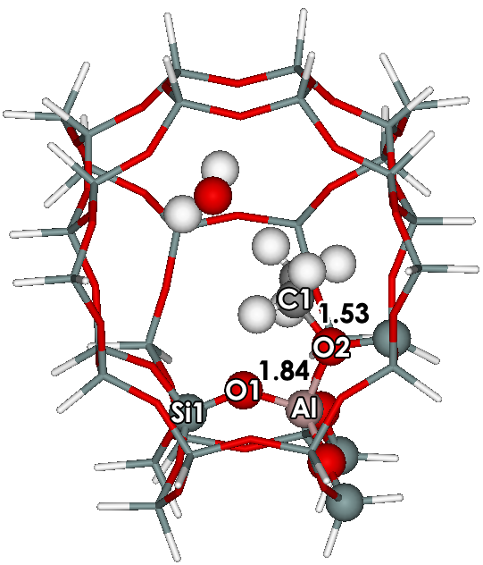 | 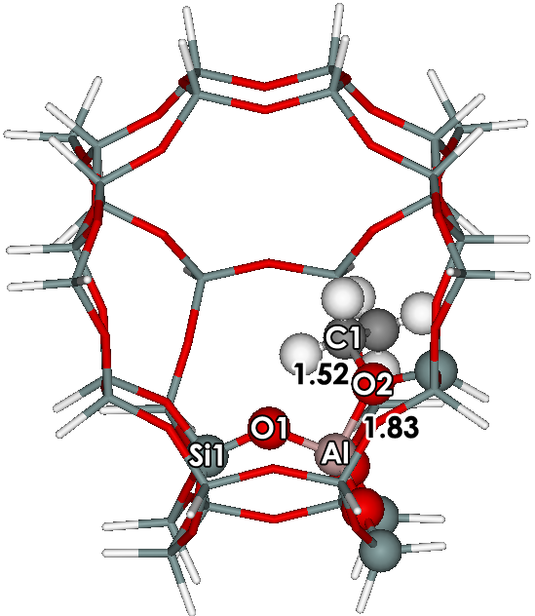
IN1-Al | IN2-Al
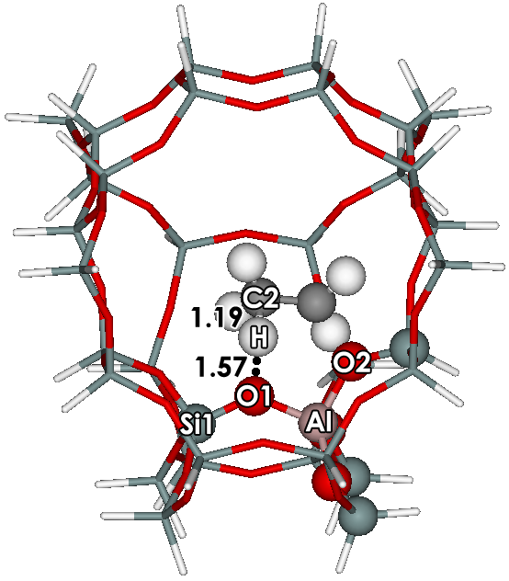 | 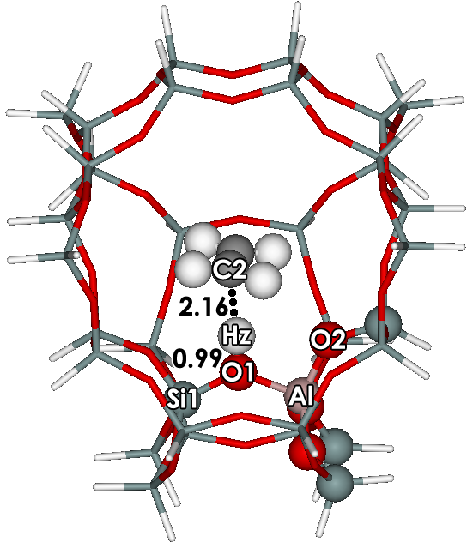
TS2-Al | PR-Al
Figure S8 Structures occurring in the stepwise mechanism. obtained from ONIOM 5T:34T MP2/6-31G (d,p):M06-2X/6-31G(d,p) calculations. Distances are given in Å

Table S14: Selected structural parameters and energies for the stepwise mechanism on the H-[Al]-ZSM-5 zeolites.
 | AD-Al-1C | TS1-Al | IN1-Al | IN2-Al | TS2-Al | PR-Al
Distance (Å)
Si1-O1 | 1.59 | 1.57 | 1.57 | 1.59 | 1.60 | 1.66
Si2-O2 | 1.61 | 1.60 | 1.67 | 1.68 | 1.60 | 1.59
Al-Hz | 2.88 | 4.85 | 5.91 | - | - | -
Al-O1 | 1.73 | 1.71 | 1.68 | 1.69 | 1.73 | 1.82
Al-O2 | 1.76 | 1.75 | 1.84 | 1.83 | 1.74 | 1.69
Hz-O | 1.00 | 0.97 | 0.97 | - | - | -
O1-Hz | 1.68 | 3.48 | 4.78 | - | - | -
O1-H | 3.92 | 3.35 | 3.14 | 4.05 | 1.57 | 0.99
C1-C2 | 1.51 | 1.48 | 1.50 | 1.51 | 1.40 | 1.34
C1-O2 | 3.29 | 2.18 | 1.53 | 1.52 | 2.28 | 3.47
C1-O | 1.47 | 2.10 | 3.41 | - | - | -
C2-H | 1.09 | 1.09 | 1.09 | 1.09 | 1.19 | 2.16
Angle (º)
Si1-O1-Al | 128.19 | 131.90 | 134.29 | 128.34 | 128.99 | 129.37
Si2-O2-Al | 133.67 | 129.27 | 124.19 | 127.84 | 132.47 | 133.76

Table S15 Relative energies of ethylene on the H-[Al]-ZSM-5 zeolites from ONIOM 5T:34T MP2/6-31G (d,p):M06-2X/6-31G(d,p) calculations. Energies are given in kcal/mol. Total Activation energy are in parenthesis.
 | AD-Al-1C | TS1-Al | IN1-Al | IN2-Al | TS2-Al | PR-Al
ONIOM ª | -30.4 | 11.9 | -10.0 | 2.0 | 34.9 | 6.9
 |  | (42.3) |  |  | (32.9)
MP2 ^{b} | -19.6 | 29.7 | 0.9 | 2.1 | 42.1 | 11.2
 |  | (49.3) |  |  | (40.0)
Framework ^{c} | -10.8 | -17.8 | -10.9 | -0.1 | -7.2 | -4.3
ONIOM ^{d} | -25.7 | 15.4 | -5.7 | 1.1 | 32.5 | 2.4
 |  | (41.1) |  |  | (31.4)
MP2 ^{b} | -16.8 | 29.5 | 0.3 | 0.0 | 37.6 | 6.4
 |  | (46.3) |  |  | (37.6)
Framework ^{c} | -8.9 | -14.1 | -5.9 | 1.1 | -5.1 | -4.0
Embedded ONIOM ^{f} | -28.1 | 11.9 | -7.5 | -2.2 | 28.5 | 0.7
 |  | (40.0) |  |  | (30.7)
MP2 ^{g} | -18.9 | 24.5 | 0.0 | -1.4 | 33.6 | 5.1
 |  | (43.4) |  |  | (35.0)
Framework ^{c} | -9.2 | -12.6 | -7.5 | -0.8 | -5.1 | -4.4
ª ONIOM(MP2/6-31G(d,p):M06-2X/6-31G(d,p) model 5T:34T
^{b} MP2/6-31G(d,p)//ONIOM(MP2/6-31G(d,p):M06-2X/6-31G(d,p) model 5T//5T:34T
^{c} E_{ONIOM} – E_{high level}
^{d} ONIOM(MP2/6-311+G(2df,2p):M06-2X/6-311+G(2df,2p))//ONIOM(MP2/6-31G(d,p):M06-2X/6-31G(d,p) model 5T:34T
^{e} MP2/6-311+G(2df,2p)//ONIOM(MP2/6-31G(d,p):M06-2X/6-31G(d,p) model 5T//5T:34T
^{f} ONIOM(MP2/6-311+G(2df,2p):M06-2X/6-311+G(2df,2p))//ONIOM(MP2/6-31G(d,p):M06-2X/6-31G(d,p) with charge model 5T:34T
^{g} MP2/6-311+G(2df,2p)//ONIOM(MP2/6-31G(d,p):M06-2X/6-31G(d,p) with charge model 5T//5T:34T

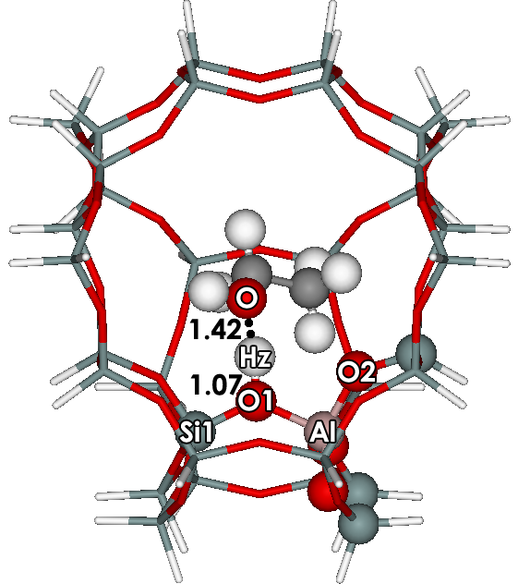 | 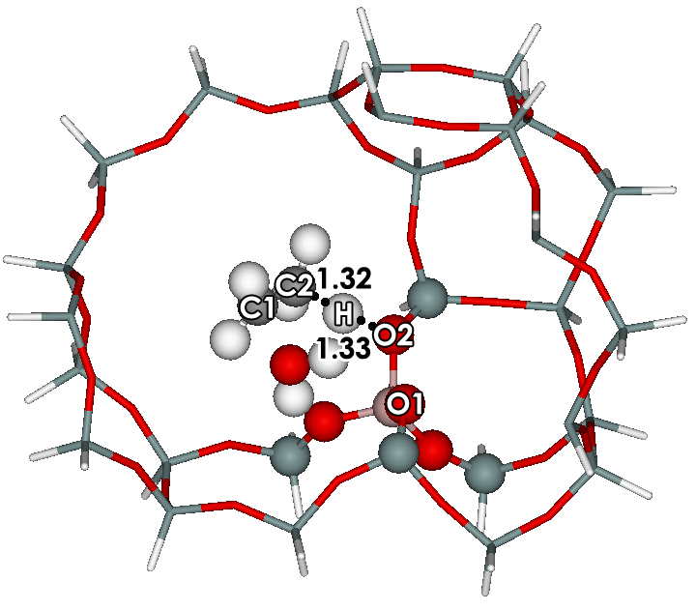
AD-Al-1A | TSc-Al
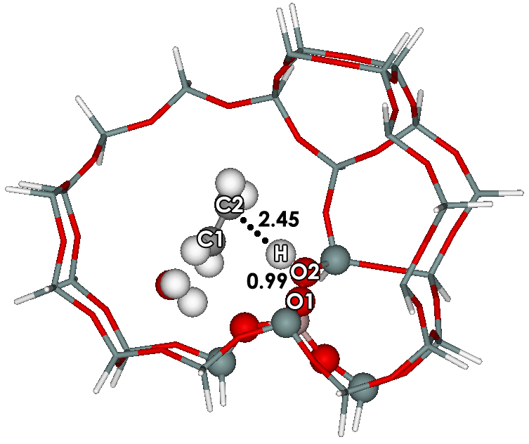 | 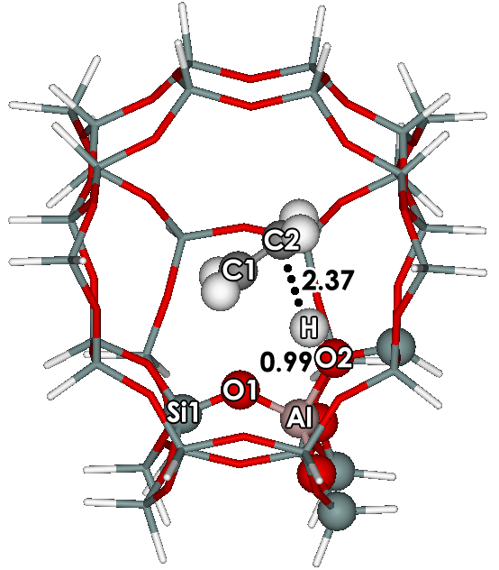
INc-Al | PRc-Al
Figure S9 The concerted mechanism of ethanol to ethylene on the Al-ZSM-5 zeolites with
ONIOM 5T:34T MP2/6-31G(d,p):M06-2X/6-31G(d,p). Distances are in Å.

Table S16: Selected structural parameters and energies for the stepwise mechanism on the H-[Al]-ZSM-5 zeolites.
 | AD-Al-1A | TSc-Al | INc-Al | PRc-Al
Distance (Å)
Si1-O1 | 1.64 | 1.59 | 1.59 | 1.59
Si2-O2 | 1.58 | 1.63 | 1.67 | 1.66
Al-Hz | 2.44 | 3.02 | 3.43 | -
Al-O1 | 1.80 | 1.70 | 1.68 | 1.69
Al-O2 | 1.69 | 1.77 | 1.83 | 1.83
Hz-O | 1.42 | 0.97 | 0.97 | -
O1-Hz | 1.07 | 2.24 | 3.62 | -
O2-H | 2.83 | 1.33 | 0.99 | 0.99
C1-C2 | 1.51 | 1.38 | 1.34 | 1.34
C1-O | 1.46 | 2.22 | 4.26 | -
C2-H | 1.09 | 1..32 | 2.45 | 2.37
Angle (º)
Si1-O1-Al | 127.57 | 128.28 | 126.16 | 127.69
Si2-O2-Al | 136.29 | 132.34 | 133.73 | 132.88
Table S17 Relative energies of ethylene on the H-[Al]-ZSM-5 zeolites from ONIOM 5T:34T MP2/6-31G (d,p):M06-2X/6-31G(d,p) calculations. Energies are given in kcal/mol. Total Activation energy are in parenthesis.
 | AD-Al-1A | TSc-Al | INc-Al | PRc-1A
ONIOM ª | -24.3 | 24.8 | 0.2 | 9.7
 |  | (49.1)
MP2 ^{b} | -16.4 | 31.1 | 8.8 | 15.3
 |  | (47.5)
Framework ^{c} | -8.0 | -6.3 | -8.5 | -5.6
ONIOM ^{d} | -21.3 | 26.3 | 1.8 | 6.2
 |  | (47.6)
MP2 ^{b} | -14.7 | 30.3 | 6.5 | 10.6
 |  | (45.0)
Framework ^{c} | -6.6 | -4.0 | -4.7 | -4.3
Embedded ONIOM ^{f} | -23.3 | 19.3 | -4.4 | 5.1
 |  | (42.6)
MP2 ^{g} | -17.1 | 25.3 | 4.3 | 11.2
 |  | (42.4)
Framework ^{c} | -6.2 | -6.0 | -8.7 | -6.2
ª ONIOM(MP2/6-31G(d,p):M06-2X/6-31G(d,p) model 5T:34T
^{b} MP2/6-31G(d,p)//ONIOM(MP2/6-31G(d,p):M06-2X/6-31G(d,p) model 5T//5T:34T
^{c} E_{ONIOM} – E_{high level}
^{d} ONIOM(MP2/6-311+G(2df,2p):M06-2X/6-311+G(2df,2p))//ONIOM(MP2/6-31G(d,p):M06-2X/6-31G(d,p) model 5T:34T
^{e} MP2/6-311+G(2df,2p)//ONIOM(MP2/6-31G(d,p):M06-2X/6-31G(d,p) model 5T//5T:34T
^{f} ONIOM(MP2/6-311+G(2df,2p):M06-2X/6-311+G(2df,2p))//ONIOM(MP2/6-31G(d,p):M06-2X/6-31G(d,p) with charge model 5T:34T
^{g} MP2/6-311+G(2df,2p)//ONIOM(MP2/6-31G(d,p):M06-2X/6-31G(d,p) with charge model 5T//5T:34T

4.3 The dehydration reaction of ethanol to ethylene on H-[Ga]-ZSM-5 zeolite
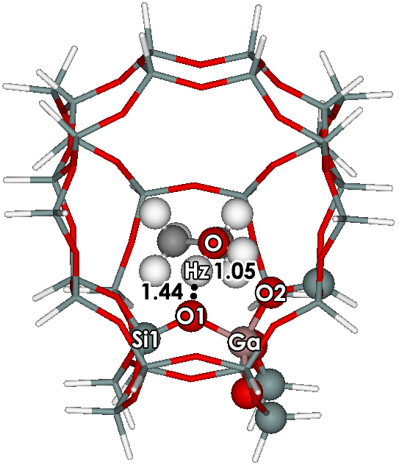 | 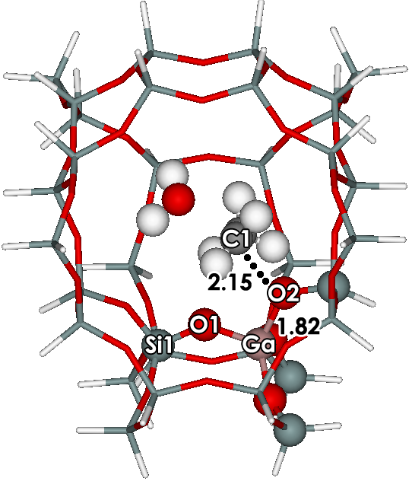
AD-Ga-1C | TS1-Ga
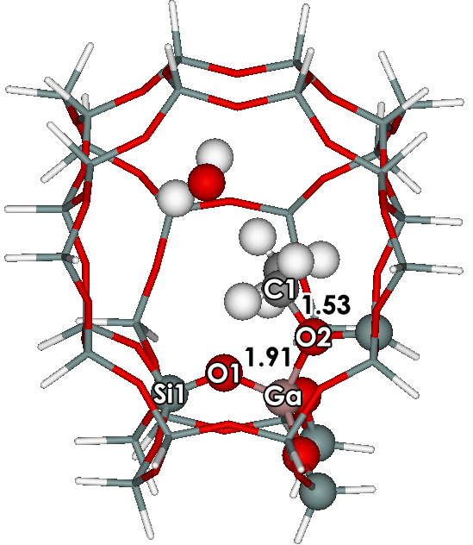 | 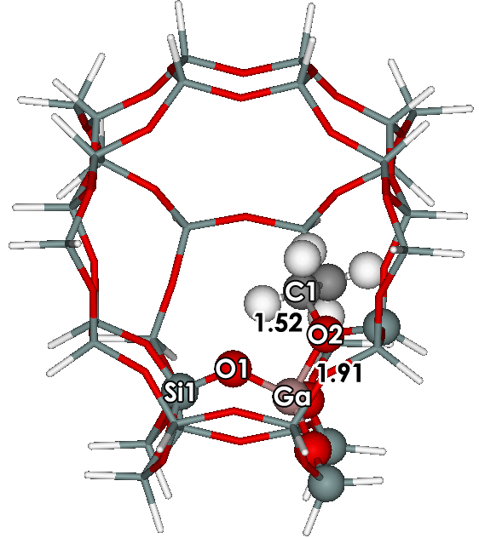
IN1-Ga | IN2-Ga
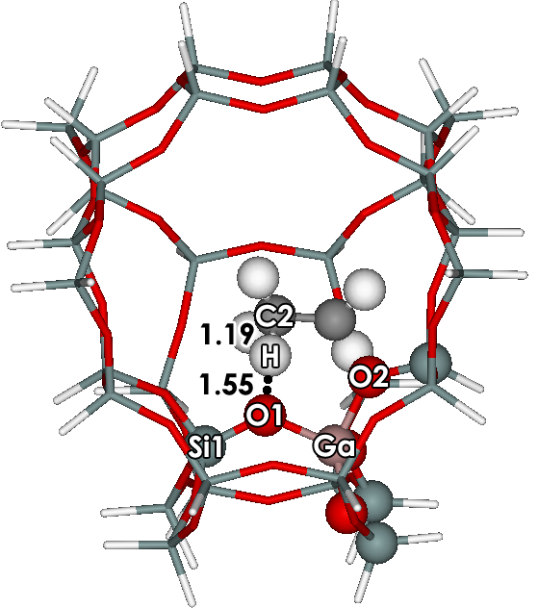 | 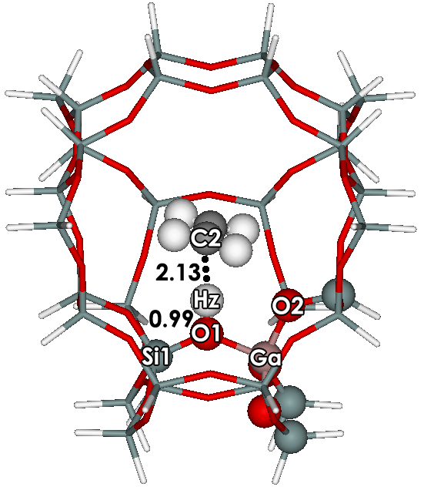
TS2-Ga | PR-Ga
Figure S10 The optimized structures of ethanol to ethylene on the Ga-ZSM-5 zeolites with
ONIOM 5T:34T MP2/6-31G(d,p):M06-2X/6-31G(d,p). Distances are in Å.

Table S18: Selected structural parameters and energies for the stepwise mechanism on the H-[Ga]-ZSM-5 zeolites.
 | AD-Ga-1C | TS1-Ga | IN1-Ga | IN2-Ga | TS2-Ga | PR-Ga
Distance (Å)
Si1-O1 | 1.60 | 1.56 | 1.56 | 1.57 | 1.59 | 1.65
Si2-O2 | 1.59 | 1.60 | 1.67 | 1.67 | 1.59 | 1.58
Ga-Hz | 2.61 | 4.90 | 5.95 | - | - | -
Ga-O1 | 1.81 | 1.78 | 1.74 | 1.74 | 1.80 | 1.89
Ga-O2 | 1.80 | 1.82 | 1.91 | 1.91 | 1.81 | 1.75
Hz-O | 1.05 | 0.97 | 0.97 | - | - | -
O1-Hz | 1.44 | 3.47 | 4.73 | - | - | -
O1-H | 3.11 | 2.88 | 2.99 | 3.97 | 1.55 | 0.99
C1-C2 | 1.51 | 1.48 | 1.50 | 1.51 | 1.40 | 1.34
C1-O2 | 3.27 | 2.15 | 1.53 | 1.52 | 2.27 | 3.31
C1-O | 1.49 | 2.10 | 3.40 | - | - | -
C2-H | 1.09 | 1.09 | 1.09 | 1.09 | 1.19 | 2.13
Angle (º)
Si1-O1-Ga | 126.16 | 127.88 | 128.78 | 123.57 | 126.01 | 128.75
Si2-O2-Ga | 132.09 | 127.84 | 124.06 | 127.3 | 129.69 | 128.20

Table S19 Relative energies of ethylene on the H-[Ga]-ZSM-5 zeolites from ONIOM 5T:34T MP2/6-31G (d,p):M06-2X/6-31G(d,p) calculations. Energies are given in kcal/mol. Total Activation energy are in parenthesis.
 | AD-Ga-1C | TS1-Ga | IN1-Ga | IN2-Ga |  | TS2-Ga | PR-Ga
ONIOM ª | -33.0 | 9.3 | -11.8 |  | 0.8 | 31.9 | 5.8
 |  | (42.3) |  |  |  | (31.1)
MP2 ^{b} | -24.4 | 26.8 | -0.3 |  | 1.5 | 39.0 | 10.2
 |  | (51.2) |  |  |  | (37.5)
Framework ^{c} | -8.6 | -17.5 | -11.6 |  | -0.7 | -7.1 | -4.3
ONIOM ^{d} | -25.1 | 16.5 | -5.2 |  | 3.1 | 33.4 | 2.5
 |  | (41.6) |  |  |  | (30.3)
MP2 ^{b} | -18.0 | 29.5 | 1.4 |  | 1.9 | 38.2 | 6.3
 |  | (47.5) |  |  |  | (36.3)
Framework ^{c} | -7.1 | -13.0 | -6.6 |  | 1.2 | -4.8 | -3.8
Embedded ONIOM ^{f} | -27.7 | 13.4 | -6.0 |  | 0.4 | 29.5 | 0.9
 |  | (41.1) |  |  |  | (29.1)
MP2 ^{g} | -20.2 | 24.8 | 1.8 |  | 0.8 | 34.3 | 5.1
 |  | (45.0) |  |  |  | (33.5)
Framework ^{c} | -7.5 | -11.4 | -7.8 |  | -0.4 | -4.8 | -4.2
ª ONIOM(MP2/6-31G(d,p):M06-2X/6-31G(d,p) model 5T:34T
^{b} MP2/6-31G(d,p)//ONIOM(MP2/6-31G(d,p):M06-2X/6-31G(d,p) model 5T//5T:34T
^{c} E_{ONIOM} – E_{high level}
^{d} ONIOM(MP2/6-311+G(2df,2p):M06-2X/6-311+G(2df,2p))//ONIOM(MP2/6-31G(d,p):M06-2X/6-31G(d,p) model 5T:34T
^{e} MP2/6-311+G(2df,2p)//ONIOM(MP2/6-31G(d,p):M06-2X/6-31G(d,p) model 5T//5T:34T
^{f} ONIOM(MP2/6-311+G(2df,2p):M06-2X/6-311+G(2df,2p))//ONIOM(MP2/6-31G(d,p):M06-2X/6-31G(d,p) with charge model 5T:34T
^{g} MP2/6-311+G(2df,2p)//ONIOM(MP2/6-31G(d,p):M06-2X/6-31G(d,p) with charge model 5T//5T:34T

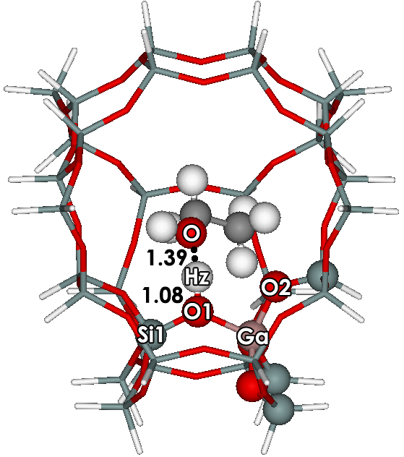 | 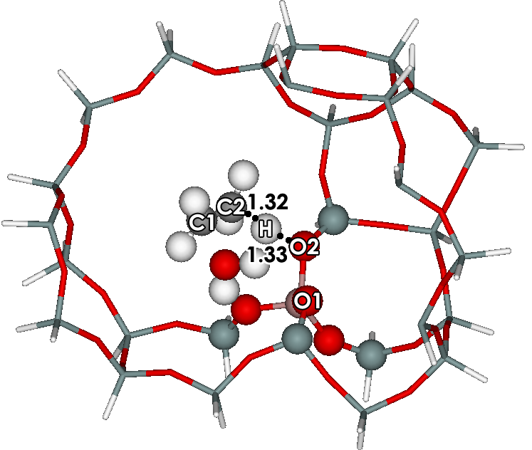
AD-Ga-1A | TSc-Ga
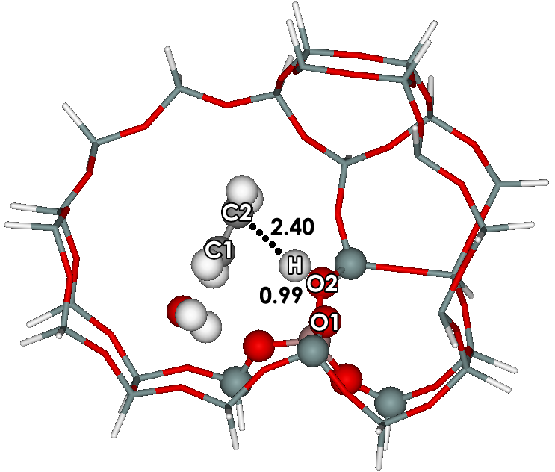 | 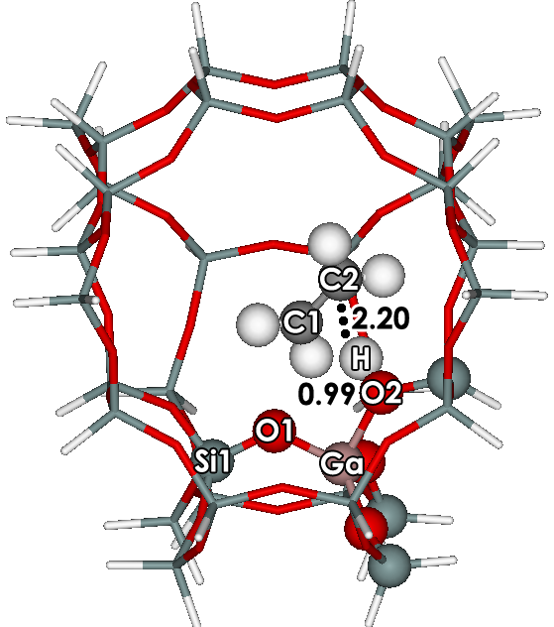
INc-Ga | PRc-Ga
Figure S11 The concerted mechanism of ethanol to ethylene on the Ga-ZSM-5 zeolites with
ONIOM 5T:34T MP2/6-31G(d,p):M06-2X/6-31G(d,p). Distances are in Å.

Table S20: Selected structural parameters and energies for the stepwise mechanism on the H-[Ga]-ZSM-5 zeolites.
 | AD-Ga-1A | TSc-Ga | INc-Ga | PRc-Ga
Distance (Å)
Si1-O1 | 1.63 | 1.58 | 1.58 | 1.57
Si2-O2 | 1.57 | 1.62 | 1.67 | 1.65
Ga-Hz | 2.50 | 2.91 | 3.45 | -
Ga-O1 | 1.87 | 1.76 | 1.74 | 1.74
Ga-O2 | 1.75 | 1.83 | 1.91 | 1.91
Hz-O | 1.39 | 0.97 | 0.97 | -
O1-Hz | 1.08 | 2.09 | 3.71 | -
O2-H | 2.88 | 1.33 | 0.99 | 0.99
C1-C2 | 1.51 | 1.38 | 1.34 | 1.34
C1-O | 1.46 | 2.33 | 4.28 | -
C2-H | 1.09 | 1.32 | 2.40 | 2.20
Angle (º)
Si1-O1-Ga | 127.01 | 123.68 | 120.72 | 122.75
Si2-O2-Ga | 130.31 | 130.93 | 134.04 | 133.58

Table S21 Relative energies of ethylene on the H-[Ga]-ZSM-5 zeolites from ONIOM 5T:34T MP2/6-31G (d,p):M06-2X/6-31G(d,p) calculations. Energies are given in kcal/mol. Total Activation energy are in parenthesis.
 | AD-Ga-1A | TSc-Ga | INc-Ga | PRc-Ga
ONIOM ª | -26.4 | 21.5 | -0.5 | 10.0
 |  | (47.9)
MP2 ^{b} | -18.0 | 27.2 | 7.9 | 14.7
 |  | (45.2)
Framework ^{c} | -8.4 | -5.7 | -8.4 | -4.7
ONIOM ^{d} | -20.9 | 27.0 | 3.5 | 8.5
 |  | (47.9)
MP2 ^{b} | -14.2 | 30.3 | 7.6 | 11.6
 |  | (44.5)
Framework ^{c} | -6.8 | -3.3 | -4.0 | -3.1
Embedded ONIOM ^{f} | -23.2 | 20.4 | -2.0 | 7.4
 |  | (43.6)
MP2 ^{g} | -16.8 | 25.3 | 5.6 | 11.7
 |  | (42.1)
Framework ^{c} | -6.4 | -4.9 | -7.6 | -4.3
ª ONIOM(MP2/6-31G(d,p):M06-2X/6-31G(d,p) model 5T:34T
^{b} MP2/6-31G(d,p)//ONIOM(MP2/6-31G(d,p):M06-2X/6-31G(d,p) model 5T//5T:34T
^{c} E_{ONIOM} – E_{high level}
^{d} ONIOM(MP2/6-311+G(2df,2p):M06-2X/6-311+G(2df,2p))//ONIOM(MP2/6-31G(d,p):M06-2X/6-31G(d,p) model 5T:34T
^{e} MP2/6-311+G(2df,2p)//ONIOM(MP2/6-31G(d,p):M06-2X/6-31G(d,p) model 5T//5T:34T
^{f} ONIOM(MP2/6-311+G(2df,2p):M06-2X/6-311+G(2df,2p))//ONIOM(MP2/6-31G(d,p):M06-2X/6-31G(d,p) with charge model 5T:34T
^{g} MP2/6-311+G(2df,2p)//ONIOM(MP2/6-31G(d,p):M06-2X/6-31G(d,p) with charge model 5T//5T:34T

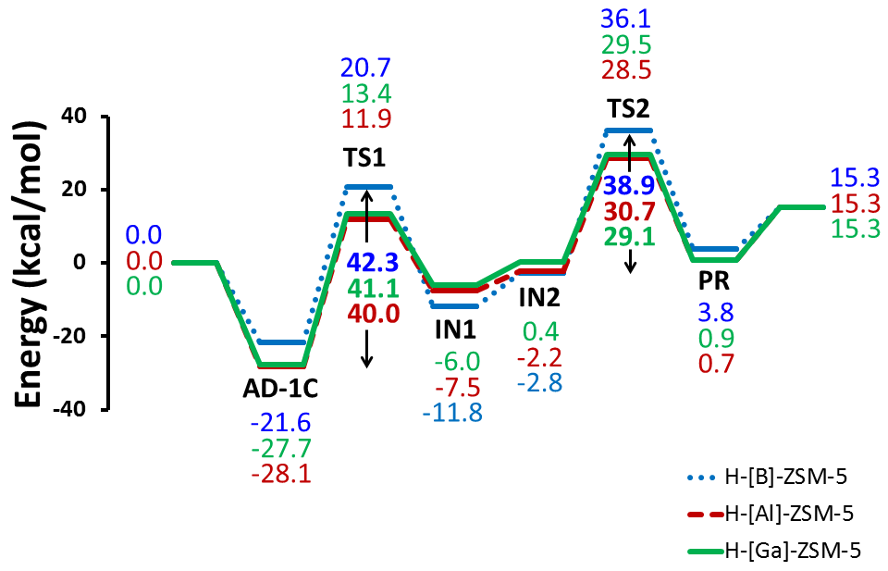

Figure S12 Energy profiles for the stepwise mechanism of on the three zeolites H-[B]-ZSM-5, H-[Al]-ZSM-5 and H-[Ga]-ZSM-5 zeolites as calculated with the embedded ONIOM (MP2/6-311+G(2df,2p):M06-2X/6-311+G(2df,2p)) // ONIOM (MP2/6-31G(d,p):M06-2X/6-31G(d,p)).
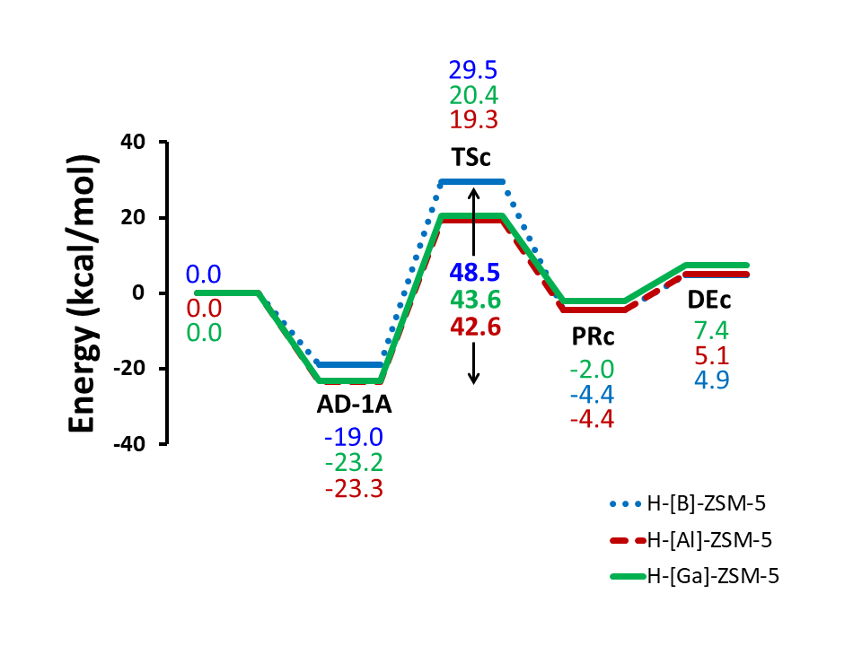

Figure S13 Energy profiles for the concerted mechanism of on the three zeolites H-[B]-ZSM-5, H-[Al]-ZSM-5 and H-[Ga]-ZSM-5 zeolites as calculated with the embedded ONIOM (MP2/6-311+G(2df,2p):M06-2X/6-311+G(2df,2p)) // ONIOM (MP2/6-31G(d,p):M06-2X/6-31G(d,p)).

