Synergistic Response of Phycosphere Bacteria with Microalga Phaeodactylum tricornutum under the 2,6-Di-tert-butyl-p-cresol Stress
Xiao Lu ^{a,b}, Jie Liu ^{a,b}, Xinfeng Xiao ª, Jianliang Xue ^{a,b}, Dongle Cheng ^{a,b}, Linlin Zhang ^{a,b} *
a. College of Safety and Environment Engineering, Shandong University of Science & Technology, Qingdao 266510, China
b. Institute of Yellow River Delta Earth Surface Processes and Ecological Integrity, Shandong University of Science & Technology, Qingdao 266510, China
*Correspondence: linlinzhsd@126.com

Table S1. Quality evaluation of transcriptome data from different groups
Sample | Clean reads | Q20 (%) | Q30 (%) | GC content (%)
Control-1 | 41842914 | 96.02 | 93.59 | 51.17
Control-2 | 42756490 | 96.27 | 93.96 | 51.06
Control-3 | 42938162 | 96.18 | 93.86 | 51.3
LC-BHT-1 | 45975816 | 96.11 | 93.72 | 51.04
LC-BHT-2 | 43027892 | 95.91 | 93.42 | 51.01
LC-BHT-3 | 44102342 | 96.1 | 93.73 | 50.91
HC-BHT-1 | 40357962 | 98.25 | 94.5 | 50.92
HC-BHT-2 | 48596048 | 98.37 | 94.81 | 51.64
HC-BHT-3 | 42435918 | 98.27 | 94.55 | 51.63

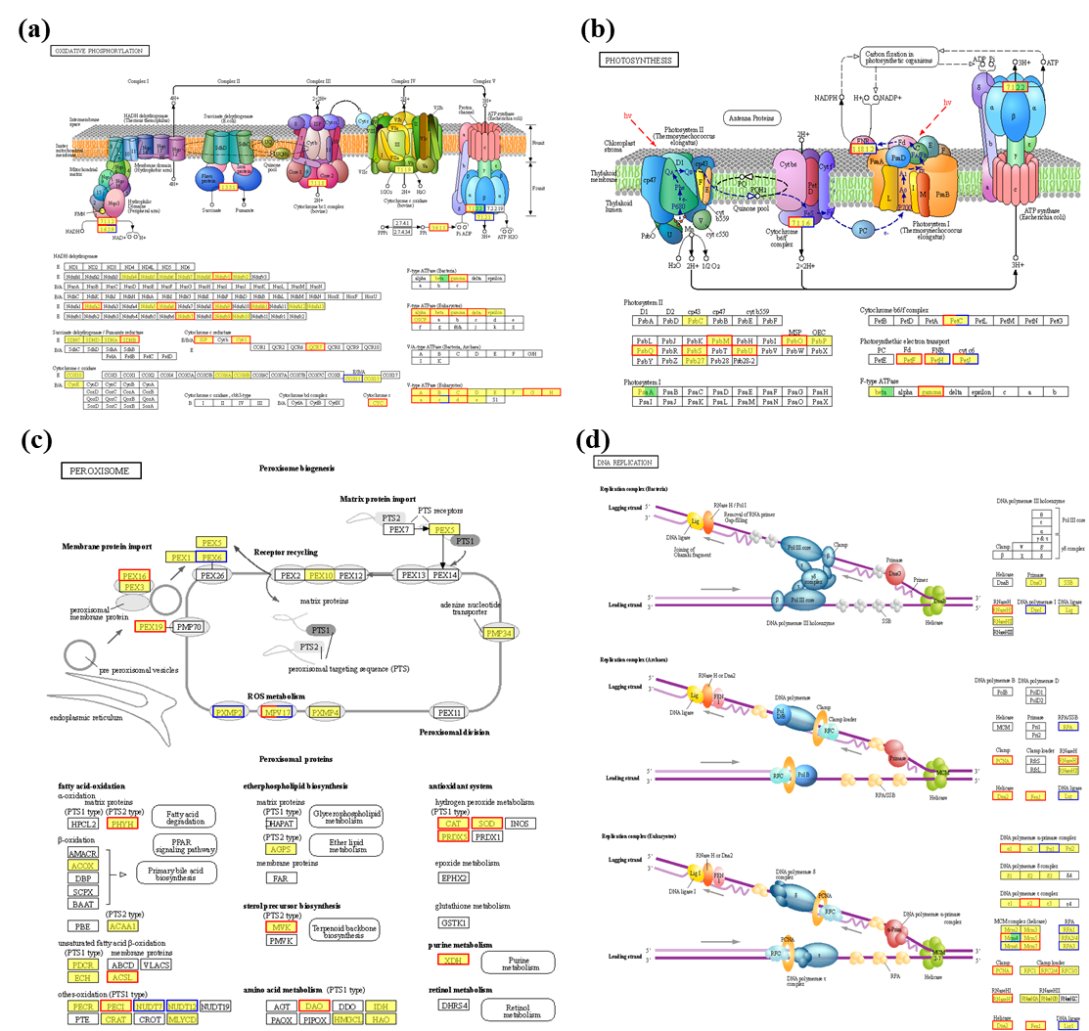
Fig. S1. DEGs annotations in the KEGG pathways under HC-BHT treatment, compared to the control. (a): oxidative phosphorylation; (b): photosystem; (c): peroxisome; (d): DNA replication.

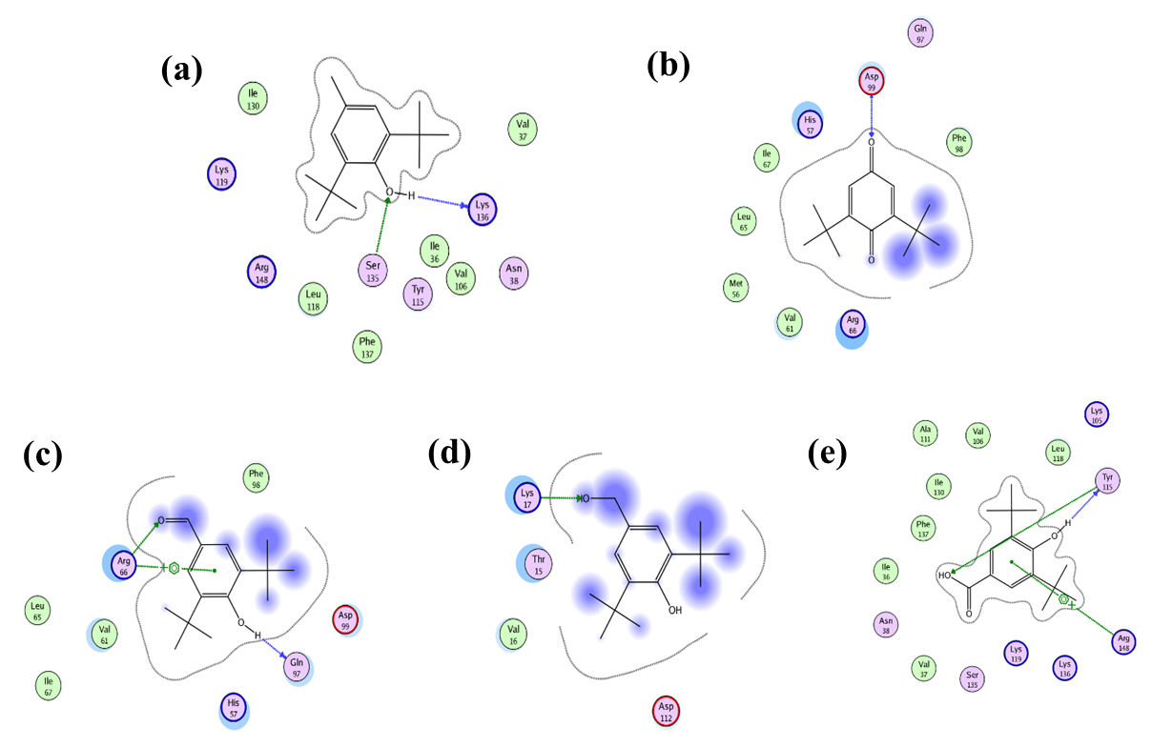
Fig. S2. Molecular docking simulation of BHT (a), BHT-Q (b), BHT-CHO(c), BHT-OH(d) and BHT-COOH (e), with aglutathione reductase of P. tricornutum cells.

Fig. S3. Bacterial community structure of BHT with different concentration at phylum level.

