Supplementary Material
Catalogue
1 VIF covariance diagnostics 1
2 Threshold effect test 1
3 Threshold and confidence intervals 1
4 Machine Learning Model Evaluation and Selection 2
5 Ranking of importance of impact factors 4
6. Interaction Effects of Female and Other Variables on HCE 5
7 Regional heterogeneity of women's impact on household carbon emissions 6
8 Supplementary Notes 7
8.1 Accounting for Household Carbon Emissions 7
8.2 Introduction to machine learning datasets 9
Reference 11

1 VIF covariance diagnostics
Table 1 VIF covariance diagnostics
Variable | VIF
X₄ | 1.97
X₇ | 1.77
X₅ | 1.70
X₃ | 1.46
X₂ | 1.30
lnX₆ | 1.23
lnX₈ | 1.15
X₁ | 1.09

2 Threshold effect test
Table 2 Threshold effect test
 | Model 1 | Model 2 | Model 3 | Model 4 | Model 5 | Model 6 | Model 7
Single | 496.56*** | 241.17*** | 190.45*** | 148.00*** | 181.73*** | 176.23*** | 198.67***
Single | (0.000) | (0.000) | (0.000) | (0.000) | (0.000) | (0.000) | (0.000)
Double | 70.66** | 64.03** | 62.25** | 57.09** | 91.9*** | 93.99*** | 146.96***
Double | (0.043) | (0.041) | (0.021) | (0.020) | (0.003) | (0.003) | (0.000)
Note：Standard errors in parentheses, * p < 0.1, ** p < 0.05, *** p < 0.01

3 Threshold and confidence intervals
Table 3 Threshold and confidence intervals
 | Threshold estimated value (Single) | 95% confidence interval (Single) | Threshold estimated value (Double) | 95% confidence interval (Double)
Model 1 | 10.11(24587) | [10.08,10.11] | 9.49(13226) | [9.44,9.49]
Model 2 | 10.11(24587) | [10.08,10.11] | 9.61(14913) | [9.51,9.59]
Model 3 | 10.09(24100) | [10.06,10.09] | 9.58(14427) | [9.57,9.58]
Model 4 | 10.05(23155) | [10.02,10.05] | 9.58(14472) | [9.57,9.58]
Model 5 | 10.01(22247) | [9.99,10.01] | 9.44(12581) | [9.41,9.44]
Model 6 | 10.01(22247) | [10.00,10.02] | 9.44(12581) | [9.41,9.44]
Model 7 | 9.46(12835) | [9.44,9.46] | 10.05(23155) | [10.03,10.05]
Note：Values in parentheses indicate the original values of the threshold variables after conversion.

4 Machine Learning Model Evaluation and Selection
Fig. 1 Comparison of the results of different machine learning prediction models. a-d denote the prediction results of the four models, RF, GBDT, XGBoost, and DT, respectively, where the goodness-of-fit R2 is 0.943, 0.921, 0.929, and 0.881, respectively.
Fig. 2 Learning curves of different machine learning. In order to determine the underfitting and overfitting problems of the models, we chose two evaluation metrics, R2 and RMSE, to plot the learning curves of the four models, RF, GBDT, XGBoost, and DT, respectively. As shown in Figs. a-d and e-h, it can be seen from the learning curves of R2 that all models except RF (Fig. a) suffer from the overfitting problem because all the other three models show very perfect goodness of fit on the training set but perform poorly on the validation set. Similarly, from the learning curves of RMSE, all models except RF (Fig. e) have obvious overfitting. Combined with Fig. 1, RF has a higher goodness of fit than the other four models and does not suffer from overfitting, so this predictive model of RF is chosen in this paper as the basis for the SHAP interpretation.

5 Ranking of importance of impact factors
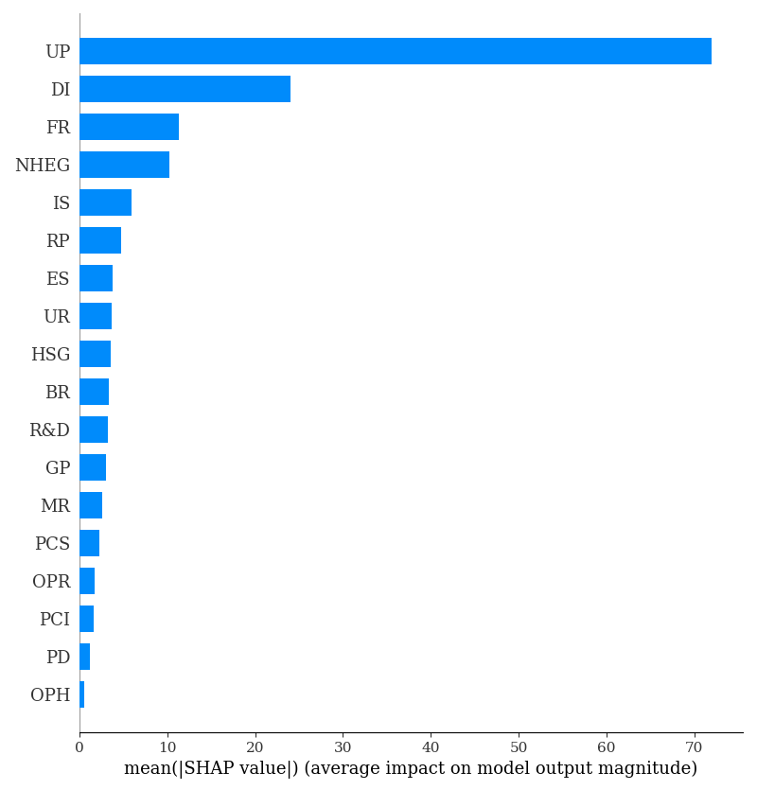
Figure 3 Random forest variables ranked in order of importance (refer to Supplementary Notes for a description of the variables in the figure)

6. Interaction Effects of Female and Other Variables on HCE
Figure 4 Interaction effects of females with other factors on household carbon emissions based on the SHAP model interpreter. a-d explain the interaction effects of females with single-person households, the proportion of elderly people, the number of tertiary education graduates, and disposable income. The x-axis of the figure represents the magnitude of the baseline eigenvalue, the y-axis (right) represents the magnitude of the eigenvalue with which it interacts (high in red, low in blue), and the y-axis (left) represents the SHAP value corresponding to the baseline eigenvalue. For example, Figure a represents the effect of FR on household carbon emissions when the UR varies in the range of -1 ~ 1.

7 Regional heterogeneity of women's impact on household carbon emissions
Figure 5 Regional heterogeneity of women's impact on household carbon emissions. a-f denote the impact of each explanatory variable on household carbon emissions in Guizhou, Heilongjiang, and Qinghai, representative provinces of China's three major regions (Southwest, Northeast, and Northwest) in 2005 and 2019.

8 Supplementary Notes

8.1 Accounting for Household Carbon Emissions
Referring to Wei, YM's definition of the food production industry (Wei et al., 2007), this paper defines the eight consumption types and their industry sectors for this study based on the industry classification standards of the national economy (GBT 4754-2011, GBT 4754-2017), as well as the industry divisions of the China Energy Statistical Yearbook and the Input-Output Table, as shown in Table 4. Referring to the suggestion of Wei et al. (Wei et al., 2007), household carbon emissions are categorized into direct carbon emissions and indirect carbon emissions. Therefore, the household carbon emissions are calculated as follows:
where E_{f} is direct carbon emissions and E_{i} is indirect carbon emissions.
Calculation of direct carbon emissions
Referring to the IPCC Guidelines for National Greenhouse Gas Inventories, the HCE direct carbon emission accounting formula is as follows:
E_{f} denotes the carbon emission from direct energy consumption of HCE (unit: tCO2), Fm denotes the actual consumption of the mth type of energy in each sector of the nth food production industry, NVC_{m} denotes the low-level heating value of the mth type of energy (unit: TJ/104(10⁸m3)), CC_{m} denotes the carbon content per unit of calorific value of the mth type of energy (unit: Tc/TJ), Om denotes the carbon oxidization rate (%) of the mth type of fossil fuel (in Tc/TJ), O_{m} denotes the carbon oxidation rate (%) of the mth fossil fuel, and m denotes the mth energy source. The types of energy involved are raw coal, washed coal, other washed coal, coke, coke-oven gas, other gases, other coking products, crude oil, gasoline, kerosene, diesel oil, fuel oil, and natural gas.
Calculation of Indirect Carbon Emissions
Referring to the calculation method of Wei et al. (Wei et al., 2007), the formula for calculating indirect carbon emissions is as follows:
Where: DE denotes the direct carbon emission intensity of energy consumption of the corresponding industry sector n of the food production industry (unit: t CO2/million yuan); E_{f,n} denotes the direct carbon emission of the nth sector (unit: tCO2), which can be calculated by referring to (1.1); G_{n} denotes the gross domestic product of the nth sector (unit: million yuan); CI denotes the implied carbon emission intensity of the food production industry (unit: t CO2/million yuan); I is the unit matrix, A is the direct consumption coefficient matrix of rubbing into the output table, andis the complete demand coefficient matrix; Ei is the indirect carbon emission of CEFI (unit: tCO2); and EX denotes the consumption expenditure of residents in the food production industry (unit: yuan).
Since the input-output tables only provide data for 2002, 2007, 2012 and 2017, this paper draws on the methodology of Liu et al. (X. Y. Liu et al., 2019) for the CIs of 2003-2019 as follows:
Wheredenotes the vector of the direct carbon intensity of the food production sector in year K (consisting of the direct carbon intensity of each sector), anddenotes the matrix of full demand coefficients in year K.

Table 4 Calculation boundary delimitation
Consumption type | Related industry
Food | Agriculture, forestry, livestock, fisheries and water; food and tobacco (production, processing)
Clothing | Textiles; textile clothing shoes, hats leather down
Residency | Non-metallic mineral products; fabricated metal products; water production and supply chain; construction
Home equipment supplies | Wood processing; furniture manufacturing; electrical machinery and equipment manufacturing
Medical care | Pharmaceutical manufacturing
Entertainment | Paper, printing and culture, education and sports; printing and recording media reproduction; culture, sports and recreation
Transportation and Communication | Transportation equipment; communications equipment, computers and other electronic equipment; transportation, storage and postal services
Other | Wholesale and retail trade

8.2 Introduction to machine learning datasets
Table 5 Machine learning dataset supplement and data sources
Abbreviation | Descriptive | Source | Literature source
GP | No. of green patents | CPOD, COD | (Lian et al., 2023)
PD | Population density | CSY | (J. B. Liu et al., 2023)
HSG | Number of high school graduates | CSY | (Cao et al., 2019)
UR | Urbanization rate | CSY | (C. L. Zhang et al., 2016)
OPH | Proportion of one-person households | CSY | (X. L. Zhang et al., 2023)
PCS | Per capita housing space | CSY | (Yan et al., 2020)
BR | Birth rate | CSY | (Huang et al., 2019)
UP | Urban population | CSY | (Yuan et al., 2019)
RP | Rural population | CSY | (Fan et al., 2021)
Note: CSY stands for China Statistical Yearbook, CPOD stands for China Patent Online Database, and COD stands for CnOpenData.

Reference
Cao, Q. R., Kang, W., Xu, S. C., Sajid, M. J., & Cao, M., 2019. Estimation and decomposition analysis of carbon emissions from the entire production cycle for Chinese household consumption. Journal of Environmental Management. 247, 525-537. doi:10.1016/j.jenvman.2019.06.044.
Fan, J. S., Zhou, L., Zhang, Y., Shao, S., & Ma, M., 2021. How does population aging affect household carbon emissions? Evidence from Chinese urban and rural areas. Energy Economics. 100. doi:10.1016/j.eneco.2021.105356.
Huang, Y. Z., Shigetomi, Y., Chapman, A., & Matsumoto, K., 2019. Uncovering Household Carbon Footprint Drivers in an Aging, Shrinking Society. Energies. 12(19). doi:10.3390/en12193745.
Lian, Y. H., Lin, X. Y., Luo, H. Y., Niu, Y., & Zhang, J. H., 2023. Empirical research on household consumption carbon emissions and key impact factors in urban and rural China. Environmental Science and Pollution Research. 30(22), 62423-62439. doi:10.1007/s11356-023-26292-y.
Liu, J. B., Peng, X. B., & Zhao, J., 2023. Analyzing the spatial association of household consumption carbon emission structure based on social network. Journal of Combinatorial Optimization. 45(2). doi:10.1007/s10878-023-01004-x.
Liu, X. Y., Wang, X. E., Song, J. N., Wang, H. N., & Wang, S. O., 2019. Indirect carbon emissions of urban households in China: Patterns, determinants and inequality. Journal of Cleaner Production. 241. doi:https://doi.org/10.1016/j.jclepro.2019.118335.
Wei, Y. M., Liu, L. C., Fan, Y., & Wu, G., 2007. The impact of lifestyle on energy use and CO(2) emission: An empirical analysis of China's residents. Energy Policy. 35(1), 247-257. doi:https://doi.org/10.1016/j.enpol.2005.11.020.
Yan, Y. M., Zhang, H. R., Long, Y., Zhou, X. Y., Liao, Q., Xu, N., & Liang, Y. T., 2020. A factor-based bottom-up approach for the long-term electricity consumption estimation in the Japanese residential sector. Journal of Environmental Management. 270. doi:10.1016/j.jenvman.2020.110750.
Yuan, R., Rodrigues, J. F. D., & Behrens, P., 2019. Driving forces of household carbon emissions in China: A spatial decomposition analysis. Journal of Cleaner Production. 233, 932-945. doi:10.1016/j.jclepro.2019.06.110.
Zhang, C. L., Ma, D., & Shan, B. G. 2016, Aug 13-14. Modeling energy consumption and carbon emission in China's household sector. Paper presented at the 6th International Conference on Mechatronics, Materials, Biotechnology and Environment (ICMMBE), Yinchuan, PEOPLES R CHINA.
Zhang, X. L., Wang, J., Pan, H. Z., Yuan, Z. H., & Feng, K. S., 2023. Changes in the socio-economic characteristics of households can decouple carbon emissions and consumption growth in China. Sustainable Production and Consumption. 43, 168-180. doi:10.1016/j.spc.2023.10.019.

