Supporting Information
Journal of Polymer Research

Advancing the 3D printing of magnetoactive epoxy shape memory composites: correlating the rheology, printability, and shape fidelity

Mohammad Hossein Zamani and Zoubeida Ounaies*

Department of Mechanical Engineering, Pennsylvania State University, University Park, Pennsylvania, USA
E-mail: zxo100@psu.edu

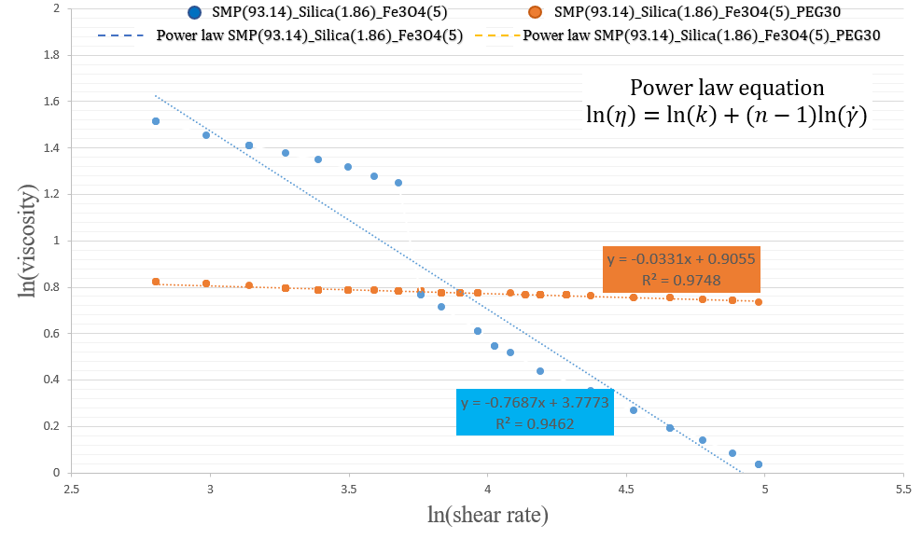
Fig. S1 Power law curve fitting to 5wt.% Fe₃O₄-loade SMP
Fig. S2 Power law curve fitting to surface treated Fe₃O₄-loade SMP
