Single-Atom Zr Promoter Boosts Oxygen Activation on Ceria-Supported Pt Catalysts
Weixin Huang^{a†}, Hao Xu^{a†}, Shih-Wei Lin^{b}, Hien N. Pham^{c}, Rui Zhangª, Dong Jiangª, Zihao Zhang^{a, d}, Andrew DeLaRiva^{c}, Shuxuan Feng^{e}, Yixiao Liª, Xinrui Zhang^{f}, Abhaya K. Datye^{c}, Chih-Jung Chen^{b, g*} and Yong Wang^{a, d*}
ªThe Gene and Linda Voiland School of Chemical Engineering and Bioengineering, Washington State University, Pullman, WA 99164, USA
^{b}Graduate School of Advanced Technology, National Taiwan University, Taipei 10617, Taiwan
^{c}Department of Chemical and Biological Engineering, and Center for Microengineered Materials, University of New Mexico, Albuquerque, NM 87131, USA
^{d}Institute for Integrated Catalysis, Pacific Northwest National Laboratory, Richland, WA 99354, USA
^{e}Department of Chemistry, University of North Dakota, Grand Forks, ND 58202, USA
^{f}Department of Materials Science and Engineering, Northwestern University, Evanston, IL 60208, USA
^{g}Global Undergraduate Program in Semiconductors, National Taiwan University, Taipei 10617, Taiwan
†These authors contributed equally.
E-mail: chihjungchen@ntu.edu.tw (C.-J. C.); wang42@wsu.edu (Y. W.)

1. Experimental Section
1.1 Catalysts Synthesis.
Tetraammineplatinum (II) nitrate (Pt(NH₃)₄(NO₃)₂, 99.995%), zirconium(IV) oxynitrate hydrate (ZrO(NO₃)₂·xH₂O, 99.99%) and cerium (III) nitrate hexahydrate (Ce(NO₃)₃·6H₂O, 99.999%) obtained from Sigma Aldrich were used as precursors. All the chemicals were used as received from the provider without further purification.
The 2 wt.% Zr₁-CeO₂ catalyst was synthesized using an atom-trapping approach. Initially, the CeO₂ support was prepared through the thermal decomposition of Ce(NO₃)₃·6H₂O at 350 °C in an air environment for a duration of 3 hours with a ramp rate of 1°C·min⁻¹. Subsequently, a precise quantity of ZrO(NO₃)₂·xH₂O (2 wt.% based on the CeO₂ foundation for Zr) was dissolved in 900 μL deionized water for the impregnation of 1 g CeO₂ powders. A 300 μL solution was introduced to CeO₂ powder, followed by drying the impregnated sample at 100 °C in an air environment for 2 hours. This procedure was repeated three times. Following this, the dried precursor underwent calcination in static air at 800 °C for 7 hours with a ramp rate of 5 °C·min⁻¹. The resulting sample was designated as Zr₁-CeO₂ or 2Zr-CeO₂. Other resulting samples were identified as 0.2Zr-CeO₂, 0.5Zr-CeO₂, 4Zr-CeO₂ and 6Zr-CeO₂, with Zr content of 0.2 wt.%, 0.5 wt.%, 4 wt.% and 6 wt.%, respectively.
The CZ samples utilized in this study were prepared using a co-precipitation method, employing Ce(NO₃)₃·6H₂O and ZrO(NO₃)₂·xH₂O as precursors, with NH₃·H₂O serving as the precipitating agent. Initially, a specific quantity of Ce(NO₃)₃·6H₂O and ZrO(NO₃)₂·xH₂O was dissolved in deionized water. Subsequently, NH₃·H₂O was carefully added dropwise to the solution until the pH reached 10. The resulting mixture was then allowed to age overnight, followed by thorough washing with deionized water and subsequent filtration. The obtained precipitate was dried in an oven under ambient air conditions at 120 °C for 12 hours, then pulverized into a powder and subjected to calcination at 500 °C for 4 hours, with a ramping rate of 5 °C·min⁻¹. The resulting samples were identified as CZ (or CZ02), and CZ10, with Zr content of 2 wt.% and 10 wt.%, respectively.
The oxide-supported catalysts with the loading of 0.9 wt.% Pt were synthesized by incipient wetness impregnation. The tetraammineplatinum (II) nitrate catalysts were impregnated on different oxide supports. After impregnation, the samples underwent an overnight drying process at 80 °C in an air environment. Following this, the dried precursors underwent calcination in static air at 800 °C for 7 hours with a ramp rate of 5 °C·min⁻¹.

1.2 Materials Characterization.
X-ray diffraction (XRD) measurements were conducted on a Rigaku SmartLab with the 2 Theta from 15 ° and 85 °, using a scanning rate of 1 °·min⁻¹ at a step of 0.01 °. The radiation used was Cu K-α with a wavelength of 0.154 nm. The visible Raman spectra (532 nm) were collected on a Horiba LabRAM Soleil Raman with a Synapse Charge Coupled Device (CCD) camera. All Raman spectra were conducted at room temperature. The laser power was 0.88 mW and the exposure time was 3 s. Scanning transmission electron microscopy (STEM) and energy-dispersive X-ray spectroscopy (EDS) mapping were carried out using a 200 kV aberration-corrected JEOL NEOARM 200CF. X-ray photoelectron spectra (XPS) were obtained using a Thermo Scientific ESCALAB 250 Xi instrument with Al Kα radiation (1486.6 eV). Argon sputtering for depth profiling involved employing an argon ion gun operated at a pressure of 2 x 10⁻⁵ Pa. The depth profiling was achieved through argon ion bombardment utilizing low-energy (3000 eV) Ar⁺ ions for a duration of 5 minutes. Spectra deconvolution and quantification were performed using the CasaXPS program. All elemental spectra were collected at the same analyzer pass energy. Quantitative analysis was achieved from the following equation: (N₁/N₂) = ((I₁S₂)/(I₂S₁)), where N is the concentration of atoms, I is the peak intensity of photoelectrons, and S is the atomic sensitivity factor provided by the instrument manufacturer. All spectra were calibrated to their corresponding C 1s (285.3 eV), and binding energy values for all fitted and assigned spectral peaks are stated with an accuracy of 0.2 eV. All X-ray absorption spectroscopy (XAS) characterizations, which include X-ray absorption near edge structure (XANES) and Extended X-ray absorption fine structure (EXAFS), were conducted at the National Synchrotron Radiation Research Center (NSRRC) in Hsinchu city, Taiwan. The Zr K-edge and Pt L-edge XAS analyses were carried out at the 01C1 and 17C1 beamlines, respectively. For these measurements, both the analyte and reference materials were affixed to 3M tapes, and the fluorescence mode was utilized to collect the XAS data.

1.3 Activity measurements.
CO, C₃H₈, and C₃H₆ oxidation experiments were conducted using a fixed bed flow reactor at atmospheric pressure. A catalyst weighing 20 mg, diluted by 150 mg of SiC, was packed between two quartz wool plugs inside a quartz tube (inner diameter of 1/4 inch). Before conducting the catalytic test, all catalysts were pre-treated at 350 °C for 0.5 h in flowing 10% O₂/Ar. For light-off tests, the catalyst bed was heated up in the reaction gas from room temperature to 350 °C or 500 °C with a ramp of 2 °C·min⁻¹. The gas composition was analyzed by an online ThermoStar GSD 320 T quadrupole mass spectrometer. For CO oxidation, the reaction gas consisted of 0.5 vol% CO and 5 vol% O₂ with Ar, with a total flow of 100 ml·min⁻¹ (GHSV of 30,000 L·g_{Pt}⁻¹·h⁻¹). For propane oxidation, the reaction gas consisted of 0.2 vol% propane and 1 vol% O₂ with Ar, with a total flow of 25 ml·min⁻¹ (GHSV of 7,500 L·g_{Pt}⁻¹·h⁻¹). For propylene oxidation, the reaction gas also consisted of 0.2 vol% propane and 1 vol% O₂ with Ar, with a total flow of 25 ml·min⁻¹ (GHSV of 7,500 L·g_{Pt}⁻¹·h⁻¹). In experiments studying the reduced catalysts, the reduction procedure involved heating the catalyst to 275 °C in Ar, reducing in 5% CO/He (50 ml·min⁻¹) for 30 min, and cooling down to room temperature in Ar.

1.4 Kinetic Studies.
The kinetic investigations were carried out on Pt₁/CeO₂ and Pt₁/Zr₁-CeO₂ by keeping the conversion of CO, C₃H₈ and C₃H₆ lower than 10%. Turnover frequency (TOF) was calculated using the number of CO, C₃H₈ and C₃H₆ molecules converted per second divided by the total number of Pt atoms that were loaded on CeO₂.

1.5 DRIFTS.
DRIFTS measurements were conducted on a Bruker Tensor 27 spectrometer equipped with a mercury-cadmium-telluride detector and a Harrick reaction cell. The sample underwent initial treatment in 10% O₂ (30 ml·min⁻¹) at 300 °C for 30 min, followed by cooling to 30 °C in He for background collection. Subsequently, the gas flow was switched to the reaction stream (50 ml·min⁻¹) mixed with CO (10%), O₂ (10%), and He (100%) for CO oxidation (1% CO + 4% O₂) and oxidative treatment (4% O₂). Throughout the measurements, DRIFTS spectra were collected every 1 min. The ramping rate for both heating up and cooling down during all measurements was set at 20 °C·min⁻¹.

1.6 Temperature Programmed Reduction (TPR).
H₂-TPR measurements were conducted using Autochem 2920 from Micromeritics. 50 mg of catalyst was used for each experiment. The exhaust line was connected to a ThermoStar GSD 320 T quadrupole mass spectrometer from Pfeiffer Vacuum for product analysis. Before each experiment, 50 mg of catalyst powder underwent pretreatment at 300 °C in 10% O₂/He for 1 hour, in He for 15 minutes, and was then cooled down to room temperature in He. After switching the gas to 5% H₂ and 2.5% Ar balanced with He (total flow 50 ml·min⁻¹), the sample was heated to 500 °C with a ramp of 10 °C·min⁻¹, during which the H₂ consumption was recorded by a mass spectrometer. Ar was employed as an internal standard to normalize the other mass signals.

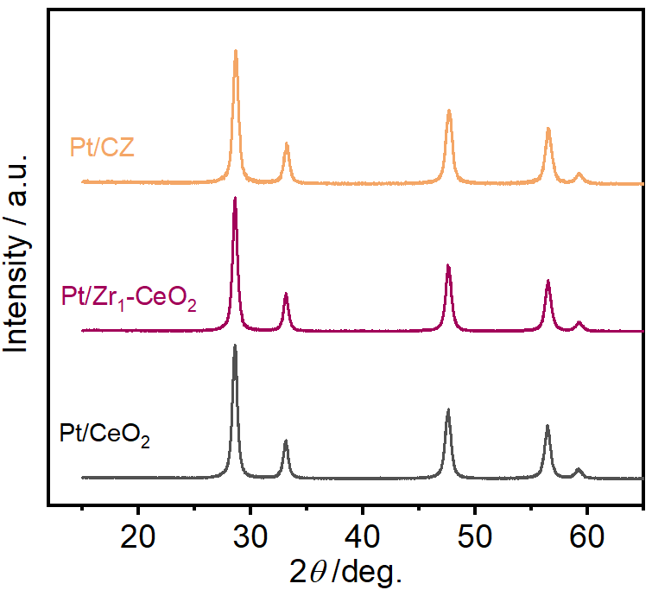
Figure S1. XRD patterns for Pt/CeO₂, Pt/Zr₁-CeO₂ and Pt/CZ.

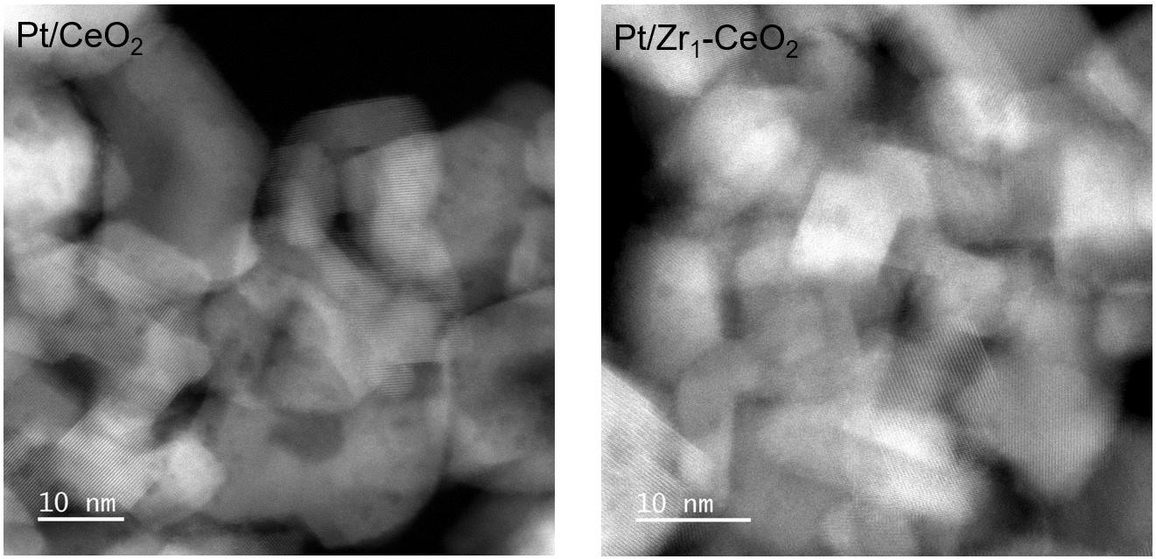
Figure S2. HAADF-STEM images of Pt/CeO₂ and Pt/Zr₁-CeO₂.

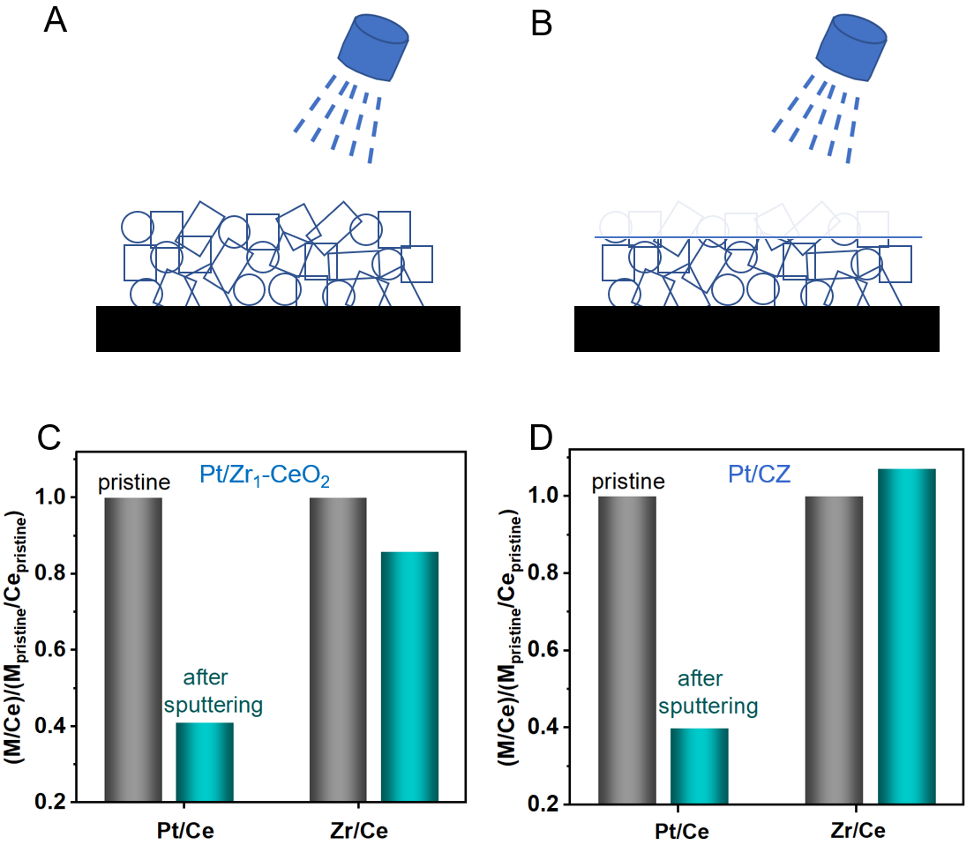

Figure S3. (A and B) Schematic diagram of samples before and after argon ion sputtering. (C and D) Change of Pt and Zr content relative to Ce in Pt/Zr₁-CeO₂ and Pt/CZ, relative to the pristine samples, as measured using XPS.

The dramatic decrease in the Pt/Ce ratio after sputtering suggests that Pt is predominantly located on the surface of both samples. In contrast, the Zr/Ce ratios show only a slight decrease, indicating that Zr is distributed throughout both the surface and bulk of the samples.
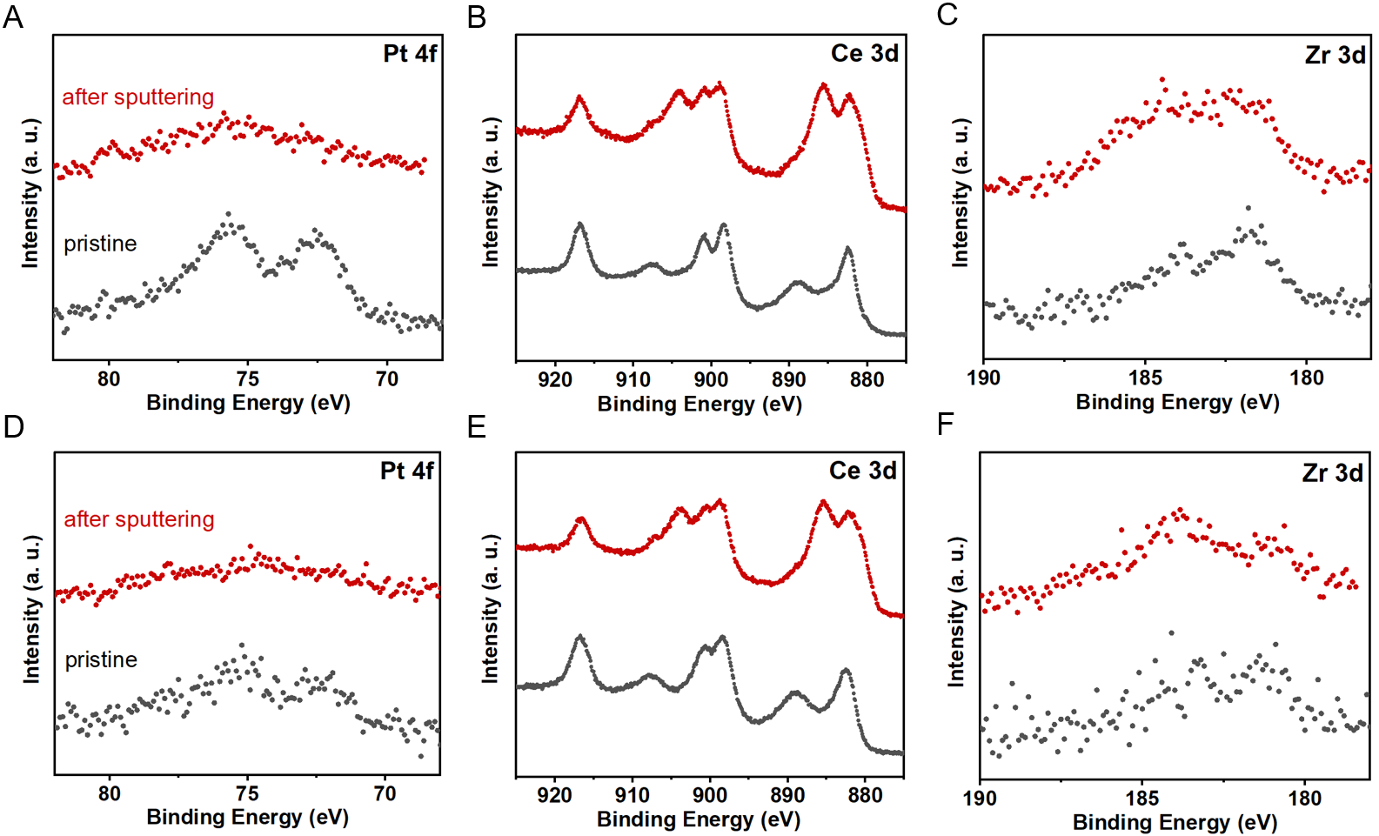
Figure S4. (A-C) Pt 4f, Ce 3d, and Zr 3d XPS spectra of pristine and sputtered Pt/Zr₁-CeO₂. (D-F) Pt 4f, Ce 3d, and Zr 3d XPS spectra of pristine and sputtered Pt/CZ.

Ion bombardment can alter the original chemical state of elements.^{[1]} Consequently, XPS spectra of the sputtered samples are used only for quantitative analysis.

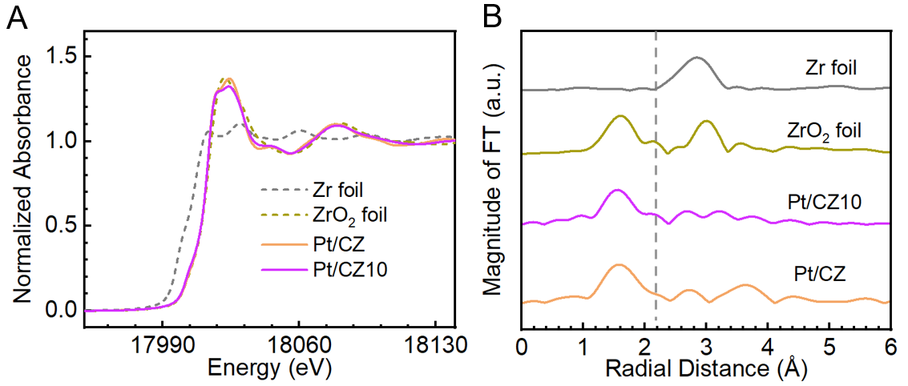
Figure S5. (A) Zr K-edge XANES and (B) Fourier transform magnitudes of EXAFS data of Pt/CZ, Pt/CZ10, and reference samples, including Zr foil and ZrO₂.

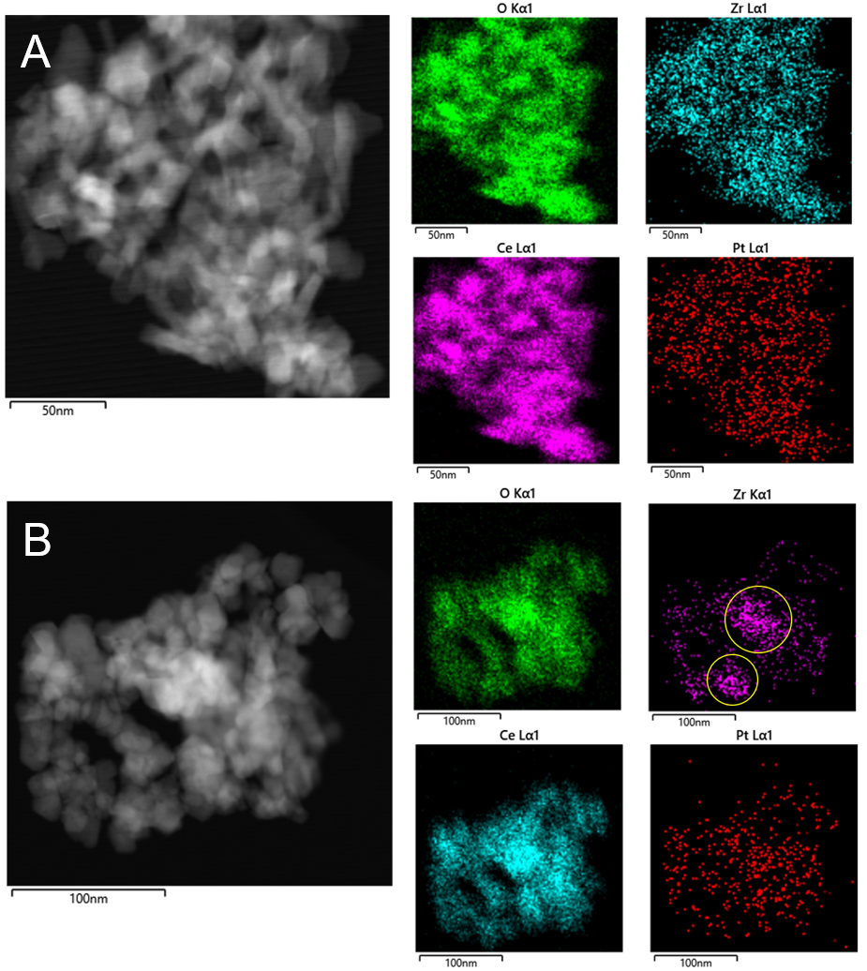

Figure S6. Representative HAADF-STEM images and EDS-STEM mappings of (A) Pt/Zr₁-CeO₂ and (B) Pt/CZ10.
EDS elemental mapping in the Pt/Zr₁-CeO₂ sample reveals a pronounced dispersion of Zr on the ceria support. In contrast, EDS elemental mapping for the Pt/CZ10 sample indicates the presence of ZrO₂ in the form of clusters.
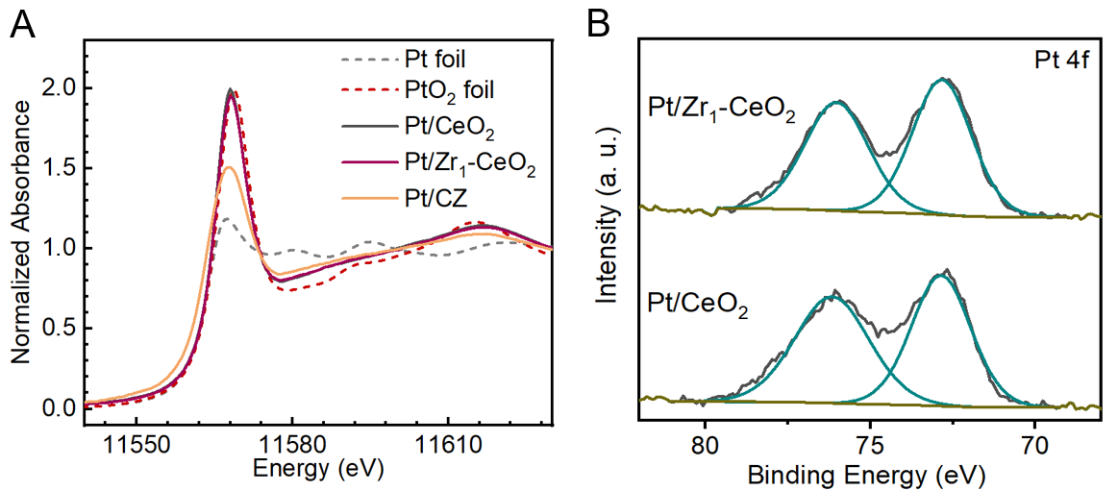
Figure S7. (A) Pt L-edge XANES of EXAFS data of Pt/CeO₂, Pt/Zr₁-CeO₂, Pt/CZ and reference samples, including Pt and PtO₂ foils. (B) Pt 4f XPS of Pt/CeO₂ and Pt/Zr₁-CeO₂.

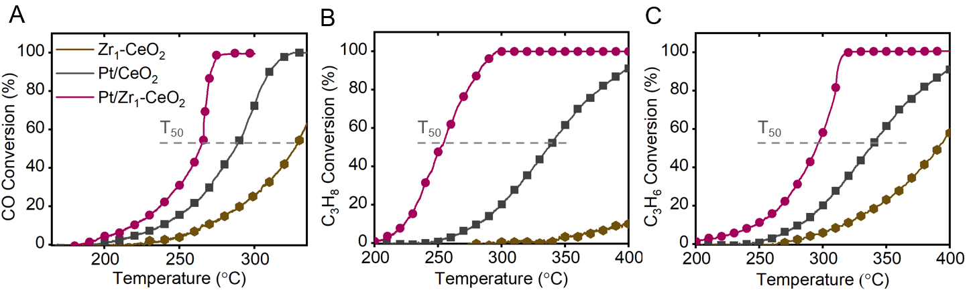
Figure S8. Light-off of (A) CO, (B) C₃H₈, and (C) C₃H₆ oxidation over Zr₁-CeO₂, Pt/CeO₂, and Pt/Zr₁-CeO₂. Reaction conditions for (A): 0.5% CO and 5% O₂ in Ar at 30,000 L·g_{Pt}⁻¹·h⁻¹. For (B), 0.2% propane and 1% O₂ in Ar at 7,500 L·g_{Pt}⁻¹·h⁻¹. For (C), 0.2% propylene and 1% O₂ in Ar at 7,500 L·g_{Pt}⁻¹·h⁻¹.

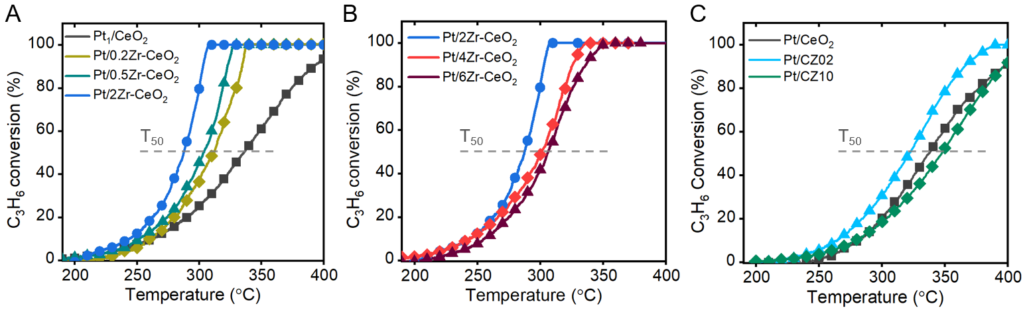
Figure S9. (A and B) Light-off of C₃H₆ oxidation over Pt/CeO₂, Pt/0.2Zr-CeO₂, Pt/0.5Zr-CeO₂, Pt/2Zr-CeO₂, Pt/4Zr-CeO₂ and Pt/6Zr-CeO₂. (C) Light-off of C₃H₆ oxidation over Pt/CeO₂, Pt/CZ02 and Pt/CZ10. Reaction conditions: 0.2% propylene and 1% O₂ in Ar at 7,500 L g_{Pt}⁻¹ h⁻¹. Note: The catalytic efficacy of Pt catalysts supported on 4Zr-CeO₂ and 6Zr-CeO₂ is comparatively reduced when compared to Pt/2Zr-CeO₂, possibly ascribed to the presence of ZrO₂ clusters.

Table S1. Fitting results of Zr K-edge EXAFS over Pt₁/Zr₁-CeO₂.
Sample | Path | R (Å) | CN | ${\text{σ}}^{\text{2}}$ $×$ 10³ (Å²) | $\text{∆}$E₀ (eV) | R factor
Pt/Zr₁-CeO₂ | Zr-O | 2.17 | 4.56 ± 0.67 | 5.14 ± 1.83 | -8.38 ± 1.71 | 0.0243

Table S2. Fitting results of Pt L₃-edge EXAFS over Pt/CeO₂ and Pt/Zr₁-CeO₂.
Sample | Path | R (Å) | CN | ${\text{σ}}^{\text{2}}$ $×$ 10³ (Å²) | $\text{∆}$E₀ (eV) | R factor
Pt/CeO₂ | Pt-O | 1.98 | 4.03 ± 0.14 | 1.83 ± 0.79 | 6.37 ± 1.60 | 0.0038
Pt/Zr₁-CeO₂ | Pt-O | 1.98 | 4.03 ± 0.37 | 3.13 ± 1.13 | 4.96 ± 5.90 | 0.0089

Reference
[1] S. Hashimoto, A. Tanaka, A. Murata, T. Sakurada, Surf Sci 2004, 556, 22–32.

