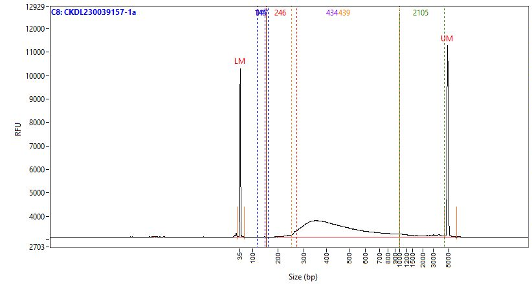
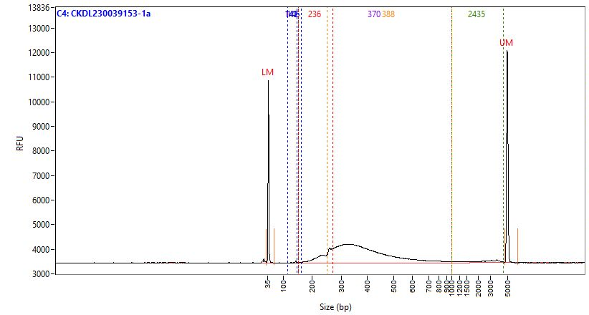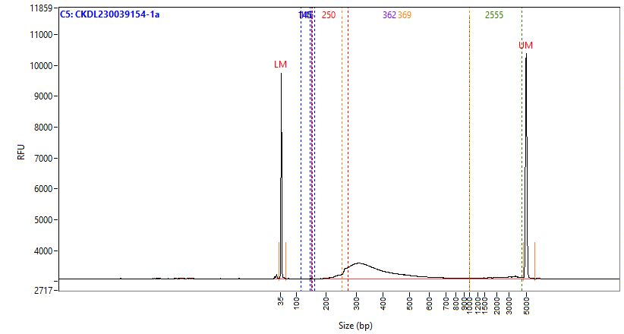
R3
R2
R1

Supplementary Figure 1: Bioanalyzer electrogram for RNAseq libraries prepared using Zymo-Seq RiboFree® Total RNA Library Kit. The library size was distributed between 250bp to 600bp.

