Table 1. Active compounds and their corresponding parameters in HGWD formula.
No | CAS | Compounds | Herb | Degree | Structure
1 | 480-18-2 | Taxifolin | CR/ AR | 13 | 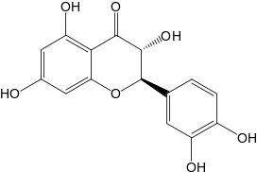
2 | 486-39-5 | (S)-Coclaurine | JF | 13 | 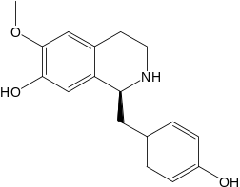
3 | 470-82-6 | 1,8-cineole | ZR | 10 | 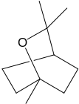
4 | 99-50-3 | 3,4-dihydroxybenzoicacid | CR | 20 | 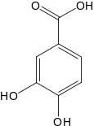
5 | N/A | 3,9-di-O-methylnissoln | AR | 11 | 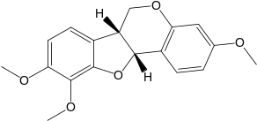
6 | 77398-90-4 | 4-gingerol | ZR | 1 | 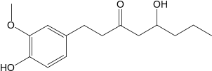
7 | 23513-14-6 | 6-gingerol | ZR | 21 | 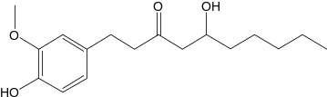
8 | 555-66-8 | 6-shogaol | ZR | 17 | 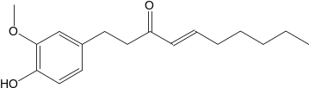
9 | 2086-83-1 | Berberine | JF | 19 | 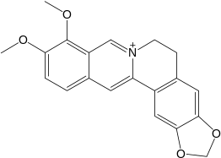
10 | 20575-57-9 | Calycosin | AR | 20 | 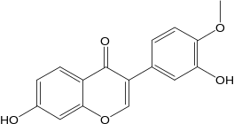
11 | 104-55-2 | Cinnamaldehyde | CR | 25 | 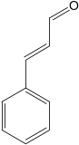
12 | N/A | Cinnamic acid | CR | 23 | 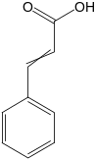
13 | N/A | Coumestrol | JF | 15 | 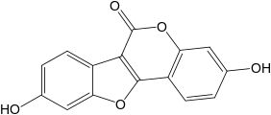
14 | 485-72-3 | Formononetin | AR | 38 | 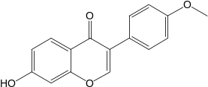
15 | 130-86-9 | Fumarine | JF | 14 | 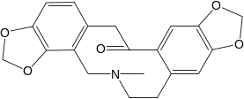
16 | 465-99-6 | Hederagenin | AR | 10 | 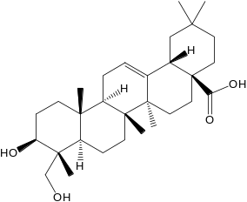
17 | 480-19-3 | Isorhamnetin | AR | 31 | 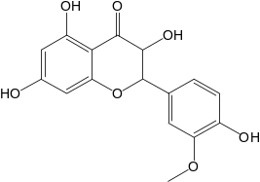
18 | 3301-49-3 | Jaranol | AR | 15 | 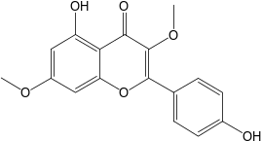
19 | 520-18-3 | Kaempferol | AR/ PRA | 45 | 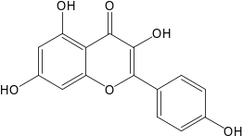
20 | 32383-76-9 | Medicarpin | AR | 3 | 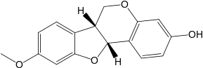
21 | 117-39-5 | Quercetin | AR/ JF | 69 | 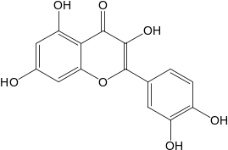
22 | 92-61-5 | Scopoletin | JF | 15 | 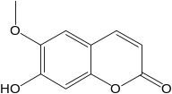
23 | 2810-21-1 | Stepharine | JF | 11 | 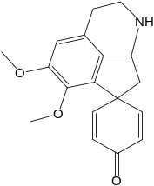
24 | 16562-13-3 | Stepholidine | JF | 3 | 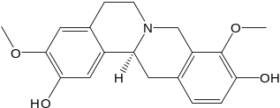
25 | 83-48-7 | Stigmasterol | AR/ZR/ JF | 17 | 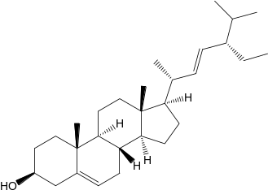
26 | 122-48-5 | Zingerone | ZR | 11 | 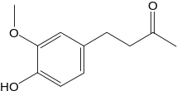
27 | 83-46-5 | Beta-sitosterol | CR/ ZR/ PRA/ AR/ JF | 22 | 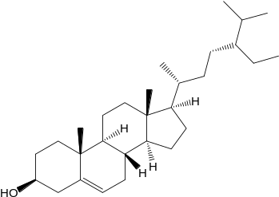
28 | 23180-57-6 | Paeoniflorin | AR/PRA | 14 | 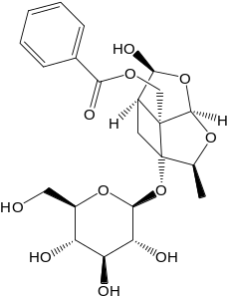
29 | 472-15-1 | Betulic acid | PRA/ AR/ JF | 2 | 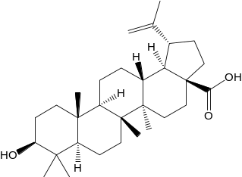
30 | 73536-69-3 | Bifendate | AR | 6 | 