Extended Data

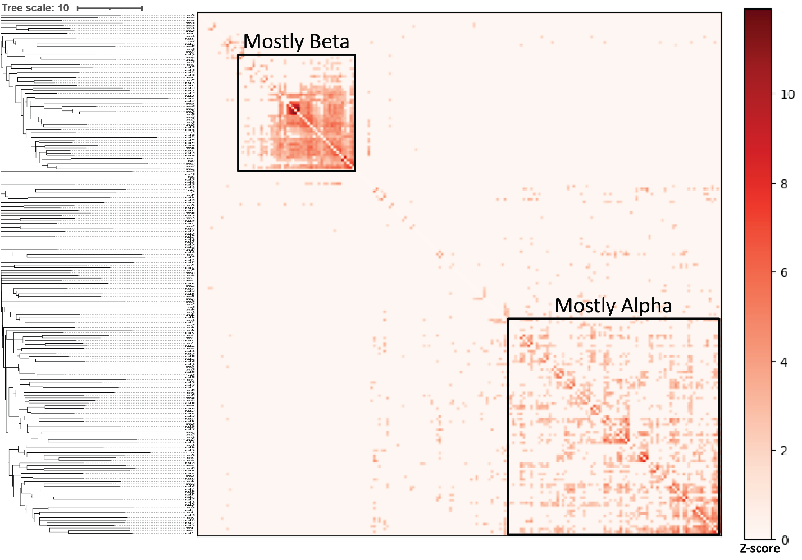
Figure S1. All-versus-all comparison of the evolved structures with Dali. A high Z-score indicates higher similarity between the compared structures. The top-left cluster represents structures that contain a similar beta-sheet, and the scattered cluster on the bottom-left represents structures containing similar alpha-helices.
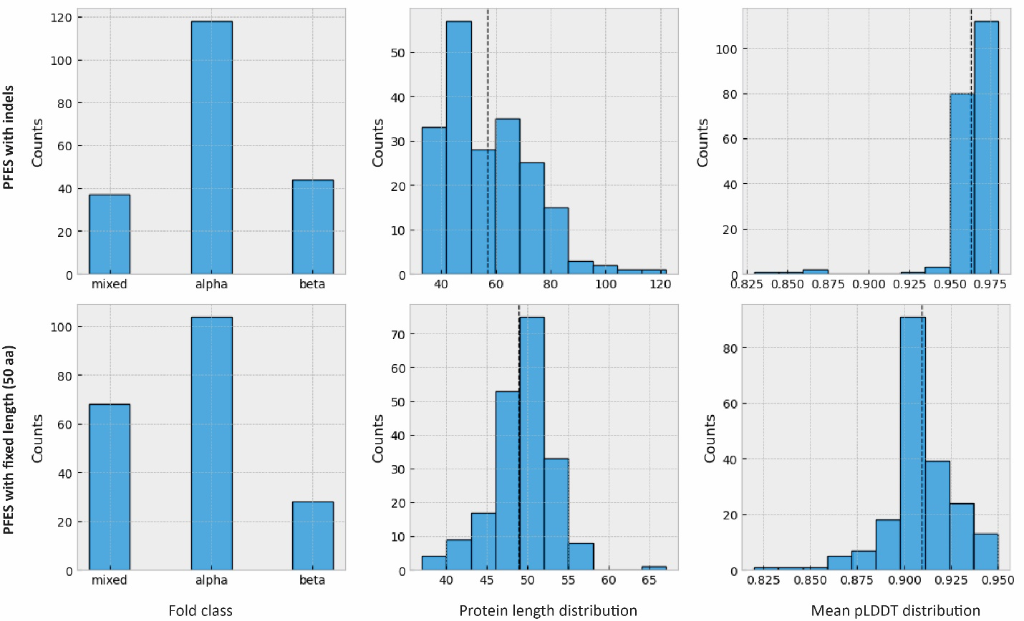
Figure S2. Protein fold class, length, mean pLDDT distributions in PFES. Simulations with indels include full or partial duplication and insertions of different lengths and were started from random sequences containing 24 residues. Simulations with constrained protein length were started with random sequences containing 50 residues, and only single amino acid indels and substitutions were allowed.

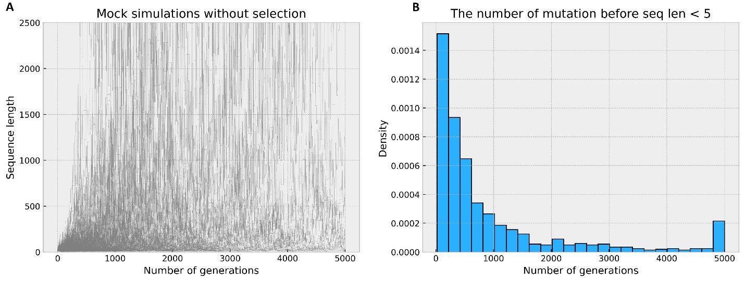
Figure S3. PFES without selection demonstrating changes in the protein length driven solely by the rates of indels presented in Table S2. (A) Simulations showing the length of sequences in the absence of any selective pressure, n=1000, starting sequence length = 24. (B) Distribution of the number of mutations before reaching the sequences sequence length of < 6 residues.

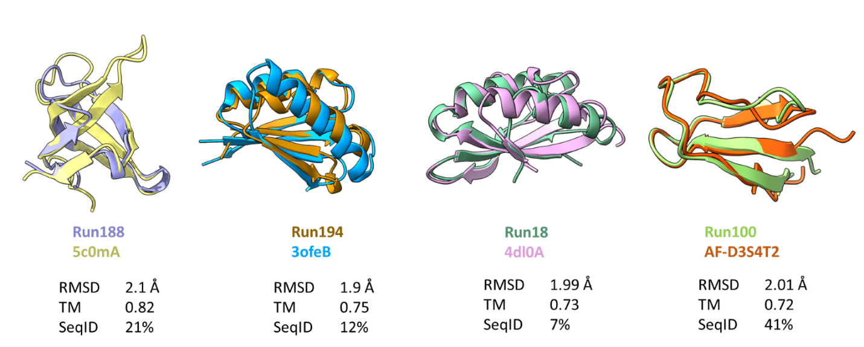
Figure S4. Proteins from simulated evolution are structurally similar to natural proteins from PDB and AFDB databases.

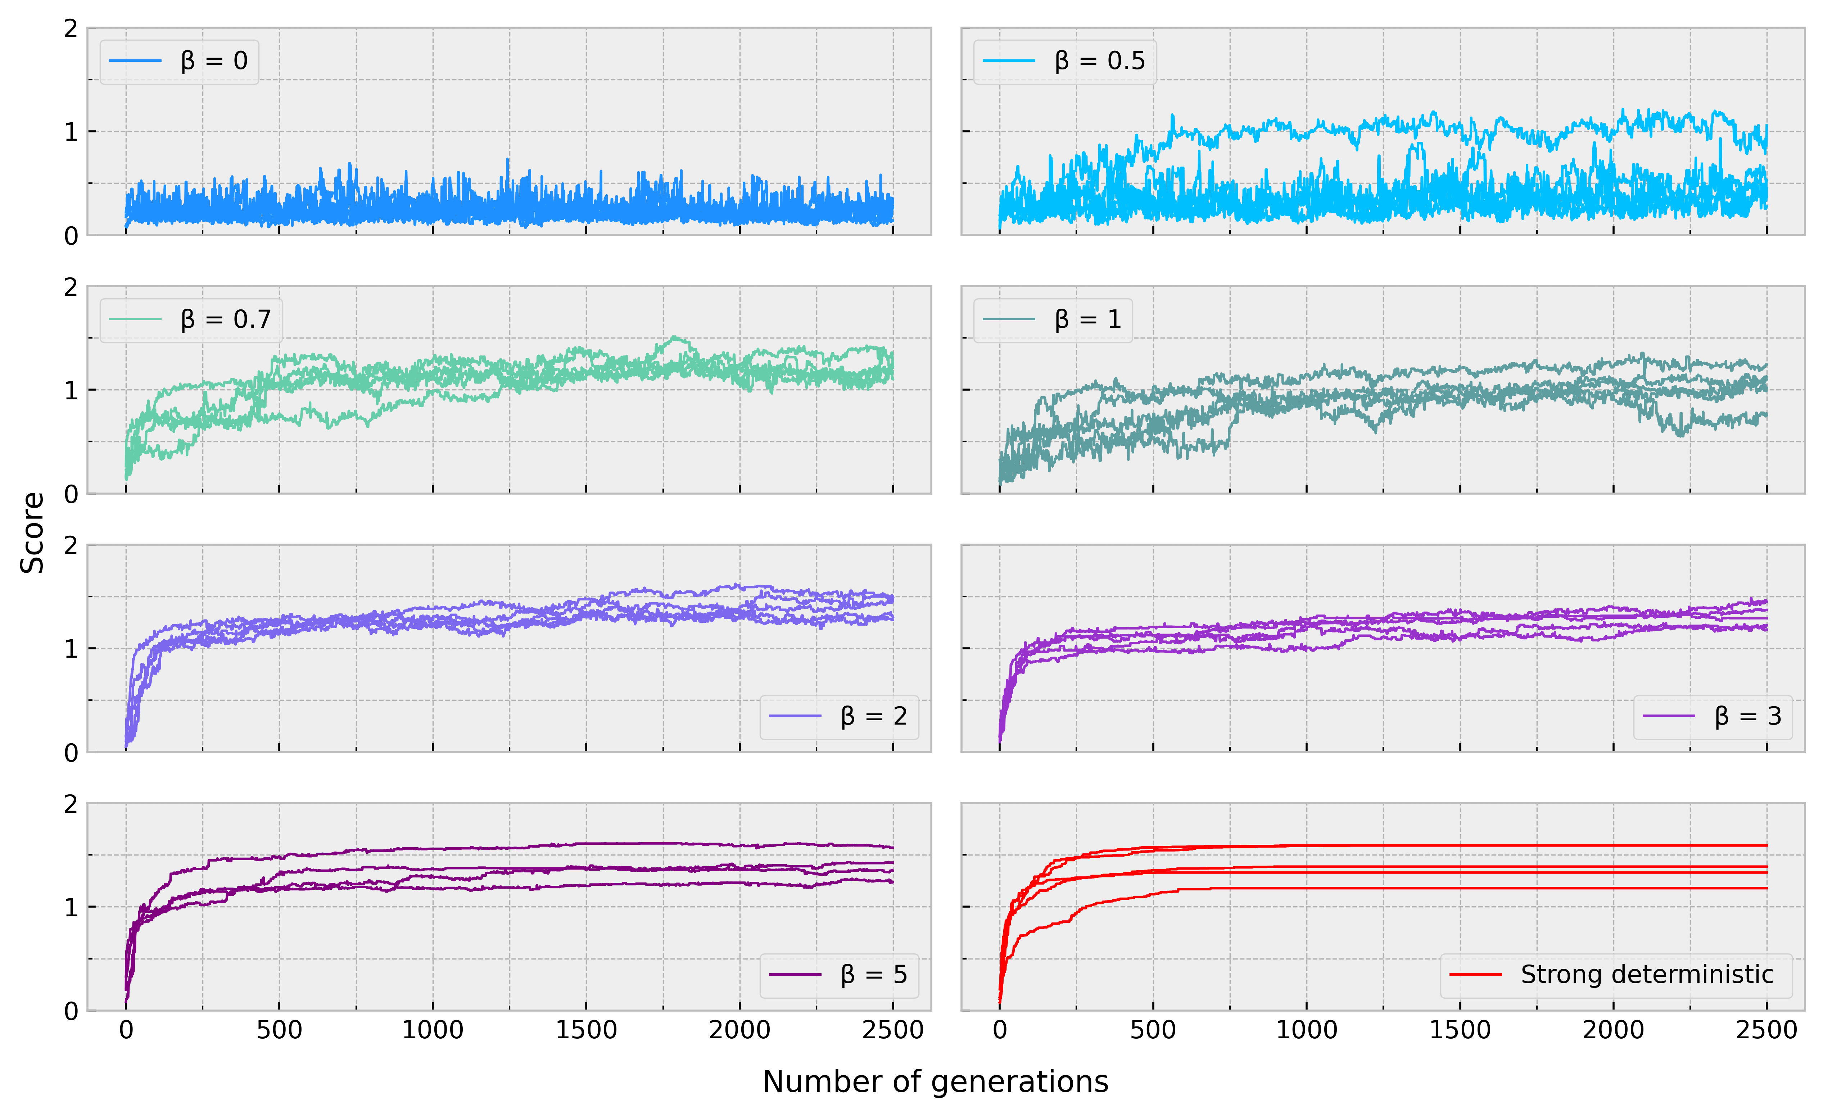
Figure S5. Simulation with stochastic selection of a 50 amino acid random peptide with different β.

Table S1. Foldseek search results
query | target | prob | fident | qcov | alnlen | evalue | db | nhits
run105 | 3vu4_B | 1.00 | 0.08 | 0.90 | 73 | 0.00033 | pdb | 2640
run48 | 7vfk_B | 1.00 | 0.12 | 0.96 | 92 | 0.00180 | pdb | 2023
run69 | 7vfm_C | 1.00 | 0.15 | 0.92 | 73 | 0.00190 | pdb | 2010
run99 | 4x7r_A | 1.00 | 0.19 | 0.82 | 52 | 0.00254 | pdb | 1912
run124 | 2q4m_A | 1.00 | 0.11 | 0.98 | 143 | 0.00350 | pdb | 675
run18 | 4dl0_C | 1.00 | 0.13 | 0.99 | 71 | 0.00748 | pdb | 1071
run93 | 7vfk_B | 1.00 | 0.10 | 0.94 | 68 | 0.00834 | pdb | 1995
run188 | 5c0m_A | 1.00 | 0.18 | 0.98 | 57 | 0.00996 | pdb | 2001
run22 | 5lhz_C | 1.00 | 0.17 | 1.00 | 52 | 0.09474 | pdb | 818
run100 | 6htj_B | 1.00 | 0.19 | 0.97 | 37 | 0.25540 | pdb | 1699
run130 | 6hhm_A | 0.99 | 0.04 | 0.82 | 45 | 0.61880 | pdb | 464
run87 | 5twb_A | 0.99 | 0.09 | 0.84 | 32 | 0.45460 | pdb | 653
run185 | 5twb_A | 0.99 | 0.12 | 0.92 | 34 | 0.46980 | pdb | 776
run16 | 6y2s_A | 0.99 | 0.13 | 0.83 | 45 | 0.53680 | pdb | 580
run77 | 7ywp_A | 0.99 | 0.11 | 0.94 | 84 | 0.04018 | pdb | 417
run133 | 6czi_B | 0.99 | 0.16 | 0.96 | 100 | 0.04278 | pdb | 111
run141 | 3bk5_A | 0.98 | 0.10 | 0.96 | 48 | 0.94090 | pdb | 519
run50 | 3u8v_B | 0.98 | 0.11 | 0.87 | 62 | 0.62310 | pdb | 132
run80 | 2mm3_A | 0.98 | 0.13 | 0.94 | 46 | 0.67640 | pdb | 419
run31 | 5uw7_A | 0.98 | 0.09 | 0.98 | 98 | 0.04906 | pdb | 304
run156 | 6ttu_T | 0.98 | 0.14 | 0.97 | 77 | 0.30910 | pdb | 266
run5 | 2ecf_A | 0.97 | 0.19 | 0.98 | 48 | 0.45540 | pdb | 437
run38 | 7l9e_E | 0.96 | 0.14 | 0.95 | 59 | 0.49280 | pdb | 495
run194 | AF-A0A4Q2RST3 | 1.00 | 0.22 | 1.00 | 69 | 0.00093 | afdb | 651
run41 | AF-A0A143G9F3 | 1.00 | 0.21 | 0.86 | 61 | 0.00479 | afdb | 376
run193 | AF-A0A814L140 | 1.00 | 0.15 | 1.00 | 72 | 0.02876 | afdb | 389
run96 | AF-A0A2D3PMG7 | 1.00 | 0.08 | 0.95 | 89 | 0.03642 | afdb | 131
run199 | AF-A0A7W0LT51 | 1.00 | 0.29 | 0.89 | 42 | 0.04865 | afdb | 816
run146 | AF-A0A7S4L576 | 1.00 | 0.21 | 0.95 | 57 | 0.05781 | afdb | 39
run95 | AF-A0A7C7HK81 | 1.00 | 0.20 | 0.88 | 50 | 0.07864 | afdb | 581
run165 | AF-A0A2D8AN05 | 1.00 | 0.28 | 0.93 | 39 | 0.14870 | afdb | 174
run197 | AF-A0A0F9JEQ6 | 1.00 | 0.16 | 1.00 | 56 | 0.17330 | afdb | 90
run90 | AF-A0A7W7KAE5 | 1.00 | 0.21 | 0.88 | 43 | 0.17680 | afdb | 96
run176 | AF-W7Z7K7 | 1.00 | 0.16 | 0.97 | 38 | 0.17950 | afdb | 499
run180 | AF-A0A0C2W3X4 | 1.00 | 0.05 | 0.92 | 43 | 0.19380 | afdb | 609
run187 | AF-A0A7Y2Y380 | 1.00 | 0.11 | 0.98 | 45 | 0.23340 | afdb | 951
run139 | AF-A0A5E4I478 | 1.00 | 0.19 | 0.96 | 43 | 0.26220 | afdb | 1040
run106 | AF-A0A1Q2CMH5 | 1.00 | 0.24 | 0.96 | 42 | 0.31340 | afdb | 1174
run170 | AF-A0A3M1T0E8 | 1.00 | 0.12 | 1.00 | 66 | 0.31390 | afdb | 268
run102 | AF-A0A495M102 | 1.00 | 0.20 | 0.95 | 35 | 0.35360 | afdb | 31
run92 | AF-A0A7Z9JEL9 | 1.00 | 0.15 | 0.95 | 60 | 0.55210 | afdb | 77
run178 | AF-A0A3D8T9U8 | 1.00 | 0.21 | 0.81 | 43 | 0.61670 | afdb | 74
run111 | AF-A0A3B6THA5 | 1.00 | 0.16 | 0.96 | 45 | 0.50580 | afdb | 21
run171 | AF-A0A7X7Q3P4 | 1.00 | 0.18 | 0.85 | 33 | 0.52200 | afdb | 125
run3 | AF-A0A7X1E4C3 | 1.00 | 0.18 | 0.98 | 87 | 0.02829 | afdb | 9
run115 | AF-A0A5C7PGG2 | 1.00 | 0.12 | 0.89 | 33 | 1.02200 | afdb | 9
run107 | AF-X0SW97 | 1.00 | 0.21 | 0.83 | 47 | 0.89180 | afdb | 59
run186 | AF-A0A3S9TJV0 | 1.00 | 0.10 | 0.98 | 83 | 1.00600 | afdb | 7
run42 | AF-A0A842B3M2 | 1.00 | 0.11 | 1.00 | 45 | 1.20700 | afdb | 3
run29 | AF-A0A0E9NQ65 | 0.99 | 0.21 | 0.90 | 103 | 0.00134 | afdb | 1
run196 | AF-A0A242WAS5 | 0.99 | 0.18 | 0.93 | 57 | 0.23890 | afdb | 16
run140 | AF-A0A414NWH6 | 0.99 | 0.28 | 0.97 | 36 | 2.30300 | afdb | 23
run151 | AF-A0A521K8B3 | 0.99 | 0.33 | 0.91 | 40 | 0.54510 | afdb | 47
run131 | AF-A0A2R6RQF2 | 0.99 | 0.28 | 0.93 | 39 | 1.18800 | afdb | 6
run108 | AF-A0A7C4TWM1 | 0.99 | 0.21 | 0.92 | 56 | 1.62600 | afdb | 2
run190 | AF-A0A1Q4GU02 | 0.99 | 0.15 | 0.83 | 41 | 1.07700 | afdb | 36
run198 | AF-F4P5B8 | 0.99 | 0.19 | 0.96 | 53 | 0.66070 | afdb | 21
run36 | AF-A0A3P6B3K0 | 0.99 | 0.21 | 0.88 | 43 | 2.00800 | afdb | 15
run53 | AF-T1XNQ2 | 0.99 | 0.12 | 0.96 | 82 | 2.01300 | afdb | 3
run25 | AF-A0A849ZRA1 | 0.98 | 0.14 | 0.90 | 43 | 3.90900 | afdb | 1
run129 | AF-I1IM41 | 0.98 | 0.19 | 0.91 | 42 | 4.24100 | afdb | 1
run157 | AF-A0A517TSJ5 | 0.98 | 0.17 | 0.91 | 78 | 1.59100 | afdb | 2
run66 | AF-S1N7D9 | 0.98 | 0.17 | 0.96 | 53 | 4.10100 | afdb | 10
run83 | AF-A0A537X4E9 | 0.98 | 0.14 | 1.00 | 88 | 0.28350 | afdb | 5
run47 | AF-A0A316YHF2 | 0.98 | 0.14 | 0.96 | 90 | 0.37140 | afdb | 7
run128 | AF-A0A1Q6UZD7 | 0.98 | 0.17 | 0.84 | 36 | 1.77100 | afdb | 13
run159 | AF-A0A535GJU4 | 0.97 | 0.08 | 0.93 | 52 | 3.79500 | afdb | 5
run168 | AF-M1VDQ2 | 0.97 | 0.21 | 0.88 | 53 | 4.11700 | afdb | 3
run110 | AF-A0A239QJR5 | 0.97 | 0.21 | 0.83 | 34 | 4.81300 | afdb | 1
run64 | AF-A0A429CVJ2 | 0.96 | 0.25 | 0.95 | 56 | 2.36200 | afdb | 1
run26 | AF-A0A7K4DWC2 | 0.96 | 0.07 | 0.89 | 68 | 3.39600 | afdb | 1
run86 | AF-A0A7J0EWZ7 | 0.96 | 0.17 | 0.98 | 41 | 0.86610 | afdb | 4
run109 | AF-A0A418PM05 | 0.96 | 0.25 | 0.82 | 28 | 4.14700 | afdb | 2
run32 | MGYP000472187349 | 0.99 | 0.15 | 0.92 | 62 | 0.17890 | esm | 1
run72 | MGYP001476248561 | 0.99 | 0.16 | 0.92 | 55 | 1.59300 | esm | 4
run88 | MGYP003324074694 | 0.98 | 0.20 | 0.95 | 41 | 0.24300 | esm | 2
run94 | MGYP001385367156 | 0.98 | 0.14 | 0.95 | 78 | 0.70690 | esm | 1
run52 | MGYP003295344537 | 0.98 | 0.18 | 0.91 | 40 | 1.33500 | esm | 1
run104 | MGYP003590916796 | 0.98 | 0.16 | 0.98 | 62 | 0.47420 | esm | 1
run154 | MGYP003706959411 | 0.96 | 0.16 | 0.97 | 69 | 1.54600 | esm | 1
run79 | MGYP003353214145 | 0.96 | 0.13 | 0.87 | 32 | 1.75000 | esm | 1

rep target – a representative target for this query; prob – foldseek probability; fident – fraction of identical matches; qcov – query coverage, alnlen – alignment length; db – database where the representative hit is coming from; nhits – total number of hits

Table S2. All Foldseek hits with probability> 0.95 and query coverage of 80%.
Tables S3.
Amino acid | AA | Flat rate | Codon rates | Uniprot rate
Alanine | A | 1 | 1.311 | 1.652
Cysteine | C | 1 | 0.656 | 0.278
Aspartate | D | 1 | 0.656 | 1.092
Glutamate | E | 1 | 0.656 | 1.344
Phenylalanine | F | 1 | 0.656 | 0.774
Glycine | G | 1 | 1.311 | 1.414
Histidine | H | 1 | 0.656 | 0.456
Isoleucine | I | 1 | 0.984 | 1.182
Lysin | K | 1 | 0.656 | 1.16
Leucine | L | 1 | 1.967 | 1.93
Methionine | M | 1 | 0.328 | 0.482
Asparagine | N | 1 | 0.656 | 0.812
Proline | P | 1 | 1.311 | 0.95
Glutamine | Q | 1 | 0.656 | 0.786
Arginine | R | 1 | 1.967 | 1.106
Serine | S | 1 | 1.967 | 1.33
Threonine | T | 1 | 1.311 | 1.072
Valin | V | 1 | 1.311 | 1.372
Tryptophan | W | 1 | 0.328 | 0.22
Tyrosine | Y | 1 | 0.656 | 0.584
Single residue insertion | + | 1 | 1 | 1
Single residue deletion | - | 1 | 1 | 1
Partial duplication | * | 0.4 | 0.4 | 0.4
Random insertion | / | 0.4 | 0.4 | 0.4
Partial deletion | % | 0.9 | 0.9 | 0.9
Circular permutation | p | 0.1 | 0.1 | 0.1
Full duplication | d | 0.05 | 0.05 | 0.05

