Electronic Supplementary Information
Metal-organic frameworks encapsulating gold nanoclusters and carbon dots for ratiometric fluorescent detection of formaldehyde in real food samples, construction materials and indoor environments
Man Duª, Meimei Songª, Shuang Houª, Yue Zhang^{a,}*, Haijun Lvª, Shuchun Zhaoª, Hongxia Duª, Hongyong Guo^{b,}**
ªCollege of Chemical and Pharmaceutical Engineering, Hebei University of Science and Technology, Shijiazhuang, 050018, P. R. China;
^{b}Hebei Lansheng Bio-Tech Co., Ltd, Shijiazhuang, 052263, P. R. China.
*Corresponding author
**Corresponding author
E-mail addresses: yuezhang@hebust.edu.cn (Yue Zhang); hongyongguo@163.com (Hongyong Guo).

Table S1 Comparison of reported fluorescent probes for formaldehyde detection
Probes |  | Type | Signal type | λ_{ex}/λ_{em}  nm | Linear  range  μM | LOD  μM | Applications
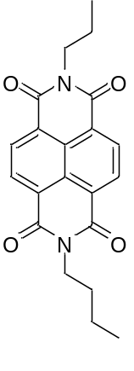  [1] |  | Organic molecule | Turn-on | 350/562 | 0.2-18.5 | 1.4 | Fish samples detection
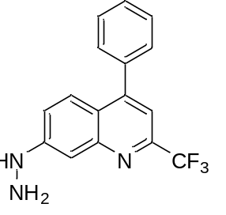  [2] |  | Organic molecule | Turn-on | 385/525 | 0.06-7 | 0.0081 | Cells and zebrafish imaging
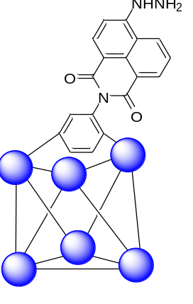  [3] |  | MOF | Turn-off | 330/426 | 20-60 | 0.167 | Water samples detection
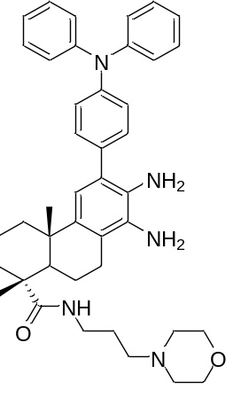  [4] |  | Organic molecule | Turn-on | 325/425 | 0-65 | 0.038 | Water and food samples detection  Gas detection Cells and zebrafish imaging
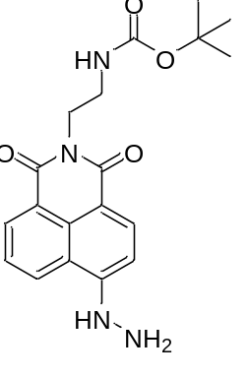  [5] |  | Organic molecule | Turn-on | 438/558 | 0-40 | 1.1 | Cells imaging  In vivo diagnosis of diabetes
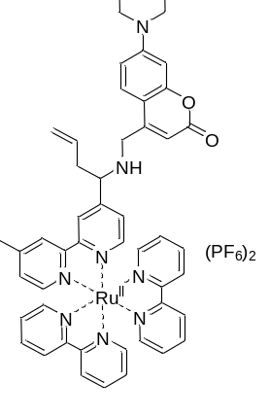  [6] |  | Transition metal–organic molecular hybrid materials | Ratiometric | 450/505,610 | 0-50000 | 17.7 | Cells and mouse brain tissues imaging
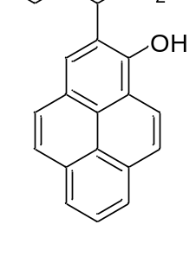  [7] |  | Organic molecule | Ratiometric | 345/390,446 | 18-4000 | 18 | Food samples detection  Liquid and gas detection  Cells imaging
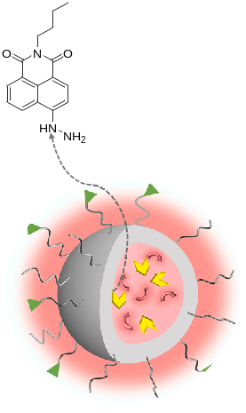  [8] |  | Nanomaterials | Ratiometric | 395/545,590 | 0-30 | 0.087 | Leather and air detection  Visual detection and quantitative analysis
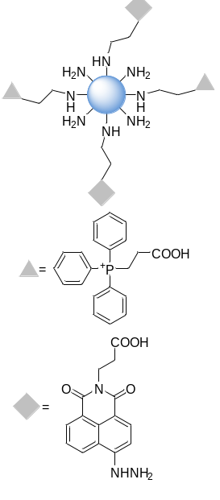  [9] | Nanomaterials |  | Ratiometric | 380/545,445 | 1-100 | 0.65 | Cells and zebrafish imaging
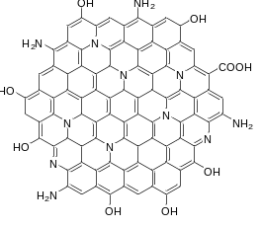  [10] |  | Nanomaterials | Turn-on | 420/532 | 0-50 | 0.079 | Indoor gas detection
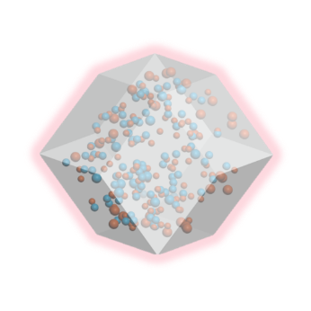  This work |  | Nanomaterials | Ratiometric | 390/468,615 | 0-16  16-21  21-40 | 2.21  0.38  0.26 | Food samples; building materials; indoor environments

Materials and instruments
Chloroauric acid (HAuCl₄·4H₂O), L-glutathione reduced (GSH), citric acid (CA), ethanediamine (EDA), 2-methylimidazole (2-MeIM), Zn(CH₃COO)₂·2H₂O, NH₂OH·HCl, HCHO, and 2,4-dinitrophenylhydrazine (2,4-DNPH) were purchased from Aladdin Reagent Company (Shanghai, China). All other chemicals and solvents used were of analytical grade and used directly without further purification. All water used was ultrapure water produced by a Millipore Milli-Q water purification system (Billerica, MA, USA) with a resistivity of 18.2 MΩ. Food samples (wine, black fungus, squid and shrimp) used in the experiments were purchased from the local supermarket, and the building materials (glass cement and paint) were purchased from the local building material market.
The morphology and composition of the prepared materials were characterized using X-ray powder diffraction (XRD, SmartLab9KW, Rigaku, Japan), Transmission Electron Microscopy (TEM, JEM-2100, JEOL, Japan), Scanning Electron Microscopy (SEM, S-4800, HITACHI, Japan), X-ray photoelectron spectroscopy (XPS, Escalab Xi+, Thermo Scientific, USA), and Fourier-transform infrared spectroscopy (FTIR, Spectrum 3, PerkinElmer, USA). UV-vis absorption spectroscopy in the range of 200-800 nm was recorded on a UV-2550 spectrophotometer (Shimadzu, Japan). Fluorescence spectra were collected using an FL-8500 fluorescence spectrometer (PerkinElmer, USA). The samples were excited at 384 nm, and the fluorescence emission ranged from 300-700 nm with a step of 1 nm. All UV-vis absorption and fluorescence measurements were carried out at room temperature. pH values were measured using a pH meter (FE28-Micro, Mettler-Toledo, Switzerland). High-performance liquid chromatography (HPLC) analysis was conducted on Waters e2695 HPLC (Waters, USA). In this study, all the fluorescence images were captured in a closed black box with a 365 nm UV analyzer (ZF-2, Anting, China).

The standard HPLC method
These real samples were previously derivatized with 2,4 dinitrophenylhydrazine (2,4-DNPH) and then analyzed by HPLC. The derivatization procedure for FA with DNPH reported previously [11, 12] was adopted with minor modifications. Aliquots of 1000 μL samples were mixed with 1000 μL of DNPH (2.0 mM dissolved in 10% methanol 50 mM HCl solution). The reaction mixtures were allowed to react at 40 ºC for 3 h. Then, 20 μL of the reaction solution was injected into the HPLC system. HPLC conditions: C18 column (5 μm, 4.6 mm×250 mm), temperature: 25 ºC, mobile phase: methanol:water=80:20 (v/v), injection volume: 20 μL, flow rate: 1.0 mL/min, detection wavelength: 362 nm.

Fig. S1. (a) Full survey scan XPS spectra of CDs/AuNCs@ZIF-8 and ZIF-8. XPS spectra of CDs/AuNCs@ZIF-8 (b) Au 4f spectrum, (c) C 1s spectrum, (d) N 1s spectrum, (e) O 1s spectrum and (f) Zn 2p spectrum.

Fig. S2. UV-vis absorbance spectra of CDs/AuNCs@ZIF-8, CDs/AuNCs@ZIF-8+FA, CDs/AuNCs@ZIF-8+NH₂OH·HCl, CDs/AuNCs@ZIF-8+NH₂OH·HCl+FA.

Limit of detection (LOD)
The limit of detection (LOD) was calculated according to the following equation.
LOD = 3σ/k Eq (S1)
Herein, for the detection of FA, the standard deviation σ was obtained from 20 measurements of the fluorescence spectra of CDs/AuNCs@ZIF-8. And the linear relationship between fluorescence intensity of CDs/AuNCs@ZIF-8 at 468 nm/615 nm and the concentration of FA was plotted and calculated to get the slope k.

Fig. S3. Time response curve of CDs/AuNCs@ZIF-8+NH₂OH·HCl system to FA. λ_{ex}=390 nm.

Fig. S4. Fluorescence spectrum of (a) CDs/AuNCs@ZIF-8, (b) CDs/AuNCs@ZIF-8+NH₂OH·HCl+FA after irradiation by sunlight. λ_{ex}=390 nm. Fluorescence photographs of (c) CDs/AuNCs@ZIF-8, (d) CDs/AuNCs@ZIF-8+NH₂OH·HCl+FA after irradiation by sunlight.

Fig. S5. Fluorescence spectrum of (a) CDs/AuNCs@ZIF-8, (b) CDs/AuNCs@ZIF-8+NH₂OH·HCl+FA after irradiation by UV light. λ_{ex}=390 nm. Fluorescence photographs of (c) CDs/AuNCs@ZIF-8, (d) CDs/AuNCs@ZIF-8+NH₂OH·HCl+FA after irradiation by UV light.

Fig. S6. Fluorescence spectrum of (a) CDs/AuNCs@ZIF-8, (b) CDs/AuNCs@ZIF-8+NH₂OH·HCl+FA after storage at different temperatures. λ_{ex}=390 nm. Fluorescence photographs of (c) CDs/AuNCs@ZIF-8, (d) CDs/AuNCs@ZIF-8+NH₂OH·HCl+FA after storage at different temperatures.

Fig. S7. The thermal gravimetric (TG) analysis of CDs/AuNCs@ZIF-8.

Table S2. Intra- and inter-day assay accuracy and precision of the proposed method.
Spiked concentration  (μM) | Found concentration  (μM) | Accuracy (%) | Precision RSD (%)
Intra-day ª (n=3)
10.00 | 10.27±0.37 | 102.35 | 3.64
20.00 | 20.95±0.58 | 98.74 | 2.18
30.00 | 31.48±0.64 | 99.92 | 3.07
Inter-day ^{b} (n=3)
10.00 | 10.59±0.43 | 98.69 | 2.37
20.00 | 21.26±0.39 | 104.38 | 1.84
30.00 | 31.42±0.76 | 101.77 | 3.56
Values are expressed as means ± SD (n=3).
ª Within the day.
^{b} Three consecutive days.

Fig. S8. SEM images of (a) ZIF-8, (b) ZIF-8+H⁺, (c) ZIF-8+NH₂OH·HCl+FA, (d) CDs/AuNCs@ZIF-8, (e) CDs/AuNCs@ZIF-8+H⁺ and (f) CDs/AuNCs@ZIF-8+ NH₂OH·HCl+FA.

Fig. S9. (a) Fluorescence spectra of CDs/AuNCs@ZIF-8+NH₂OH·HCl system response to FA and other analytes. λ_{ex}=390 nm. Inset: Photographs of CDs/AuNCs@ZIF-8+NH₂OH·HCl system with FA and other analytes under a 365 nm UV lamp. (b) Interference experiments of CDs/AuNCs@ZIF-8+NH₂OH·HCl system for the recognition of FA. λ_{ex}=390 nm, λ_{em}=468 nm. Analytes and interferents: 1, blank; 2, methanol; 3, ethanol; 4, acetonitrile; 5, FA; 6, CH₂Cl₂; 7, tetrahydrofuran; 8, acetone; 9, N,N-dimethylformamide; 10, n-hexane; 11, MgCl₂; 12, CuSO₄; 13, CaCl₂; 14, NaClO; 15, NaNO₂; 16, glutathione; 17, histidine; 18, H₂O₂.

Fig. S10. The HPLC analysis spectrum of the formaldehyde-2,4-dinitrophenylhydrazine derivatives. HPLC analysis was conducted on Waters e2695 HPLC; Flow rate was 1 mL/min; Detection wavelength was 362 nm; Chromatographic column was Elite Hypersil BDS C18 (5 μm, 4.6 mm×250 mm); Mobile phase was the mixture of methanol and water (v/v=80:20); Column temperature: 25 ºC; Injection volume: 20 μL.

References
- Saha S, Sahoo P (2022) Luminescence turn-on response of naphthalene diimide based chemosensor with formaldehyde: A novel stratagem for estimation of formaldehyde in storage fish samples. Bioorg Med Chem Lett 49:128287-128287. https://doi.org/10.1016/j.bmcl.2021.128287
- Liang ZY, Wei N, Guo XF, Wang H (2023) A new quinoline based probe with large stokes shift and high sensitivity for formaldehyde and its bioimaging applications. Anal Chim Acta 1239:340723-340723. https://doi.org/10.1016/j.aca.2022.340723
- Li XL, Qu HM, Wang YF, Zhang XK, Bai LL, Wang ZH (2023) Fluorescent probe for detection of formaldehyde based on UiO-66-NH₂. J Solid State Chem 317:123672-123672. https://doi.org/10.1016/j.jssc.2022.123672.
- Sun L, Li MX, Chen LL, Sun XB, Yang ZH, Wang SF, Gu W (2023) A highly sensitive dehydroabietic acid-based difunctional fluorescent probe for detecting formaldehyde and Ag⁺. J Lumin 257:119658-119658. https://doi.org/10.1016/j.jlumin.2022.119658
- Wang JY, Li JF, Xu LZ, Tan D, Guo R, Lin WY (2023) A robust activatable two-photon fluorescent probe for endogenous formaldehyde biomarker visualization diagnosis and evaluation of diabetes mellitus. Anal Chim Acta 1266:341371-341371. https://doi.org/10.1016/j.aca.2023.341371
- Li BY, Liu CL, Zhang WZ, Ren JY, Song B, Yuan JL (2023) Ratiometric lysosome-targeting luminescent probe based on a coumarin-ruthenium(II) complex for formaldehyde detection and imaging in living cells and mouse brain tissues. Methods 217:10-17. https://doi.org/10.1016/j.ymeth.2023.06.008
- Hu Y, Guo SM, Pen JQ, Fan Y, Wang F, Lu LM, Fu HY, Chen XQ, She YB (2023) Ratiometric pyrene-based fluorescent sensor for on-site monitoring of formaldehyde in foods and living cells. Sens Actuators B Chem 392:134064-134064. https://doi.org/10.1016/j.snb.2023.134064
- Han QX, Zhang JL, Yang LN, Guan XY, Zhao Z, Wang XC (2023) Self-assembled nano-particles of chitosan amphiphilic derivative for formaldehyde fluorescent detection and its application in test strip. Chemosphere 339:139606-139606. https://doi.org/10.1016/j.chemosphere.2023.139606
- Fu YJ, Guo XF, Wang H (2024) A mitochondria-targeted ratiometric fluorescent sensor based on naphthalimide derivative-functionalized silica-based nanodots for imaging formaldehyde in living cells and zebrafish. Spectrochimi Acta A 311:123970-123970. https://doi.org/10.1016/j.saa.2024.123970
- Ma F, Zhang T, Xing HM, Wang LF, Hu HW, Zhang YH, Chen D (2024) Solvent-free preparation of high synthetic yield carbon dots from sodium ligninsulfonate for on-site detection of formaldehyde in the environment. Mater Lett 362:136223-136223. https://doi.org/10.1016/j.matlet.2024.136223
- El-Maghrabey M, Suzuki H, Kishikawa N, Kuroda N (2021) A sensitive chemiluminescence detection approach for determination of 2,4-dinitrophenylhydrazine derivatized aldehydes using online UV irradiation-luminol CL reaction. Application to the HPLC analysis of aldehydes in oil samples. Talanta 233:122522-122522. https://doi.org/10.1016/j.talanta.2021.122522
- Herrington JS, Hays MD (2012) Concerns regarding 24-h sampling for formaldehyde, acetaldehyde, and acrolein using 2,4-dinitrophenylhydrazine (DNPH)-coated solid sorbents. Atmos Environ 55:179-184. https://doi:10.1016/j.atmosenv.2012.02.088

