Supplementary Table 1: Matching variable definitions and categorical values.

Matching variable | Data source | Definition | Period of measurement | Values
Age | Danish National Population Register | Age in years at the end of the calendar year, binned | Match year | 19-29, 30-34, 35-39, 40-44, 45-49, 50-54, 55-59, 60-64, 65-69, 70-74, 75-79, 80-84, 85-89, 90+
Personal income at baseline | Danish Income Statistics Registry | Annual disposable personal income, 2023 EUR | Match year | 25th, 50th, and 75th percentiles of personal income in each year
Household equivalized income at baseline | Danish Income Statistics Registry | Annual disposable household equivalized income (i.e. total household income adjusted for household size), 2023 EUR | Match year | 25th, 50th, and 75th percentiles of household income in each year
Labor market attachment | Danish National Population Register | Primary source of annual personal income | Match year | Wage earner, self employed, working for spouse, in school, leave recipient (sygdagepenge or orlovsydelser), unemployment recipient (arbejdesløs), social assistance recipient (kontanthjælpsmodtager), disability recipient (førtidspensionister), early retirement (efterlønsmodtager), retirement, other
Education | Integrated Student Register | Highest completed education level | Match year | Basic, upper secondary, vocational training, bachelors degree, postgraduate education
Relationship status | Danish National Population Register | Status of live-in relationships, regardless of marital status | Match year | Married, cohabitating but unmarried, or single
Household size | Danish National Population Register | Number of people in the household | Match year | 1 person, 2 people, or 3 or more people
Hospital utilization | National Inpatient Register | Total count of hospitalizations in the 2 years before match year | Total in the two years before match year | Number of hospitalizations: 0, 1, 2, 3-5, 6-10, 11+
Charlson comorbidity index | National Inpatient Register | Charlson comorbidity index value, calculated from hospital admission diagnoses over a five year period | Total in the five years before match year | 0, 1, 2, 3, 4+

Section 1: Equations for estimation of conditional and total treatment effects
1. Point-in-time Conditional Average Causal Effect (CACE_{i}):

$$CACE_{i}= \frac{1}{n_{e,s}}\sum_{j=1}^{n_{e,s}}{Y_{e,i,j}}-\frac{1}{n_{c,s}}\sum_{k=1}^{n_{c,s}}{Y_{c,i,k}}$$
where:
- Y_{e,i,j} is the income of the exposed individual j in subgroup s at time i,
- Y_{c,i,k} is the income of the control individual k in subgroup s at time i,
- n_{e,s} and n_{c,s} are the number of exposed and control individuals in subgroup s, respectively.
2. Point-in-time Average Causal Effect of the Exposed (ACX_{i}):

$$ACX_{i}=\sum_{s=1}^{S}{w_{s}}⋅CACE_{i}^{(s)}$$

where:
- CACE_{i}^{(s)} is the conditional average causal effect for subgroup s at time i ,
- $w_{s}=\frac{n_{e,s}}{n_{e}}$ is the weight for subgroup s, determined by the proportion of exposed individuals in that subgroup relative to the total number of exposed individuals n_{e},
- S is the total number of subgroups.
3. Cumulative Average Causal Effect (ACE):

$$ACE=\sum_{i=1}^{10}{{ACX}_{i}}$$
where the summation is taken over the 10-year period.

Figure 1: Average Causal Effect of the Exposed, personal income adjusted for mortality in the non-retired population.
In these results, any years after death which would be in the observation period are imputed as 0 income for individuals in the control or exposed groups.
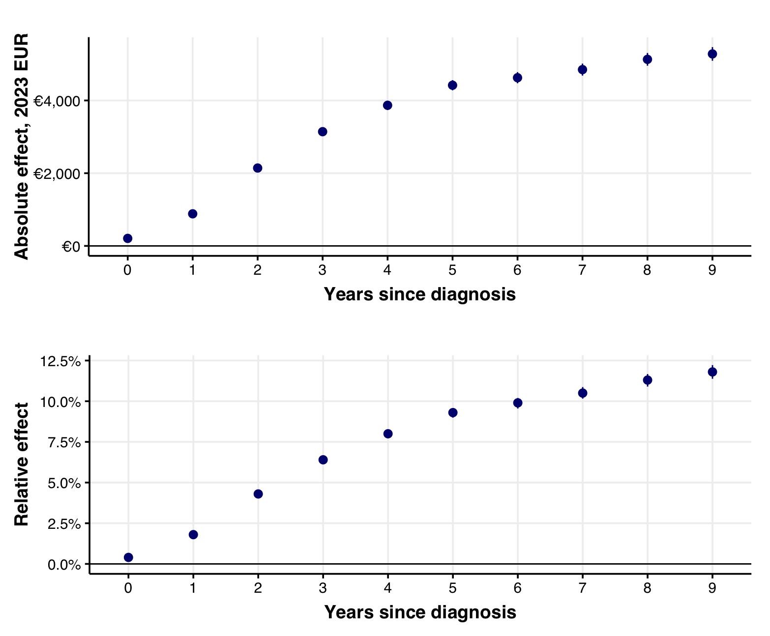

Table 2: Labor market attachment over time in the exposed and unexposed population.
Unexposed population is weighted at the match group level by the population size of the exposed population, to effectively standardize across all matching variables at baseline. Only individuals who are not retired (including early retirees) at baseline are shown in the table.

Labor market attachment status | Control population (n = 322,171) |  |  |  | Breast cancer population (n = 2748)
Labor market attachment status | Match year | Years since diagnosis |  |  | Match year | Years since diagnosis
Labor market attachment status | Match year | 2 | 5 | 10 |  | 2 | 5 | 10
Wage earner | 76.7% | 66.9% | 53.5% | 36.4% | 76.7% | 62.5% | 46.7% | 29.6%
Retired | 0.0% | 4.9% | 17.0% | 41.6% | 0.0% | 5.2% | 17.0% | 39.8%
In school | 0.4% | 0.3% | 0.3% | 0.1% | 0.4% | 0.2% | 0.1% | 0.1%
Disability recipient | 13.8% | 12.1% | 9.4% | 5.2% | 13.8% | 12.4% | 11.0% | 6.6%
Social assistance recipient | 1.6% | 1.8% | 1.8% | 2.5% | 1.6% | 1.8% | 2.4% | 3.1%
Early retirement | 0.0% | 6.0% | 9.8% | 4.6% | 0.0% | 6.4% | 10.6% | 4.3%
Self employed | 2.9% | 2.6% | 2.2% | 2.0% | 2.9% | 2.3% | 1.8% | 1.5%
Sick and parental leave recipient | 1.2% | 1.1% | 0.9% | 0.4% | 1.2% | 4.9% | 1.8% | 0.4%
Unemployment recipient | 0.5% | 1.4% | 1.3% | 0.8% | 0.5% | 0.5% | 1.1% | 0.6%
Working for spouse | 0.4% | 0.3% | 0.2% | 0.1% | 0.4% | 0.3% | 0.4% | 0.2%
Other | 2.5% | 2.0% | 1.5% | 1.4% | 2.5% | 2.0% | 1.3% | 1.0%
Died | 0.0% | 0.6% | 2.2% | 4.9% | 0.0% | 1.5% | 5.7% | 12.6%

