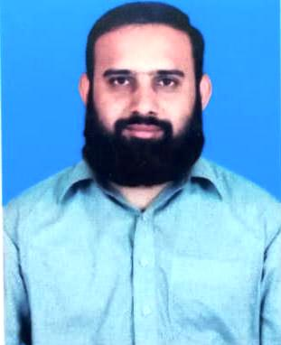
Muhammad Naveed Younis received the MCS degree in Computer Science from Virtual University, Lahore, Pakistan in 2014. In 2021, he received MS Computer Science from the University of Lahore, Lahore, Pakistan. His current research interests include Cognitive Radio Networks, Machine Learning, Deep Learning, Network Security, Cryptography and ad-hoc networks.

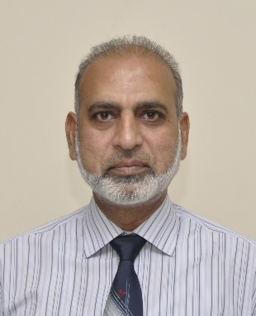
Dr. Mudasser Naseer earned his M.Phil. degree in Statistics from Government College University, Lahore, in 1999, followed by an MS in Computer Science from LUMS, Lahore, in 2004. In 2010, he completed his Ph.D. in Pattern Recognition and Intelligent Systems at Beihang University (Beijing University of Aeronautics and Astronautics), Beijing, China, under the mentorship of Prof. Shi Yin Qin, focusing on Non-Linear Dimensionality Reduction Methods. Dr. Naseer served as an Assistant Professor in the Department of Computer Science at COMSATS University, Lahore campus, from 2010 to 2016. He then joined Wenzhou-Kean University, China—a satellite campus of Kean University, New Jersey, USA—where he worked as an Assistant Professor from 2016 to 2018.
Dr. Naseer has authored numerous research articles published in esteemed journals and presented at international conferences. He also served as the General Secretary for the IEEE International Conference on Applied and Computational Sciences (ICACS) in 2020 and 2023, organized by the Faculty of IT at the University of Lahore. Actively involved in the academic community, he frequently participates in peer review processes for various international and local journals and conferences. Currently, Dr. Naseer is an Associate Professor in the Department of Computer Science & IT at the University of Lahore, Pakistan. His research interests span data science, pattern recognition, machine learning, and computational statistics.

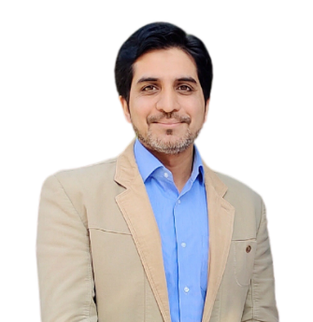
Syed Hashim Raza Bukhari (M’21, SM’21) is an Associate Professor in Department of Electrical & Computer Engineering, Air University, Islamabad, Pakistan. He is the director of Next Generation Intelligent Networks (NGIN) research group. He also served at COMSATS University Islamabad for 9 years. Hashim obtained his Ph. D degree in Electrical Engineering in 2017 from COMSATS University Islamabad (CUI), Wah Campus, Pakistan. Earlier, he received his M.S and B.Eng. degree in Computer Engineering in 2011 and 2007 respectively. He has more than 15 years of experience in academics and has received numerous appreciations upon his contributions for the improvement of teaching standards. He has also received the research productivity award for his research contributions in 2017 from COMSATS. His research interests include the issues in wireless sensor networks with dynamic spectrum access, cognitive radio networks and ad hoc networks. Hashim is currently serving as Editor IEEE Future Direction Newsletter, Guest Editor Journal of Networks and Systems Management (Springer). He is also serving as reviewer of IEEE Communications Surveys and Tutorials, IEEE Communication Magazine, IEEE Transactions on Wireless Communications, IEEE Transactions on Vehicular Technology, IEEE Communication Letters, Pervasive and Mobile Computing (Elsevier), Computers and Electrical Engineering (Elsevier), IEEE Access, Wireless Networks (Springer), Future Generation Computer Systems (Elsevier), and Ad Hoc Sensor Wireless Networks.

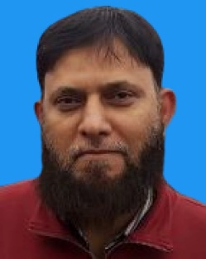
Dr. Farooq Ahmad is an Associate Professor and the Head of the Computer Science Department at COMSATS University Islamabad, Lahore Campus, Pakistan. He earned his Ph.D. in Computer Science from Harbin Institute of Technology in China. With numerous publications in esteemed international journals, he served as the Vice-Chair of the IEEE Computer Society Lahore Section from 2011 to 2012. Additionally, he has been a Conference Co-Chair and Invited Speaker at several national and international conferences. His research interests encompass formal modeling, verification, simulation, and Petri net theory and applications.

