Online supplementary information for the “Identification of neurodevelopmental transition patterns from infancy to early childhood, and risk factors predicting descending transition: a birth cohort study.”

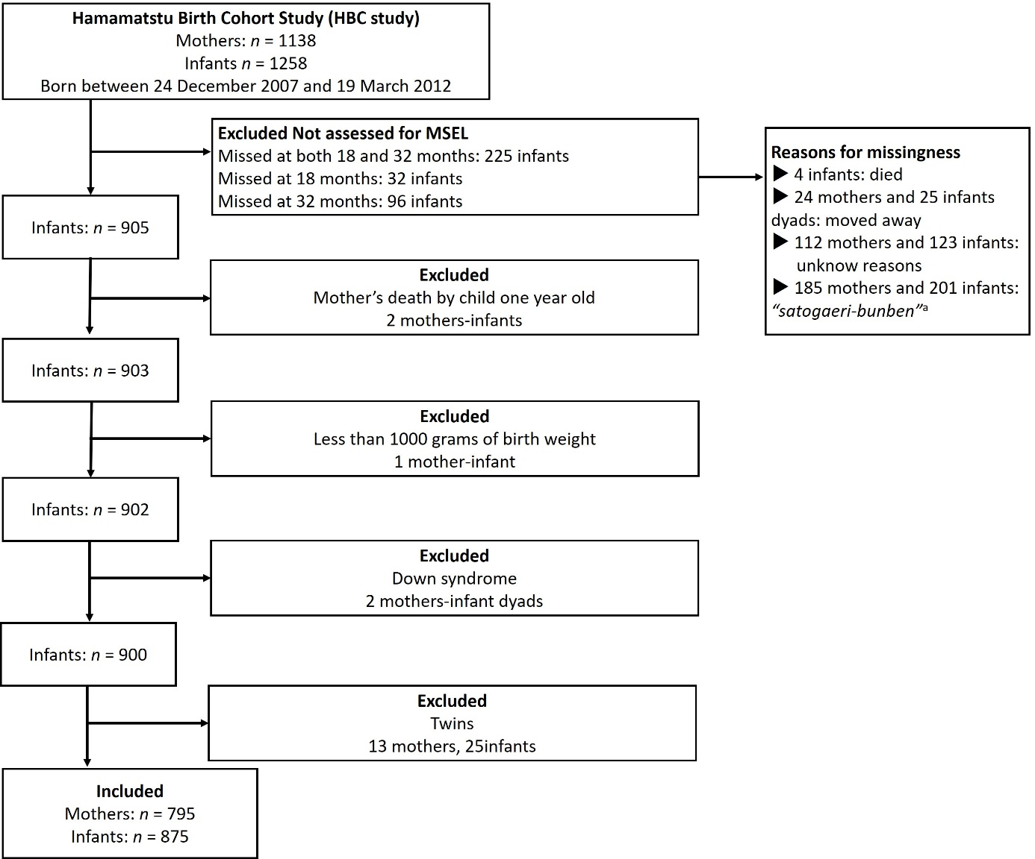

Supplementary Figure S1. Participants flow chart
ª “Satogaeri-bunben” is a Japanese traditional support system for childbirth, in which some pregnant women return to their hometown for delivery while receiving family support.
MSEL, Mullen Scales of Early Learning.

Supplementary Note 1. Details of the latent class analysis of the present study
To select the appropriate class solution in latent class analysis (LCA), we used five common fit indices¹: the Akaike information criterion (AIC), Bayesian information criterion (BIC), entropy, adjusted Lo-Mendell Rubin likelihood ratio test (LMR-LRT), and bootstrap likelihood ratio test (BLRT). Along with these indices, the number of classes was ultimately determined by considering theoretical justification and interpretability². We investigated up to seven class solutions. For LCA time 1 (i.e., 18 months), the adjusted LMR-LRT showed P <.05 up to the five-class solution, whereas BIC was smallest for the six-class solution. AIC continuously reduced, while BLRT remained significant up to the seven-class solution (upper part of Table S1). As for LCA time 2 (i.e., 32 months), the adjusted LMR-LRT similarly showed P <.05 up to the five-class solution, while BIC had the smallest value for the six-class solution. AIC continued to decrease, and BLRT showed P <.001 up to the seven-class solution (lower part of Table S1). These findings indicate the optimal solution with five classes or more for both time 1 and time 2. In our previous study of the same birth cohort, we found that five classes would best delineate the distinctive trajectories of neurodevelopment over the period of infancy (1-24 months), including the current time point (i.e., time 1)³. For comparisons and facilitation of interpretations, we opted for the five-class solution for both time 1 and time 2.

Supplementary Table S1. Fit indices in latent class analysis

 | Number of class
 | 1 | 2 | 3 | 4 | 5 | 6 | 7
Fit stats at time 1 (n = 875)
AIC | 32873.9 | 32233.1 | 31981.6 | 31882.7 | 31802.6 | 31737.5 | 31714.6
BIC | 32921.9 | 32309.9 | 32087.3 | 32017.2 | 31965.9 | 31929.5 | 31935.5
Entropy | - | 0.856 | 0.786 | 0.739 | 0.786 | 0.807 | 0.806
Adjusted LMR-LRT p value | - | < 0.001 | 0.067 | 0.132 | 0.029 | 0.167 | 0.351
BLRT p value | - | < 0.001 | < 0.001 | < 0.001 | < 0.001 | < 0.001 | < 0.001
 | Number of class
 | 1 | 2 | 3 | 4 | 5 | 6 | 7
Fit stats at time 2 (n = 875)
AIC | 32943.5 | 32079.2 | 31680.0 | 31577.7 | 31538.6 | 31489.7 | 31478.4
BIC | 32991.5 | 32156.0 | 31785.6 | 31712.2 | 31701.9 | 31681.8 | 31699.4
Entropy | - | 0.705 | 0.799 | 0.758 | 0.753 | 0.706 | 0.722
Adjusted LMR-LRT p value | - | < 0.001 | < 0.001 | 0.003 | 0.037 | 0.054 | 0.353
BLRT p value | - | < 0.001 | < 0.001 | < 0.001 | < 0.001 | < 0.001 | < 0.001
AIC, Akaike Information Criterion; BIC, Bayesian Information Criterion; BLRT, bootstrap likelihood ratio test; LMR-LRT, Lo-Mendell Rubin likelihood ratio test.

Supplementary Note 2. Details of the latent transition analysis in the present study
Latent transition analysis (LTA) enables us to identify the transition of classes assigned at different time points and investigate the association of predictors (i.e., risk factors) with class shifts. The primary aim of LTA is to compute the latent transition probabilities, which represent the likelihood that individuals change classes or remain in the same class across consecutive periods⁴. In the present study, we followed the three-step approach recommended for LTA^{5,6}. In step 1, the LTA model without risk factors or covariates was estimated; in step 2, individuals were assigned to optimal latent transition patterns; in step 3, a model with risk factors or covariates was fit to detect relevant risk factors. We used this approach to identify transition class assignments, as well as to investigate risk factors for predicting transition patterns using Mplus, version 8⁷. However, during step 3, we failed to obtain accurate and reliable estimates due to the small number of assignment memberships in many of the created cells. In effect, fewer than nine children (less than 1%) were allocated to nearly half of the total 25 cells (12/25), which was created by 5 × 5 classes at time 1 and time 2 (see Table 2). Nine out of 12 belonged to descending or catching-up transition shifts, which were of interest in this study. Therefore, we modified the original step 3⁶ and implemented the following process to enhance the precision of estimation and lead to clinically meaningful interpretations. First, we transferred the whole data on the individual latent class assignments at each time point, transition assignments, and transition probabilities derived from Mplus to Stata software⁸. Then, we combined the three normal classes (i.e., High Normal, Normal, and Low Normal; see Table 2 and Fig. 1 in the main text) at each time point into a single “3-Normals” class, resulting in reduction from five to three classes in total for both time 1 and time 2. Thus, the number of transition patterns was reduced from 25 to 9 (3 × 3) patterns. Second, we examined any differences in background characteristics across these three classes at time 1 to identify potential confounders (covariates) for subsequent analyses. Through the screening analytical steps, distributions of various factors such as sex, premature birth (<37 weeks), low placenta-to-birth weight ratio (<10th percentile), and household income were found to significantly differ across the three classes; thus, they were included as covariates in the analyses. Third, we used logistic regression analysis with the forward stepwise method in which the minimum number of risk factors associated with transition patterns was identified following the principle of parsimony, with covariates being compulsorily held to allow for their confounding effects. Notably, in the original three-step approach⁶, risk factors and covariates are entered compulsorily, thereby rendering the derived estimates unreliable due to the inflated number of parameters. In this analysis, we regarded all the variables listed in Table 1 as risk factors, except for the four covariates. Here, we used the maximum class probability from LTA (converted into odds ratio) to account for variability in the likelihood of transition pattern assignments. Since two or more children born from the same mother were enrolled, such clustering was accounted for by using robust variance estimation. The results showed that maternal pre-pregnancy body mass index (>25 kg/m²), maternal education, and infant's body mass index at 18 months (>1 standard deviation) were associated with descending transition patterns (see Table 3).

Supplementary Table S2. Association between risk factors and neurodevelopmental catching-up and persistent delayed transition patterns in the final model of multinomial logistic regression analysis

 | Transition from expressive language delayed at time 1 (19)
 | to 3-Normals at time 2 (15) | Delayed at time 2 (3) | Markedly Delayed at time 2 (1)
 | OR [95% CI] | OR [95% CI] | OR [95% CI]
Risk factor
Maternal overweight status at pre-pregnancy | 0.83 [0.10, 6.69] | NA | NA
Low maternal education (yr) | 1.21 [1.01, 1.49]* | 0.91 [0.46, 1.81] | 1.96 [1.58, 2.43]****
Male sexª | 1.13 [0.40, 3.20] | NA | NA
Small for gestational age | 0.93 [0.11, 7.53] | 3.85 [0.010, 1409.03] | NA
Premature birth before 37 weeksª | NA | 0.90 [0.69, 1.18] | NA
Infant overweight status at 18 months | NA | NA | NA
Low placenta-to-birthweight ratio (<10th percentile) ª | NA | 9.06 [0.54, 152.11] | NA
Household income (million JPY) ª | 0.98 [0.81, 1.19] | 0.90 [0.69, 1.18] | 1.11 [1.01, 1.21]*
 | Transition from Delayed at time 1 (27)
 | to 3-Normals at time 2 (9) | Delayed at time 2 (10) | Markedly Delayed at time 2 (8)
 | OR [95%CI] | OR [95%CI] | OR [95%CI]
Risk factor
Maternal overweight status at pre-pregnancy | 4.79 [0.91, 25.26] | 0.90 [0.09, 8.57] | 1.40 [0.17, 11.37]
Low maternal education (yr) | 1.09 [0.74, 1.61] | 1.26 [0.85, 1.88] | 1.42 [0.86, 2.32,]
Male sexª | 2.73 [0.62, 11.96] | 1.69 [0.42, 6.68] | NA
Small for gestational age | 10.13 [2.23, 45.85]*** | NA | NA
Premature birth before 37 weeksª | 2.40 [0.41, 13.82] | 3.18 [0.27, 37.10] | NA
Infant overweight status at 18 months | 2.78 [0.24, 31.99] | 2.15 [0.24, 19.18] | NA
Low placenta-to-birthweight ratio (<10th percentile) ª | 1.38 [0.20, 9.39] | 1.86 [0.39, 8.80] | 2.70 [0.59, 12.31]
Household income (million JPY) ª | 0.61 [0.47, 0.79]**** | 0.73 [0.51, 1.03] | 0.99 [0.77, 1.26]
The reference transition pattern is ‘3-Normals to 3-Normals’
ª included as covariates.
OR, odds ratio; CI, confidence interval; JPY, Japanese Yen; NA, not available.
*P <.05. **P <.01. ***P <.005. ****P <.001.

Supplementary Note 3. Results and inferences for catching-up and persistent delayed transition patterns
Approximately half (51%) the infants (n = 24) who belonged to delayed classes (i.e., ‘Expressive Language,’ EL-Delayed, and ‘Delayed’ classes) at time 1 (n = 47) moved to normal classes (i.e., ‘3-Normals’) at time 2, showing catching-up transition patterns (see Table 2). This finding is inconsistent with those of previous studies reporting that approximately 80-90% of children who initially belonged to a delayed class eventually caught up^{9,10}. In these studies, however, ‘delayed class’ was arbitrarily defined using deviations from an average (e.g., below -1 SD); thus, the prevalence of developmental delays in infancy might be overestimated. Infants in the EL-Delayed class in our study may include the so-called ‘late talkers’ (LT), or children under 3 years old who have unusually small vocabularies with unknown primary causes¹¹. Overall, children with LT have a good prognosis, with 60-70% of children moving into the average range on language measures by preschool¹². Our study supports this finding in that 79% of infants assigned to the EL-Delayed class at time 1 caught up to the normal classes by time 2.
Table S2 shows the association between predictor variables and the catching-up and persistent delayed transition patterns from the EL-Delayed class (upper, Table S2) and the Delayed class (lower, Table S2) at time 1 to the 3-Normals class. Low maternal education level was associated with catching-up transition patterns from the EL-Delayed class to the 3-Normals class. However, when the inverse probability weighting method, as described in the main text (Data Attrition), was applied to the model, the finding became no longer significant (OR: 1.17, 95% CI: 0.91, 1.49, P =.24), implying that the seeming association might reflect a bias arising from sample selection procedures.
Small for gestational age (SGA) was found to be positively associated with the catching-up transition pattern from the Delayed class to the 3-Normals class. Although SGA infants reportedly have lower levels of cognitive, language, and motor development than infants with appropriate gestational age¹³, a catching-up phase of neurodevelopmental progress during early childhood has been noted in these children^{14,15}, which is compatible with the findings of the present study. As for the mechanisms for this catching-up phase in children with SGA, growth hormone/insulin-like growth factors have been proposed¹⁶.
Household income used as a covariate was negatively associated with the catching-up transition pattern from Delayed to 3-Normals; infants from low income were more likely to make the catching-up transition from the Delayed class at time 1 to the 3-Normals class at time 2, with the odds ratio (OR) being 0.61 (95% CI: 0.47, 0.79; P <.0001) when compared with infants who transitioned from 3-Normals at time 1 to 3-Normals at time 2. Given that higher income has been reported to be positively related to child development¹⁷, our finding, which is contrary, is puzzling. One possible interpretation of our finding is an involvement of public health care professionals in supporting the development of infants with socioeconomically deprived background^{17,18}. Those infants from low socioeconomic status identified as the Delayed class at time 1 in this study may have naturally raised more attention from health care providers (e.g., through nationwide infant check-ups)¹⁹ and prompted intervention to foster their development.
There was no association between risk factors and persistent delayed transition patterns (i.e., from the EL-Delayed class and the Delayed class at time 1 to the Delayed class and the Markedly Delayed, M-Delayed, class at time 2), except that maternal education and household income were associated with the transition pattern of EL-Delayed to M-Delayed. However, these exceptions were grounded on small sample size (n = 1), which warrant further investigations.

Supplementary Table S3. Comparison of participants’ characteristics between the group included in the analysis and the group excluded from the analysis

 | Included  (n = 875) | Excluded  (n = 383)
 | Mean (SD) | Mean (SD) | P valueª
Infants
Birth weight (g) | 2957.0 (422.2) | 2902.4 (472.8) | 0.042
Gestational age at birth (weeks) | 39.0 (1.4) | 38.6 (1.8) | < 0.0001
 | n (%) | n (%) | P valueª
Sex
Male | 432 (49.4%) | 216 (56.4%) | 0.022
Female | 443 (50.6%) | 167 (43.6%)
Prematurity
<37 weeks | 46 (5.3%) | 40 (10.4%) | 0.0011
≥37 weeks | 829 (94.7%) | 343 (89.6%)
Small for gestational age
<10th percentile | 77 (8.8%) | 29 (7.6%) | 0.47
10th–100th percentile | 798 (91.2%) | 354 (92.4%)
Age-standardised BMI scores at 18 months
>1 standard deviation | 50 (6.1%) | 3 (2.5%) | 0.11
<1 standard deviation | 776 (93.9%) | 116 (97.5%)
 | n (%) | n (%) | P valueª
Parents
Maternal BMI at pre-pregnancy (kg/m²)
>25.0 | 100 (11.4%) | 30 (7.8%) | 0.054
<25.0 | 775 (88.6%) | 353 (92.2%)
Placenta-to-birth-weight ratio (twin excluded)
<10th percentile | 152 (17.7%) | 65 (19.5%) | 0.46
10th–100th percentile | 707 (82.3%) | 268 (80.5%)
 | Mean (SD) | Mean (SD) | P valueª
Paternal age at birth (yr) | 33.5 (5.7) | 32.5 (6.0) | 0.0065
Maternal age at birth (yr) | 31.7 (5.0) | 30.7 (5.1) | 0.0005
Paternal education (yr) | 14.1 (2.6) | 13.8 (2.8) | 0.059
Maternal education (yr) | 13.8 (1.8) | 13.6 (2.2) | 0.028
Household income (million JPY) | 6.0 (2.7) | 5.9 (2.9) | 0.41
SD, standard deviation; BMI, body mass index; JPY, Japanese Yen.
ª t-test for continuous variables and the chi-square test for categorical variables were used.

Supplementary Table S4. Association between risk factors and neurodevelopmental transition patterns in the final model of multinomial logistic regression after excluding infants with a clinical diagnosis of autism spectrum disorder (n = 26)

 | Transition from 3-Normals at time 1 (746)
 | to 3-Normals at time 2 (673) | Delayed at time 2 (62) | Markedly Delayed at time 2 (11)
 | Reference | OR [95%CI] | OR [95%CI]
Risk factor
Maternal overweight status at pre-pregnancy | .. | 2.61 [1.25, 5.43]** | NA
Low maternal education (yr) | .. | 1.23 [1.06, 1.42] | 1.08 [0.78, 1.49]
Male sex ª | .. | 1.41 [0.79, 2.51] | 10.96 [2.47, 48.51]***
Small for gestational age | .. | 2.07 [0.82, 5.22] | 0.68 [0.056, 8.50]
Premature birth before 37 weeks ª | .. | 1.16 [0.36, 3.81] | 8.69 [1.74, 43.39]**
Infant overweight status at 18 months | .. | 1.65 [0.62, 4.34] | 8.8 2[1.88, 41.36]**
Low placenta-to-birthweight ratio (<10th percentile) ª | .. | 1.52 [0.74, 3.12] | NA
Household income (million JPY) ª | .. | 0.90 [0.79, 1.01] | 0.91 [0.66, 1.26]
 | Transition from Expressive Language Delayed at time 1 (17)
 | to 3-Normals at time 2 (15) | Delayed at time 2 (2) | Markedly Delayed at time 2 (0)
 | OR [95%CI] | OR [95%CI] | OR [95%CI]
Risk factor
Maternal overweight status at pre-pregnancy | 0.90 [0.11, 7.31] | NA | NA
Low maternal education (yr) | 1.23 [1.01, 1.49]* | 3.12 [0.59, 16.66] | NA
Male sex ª | 1.17 [0.41, 3.33] | NA | NA
Small for gestational age | 0.92 [0.11, 7.45] | 33.23 [0.27, 3845.80] | NA
Premature birth before 37 weeks ª | NA | 140.01 [0.0094, 2 0652.31] | NA
Infant overweight status at 18 months | NA | NA | NA
Low placenta-to-birthweight ratio (<10th percentile) ª | 2.90 [0.94, 8.94] | NA | NA
Household income (million JPY) ª | 0.99 [0.82, 8.94] | 1.16 [0.92, 1.46] | NA
 | Transition from Delayed at time 1 (22)
 | to 3-Normals at time 2 (8) | Delayed at time 2 (10) | Markedly Delayed at time 2 (4)
 | OR [95%CI] | OR [95%CI] | OR [95%CI]
Risk factor
Maternal overweight status at pre-pregnancy | 5.68 [1.08, 29.77]* | 0.87 [0.088, 8.52] | NA
Low maternal education (yr) | 1.05 [0.68, 1.63] | 1.28 [0.84, 1.92] | 2.01 [1.08, 3.70]*
Male sex ª | 2.21 [0.48, 10.02] | 1.74 [0.43, 6.93] | NA
Small for gestational age | 11.86 [2.42, 58.12]*** | NA | NA
Premature birth before 37 weeks ª | 2.65 [0.44, 15.75] | 3.15 [0.26, 37.25] | NA
Infant overweight status at 18 months | 3.19 [0.24, 40.98] | 2.10 [0.23, 18.94] | NA
Low placenta-to-birthweight ratio (<10th percentile) ª | 1.58 [0.22, 11.17] | 1.88 [0.40, 8.77] | 2.96 [0.38, 22.89]
Household income (million JPY) ª | 0.66 [0.54, 0.81]**** | 0.74 [0.53, 1.04] | 1.11 [0.86, 1.43]
OR, odds ratio; CI, confidence interval; JPY, Japanese Yen; NA, not available.
ª included as covariates.
*P <.05. **P <.01. ***P <.005. ****P <.001.

Supplementary Table S5. Association between neurodevelopmental transition patterns and adaptive behaviour at 40 months in linear regression analysisª after excluding infants with a clinical diagnosis of autism spectrum disorder (n=26)

 | Adaptive Behaviour Composite standardised score
 | coefficient (95%CI)
Transition patterns (n)
3-Normals to 3-Normals (646) | reference
3-Normals to Delayed (59) | -7.52 [-9.41, -5.62]****
3-Normals to Markedly Delayed (10) | -12.05 [-18.71, -5.40]****
EL-Delayed to 3-Normals (14) | -2.44 [-5.24, 0.34]
Delayed to 3-Normals (8) | 0.47 [-4.44, 5.39]
EL-Delayed to Delayed (2) | -15.24 [-17.37, -13.11]****
EL-Delayed to Markedly Delayed (0) | ..
Delayed to Delayed (10) | -9.85 [-13.47, -6.23]****
Delayed to Markedly Delayed (4) | -18.61 [-24.01, -13.22]****
EL-Delayed, Expressive Language Delayed.
ª Covariates used in this analysis comprised infant's sex (male), premature birth (<37 weeks), low placenta-to-birthweight ratio (<10th percentile), household income, maternal body mass index at pre-pregnancy (>25 kg/m²), small for gestational age (<10th percentile), infant’s standardised body mass index at 18 months of age (>1 SD), and maternal educational history.
****P <.001.

References

1. Ausderau, K. K. et al. Sensory subtypes in children with autism spectrum disorder: latent profile transition analysis using a national survey of sensory features. J. Child Psychol. Psychiatry. 55, 935-944 (2014).
2. Berlin, K. S., Parra, G. R. & Williams, N. A. An introduction to latent variable mixture modeling (part 2): longitudinal latent class growth analysis and growth mixture models. J. Pediatr. Psychol. 39, 188-203 (2014).
3. Nishimura, T., Takei, N., Tsuchiya, K. J., Asano, R. & Mori, N. Identification of neurodevelopmental trajectories in infancy and of risk factors affecting deviant development: a longitudinal birth cohort study. Int. J. Epidemiol. 45, 543-553 (2016).
4. Collins, L. M. & Lanza, S. T. Latent class and latent transition analysis: With applications in the social, behavioral, and health sciences. Vol. 718 (John Wiley & Sons, 2010).
5. Muthen, B. & Muthen, L. K. Integrating person-centered and variable-centered analyses: growth mixture modeling with latent trajectory classes. Alcohol. Clin. Exp. Res. 24, 882-891 (2000).
6. Nylund-Gibson, K., Grimm, R., Quirk, M. & Furlong, M. A latent transition mixture model using the three-step specification. Struct. Equ. Modeling. 21, 439-454 (2014)..
7. Muthén, L. K. & Muthén, B. O. 1998–2012. Mplus user’s guide. (Muthén & Muthén, 2012).
8. StataCorp, L. Stata treatment-effects reference manual. (A Stata Press Publication, 2015).
9. Hillemeier, M. M., Morgan, P. L., Farkas, G. & Maczuga, S. A. Perinatal and socioeconomic risk factors for variable and persistent cognitive delay at 24 and 48 months of age in a national sample. Matern. Child. Health. J. 15, 1001-1010 (2011).
10. McManus, B. M., Robinson, C. C. & Rosenberg, S. A. Identifying Infants and Toddlers at High Risk for Persistent Delays. Matern. Child. Health. J. 20, 639-645 (2016).
11. Rescorla, L. Late talkers: do good predictors of outcome exist? Dev. Disabil. Res. Rev. 17, 141-150 (2011).
12. Dale, P. S., McMillan, A. J., Hayiou-Thomas, M. E. & Plomin, R. Illusory recovery: Are recovered children with early language delay at continuing elevated risk? Am. J. Speech Lang. Pathol. 23, 437-447 (2014).
13. Savchev, S. et al. Neurodevelopmental outcome of full‐term small‐for‐gestational‐age infants with normal placental function. Ultrasound Obstet. Gynecol. 42, 201-206 (2013).
14. Taine, M. et al. Early postnatal growth and neurodevelopment in children born moderately preterm or small for gestational age at term: A systematic review. Paediatr. Perinat. Epidemiol. 32, 268-280 (2018).
15. Takeuchi, A. et al. Catch-up growth and neurobehavioral development among full-term, small-for-gestational-age children: a nationwide japanese population-based study. J. Pediatr. 192, 41-46 (2018).
16. Cho, W. K. & Suh, B. K. Catch-up growth and catch-up fat in children born small for gestational age. Korean J. Pediatr. 59, 1-7 (2016).
17. Demirci, A. & Kartal, M. Sociocultural risk factors for developmental delay in children aged 3–60 months: a nested case-control study. Eur. J. Pediatr. 177, 691-697 (2018).
18. Ozkan, M., Senel, S., Arslan, E. A. & Karacan, C. D. The socioeconomic and biological risk factors for developmental delay in early childhood. Eur. J. Pediatr. 171, 1815-1821 (2012).
19. Kamio, Y. et al. Brief Report: Best Discriminators for Identifying Children with Autism Spectrum Disorder at an 18-Month Health Check-Up in Japan. J. Autism Dev. Disord. 45, 4147-4153 (2015).

