 | RDA1 | RDA2 | RDA3 | RDA4 | RDA5
Eigenvalue | 3778.69 | 2124.286 | 1617.635 | 1161.829 | 1117.472
Proportion Explained | 0.385584 | 0.216766 | 0.165066 | 0.118555 | 0.114029
Cumulative Proportion | 0.385584 | 0.60235 | 0.767416 | 0.885971 | 1
Table S2. Summary of Redundancy Analysis (RDA) eigenvalues and explained variance. The table lists the eigenvalues and the proportion of variance explained by the first five RDA axes. The Eigenvalue row indicates the magnitude of the variance captured by each corresponding RDA axis. The Proportion Explained row shows the fraction of the total variance that each axis explains. The Cumulative Proportion row provides the running total of the variance explained when the axes are considered together.

 | Variance | Variance Proportion | P-value
Precipitation of Driest Quarter | 2860.851 | 7.32% | 0.009
Mean Temperature of Driest Quarter | 2501.945 | 6.40% | 0.02
Temperature Annual Range | 1475.461 | 3.77% | 0.206
Isothermality | 1651.543 | 4.22% | 0.148
Precipitation Seasonality | 1310.112 | 3.35% | 0.328
Overall | 9799.912 | 25.06% | -
Residual | 29308.09 | 74.94% | -
Table S3. Statistical analysis of environmental variables influencing gene expression as determined by RDA. This table presents the variance attributed to each environmental variable and the corresponding P-value testing the null hypothesis that the variable does not explain a significant portion of the variance in gene expression.

Variable 1 | Variable 2 | Original | P-value
Mean Temperature of Driest Quarter | Peptidase and Nucleotidyltransferase Activities Related Genes | 0.202219 | 0.010738
Isothermality | Cyclic and Aromatic Compound Biosynthetic Process Related Genes | 0.380726 | 0.005085
Isothermality | Peptidase and Nucleotidyltransferase Activities Related Genes | 0.448716 | 0.001582
Precipitation Seasonality | Cyclic and Aromatic Compound Biosynthetic Process Related Genes | 0.426026 | 0.000654
Precipitation Seasonality | Peptidase and Nucleotidyltransferase Activities Related Genes | 0.658637 | 2.06E-06
Cyclic and Aromatic Compound Biosynthetic Process Related Genes | CW | -0.92838 | 0.034311
Peptidase and Nucleotidyltransferase Activities Related Genes | Average Angle of Dips | -1.31775 | 0.010273
Table S4. Partial Least Squares Path Modeling (PLS-PM) Analysis of the Associations Between Environmental Factors, Gene Groups, and Phenotypic Traits. The Original column represents the path coefficients indicating the strength and direction of the relationships, while the P-value column tests the null hypothesis that the observed relationship is not significant.

Variables | R² | Block Communality | Mean Redundancy | AVE
Cyclic and Aromatic Compound Biosynthetic Process Related Genes | 0.937954 | 0.667706 | 0.626278 | 0.667706
Peptidase and Nucleotidyltransferase Activities Related Genes | 0.944219 | 0.590306 | 0.557379 | 0.590306
DBH | 0.304227 | 1 | 0.304227 | 1
Heigh | 0.621929 | 1 | 0.621929 | 1
CW | 0.761467 | 1 | 0.761467 | 1
Average Angle of Dips | 0.682429 | 1 | 0.682429 | 1
Ratio of Crown to Height | 0.31502 | 1 | 0.31502 | 1
Table S5. Summary of PLS-PM analysis indicating the R-squared (R²), Block Communality, Mean Redundancy, and Average Variance Extracted (AVE) for gene groups and phenotypic traits. The R² values represent the proportion of variance in the endogenous constructs that is explained by all of the exogenous constructs linked to it, indicating the strength of the model. Block Communality reflects the shared variance between the construct and its indicators, while Mean Redundancy provides the average variance shared between the construct and its indicators, weighted by the R² values of the endogenous constructs. The AVE values in the final column measure the amount of variance that a gene group or trait captures from the variables it is supposed to measure, with values closer to 1 indicating higher explanatory power. This table provides insights into the reliability and predictive accuracy of the gene groups and phenotypic traits within the PLS-PM framework, essential for understanding their roles in the species' adaptability and growth characteristics.

Figure S1. Distribution map of 14 different seed provenances for Chamaecyparis hodginsii. Each colored dot represents a distinct provenance of seed collection.

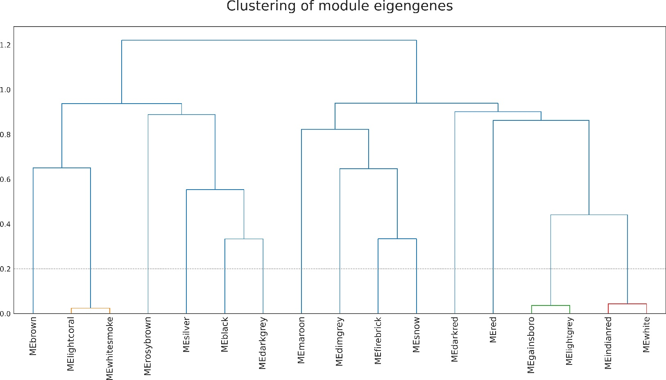
Figure S2. Dendrogram of module eigengenes from Weighted Gene Co-expression Network Analysis (WGCNA). The dendrogram illustrates the hierarchical clustering of modules based on the similarity of their eigengene profiles. Each branch represents a module identified by a unique color, with the height of the merge (y-axis) indicating the degree of similarity between modules. A cut height of 0.2 was used to define modules, where branches above this threshold represent distinct modules. Modules clustering together below the cut height are highly similar, suggesting potential functional relatedness or shared regulatory influences.

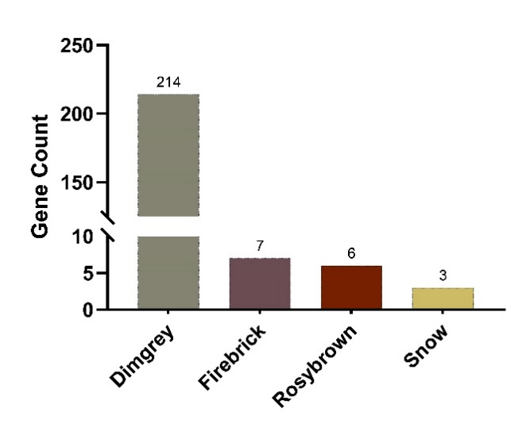
Figure S3. Bar graph representing the distribution of key genes across four distinct modules identified by RDA and WGCNA with a threshold of KME > 0.6. Each bar corresponds to one of the modules with the height of the bar reflecting the count of key genes within that module. The number at the top of each bar indicates the exact count of genes. This figure illustrates the varying number of key genes associated with each module, which may signify the relative importance or influence of each module in relation to the traits or environmental responses being studied.

