Supplementary Information
1. Parker spiral IMF conditions
The IMF originates at the Sun and is carried into space by the solar wind. The Sun’s rotation causes the formation of spiral-shaped magnetic field streamlines in the solar ecliptic (X-Y) plane, commonly referred to as the Parker spiral. The magnetic field is carried with the solar wind, and stretched radially outwards as the Sun rotates, such that IMF lines are parallel with the solar wind streamlines above and below the heliospheric current sheet (the locus of points formed by the maximum radial extent of field lines connected to the Sun). Since the solar magnetic axis is slightly misaligned with the solar rotation axis, the ecliptic plane samples field lines either slightly above or below the current sheet, which are directed parallel/anti-parallel to the magnetic field lines projected onto the X-Y plane, as depicted by the white lines in Figure 1. The average IMF components are listed in Table S1, which are referred to be Parker spiral IMF conditions. The data are categorized based on the IMF direction: the first and second rows represent anti-parallel configurations of the IMF, where both the B_{x} and B_{y} components have opposite signs, indicating opposite directions of the IMF. The first rows present the input IMF parameters used in the test particle simulations.

2. LND field of view
The LND instrument is installed inside the lander of the Chang’E 4 mission. The sensor head of LND has a re-closeable door, the door is open during its local daytime from ∼ 8 h_{M} to ∼ 16 h_{M} to allow an unimpeded field of view (FOV) into the sky, and the door is closed during its nighttime to reserve heat inside the payload. The LND FOV points approximately 13$°$ from the viewing direction to the zenith direction to avoid an obstruction by the payload structure [18]. The lander of the Chang’E 4 mission landed in the von Karman crater at 177.5991$°$ E, 45.4446 $°$ S [22]. The FOV of LND is mainly perpendicular to the local IMF under the Parker spiral IMF conditions, as confirmed by the Figure S1. Therefore, the potential influence of the FOV of LND on our statistical results can be shown to be unimportant.

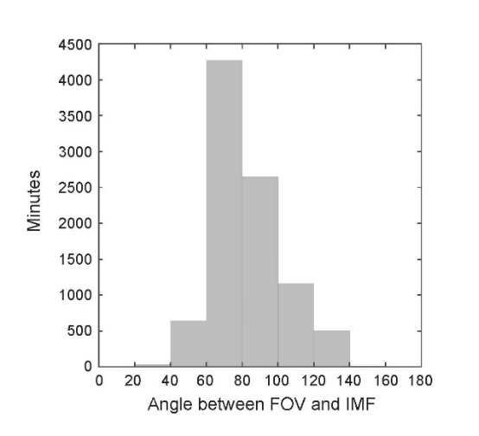
Fig. S1. Statistical distribution of the angle between the FOV of LND and the local IMF. The y-axis represents the total event count in minutes, indicating the number of sample events observed under Parker spiral IMF conditions. The histogram shows the occurrence frequency of different angles, highlighting the dominant angle between 60 and 120.
Table S1. Parker spiral IMF parameters measured by ARTEMIS. This table presents the statistical results of the IMF components (B_{x}, B_{y}, B_{z}) in nanotesla (nT) as measured by ARTEMIS. The first rows present the input IMF parameters used in the test particle simulations.
IMF direction | B_{x} | B_{y} | B_{z}
B_{x}>0 and B_{y}<0 | 3.03 | -2.54 | 0.06
B_{x}<0 and B_{y}>0 | -3.00 | 2.63 | 0.04

