Economic and environmental impact analysis of biomass collection and pre-processing in northern and southern China

S1 Amount of biomass available
The amount of agricultural residue straw was obtained by the product of crop yield and grass to grain ratio. On the assumption that the straw is uniformly distributed over the provincial area:
$M_{raw}=\sum_{i}{\sum_{j}{M_{i,j}k_{i}k_{j}}}$ (S1)
$M_{i,j,k}$(wt) represent the yield of crop $j$(wt) in area $i$. where the amount available for cellulosic ethanol $M_{raw,e}$(wt):
$M_{raw,e}=M_{raw} k_{c}k_{u}$ (S2)
$k_{c}$ represent the collectability coefficient of straw in the area, which is commonly chosen as 0.85 in China. $k_{u}$ is the percentage of straw selected as bioethanol feedstock among them, and in this study all of them were selected for off-farm utilization, and the $k_{c}$ was selected to be 0.85, taking into account the loss of.

S1.1 Straw distribution in Heilongjiang and Zhejiang
Heilongjiang and Zhejiang were selected as the representative regions of north and south of China. The straw distribution in the two provinces are shown in Table S1. The total straw production is 9381 t in Heilongjiang and 719 t in Zhejiang, respectively. Calculated in accordance with eq S2, the straw yield per unit area is 50.57 t/km² in Heilongjiang and 18.02 t/km² in Zhejiang.

Table S1. Straw data of Heilongjiang and Zhejiang
Type | Heilongjiang crop production, $M_{i,j}$/wt | Zhejiang crop  production, $M_{i,j}$/wt | Ratio of straw | Amount of straw available for Heilongjiang$M_{raw}$/wt | Amount of straw available for Heilongjiang$M_{raw}$/wt
Paddy | 2913.7 | 469.1 | 1.0 | 742.99 | 119.62
Wheat | 26.3 | 48.3 | 1.17 | 7.85 | 14.41
Corn | 4149.2 | 25.6 | 1.25 | 1322.56 | 8.16
Other cereals | 15.2 | 4.4 | 1.55 | 6.01 | 1.74
Soya bean | 718.8 | 21.3 | 1.60 | 293.27 | 8.69
Mung bean | 12.9 | 8.7 | 2 | 6.58 | 4.44
Potato | 31.7 | 43.5 | 0.58 | 4.69 | 6.43
Peanut | 10.5 | 4.9 | 0.85 | 2.28 | 1.06
Rape | 0 | 25.8 | 2.6 | 0 | 17.11
Sesame | 0 | 0.8 | 2.2 | 0 | 0.45
Cotton | -- | 0.6 | 3.25 | 0 | 0.50
Bast fibre plants | 11.0 | 0 | 1.76 | 4.94 | 0.00
Tobacco leaf | 2.7 | 2.0 | 1.6 | 1.10 | 0.82
Total amount | -- | -- | -- | 9381 | 719

S1.2 Straw distribution in the straw subsidized areas
Heilongjiang and Zhejiang there is a large gap in the distribution of straw, the main straw area of Heilongjiang is concentrated, so the local use of straw in these areas to subsidize; Zhejiang province straw dispersed, the main production area for the northern part of the region, the local use of all the region to subsidize the use of straw, the specific data are shown in Tables S2, S3.

Table S2. Straw collection, storage and transportation subsidy
parameters | Minimum Straw Utilization for Straw Subsidy | Subsidized area | Subsidized standards
Heilongjiang | 0 | 20 counties | 45000 y/km²
Zhejiang | ≥1000 t | entire province | 50%
Zhejiang | ≥10000 t | entire province | 80%

Table S3. Available density of straw in subsidized areas and selected range
parameters | range | area (km²) | Distribution density of  available straw (wt/km²)
Zhejiang | North | 6.33 | 90.9
Heilongjiang | Southwest | 11.83 | 380.8
Heilongjiang | Northeast | 9.46 | 317.3

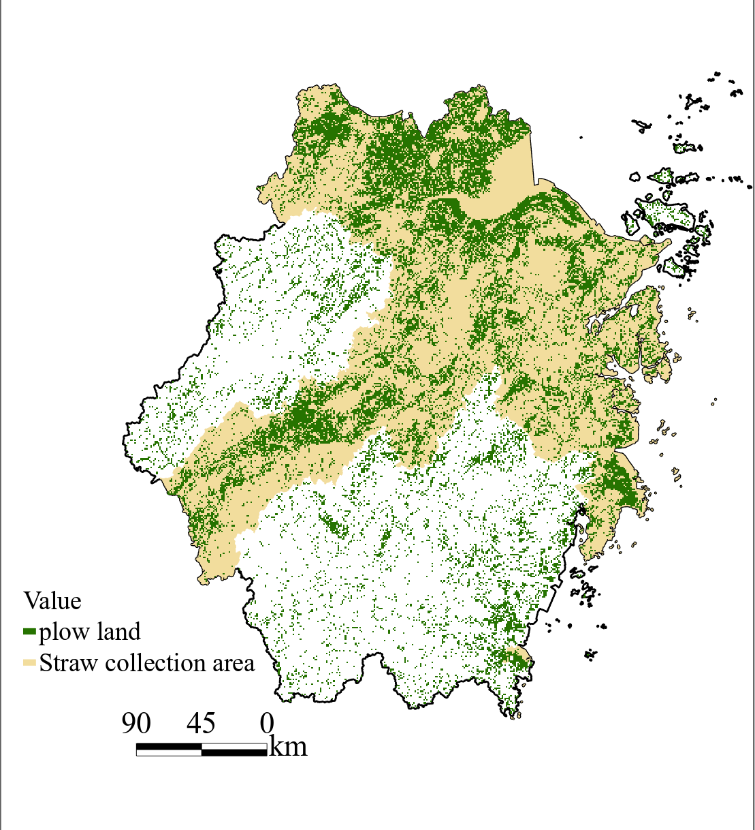
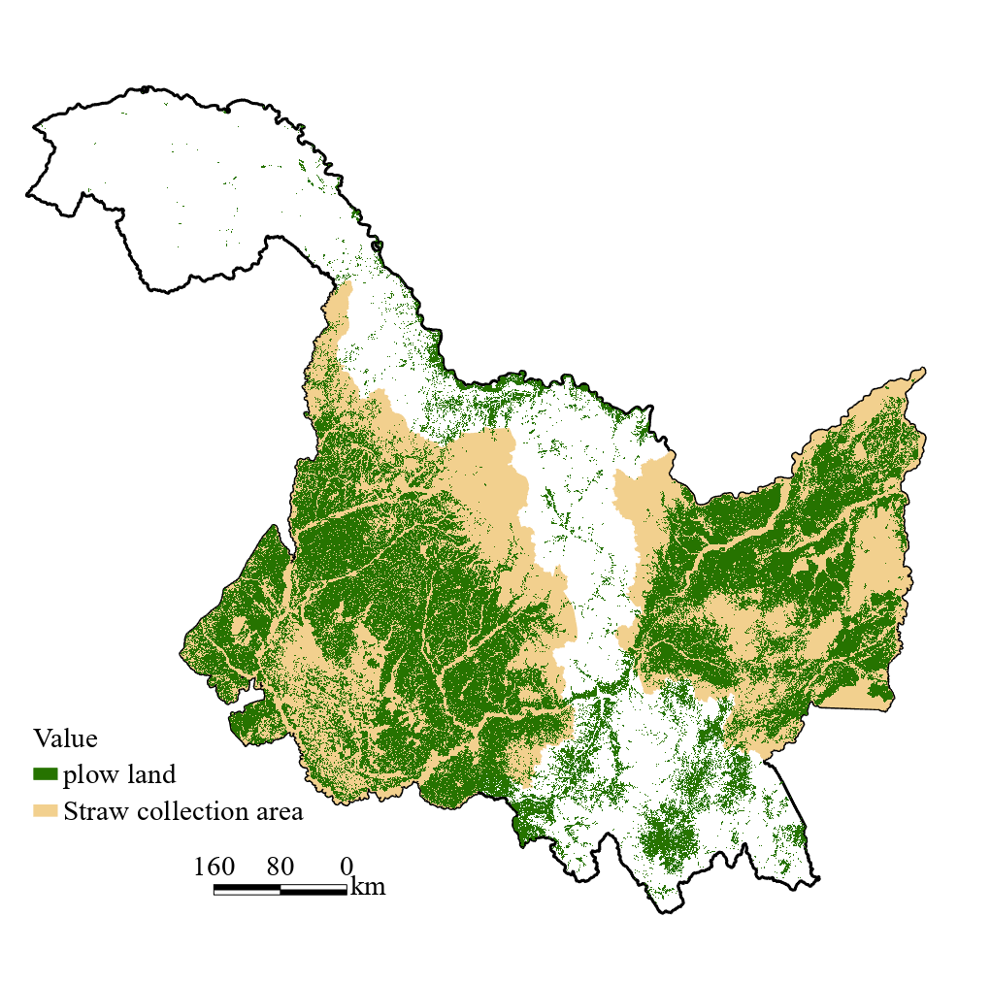
Fig S1. Cropland distribution and straw collection option areas and circular model analysis areas in Heilongjiang and Zhejiang (a: Heilongjiang; b: Zhejiang)
(a)
(b)

S2 Supply Chain Cost Model
We modeled the quantity and costing of equipment involved in the straw collection, pretreatment and transportation process for each supply chain model using a unified approach. In particular, the operating costs of equipment typically include equipment depreciation ($C_{ds}$), energy costs ($C_{f}$), maintenance costs ($C_{r}$) and labor costs ($C_{p}$), as shown in Equation S3, The equipment parameters required at each stage are also listed in Table S4.
$C_{m}=(C_{d}−C_{ds})/T+C_{f}+C_{r}+C_{p}$ (S3)
Depreciation of equipment is usually calculated by reference to the residual value of the equipment at the end of year T and the cost of acquisition. Typically, 50 per cent of the residual value of the equipment at the end of 10 years is taken, i.e., depreciation of the equipment for each year is taken as 5 per cent of the acquisition cost of the equipment.
$C_{ds}=5\%C_{d}$ (S4)
Typically, the cost of maintenance of equipment is also usually charged at 5 per cent of the acquisition of equipment.
$C_{r}=5\%C_{d}$ (S5)
The cost of labor required for the equipment shows a positive correlation with the number of hours of operation of the equipment ($t_{m}$, d) and the number of people required for the separate equipment ($N_{u}$), however, because of the different levels of complexity of the equipment, there are differences in the number of people required, which is calculated as shown in the following equation
$C_{p}=t_{m}×N_{u}$ (S6)
In addition, the number of certain equipment required for different modes of supply ($A_{m}$) is calculated from the total amount of straw to be treated per year ($Q_{m}$, t), the number of effective working hours per year ($t_{m}$, h), and the capacity of a single piece of equipment($q_{m}$,t/h). In addition, it is assumed that the number of equipment required is increased by one unit over the calculated number of equipment, taking into account issues such as maintenance of the equipment.
$A_{m}=Q_{m}/t_{m}×q_{m}+1$ (S7)

Table S4. facilities related parameters
Instrument | Power（kw） | Price/y | Marketers | Handling capacity（t/h） | Fuel consumption （L/h）
Automatic pick-up baler | 66 | 76000 | Zoomlion | 40 | 16
Grass catcher | 60 | 10000 | Jining Hengwang | Baling 15、kneading22.5、  Crushing-baling 33.8、Pelletizing45 | 12.6
Kneading machine | 24 | 20000 | Shandong | 10 | --
Crushing - baling presses | 37 | 30000 | Combination | 2.5 | --
Pelletizers | 132 | 15000 | Henan Yuhui | 2.5 | --
Ethanol plant pulverizer | 22 | 20000 | Jining Hengwang | Baling 2.5、  kneading 5、  Pelletizing 3 | --

S2.1 Collection cost model
In the process of straw collection, the difference of collection volume has a huge impact on the cost, and the calculation of collection radius ($r$, m) can be more directly used for the analysis of transportation and other costs. The collection radius is calculated by Eq. S8, where $S$ is the area of collection, which is calculated according to the ratio of the collection volume ($M_{raw}$) and the density of straw distribution in the area in Eq. S9. 0.7 is taken into account for the curvature of the road during the collection process because the route during transportation does not run in a straight line, so the collection radius actually used for the transportation phase of the calculation needs to be divided by 0.7.
$r=\sqrt{\frac{S}{π}}/0.7$ (S8)
$S=M_{raw}/(\frac{M_{0}}{S_{0}}$) (S9)
In this study, the collection radius calculation followed this formula both for the 10000 t and 50000 t collection stations and for thecellulosic ethanol plants with larger total collection volumes.
Moreover, in this study, acquisition costs were added directly to the total collection costs for both manual and mechanical collection. The cost of manual collection is calculated as shown in Eq. S10. The meanings and values of the required parameters can be found in Table S1.
$C_{c·p}=Q_{biomass}×C_{biomass}+Q_{biomass}/Q_{p}×C_{p}$ (S10)
The automatic picking and baling machine picks and bales straw directly in the field, and the cost is calculated as in Eq. S11. Where $C_{m·p}$ is the annual operating cost of each collection machine, y; $A_{m·p}$ is the number of collection machines required, and all these parameters are calculated according to the calculation section of the equipment model described above.
$C_{c·m}=Q_{biomass}×C_{biomass}+C_{m·p}×A_{m·p}$ (S11)

S2.2 Transportation cost model
The transportation cost of straw ($C_{t}$) shown in Fig. 1 includes the transportation cost of the collection and storage station and the transportation cost of the cellulosic ethanol plant, and the calculation model of the transportation cost of the two stages individually wants to be the same, but because of the different vehicles used for transportation, the calculation parameters chosen are different, all of which are obtained in Table S2. In addition, when converting an agricultural vehicle into an electric vehicle, the energy cost is calculated by directly converting the energy consumption to electricity, and the parameters are also shown in Table S4.
$C_{t}=\frac{2}{3}β(C_{tr}×Q_{biomass}×r+C_{tR}×({Q_{biomass}−q}_{biomass})×R)$ (S12)
The transport rate of biomass per unit load is the cost of a round trip per unit load kilometer (including fuel cost, labor cost, maintenance cost, purchase cost).
$C_{tr}=C_{fr}{∙q}_{f}+\frac{T_{w}{∙C}_{pr}}{{2ml}_{tr}}+\frac{T_{w}{∙C}_{mr}}{{2ml}_{tr}}+\frac{{(C}_{p}{−C}_{pt}{)∙T}_{w}}{{2ml}_{tr}{T∙N}_{wd}{∙T}_{ma}}$ (S13)

In this study，assume that a transport is completed, and the ratio of empty to full load is 1:1

$q_{f}=(g_{e}/v_{1}+g_{eo}/v_{o})×N_{en}/2m$ (S14)
Transport time spent on the road for a round trip ($T_{p}$, h)
$T_{p}=l_{tr}×(1/v_{1}+1/v_{o})$ (S15)
In addition to the time consumed on the road in the process of vehicle transportation, the auxiliary time such as loading and unloading is 0.8 h, then the working time of the vehicle for one round trip ($T_{w}$, h)
$T_{w}=T_{p}+0.8$ (S16)
In order to improve efficiency, straw loading and unloading is used when transporting straw from the collection and storage station to the processing plant. The loading and unloading costs ($C_{l}$, y/t) were calculated in the same way as the equipment costs described previously
$C_{l}=2C_{m∙l}×N_{m∙l}$ (S17)

Table S4. Transport vehicle parameters
Type of machine | Tractor | Electric trailer | Lorry
Full load speed $v_{1}$（km/h） | 20 | 1.47 | 25
Unladen speed $v_{o}$（km/h） | 30 | 25 | 45
Full load fuel consumption rate $g_{e}$（kg/kWh) | 0.30 | 0.25 kWh/km | 0.25
No-load fuel consumption rate $g_{eo}$（kg/kWh) | 0.22 | 2.04 kWh/km | 0.54
Power $N_{en}$（kW） | 100 | 36 | 300
Price（y） | 30000 | 30000 | 400000
Loose poles t/car | 0.8 | 0.8 | --
Baling t/car | 3 | 3 | 11.7
Kneading t/car | -- | -- | 17.6
Crushing-baling t/car | -- | -- | 26.3
Pelletizing t/car | -- | -- | 35.1

S2.3 Storage cost model
The storage costs of straw are divided into fixed costs ($C_{s∙c}$,y) and variable costs ($C_{s∙d}$, y)
$C_{s}=C_{s∙c}+C_{s∙d}$ (18)
The fixed cost is the storage cost of the pre-treated straw, all of which has to be transported in batches from the storage site to thecellulosic ethanol plant. Because of the large number of storage sites, the lease needs to be made on an annual basis, and no more vacant months are taken into account. The fixed cost is the product of the annual land rent ($C_{r},y·hm$⁻²) and the leased area ($S_{s}$, $hm$⁻²), the annual land rent is shown in the table S3, which is obtained from the research; the leased area is calculated according to Eq.19. Because the storage area is affected by the form of stacking of straw and the density of straw after pretreatment, the stacking height of straw ($h$, m), the occupancy coefficient of straw ($ɑ$), and the density of straw after pretreatment($ρ$,kg/m³) are taken into account in the calculation process.
$C_{s∙c}=C_{r}×S_{s}$ (19)
$S_{s}=Q_{biomass}/(h×ɑ×ρ)$ (20)
In a similar way, variable storage costs can be calculated. The difference, however, is that the calculation of variable costs takes full account of the short harvest period and the long pre-treatment time of the straw. That is, the straw needs to be stacked in the form of loose poles or bales made by picking and baling machines before it is pre-treated after transportation to the collection and storage points. Therefore, the calculation of variable cost takes into account the collection time($Q_{P}$,d) and the density of straw after collection before treatment($ρ_{0}$,kg/m³), and the calculation equation is shown below. In this study, storage volumes of 50,000 t and 10,000 t per unit storage site were selected for analysis, respectively.
$C_{s∙d}=C_{r}×S_{d}$ (21)
$S_{d}=Q_{biomass}×/(Q_{P}×h×ɑ×ρ_{0})$ (22)

S2.4 Cost model of pretreatment and pulverization in cellulosic ethanol plant
In order to reduce the transportation rate, three different pre-treatment methods (Kneading, Crushing - Briquetting, Pelletizing) were carried out at the storage station and compared with the bales made by the original automatic pick-up baler. Because the raw material forcellulosic ethanol plant is considered in this study, it needs to be crushed and treated before production. Therefore, among the four types of pre-treated straw, in addition to the crushed and baled straw which only needs to be unpacked, the other forms of straw need to be crushed by the secondary pre-treatment to ensure that each supply chain from the source tocellulosic ethanol raw material is uniform. The parameters involved in the formula for pretreatment costs are all in accordance with Table S4.
$C_{p}=A_{m·p1}C_{m·p1}+A_{m·p2}C_{m·p2}$ (23)

3 CO₂ emissions analysis
Each stage of the supply chain involves the consumption of electricity or fuel, resulting in different CO₂ equivalents, which should be taken into account in the feasibility analysis.Therefore, in this study, the CO₂ equivalent emissions of each supply mode were calculated as the sum of the CO₂ equivalent emissions of the individual stages, and since the storage process does not consume a large amount of energy, but only electricity for lighting, etc., it was chosen to be ignored in the calculations here.
$M_{CO2}=M_{CO2,C}+M_{CO2,T}+M_{CO2,P}$ (24)
When calculating the CO₂ equivalence of the collection phase, manual collection is assumed to produce no CO₂, while mechanical collection requires fuel consumption, which is calculated based on the amount of diesel consumed. In the collection phase, $q_{f,c}$(kg/h·t) is the fuel consumption per unit hour of work of the automatic picking and baling machine and $t_{m,c}$(h)is the all time required to collect $Q_{biomass}$ of straw. 2.8 is the mass factor of CO2 per kilogram of diesel fuel burned. The $q_{f,c}$ is the calculation data of energy consumption cost according to the previous cost calculation, which can be directly used here.
$M_{CO2,C}=2.8q_{f,c}t_{m,c}Q_{biomass}$ (25)
At the transportation stage, since by fuel consumption is affected by empty and full loads, the unit of fuel consumption is converted to the mass of diesel fuel required to transport 1km of straw per unit mass to simplify the calculation ($q_{f,t}$, kg/(km·t)). In the case of using an electric tractor instead of a tractor, the unit of energy consumption is converted to the amount of electricity required to transport 1t of straw 1km ($q_{e,t}$, kWh/(km·t)). 0.997 is the mass factor of carbon dioxide produced when supplying 1 KWh of thermal electricity. The $q_{f,t}$and $q_{e,t}$are the calculation data of energy consumption cost according to the previous cost calculation, which can be directly used here.
$M_{CO2,T}=2.8q_{f,t}t_{m,t}Q_{biomass}$ (26)
$M_{CO2,P}=0.997q_{e,t}t_{m,t}Q_{biomass}$ (27)
In the pre-treatment stage, the power consumption of the equipment is obtained directly from the product of power and time. The $q_{e,t}$ is the calculation data of energy consumption cost according to the previous cost calculation, which can be directly used here.
$M_{CO2,P}=0.997q_{e,t}t_{m,p}Q_{biomass}$ (28)
In addition, the CO₂ emissions from the function of utilizing wind power instead of thermal power are also considered in this study and are calculated in the following equation. 0.006 represents the CO₂ mass factor produced by consuming 1 kWh of wind power. The $q_{e,t}$ is the calculation data of energy consumption cost according to the previous cost calculation, which can be directly used here.

$M_{CO2,P}=0.006q_{e,t}t_{m,p}Q_{biomass}$ (29)

Table S5. Other parameters of straw collection, storage and transportation
Item Unit | Symbol/Unit | Heilongjiang |  | Zhejiang
Manual collection time | $D_{p}$/d | 90 | 90
Manual efficiency | $Q_{p}$/(t·d⁻¹) | 3 | 3
Mechanical collection time | Qmp/d | 30 | 30
Collection price | $C_{biomass}$/(y·t⁻¹) | 80 | 80
Labor cost | $C_{p}$/(y·d⁻¹) | 200 | 200
Labor and pickup machine working time | $T_{d}$/(h·d⁻¹) | 8 | 8
Equipment working time | $T_{ma}$/(h·d⁻¹) | 20 | 20
Diesel price | $C_{fr}$/(y·kg⁻¹) | 7.60 | 7.74
Electricity price | $C_{E}$/(y·kwh⁻¹) | 0.5858 | 0.6068
Bioethanol plant working days | $N_{wd}$/d | 330 | 330
Density of baled straw | ρ/(kg·m⁻³) | 200 | 200
Bulk straw density | ρ/(kg·m⁻³) | 60 | 60
Density of kneaded straw | ρ/(kg·m⁻³) | 300 | 300
Crushed-baled straw density | ρ/(kg·m⁻³) | 450 | 600
Pelletized | ρ/(kg·m⁻³) | 600 | 800
Plant rental cost | $C_{s}$/(y·hm⁻²) | 20000 | 30000

S3 Impact of collection volume on supply chain costs
Fig.S2 Impact of collection volume on supply chain costs (a: Heilongjiang; b: Zhejiang)

S4 Comparison of storage station sizes
Fig. S2 Impact of collection radius on supply chain costs at 50000t collection station size (a: Heilongjiang; b: Zhejiang)

S5 Cost and Carbon Impact of Electric Tractors
Fig. S3 Impact of collection radius on supply chain costs under replacement by electric tractors (a: Heilongjiang; b: Zhejiang)

Fig. S4 Impact of collection radius replaced by electric tractor on supply chain CO₂ emissions (a: Heilongjiang; b: Zhejiang)

