Supplementary information: Ortho-functionalization of a ²¹¹At-labeled aryl compound provides stabilization of the C-At bond against oxidative dehalogenation

Romain Fouinneteauª, Clémence Maingueneauª, Nicolas Galland^{b}, Cécile Perrio^{c*}, François Guérard^{a*}
ª Nantes Université, Inserm, CNRS, Université d’Angers, UMR 1307, CRCI2NA Nantes, France
^{b} Nantes Université, CNRS, CEISAM, UMR 6230, F-44000 Nantes, France
^{c} Normandie Univ, UNICAEN, CEA, CNRS, Cyceron, Caen, France
*Corresponding author: francois.guerard@univ-nantes.fr, perrio@cyceron.fr

I) Radio-chromatogram analysis procedure

Analysis of a stability medium is a two-stage process (Figure S1):
- Injection of an aliquot of the medium into the HPLC. The injection volume is pre-defined according to the volume activity of the medium analyzed (injection of approximately 10 kBq).

- Following analysis of the medium, a sodium sulfite solution (50µL - 10mg/mL) is injected to wash the HPLC system of any free astatine remaining on the column.
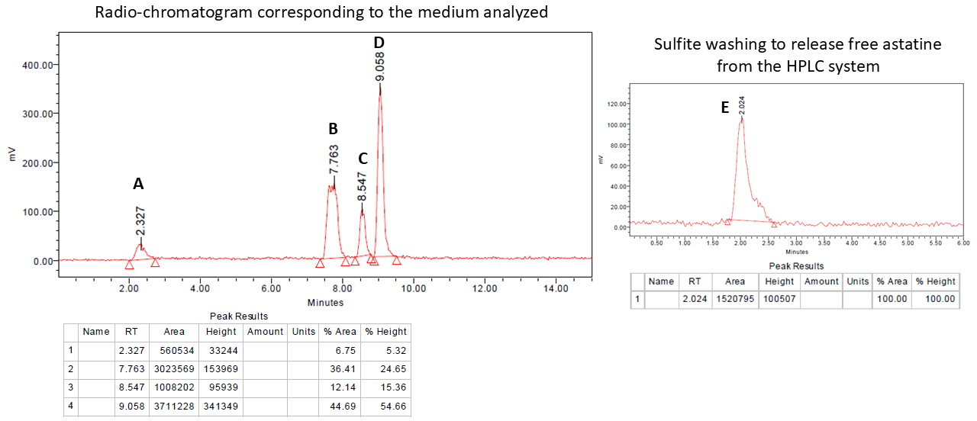
Figure S1. Example of [²¹¹At]AEB stability medium at 5 h in rat liver microsome
Each peak is then integrated, providing each peak area (noted A(A), A(B) etc…) to quantify the species present. Compound degradation (released astatine) during a stability assay was quantified by the ratio of free astatine (outgoing peak to injection peak (rt ≈ 2 min) when present (Figure S1 - A)) + sulfite washing (Figure S1 – E) to the sum of radio-chromatogram areas (free astatine area + area of peaks corresponding to astatoaryl compounds (Figure S1 – B, C and D)).
$$Released astatine \left(\%\right)=\frac{A \left(A\right)+A \left(E\right)}{A \left(A\right)+A \left(B\right)+A \left(C\right)+A \left(D\right)+A \left(E\right)}×100= \frac{560534+1520795}{560534+3023569+1008202+3711228+1520795} ×100 ≈21 \%$$

Equation S1. Example of calculation of astatine released during stability

II)Radio-chromatograms of radiolabeling medium

3-[²¹¹At]astato-N-ethylbenzamide [²¹¹At]AEB (4)
Iodinated references
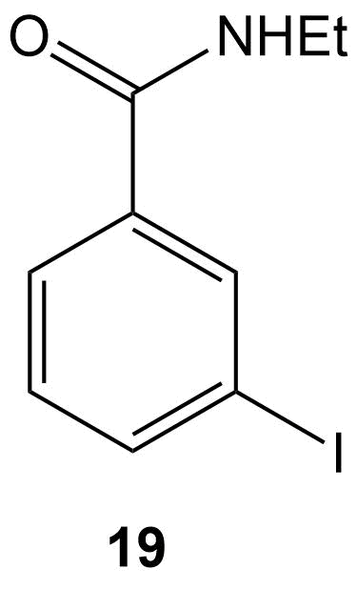  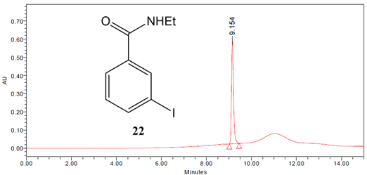 | 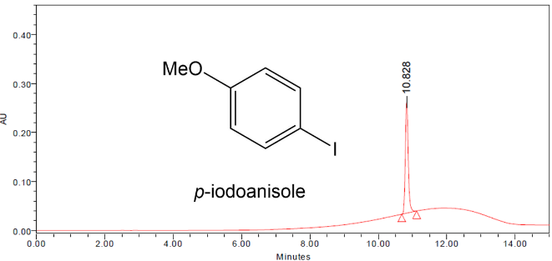
Radiolabeling medium | Sulfite washing
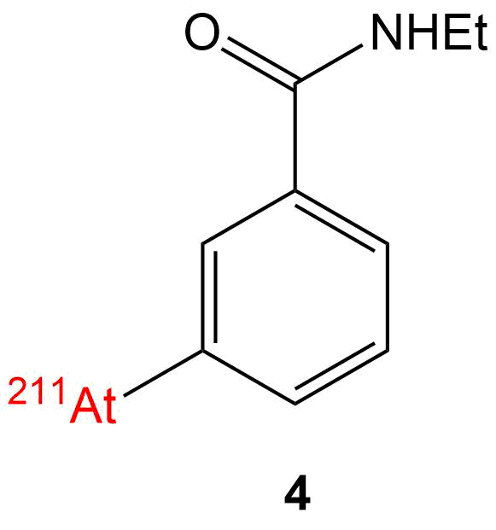  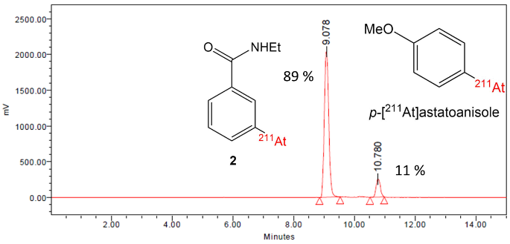 | 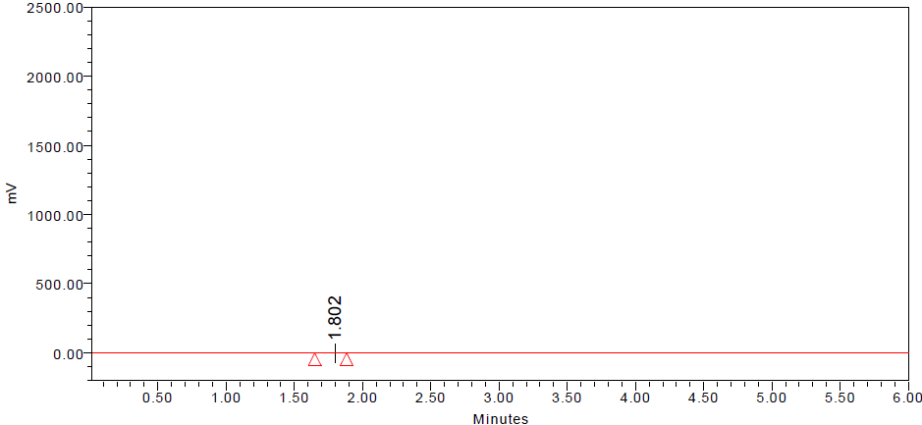  Free At < 1%
Purification
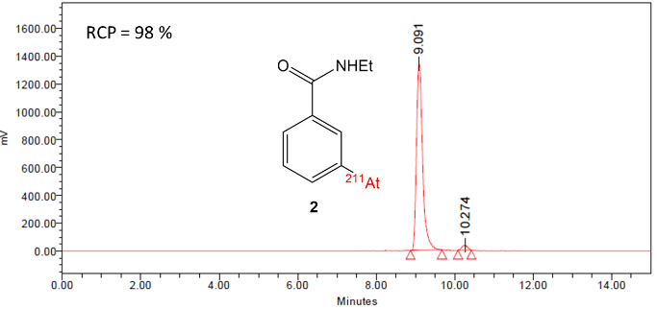 | 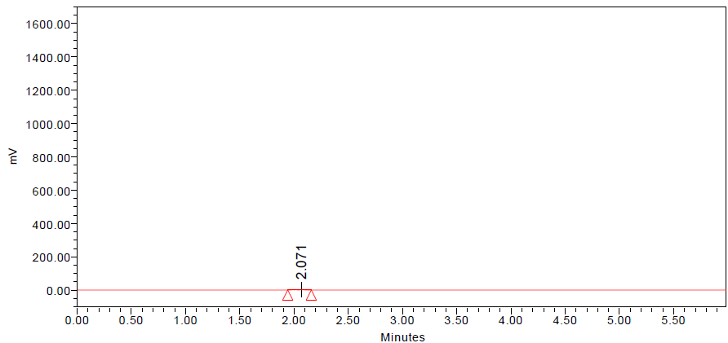  Free At < 1%

Figure S2. Iodinated references and radio-chromatograms of radiolabeling medium before and after purification of 4

(2-[²¹¹At]astatophenyl)methanol (2)
Iodinated references
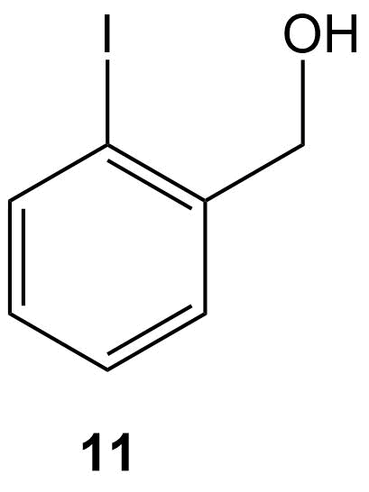
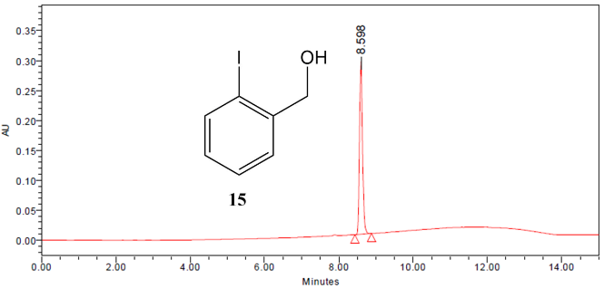
Radiolabeling medium | Sulfite washing
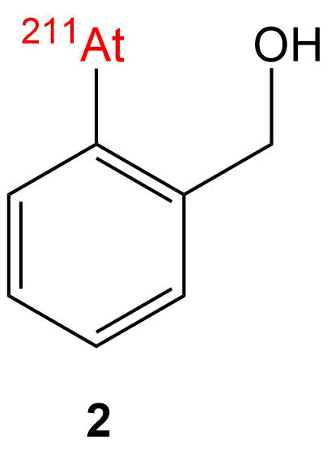  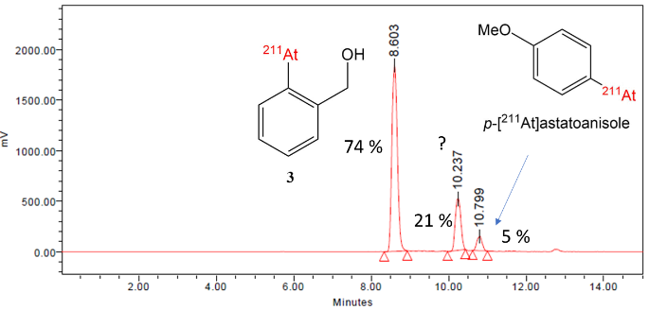 | 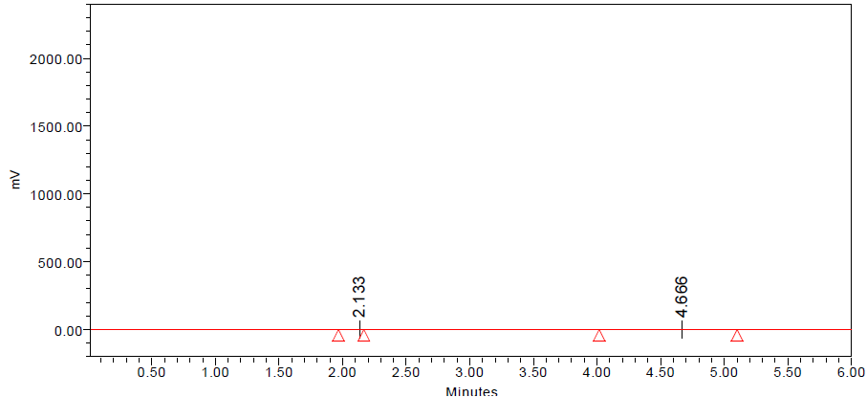  Free At < 1%
Purification
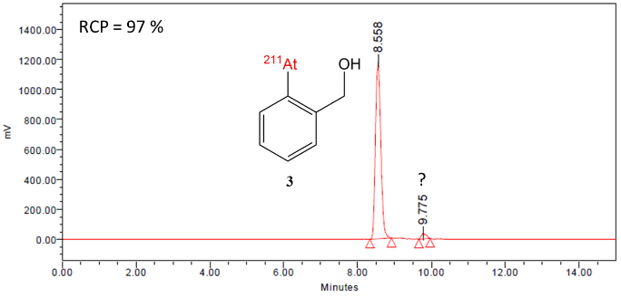 | 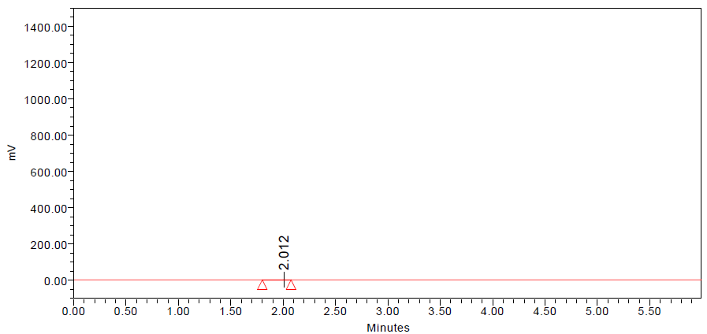  Free At < 1%

Figure S3. Iodinated references and radio-chromatograms of radiolabeling medium before and after purification of 2

(2-[²¹¹At]astato-2,3-phenylene)dimethanol (3)
Iodinated references
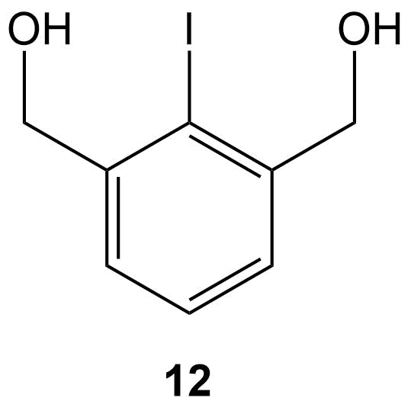
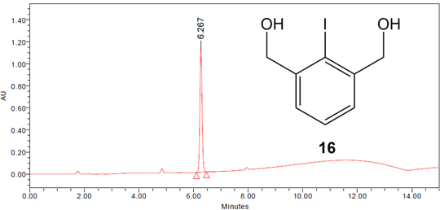
Radiolabeling medium | Sulfite washing
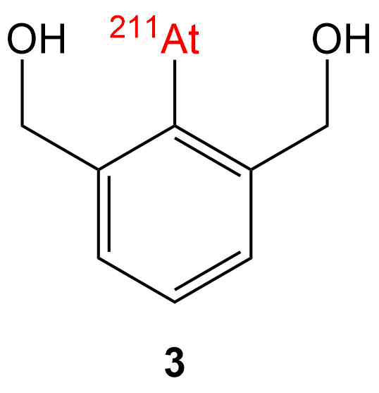  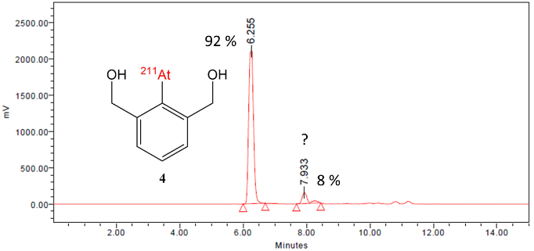 | 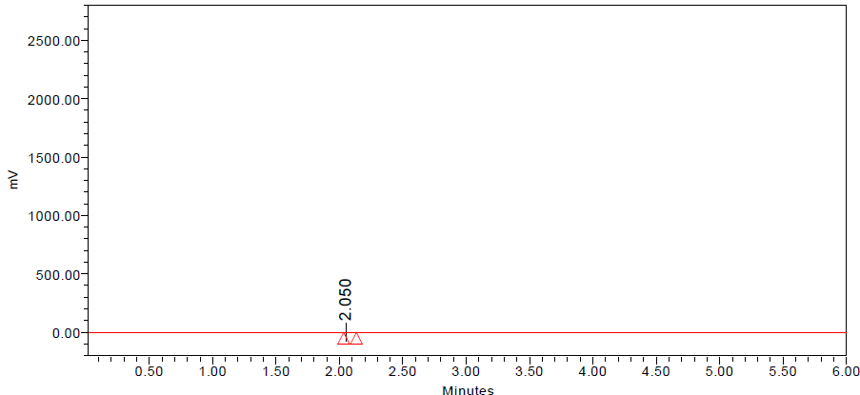  Free At < 1%
Purification
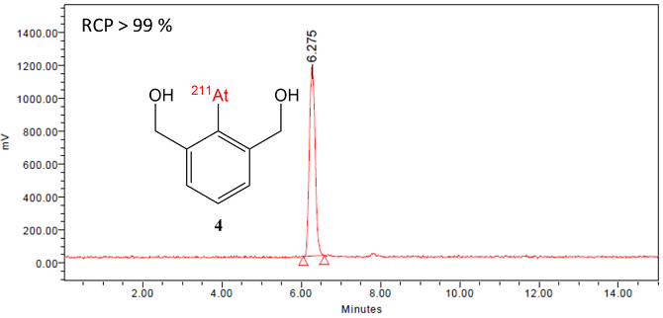 | 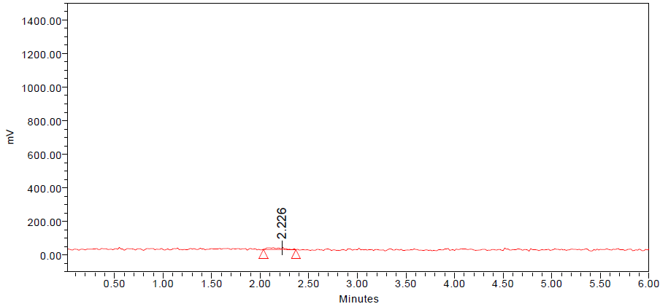  Free At < 1%

Figure S4. Iodinated references and radio-chromatograms of radiolabeling medium before and after purification of 3

III) Radio-chromatograms of stability medium

Stability medium analysis | Sulfite washing
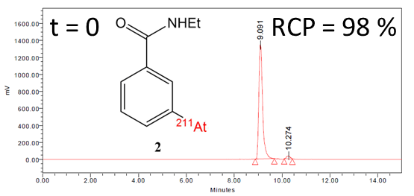 | Free At < 1%
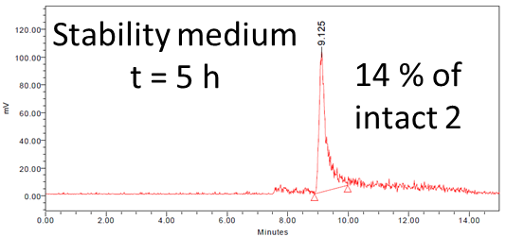 | 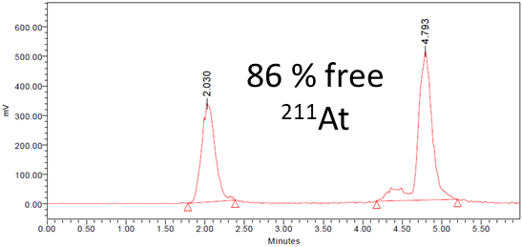
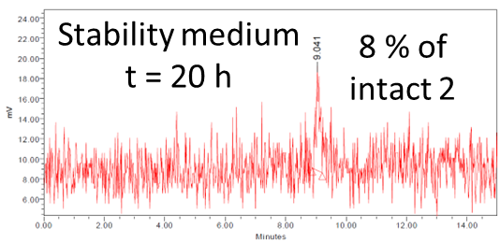 | 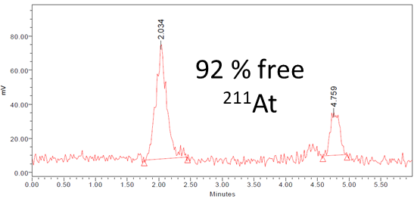

Figure S5. HPLC monitoring of [²¹¹At]AEB stability in oxidizing/acidic media (KMnO₄ 1 mM – acetate buffer pH 4.7 50 mM)

Stability medium analysis | Sulfite washing
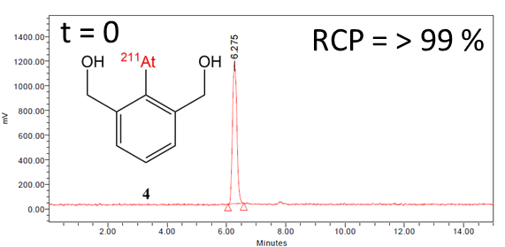 | Free At < 1%
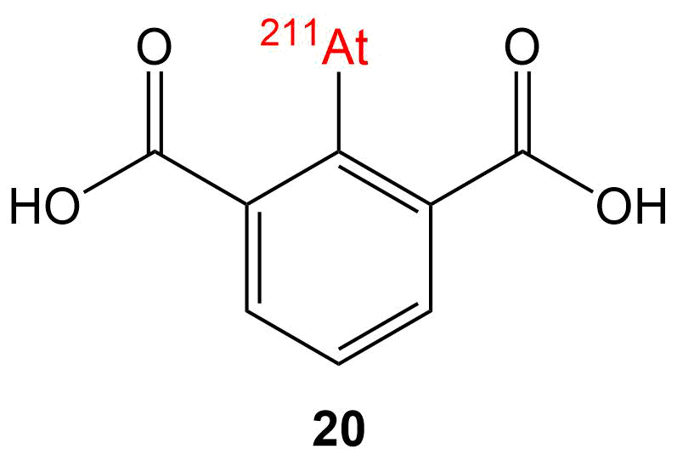  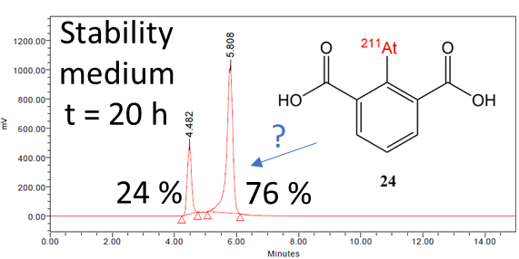 | 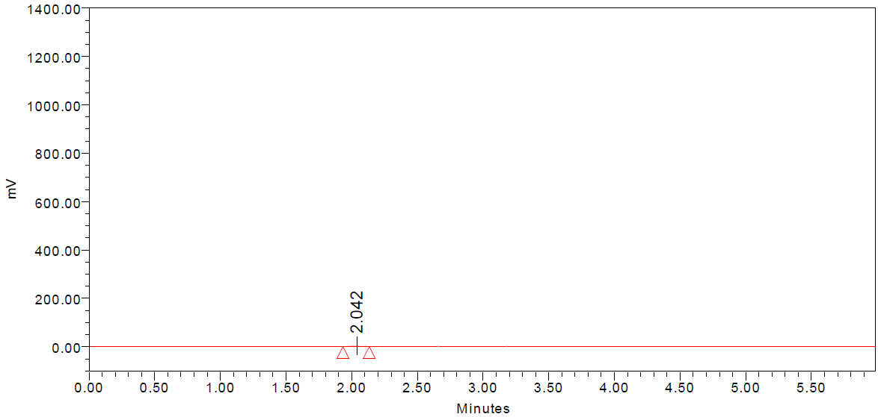  Free At < 1%
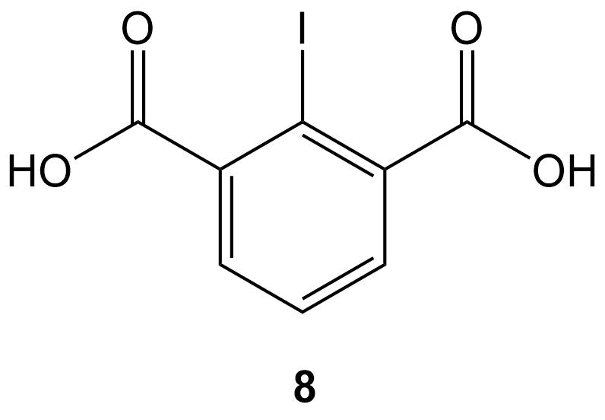  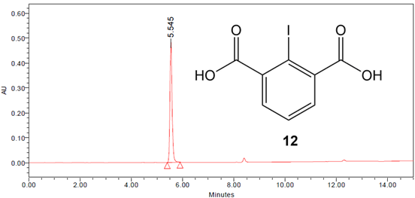 | -

Figure S6. HPLC monitoring of 3 stability in oxidizing/acidic media (KMnO₄ 1 mM – acetate buffer pH 4.7 50 mM)

Free At < 1%
Stability medium analysis | Sulfite washing
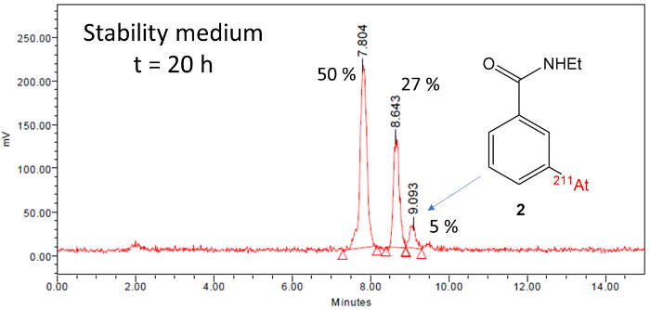 | 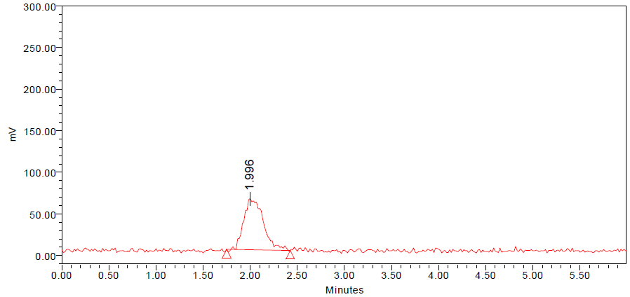  Free At 18%

Figure S7. HPLC monitoring of 4 stability in rat liver microsome

Stability medium analysis | Sulfite washing
 | Free At < 1%
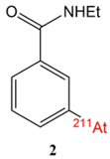  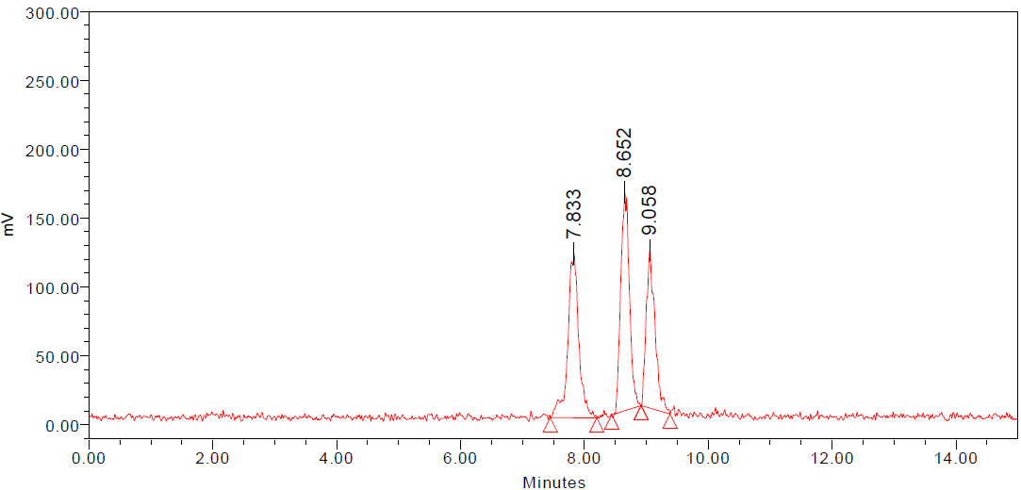  Stability medium t = 20 h  25%  34%  32% | 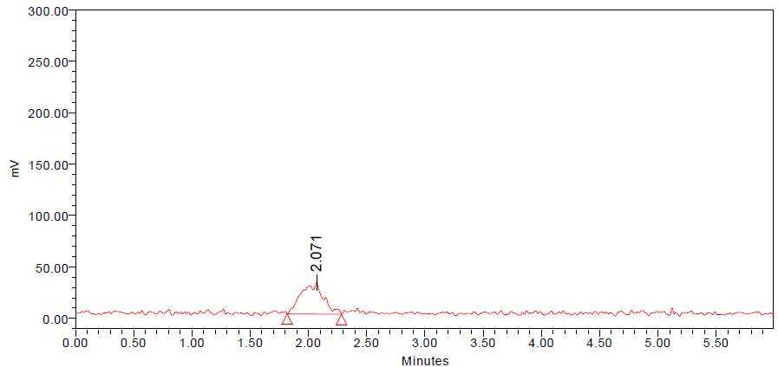  Free At 9%

Figure S8. HPLC monitoring of 4 stability in human liver microsome

Stability medium analysis | Sulfite washing
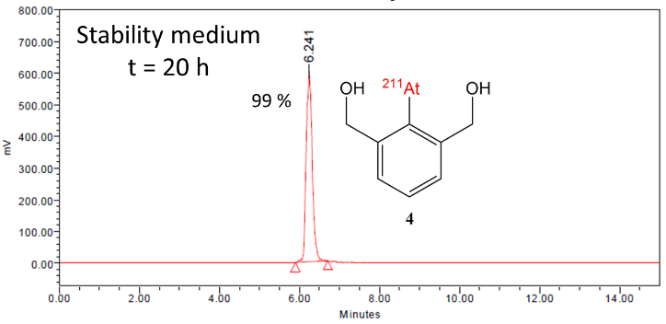 | 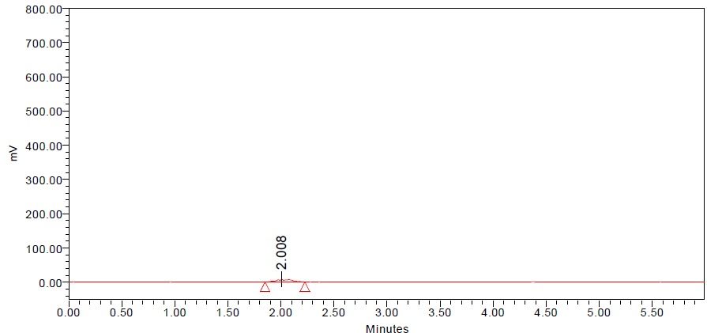  Free At 1%
Free At < 1%
Figure S9. HPLC monitoring of 3 stability in rat liver microsome

Stability medium analysis | Sulfite washing
 | Free At < 1%
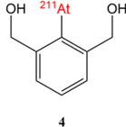  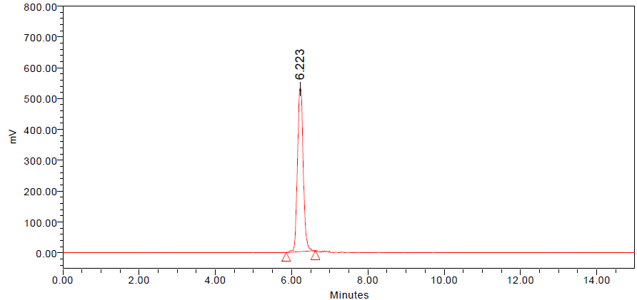  Stability medium t = 20 h  99% | 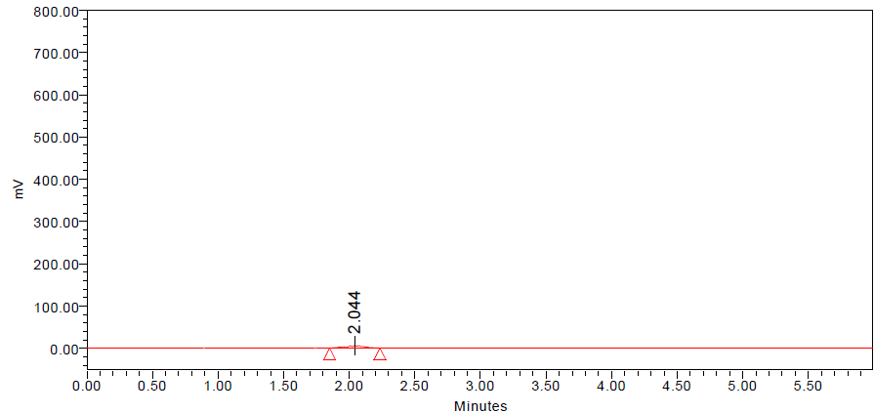  Free At 1%

Figure S10. HPLC monitoring of 3 stability in human liver microsome

IV) Stability of [²¹¹At]astatobenzene in rat liver microsome

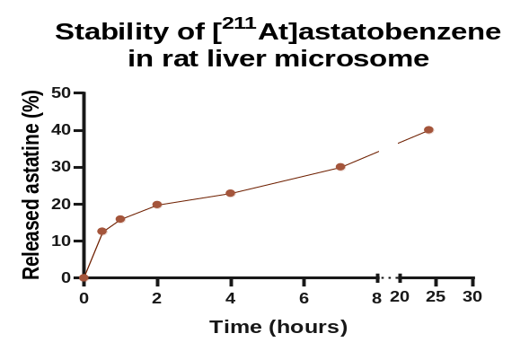
Figure S11. Monitoring of deastatination of [²¹¹At]astatobenzene in rat liver microsome at 30 min, 1, 2, 4, 7 and 24 h (n = 1)

V) Analysis of synthesized molecules

2-iodo-benzoic acid (7)
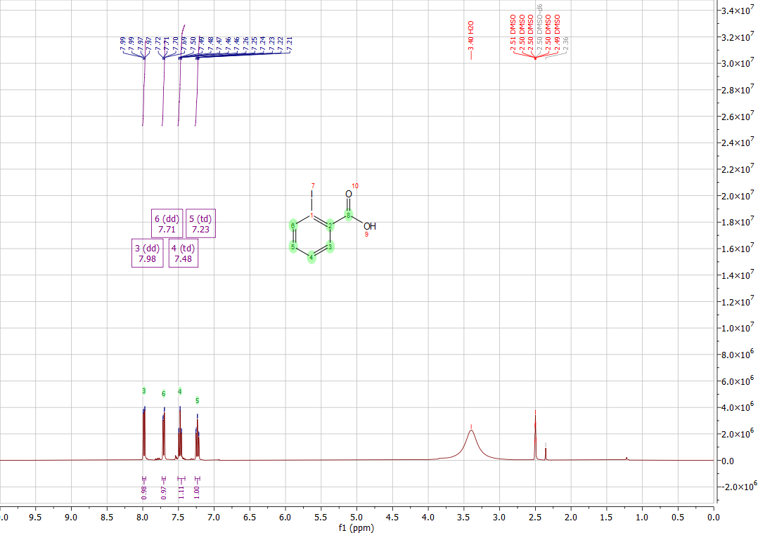
Figure S12. ¹H NMR spectrum of compound 7
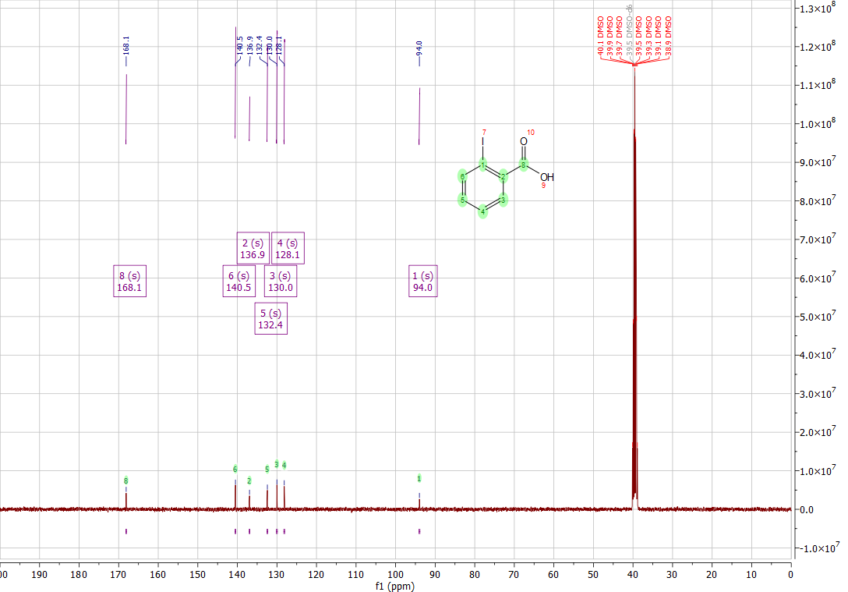
Figure S13. ¹³C NMR spectrum of compound 7

2-iodo-isophtalic acid (8)
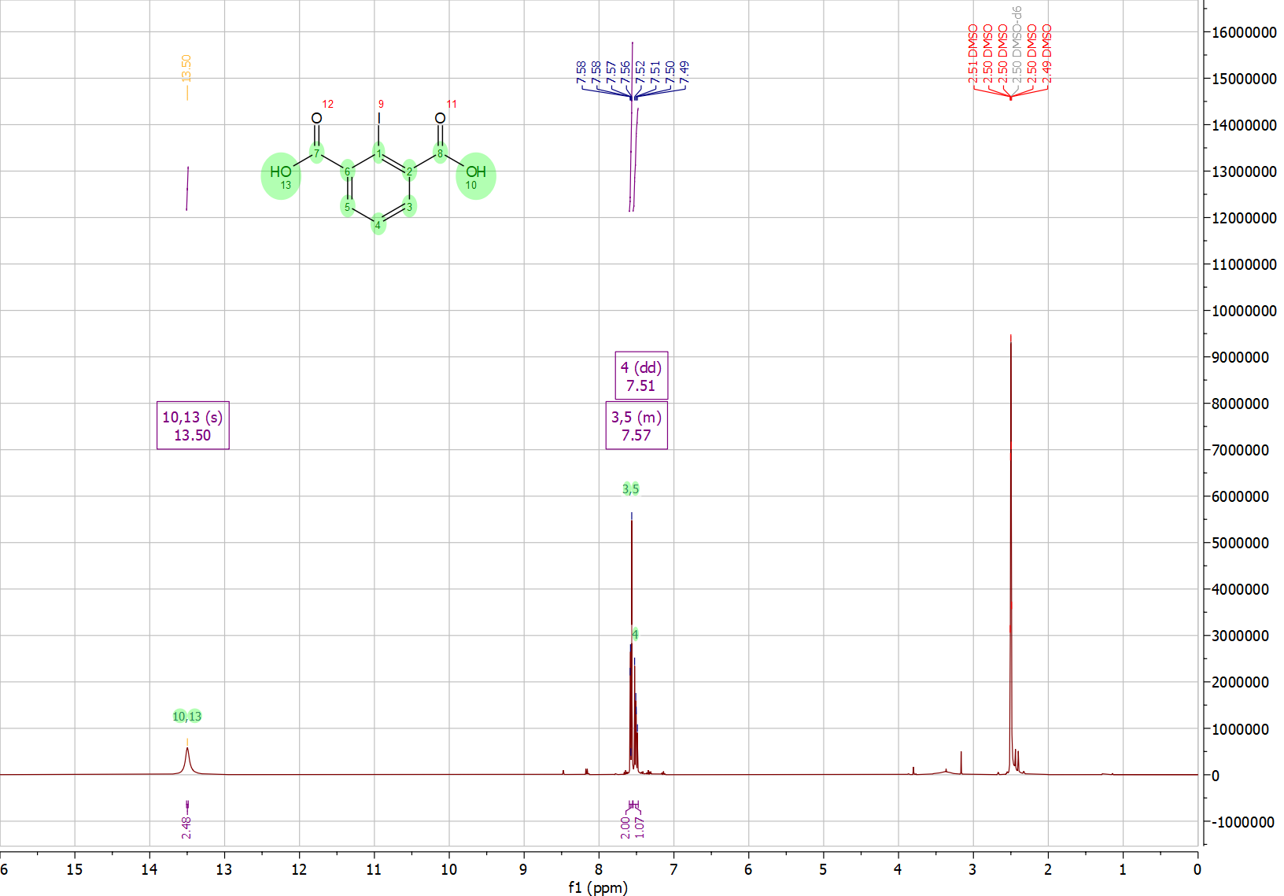
Figure S14. ¹H NMR spectrum of compound 8
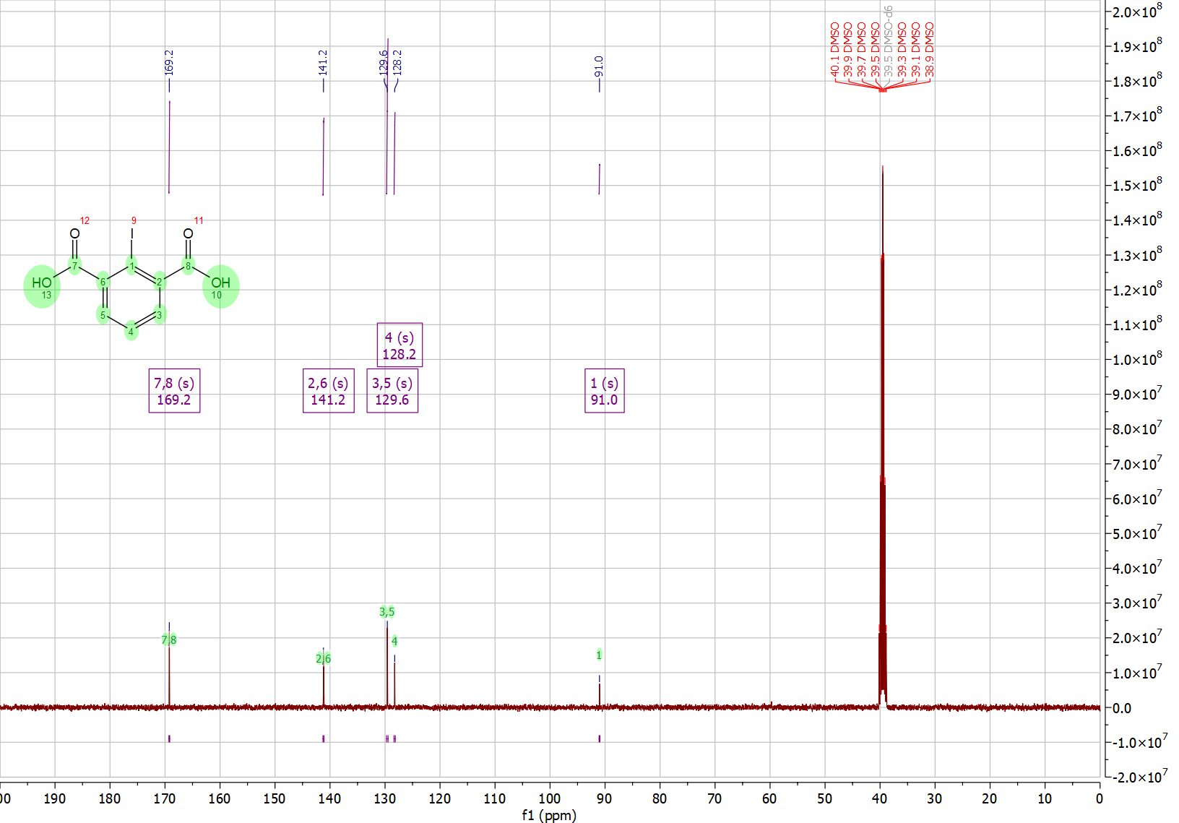
Figure S15. ¹³C NMR spectrum of compound 8
2-iodo-benzoic acid methyl ester (9)
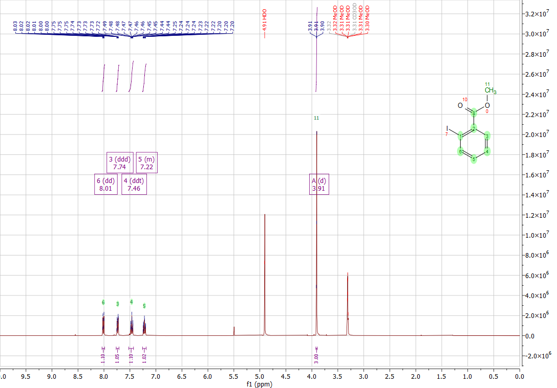
Figure S16. ¹H NMR spectrum of compound 9
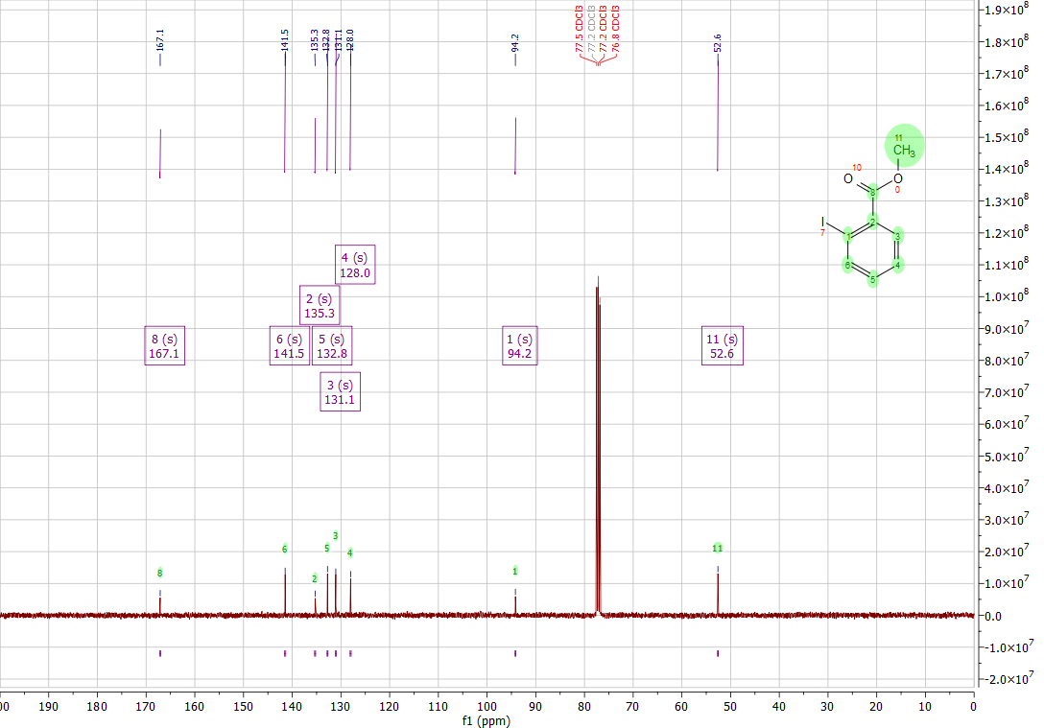
Figure S17. ¹³C NMR spectrum of compound 9
2-iodo-isophtalic acid dimethyl ester (10)
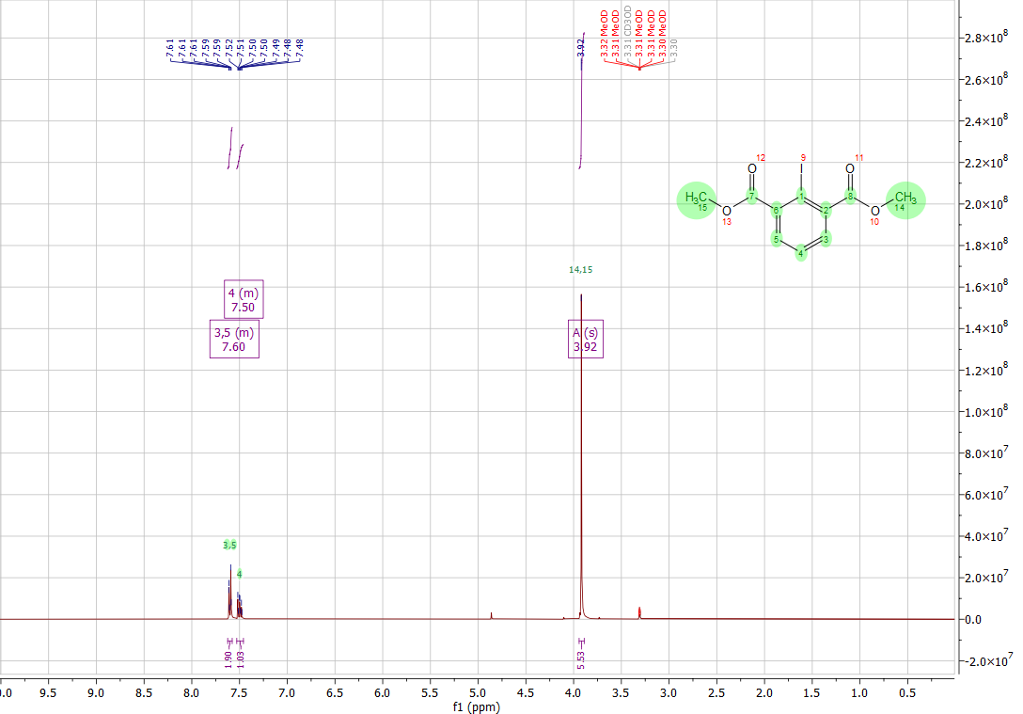
Figure S18. ¹H NMR spectrum of compound 10
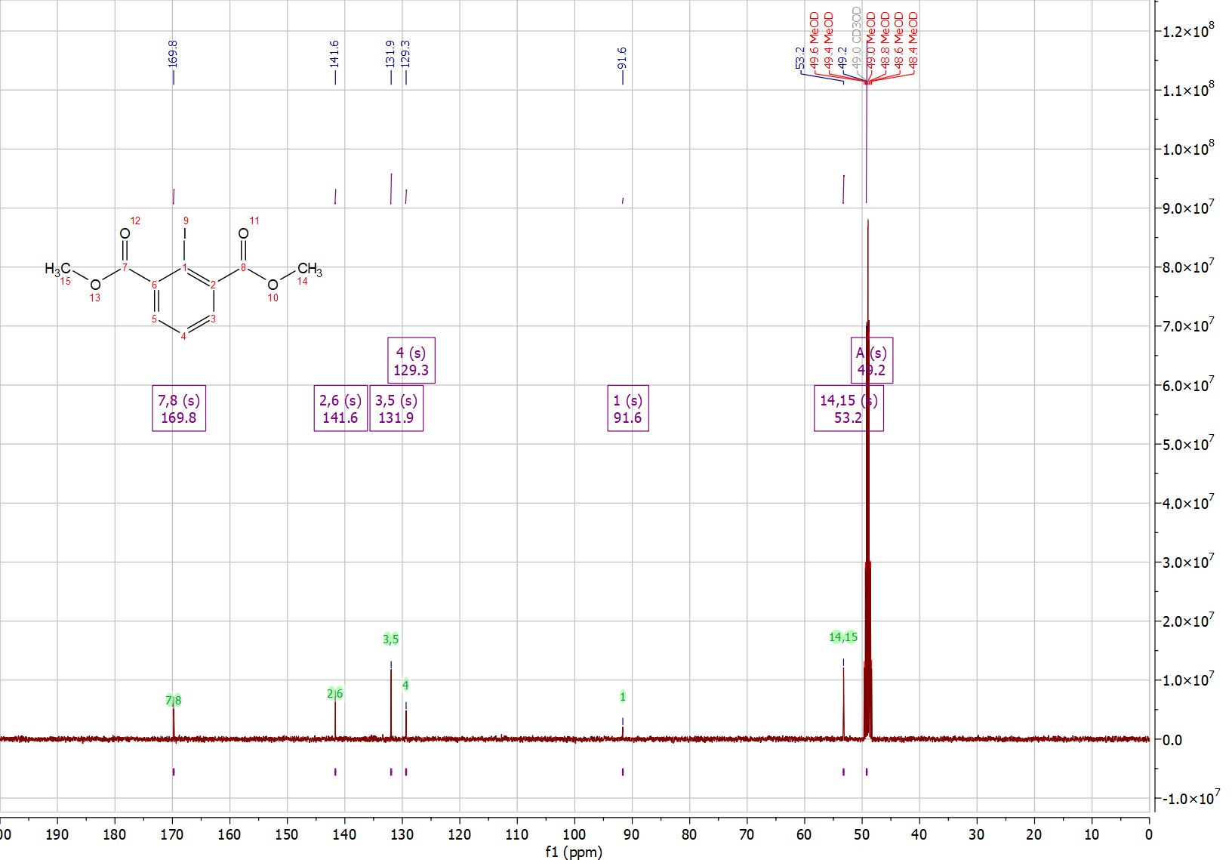
Figure S19. ¹³C NMR spectrum of compound 10
(2-iodo-phenyl)-methanol (11)
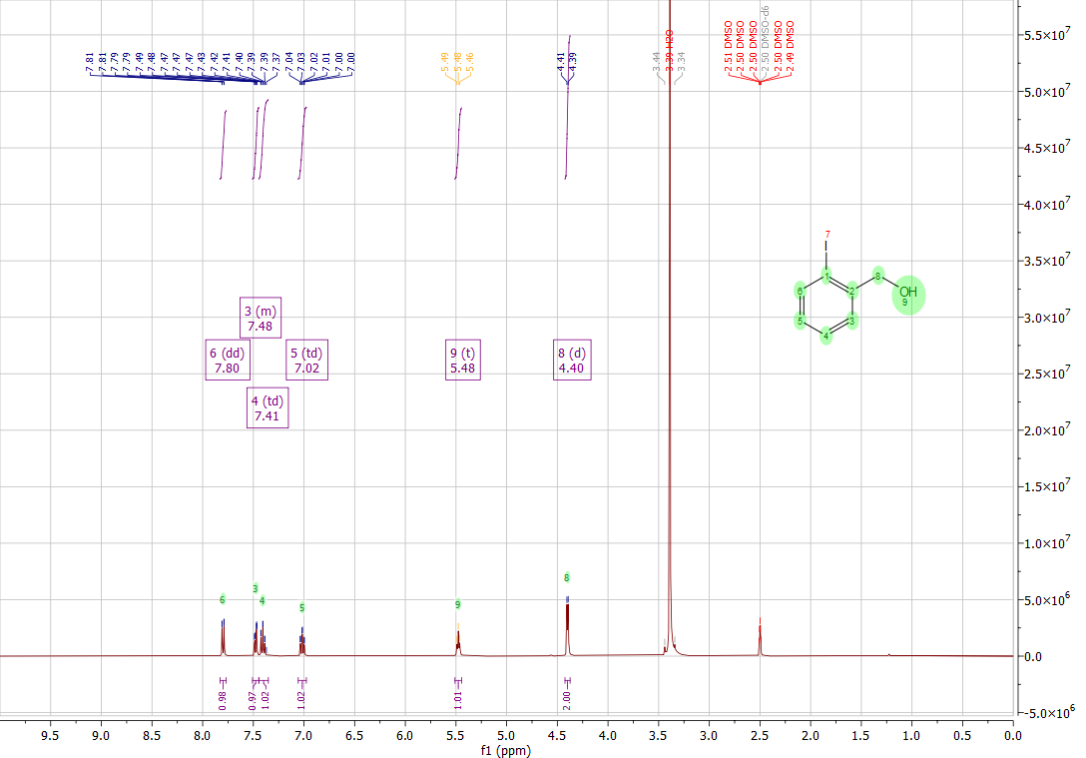
Figure S20. ¹H NMR spectrum of compound 11
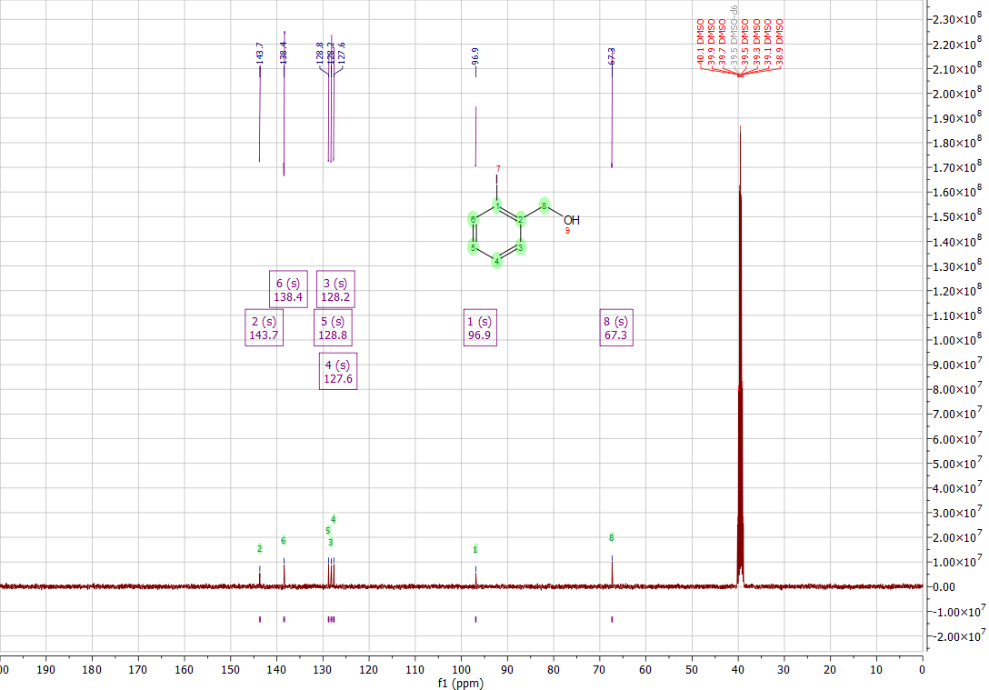
Figure S21. ¹³C NMR spectrum of compound 11
(3-hydroxymethyl-2-iodo-phenyl)-methanol (12)
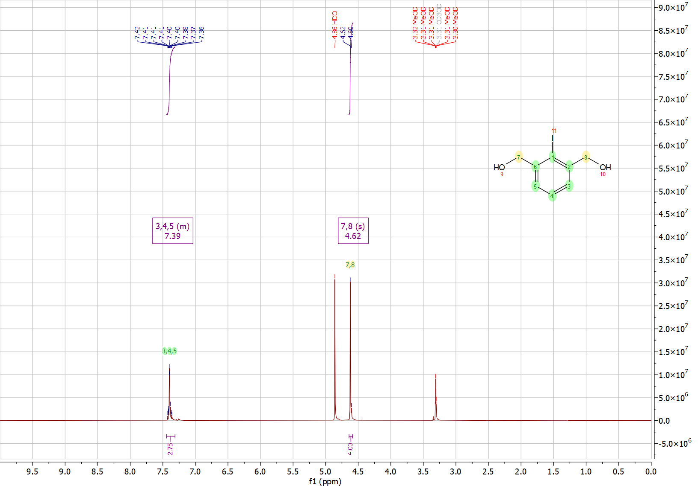
Figure S22. ¹H NMR spectrum of compound 12
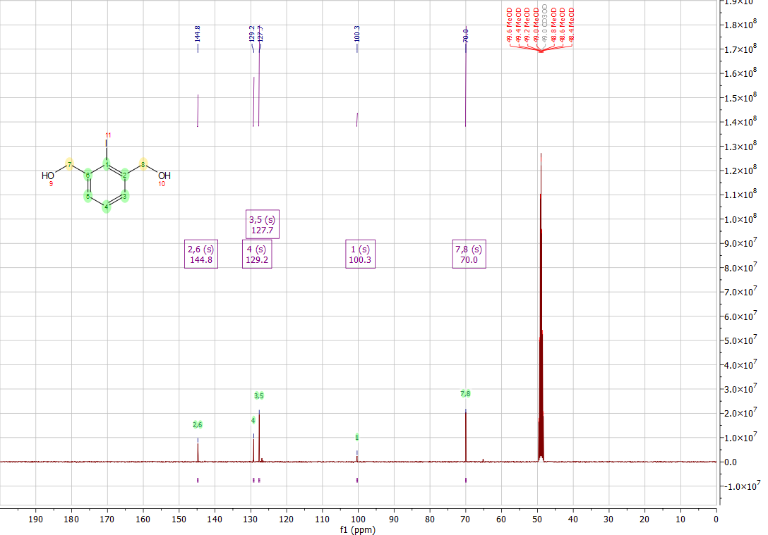
Figure S23. ¹³C NMR spectrum of compound 12
Acetic acid 2-iodo-benzyl ester (13)
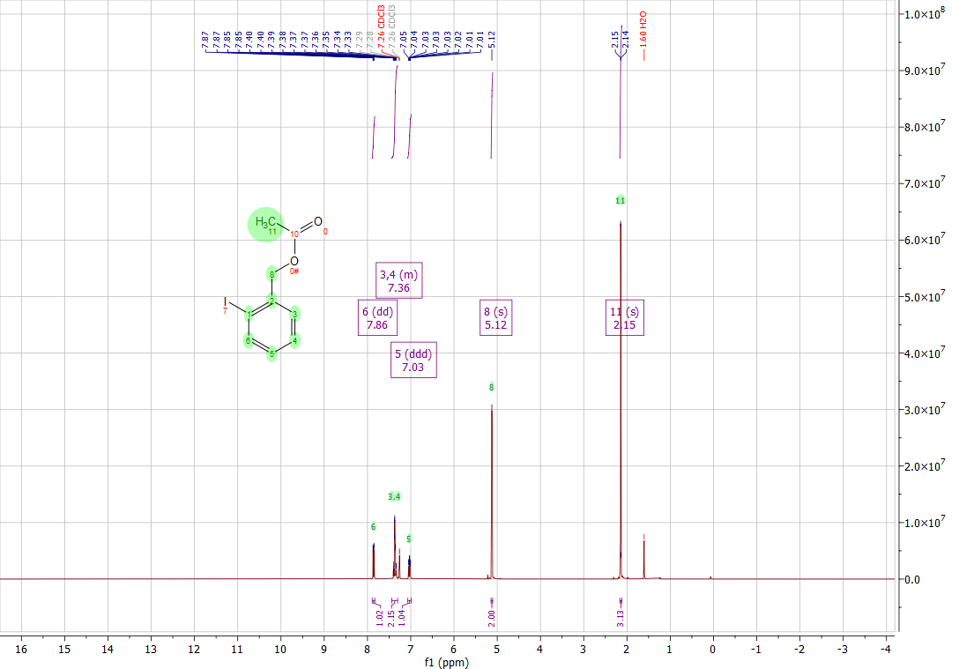
Figure S24. ¹H NMR spectrum of compound 13
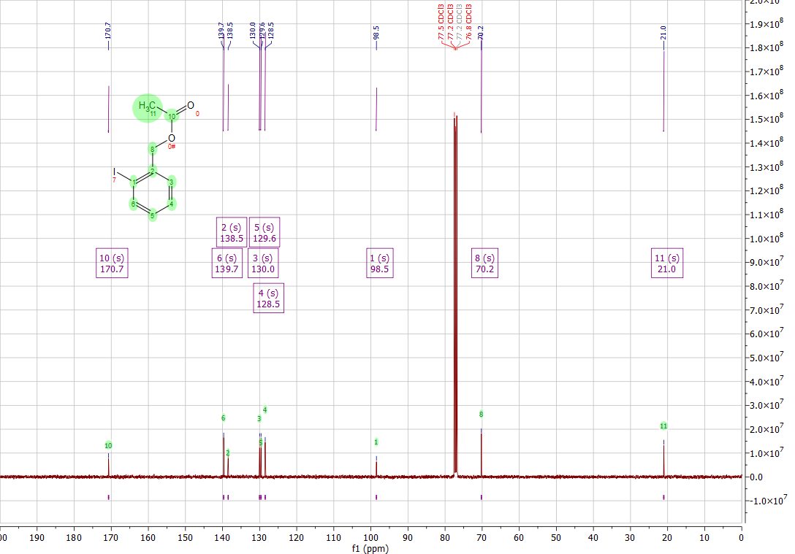
Figure S25. ¹³C NMR spectrum of compound 13
Acetic acid 3-acetoxymethyl-2-iodo-benzyl ester (14)
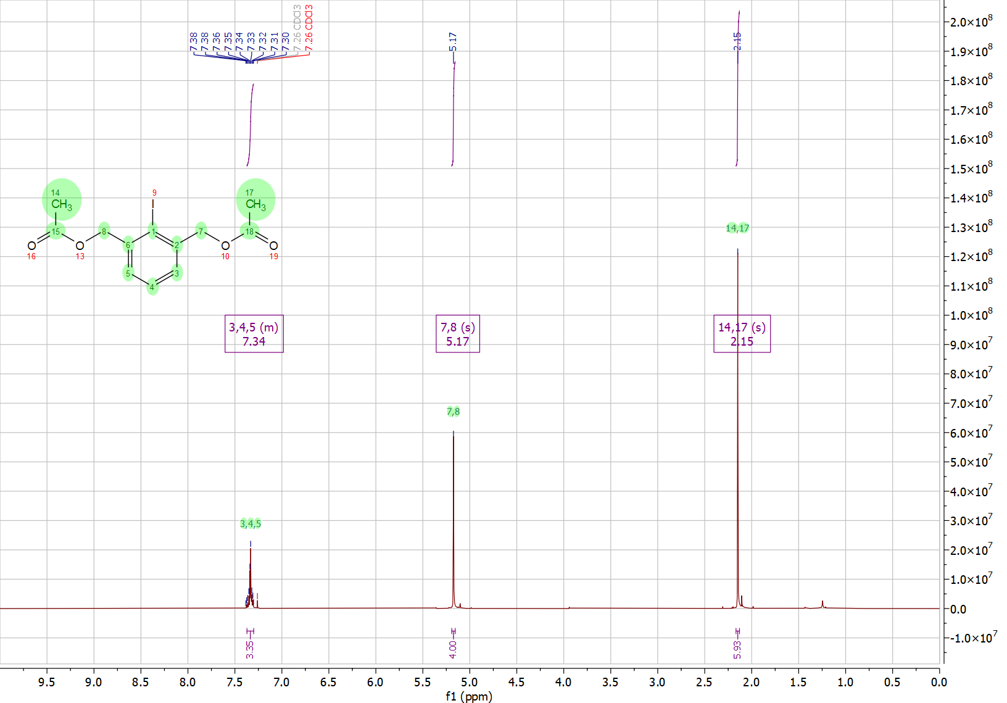
Figure S26. ¹H NMR spectrum of compound 14
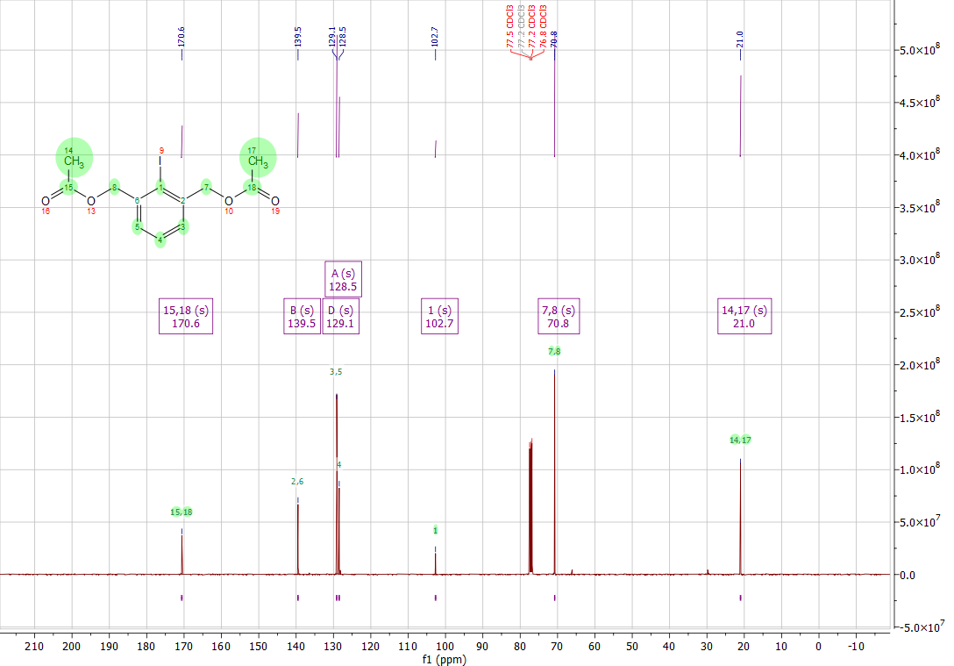
Figure S27. ¹³C NMR spectrum of compound 14
((2-hydroxymethyl)phenyl)(4-methoxyphenyl)iodonium 4-methylbenzenesulfonate (15)
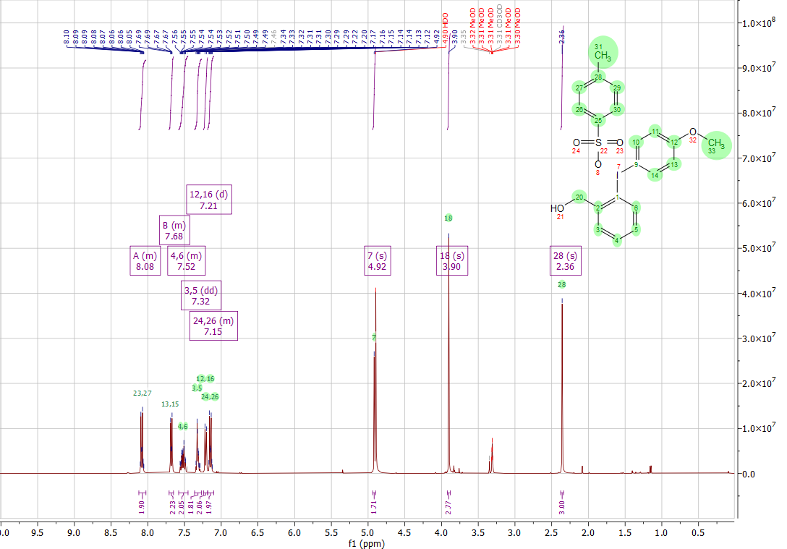
Figure S28. ¹H NMR spectrum of compound 15
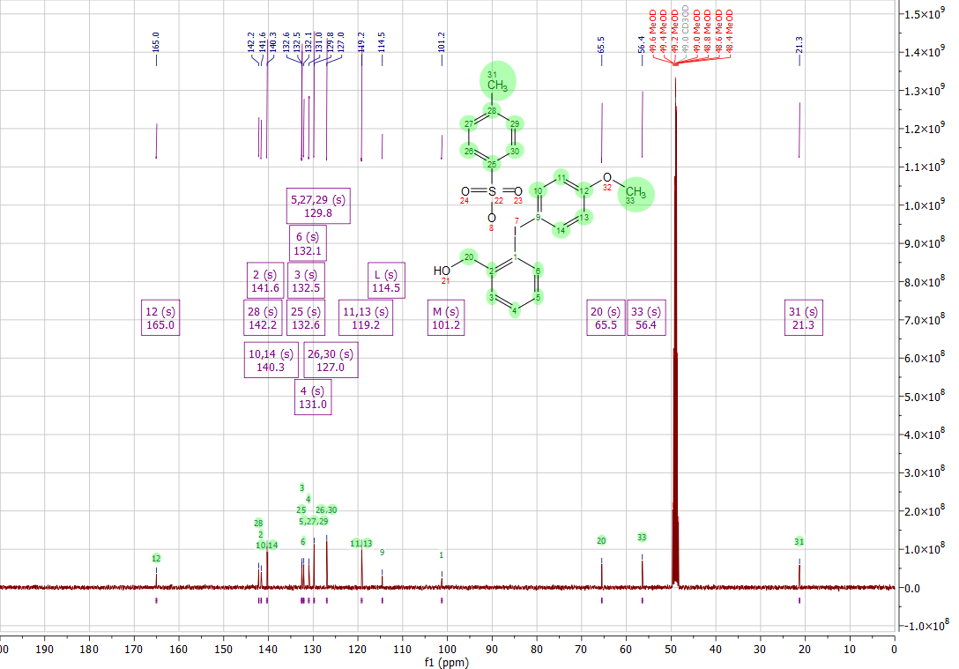
Figure S29. ¹³C NMR spectrum of compound 15
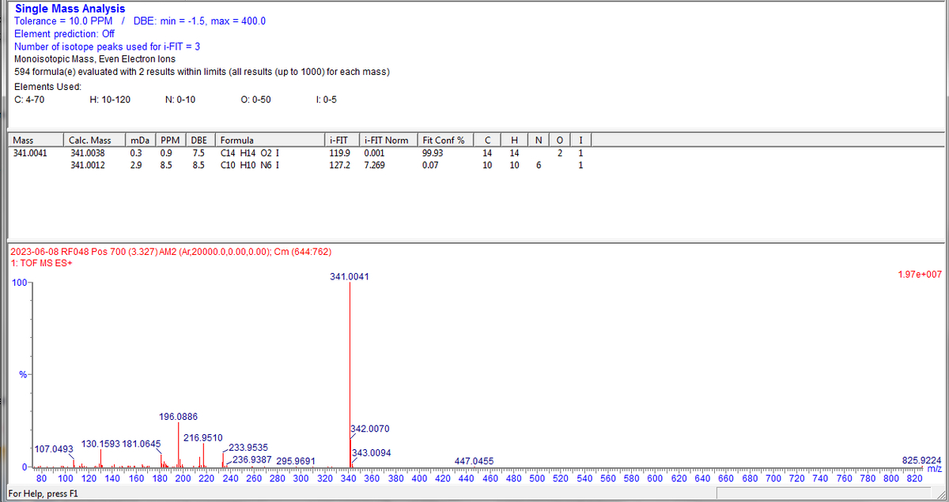
Figure S30. Mass spectrum of compound 15

(2,6-bis-hydroxymethyl-phenyl)-(4-methoxy-phenyl)-iodonium 4-methylbenzenesulfonate (16)
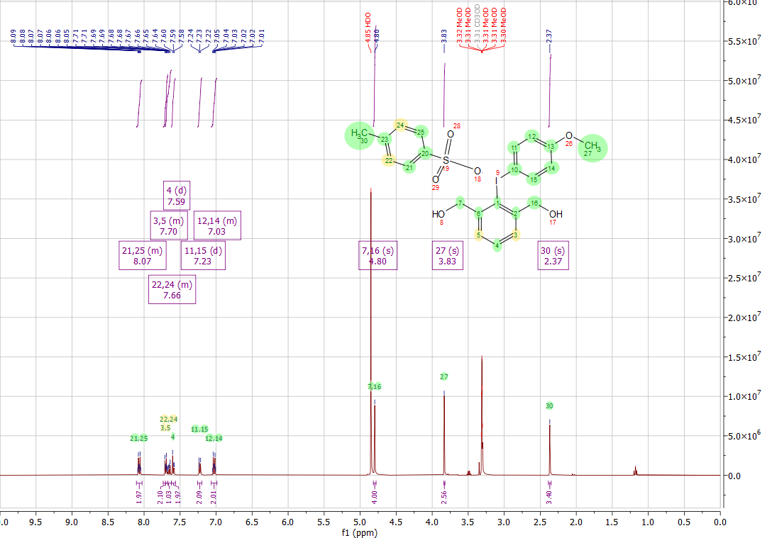
Figure S31. ¹H NMR spectrum of compound 16
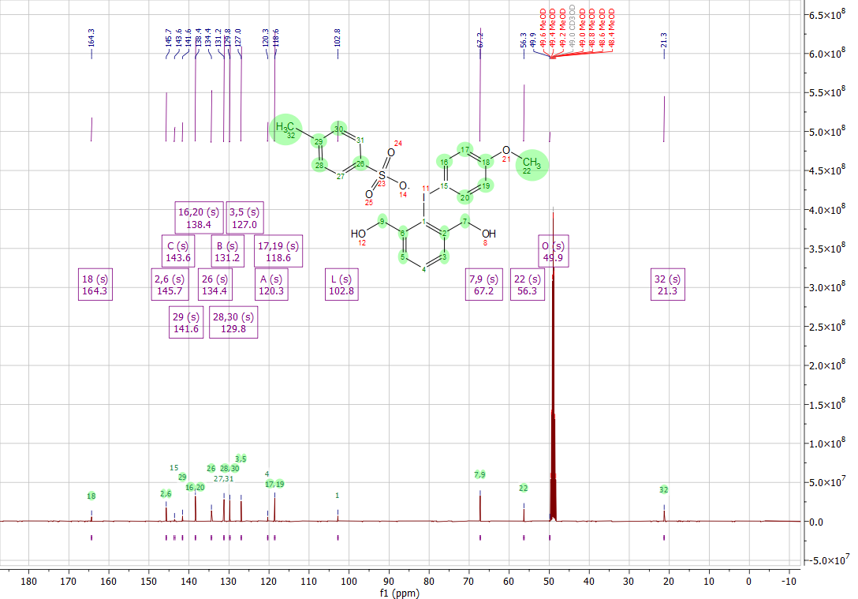
Figure S32. ¹³C NMR spectrum of compound 16
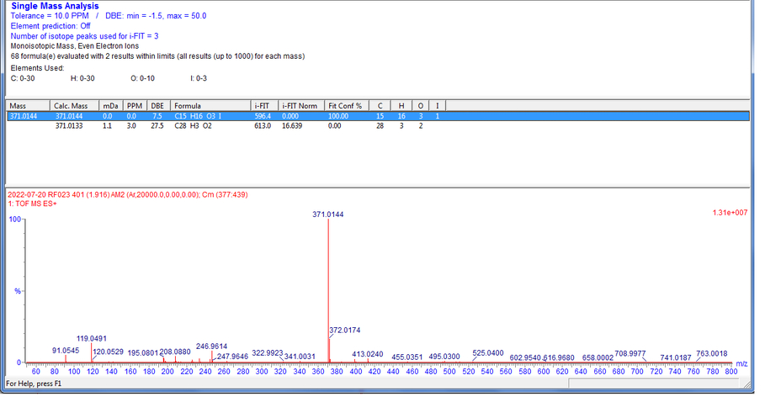
Figure S33. Mass spectrum of compound 16

3-iodo-N-ethylbenzamide (19)
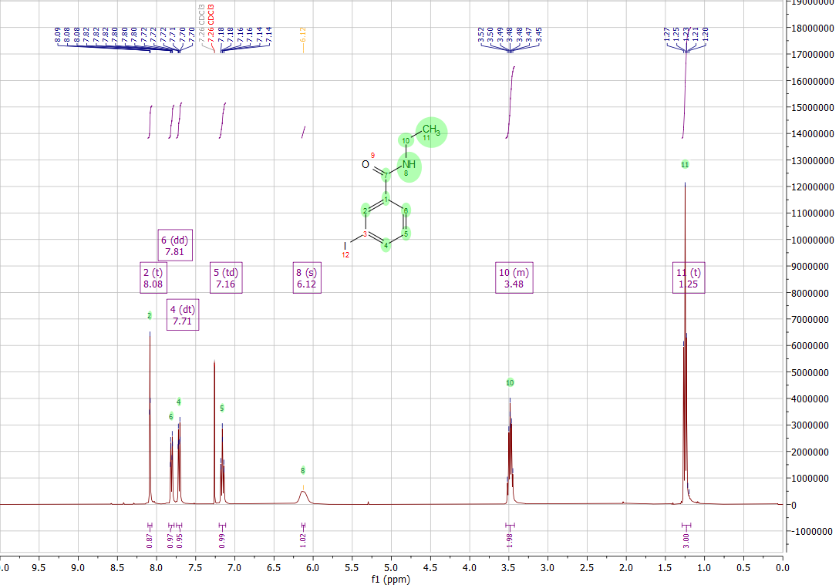
Figure S34. ¹H NMR spectrum of compound 19
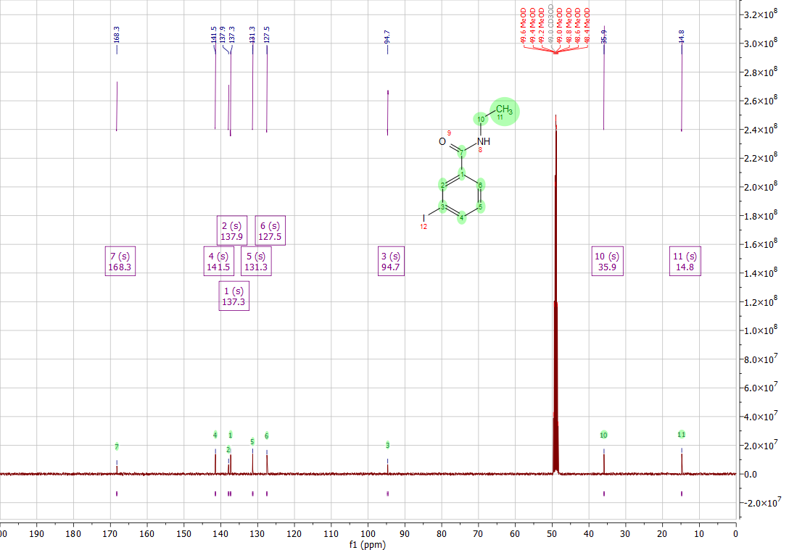
Figure S35. ¹³C NMR spectrum of compound 19

((3-ethylcarbamoyl)phenyl)(4-methoxy-phenyl)iodonium 4-methylbenzenesulfonate (17)
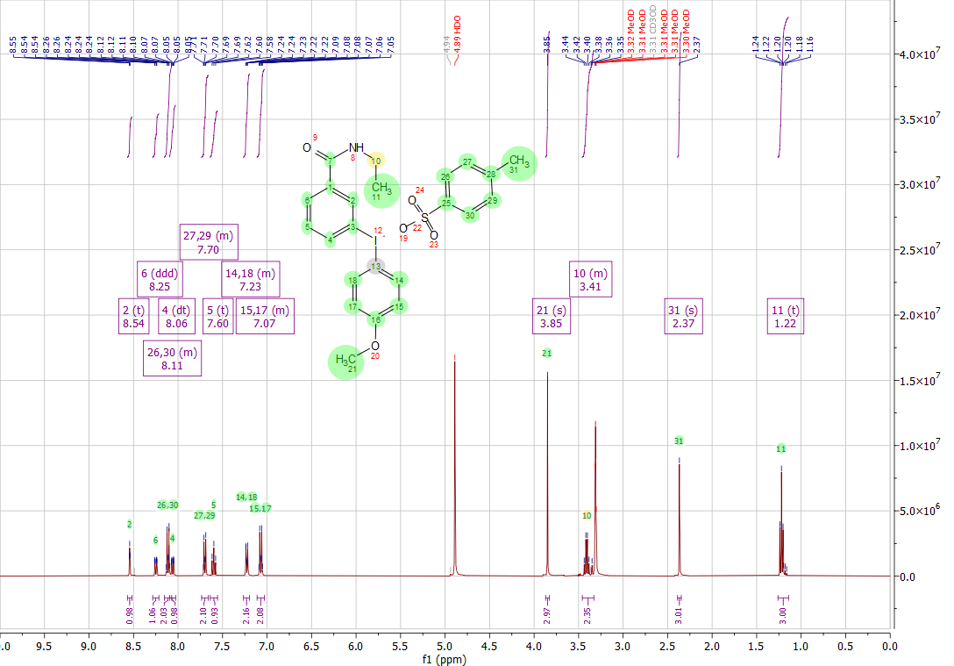
Figure S36. ¹H NMR spectrum of compound 17
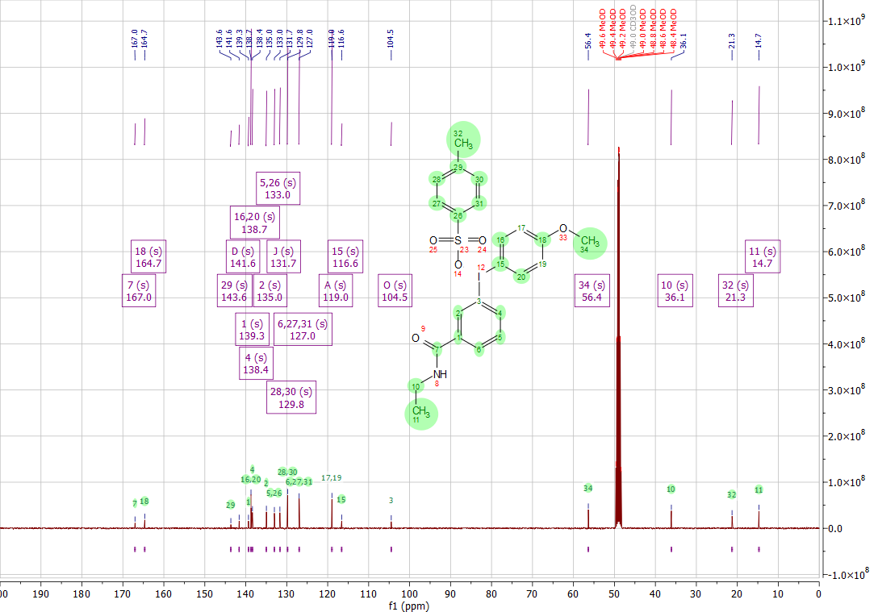
Figure S37. ¹³C NMR spectrum of compound 17
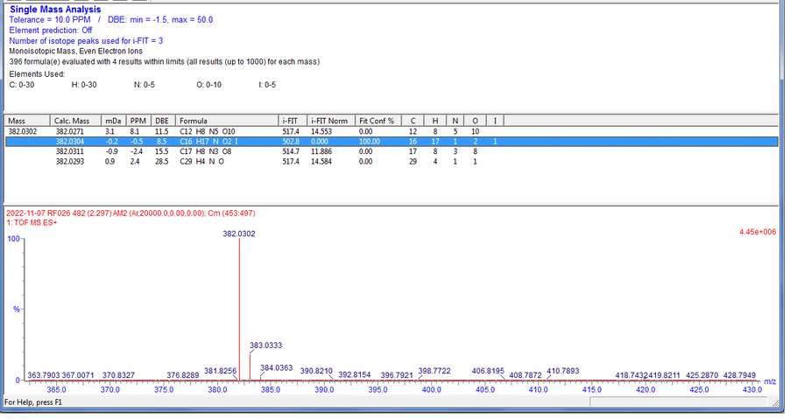
Figure S38. Mass spectrum of compound 17

