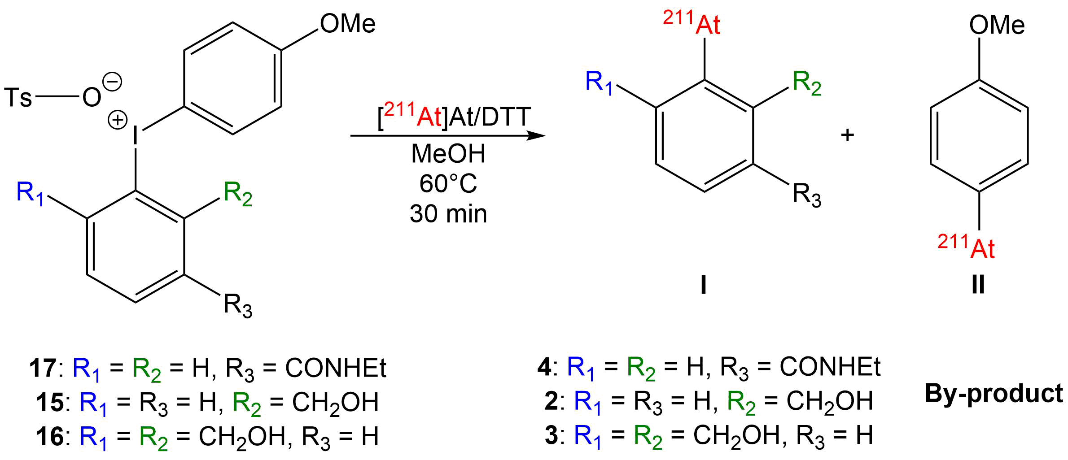
Precursor | RCY I (%) | RCY II (%)
17 | 83 ± 2 (61 ± 27)ª | 9 ± 1 (12 ± 8)ª
15 | 77 ± 3 | 4 ± 1
16 | 87 ± 2 (81 ± 10)ª | 1 ± 1 (1 ± 1)ª

Table 1. Radiolabeling of iodonium salts. Standard conditions: 95 µL of precursor (2.5 mM in MeOH) and 5 µL of ²¹¹At- (0.5-100 MBq) reduced with DTT (10 mg.mL⁻¹) in water (n = 3). RCYs were determined by radio-HPLC analyses of crude product (radio-chromatograms are provided in SI: figures S2, S3 and S4). ª Value in parentheses given for reactions run at room temperature

